Kelsey Kavanagh
Designs in Education Technology
Tech Expert Module- Draft
10/5/2011
Inanimate Alice
Overview:
Inanimate Alice is a digital novel that is truly unique because it is transmedia storytelling, meaning that the story is told through multiple technological channels. Rather than being based off a preexisting novel, story, or movie, Inanimate Alice is notable because it was originally conceptualized as a transmedia story. Students read the story of Alice on the screen, accompanied by sound effects, videos, music, puzzles, and games. The digital novel is entirely interactive, requiring the reader to participate to drive the story forward. The website is structured as individual stories or chapters of Inanimate Alice. Students can “play” these chapters like a video, while also reading the accompanying text. At certain points in the story, there are interactive elements that vary from something as simple as requiring the viewer to click to continue to a more complex game or puzzle.
Right now, there are four episodes of Inanimate Alice available online. The first episode starts when she is eight years old. There will eventually be ten episodes available that will feature Alice into young adulthood. However, the episodes are adaptable for almost any age. Teachers have created lessons plans for students from elementary school to college. Essentially, educators can use Inanimate Alice in the same way they would use canonical literature, so it is adaptable to what the teacher wants to teach. The episodes can provide fodder for class-discussion, plot analysis, writing and essay prompts, or any number of other activities that can happen in a Language Arts classroom. In addition, one of the more recent Virginia Standards of Learning for Sixth Grade Language Arts requires that students can understand the elements of media literacy, which includes comparing and contrasting auditory, visual, and written media messages (SOL 6.3).

Getting Started With Inanimate Alice:
Download an “education pack,” a PDF with background information and sample lesson ideas for grades 6-12 from http://www.inanimatealice.com/education.html. To do this, you will have to provide an e-mail address and a little bit of information.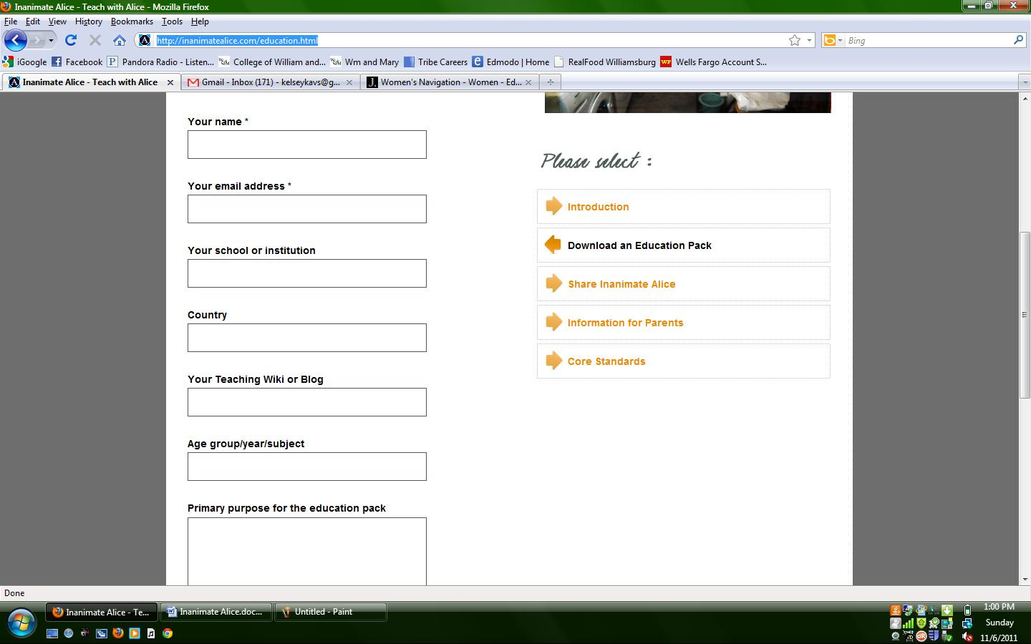
After submitting the above page, you will then receive an e-mail with a link to click on that will download the PDF. Read for lesson planning and assessment ideas. While this is a useful point to start from, Inanimate Alice can be taught without the education pack just as well or even better. Many of the best ideas found in the Classroom Examples came from the teachers’ own creativity rather than the education pack, so view the provided lessons plans as a starting point. I would also send this page http://www.inanimatealice.com/parents.html home for parents, so they have an understanding of the digital novel and do not mistakenly think that their children are just playing video games in school.
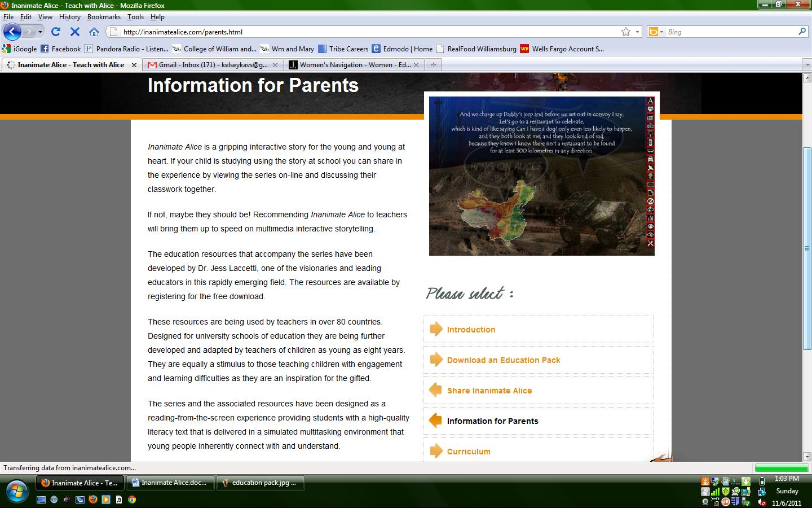
Next, view the four episodes available at www.inanimatealice.com.
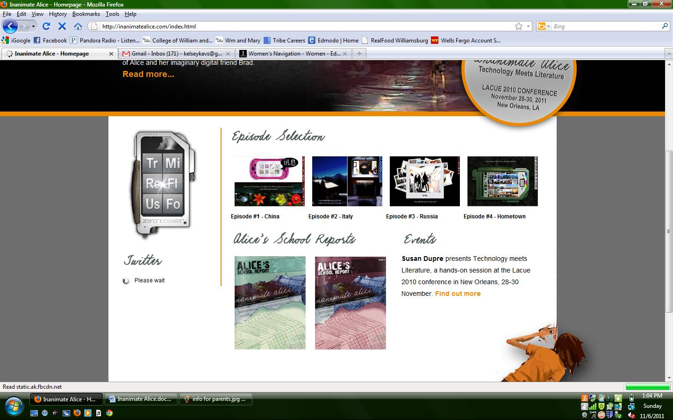
As you can see, there are four episodes. It is best to start from episode one and go to episode four, both for yourself and when you use the material with students. Each episode builds upon the previous one. In addition, the first episode is quite short with minimal interaction. Each episode gets progressively longer and includes more technological interaction.
When you or your students choose an episode, the episode will pop up in a new screen. While the episode loads, a screen will appear that gives a brief description and instructions.
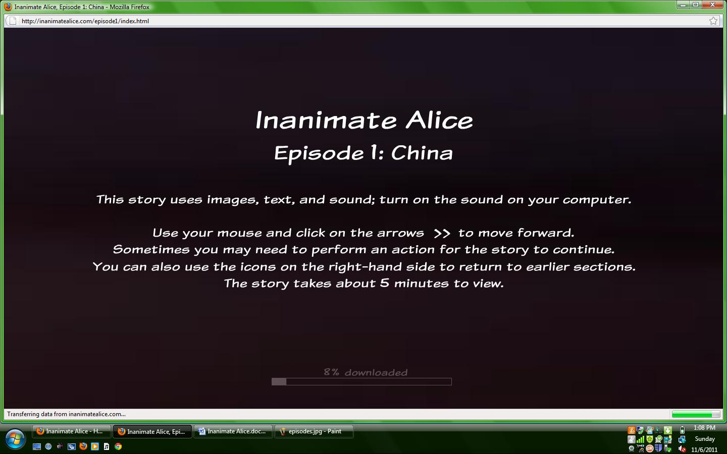
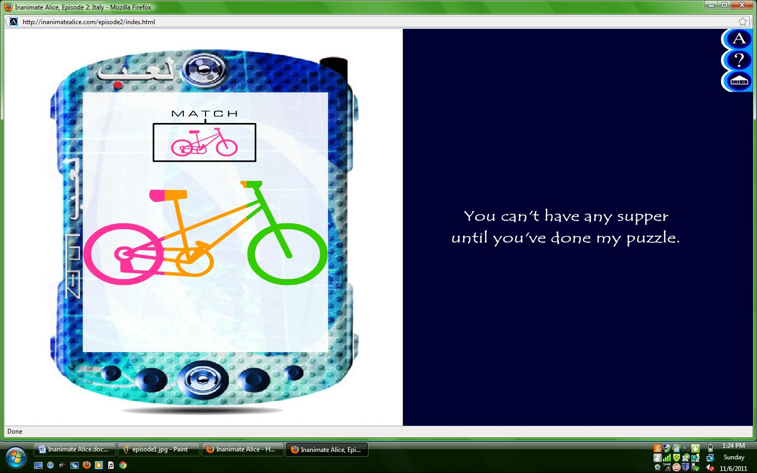
Above: an example of one of the more interactive segments of Inanimate Alice. Students can solve the puzzle by clicking on the correct pieces with a mouse. (From Episode #2- Italy)
Next, decide on the logistics of presenting this to your students. Will they be doing it at home? If so, you need to be sure all students have access to computers and internet. You can present Inanimate Alice over a projector and speakers and have the class view it as a group. However, that method would take away some of the fun of allowing students to click through the novel themselves and participate in games and puzzles. If possible, it would be best to reserve a computer lab. This way, students can complete the episodes individually, but by giving them time and space to complete them you are ensuring that students won’t have an unfair disadvantage if they do not have a computer at home. If you choose to reserve a computer lab so that students can complete the digital novel independently, each student will need headphones.
The first episode will need introduction to students. Use lesson ideas from the education pack or think of your own way to introduce transmedia: the interactive use of sound, image, and text. Inanimate Alice is one of the most flexible educational tools available. You can use it as the basis for almost any Language Arts lesson, whether that involves creative writing and media literacy, or more traditional lessons that would usually be done with text, such as plot, kinds of narration, character development, etc. Best of all, it can be used for integrative units that include a little bit of everything.
Classroom Examples:
Case Study by Julie Call, Middle School Reading Specialist, in Minneapolis Public Schools
Julie Call did a case study with 6th and 7th graders using Inanimate Alice and recorded teacher and student responses. Her goal was to increase digital literacy and familiarize students with alternative methods of story-telling. Both teachers and students agreed that the interactive qualities of Inanimate Alice encouraged students to read. Many non-readers enjoyed the digital novel, viewing it more as a video game. This case study used Inanimate Alice as more of a motivational tool to increase reading and as a way to increase media literacy. It was not used in general Language Arts classrooms or taught with an integrated lesson.
http://issuu.com/chslibrarian/docs/case_study

Pascoe Vale Primary School (Australia)
Students in Grade 6 analyzed author’s writing styles and digital techniques in Episodes 1-3. Then, each student had to use his or her analyses to synthesize their own Episode 4 with PowerPoint. The PowerPoints were shared with the class using a Wiki before viewing the author’s Episode 4. Projects that required students to use transmedia to write their own episodes of Inanimate Alice were common in many examples. After viewing the episodes, a project such as this one can encourage students to think about the impact of transmedia and use higher order thinking skills like synthesis and evaluation to create their own version.
http://inanimatealice.wordpress.com/2009/05/20/pascoe-vale-ps-creates-amazing-inanimate-alice-resource/

Diane Aronow’s 10th and 11th Collaborative English courses
Diane Aronow’s classes were comprised mostly of special education students. She used the program and corresponding education pack, along with some of her own ideas. Ms. Aronow reported that the interactive qualities of Inanimate Alice helped her students understand literary elements better. As a culminating project, they worked in groups to create their own episode using PhotoStory 3. Read Diane Aronow’s blog posts or view samples of student PowerPoints.
http://inanimatealice.wordpress.com/2009/03/18/english-students-create-their-versions-of-inanimate-alice/

Mr. Wood and Team 17
Mr. Wood’s Wiki does not name a school or age group, probably to keep his students confidential on the internet, but his lessons appear to be for an upper-elementary or middle school English course. Mr. Wood’s incredibly detailed Wiki shows that Inanimate Alice can be taught like a novel. Students learned about characterization, made timelines of the plot, and discussed other literary elements such as narration and foreshadowing. Inanimate Alice also provided material for students to use to practice brainstorming and inference. This example shows that anything that an educator can do with a novel or short story can also be done with Inanimate Alice. It is a very versatile educational tool.
http://inanimatealice-aperspective.wikispaces.com/

Assessing Inanimate Alice for the Classroom:
Pros:
- The interactive elements feel like a video game or puzzle, while the visual elements mimic a comic book, so it is fun for students. It increases motivation to read.
- The sound effects and visuals combined with relatively simple text could be extremely beneficial to English Language Learners.
- Adaptable for many age groups. The story is easy enough for younger children to read, especially with the added help of the visual and auditory aspects. Older students can delve more deeply into the transmedia aspect of the story by analyzing the overall of effectiveness of the different elements in enriching the story.
- Alice is in a new world-location for each episode (China, Italy, Russia), and she has friends of many different nationalities, helping students learn about new places and make cross-cultural connections and appreciate diversity.
- Allows reader to feel like they are in the place of Alice. Some of the visual accompaniments do not show Alice herself but rather what she is seeing.
- Familiarizes students with different forms of media.
Cons:
- For students who enjoy reading already, the sound effects and pictures could seem distracting.
- Your students may not all have equal access to a computer.
- Requires careful setup and lesson planning for the digital novel to be effective.
- Some children may not be able to relate to the world Alice lives in. For instance, a school in a small, rural community might not identify with Alice’s world-traveling, as it is sometimes presented as an almost nomadic living situation.
- Can be slow without a good internet connection.
Considerations for Teachers:
1. Take advantage of resources. There are a lot of teachers using Inanimate Alice right now. While you might not want to use their exact lessons, they can serve as a good starting point. Visit inanimatealice.wordpress.com and iteachinanimatealice.blogspot.com for ideas.
2. Use different types of media. Because Inanimate Alice consists of different types of media, try to get students involved in transmedia also. Allow them to use podcasts, Powerpoint, PhotoStory, etc. to show their understanding of the material.
3. Use thought-provoking questions for discussion by asking students to fill in the gaps. Examples: Who is Brad? Why do you think Alice needs him? What do you think happened at the end of Episode 1?
4. Discuss the multimodal aspects of Inanimate Alice. Don’t treat the music and visual as accompaniments, but rather as literary elements of their own.

