Group Size: Whole Class
Introduction:
Every person should at one point learn how to tie a tie. This holds especially true for males, but women too may find one day that having the skill comes in handy. Having the ability to correctly and efficiently tie a tie can be beneficial in a number of situations and is a universal skill every young adult should learn.
Learning Objectives:
For the purpose of this assignment, the class will be focusing on the half Windsor knot. Even though there are a number of different knot styles such as the Pratt knot or the Windsor knot, the focus will remain on one basic knot. By the end of this learning session, every student will have the ability to correctly and efficiently tie a half Windsor knot at the appropriate length. Knowing how to tie a tie is a necessary part of growing up and understanding how to dress appropriately for certain situations. Students will feel comfortable how, when and where to tie a tie.
Guiding Question:
Using a basic tie, how can a person correctly tie a half Windsor knot to look formal and presentable?
Materials:
Formal Long-Sleeved button up collared shirt; tie; computer (with Internet access)
Procedures:
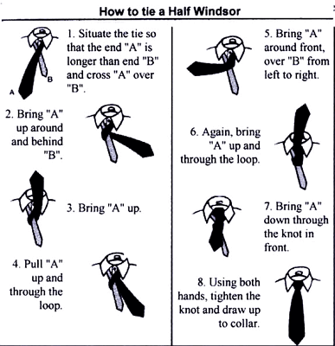
Procedures (cont’d):
Above is a chart showing all the steps involved in properly tying a tie. With each step, there is an illustration explaining exactly what to do for each step and the correct location of your hands and the tie. At the end of each step, the instructor will individually guarantee each step has been performed properly so as to ensure proper technique for the final assessment. If for any reason there is confusion about one of the steps shown above or if any student seems to be having difficulty, the instructor will make sure to bring the student up to speed with the rest of the class as well as make sure he or she feels comfortable for the remainder of the task.
Assessment:
The assessment will fall into two sections. Visualizing and Performing. The student will watch a video of a man incorrectly tying a tie. He/she must be able to identify the errors and explain what should have happened to have the tie come out correctly. Once he or she is able to properly identify the procedure, he/she will have to perform the task themselves in a timely manner.
Answer Key or Rubric:
Video: Each error properly identified will result in a certain number of points equaling 40 total points.
Performance: The student will be observed performing the task and graded upon the knot itself and the amount of time. Time over the allotted time will result in points taken off. Errors will result in points taken off. Incorrect tie will result in a 0. Performance = 60 points.
__/40 +__/60 =___/100
Benchmark or Standards: VA.68.S.2

