Literacy Opportunities for North American Studies

CAP 2011 ELA Grade 5 Completed November 15, 2011

East Meadow U.F.S.D.

Bowling Green Elementary School
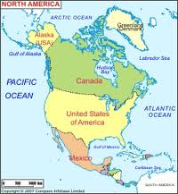

CAP WRITERS
Jennie Re ~ Ellen Kelter ~ Jocelyn Weston

Board of Education
Joseph Parisi, President
Walter Skinner, Vice President
Joseph Danenza
Corey Fanelli
Marcee Rubinstein
Jeffrey Rosenking

Administration

Louis R. DeAngelo, Superintendent of Schools
Robert Gorman, Asst. Superintendent for Business and Finance
Anthony Russo, Assistant Superintendent for Personnel and Administration
Cindy Munter, Assistant to the Superintendent for Curriculum and Instruction
Patrick Pizzo, Director of School Facilities and Operations
Mary Ann O’Brien, Assistant Business Administrator
Maria Casamassa, Director of Literacy and Funded Programs
Maria Ciarametaro, Principal of Bowling Green Elementary School
Frank Lukasik, Assistant Principal of Bowling Green Elementary School

Literacy Opportunities for North American Studies

Table of Contents

Abstract 3

Rationale 4

New York State P-12 Common Core Learning Standards 5-8

Lesson #1: Analyzing Photographs: Declaring Independence 9-10
Lesson #2: Categorizing: United States Bill of Rights 11

Lesson #3 Drawing Inferences: National Anthems 12-13

Lesson #4: Writing a Summary: The Role of the Canadian Prime Minister 4-15

Lesson #5: Making Connections: Map Reading Skills 16

Lesson #6 Using Data Charts: Capitol Cities 18

Lesson #7: Analyzing Historical References in Poetry 19

Lesson #8: Producing Short Research Projects: National Holidays 20

Appendix 21-29

Bibliography 30

Kelter~Re~Weston 11/2011

Literacy Opportunities for North American Studies

Abstract

This CAP, Literacy Opportunities for North American Studies- grade 5, presents interdisciplinary lessons which allow teachers to merge Social Studies content with appropriate literacy strategies in alignment with NYS Common Core Standards. Students will read and understand informational text for different purposes, write informative or explanatory text and narratives based on their reading, engage effectively in a range of collaborative discussions and produce a research project. Students will also create visual displays and oral presentations to enhance the development of the themes or main ideas of grade 5 Social Studies content.
These lessons, which contain suggestions for differentiated instruction, are applicable to multilevel or heterogeneous classrooms and provide opportunities for teachers to augment their Social Studies and Literacy curricula.

Kelter~Re~Weston 11/2011

Literacy Opportunities for North American Studies

Rationale

This CAP introduces teachers to learning opportunities that are aligned with the New York State Common Core Learning Standards. The writers have included specific lessons in the areas reading, writing, and critical thinking using non-fiction literature. The CAP includes a wide range of sources of different genres. Teachers of grade five who use this curriculum will find an appendix of references to enable their students to interact with text, use graphic organizers, and to become active readers and writers.

The reading strategies are applicable to the fifth grade Social Studies curriculum. Historical, economic, and cultural connections will be explored among the countries of the United States, Canada, and Mexico.

Each lesson presented in this CAP includes the following components:
- Lesson Objective
- Procedure
- Resources
- Suggestions for Differentiated Instruction

The strategies suggested by the writers are applicable to small group or whole class instruction and may be used across the curriculum. These strategies will enable the teacher to differentiate instruction to best meet the needs of each student.

Literacy Opportunities for North American Studies
English Language Arts Standards Grade 5
Reading: Foundational Skills

Phonics and Word Recognition
- RF.5.3. Know and apply grade-level phonics and word analysis skills in decoding words.
    - Use combined knowledge of all letter-sound correspondences, syllabication patterns, and morphology (e.g., roots and affixes) to read accurately unfamiliar multisyllabic words in context and out of context.

Fluency
- RF.5.4. Read with sufficient accuracy and fluency to support comprehension.
    - Read grade-level text with purpose and understanding.
    - Read grade-level prose and poetry orally with accuracy, appropriate rate, and expression.
    - Use context to confirm or self-correct word recognition and understanding, rereading as necessary.

Reading: Literature

Key Ideas and Details
- RL.5.1. Quote accurately from a text when explaining what the text says explicitly and when drawing inferences from the text.
- RL.5.2. Determine a theme of a story, drama, or poem from details in the text, including how characters in a story or drama respond to challenges or how the speaker in a poem reflects upon a topic; summarize the text.
- RL.5.3. Compare and contrast two or more characters, settings, or events in a story or drama, drawing on specific details in the text (e.g., how characters interact).

Craft and Structure
- RL.5.4. Determine the meaning of words and phrases as they are used in a text, including figurative language such as metaphors and similes.
- RL.5.5. Explain how a series of chapters, scenes, or stanzas fits together to provide the overall structure of a particular story, drama, or poem.
- RL.5.6. Describe how a narrator’s or speaker’s point of view influences how events are described.

Integration of Knowledge and Ideas
- RL.5.7. Analyze how visual and multimedia elements contribute to the meaning, tone, or beauty of a text (e.g., graphic novel, multimedia presentation of fiction, folktale, myth, poem).
- RL.5.8. (Not applicable to literature)
- RL.5.9. Compare and contrast stories in the same genre (e.g., mysteries and adventure stories) on their approaches to similar themes and topics.

Range of Reading and Complexity of Text
- RL.5.10. By the end of the year, read and comprehend literature, including stories, dramas, and poetry, at the high end of the grades 4–5 text complexity band independently and proficiently.

Reading: Informational Text

Key Ideas and Details
- RI.5.1. Quote accurately from a text when explaining what the text says explicitly and when drawing inferences from the text.
- RI.5.2. Determine two or more main ideas of a text and explain how they are supported by key details; summarize the text.
- RI.5.3. Explain the relationships or interactions between two or more individuals, events, ideas, or concepts in a historical, scientific, or technical text based on specific information in the text.

Craft and Structure
- RI.5.4. Determine the meaning of general academic and domain-specific words and phrases in a text relevant to a grade 5 topic or subject area.
- RI.5.5. Compare and contrast the overall structure (e.g., chronology, comparison, cause/effect, problem/solution) of events, ideas, concepts, or information in two or more texts.
- RI.5.6. Analyze multiple accounts of the same event or topic, noting important similarities and differences in the point of view they represent.

Integration of Knowledge and Ideas
- RI.5.7. Draw on information from multiple print or digital sources, demonstrating the ability to locate an answer to a question quickly or to solve a problem efficiently.
- RI.5.8. Explain how an author uses reasons and evidence to support particular points in a text, identifying which reasons and evidence support which point(s).
- RI.5.9. Integrate information from several texts on the same topic in order to write or speak about the subject knowledgeably.

Range of Reading and Level of Text Complexity
- RI.5.10. By the end of the year, read and comprehend informational texts, including history/social studies, science, and technical texts, at the high end of the grades 4–5 text complexity band independently and proficiently.

Writing

Text Types and Purposes
- W.5.1. Write opinion pieces on topics or texts, supporting a point of view with reasons and information.
    - Introduce a topic or text clearly, state an opinion, and create an organizational structure in which ideas are logically grouped to support the writer’s purpose.
    - Provide logically ordered reasons that are supported by facts and details.
    - Link opinion and reasons using words, phrases, and clauses (e.g., consequently, specifically).
    - Provide a concluding statement or section related to the opinion presented.
- W.5.2. Write informative/explanatory texts to examine a topic and convey ideas and information clearly.
    - Introduce a topic clearly, provide a general observation and focus, and group related information logically; include formatting (e.g., headings), illustrations, and multimedia when useful to aiding comprehension.
    - Develop the topic with facts, definitions, concrete details, quotations, or other information and examples related to the topic.
    - Link ideas within and across categories of information using words, phrases, and clauses (e.g., in contrast, especially).
    - Use precise language and domain-specific vocabulary to inform about or explain the topic.
    - Provide a concluding statement or section related to the information or explanation presented.
- W.5.3. Write narratives to develop real or imagined experiences or events using effective technique, descriptive details, and clear event sequences.
    - Orient the reader by establishing a situation and introducing a narrator and/or characters; organize an event sequence that unfolds naturally.
    - Use narrative techniques, such as dialogue, description, and pacing, to develop experiences and events or show the responses of characters to situations.
    - Use a variety of transitional words, phrases, and clauses to manage the sequence of events.
    - Use concrete words and phrases and sensory details to convey experiences and events precisely.
    - Provide a conclusion that follows from the narrated experiences or events.

Production and Distribution of Writing
- W.5.4. Produce clear and coherent writing in which the development and organization are appropriate to task, purpose, and audience. (Grade-specific expectations for writing types are defined in standards 1–3 above.)
- W.5.5. With guidance and support from peers and adults, develop and strengthen writing as needed by planning, revising, editing, rewriting, or trying a new approach.
- W.5.6. With some guidance and support from adults, use technology, including the Internet, to produce and publish writing as well as to interact and collaborate with others; demonstrate sufficient command of keyboarding skills to type a minimum of two pages in a single sitting.

Research to Build and Present Knowledge
- W.5.7. Conduct short research projects that use several sources to build knowledge through investigation of different aspects of a topic.
- W.5.8. Recall relevant information from experiences or gather relevant information from print and digital sources; summarize or paraphrase information in notes and finished work, and provide a list of sources.
- W.5.9. Draw evidence from literary or informational texts to support analysis, reflection, and research.
  - Apply grade 5 Reading standards to literature (e.g., “Compare and contrast two or more characters, settings, or events in a story or a drama, drawing on specific details in the text [e.g., how characters interact]”).
  - Apply grade 5 Reading standards to informational texts (e.g., “Explain how an author uses reasons and evidence to support particular points in a text, identifying which reasons and evidence support which point[s]”).

Range of Writing
- W.5.10. Write routinely over extended time frames (time for research, reflection, and revision) and shorter time frames (a single sitting or a day or two) for a range of discipline-specific tasks, purposes, and audiences.
    - Use a variety of transitional words, phrases, and clauses to manage the sequence of events.
    - Use concrete words and phrases and sensory details to convey experiences and events precisely.
    - Provide a conclusion that follows from the narrated experiences or events.

Speaking & Listening

Comprehension and Collaboration
- SL.5.1. Engage effectively in a range of collaborative discussions (one-on-one, in groups, and teacher-led) with diverse partners on grade 5 topics and texts, building on others’ ideas and expressing their own clearly.
    - Come to discussions prepared, having read or studied required material; explicitly draw on that preparation and other information known about the topic to explore ideas under discussion.
    - Follow agreed-upon rules for discussions and carry out assigned roles.
    - Pose and respond to specific questions by making comments that contribute to the discussion and elaborate on the remarks of others.
    - Review the key ideas expressed and draw conclusions in light of information and knowledge gained from the discussions.
- SL.5.2. Summarize a written text read aloud or information presented in diverse media and formats, including visually, quantitatively, and orally.
- SL.5.3. Summarize the points a speaker makes and explain how each claim is supported by reasons and evidence.

Presentation of Knowledge and Ideas
- SL.5.4. Report on a topic or text or present an opinion, sequencing ideas logically and using appropriate facts and relevant, descriptive details to support main ideas or themes; speak clearly at an understandable pace.
- SL.5.5. Include multimedia components (e.g., graphics, sound) and visual displays in presentations when appropriate to enhance the development of main ideas or themes.
- SL.5.6. Adapt speech to a variety of contexts and tasks, using formal English when appropriate to task and situation

Literacy Opportunities for North American Studies

Lesson #1: Analyzing Photographs

Objective: To analyze the artistic portrayal of historical moments in the United States and Canada.

Resources:
Hakim, Joy. A History of US. New York: Oxford University Press, 1999.
Thorsen, Steffen. Time and Date AS 1995–2011. http://www.timeanddate.com/holidays/canada/canada-day
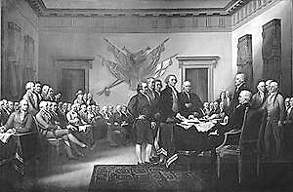
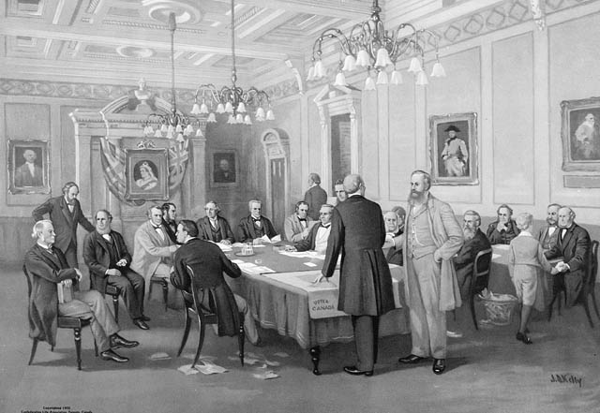
The Fathers of Confederation
at the London Conference, 1866
In John Trumbull's painting Declaration of Independence, the five-man drafting committee is presenting its work to the Continental Congress. Jefferson is the tall figure in the center laying the Declaration on the desk.

Procedure:
- Present the two paintings, without the labels and preferably in color, on a smart board or on individual computers.
- Ask the students to find clues in the paintings that indicate time period, architecture, clothing style, technology, and possible subjects of each painting.
- Discuss each painting as if it were written text: characters, setting, action, symbols, main idea.
- Research Questions:
- How are Canada’s representatives selected?
- How are the United States representatives selected?

Kelter ~Re~Weston 11/2011

Literacy Opportunities for North American Studies

Lesson #1: Analyzing Photographs [continued]

- Who are some of the people depicted in each of the two paintings?
- In which years did these events take place?
- When did the artists render their paintings?
- Why do you think that the paintings are so similar in their design?

- Use the Venn Diagram [Appendix page 1] to notate the similarities and differences between the two paintings.

Opportunities for Differentiation:

For students who are less able:

The teacher may pre-write the answers and have the students insert them into the correct part of the Venn Diagram.

For students who are more able:

Write a quote that might have been said by one of the witnesses portrayed in each painting.

Kelter ~Re~Weston 11/2011

Literacy Opportunities for North American Studies

Lesson #2: Categorizing: United States Bill of Rights

Objective: The students will read and analyze the original United States Bill of Rights document to understand how these rights are used in the legal system in our country.

Resource:
Hakim, Joy. A History of US. New York: Oxford University Press, 1999.
Lockledge, Ann. Movements in American History. Grand Rapids: Instructional Fair, 1997.

Procedure:

Discuss the reasons why the United States government added the first ten amendments to the Constitution [example: the fourth amendment was added after British soldiers quartered in colonists’ homes without their consent].

Read the original first ten amendments of the United States Constitution. These are called The Bill of Rights. Use key words from the text to categorize each amendment. [graphic organizer Appendix page 2]

Opportunities for Differentiation:
- Students can compile a Bill of Rights for the school that includes bully prevention and character education principles.
- Teachers may use the paraphrased version of the Bill of Rights to introduce concepts to less able readers.

Kelter ~Re~Weston 11/2011

Literacy Opportunities for North American Studies

Lesson #3: Reading for Information and Drawing Inferences: National Anthems

Objective: The students will read for understanding and draw inferences from the text.

Resources:
Key, Francis Scott. “ The Star-Spangled Banner.” September, 1814
Weir, Robert Stanley. “O Canada.” 1908

Vocabulary: “Star-Spangled Banner”
- twilight
- hailed
- gleaming
- perilous
- ramparts
- gallantly

Vocabulary: “O Canada”
  - native
  - patriot
  - command
  - glowing
  - glorious

Introduction: Singing a national anthem is one way to express national pride or patriotism. An anthem is a song of praise.

Procedure: “The Star-Spangled Banner”
- Building Background: “Star-Spangled Banner”
During the War of 1812, Francis Scott Key was held on board a British ship while the British attacked Fort McHenry. The next morning when he awoke, he was happy to see the American flag still flying over the fort which meant that the Americans had won the battle. This victory inspired Key to write the “Star-Spangled Banner.”
- Presentation of text: “Star-Spangled Banner” [see index]
- Reading for information and drawing inferences:
        - line 2- When did Francis Scott Key first salute the American flag flying over Fort McHenry in Baltimore Harbor?
        - line 1- What does Key see the next morning?

Kelter ~Re~Weston 11/2011

        - line 3 and 4- How is the American flag described? Which word is used to describe the battle as dangerous? Why do you think that Key described the American flag as waving “gallantly” in the wind?
        - lines 5 and 6- How were the soldiers able to see that the flag was still flying over the fort during the night?
        - line 8- How does Francis Scott Key describe the United States of America in this line of the anthem? Why do you think he chose these words? [‘land of the free; home of the brave’] Do you think that this description is true today?

Procedure: “O Canada”
Building Background: “O Canada”
1. Originally "O Canada" was a patriotic poem by Sir Adolphe-Basile Routhier, a Quebec judge. It had been the best known patriotic song prior to World War I. The original French version was first sung in 1880 during a national convention of French Canadians in Quebec City. Many English versions have appeared, but the one which was widely accepted was written in 1908 by another judge, R. Stanley Weir, in honor of the 300th anniversary of the founding of Quebec City. A modified version of the first verse of Weir's poem was proclaimed as Canada's national anthem in 1980.
2. Presentation of text: “O Canada” [see index]
3. Reading for information and drawing inferences:
line 1- What is meant by ‘native land?’
line 2- What do true patriots love?
lines 3 and 4- How do Canadian citizens feel about their country?
lines 6, 8 and 9- What does it mean to ‘stand on guard?’ How can you show your allegiance to your country?

Opportunities for Differentiation:
- Auditory Learning: Students may listen to a recording of each national anthem online (see index.)
- Shared Writing: Teacher and students may rewrite anthem lyrics using simpler language.
- Visualization: Students may draw a picture to show their understanding and interpretation of the lyrics.

Kelter ~Re~Weston 11/2011

Literacy Opportunities for North American Studies

Lesson #4: Writing a Summary: The Role of the Canadian Prime Minister [p.1]

Objectives:
- to understand the role and responsibilities of the Canadian Prime Minister
- to write a summary integrating vocabulary and information from different sources

Resource:
Canada Heritage. February 12, 2010. www.pch.gc.ca/eng.
Library and Archives Canada. 1995-2011. http://www.collectionscanada.gc.ca/

Procedure:
- Read about the role of the Canadian Prime Minister [see appendix page__]
- Think about the importance of choosing his or her Cabinet members.
- Have a think-pair-share discussion about this quote by Pierre Trudeau, Canada's 15th prime minister: “Men who want very badly to head the country shouldn't be trusted."
- Discuss and learn the new vocabulary words below.
- Ask the students to read the Role of the Canadian Prime Minister and write a short summary of the article. [see appendix page_____]

Suggested Summary Format: The following sections may be given to students in the form of a checklist or a rubric.
FIRST, answer the following questions:
- What are you summarizing?
- What does it begin with?
- What is in the middle?
- How does it end?
NEXT, remember to…
- delete trivial information.
- delete repetitive information.
THEN, ask yourself the following questions:
- Is anything left out?
- Is the information in the right order?
- Have I written about what is most important?
FINALLY, reread your writing out loud to see if your writing…
- makes sense and
- sounds right.

Kelter ~Re~Weston 11/2011

Literacy Opportunities for North American Studies

Lesson #4: Writing a Summary: The Role of the Canadian Prime Minister [p2.]

Vocabulary:

cabinet: The group of people chosen by the prime minister to help run the country. They are also usually Members of Parliament, which means that Canadians have elected them.

federal election: The party that wins the most ridings in a general federal election is asked by the governor general to form the government. The leader of that party becomes the prime minister of Canada. If the party wins in more than 154 ridings, it will have a majority government, which makes it much easier to get legislation passed in the House of Commons.

mandate: The political authority that voters give to a candidate that wins an election.

minority government: If the winning party wins 154 seats or fewer, it will form a minority government. In order to get legislation through the House, a minority government usually has to adjust policies to get enough votes from members of Parliament of other parties. A minority government must constantly work to maintain the confidence of the House of Commons in order to stay in power.

ridings: election districts

Kelter ~Re~Weston 11/2011

Literacy Opportunities for North American Studies

Lesson #5: Making Connections: Map Reading Skills

Objective:
- The students will be able to read a map key and identify topographical and natural resources in two different maps of Mexico
- The students will make predictions about the types of resources that might be available in different types of geographical terrain.
- The students will be able to write cause and effect statements.

Resources:
- Topographical and Natural Resources Maps of Mexico [see appendix pages ______
- Encyclopedia Britannica website.
- Globe or large classroom world map.

Procedure:
- The students will examine the topographical map of Mexico and key.
- The teacher will ask the students to predict the many, varied possible natural resources that might be found there. Sample questions:
- Which cities are located in the most mountainous region of Mexico?
- Which natural resources are most likely to be found there?
- How does the terrain of the country change when the land is closer to the seas?
- Introduce the symbols that represent the elements shown on the map key of the Natural Resources Map.
- Compare the name of the element with the actual Latin name of each work. [Ag, Au, Pb]
- Determine whether the students’ predictions about the natural resources were correct.

Opportunities for Differentiation:
- Examine the periodic table and learn about atomic weight and structure.
- Research one of the natural resources using more than one source of information.
  - Draw a web that shows the many, varied uses of a particular mineral resource.
  - Design a travel brochure to show the highlights of one city.

Kelter ~Re~Weston 11/2011

Literacy Opportunities for North American Studies

Lesson #6: Using Data Charts: Capitol Cities

Objective:
- To organize and record information using a data chart.
- To plan a tour of one of three Capitol cities: Mexico City, Ottawa, or Washington, D.C.

Resources:
- City of Ottawa . 2001-2011 http://ottawa.com/about/main_e.shtml

Keddie, Marlo. Canada Past Present and Future: A Series of Books About Canada. . Trafford Publishing. Bloomington, IN, 2011.
- Stein, R. Conrad. Mexico City. Chicago: Children’s Press. 1996.
- See list of non-fiction books in the bibliography for suggested materials

Procedure:
- Data Charts are tools for organizing information about a topic, recording important ideas in a prewriting activity or to summarize learning at the end of a unit of study.
- Use the Data Chart [appendix page____] to record information about the three Capitol cities; Mexico City, Ottawa, and Washington, D.C. in the suggested categories below:
Landmarks and Monuments
Natural Wonders
Government Buildings
Historical Buildings
Museums
Sports Arenas
Noteworthy Architecture
- Each student or research group should select one of the cities to research.
- Students may create a “Key to the City” decorated with landmark places to visit.

Kelter ~Re~Weston 11/2011

Literacy Opportunities for North American Studies

Lesson #7: Analyzing Historical References in Poetry

Objective:
- To review previously-learned vocabulary and their definitions [see lesson #6]
- Students will read and respond to historically or culturally significant works of literature.
- The students will clarify the ideas and connect them with other literary works.
- The students will examine poetry written in various forms.

Resources:

Dotlich, Rebecca Kai. “Washington, D.C,” 2000.

Hopkins, Lee Bennett. My America: A Poetry Atlas of the United States. New York: Simon and Schuster, 2000.

Meltzer, Milton. Hour of Freedom: American History in Poetry. Honesdale: Wordsong, 2003.

Procedures:
- The teacher reads the poem “Washington, D.C. by Rebecca Kai Dotlich, aloud as the students look at their own copies.

The teacher emphasizes the meter, vocabulary, and use of descriptive language.

The teacher asks the students the following questions to lead to discussion:
- What is the structure of the poem? [4-line verses with rhyme in lines 2 and 4 except for stanza 3]
- Why do you think that two verses are italicized?
- Why do you think Rebecca Kai Dotlich repeats the first verse at the end of the poem?
- Why are the words Capitol and capital written in these two different ways?

Work in teams using on-line resources to identify the following terms and names:
- Potomac River
- U.S. Capitol and the White House
- King and Kennedy
- Arlington
- The Tomb of the Unknown Soldier
- Granite Wall
- Which words or phrases in the poem evoke a strong feeling of joy or sorrow? [Think – Pair – Share]
- The teacher and students will perform a choral reading of the poem.

Opportunities for Differentiation:

Read and analyze the historical significance of “The New Colossus” by Emma Lazarus.

Assign an historical poem to each student who will read it aloud to the class and explain its significance.

Literacy Opportunities for North American Studies

Lesson #8: Producing Short Research Projects: National Holidays

Objective:
- Students will recognize that all countries celebrate holidays for similar reasons.
- Students will conduct short research projects that use several sources to build knowledge through investigation of different aspects of a topic.
- Students will be able to work in groups to plan a travel brochure or an invitation encouraging tourism during the specific national holiday celebration.

Resources:
“Canada Day in Canada.” Time and Date AS 1995–2011 http://www.timeanddate.com/holidays/canada/canada-day
Landau, Elaine. Mexico. New York: Children's Press, 2008.
Jermyn, Leslie. Mexico. Milwaukee: Times Editions, 2000.
See the bibliography for additional teacher resources and workbooks.

Procedures:
- Begin a discussion of holidays celebrated in the United States [Fourth of July, Veteran’s Day, Thanksgiving, Memorial Day]
- When are they celebrated?
- What is the historical significance of the holiday?
- How is it celebrated?
- What are the customs and traditions associated with the holiday?
- What are the special foods that are associated with the holiday?
- Give students a brief introduction to each of the following national holidays:
  - Mexico: Cinco de Mayo, Independence Day, Benito Juarez
  - Canada: Canada Day, Victoria Day
  - United States: Fourth of July, Memorial Day, Thanksgiving
- The small groups will use the data worksheet [see appendix page 8]
- Products may include the following: Invitation to a party, travel brochure, poster advertising the celebration or parade, or a travel guide and maps.

Opportunities for Differentiation:
- Use text-to-self connections to think and write about the way your family celebrated one of the American holidays.
- Plan a party to celebrate one of the international holidays.
- Interview a relative or family friend who comes from another country. Find out one of their holidays was celebrated.

.
Kelter ~Re~Weston 11/201

Literacy Opportunities for North American Studies

Lesson #1: Analyzing Photographs [Appendix page 1]

Name______________________ Date_________________

Directions: Use the Venn Diagram to compare and contrast two paintings. Think about the theme of the work, the people depicted, clues about the historical time period, and the artistic design of each work of art.

Write about Trumbull’s painting. How is it different from the Canadian work of art?

Write about the depiction of the signing of Canada’s document of independence. How is it difference from the American painting?

Write about the ways these paintings are similar.

Literacy Opportunities for North American Studies

Lesson #2: Categorizing: United States Bill of Rights

Name________________________________ Date________________

Directions: Read the original first ten amendments of the United States Constitution. These are called The Bill of Rights. Use key words from the text to categorize each amendment.

Bill of Rights Evidence from Text Text-to-Self Connections
Right to do something

Right to have something
Right to be something

Rights when accused

Other rights

Kelter ~Re~Weston 11/2011

Literacy Opportunities for North American Studies

Lesson #3: Reading for Information and Drawing Inferences: National Anthems [Appendix page3]

Canada Day in Canada

Quick Facts
Canada Day is a federal holiday on July 1 to mark the anniversary of the date that Canada became a self-governing country.

On July 1, 1867, Canada became a self-governing dominion of Great Britain and a federation of four provinces: Nova Scotia; New Brunswick; Ontario; and Quebec. The anniversary of this date was called Dominion Day until 1982. Since 1983, July 1 has been officially known as Canada Day.

How is this day celebrated?
In many towns and cities, municipal or city governments organize many events. These include pancake breakfasts, parades, concerts, carnivals, festivals, firework displays and citizenship ceremonies for new Canadian citizens. The celebrations often have a patriotic mood. Canada's national flag is widely displayed and a lot of people paint their faces red and white, which are Canada's national colors. The celebrations in Ottawa, which is Canada’s capital city, are particularly exuberant.
In the province of Quebec, many home leases start on July 1 and last for exactly one year. Therefore, many people in Quebec spend Canada Day moving their possessions from one house to another. In this province, Canada Day is also known as Moving Day.
In the province of Newfoundland and Labrador, July 1 is also Memorial Day. This commemorates the first day of the Battle of the Somme during World War I. In Newfoundland and Labrador, the morning of July 1 is usually sad and somber. Flags are flown at half-mast and memorial services are held. In the afternoon, Canada Day celebrations in the province are similar to those in the rest of the country.

Kelter ~Re~Weston 11/2011

Literacy Opportunities for North American Studies

Lesson #3: Reading for Information and Drawing Inferences: National Anthems [Appendix page 4]

Symbols
Canada's national flag is seen on Canada Day. This consists of two vertical red rectangles separated by a white square. The white square contains a red image of a maple leaf. Canada’s national colors are red and white and are used in many ways on Canada Day. Some people wear red and white clothing and others paint their faces in these colors.
The O Canada version that gained the widest currency was made in 1908 by Robert Stanley Weir, a lawyer and at the time Recorder of the City of Montréal. A slightly modified version of the 1908 poem was published in an official form for the Diamond Jubilee of Confederation in 1927, and has since been generally accepted in English speaking Canada. Following further minor amendments, the first verse of Weir's poem was proclaimed as Canada's national anthem in 1980. The version adopted pursuant to the National Anthem Act in 1980 reads as follows:

"O Canada! Our home and native land!
True patriot love in all thy sons command.
With glowing hearts we see thee rise,
The True North, strong and free!
From far and wide, O Canada,
We stand on guard for thee.
God keep our land glorious and free !
O Canada, we stand on guard for thee.
O Canada, we stand on guard for thee."

Kelter ~Re~Weston 11/2011

Literacy Opportunities for North American Studies

Lesson #4: Writing a Summary: The Role of the Canadian Prime Minister [appendix page 5]

The prime minister is the leader of Canada and is sometimes called the "first among equals." This means that even though all members of the Cabinet are equal, the prime minister is the most powerful. The prime minister is in charge of Canada's federal government. Arthur Meighen, Canada's ninth prime minister, said, "The powers of a prime minister in Parliament are supreme in their importance."

Although the prime minister is the head of government, Queen Elizabeth II of England is the head of the country. Since the Queen is not often in Canada, she is represented by the governor general. The governor general is the one who approves new laws made by the government.

Pierre Trudeau, Canada's 15th prime minister, told Canadians that "men who want very badly to head the country shouldn't be trusted." But in fact, wanting power is very important. Becoming prime minister is not easy and takes many years of work.

Most of Canada's prime ministers have been lawyers. Other prime ministers have worked as teachers, businessmen, doctors, soldiers, and civil servants. Alexander Mackenzie was a stonemason (someone who builds things using stones), then a writer, and later a politician.

Stephen Harper is our 22nd prime minister. He is the first Conservative prime minister of Canada since 1993. On October 15, 2003, he signed an agreement with Progressive Conservative Party leader Peter MacKay to create the Conservative Party of Canada. In March 2004, Harper received a vote of support from Conservative Party members to lead the new party. Following the January 23, 2006 federal election, the Conservative Party formed a minority government.

Being prime minister has rewards. The Queen knighted seven of the first eight prime ministers. The prime minister also has the chance to meet other world leaders and many famous people like movie stars, sports champions and rock-and-roll heroes. The prime minister is also paid a salary and lives in a large house in Ottawa, the capital of Canada.

Kelter ~Re~Weston 11/2011

Literacy Opportunities for North American Studies

Lesson #5 Map Studies of Mexico: Topographical Map [Appendix page 6]

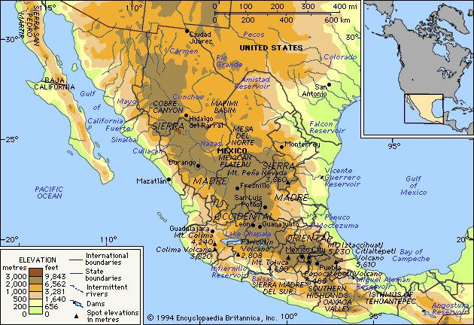

Encyclopedia Britannica 1994

Kelter ~Re~Weston 11/2011

Literacy Opportunities for North American Studies

Lesson #5 Map Studies of Mexico: Topographical Map [Appendix page 7]
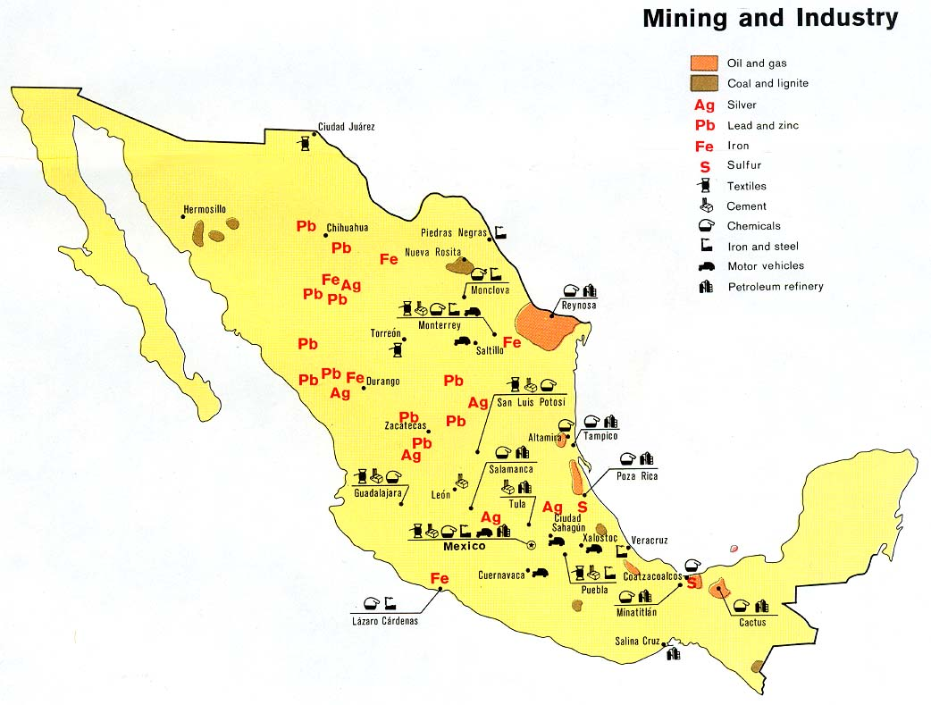

http://www.map-of-mexico. org/mexico-relief-map.jpg

Kelter ~Re~Weston 11/2011

Important  Features | Washington, D.C | Ottawa | Mexico City
Landmarks

Natural
Wonders
Historical
Buildings

Museums

Theaters or
Concert Halls

Sports Arenas or Parks

Noteworthy Architecture

Literacy Opportunities for North American Studies

Lesson #6: Data Charts: Capitol Cities [appendix page 8]

Kelter ~Re~Weston 11/2011

Literacy Opportunities for North American Studies

Lesson #8: Producing Short Research Projects: National Holidays [appendix page 8]

Name __________________________________ Date ____________________

Directions: You will be planning a celebration of a national holiday that commemorates an historical event. Use this worksheet to record facts about the holiday your group is assigned.

Country __________________ National Holiday ______________________

Write the name of the holiday _____________________________________

When is the holiday celebrated? ____________________________________

1. Record the facts that explain the reasons why the holiday is celebrated.

2. What are the special customs or traditions associated with this holiday?

3. What values or beliefs does this holiday reflect?

4. What are the special foods that may be eaten to celebrate this holiday?

5. List the varied symbols or images that might be used in decorations for this holiday.

6. Prepare an invitation to your group celebration. Use details from your research to show that you understand the importance of this holiday to the citizens who celebrate it every year.

Kelter ~Re~Weston 11/2011

Name ________________________ Date___________

Name of Presenter _________________________________________

Title of the project__________________________________________

Score each criteria on a scale of 1-5. [5 is best] Total the points received and multiply by 10. Answer the two questions on the bottom of this page.

- The presenter explained the main idea
of the project. 1 2 3 4 5

- The presenter spoke in a loud and clear
voice that we could all hear. 1 2 3 4 5

- The materials or product choice was
appropriate for the subject of the research. 1 2 3 4 5

- The research project shows effort and care.
It is neatly done and organized. 1 2 3 4 5

- The presenter shared many interesting facts. 1 2 3 4 5

- I learned many new facts and ideas. 1 2 3 4 5

- The presenter was able to answer questions 1 2 3 4 5
about the topic.

8. The product was creative. 1 2 3 4 5

- Rate the bibliography. Three or more sources 1 2 3 4 5
earns a rating of 5.

10. Did you learn new information from this presentation? 1 2 3 4 5

TOTAL POINTS _____________

Please give the presenter a compliment. Be specific.

Please give the presenter a good suggestion for future presentations.

________________________________________________________________________________________________________________________________

Literacy Opportunities for North American Studies
Bibliography

Canada Heritage. February 12, 2010. www.pch.gc.ca/eng.

City of Ottawa . 2001-2011 http://ottawa.com/about/main_e.shtml

Bernstein, Vivian. America's Story. 2. Orlando: Steck-Vaughn, 2006.

Dotlich, Rebecca Kai. “Washington, D.C,” 2000.

Hakim, Joy. A History of US. New York: Oxford University Press, 1999.

Hopkins, Lee Bennett. My America: A Poetry Atlas of the United States. New York: Simon and Schuster, 2000.

Jermyn, Leslie. Mexico. Milwaukee: Times Editions, 2000.

Keddie, Marlo. Canada Past Present and Future: A Series of Books About Canada. Trafford Publishing. Bloomington, IN, 2011.

Landau, Elaine. Mexico. New York: Children's Press, 2008.
Lockledge, Ann. Movements in American History. Grand Rapids: Instructional Fair, 1997.

Meltzer, Milton. Hour of Freedom: American History in Poetry. Honesdale: Wordsong, 2003.

Reilly, Mary Joe, and Leslie J. Mexico. New York: Benchmark Books, 2002

Rogers, Barbara, and S. Rogers. Canada. New York: Children's Press, 2000.

Stein, R. Conrad. Mexico. New York: Children's Press, 1998.

Stein, R. Conrad. Mexico City. Chicago: Children’s Press. 1996.

Sexton, Colleen. Canada. Minneapolis: Bellweather Media, 2011.

Thorsen, Steffen. Time and Date AS 1995–2011. http://www.timeanddate.com/holidays/canada

Walsh, Kieran. Canada. Vero Beach: Rourke, 2005

