Liz Kelly
US/VA History
Grade 11
High School
Educational Technology Lesson Plan: Introduction to the Vietnam War

Introduction to the Vietnam War: Technology Lesson

Context

Overview

This lesson serves to provide students with an understanding of the political divisions that emerged with regards to the Vietnam War in the late 1960s and early 1970s. Students will have some background information about this topic both from this course and from United States History courses taken in middle school. Students will have a firm understanding of activism in the 1960s after having learned about the Counterculture in the previous chapter of their textbook. Students will have some knowledge about the Vietnam War and some of the political divisions that sprouted from this event from their middle school classes in United States History. It is important to discuss the political divisions about the Vietnam War because students will learn methods employed by other students in the past to express their political views (students can make connections to the world beyond the classroom), the role of music in the anti-war movement (again making connections to the world beyond the classroom), ways that the home front during the Vietnam War was unique (allowing students to engage in ethical valuing and to make connections to the world beyond the classroom), and how the American government was influenced by the Vietnam War (integrating topics in government).

Background Information

The focus of this lesson is an introduction to political divisions regarding the Vietnam War. The lesson is designed for 11th Grade US/VA History classes. The lesson is designed to take ninety minutes of class time to complete in one ninety minute long class block. The objectives for this lesson address SOL VUS.1h,i and VUS.13b.

Objectives

Academic

- Students will be able to identify and explain different methods of student activism in the 1960s.
- Students will be able to explain how the events of the Vietnam War influenced US politics.
- Students will be able to identify and explain key events in the election of 1968.

Intellectual

- Students will be able to interpret the significance of excerpts from primary sources (VUS.1h)
- Students will be able to identify the costs and benefits of specific choices made, including the consequences, both intended and unintended, of the decisions and how people and nations responded to positive and negative incentives (VUS.1i)
- Students will be able to explain the American role in the war in Vietnam (VUS.13b)

Assessment

Summative

Students will complete an assessment worksheet at the end of the class period to assess their achievement of the lesson objectives. Students will work individually to complete this assessment sheet. This assessment sheet will review information from the first two sections of the Vietnam War chapter as well as information students learned in this lesson. The assessment sheet will serve to inform my teaching; I will be able to see what concepts students struggled with from this lesson and what concepts they are still grappling with for the unit as a whole.

Content and Instructional Strategies

Bellringer 10 Minutes

Students will work for ten minutes to answer the following questions: What were some methods used to protest the Vietnam War in the late 1960s and early 1970s? Do you think these methods were effective? Explain why or why not. These questions will be projected onto the screen at the front of the class in a PowerPoint slide. Students will answer the question on their bellringer sheet in their notebooks. I will use PowerPoint since I can save the slide show and use it in the future. Also, using technology in this instance is helpful to make sure that all students can clearly view the bellringer questions; the font will be large and bolded.

Plan B: If the projector or computer is not working that day, I will write the bellringer question on the board. I will have the question available in my printed copy of the lesson plan. I will read the question out loud at the start of the class block so that students can hear the question if they cannot see it on the board. I will instruct students to write down their answers on their bellringer sheets in their notebooks.

Listen to Audio 30 Minutes

Students will listen to three different songs from the late 1960s written in protest to the Vietnam War. This lesson will start with the end of the decade, and then work backwards to see how events unfolded leading up to the anti-war protests. I chose three different songs so that students could hear three different perspectives in the anti-war movement: one from an African American, one from White males, and one from a woman.

I will pass out the handouts with guiding questions and lyrics to last two songs. I will instruct students to reference the lyrics as they view and listen to the last two songs. I will instruct students to first read the guiding questions before I play the clips, and to consider those questions as they view and/or listen to the artist.

First students will view the following clip:
Jimi Hendrix: National Anthem (Woodstock, 1969)
http://www.youtube.com/watch?v=hkz7wUg1L1o&feature=related
After students view this clip, I will ask them to discuss the following questions with their partner and to write their answers down on the document guide sheets: Do you think this artist supported or disapproved of the Vietnam War? Why did the artist choose not to sing the lyrics to the National Anthem? How would people of different perspectives have reacted to this rendition of the National Anthem? I will ask each pair to share what they thought about the clip, and then we will discuss what they heard and what they saw as an entire class.

Second, students will view the following clip:
Creedence Clearwater Revival: Fortunate Son (1969)
http://www.youtube.com/watch?v=ec0XKhAHR5I
After students view this clip, I will ask them to discuss the following questions with their partner: Do you think this band supported or disapproved of the Vietnam War? Who is the “Fortunate Son(s)” in this song? What aspect of the War is this song about? Students will be instructed to use evidence from the lyrics to support their answers. I will ask each pair to share what they thought about the song, and then we will discuss what they heard as an entire class.

Last, students will view the following clip:
Buffy Sainte-Marie: Universal Soldier (1969)
http://www.youtube.com/watch?v=VTFnWdOzrMM&feature=related
After students view this clip, I will ask them to discuss the following questions with their partner: Do you think this artist supported or disapproved of the Vietnam War? Who is the “Universal Soldier?” Why is this song important in understanding the home front during the Vietnam War? Who is the target of the artist’s disapproval? I will ask each pair to share what they thought about the clip, and then we will discuss what they heard and what they saw as an entire class.

Plan B: If the computer or sound system is not working, I will simply have the students read the printed lyrics to the second and third songs and we will proceed with those activities as planned (students will complete the guide questions at the end of the page with their partner then we will discuss their answers as an entire class). It will be a shame that the students will not be able to listen to the songs, but the lyrics will provide the students with enough information for them to interpret and discuss the meanings. Since ten minutes will be free after the bellringer when students would have otherwise been listening to Jimi Hendrix playing the National Anthem, I will talk to the students about Woodstock, and explain some key details about this song and the event. I will explain that in his rendition of the National Anthem, Jimi Hendrix mimicked the sound of screams and bombs dropping. I will ask students to discuss with their partner what this meant and how people from different perspectives might have reacted to hearing the song. After students discuss those questions with their partner, I will ask each pair to share their ideas with the class and we will discuss these ideas together.

Compare/Contrast 20 Minutes

Students will complete the last section of the song guide handout where they will engage in higher order thinking to compare and contrast the three songs. Students will take ten minutes of class time to complete this section individually.

After students compare and contrast the three different songs, students will investigate different perspectives about the Vietnam War. Students will form six groups of four people in each class to complete the perspectives portion of the compare and contrast section of the lesson. Students will turn to the next page in their song guide handout, where they will see an image (there will be six different images); students will form groups with the three other students who have the same image. Within these groups, students will work to evaluate how the person in their image would have reacted to the songs and the Vietnam War and explain their reasoning. This activity will help students to investigate different perspectives and to gain an understanding of ideas and events that influence people’s political behavior (a topic they will explore further in their Political Behavior Unit in the American Government class next year). In addition, viewing images will help students who are visual learners to put a face with a cause (who did support the war? who fought in the war? etc.) Also, students will have the opportunity to engage in substantive conversation with their peers as they discuss different perspectives about the War in their groups. Students will work in their groups for ten minutes to complete this portion of the lesson. I will walk around the classroom to help students complete this class work, and after the groups finish they will share what they discussed with the entire class.

Take Notes 20 Minutes

Students will take notes on the political divisions that emerged regarding the Vietnam War in the late 1960s and early 1970s. I will hand out a notes guide sheet for students to complete as they view the PowerPoint. I will discuss the slides with my students and welcome any questions. I will use PowerPoint to present the notes so that students can view the information on the slides in addition to audibly hearing the information as I discuss it with the class. PowerPoint is a better option than writing notes down on the white board because it saves time; I do not have to spend time writing information down and then erasing it to write down new information.

Plan B: If the computer is not working and I cannot access my PowerPoint slides, I will simply teach the students by explaining the notes out loud. I will pass out the guided notes sheet and work with students to answer the blanks and explain each answer. I will write key concepts or events on the white board so that students who learn better visually will be able to see them.

Answer and Generate Questions: Assessment 10 Minutes

Students will work individually to complete an assessment sheet. This assessment sheet will review information from the first two sections of the Vietnam War chapter as well as information students learned in this lesson. The assessment sheet will serve to inform my teaching; I will be able to see what concepts students struggled with from this lesson and what concepts they are still grappling with for the unit as a whole.

Resources

White Board
White Board Marker
White Board Eraser
Projector/Projector Screen
Projector Remote
Computer Login
Computer with Internet Access and Working Speakers
Working Link to “Jimi Hendrix- National Anthem of the United States [Live Woodstock 1969]”
Working Link to “Creedence Clearwater Revival: Fortunate Son”
Working Link to “Buffy Sainte-Marie: Universal Soldier [HD video/ Excellent quality] (Live, 1969)”
Computer with PowerPoint loaded with the Bellringer slide and Notes
Song Guide Questions and Perspectives Worksheet (68 Copies)
Guided Notes Worksheet (68 Copies)
Assessment Worksheet (68 Copies)

Name: ___________________________________________________ Date: _____________
Vietnam War: Political Division- Protest Songs
Part I. Song Guide Questions
Directions: Answer the following questions with a partner. Be specific and include as much detail as possible to support your ideas.

Jimi Hendrix
“National Anthem” (1969)

Do you think this artist supports the Vietnam War? Why or why not?

Why did the artist choose not to sing the lyrics to the National Anthem?

How would people of different perspectives have reacted to this rendition of the National Anthem?

Creedence Clearwater Revival
“Fortunate Son” (1969)

Some folks are born made to wave the flag
Ooh, they're red, white and blue
And when the band plays "Hail to the chief"
Ooh, they point the cannon at you, Lord
It ain't me, it ain't me, I ain't no senator's son, son
It ain't me, it ain't me; I ain't no fortunate one, no
Some folks are born silver spoon in hand
Lord, don't they help themselves, oh
But when the taxman comes to the door
Lord, the house looks like a rummage sale, yes
It ain't me, it ain't me, I ain't no millionaire's son, no
It ain't me, it ain't me; I ain't no fortunate one, no
Some folks inherit star spangled eyes
Ooh, they send you down to war, Lord
And when you ask them, "How much should we give?"
Ooh, they only answer More! more! more! yoh
It ain't me, it ain't me, I ain't no military son, son
It ain't me, it ain't me; I ain't no fortunate one, one
It ain't me, it ain't me, I ain't no fortunate one, no no no
It ain't me, it ain't me, I ain't no fortunate son, no no no

Directions: Answer the following questions with a partner. Be specific and include as much detail as possible to support your ideas.
Do you think this band supported or disapproved of the Vietnam War? Why or why not?

Who is the “Fortunate Son(s)” in this song? Explain your answer.

What aspect of the War is this song about? Use evidence to support your answer.
Buffy Sainte-Marie
“Universal Soldier” (1969)

He's 5 foot 2 and he's 6 feet 4
He fights with missiles and with spears
He's all of 31 and he's only 17.
He's been a soldier for a thousand years
He's a Catholic, a Hindu, an atheist, a Jain
A Buddhist, and a Baptist and Jew.
And he knows he shouldn't kill
And he knows he always will kill
You'll for me my friend and me for you
And He's fighting for Canada.
He's fighting for France.
He's fighting for the USA.
And he's fighting for the Russians.
And he's fighting for Japan
And he thinks we'll put an end to war this way.
And He's fighting for democracy,
He's fighting for the reds
He says it's for the peace of all.
He's the one, who must decide,
who's to live and who's to die.
And he never sees the writing on the wall.
But without him,
how would Hitler have condemned him at Dachau?
Without him Caesar would have stood alone
He's the one who gives his body
as a weapon of the war.
And without him all this killing can't go on
He's the universal soldier
And he really is the blame
His orders comes from
far away no more.
They come from him.
And you and me.
And brothers can't you see.
This is not the way we put an end to war

Directions: Answer the following questions with a partner. Be specific and include as much detail as possible to support your ideas.

Do you think this artist supported or disapproved of the Vietnam War? Why or why not?

Who is the “Universal Soldier?” Use evidence to support your answer.

Why is this song important in understanding the home front during the Vietnam War? Use your background knowledge about the home front in previous wars to inform your answer.

Who is the target of the artist’s disapproval?

Part II. Compare/Contrast
Directions: On a separate sheet of paper, compare and contrast the three different songs by Jimi Hendrix, Creedence Clearwater Revival, and Buffy Sainte-Marie. How did the song lyrics differ? In what ways were the messages the same? What audience were these songs written and/or performed for? Use evidence from the song lyrics or the video clips to support your ideas.

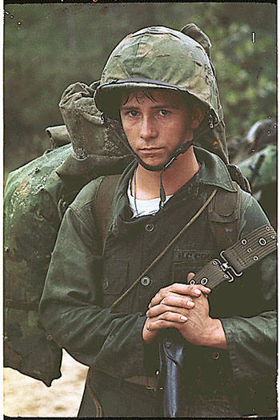

Who is this person?

Do you think he supports or disapproves of the Vietnam War?

How would this person react to hearing the Jimi Hendrix song? Creedence Clearwater Revival? Buffy Sainte-Marie?
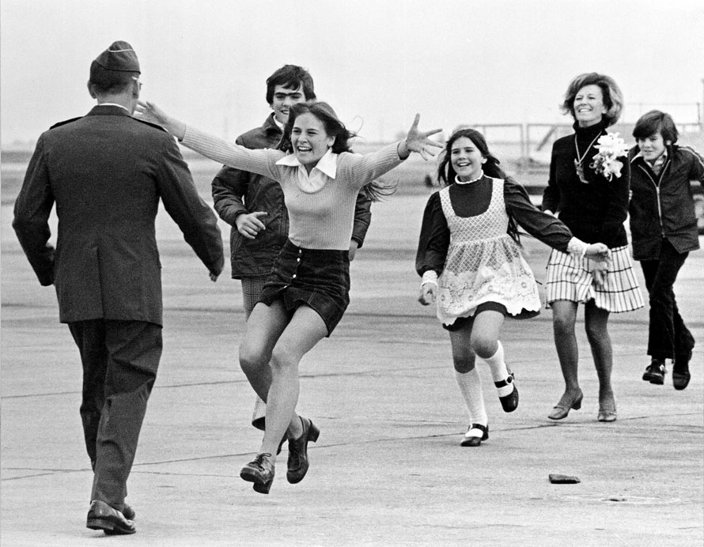

Who are these people?

Do you think they support or disapprove of the Vietnam War? Explain your reasoning.

How would people in this family react to hearing the Jimi Hendrix song? Creedence Clearwater Revival? Buffy Sainte-Marie?

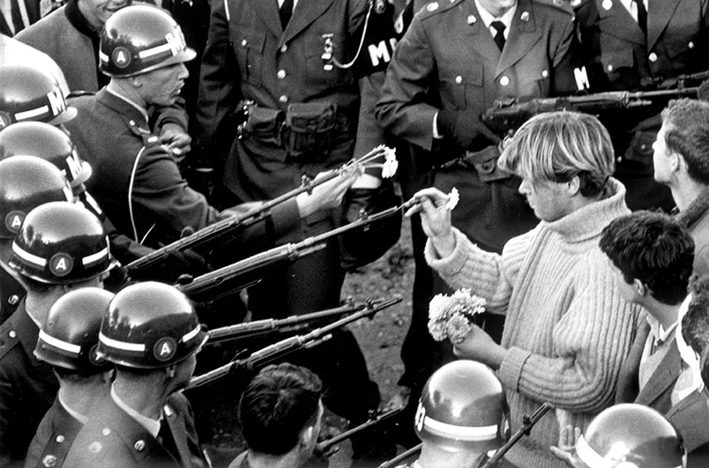

Who are these people?

Do you think they support or disapprove of the Vietnam War? Explain your reasoning.

How would these people react to hearing the Jimi Hendrix song? Creedence Clearwater Revival? Buffy Sainte-Marie?

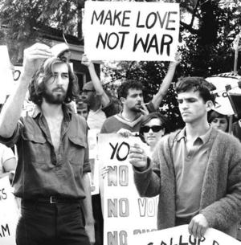

Who are these people?

Do you think they support or disapprove of the Vietnam War? Explain your reasoning.

How would these people react to hearing the Jimi Hendrix song? Creedence Clearwater Revival? Buffy Sainte-Marie?

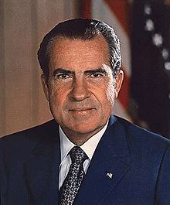

Who is this person?

Do you think he supports or disapproves of the Vietnam War?

How would this person react to hearing the Jimi Hendrix song? Creedence Clearwater Revival? Buffy Sainte-Marie?

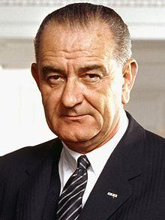

Who is this person?

Do you think he supports or disapproves of the Vietnam War?

How would this person react to hearing the Jimi Hendrix song? Creedence Clearwater Revival? Buffy Sainte-Marie?

Name: _________________________________________________ Date: _________________
Assessment Worksheet: Cumulative
Part I. Circle the best answer to the following multiple choice questions.
- The Viet Cong employed what strategy to hold out against superior firepower?
- Tunnel System
- Land Mines
- Nuclear Weapons
- Poisonous Gas

- Which of the following was not a form of student activism in the 1960s?
- Students for a Democratic Society
- Draft Resistance
- Free Speech Movement
- League of the White Rose

- After World War II, President Truman pledged American aid to any nation threatened by:
- Fascism
- Racism
- Communism
- Nazism

- A turning point in the Vietnam War was the ____________, when the Viet Cong and North Vietnamese demonstrated that they could launch a massive attack on targets throughout South Vietnam.
- Battle of Saigon
- Tet Offensive
- Ho Chi Minh Trail
- My Lai Massacre

- In the 1968 election, Richard Nixon boasted of a _______________ which helped him to win the election.
- Secret plan to end the Vietnam War
- Secret plan to capture all Viet Cong soldiers
- Secret nuclear weapon
- Secret plan to invade China

Part II. Answer the following short answer questions in complete sentences. Use evidence to support your reasoning.
- Why was the Vietnam War called the “Living Room War?”

- If Johnson decided to run in the 1968 election, do you think he would have won? Why or why not?

Part III. Construct your own short answer question from today’s lesson that could be used on the unit test.

Bibliography
(2011). Fortunate Son Lyrics. http://www.sing365.com/music/lyric.nsf/fortunate- son-lyrics-creedence-clearwater-revival/eb5ca92f255d29b648256aab0030d12a

Buffy Sainte-Marie - Universal Soldier [HD video / Excellent quality] (Live, 1969). http://www.youtube.com/watch?v=VTFnWdOzrMM&feature=related

Cayton, A., Perry, E.I., Reed, L., Winkler, A. (2007). America: Pathways to the Present. Prentice Hall, 1022-1043.

Creedence Clearwater Revival: Fortunate Son. http://www.youtube.com/watch?v=ec0XKhAHR5I

Guardian News and Media Ltd. (2011). The ten best protests. http://www.guardian.co.uk/culture/gallery/2010/nov/14/ten-best-protests

Jelsoft Enterprises, Ltd. (2011). Vietnam War Soldiers.

http://www.anthrocivitas.net/forum/showthread.php?p=74927

Jimi Hendrix - National Anthem Of The United States - [Live Woodstock 1969]. http://www.youtube.com/watch?v=hkz7wUg1L1o&feature=related
LetsSingIt. (2011). Buffy Sainte-Marie Universal Soldier Lyrics. http://artists.letssingit.com/buffy-sainte-marie-lyrics-universal-soldier-wmz5kk2
St. Petersburg Times. (2011). The Vietnam War ended on April 30, 1975. http://www.tampabay.com/blogs/alleyes/content/vietnam-war-ended-april-30-1975-23- images
The Moratorium Movement. http://historyvietnamwar.yolasite.com/the-moratorium- movement.php
Wikipedia. (2011). Richard Nixon. http://en.wikipedia.org/wiki/Richard_Nixon
Wikipedia. (2011). Lyndon Johnson. http://en.wikipedia.org/wiki/Lyndon_B._Johnson

