Emergence of Nation States
Context
This 65 minute lesson is for use with a ninth grade World History I call during their unit on the late medieval period.

Objectives
Students will be able to explain the causes of the emergence of nation-states in Europe and understand the effects
Students will know the locations of the modern nations (France, England, Spain, and Russia) and understand the regions from which they emerged
Students will evaluate the quality of sources of information during internet research.
VA SOL:
WH12.a: The student will demonstrate knowledge of social, economic, and political changes and cultural achievements in the late medieval period by describing the emergence of nation-states (England, France, Spain, and Russia) and distinctive political developments in each;

Assessment
Students will be assessed on the quality of the timeline they develop during class time tracking the emergence of each of the European-Nation states. Students will present their findings to the class which will also help the teacher gauge understanding.

Content and Instructional Strategies
- Hook (15 minutes)
  - Students will first be asked to complete a journal entry to the prompt: “How do rulers gain more power?”
  - After their short individual brainstorm they will be asked to turn to their neighbor and discuss what each wrote
  - Finally we will come together as a class and talk about some of our ideas
- Spatial Orientation (10 minutes)
  - In most classes it seems that students do not actually have a good global orientation when we are discussing regions that are far away
  - During this period the teacher will use Google Earth to show the students where Europe is in relation to America, and the borders of the modern nations which are the direct descendants of the late medieval period. (If this technology is unavailable: The teacher should use a traditional map to help orient studnets).
  - The students will use their map of Europe to fill in the countries being discussed.
- Research into Topic (20 minutes)
  - Students will now be split into 4 groups and asked to use the laptops brought in on the laptop cart in order to do research on the emergence of nation-states in the late medieval period. That is, they will be discovering how these modern nations began to take shape.
  - Each group will be assigned a different country (Russia, France, England, and Spain).
  - They will fill out the worksheet (attached) for each country in question.
  - Students should be asked to consult their textbooks to ensure the validity of the information they are finding. If the laptops are unavailable: Students could go to the computer lab to do their research. If the lab is unavailable students should exclusively use their textbooks to learn more about each country.
- Timeline Creation (25 minutes)
  - We will now come together as a class and create a time line using the website http://www.tiki-toki.com/ to share our findings.
  - Each group will report out about important events that they found concerning their country and the emergence of nation states. The teacher will log this information in the timeline so the students have a resource with all of the information they need.
  - It would be useful for the teacher to make the template for this timeline ahead of time so there is learning time wasted while the teacher makes out different categories for each of the countries in question.
  - A finished timeline would look something like this: http://www.tiki-toki.com/timeline/entry/14364/Emergence-of-Nation-States/. Each group, however, will be asked to justify how the events they cited helped contribute to the emergence of the country as a nation-state.
  - If the timeline technology is unavailable: The teacher should create a non-digital version of the timeline on the board or on a large sheet of construction paper.
- Debrief and Journal Entry (20 minutes)
  - Students will now be asked to reevaluate their journal prompt from the beginning of class
  - They should write which of their hypothesis about how rulers gain power were confirmed and which new ideas could be added. They should also write about what was similar and different in the case of each emerging nation state.
  - This should take the form of about two paragraphs using complete sentences
  - We will then come together as a class and talk about our journal entries and the lesson as a whole.

Resources:
Emergence of Nation-States Worksheet
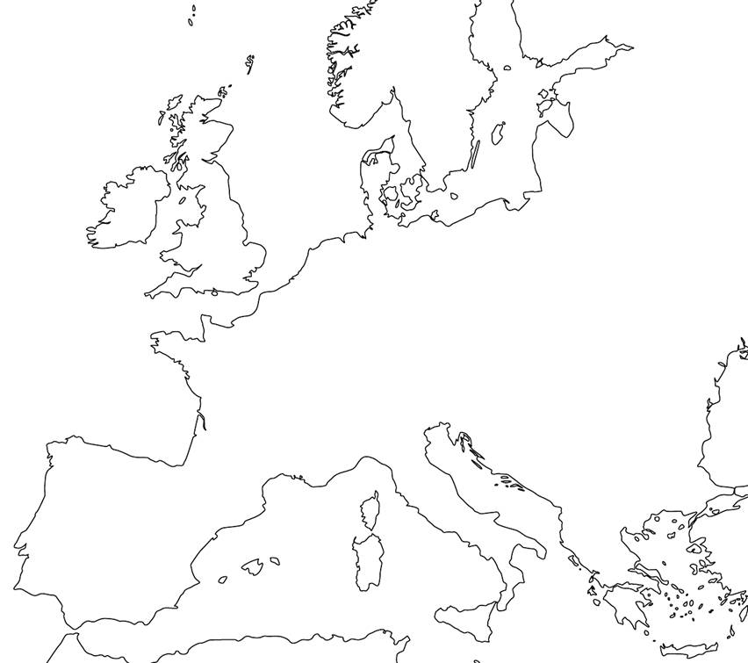
Fill in the names of the four countries we discuss on this map (Careful, there are no borders!):

When answering the following questions, keep track of important events and dates:
Were there any rulers who had a lot of power in your country? What actions did they take? Did they reform government? How did they expand territory and consolidate power?

Did your country develop a sense of nationalism? If so, why?
Did the church influence emergence of your country as a nation-state?
Technology Reflection

There are many ways in which this lesson is differentiated, or universally designed, for diverse learners. All students will benefit from the spatial orientation provided by using Google Earth. It is very useful to actually see the globe spin as we move from our current location to the countries of Europe we are discussing. Hopefully this will help students who usually have trouble transferring information from a filled in map to a blank one. Group work is always an important differentiation tool. This method allows students of varying skill levels to work together and help each other to get a better understanding of the subject. Students who have trouble with public speaking will not be asked to convey information to the whole class as just one group member needs to do this task. Finally, the use of the laptops for internet research provides almost endless possibilities for the many ways students absorb information.
With regard to this particular lesson technology interacts with content in the way that it orients our perspective within a larger spatial and historical one. Google Earth allows us to physically see the distance between us and the nation-states we are discussing and between the nation-states themselves. The use of timeline software allows students to orient themselves spatially in time and see how the different European nations became centralized over time. Less important than the actual dates they are discussing is the ordering of events and an understanding of how these nation-states emerged. The laptops allow students to tap into resources they could have never imagined that go far beyond the basic information in the textbook. The hope is that students will be able to find events that help explain the emergence of powerful, centralized, nation-states that are not necessarily enumerated in their textbook.
The use of laptops is important pedagogically because it gives students a personal stake in the information that they find and use. Interactive learning and research are much more engaging than the teacher simply lecturing what students need to know. Having students find this information on their own and then organizing it as a class in a meaningful way (the timeline) should help students have a deeper understanding of the material.
Technology, content, and pedagogy all fit together in this lesson. Through the activity using Google Earth and impressive technology is used to engage the students in order to enhance their understanding of the lesson. Using computers to research material not only allows student to go beyond the content in their textbook, but gives them personal ownership of the data that they find. Finally, the creation of a timeline helps students orient themselves and their events historically; an activity which is only enhanced by the interface on Tiki Toki and its ability to be saved and viewed by the whole class at any time in the future.
All of the technology used in this lesson is worth it, especially when the teacher is prepared to effectively and efficiently employ it. While Google Earth may seem as more of a gimmick than anything else I would argue that its ability to convey distance helps students much more than a conventional map. The use of laptops for research opens up a world of information far beyond the conventional textbook data and what is necessary for the SOL. The use of the timeline software is better than the alternative because it is streamlined, easy to read, and is accessible by everyone for future study.

