**A World of Connections:**

**Differentiating the Third Grade Social Studies Curriculum**

**For English Language Learners**

**C:\Users\user1\AppData\Local\Microsoft\Windows\Temporary Internet Files\Content.IE5\TVC9LQAA\MC900290703[1].wmf**

**Curriculum Area Project Grade 3**

**Social Studies**

Bowling Green Elementary School

East Meadow School District

August 2011

CAP Coordinator - Barbara Suter, ESL

Third Grade Teacher: Vera Zinnel

Principal: Maria Ciarametaro

Superintendent: Louis DeAngelo

**Table of Contents**

**Abstract 3**

**Rationale 4**

**Unit Overview 5**

**Scope and Sequence and Activities 6**

**Activity 1 – Where in the World Is...? 7**

**Activity 2 – What is Geography? 20**

**Activity 3 – Welcome to Westbury, New York 30**

**Activity 4 – All About … (name of country) 37**

**Bibliography 45**

**Works Cited 46**

**Appendices 47**

**Appendix A – Explaining BICS and CALP 48**

**Appendix B – Stages of Language Proficiency 49**

**Appendix C – Tips for Teaching ELLs 50**

**Abstract**

This CAP addresses the third-grade New York State Social Studies Core Curriculum, Communities Around the World – Learning About People and Places, and scaffolds the students’ understanding of world communities. The students will learn about the social, political, geographic, economic, and historic characteristics of different world communities, beginning with their own. In addition, the activities included will help educators differentiate the curriculum for the English Language Learners (ELLs) in their classrooms.

Please Note: The activities included as part of this unit are based on a “balanced literacy” approach to teaching.

**Rationale**

**Why the Curriculum Must Be Differentiated for English Language Learners**

The 2000 U.S. Census reports that 17.9 percent of the national population ages five and older speaks a language other than English at home and 60 percent of that total speaks Spanish (Griffin and McGovern, 2006). While this particular data is not yet available for the census taken in 2010, between 2000 and 2010 the Hispanic population grew by 43 percent (Humes, Jones and Ramirez, 2011). This may indicate that the percentage of the population that speaks a language other than English at home will increase as well. These children, who are often labeled English Language Learners (ELLS), are expected to perform as well as their monolingual peers within a relatively short period of time. This is despite the fact that it is commonly known among ESL educators that it can take an ELL from five to ten years to develop academic language proficiency. Social language development is much more rapid (from 6 months to two years).

As educators we have a responsibility to offer the academic support that ELLs will need to meet this overwhelming challenge. Differentiation of the curriculum (providing options for learners with different rates of learning and learning styles) addresses the needs of native speakers of English. For ELLs, however, there must be an additional layer of differentiation that takes into account their language competency levels as well as the amount of time needed to achieve true academic proficiency in English. Without a basic understanding of the language tasks that ELLs can accomplish at their individual levels of English proficiency, and appropriate adjustment for these levels, instruction will most likely not provide the desired outcome.

Just as it would not make sense to provide a native English speaker with reading materials that are beyond his or her level of comprehension, it does not make sense to give ELLs curriculum materials in English that are well beyond their ability to comprehend at their particular stage of second language acquisition. To help teachers differentiate the curriculum for the ELLs in their classroom, we have provided a model unit for the third-grade social-studies curriculum, Communities Around the World, with specific adaptations that can be made to support the instructional level of ELLs.

**Unit Overview**

**Content**

This unit includes activities to help the teacher differentiate the Third Grade Social Studies Curriculum for the ELLs in their class. The activities can be used for all students. A Scope and Sequence is included as are original worksheets to facilitate learning.

**Enduring Understandings Addressed**

Students will understand:

- what the term geography means

- what the term culture means as it pertains to human interaction

- which culture(s) the students belong to and its (their) attributes

- that cultures have similarities and differences

- that there is a diversity of people and cultures around the world

- that people and cultures change over time for various reasons

- that the geography of an area plays an important role in economic activities, needs and wants,

communication, and lifestyle

- that communities have rules and governments

**Guiding Questions**

1. What is my place in the world?
2. What does culture mean and why is it important?
3. Why are cultures around the world different from each other?
4. How are cultures the same?
5. How do people live in other countries?
6. How does learning about other cultures help us understand and interact with people who are different from us?

**Knowledge and Skills**

**Students will know:**

- what geography means and why it is important

- what town, state, country, and continent they live in

- what culture means and why it is important

- how cultures are the same and different

- how people live in different parts of the world

- that understanding different cultures will help them to become good citizens of the world

**Students will be able to:**

- identify their town, state, country, and continent on a map

- define the word culture and list reasons why it is important

- discuss some similarities and differences between cultures

- explain how people live in different parts of the world

- participate in a group project that will demonstrate their empathy for others

- complete a social studies binder called *“The World and My Place In It”* that will feature the

Research and writing they have accomplished throughout the unit

**Scope and Sequence Activities**

**for**

**“A World of Connections”**

C:\Users\user1\AppData\Local\Microsoft\Windows\Temporary Internet Files\Content.IE5\TVC9LQAA\MC900297231[1].wmf

**Activity 1**

**“Where in the World Is...?”**

**(A student completed booklet)**

**Essential Question**:

What is my place in the world?

**Knowledge and Understanding** :

Students will know and be able to identify on a map their town, state, country, and continent.

**Differentiation**:

In order for meaningful learning to take place, ELLs must be able to make a personal connection to the information being taught. Before we can begin to discuss the concept of communities around the world, ELLs must be provided with background knowledge and vocabulary pertaining to the concept of “community.” For this reason we begin the unit with a focus on their local surroundings.

Because many students do not yet know such vital information as their addresses and phone numbers, we will begin with that information. Next, to scaffold students’ understanding of the concept of community, vocabulary and concepts will be taught such as: street (avenue, lane, court), neighborhood, town, county, state, country, and continent. Parents will be asked to become involved by helping their child to find out such vital information as their addresses and phone numbers. The children will learn to use maps and books to expand their knowledge and concept of their place in the world. Charts created during discussions and activities and displayed in the classroom will provide a concrete visual reference for ELLs.

**Learning Sequence**:

1. Read the text *Me on the Map,* by Joan Sweeny, as a shared reading.
2. Lead and chart a discussion about the child’s “place in the world” from their local address (ie street) to their global location (ie Earth).
3. Send home the worksheet, *Where Do I Live?* to be completed with adult assistance. (See appendices.)
4. Students will examine both traditional maps and maps on the internet of the local area. Working in small groups, students will identify their street and town locations on a map.
5. Students will be given the booklet *Where in the World is...?* to be completed as a teacher-directed activity. (See appendices.)
6. Using the worksheet completed as homework, students will fill in the first two pages of the booklet independently.
7. As the students complete each additional page, the geographic concepts of neighborhood, town, county, state, country, continent, and planet, will be taught and charted for reference. Scaffolded pages of the booklet will be finished following class discussions.

***Estimated time for Activity One is two weeks.***

**Demonstrating Understanding**:

Students will complete the assessment page at the back of the *Where in the World Is...?*  book. They will be asked to share their books with their families. Families and friends will fill out the comment section at the back of the book.

Name Date

“Where Do I Live?”

1. What is your address including zip code?
2. Name two streets in your neighborhood.

Where in the World Is...

?

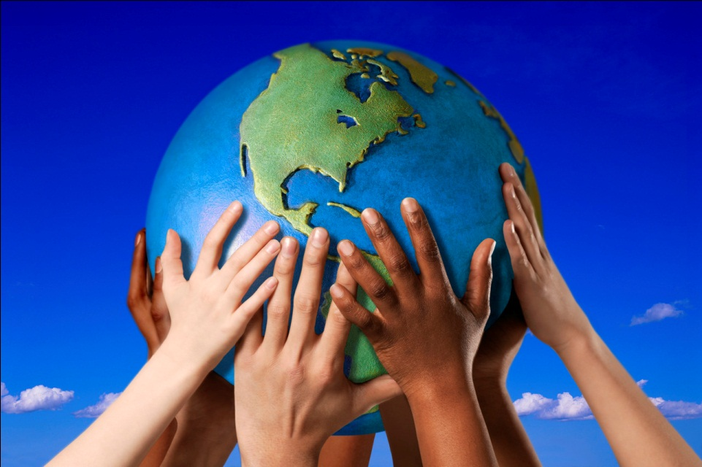

My name is

.

I live on a street. The name of my

street is

.

MCBD05150_0000[1]

My street is part of a neighborhood. Some other streets in my neighborhood are

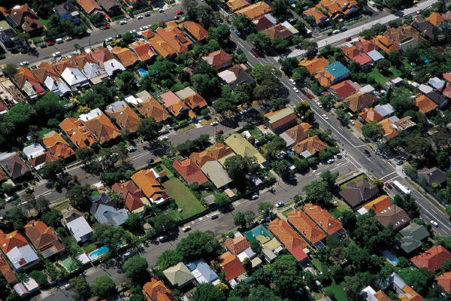

My neighborhood is part of a town. The name of my town is

.

j0232016

Westbury is part of a county. The name of my county is

.

j0078799

Nassau County is part of a state.

The name of my state is

.

MCj04082760000[1]

New York is part of a country. The name of my country is

.

MCj04084370000[1]

The United States of America is part of a continent. The name of my continent is

.

MCj04082800000[1]

North America is part of a planet. The name of my planet is

.



Directions: Complete this page to show what you have learned.

I live in many places. The names of the places where I live are:

My street

My town

My county

My state

My country

My continent

My planet

Comments from Family and Friends

Please write one thing you liked about my book.

**Activity 2**

**“What Is Geography?”**

**(Small groups research and write about geography terms)**

**Essential Question**: What is my place in the world?

**Knowledge and Understanding** : Students will know what geography is and why it is important. They will be able to share information about the geography term they researched with their group as well as learn the terms the other groups have researched.

**Differentiation**: Groups will be created by the teacher that will be made up of ELLs and English speakers who can serve as language models. Computer literacy will also be considered when creating groups as many ELLs do not have computers in their homes to practice on. The research activity will be modeled by the teacher and the procedure charted for the whole class using a geography term of the teacher’s choice (ie The Indian Ocean). A scaffolded worksheet, *“Geography Research Worksheet,”* will be used to guide and instruct the groups through the process of gathering facts via the internet. An additional language objective for ELLs included in the worksheet is learning how to formulate questions. Questioning is a metacognitive strategy that will help ELLs learn to engage interactively in what they are learning. As they interact with their peers, they will practice both question formulation and learn to participate in a rich dialogue with their peers.

The concept of writing a paragraph and a sequence of paragraphs will be modeled and charted. Groups will be encouraged to take the facts they have gathered from their worksheets and expand them into paragraphs. The assessment activity is designed to provide additional practice for ELLs’ listening skills.

**Learning Sequence**:

1. Read chapters 1 and 3 of the text, *My World and Globe* by Ira Wolfman, as a shared reading.
2. Lead and chart a discussion about geography terms including the names of the continents and oceans.
3. Explain to the class that they will be researching and writing about a geography term with a small group.
4. Model how to search the internet for information using the *“Geography Research Worksheet”* by selecting a geography term (ie Indian Ocean).
5. After finding and recording three interesting facts about their geography term, the class will be asked to think of any questions they may still have about the term being modeled. ELLs may need additional language modeling for formulating questions.
6. The teacher will explain how to use a search engine such as Google to find the answers to the questions. Explain to the class that adding the words “for kids” to the search box will bring them to sites that they will be able to understand with minimal adult direction.
7. Groups will be formed and the worksheet handed out. The teacher will monitor the progress of groups and provide help or make group adjustments as needed.
8. After completion of worksheets, the teacher will explain that the information will be put into paragraphs. Using the modeled term researched earlier the teacher will model and chart the components of a paragraph (i.e. main idea, topic sentence, supporting ideas) using the “How to Write a Paragraph” guide.
9. After the information about the modeled term is written in paragraph form, the chart will be displayed in the classroom for future reference as each group begins to work independently on their paragraphs.
10. Each group will begin to write their paragraphs following the guidelines on the worksheet.
11. The teacher will monitor and conference with each group
12. When the final drafts are approved, the groups will be responsible for typing the final version.
13. The teacher will proofread the typed final draft of each group’s report. The group will then revise and print a copy for every student to include in “The World and My Place In It” binders.

**Estimated time for completion of Activity Two is two to three weeks.**

**Demonstrating Understanding**:

Each group will present its report to the class. As the group is presenting, the other students will be expected to write one fact they found interesting about each report. ELLs who are unable to do this will be paired with English speakers who will serve as language models. Copying others’ work is a valid practice for beginner and intermediate ELLs as they have not yet mastered the vocabulary or the writing skills necessary to produce a “polished” piece of writing. Writing is the most complex academic skill for ELLs to acquire, and it is often the last of the four skills (speaking, listening, reading and writing) to be mastered.

C:\Users\user1\AppData\Local\Microsoft\Windows\Temporary Internet Files\Content.IE5\TVC9LQAA\MC900233958[1].wmf

Names

**Geography Research Worksheet**

We are researching

Go to the school website and click “Links for Students.” Look for online encyclopedias and click on “World Book Online.” Look for the picture and words “World Book Kids” and click on it. Type your geography term into the search box and hit the “enter” key.

Find three interesting facts about your topic. Write the interesting facts on the lines below. Try to put the facts in your own words.

1.

2.

3.

Ask two questions you still have about your geography term.

Find the answers to your questions and write them below.

Name Date

Geography Report Fact Sheet

Directions: Write one fact you found interesting about each group’s report

1.Geography

2. Continent

3. North America

4. South America

5. Europe

6.Asia

7. Africa

8. Australia

9. Antarctica

10. Indian Ocean

11. Arctic Ocean

12. Atlantic Ocean

13. Pacific Ocean

C:\Users\user1\AppData\Local\Microsoft\Windows\Temporary Internet Files\Content.IE5\DZK6QVI2\MC900290704[1].wmf

How to Write a Paragraph

1. Write your ideas or information in complete sentences on the “Paragraph Sloppy Copy” form. This will be your “sloppy copy.”
2. Prioritize! This means to decide which idea or which information is the most important, what is the second most important idea or fact, and so on...
3. Decide what your MAIN IDEA is and turn it into a TOPIC SENTENCE to put at the beginning of your paragraph.

For example:

Our group did research about what ***geography*** means and what kinds of work geographers do for a living. First, we learned that...

1. The final copy of your paragraph should have several (3-4) complete sentences and should look like this:

(indent) Xxxxx xxxxx xxxxxxx xxxxx xxxxx

Xxxxxxx xx. Xxx xxxxx xxxxxx xxxxx xxxxxxx xxxxx xxx xxx.

Xxxx xxxxxxx xxx. Xxxxxxx xxx xxxxxx xxxx xxxxxx. Xxxxxxxx

xxxxxxxxxx xx xxxx xxxx Xxxxx xxxx.

Name Date

Paragraph Sloppy Copy

Paragraph #

**Activity 3**

**“Welcome To Westbury, New York”**

**(Students create an essay, a power-point presentation, and a mini-book exploring their community)**

**Essential Questions**:

What is my place in the world?

What does culture mean and why is it important?

**Knowledge and Understanding**:

Students will learn about their neighborhood and the role that families play in the culture of their neighborhood and community.

**Differentiation:**

Now that the students understand and are familiar with the concepts of geography, they will begin to explore their own community in depth. This background knowledge will provide ELLs with a basis for comparison as they learn about other communities in the world. To make this task meaningful, they will explore how *they* and *their* families live in their communities.

The students will provide details about their own families, including family members. The varieties of modern family units will be discussed. When looking at books about different world communities, topics such as typical greetings, dwellings, school day, and customs will be discussed. To help prepare the students to write about their own neighborhood and community, a guided worksheet is included to help focus their inquiries. ELLs need a scaffolded approach to help them organize their ideas in preparation for writing.

**Learning Sequence:**

1. Read the text, How *My Family Lives in America* by Susan Kulkin, as a shared reading.
2. Lead and chart a discussion about the three families featured in the book.
3. Use a Venn diagram to emphasize how the families are the same and how they are different.
4. Using the worksheet, *Welcome to Westbury, New York* the teacher will model and chart each section using details from her own life. The charts will be displayed for future reference.
5. Following the modeling of each section, the students will complete the section on their own. The teacher will monitor and conference with individual students as needed.
6. For the last section on customs and traditions, the worksheet, *“My Family’s Customs and Traditions,”* will be sent home to be completed with the help of family members. Using the information from the worksheet, the students will complete the final section in class.
7. The teacher will model how to write a paragraph for each section that will be included in a typed essay to be placed in “The World and My Place In It” binders.
8. Following the modeling, the students will complete their own paragraphs. Those who need additional reinforcement on how to write a paragraph will be given the outline from Activity 2. The teacher will monitor each student’s writing. 0
9. Edited versions of their essays will be typed by each child.
10. The essays will then be turned into Power Point presentations. With the help of the computer teacher, the children will learn the process of creating a Power Point presentation.
11. Once finished, the presentations will be printed to create a mini-book.

***Estimated time for this activity is three is seven weeks.***

**Demonstrating Understanding:**

Students will present their power-point projects to other third grade classes. This will be followed by a question and answer period in which the students will be expected to answer the questions (to the best of their ability in the case of ELLs).

C:\Users\user1\AppData\Local\Microsoft\Windows\Temporary Internet Files\Content.IE5\BWX2A7LH\MC900045085[1].wmf

C:\Users\user1\AppData\Local\Microsoft\Windows\Temporary Internet Files\Content.IE5\TVC9LQAA\MC900437403[1].wmf

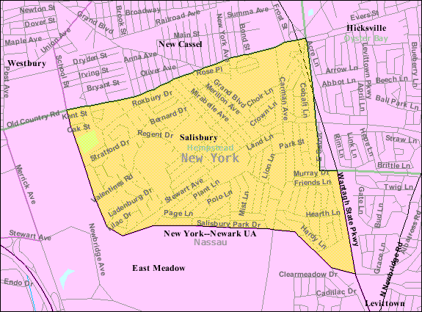

**Welcome to Westbury, New York**

**(Section 1)**

My name is

When I want to greet my friends and family I say

“ .“

My family lives in a (house, apartment)

in Westbury, New York.

There are people in my family.

They are (name who is in your family)

**(Section 2)**

I live in a suburb in New York. My neighborhood (describe)

My home (describe house)

The room where I sleep is (describe)

**(Section 3)**

I like to (tell about what you do at home and after school)

**(Section 4)**

In school

**(Section 5)**

Some of my family’s customs and traditions are

Name Date

**My Family’s Customs and Traditions**

America is a country with traditions from all over the world. What are some of your family’s customs and traditions? List two or three customs and traditions your family practices together.

Example: In our family on Christmas Eve, we all gather together. The food we serve is fish only. We eat seven different kinds of fish the way that our ancestors in Italy did. Some of our family doesn’t like seafood so we also have pasta. Another tradition our family has is that we eat breakfast for dinner once a week. On a Friday or Saturday we will have pancakes and bacon for dinner.

**Activity 4**

**“All About ”**

**(The students research and write about different countries and complete visa information sheets)**

**Essential Questions:**

What does culture mean and why is it important?

Why are cultures around the world different from each other?

How are cultures the same?

How do people live in other countries?

How does learning about other cultures help us understand and interact with people who are different from us?

**Knowledge and Understanding:**

Students will understand what culture means and why it is important. They will also be able to describe how cultures are the same and different and how people live in different parts of the world. Students will learn how understanding different cultures will help them to become good citizens of the world. Students will participate in a group project that will demonstrate their empathy for others. They will complete a social studies binder called *“The World and My Place In It”* that will feature the work they have accomplished throughout the unit.

**Differentiation:**

It would be particularly helpful for English Language Learners to be asked to compare their heritage culture with another culture so that they can draw upon their prior knowledge of their own culture to make comparisons and to validate their life experience. But first, in order to accomplish the more challenging academic tasks of researching information about a culture and comparing it to another to achieve an understanding of the meaning of “culture,” English Language Learners need to be explicitly taught how to ask questions about their own families and their community. They will need scaffolding and modeling to learn how to answer these questions both verbally and in writing. Finally, in order to communicate their new awareness, they need to be taught to compile their information into meaningful formats that can be shared with others such as short essays, power-point presentations and mini-books.

Only when English Language Learners s have been taught the more complex “academic” language that is needed for such “higher-order” tasks as researching, comparing, and presenting their knowledge orally and in writing, can they then successfully engage in activities that will facilitate their exploration of their own and other cultures. Only when they have achieved a better understanding of the role that culture plays in their own lives through reading appropriate literature and engaging in meaningful discussions in their classroom, can English Language Learners then begin to make the leap to a more global understanding of how cultures differ, how world communities interact, and how they, as individuals, can develop empathy for people of other cultures.

**Learning Sequence:** (This learning sequence uses Japan as an example but may be adapted for any country)

1. Using the supplemental book *Passport to World Communities* that accompanies the text book, the teacher will guide learning about various countries.
2. Each child will have a copy of *Passport to World Communities* and will begin learning about Japan by reading Unit 1 pages 2 and 3, “Welcome to Japan!” The children will read independently and then together as a class for reinforcement of vocabulary and concepts.
3. Interesting facts will be charted during a class discussion about the life of a typical Japanese child.
4. The children will be asked to complete a Venn diagram comparing themselves and Yoshi, the boy in the book.
5. As a whole class, a Venn diagram will be completed by having the children share ideas they wrote on their diagrams.
6. A paragraph may be written using the Venn diagram and put into *“The World and My Place In It”* binders.
7. A large classroom map will be used to help the class identify Japan and where it is relative to The United States.
8. The geography of Japan will be the next topic of study. The class will read and discuss the section on pages 4 and 5 in the supplemental book.
9. After each paragraph, the children will write on post-its two facts they found interesting.
10. During a class discussion, the children will be encouraged to share their interesting facts, being careful to listen to their classmates so as not to repeat what has already been stated. This will help to focus the children on listening to each other and will help improve the ELLs listening skills.
11. After all the facts have been shared and charted, the idea of importance will be discussed. Which facts do they feel are the most important ones about Japan’s geography? The class will decide on four important facts.
12. Using the *“Country Fact Sheet”* the children will record the important facts under the Geography heading.
13. The same procedure (8 – 12) will be used for the section on government.
14. The last section of the worksheet is called *Other Interesting Facts* and each child will go through the chapter on Japan and pick four other facts of their own choosing.
15. Using the *“Country Fact Sheet”* the children will fill out a visa for Japan. Some additional information will be needed such as currency and religion which can be obtained by looking in the supplemental book or online encyclopedias. The visa will be placed into the *“The World and My Place In It”* binders.
16. A tale or story native to Japan will be read as a read-aloud**.** *Peach Boy* or *Momotaro* is an old story that has many versions in print. There are also animated programs that can be shared with the class. Analyze the story and characters using a variety of graphic organizers.
17. Using the mentor text, *All the Small Poems and Fourteen More* by Valerie Worth, students can create non-fiction poetry using facts they learned about Japan.
18. Read several poems from the book and lead a discussion in which the students realize that the poems are several sentences that do not rhyme and that these lines are broken (line breaks) at various points.
19. Using the “Non-Fiction Poetry” worksheet, model choosing two facts and asking one question about Japan.
20. Model how to create line breaks using / at different points in each sentence. Read them to hear how they sound and write them on the sloppy copy form.
21. The children will complete these steps independently and the teacher will monitor and provide assistance as needed.
22. Final edited copies of the poems can be written or typed.

Additional activities that may be completed with other countries are as follows:

* Putting on a play based on a tale and creating a script, invitations for parents, and programs
* Researching animals and geographic wonders (rainforest, volcanoes) native to the country
* Making food from the country by following a recipe
* Writing letters or organizing a fund raiser to help others in a country you are studying
* Creating “Did You Know” fact cards to be read during the morning announcements or shared with other classes

***Estimated time for learning about each country is seven weeks.***

**Demonstrating Understanding:**

Students will share their binders with their families. Small groups may present information to other classes.

Name Date

“Country Fact Sheet”

Country

Geography:

Government:

Other Interesting Facts:

**Visa**

Country:

Capital:

Government:

Geography:

Customs/Traditions, Holidays:

Language(s):

Currency:

Interesting Facts:

Country’s Flag

**Non-Fiction Poetry**

Name Date

The topic of the reading was

Write one thing you want to remember.

Write one thing you found interesting.

Write one question you still have.



Appendices

* Appendix A

**Explaining BICS and CALP:**

**Social (BICS) and Cognitive Academic Language Proficiency (CALP) for English Language Learners**

There are two kinds of language proficiency that teachers need to recognize in order to better understand and monitor the progress of their ELLs: They are called BICS and CALP.

BICS means Basic Interpersonal Communication Skills and refers to language that is needed for survival and in social situations. This is the day-to-day language that people use to interact with others. This type of proficiency is usually acquired by an ELL within six months to two years of arrival in the U.S. or when beginning school for the first time in the U.S.

CALP refers to Cognitive Academic Language Proficiency which means the language skills that are needed to perform successfully in academic settings. CALP includes proficiency in listening, speaking, reading and writing with regard to content-area material. This type of language proficiency usually takes an ELL from five to seven years to develop, and can often take longer if the ELL is not literate in his or her first language. Listening and speaking are usually the first areas in which a student will develop academic proficiency; proficiency in the more complex tasks of reading and writing usually takes a bit longer.

Appendix B

**Stages of Language Proficiency:**

**Examples of Academic Tasks That ELLs Can Perform at Each Stage**

Language Development Stages Instructional Implications

|  |  |
| --- | --- |
| Preproduction Stage (6 mos. to 1 year), otherwise known as the “Silent Period”  Characterized by nonverbal behavior such as nodding, pointing, and performing actions. Students are in the passive “absorption period” of learning the new language.  Early Production Stage (6 mos. to 2 years)  Characterized by brief responses using short phrases; frequent errors in grammar and pronunciation; students have a small vocabulary. This is a transitional  stage when errors are still acceptable as the ELL  experiments with his/her new language skills.  Speech Emergence Stage (1 to 3 years)  Characterized by an increase in listening comprehension and more active use of language with controlled vocabulary. Student will begin to use academic language.  Intermediate Fluency (3-7 years)  Characterized by ability to communicate more comprehensibly in written and spoken English with skills that approach native fluency. Errors will appear from time to time and corrections should be gently “modeled.” | Do not force students to speak before they are ready to.  Focus on listening and simple physical response activities.  Students can begin to understand language made more comprehensible through use of pictures, objects and hands-on activities. Build new vocabulary through “experiences” provided to the student.  Continue to provide an anxiety-free environment for limited language responses. Expand listening skills and begin to expect short answers such as yes/no or completion of framed sentence, charts, and graphic organizers. Student can name, list, sequence, draw, describe and role play.  Students are able to participate more fully in mainstream academic subjects and are ready to “risk” more meaningful interaction with peers in classroom setting. Students can engage in such tasks as restating, categorizing, comparing and contrasting, predicting and general discussion.  Students are developing academic language proficiency in the more challenging areas of reading and writing. Class activities must be structured to support this learning: opportunities for language based on “experience” are crucial at this stage. Students can describe in more detail, support and evaluate, and create in more meaningful ways. |

Appendix C

**Tips for Providing Comprehensible Input for English Language Learners**

* Whenever possible, help the ELL build background knowledge of American culture. ELLs come from many cultures and many have not had the same life experiences as American-born children.
* To build background knowledge and vocabulary, use photos, pictures, movies, objects, and any other instructional materials that will help the ELL to make a connection to the subject being introduced. **Connections are essential for an ELL in order for meaningful learning to take place.**
* Pay attention to your speech:

Slow down...use pauses frequently to give the student time to comprehend. Repeat if necessary; restate if the child still does not comprehend.

Speak slowly and clearly and try to abbreviate your sentences...keep it simple

Do not shout or speak loudly; doing so does not help comprehension...it intimidates the student

With new ELLs, try to use the present tense as much as possible; chances are as a “beginner,” the student will not understand past and future tenses

Use fewer pronouns and more names and nouns

Try to use idioms and slang as seldom as possible in the early stages of learning English

Do not always “correct” but “model” correct language instead.

* Make connections to whatever the child knows or has learned to provide a context for learning new material.

Say, for example: “Remember when we read the story (or saw the movie)...and talked about….”

* Repeat, simplify, restate. Return to “already learned” information as often as possible, thereby giving the ELL many opportunities to reinforce the new vocabulary and concepts being learned.

*Many factors affect language learning, including and especially the emotional state of the ELL. Try not to put pressure on your ELLs, as anxiety will inhibit their language expression. They must feel comfortable enough to make mistakes and take chances as they “acquire” their new language; this is part of the normal process of second-language learning. Do not always “correct,” but instead “model” correct language usage.*

**A smile and a few minutes a day devoted to your ELL(s) will go a long way!**

# Works Cited

Aronin, Carol: Colucci, Michael A. Passport to World Communities. Glenview: Pearson Education, Inc., 2004.

Griffin, Deborah and Pamela McGovern. Geographic clustering of language spoken. Advisory. Language working groups of the race and ethnic advisory committee. Washington, D.C.: U.S. Census Bureau, 2006.

Humes, Karen, Nicholas A. Jones and Roberto R. Ramirez. Overview of race and hispanic origin: 2010. 2010 Census Brief. U.S. Department of CommerceEconomics and Statistics Administration. Washington, D.C.: U.S. Census Bureau, 2011.