A Study of the United States of America
Title: The States and Capitals
Subjects: American History, American Geography
Intended Grade Level: High School
Class length: 2 hour class period
Description: This lesson is designed as an introductory lesson in American Geography or an introductory lesson for Modern American History. It focuses on the study of the names of United States, their physical boundaries, and their capitals; as well as a few of their geographic and cultural differences. The lecture activity introduces each state and capital with three interesting facts. Maps are passed around so during the lecture they can be filled out and used as a note guide. The lesson includes an Internet search of the States and each state’s culture.
Curriculum Benchmark: SS.912.G.2.1: Identify the physical characteristics and the human characteristics that define and differentiate regions.
Procedures:
Pre-activities:
Students: This lesson is designed as an opening module; therefore, there is no student preparation.
Teachers: Review PowerPoint® presentation. Check computers for access to the Internet. Print blank map worksheets and presentation summary handouts. Obtain posters and markers.
Lecture Activities: Give presentation. A summary sheet of presentation with blanks to be filled in should be given to the students. Ask if students have traveled to any of the states or know anyone who’s lived in one of the states. Also, ask students if they know by the shape on the presentation slides what the state is and the capitals and some facts about the state. Students should be able to identify most of the 50 states on a map and know each state capital along with three facts per state by the end of the lecture. Lecture/Discussion: 30-40 minutes
Internet Activities: Students will look up the 50 states and their capitals and facts at one of the following websites:
http://www.50states.com/ http://www.theus50.com/
During the activity they will fill out the blank map of the United States with the state names as well as any unfilled blanks from the presentation handout. Worksheet time: 20-30 minutes http://www.50states.com/maps/print/usamap.htm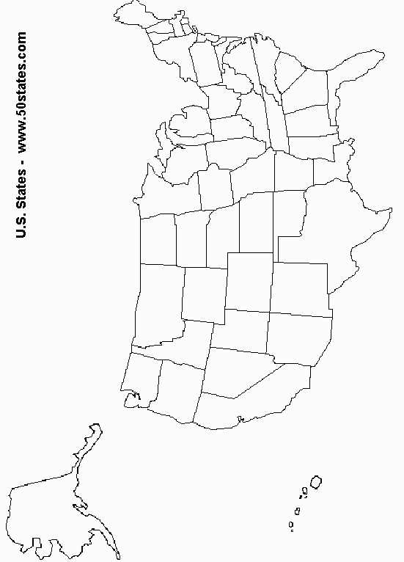
Post Activities: Students will divide into groups of 5 and discuss among them their favorite states. Each group will choose a state to make a poster out of. The poster will consist of the State name, shape, capital, three facts and drawings representing the three facts. After the poster is complete each group will present their poster to the class and discuss why they choose that state. Activity and Discussion: 30 minutes
Post-quiz: Students will fill out blank map of the United States and will complete a 20 question multiple choice and matching quiz of the capitals with their states and state facts. Quiz time: 30 minutes
Assessment/Evaluation:
1. Students will identify the 50 States on a map with correct spelling.
2. Students will identify the State capitals and three state facts with each of the 50 States.
3. Student uses internet to gather information about the 50 States.
4. Students will discuss their preferred State and create a poster about that State.

Student__________________________ Date_____________
Activity | 1- needs improvement | 2-satisfactory | 3-Excellent | Total
Fill in presentation handout | All or almost all blanks empty | Less than 10 blanks empty | 0-5 blanks empty
Complete blank map | All or almost all map blank | Less than 30 states blank | 50-45 states blank
Discuss favorite state | Talking about unrelated topics; no  classroom participation | Some classroom participation and discussion | Guiding discussion or actively participating
Create state poster | No participation | Some coloring/ writing or participation | Actively drawing or participating
 | 0- needs improvement |  | 45- Excellent
Complete Blank map quiz | Blanks empty or incorrectly filled out | Spelling errors/ some blanks empty or incorrectly filled out | Correct answers and spelling
Complete matching/multiple choice quiz | Blanks empty or incorrectly filled out | Some blanks empty or incorrectly filled out | Correct answers and spelling
Total | 4/100 |  | 102/100

* A final grade of 60/100 and above is considered a passing grade.
Submitted By:
Elisabeth Emery
University of Florida
352.978.2641
eemery@ufl.edu

