Curriculum Area Project

East Meadow School District

Grade 7- Science Research -2011

**Writers:**

1. Cynthia Dale
2. Judy Harmon
3. Linda Lynch
4. Elliot Oppenheim
5. Joseph Pavia
6. Nanda Sundri
7. Wendy Wansor
8. Maureen Vella – Supervisor

**Schools:**

W.T. Clarke Middle School Principal: Stacey Breslin

Woodland Middle School Principal: James Lethbridge

**Subject Area:**

Science Research

RATIONALE

The Christopher Columbus Innovation will help challenge our middle school students to explore opportunities for positive change in their communities. The program will involve students in science, technology, engineering, and math (STEM). Teams of up to four students and a coach will identify a community issue and use the scientific process to solve it. Creative, curious- minded students will define and refine their innovative idea throughout the year. Students will research and design a product to test their idea. Products will then be evaluated in order to move up in the competition.

Eight finalist teams will win an all-expense-paid trip to Walt Disney World, where they compete for U.S. Savings Bonds and the $25,000 Columbus Foundation Community Grant to help bring their idea to life in their community.

ABSTRACT

The Science Research Curriculum Area Project will be implemented into the seventh grade science research classes. Students will participate in the Christopher Columbus Awards, a national, community-based science, technology, engineering and math (STEM) program for middle school students. Students will be afforded the opportunity to brainstorm community problems and formulate solutions by following the steps of the scientific method.

Throughout the year, as students projects evolve through the research process, the following New York State Standards will be addressed.

Standard 1: Analysis, Inquiry and Design Students will use mathematical analysis, scientific inquiry, and engineering design, as appropriate, to pose questions, seek answers, and develop solutions.

Standard 2: Information Systems Students will access, generate, and transfer information, using appropriate technologies.

Standard 6: Interconnectedness: Common Themes Students will understand the relationship and common themes that connect mathematics, science, and technology and apply the themes to these and other areas of learning.

Standard 7: Interdisciplinary Problem Solving: Students will apply the knowledge and thinking skills of mathematics. Science and technology to address real-life problems and make informed decisions.

Table of Contents

|  |  |
| --- | --- |
| **Page #’s** | **Content** |
| 1. | Cover Sheet |
| 2. | Rationale |
| 3. | Abstract |
| 5-26 | Introduction |
| 27-33 | Science Research Activities |
| 34-43 | Technology |
| 44-52 | Computers |
| 53-61 | Marketing |
| 62 | Rubric |
| 63-66 | Common Core Standards |
| 67-76 | Calendar |

Unit 1: Introduction

Have teams conduct research and write a one-page essay identifying their   
issue and explaining how they chose that issue, why it's important to the   
team and to the community and what would happen if this problem is not   
addressed. This will serve as the team's first draft of Section 1 of the   
competition entry (see Entry Components & Checklist).

Unit 2: Research

Have students research their community issue to learn as much as they   
can about the problem and its potential solutions. As they conduct their   
research, students should keep a list of the resources they used (people,   
organizations, the Internet, etc.), the information they used to   
understand the issue and the steps they took to formulate their proposed   
solution. Have students use this information to write their first draft of   
Section 2 (Research) of the competition entry (see Entry Components &   
Checklist).

Unit 3: Testing

Have students test their proposed solution. As they test, they should also   
complete Section 3 (Testing) of the competition entry, explaining how   
they organized the test, what problems or variables they accounted for,   
the results of their test and any re-testing they needed to do.

Unit 4: The Solution

Have students complete Section 4 (The Solution) of the competition   
entry, explaining their solution and how it could be made a reality in   
their community. Students will also need to address any challenges to   
implementing their solution. Any additional tests the team needs to   
conduct should be completed by the next deadline.

Unit 5:

The Visual

**Team Roles and Their Descriptions**

Team projects ate made up of four parts: group accountability, positive interdependence,   
individual responsibility, and face-to-face interaction. Each team member will have a role and   
each role has clearly defined tasks.

**Project Director**

The project director is responsible for the   
group.

Roles and responsibilities:

* Reads directions to the group
* Keep group on task
* Makes sure deadlines are met
* Shares summary of group work and   
  results with class

**Technical Manager**

The technical manager is in charge of   
recording all data.

Roles and Responsibilities:

* Records data in tables and/or graphs
* Completes conclusions and final   
  summanes
* Assists with procedure of activity
* Assists with cleanup

**Materials Manager**

The materials manager is responsible for   
obtaining all necessary materials for the group.

Roles and responsibilities:

* Picks up needed materials
* Organizes materials in the work space
* Facilitates the use of materials during   
  activity
* Returns all materials at the end of the   
  activity to the proper place

**Safety Director**

The safety director is responsible for enforcing   
classroom rules and conducting the activity.

Roles and Responsibilities:

* Assists the Project Director with   
  keeping the group on task
* Ensures the procedures of the contest   
  are followed
* Keeps track of time
* Assists Materials Manager

Collaborative Inquiry for Students: Preparing Minds for the Future

**TEAM Model for Collaborative Inquiry**

Section 3: Discover-Collaboration

Once teams are formed it is imperative that the group learn to organize, collaborate, and work together   
as a team to accomplish the task. You can teach your students the TEAM approach to working in   
collaborative teams.

T

E

A

**Team Member Strengths**

* Get to know your team members.
* Know each member's strengths, experience, learning profile, and leadership style.

**Establish Team Structure**

* Establish the purpose of the group and the final product, performance, or outcome.
* Establish roles, responsibilities, process, and timelines.
* Establish the manner in which the experience will be assessed.

**Actively Communicate**

* Active listening.
* Active dialogue.
* Active attention to styles.

**M Make Collaborative Decisions**

* Choose a process for generating ideas.
* Choose a process for making decisions.



105

Section 3: Discover-Collaboration

Collaborative Inquiry for Students: Preparing Minds for the Future

***Teamwork is the ability to work together   
toward a common vision.***

***The ability to direct individual accomplishments   
toward organizational objectives.***

***It is the fuel that allows common people   
to attain uncommon results.***

-Andrew Carnegie, industrialist

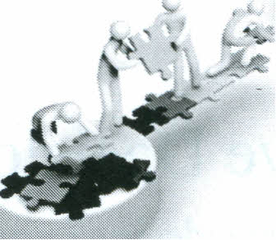

106

Collaborative Inquiry for Students: Preparing Minds for the Future

Leadership Compass Inventory

Check the statements below that best describe your approach to work   
and decision rnakinq.

1. Assertive, active, decisive

2. Allows others to feel important

3. Risk-taker, adventurous, spontaneous

4. Uses data to make logical and analytical decisions

Appendix

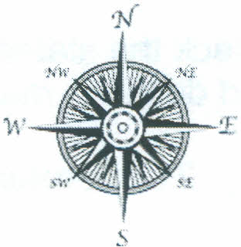

5. Moves carefully, deliberately, and follows procedures and guidelines

6. Very idea-oriented, focuses on future thought

7. Friendly, likeable team player

8. Likes to be in control and determine the course of events

9. Quick to act, expresses urgency for others to act quickly also

10. Supportive, nurturing, and caring towards colleagues

11. Innovative, creative, and sees the big picture

12. Provides planning and resources to others

13. Seen as practical, dependable, and thorough

14. Has insight into mission and purpose

15. Willing to trust others' statements at face value

1. Enjoys challenging people and situations
2. Thinks in terms of the *bottom line*

18. Feelings-based, trusts own emotions and intuition as truth

19. Strong spiritual awareness, free spirited, unconventional

1. Works well with existing resources. Gets the most out of what has been   
   done in the past.

*Continued on the next page*

Adapted from the Northwest Leader Corps training curriculum written and compiled by Nicole Trimble. An EnCorps resource.   
Please retain the original program attribution when adapting or using this resource. Rev. June 2007.

337

Leadership Compass Inventory

Collaborative Inquiry for Students: Preparing Minds for the Future

Check the statements below that best describe your approach to work   
and decision making

_ 21. Careful, thoroughly examines people's needs in situations

_ 22. Appreciates a lot of information

1. Peace-loving, sympathetic, and helpful
2. Likes a quick pace and the fast track

25. Courageous, ambitious, and confident

26. Able to focus on the present moment

27. Looks for overarching themes and ideas

28. Introspective, self-analytical, focused, reserved

1. Weighs all sides of an issue, balanced
2. Values the words: *option* and *possibility*
3. Values the words: *right* and *fair*
4. Perseveres-not stopped by "No!"

33. Divergent thinker with an active imagination

34. Process-centered

35. Likes to experiment and explore

36. Values the words: *objective* and *organized*

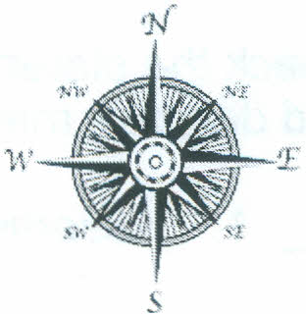

37. Generous, non-competitive, and likes to build on the ideas of others

38. Goal-centered, ambitious

39. Values the words: "Do it now!" and "I'll do it."

_ 40. Skilled at finding the fatal flaw in an idea or a project

North

---

South

---

East _

West

---

Collaborative Inquiry for Students: Preparing Minds for the Future

**Leadership Compass Inventory Scoring**

Appendix

Circle the letters below that match the items checked on your inventory.

Record the total number of each letter on the lines provided at the end of the inventory.

N 1. Assertive, active, decisive

5 2. Allows others to feel important

E 3. Risk-taker, adventurous, spontaneous

W 4. Uses data to make logical and analytical decisions

W 5. Moves carefully, deliberately, and follows procedures and guidelines

E 6. Very idea-oriented, focuses on future thought

5 7. Friendly, likeable team player

N 8. Likes to be in control and determine the course of events

N 9. Quick to act, expresses urgency for others to act quickly also

5 10. Supportive, nurturing, and caring towards colleagues

E 11. Innovative, creative, and sees the big picture

W 12. Provides planning and resources to others

W 13. Seen as practical, dependable, and thorough

E 14. Has insight into mission and purpose

5 15. Willing to trust others' statements at face value

N 16. Enjoys challenging people and situations

N . 17. Thinks in terms of the *bottom line*

5 18. Feelings-based, trusts own emotions and intuition as truth

E 19. Strong spiritual awareness, free spirited, unconventional

W 20. Works well with existing resources. Gets the most out of what has been   
 done in the past

Appendix

Collaborative Inquiry for Students: Preparing Minds for the Future

Leadership Compass Inventory Scoring

Circle the letters below that match the items checked on your inventory.

Record the total number of each letter on the lines provided at the end of the inventory.

W 21. Careful, thoroughly examines people's needs in situations

E 22. Appreciates a lot of information

5 23. Peace-loving, sympathetic, and helpful

N 24. Likes a quick pace and the fast track

N 25. Courageous, ambitious, and confident

5 26. Able to focus on the present moment

E 27. Looks for overarching themes and ideas

W 28. Introspective, self-analytical, focused, reserved

W 29. Weighs all sides of an issue, balanced

E 30. Values the words: *option* and *possibility*

5 31. Values the words: *right* and *fair*

N 32. Perseveres-not stopped by "No!"

E 33. Divergent thinker with an active imagination

5 34. Process-centered

E 35. Likes to experiment and explore

W 36. Values the words: *objective* and *organized*

5 37. Generous, non-competitive, and likes to build on the ideas of others

N 38. Goal-centered, ambitious

N 39. Values the words: "Do it now!" and "I'll do it."

W 40. Skilled at finding the fatal flaw in an idea or a project

Collaborative Inquiry for Students: Preparing Minds for the Future

**Leadership Compass**

**North   
The Driver   
Warrior- Power**

Section 3: Discover-Collaboration

**Approach to Work**

* Assertive, active, decisive
* Likes to be in control and determine the course of events
* Quick to act, expresses urgency for others to act quickly also
* Enjoys challenging people and situations
* Thinks in terms of the *bottom line*
* Likes a quick pace and the fast track
* Courageous, ambitious, and confident
* Perseveres-not stopped by "No!"
* Goal-centered, ambitious
* Hardworking leader who is comfortable being in front
* Values the words: "Do it now!" and "I'll do it."

**Best Ways to Work with a North**

* Present your case quickly, clearly, and with enthusiasm and

confidence

* Let them lead and clearly communicate their role
* Focus on the *challenge* of the task
* Provide them with plenty of autonomy
* Stick to established procedures and timelines
* Give them positive, public recognition
* Use them to complete tasks that require motivation,   
  persuasion, and initiative

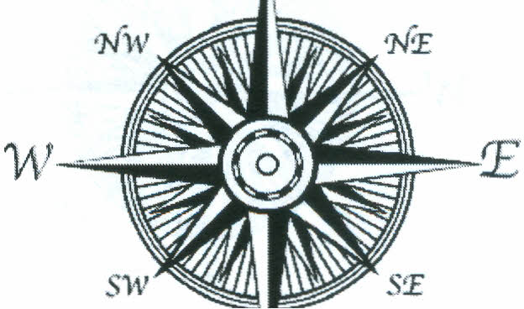

Section 3: Discover-Collaboration

**Leadership Compass**

Collaborative Inquiry for Students: Preparing Minds for the Future

**South**

**The Nurturer   
Healer- Love**

**Approach to Work**

* Friendly, likeable team player
* Allows others to feel important
* Supportive, nurturing, and caring towards colleagues
* Willing to trust others' statements at face value
* Peace-loving, sympathetic, and helpful
* Feelings-based, trusts own emotions and intuition as truth
* Able to focus on the present moment
* Process-centered
* Generous, non-competitive, and likes to build on the ideas of others
* Values the words: *right* and *fair*

**Best Ways to Work with a South**

* Focus on the relationship and communication
* Allow decisions based on values, ethics, feelings, and opinions
* Check in often to see if work is on task and offer help
* Listen carefully and let them talk and discuss issues out
* Provide limited choices and make honesty safe
* Provide plenty of positive reassurance and thanks
* Allow them to assume roles they are passionate about

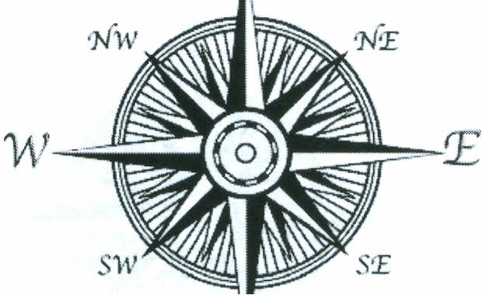

*s*

Collaborative Inquiry for Students: Preparing Minds for the Future

**Leadership Compass**

**East**

**The Dreamer   
Visionary-Vision**

**Approach to Work**

* Innovative, creative, and sees the big picture
* Very idea-oriented, focuses on future thought
* Risk-taker, adventurous, spontaneous
* Has insight into mission and purpose
* Looks for overarching themes and ideas
* Appreciates a lot of information
* Divergent thinker with an active imagination
* Strong spiritual awareness, free spirited, unconventional
* Likes to experiment and explore
* Values the words: *option* and *possibility*

Section 3: Discover-Collaboration

**Best Ways to Work with an East**

* Show appreciation and enthusiasm for divergent thinking and

creative ideas

* Be patient and avoid criticizing or judging ideas
* Provide a big picture and expected outcome
* Provide a variety of tasks and allow down time
* Keep them engaged with hands-on or creative aspects of the   
  project
* Develop ownership, buy-in, and cooperation
* Provide freedom, options, and choices

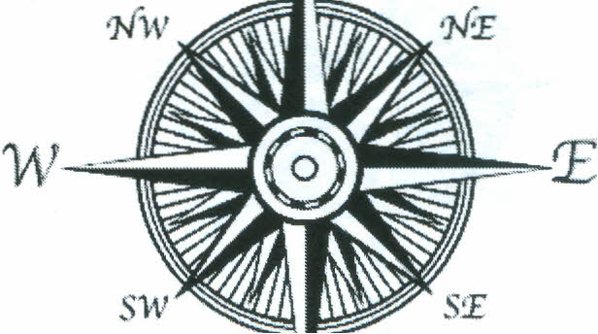

Section 3: Discover---Collaboration

**Leadership Compass**

Collaborative Inquiry for Students: Preparing Minds for the Future

**West**

**The Analyst   
Teacher-Wisdom**

**Approach to Work**

* Seen as practical, dependable, and thorough
* Provides planning and resources to others
* Moves carefully, deliberately, and follows procedures and guidelines
* Uses data to make logical and analytical decisions
* Weighs all sides of an issue, balanced
* Introspective, self-analytical, focused, reserved
* Careful, thoroughly examines people's needs in situations
* Works well with existing resources, gets the most out of what has   
  been done in the past
* Skilled at finding the fatal flaw in an idea or a project
* Values the words: *objective* and *organized*

**Best Ways to Work with a West**

* Allow plenty of time for research, thinking, and decision-making,   
  especially when change is involved
* Provide data, factual details and figures, and extensive written

information

* Let them be the expert, ask their opinion, and allow frank feedback
* Minimize the expression of emotion and use logic when possible
* Appeal to tradition, a sense of history, and correct procedures
* Stay on task, meet timelines and deadlines

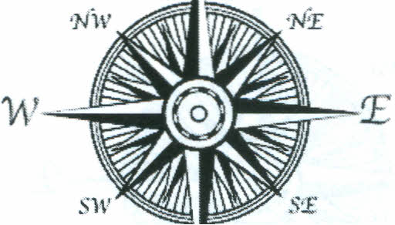

*s*

Sources:

Northwest Leader Corps by Nicole Trimble, 2007.

*The Personality Compass* by Diane Turner and Thelma Greco, 1998.

*The Medicine Way: A Shamanic Path to Self-Mastery.* Kenneth Meadows. Element, 1991.   
*The Medicine Wheel: Earth Astrology.* Sun Bear and Waburn. Simon and Schuster, 1980.

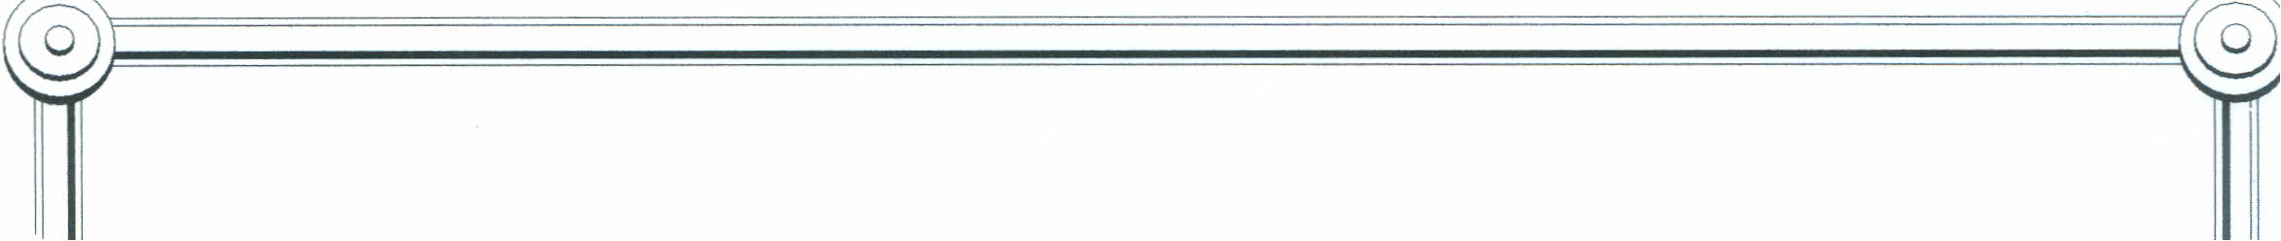

TEAM NAME:

TEAM ROLES:

**Project Director:** _

**Materials Manager:** _

TechnicaIManager: _

**Safety Director:** _

@0~======================================~@0



COMPANY NAME:

COMPANY LEADERSHIP:

Chief Executive Officer (CEO): _

Chief Financial Officer (CFO): _

Vice President of Marketing: _

Chief Operating Officer (COO): _

@)~======================================~@)

*Science Research Project Resource*

This teacher created website is a collection of websites the students can visit and use as a   
resource for the project. Several folders can be created with various topics. The students enter   
the URL of the website (www.iKeepBookmarks.comlEMlemonade). select the topic they are   
interested in viewing; they click on it and go directly to the site. Only the teachers can edit the   
site and add websites.

Website: <http://www.iKeepBookmarks.com>

Account: EMlemonade

Password: stand

**Unit 1: INTRODUCTION**

**PROJECT OVERVIEW:**

*We are challenging you to use your imagination and creativity to make*

*your community a better place to live. We think you have what it takes to identify a problem, look into it, come up with an innovative solution, test and refine the solution . . . and have fun doing it!*

**BRAINSTORMING:**

*As a team identify needs for a product or service*

|  |  |
| --- | --- |
| Need | Idea to fill the need |
| 1. |  |
| 2. |  |
| 3. |  |
| 4. |  |

**Research:**

* Search to see if your need has been met already
* Conduct a patent search by accessing websites such as:

<http://patft.uspto.gov>

**Essay: First Draft of Section 1 of Competition (1 page) Due Date______________**

* Identify your issue.
* Explain how you chose that issue.
* Why is the issue important to your team and community?
* What would happen if the problem is not addressed?

**UNIT 2: RESEARCH**

1. State your solution or hypothesis:___________________________________

__________________________________________________________________

__________________________________________________________________

1. Identify the resources you will need to develop, research, and support your position. You may add to these later as needed.

___________________________________________________________________________________________________________________________________________________________________________________________________________________________________________________________________________________________________________________________

1. Identify the laboratory equipment, project supplies and tools you will need for product development and/or experiments.

___________________________________________________________________________________________________________________________________________________________________________________________________________________________________________________________________________________________________________________________

1. List the sequence of steps you will need to take in the development, research, and product or experiment implementation. Include a timeline estimate.

__________________________________________________________________________________________________________________________________________________________________________________________________________________________________________________________________________________________________________________________________________________________________________________________

1. Identify problems you may encounter with the research, development, and implementation of steps listed above.

___________________________________________________________________________________________________________________________________________________________________________________________________________________________________________________________________________________________________________________________

**Essay:** First Draft of Section 2 of the competition entry (3 pages)

* List resources used include people, organizations, web-sites, etc.
* The information you used to understand the issue
* The steps you took to formulate your proposed solution

**UNIT 3: Developing & Testing**

Now it’s time to get hands-on by using the scientific methods of inquiry and investigation.

Based on what you’ve discovered, propose a unique, creative solution.

__________________________________________________________

What innovative technology or approach would you like to test in order to try to solve the problem?

_________________________________________________________

Design a test to see whether your solution will work.

Be sure to record all your data and control any variables.

Run experiments with a prototype to test your solution under various conditions.

If your solution doesn’t work, don’t give up. . . brainstorm and test a new solution.

Keep testing and modifying possible solutions to reach the best result.

Most problems have more than one solution.

Can you improve on your solution?

Essay:

* Explain how you organized the test
* What problems or variables were accounted for
* The results of your test and any re-testing you needed to do

**UNIT 4: The Solution**

Essay: Section 4 (3pages)

* Explain your solution and how it could be made a reality in your community.
* Explain any challenges to implement your solution.

**Any additional tests your team needs to conduct should be completed by the next deadline.

**UNIT 5: THE VISUAL**

Prepare your visual presentation for the judges. Good entries employ:

A powerful visual presentation to illuminate the team's problem and solution.

Drawings should be accurate and easy to understand.

Photographs should be clear when photocopied.

Audio/video components should be intelligible.

The visual presentation is **one** of the following:

Mechanical/Blueprint Drawing (no larger than two 8-1/2" x 11" pages)

Diagram (no larger than two 8-1/2" x 11" pages)

Photographic Series (no more than four photos total and no collages on two 8-1/2" x 11" pages)

DVD (five-minute maximum length)

PowerPoint Presentation on CD (no more than 20 slides maximum; no video elements inside the slides)

**Science Research**

*Activity 1: Introduction to the Internet*

* + Overview and History
  + Google and Beyond: Search, Metasearch, and Directories & Databases

A class discussion will be conducted to explore various websites and searches.

*Activity 2: Evaluation of a Website*

* What does the URL tell you?
* What is wrong with Wikipedia?

The students will complete the activity; *Solving Real World Problem*. This activity involves reading an online article, *Penguin Shoes Ensure Happy Feet*, and answering questions.

The second part of the activity is the evaluation of the website. Each student will complete the worksheet, *Evaluation of a Website*. The students will share their findings during a class discussion.

*Activity 3: Overview of Research Process*

* + Setting up folders in the student user account
  + Collecting data and pictures
  + Storing data and pictures
  + Bookmarking sites

Each student will create a folder for Research. The folder can include additional sub-folders to various topics, such as Pictures, Videos, Facts and Figures, etc. The students will also bookmark sites they can use in the future. Each student will complete the worksheet, *Beginning the Research Process.*

*Activity 4: Completion of a Web Quest*

Working in pairs, the students will complete the *Research Web Quest* by using various sites to determine the answers. The students will share their answers and the sources they used. A comparison of the reliability of the websites will be discussed.

Name __________________________ Date _______________

*Activity: Solving Real World Problems*

**Article: Penguin Shoes Ensure Happy Feet**

Go to this website:

<http://news.nationalgeographic.com/news/2006/11/061115-penguin-shoes.html>

1. What was the problem or need for the penguin?
2. Why did this problem develop?
3. Why did this cause a concern for the penguin and the marine biologists?
4. What was the marine biologists’ idea to fill this need or solve the problem?
5. In your opinion, how do you think the scientists came up with this solution?
6. How does the future look for the penguin?

Name _________________________ Date ___________________

*Activity: Evaluation of a Website*

URL for evaluation: [news.nationalgeographic.com/news/2006/11/061115-penguin-shoes.html](http://news.nationalgeographic.com/news/2006/11/061115-penguin-shoes.html)

1. What is the website? ______________________________________

2. What is the domain? __________________________

(*Domain examples*: mil.=military, gov.=government, edu.=educational, org.=organization, com.=commercial or corporation, net.=Internet service provider)

3. Is it published overseas? yes no

(examples: .uk, .jp, etc)

4. Does the site cover the topic? yes no

5. Can you understand the information? yes no

6. Is the information up to date? yes no

(date of article: _____________)

7. Why was the site created?

a) entertainment (examples: sikids.com/games, funbrain.com/kidscenter.html)

b) commercial (examples: ebay.com, amazon.com)

c) advocate an idea (examples: greenpeace.com, foodnetwork.com)

d) present information (examples: weather.com, time.com)

8. Who is the author of this site? __________________________________________

9. Are there credentials for this author? yes no

10. Is this the author’s opinion? yes no

11. Are there links and source notes on this page? yes no

12. What is your overall opinion of this website? Is it a good source? (Think of the 5W’s!)

________________________________________________________________________________________________________________________________________________________________________________________________________________________________________________________________________________________________________________________

Name___________________ Date __________________

*Activity: Beginning the Research Process*

1. Log into your school account.

2. Create a folder for pictures. Label the folder, Pictures.

3. Create a folder for videos. Label the folder, Videos.

4. Create a folder for history. Label the folder History.

5. Create a folder for facts and figures. Label the folder, Facts and Figures.

6. Using the Internet, go to the website, <http://www.phila.gov/>

7. On the website, click on Permits and Certificates, click on Block Party Permit. What three holidays are you permitted to have a Block Party in Philadelphia?

______________________________________________________________________________

8. Bookmark this site by adding it to your Favorites.

9. Return to the original website. Click on the icon, Visit Philly.com

10. Click on the Favorite Attractions, The Liberty Bell Center.

11. Copy a picture of the Liberty Bell and save picture in the Picture folder.

12. Go back to Favorite Attractions page. Click on the National Constitution Center. Using the arrows, browse through the pictures shown. Look at the ones labeled, Signers Hall. Save one picture in the Picture folder.

13. Go to Google.com and do a search for U.S. Constitution Preamble + video. Watch the video and add the link to your favorites. (Suggestion: try schooltube.com or www.gamequarium.org)

14. Go to Google.com. Search Google Doodles. Find out what the Global Google Doodle was for July 20, 2011. What is the significance of the peas in the doodle? __________________________________________________________________________________________________________________________________________________________________________________________________________________________________________

_____________________________________________________________________________

Name __________________________ Date_________________

*Activity: Research Web Quest*

Introduction: There are various different sources to find information when you need to do research. Some sources include: an encyclopedia, both in print and on line, Internet websites, magazines, newspapers, databases, books, site visits, experts, journals, and atlases. Keep in mind some websites are more reliable than others. There are content websites (cnn.com about.com), retail websites (amazon.com, ebay.com), blogs (discussion sites), databases (weather.com, mapquest.com, worldatlas.com), and company websites (campbell.com, nike.com). Educational institutions and governmental agencies are more reliable sites than someone’s personal page.

Directions: Find the answer to each of the following questions. Please note the URL where you found the answer.

1. Who was the 7th President of the United States of America?__________________________

URL: ___________________________________________________

1. What is the tomorrow’s weather forecast for Clarke City, Canada? ______________________

URL: ___________________________________________________

1. Who were the first two astronauts on the moon? ______________________________

URL: ___________________________________________________

1. How many black pentagons are on a modern soccer ball that has 32 panels? ________________

URL: ___________________________________________________

1. Draw an *interrobang*. _________________________

URL: ___________________________________________________

1. What company makes the game, *Angry Birds*? ___________________________

URL: ___________________________________________________

1. What two baseball teams played in the 2000 World Series? _____________________________

URL: ___________________________________________________

1. What are the longitude and latitude coordinates of Westbury, New York? ___________________

URL: ___________________________________________________

1. Name three types of soup included in Andy Warhol’s pop art creation, *32 Campbell Soup Cans*?

__________________________________________________________

URL: ___________________________________________________

1. How much money did the *Harry Potter* finale make during its opening weekend July18, 2011?

_____________________________

URL: ___________________________________________________

1. What is Dr. Seuss’ real name? ________________________

URL: ___________________________________________________

1. Who is the CEO of *Apple*? _____________________________

URL: ___________________________________________________

1. Describe the first commercial to introduce the *Macintosh* computer by *Apple*.

______________________________________________________________________________________________________________________________________________________________

URL: ___________________________________________________

1. Write 2 portmanteaus. ______________________________________

URL: ___________________________________________________

1. What is *Burger King’s* motto? _____________________________________________

URL: ___________________________________________________

1. What company’s motto is, “*one person, one cup and one neighborhood at a time*”? ___________

URL: ___________________________________________________

1. What is the function of the ozone layer? ______________________________________________

URL: ___________________________________________________

1. When is the next full moon? ______________________________________

URL: ___________________________________________________

1. How many bones are in the adult human skeleton? ____________________________

URL: ___________________________________________________

1. How many *iPhones* were sold in 2010?____________________________

URL: ___________________________________________________

1. Draw the corporate logo for *BMW*.

URL: ___________________________________________________

**Scientific Method Activities Outline**

*Activity 1: Discussion of the Scientific Method*

A class discussion will involve identifying the 6 steps of the scientific method and the importance of an organized way to conduct an investigation. Using the following interactive websites below, we will review the steps of the scientific method.

Website: [www.panpipes.net/edit6200/index.html](http://www.panpipes.net/edit6200/index.html)

Website: [www.quia.com/mc/457.html](http://www.quia.com/mc/457.html)

Website: www.biologycorner.com/worksheets/controls.html

*Activity 2: Analysis of an Experiment*

Using *Science World* magazine, read and discuss the experiments in the Scientific Method issue. Working in groups of 2 or 3, have the students read the experiment and identify the various components (independent variable, dependent variable, constants, control, observations) of the experiment. The students will share their findings with the class.

*Activity 3: Making Observations*

The class will discuss the difference between a qualitative observation, a quantitative observation, and an inference. This website can be used to practice making observations and inferences.

Website: www.uga.edu/srel/kidsdoscience/games/observation-puzzle.pdf

The website below is a lesson that will stress the importance of making observations.

Website: www.middleschoolscience.com/apple.htm

*Activity 4: Writing Procedures*

The students will work in pairs to write the procedure for a real world activity. Some examples might include: making a peanut butter and jelly sandwich, making an ice cream sundae, or making ice cubes. The students will write directions from start to finish in a minimum of 10 steps. The students will switch procedures and assess the accuracy of the directions.

*Note: Throughout the year, experiments and activities are conducted in science class that provide additional opportunities to analyze the scientific method, follow procedures to conduct the activities, and form conclusions.*

Name: ___________________________ Due Date: _______________

Period: _____ Days: _____________ Topic: __________________

Technology Report (Inventions)  
*Directions*: Choose a topic, from the list provided, and must be **approved by instructor.** Use the outline below to gather information and record your sources, (two required). Must submit completed outline and typed final draft (at least 2 full pages) by due date. In addition; you must include a cover page (title, name, date, and period) and at least TWO photos of the invention or time line that **help** explain your topic. *You may use the back of this outline or separate paper if more space is needed.*

**I.** **Introduction:** Write an opening statement giving an overview of the invention you chose. (Capture our interest, why did you choose this?)

**II. History**:

1. Who invented it? (could be: company, person or several people)
2. When was it invented? (could also include changes to the invention)
3. Where was it invented? (State, Country, where did the inventor live?)
4. Why was it invented? (What problem were they trying to solve?)
5. How was it invented?
6. Other important or related information: (any other info related to topic you found interesting)  
   **III. Describe its function**:   
      
    a. What does it do?
7. How does it work? (Technical info, what makes it do what it was intended for?)
8. Explain some advantages of the invention. (How did it change our lives?)
9. Explain some disadvantages of the invention. (Did it create other problems?)

1. **Future:** Imagine the world twenty years from now. How will technology change your chosen invention?   
   1. Will it still exist?
   2. How might it change?
   3. Will it be used for the same purpose?
   4. Will it become part of another invention?
   5. What further technological advancement will be needed or developed before it can advance to the next step or level?
   6. What would it look like? (draw or sketch if you can)
2. **Conclusion**: (closing statement)
3. **Presentation:**  You will present your invention (report to the class). I do not want you to read it word for word. But rather you told us about it. You can create a power point, poster board, use visual aids as well as the smart board to help make an interesting presentation.  
     
   *The Presentation is in addition to a written report to be turned in.
4. **Bibliography:** (must use at least two sources) ([www.citationmachine.net](http://www.citationmachine.net) or [www.noodletools.com](http://www.noodletools.com) ) these two web sites will assist you in learning how to properly make bibliographic citations.  
      
   1.   
     
     
     
     
   2.  
     
     
     
     
   3.  
     
     
     
     
   4.
5. **Parents Signature:** _____________________________________  
     
   My son / daughter has shown us the outline and explained what is expected of them as well as the due date for the written report.   
     
   If you have any questions please feel free to contact me. Thank you for your support.

**Lesson Plans Ideas for Inventor Unit**

What is a patent?

What is involved in the design process?

Brainstorming ideas and market surveys

Failed inventions

Inventions by men and women

Inventions by kids

Manufacturing and prototypes

Name_______________________________Topic_____________Date___________

Planning Worksheet

1. State your thesis or hypothesis: ____________________________________________________________________________________________________________________________________________________________________

__________________________________________________________________________________

2. Identify the resources you will need to develop, research, and support your position.

______________________________________________________________________________________________________________________________________________________________________________________________________________________________________________________

__________________________________________________________________________________

3. Identify the laboratory equipment, project supplies and tools needed for product development and/or experiments.

______________________________________________________________________________________________________________________________________________________________________________________________________________________________________________________

_____________________________________________________________________

4. List the sequence of steps you will need to take in the development, research and product or experiment implementation. Include a timeline estimate.

______________________________________________________________________________________________________________________________________________________________________________________________________________________________________________________

5. Identify problems you may encounter with the research, development and implementation steps listed above.

______________________________________________________________________________________________________________________________________________________________________________________________________________________________________________________

6. Return to numbers 2-4. Use a pen of a different color to modify your plan to avoid these problems

|  |  |
| --- | --- |
| **Inventions for the 21st Century** |  |

|  |  |  |  |  |  |  |  |  |  |  |
| --- | --- | --- | --- | --- | --- | --- | --- | --- | --- | --- |
|  |  | |  |  | | --- | --- | |  |  | |  | Photo: PhotoDisc   |  | | --- | | **OTHER MINI-LESSONS** |  |  | | --- | | • [What Is An Invention?](http://teacher.scholastic.com/lessonrepro/lessonplans/theme/inventions01.htm)  • [Inventions All Around Us!](http://teacher.scholastic.com/lessonrepro/lessonplans/theme/inventions02.htm)  • [Top 10 Inventions](http://teacher.scholastic.com/lessonrepro/lessonplans/theme/inventions03.htm)  • Inventions for the 21st Century | | |  |  |   **Activity:** Groups will focus on innovations in the following fields: communication, transportation, medicine, sports, and games. They'll choose important inventions in that field and look at how these inventions have changed the way we live. They'll consider how our world may change in this new century and what changes may require new inventions. Finally, they'll imagine new inventions for the future.   1. Divide the class into four groups and assign each group one topic: communication, transportation, medicine, sports, and games. Tell students they will be looking at important inventions in each area, then imagining inventions for this new century. 2. Each group should use the related Web sites below to complete their assignment. First, they should review the inventions featured in the Web sites. Then have them choose five important or interesting inventions in that area. For each invention, the group should write the answers to the following questions.   • In what ways do you think our world will change in this new century?  • How does it change the way we live? (How does it help people make their lives better, easier, healthier, or more enjoyable?)   1. Then ask groups to break into pairs and talk about what kinds of inventions will be needed in the future. Have them consider the following questions   • What does this invention do?  • What new things will people need to be able to do?   1. Have each pair imagine a completely new invention that would help meet the needs of the 21st century. They should give this invention a name, describe what it does, and how it will improve people's lives. Have students create a poster with these facts and an illustration of their invention. Partners should present their posters to the class. |

Web site used:

http://teacher.scholastic.com/lessonrepro/lessonplans/theme/inventions04.htm

|  |  |
| --- | --- |
| **Top 10 Inventions** |  |

|  |  |  |  |  |  |  |  |  |  |  |
| --- | --- | --- | --- | --- | --- | --- | --- | --- | --- | --- |
|  |  | |  |  | | --- | --- | |  |  | |  | Photo: PhotoDisc   |  | | --- | | **OTHER MINI-LESSONS** |  |  | | --- | | • [What Is An Invention?](http://teacher.scholastic.com/lessonrepro/lessonplans/theme/inventions01.htm)  • [Inventions All Around Us!](http://teacher.scholastic.com/lessonrepro/lessonplans/theme/inventions02.htm)  • Top 10 Inventions  • [Inventions for the 21st Century](http://teacher.scholastic.com/lessonrepro/lessonplans/theme/inventions04.htm) | | |  |  |   **Activity:** As a class, students will choose the ten most important inventions of the 20th century. Next, partners will research important facts about each invention. Then, each student will write about and vote on the one invention that has had the greatest impact on people's lives.   1. Hold a class discussion about some of the most important inventions of the 20th century. Which invention has really changed the way people live? Which ones would be the most difficult to live without? Which inventions have the greatest impact on the most people around the world? Brainstorm ideas and write them on the board. 2. Help students review the list to make sure each invention was invented during the 1900s. If there are questions, assign one or two students to check the facts online. 3. As a class, decide on the ten most important inventions from the list. (You could have students write their ten choices on a list, collect the list, and tally the votes.) Create a new list with the class's "Top 10" list. 4. Divide the students into groups of two or three and have each group research one of the ten inventions using the sites below. On a piece of notebook paper, descriptions should include:   • the name of the invention  • a picture of the invention  • the name of the inventor  • the date or year it was invented  • one or two facts about how it was invented  • a description of what it does   1. Divide students into five groups, each assigned to one of the inventors above. Ask them to answer the following questions. They may use the Web sites below to help them research.   • How does this invention help people?  • How do you think this invention changed the way people live?  • What kinds of things did this person need to know in order to create his invention?  • Would you consider this a successful invention? Why or why not?   1. Create a "Top 10 Inventions" bulletin board. Have each group present their report to the class, and hang their reports in a line across the bottom of the board. 2. Finally, ask each student to consider which of these inventions they think is the most important. They should consider which one invention has had the greatest impact on people's lives. Give each student an index card. On their cards, they should write the name of the invention they chose and two to three sentences describing why that innovation is the most important to our lives today. 3. Have each student read his or her card aloud and place it above the report for that invention. The cards should be placed one above the other over each invention, creating a visual bar graph. Which invention did students vote number 1, and why. |

Website used:

<http://teacher.scholastic.com/lessonrepro/lessonplans/theme/inventions03.htm>

|  |  |
| --- | --- |
| **What is an Invention?** |  |

|  |  |  |  |  |  |  |  |  |  |  |
| --- | --- | --- | --- | --- | --- | --- | --- | --- | --- | --- |
|  |  | |  |  | | --- | --- | |  |  | |  | Photo: PhotoDisc   |  | | --- | | **OTHER MINI-LESSONS** |  |  | | --- | | • What Is An Invention?  • [Inventions All Around Us!](http://teacher.scholastic.com/lessonrepro/lessonplans/theme/inventions02.htm)  • [Top 10 Inventions](http://teacher.scholastic.com/lessonrepro/lessonplans/theme/inventions03.htm)  • [Inventions for the 21st Century](http://teacher.scholastic.com/lessonrepro/lessonplans/theme/inventions04.htm) | | |  |  |   **Activity:** Students will talk about what inventions are (how they're different from discoveries) and learn to recognize some of the many inventions all around them. Then they'll look at a few famous inventors and their inventions, and talk about how each innovation changed the way people lived.   1. Write the following words on the board: telephone, fire, toothpaste, aspirin, electricity, wheel, gold. Ask your class to choose which of these are inventions. (answer: telephone, toothpaste, aspirin, wheel) Ask them why the other things on the list are not inventions. (They're found in nature; people didn't create them.) Which of these items might be considered discoveries? (fire, electricity, gold) Why? (They had already existed in nature when someone discovered them for the first time.) 2. On the board, write: "An invention is ..." and ask the class to brainstorm answers. For example, an invention is: something new, something created by a person, something that people use. When this list is complete, ask them to develop a definition of invention. (The Discovery School site below gives the following definition: "Invention is the creation of a new device, process, or product." The Merriam-Webster Dictionary defines invention as: "an original device or process.") 3. Ask students to name inventions they can see in the classroom. For each invention, ask them to describe what the invention is used for. As they brainstorm, keep a list on the board. If they point out things that are not inventions, ask them to return to the definition. 4. Write the following names on the board: Alexander Graham Bell, Thomas Alva Edison, Henry Ford, Orville and Wilbur Wright. Tell students that these are some of the most famous inventors. Ask students if they know what each of them invented and write the invention next to the name.   • Alexander Graham Bell: Telephone  • Henry Ford: Assembly line and the Model T (the first popular car to be sold to many people)  • Wright brothers: Airplane  • Thomas Alva Edison: Light bulb and phonograph (the first machine to record and play back sounds), and many others  • Eli Whitney: Cotton gin   1. Divide students into five groups, each assigned to one of the inventors above. Ask them to answer the following questions. They may use the Web sites below to help them research.   • How does this invention help people?  • How do you think this invention changed the way people live?  • What kinds of things did this person need to know in order to create his invention?  • Would you consider this a successful invention? Why or why not?   1. Bring the class together and have each group read their answers. What makes all these inventions important? |

Website used:

<http://teacher.scholastic.com/lessonrepro/lessonplans/theme/inventions01.htm>

**Introducing … Power Point**

***Skills you will learn include:***

* Launching PPT
* Choosing a background / design
* Creating a title slide
* Selecting a slide layout
* Adding & deleting slides
* Inserting text, images, and charts
* Adding sounds and videos
* Using animation and transitions
* Timing your PPT
* Creating notes for your presentation
* Printing your PPT
* Presenting your PPT

KEY RESOURCE:

***www.gcflearnfree.org/powerpoint***

*The Assignment:*



1. *Select an invention from the list*
2. *Create your Power Point*
3. *Your PPT* ***must*** *include:*
4. *Create Notes for your presentation*
5. *Print out a hard copy (3 slides per page!)*
6. *Present your PPT to the class*

**Inventions PPT Assignment**

Pick an invention.

1. Research your invention online.
2. Create a short PowerPoint about your invention.
3. Your PowerPoint should answer the questions:
   1. Who is credited with your invention?
   2. When did your invention take place?
   3. What problem did your invention solve?
   4. How has your invention evolved?
   5. How did your invention change society/the world?

Your PowerPoint should include:

1. At least 6 slides.
2. A Title Slide.
3. At least 10 images (pictures, clipart)
4. Transitions
5. At least 3 animations.
6. Audio and video are optional.
7. A slide citing your sources.

|  |  |  |
| --- | --- | --- |
| Adhesive tape | Aspirin | Internet |
| Television | Zipper | Bubble gum |
| Chocolate Chip cookies | Life Savers | Air conditioner |
| Traffic light | Wheelchair | Toothpaste |
| Monopoly | Typewriter | Penicillin |
| Thermometer | Telephone | Submarine |
| Seatbelts | Potato chips | Play-Doh |
| Stapler | Band-aids | Paperclip |
| Remote control | Smoke detector | Blue jeans |
| Braces | Bicycle | Diapers |
| Drinking straws | Dry ice | Elevator |
| Fingerprinting | Ice cream | iPod |
| Metal dector | Cell phone | MRI |
| Velcro | Barcodes | Dynamite |
| Eraser | Flushing toilet | GPS |
| Light bulb | Rubber band | Stethoscope |
| Telescope | Umbrella | Suntan lotion |

# PowerPoint Presentations

Have you ever given a PowerPoint presentation and noticed that something about it just seemed a little… off? If you’re unfamiliar with basic PowerPoint design principles, it can be hard to create a slide show that presents your information in the best light. Poorly designed presentations can leave an audience feeling confused, bored, and even irritated. Review these Do’s and Don’ts for tips on making your next presentation more engaging.

* **Don’t read your presentation straight from the slides.** If your audience can both read and hear, it’s a waste of time for you to simply read your slides aloud. Your audience will zone out and stop listening to what you’re saying, which means they won’t hear any extra information you include. Instead of typing out your entire presentation, include only main ideas, keywords, and talking points in your slide show text. Engage your audience by sharing the details out loud. [http://blog.gcflearnfree.org/2011/01/25/simple-dos-and-donts-for-better-powerpoint-presentations/ - _msoanchor_1#_msoanchor_1](http://blog.gcflearnfree.org/2011/01/25/simple-dos-and-donts-for-better-powerpoint-presentations/#_msoanchor_1#_msoanchor_1)
* **Do Follow the 5/5/5 rule.** To keep your audience from feeling overwhelmed, you should keep the text on each slide short and to the point. Some experts suggest using the **5/5/5** **rule**: no more than **five** words per line of text, **five** lines of text per slide, or **five** text-heavy slides in a row.
* **Don’t forget your audience.** Who is going to be watching your presentation? The same goofy effects and funny clip art that would entertain a classroom full of middle school students might make you look unprofessional in front of business colleagues and clients. Humor can lighten up a presentation, but if you use it inappropriately, your audience might think you don’t know what you’re doing. Know your audience, and tailor your presentation to their tastes and expectations.
* **Do** **choose readable colors and fonts.** Your text should be easy to read and pleasant to look at. Large, simple fonts and theme colors are always your best bet. The best fonts and colors can vary depending on your presentation setting. Presenting in a large room? Make your text bigger than usual so that the people in the back can read it. Presenting with the lights on? Dark text on a light background is your best bet for visibility.
* **Don’t overload your presentation with animations.** As anyone who’s sat through a presentation while every letter of every paragraph zoomed across the screen can tell you, being inundated with complicated animations and exciting slide transitions can be extremely irritating.  Before including effects like this in your presentation, ask yourself: Would this moment in the presentation be equally strong without an added effect? Does it unnecessarily delay information? If the answer to either question is yes, or even “maybe,” leave out the effect.
* **Do use animations sparingly to enhance your presentation.** Don’t take the last tip to mean that you should avoid animations and other effects altogether. When used sparingly, subtle effects and animations can really add to your presentation. For example, having bullet points appear as you address them rather than before can help you keep your audience’s attention.

Website used:

<http://blog.gcflearnfree.org/2011/01/25/simple-dos-and-donts-for-better-powerpoint-presentations/>

**Introducing … Excel**

***KEY RESOURCE:***

[***www.gcflearnfree.org***](http://www.gcflearnfree.org)***/excel***

*The Assignment:*

1. *Take the Pet Data from the entry survey. Analyze and group the data.*
2. *Using Excel, create a chart or graph to present the data.*
3. *Your Chart/Graph* ***must*** *include:*
   * *Title*
   * *Labels / key*
   * *Color*
   * *Additional graphics are optional*
4. *Print your graph / chart*

***Skills you will learn include:***

* Launching and navigating Excel
* Understanding worksheets, workbooks and spreadsheets
* Entering text and numbers
* Using simple formulas
* Creating charts and graphs
* Adding labels, titles, and keys
* Adding color
* Importing Excel into PPT

**PET SURVEY**



How many of the following pets does your family have?

_____CAT

_____DOG

_____REPTILE (turtles, lizards, snakes)

_____FISH

_____BIRD

_____OTHER

_____We do not have pets in our house.

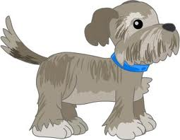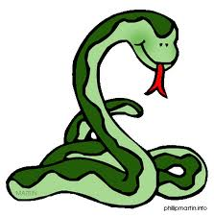

Excel: Create a Chart / Graph

[Home](http://www.internet4classrooms.com/index.htm) >  [Technology Tutorials](http://www.internet4classrooms.com/on-line.htm)  >  [MS Excel](http://www.internet4classrooms.com/on-line_excel.htm)  >  [Creating a Chart or Graph](http://www.internet4classrooms.com/excel_create_chart.htm)

advertisement

**Step 1 - Launch Excel -** If Excel is already open on your workstation open a new Excel workbook, There are three ways to do that.  
**1.** Go to the Standard toolbar. Click on the **New** **Workbook** button.  **2.** Go to the **File** menu. Select **New**.  **3.** Use a keyboard combination: on a Macintosh use **Command + N** and on a Windows computer use **Ctrl + N**



**Step 2** - **Enter the data to be graphed.** For the purpose of this lesson you will use data from a Favorite Fruit Survey. Enter it as you see below:

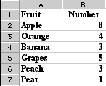

**Step 3 - Highlight data to be graphed.** Do not include the row with heading titles, only the names of fruit and the numbers. If your worksheet looks like the one above; put your cursor in call A2, click hold the mouse button down and drag to cell B7. Highlighted data should look like the image below:

*Note: Cell A2* ***is*** *selected, the select color extends around the cell*

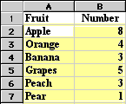

**Step 4 - Select the Chart Wizard**. That is done by going to the **Insert** menu and selecting **Chart**. You can also click on the **Chart** **Wizard** button on the Standard toolbar.



**Step 5** - From the Chart Wizard box that opens select Chart type. For this activity, I selected pie.

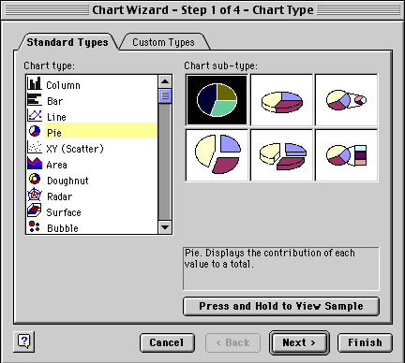

After you have selected the Chart type, click and hold your mouse pointer down on the **Press and Hold...** button to see what your data looks like in the chart type you selected. If you do not like the look, select another chart type. After you have selected the chart type you will have two options:

* Select Next and let Chart Wizard show you a series of options to make changes to your chart.
* Select Finish and Chart Wizard puts your completed chart on the spreadsheet. [**You can see the finished product below**](http://www.internet4classrooms.com/excel_create_chart.htm#finish#finish).

The second step taken by Chart Wizard is to verify the range of data being used for this chart. The Data range displayed below is read "all cells from A2 to B7."

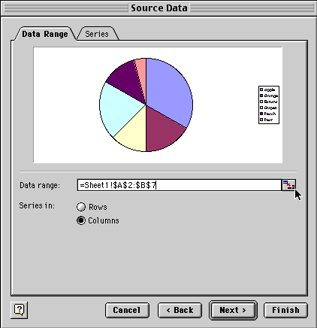

Notice where the cursor is located in the dialog box above. It is pointing to the small box at the end of the line where the Data range is displayed. If the data range should be changed, click on the box the cursor is pointing to.



The dialog box shrinks allowing you to see your entire spreadsheet. You can edit the data range in this small window. When you are finished, click the same box at the end to restore the window.

Select **Next** to go to the dialog box below. This box allows you to add a title to the chart, make changes on the legend, or make changes on the data labels.

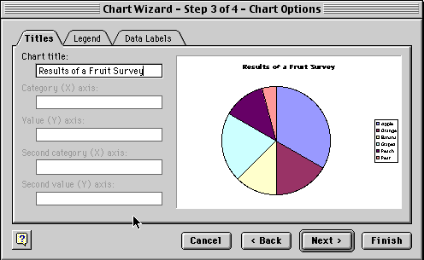

Select **Next** to move to the final dialog box which allows you to see the chart as a new sheet or place it on one of the sheets in your workbook.

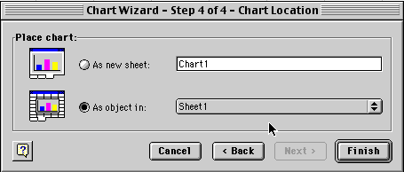

If you let the Chart Wizard finish your chart after the first dialog box, or work through each of the four steps, your chart will look something like the one below.

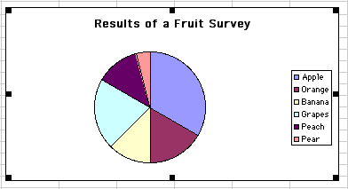

Website: <http://www.internet4classrooms.com/excel_create_chart.htm>

**Marketing 101**

# Topics to be covered include:

1. Introduction to marketing
   1. Definition of marketing
   2. Why marketing matters
2. The 4 Ps
   1. Product
   2. Price
   3. Place (distribution, sales channels)
   4. Promotion
3. Developing your Product and Setting your price
   1. Market research
   2. Competitive arena
   3. SWOT analysis
4. Optimizing Distribution and Sales
   1. Offline sales venues
   2. Online sales
   3. Getting and keeping customers (CRM)
5. Promotion
   1. Developing a USP (Unique Selling Proposition)
   2. Advertising: Print, Broadcast, Online
   3. Social Media
   4. Contests, Events, and Promotions
   5. Public Relations
   6. Packaging
6. Creating a Marketing Plan
   1. Tying it all together: YOUR Marketing Plan







The Art of Persuasion

Techniques advertisers use:

1. Humor
2. Testimonials
3. Celebrity Endorsements
4. Product Comparison
5. Bandwagon
6. Rebel
7. Scientific/Statistical
8. Beautiful People
9. Music
10. Lots of adjectives
11. Catchy slogans
12. Brand/mascot/slogan

Slogan: a memorable motto or phrase often used by politicians or enterprises; a catch phrase.

Think of 5 famous slogans:

1. ____________________________
2. ____________________________
3. ____________________________
4. ____________________________
5. ____________________________

Television Advertisements



1. Describe one of you favorite television ads: ______________________________________________________________

______________________________________________________________________________________________________________________________________________________________________________________________________

I like this ad because:

____________________________________________________________________________________________________________________________________________________________________________________________________________________________________________________________________________________________________________________________________________________________________________________________________________

Does the ad make you more likely to buy the product or service advertised?

Why or why not?

________________________________________________________________________________________________________________________________________________________________________________________________________________________________________________________________________

How could you make this advertisement even better?

________________________________________________________________________________________________________________________________________________________________________________________________________________________________________________________________________



2. Describe another one of your favorite television or magazine ads: ______________________________________________________________

______________________________________________________________________________________________________________________________________________________________________________________________________

I like this ad because:

____________________________________________________________________________________________________________________________________________________________________________________________________________________________________________________________________________________________________________________________________________________________________________________________________________

Does the ad make you more likely to buy the product or service advertised?

Why or why not?

________________________________________________________________________________________________________________________________________________________________________________________________________________________________________________________________________

How could you make this advertisement even better?

________________________________________________________________________________________________________________________________________________________________________________________________________________________________________________________________________

 **Grade 7 – CAP 2011-2012 Science Research Alignment to NYS Standards**

Throughout the year, as students’ projects evolve through the research process, the following New York State Standards will be addressed.

|  |
| --- |
| **New York State Intermediate Level Science Core Curriculum** |
| **Standard 1: Analysis, Inquiry, and Design**  **Students will use mathematical analysis, scientific inquiry, and engineering design, as appropriate, to pose questions, seeks answers, and develop solutions.**  **Scientific Inquiry – Key Idea 1:** **The central purpose of scientific inquiry is to develop explanations of natural phenomena in a continuing, creative process.**  S1.1 Formulate questions independently with the aid of references appropriate for guiding the search for explanations of everyday observations.  S1.1a formulate questions about natural phenomena  S1.1b identify appropriate references to investigate a question  S1.1c refine and clarify questions so that they are subject to scientific investigation  **Engineering Design – Key Idea 1: Engineering design is an iterative process involving modeling and optimization (finding the best solution within given constraints); this process is used to develop technological solutions to problems within given constraints.**  T1.1 Identify needs and opportunities for technical solutions from an investigation of situations of general or social interest.  T1.1a identify a scientific or human need that is subject to a technological solution  which applies scientific principles  T1.2 Locate and utilize a range of printed, electronic, and human information resources to obtain ideas. (T1.2a)  T1.2a use all available information systems for a preliminary search that  addresses the need  T1.3 Consider constraints and generate several ideas for alternative solutions, using  group and individual ideation techniques (group discussion, brainstorming, forced connections, role play); defer judgment until a number of ideas have been generated; evaluate (critique) ideas; and explain why the chosen solution is optimal.  T1.3a generate ideas for alternative solutions  T1.3b evaluate alternatives based on the constraints of design  T1.4 Develop plans, including drawings with measurements and details of construction, and construct a model of the solution, exhibiting a degree of craftsmanship.  T1.4a design and construct a model of the product or process  T1.4b construct a model of the product or process  T1.5 In a group setting, test their solution against design specifications, present and evaluate results, describe how the solution might have been modified for different or better results, and discuss trade-offs that might have to be made.  T1.5a test a design  T1.5b evaluate a design |

|  |
| --- |
| **Standard 2: Information Systems**  **Students will access, generate, and transfer information, using appropriate technologies.**  **Key Idea 1: Information technology is used to retrieve, process, and communicate information as a tool to enhance learning.**  1.3 Systematically obtain accurate and relevant information pertaining to a particular topic from a range of sources, including local and national media, libraries, museums, governmental agencies, industries and individuals.  **Key Idea 2: Knowledge of the impacts and limitations of information systems is essential to its effectiveness and ethical use.**  2.1 Understand the need to question the accuracy of information displayed on a computer because the results produced by a computer may be affected by incorrect data entry.  **Key Idea 3: Information technology can have positive and negative impacts on society, depending upon how it is used.**  3.1 Use graphical, statistical, and presentation software to present projects to fellow classmates.  3.2 Describe applications of information technology in mathematics, science, and other technologies that address needs and solve problems in the community. |
| **Standard 6—Interconnectedness: Common Themes**  **Students will understand the relationships and common themes that connect mathematics, science, and technology and apply the themes to these and other areas of learning.**  **Key Idea 2: Models are simplified representations of objects, structures, or systems used in analysis, explanation, interpretation, or design.**  2.1 Select an appropriate model to begin the search for answers or solutions to a question or problem.  2.2 Use models to study processes that cannot be studied directly (e.g., when the real process is too slow, too fast, or too dangerous for direct observation).  2.3 Demonstrate the effectiveness of different models to represent the same thing and the same model to represent different things.  **Key Idea 6: In order to arrive at the best solution that meets criteria within constraints, it is often necessary to make trade-offs.**  6.1 Determine the criteria and constraints and make trade-offs to determine the best decision.  6.2 Use graphs of information for a decision-making problem to determine the optimum solution. |

|  |
| --- |
| **Standard 7—Interdisciplinary Problem Solving**  Students will apply the knowledge and thinking skills of mathematics, science, and technology to address real-life problems and make informed decisions.  **Key Idea 1: The knowledge and skills of mathematics, science, and technology are used together to make informed decisions and solve problems, especially those relating to issues of science/technology/society, consumer decision making, design, and inquiry into phenomena.**  1.1 Analyze science/technology/society problems and issues at the local level and plan and carry out a remedial course of action.  1.2 Make informed consumer decisions by seeking answers to appropriate questions about products, services, and systems; determining the cost/benefit and risk/benefit tradeoffs; and applying this knowledge to a potential purchase.  1.3 Design solutions to real-world problems of general social interest related to home, school, or community using scientific experimentation to inform the solution and applying mathematical concepts and reasoning to assist in developing a solution.  **Key Idea 2: Solving interdisciplinary problems involves a variety of skills and strategies, including effective work habits; gathering and processing information; generating and analyzing ideas; realizing ideas; making connections among the common themes of mathematics, science, and technology; and presenting results.**  2.1 Students participate in an extended, culminating mathematics, science, and technology project. The project would require students to:   * **Working Effectively:** Contributing to the work of a brainstorming group, laboratory partnership, cooperative learning group, or project team; planning procedures; identify and managing responsibilities of team members; and staying on task, whether working alone or as part of a group. * **Gathering and Processing Information:** Accessing information from printed media, electronic data bases, and community resources and using the information to develop a definition of the problem and to research possible solutions. * **Generating and Analyzing Ideas:** Developing ideas for proposed solutions, investigating ideas, collecting data, and showing relationships and patterns in the data. * **Common Themes:** Observing examples of common unifying themes, applying them to the problem, and using them to better understand the dimensions of the problem. * **Realizing Ideas:** Constructing components or models, arriving at a solution, and evaluating the result. * **Presenting Results:** Using a variety of media to present the solution and to communicate the results. |

|  |
| --- |
| **Standard 4—The Living Environment**  **Key Idea 7: Human decisions and activities have had a profound impact on the physical and living environment.**  **Introduction: The number of organisms an ecosystem can support depends on the resources available and physical factors: quantity of light, air, and water; range of temperatures; soil composition. To ensure the survival of our planet, people have a responsibility to consider the impact of their actions on the environment.**  7.1 Describe how living things, including humans, depend upon the living and nonliving environment for their survival.  Major Understandings:  7.1a A population consists of all individuals of a species that are found together at a given place and time. Populations living in one place form a community. The community and the physical factors with which it interacts compose an ecosystem.  7.1c In all environments, organisms interact with one another in many ways.  Relationships among organisms may be competitive, harmful, or beneficial. Some species have adapted to be dependent upon each other with the result that neither could survive without the other.  7.1e The environment may contain dangerous levels of substances (pollutants) that are harmful to organisms. Therefore, the good health of environments and individuals requires the monitoring of soil, air, and water, and taking steps to keep them safe.  7.2 Describe the effects of environmental changes on humans and other populations.  Major Understandings:  7.2a In ecosystems, balance is the result of interactions between community members and their environment.  7.2b The environment may be altered through the activities of organisms. Alterations are sometimes abrupt. Some species may replace others over time, resulting in long-term gradual changes (ecological succession).  7.2c Overpopulation by any species impacts the environment due to the increased use of resources. Human activities can bring about environmental degradation through resource acquisition, urban growth, land-use decisions, waste disposal, etc.  7.2d Since the Industrial Revolution, human activities have resulted in major pollution of air, water, and soil. Pollution has cumulative ecological effects such as acid rain, global warming, or ozone depletion. The survival of living things on our planet depends on the conservation and protection of Earth’s resources. |
| Note: Since students projects will vary based on the community/human problem being addressed through their research, not all science performance indicators can be cited in this document. The above science performance indicators from Standard 4 are included given their community and environmental relatedness. |

