**Grade 4**

**CAP**

**Grade 4- Placing Common Core Standards in the Math Curriculum**



**July 2011**

Charles Angeli – Cap Coordinator

Synde Cohen

Kelly Kelly

Denise Kerr

Barbara McGee-Wingerter

Christine Peer

Table of Contents



Abstract ......................................................................... 2

Rationale ......................................................................... 3

New York State Standards ....................................... 5

8 Common Core Practices ........................................... 10

Common Core State Standards.................................. 34

Grade 4 Pacing Calendar .............................................. 41

C:\Users\user1\AppData\Local\Microsoft\Windows\Temporary Internet Files\Content.IE5\233QVU8X\MC900290682[1].wmfC:\Users\user1\AppData\Local\Microsoft\Windows\Temporary Internet Files\Content.IE5\DZK6QVI2\MC900435987[1].wmf

Abstract

Grade 4

Fourth Grade Common Core - Math

July 2011

This CAP was developed to provide greater focus on mathematical experiences in the classroom. With an eye on integrating the Common Core Standards into our existing pacing calendar it will help prepare the students and teachers for this year and the following school year when the Common Core is implemented. The Common Core fosters a greater in-depth understanding of mathematical concepts and their connections to everyday life.

The Common Core Standards have been integrated into the math curriculum through the pacing calendar. These standards provide for a greater examination of the math concepts by the students.

Additionally, this CAP includes a teacher friendly guide to the eight Common Core practices and aligns the New York State Standards to the Common Core. This will help enhance the students’ learning and to better prepare them for the May assessments and for real world applications.

RATIONALE

Grade 4

Fourth Grade Common Core Math - CAP

July 2011

Now with the New York State Math Assessment being aligned to the Common Core it is essential for all elementary teachers to have a pacing calendar that not only addresses the New York State Standards but also integrates the Common Core into their teaching. The Common Core practices seek to develop math proficiency in students and establish a thorough understanding of math practices.

With classroom instructional time being so precious, our intent was to provide a concise curriculum calendar integrating the core curriculum with the New York State Standards. We knew our students would benefit greatly by incorporating the Common Core Standards with our math pacing calendar. Also, included in the CAP is an explanation of the Common Core Standards.

This CAP will help teachers and students acclimate to the new Common Core Curriculum.

|  |  |  |
| --- | --- | --- |
| **Grade 4** | | |
| **Performance Indicator Code** | **Performance Indicator** | **Sept.-April/ May-June Instructional Periods** |
| **Number Sense and Operations** | | |
| **Number Systems** | | |
| 4.N.1 | Skip count by 1,000’s | September-April |
| 4.N.2 | Read and write whole numbers to 10,000 | September-April |
| 4.N.3 | Compare and order numbers to 10,000 | September-April |
| 4.N.4 | Understand the place value structure of the base ten number system 10 ones = 1 ten 10 tens = 1 hundred 10 hundreds = 1 thousand 10 thousands = 1 ten thousand | September-April |
| 4.N.5 | Recognize equivalent representations for numbers up to four digits and generate them by decomposing and composing numbers | September-April |
| 4.N.6 | Understand, use, and explain the associative property of multiplication | September-April |
| 4.N.7* | Develop an understanding of fractions as locations on number lines and as divisions of whole numbers | September-April |
| 4.N.8* | Recognize and generate equivalent fractions (halves, fourths, thirds, fifths, sixths, and tenths) using manipulatives, visual models, and illustrations | September-April |
| 4.N.9* | Use concrete materials and visual models to compare and order unit fractions or fractions with the same denominator (with and without the use of a number line) | September-April |
| 4.N.10* | Develop an understanding of decimals as part of a whole | September-April |
| 4.N.11* | Read and write decimals to hundredths using money as a context | September-April |
| 4.N.12* | Use concrete materials and visual models to compare and order decimals (less than 1) to the hundredths place in the context of money | September-April |
| **Number Sense and Operations Number Theory** | | |
| 4.N.13 | Develop an understanding of the properties of odd/even numbers as a result of multiplication | September-April |
| **Number Sense and Operations Operations** | | |
| 4.N.14 | Use a variety of strategies to add and subtract numbers up to 10,000 | September-April |

|  |  |  |
| --- | --- | --- |
| 4.N.15 | Select appropriate computational and operational methods to solve problems | September-April |
| 4.N.16 | Understand various meanings of multiplication and division | September-April |
| 4.N.17 | Use multiplication and division as inverse operations to solve problems | September-April |
| 4.N.18 | Use a variety of strategies to multiply two-digit numbers by one-digit numbers (with and without regrouping) | September-April |
| 4.N.19* | Use a variety of strategies to multiply two-digit numbers by two-digit numbers (with and without regrouping) | September-April |
| 4.N.20 | Develop fluency in multiplying and dividing multiples of 10 and 100 up to 1,000 | September-April |
| 4.N.21 | Use a variety of strategies to divide two-digit dividends by one-digit divisors (with and without remainders) | September-April |
| 4.N.22 | Interpret the meaning of remainders | September-April |
| 4.N.23* | Add and subtract proper fractions with common denominators | September-April |
| 4.N.24* | Express decimals as an equivalent form of fractions to tenths and hundredths | September-April |
| 4.N.25* | Add and subtract decimals to tenths and hundredths using a hundreds chart | September-April |
| **Number Sense and Operations Estimation** | | |
| 4.N.26 | Round numbers less than 1,000 to the nearest tens and hundreds | September-April |
| 4.N.27 | Check reasonableness of an answer by using estimation | September-April |
| **Algebra Variables and Expressions** | | |
| 4.A.1 | Evaluate and express relationships using open sentences with one operation | September-April |
| **Algebra Equations and Inequalities** | | |
| 4.A.2* | Use the symbols <, >, =, and ≠ (with and without the use of a number line) to compare whole numbers and unit fractions and decimals (up to hundredths) | September-April |
| 4.A.3 | Find the value or values that will make an open sentence true, if it contains < or > | September-April |
| **Algebra Patterns, Relations and Functions** | | |
| 4.A.4 | Describe, extend, and make generalizations about numeric (+,-,×,÷) and geometric patterns | September-April |
| 4.A.5 | Analyze a pattern or a whole-number function and state the rule, given a table or an input/output box | September-April |

|  |  |  |
| --- | --- | --- |
| **Geometry**  **Shapes** | | |
| 4.G.1 | Identify and name polygons, recognizing that their names are related to the number of sides and angles (triangle, quadrilateral, pentagon, hexagon, and octagon) | September-April |
| 4.G.2 | Identify points and line segments when drawing a plane figure | September-April |
| 4.G.3 | Find perimeter of polygons by adding sides | September-April |
| 4.G.4 | Find the area of a rectangle by counting the number of squares needed to cover the rectangle | September-April |
| 4.G.5 | Define and identify vertices, faces, and edges of three-dimensional shapes | September-April |
| **Geometry Geometric Relationships** | | |
| 4.G.6 | Draw and identify intersecting, perpendicular, and parallel lines | May-June |
| 4.G.7 | Identify points and rays when drawing angles | May-June |
| 4.G.8  **Measurement**  **Units of Measurement**  4.M.1 | Classify angles as acute, obtuse, right, and straight  Select tools and units (customary and metric) appropriate for the length being measured | May-June  September-April |
| 4.M.2 | Use a ruler to measure to the nearest standard unit (whole, ½ and ¼ inches, whole feet, whole yards, whole centimeters, and whole meters) | September-April |
| 4.M.3 | Know and understand equivalent standard units of length: 12 inches = 1 foot, 3 feet = 1 yard | September-April |
| 4.M.4 | Select tools and units appropriate to the mass of the object being measured (grams and kilograms) | September-April |
| 4.M.5 | Measure mass, using grams | September-April |
| 4.M.6 | Select tools and units appropriate to the capacity being measured (milliliters and liters) | September-April |
| 4.M.7 | Measure capacity, using milliliters and liters | September-April |
| **Measurement Units** | | |
| 4.M.8 | Make change, using combined coins and dollar amounts | September-April |
| 4.M.9 | Calculate elapsed time in hours and half hours, not crossing A.M./P.M. | September-April |
| 4.M.10 | Calculate elapsed time in days and weeks, using a calendar | September-April |

|  |
| --- |
| **Statistics and Probability**  **Collections of Data** |

|  |  |  |
| --- | --- | --- |
| 4.S.1 | Design investigations to address a question from given data | May-June |
| 4.S.2 | Collect data using observations, surveys, and experiments and record appropriately | May-June |
| **Statistics and Probability Organization and Display of Data** | | |
| 4.S.3 | Represent data using tables, bar graphs, and pictographs | September-April |
| **Statistics and Probability Analysis of Data** | | |
| 4.S.4* | Read and interpret line graphs | September-April |

|  |  |
| --- | --- |
| **Key to Performance Indicator Code:** | 4.N.22 4 = 4th Grade N = Number Sense & Operations 22 = Performance Indicator Number |

**Mathematics: Standards for Mathematical Practice**

The Standards for Mathematical Practice describe varieties of expertise that mathematics educators at all levels should seek to develop in their students. These practices rest on important “processes and proficiencies” with longstanding importance in mathematics education. The first of these are the NCTM process standards of problem solving, reasoning and proof, communication, representation, and connections. The second are the strands of mathematical proficiency specified in the National Research Council’s report *Adding It Up*: adaptive reasoning, strategic competence, conceptual understanding (comprehension of mathematical concepts, operations and relations), procedural fluency (skill in carrying out procedures flexibly, accurately, efficiently and appropriately), and productive disposition (habitual inclination to see mathematics as sensible, useful, and worthwhile, coupled with a belief in diligence and one’s own efficacy).

**1. Make sense of problems and persevere in solving them.**

Mathematically proficient students start by explaining to themselves the meaning of a problem and looking for entry points to its solution. They analyze givens, constraints, relationships, and goals. They make conjectures about the form and meaning of the solution and plan a solution pathway rather than simply jumping into a solution attempt. They consider analogous problems, and try special cases and simpler forms of the original problem in order to gain insight into its solution. They monitor and evaluate their progress and change course if necessary. Older students might, depending on the context of the problem, transform algebraic expressions or change the viewing window on their graphing calculator to get the information they need. Mathematically proficient students can explain correspondences between equations, verbal descriptions, tables, and graphs or draw diagrams of important features and relationships, graph data, and search for regularity or trends. Younger students might rely on using concrete objects or pictures to help conceptualize and solve a problem. Mathematically proficient students check their answers to problems using a different method, and they continually ask themselves, “Does this make sense?” They can understand the approaches of others to solving complex problems and identify correspondences between different approaches.

**2. Reason abstractly and quantitatively.**

Mathematically proficient students make sense of quantities and their relationships in problem situations. They bring two complementary abilities to bear on problems involving quantitative relationships: the ability to *decontextualize*—to abstract a given situation and represent it symbolically and manipulate the representing symbols as if they have a life of their own, without necessarily attending to their referents—and the ability to *contextualize*, to pause as needed during the manipulation process in order to probe into the referents for the symbols involved. Quantitative reasoning entails habits of creating a coherent representation of the problem at hand; considering the units involved; attending to the meaning of quantities, not just how to compute them; and knowing and flexibly using different properties of operations and objects.

**3. Construct viable arguments and critique the reasoning of others.**

Mathematically proficient students understand and use stated assumptions, definitions, and previously established results in constructing arguments. They make conjectures and build a logical progression of statements to explore the truth of their conjectures. They are able to analyze situations by breaking them into cases, and can recognize and use counterexamples. They justify their conclusions, communicate them to others, and respond to the arguments of

others. They reason inductively about data, making plausible arguments that take into account the context from which the data arose. Mathematically proficient students are also able to compare the effectiveness of two plausible arguments, distinguish correct logic or reasoning from that which is flawed, and—if there is a flaw in an argument—explain what it is. Elementary students can construct arguments using concrete referents such as objects, drawings, diagrams, and actions. Such arguments can make sense and be correct, even though they are not generalized or made formal until later grades. Later, students learn to determine domains to which an argument applies. Students at all grades can listen or read the arguments of others, decide whether they make sense, and ask useful questions to clarify or improve the arguments.

**4. Model with mathematics.**

Mathematically proficient students can apply the mathematics they know to solve problems arising in everyday life, society, and the workplace. In early grades, this might be as simple as writing an addition equation to describe a situation. In middle grades, a student might apply proportional reasoning to plan a school event or analyze a problem in the community. By high school, a student might use geometry to solve a design problem or use a function to describe how one quantity of interest depends on another. Mathematically proficient students who can apply what they know are comfortable making assumptions and approximations to simplify a complicated situation, realizing that these may need revision later. They are able to identify important quantities in a practical situation and map their relationships using such tools as diagrams, two-way tables, graphs, flowcharts and formulas. They can analyze those relationships mathematically to draw conclusions. They routinely interpret their mathematical results in the context of the situation and reflect on whether the results make sense, possibly improving the model if it has not served its purpose.

**5. Use appropriate tools strategically.**

Mathematically proficient students consider the available tools when solving a mathematical problem. These tools might include pencil and paper, concrete models, a ruler, a protractor, a calculator, a spreadsheet, a computer algebra system, a statistical package, or dynamic geometry software. Proficient students are sufficiently familiar with tools appropriate for their grade or course to make sound decisions about when each of these tools might be helpful, recognizing both the insight to be gained and their limitations. For example, mathematically proficient high school students analyze graphs of functions and solutions generated using a graphing calculator. They detect possible errors by strategically using estimation and other mathematical knowledge. When making mathematical models, they know that technology can enable them to visualize the results of varying assumptions, explore consequences, and compare predictions with data. Mathematically proficient students at various grade levels are able to identify relevant external mathematical resources, such as digital content located on a website, and use them to pose or solve problems. They are able to use technological tools to explore and deepen their understanding of concepts.

**6. Attend to precision.**

Mathematically proficient students try to communicate precisely to others. They try to use clear definitions in discussion with others and in their own reasoning. They state the meaning of the symbols they choose, including using the equal sign consistently and appropriately. They are careful about specifying units of measure, and labeling axes to clarify the correspondence with quantities in a problem. They calculate accurately and efficiently, express numerical answers with a degree of precision appropriate for the problem context. In the elementary grades, students give carefully formulated explanations to each other. By the time they reach high school they have learned to examine claims and make explicit use of definitions.

**7. Look for and make use of structure.**

Mathematically proficient students look closely to discern a pattern or structure. Young students, for example, might notice that three and seven more is the same amount as seven and three more, or they may sort a collection of shapes according to how many sides the shapes have. Later, students will see 7 × 8 equals the well remembered 7 × 5 + 7 × 3, in preparation for learning about the distributive property. In the expression *x*2 + 9*x* + 14, older students can see the 14 as 2 × 7 and the 9 as 2 + 7. They recognize the significance of an existing line in a geometric figure and can use the strategy of drawing an auxiliary line for solving problems. They also can step back for an overview and shift perspective. They can see complicated things, such as some algebraic expressions, as single objects or as being composed of several objects. For example, they can see 5 – 3(*x* – *y*)2 as 5 minus a positive number times a square and use that to realize that its value cannot be more than 5 for any real numbers *x* and *y*.

**8. Look for and express regularity in repeated reasoning.**

Mathematically proficient students notice if calculations are repeated, and look both for general methods and for shortcuts. Upper elementary students might notice when dividing 25 by 11 that they are repeating the same calculations over and over again, and conclude they have a repeating decimal. By paying attention to the calculation of slope as they repeatedly check whether points are on the line through (1, 2) with slope 3, middle school students might abstract the equation (*y* – 2)/(*x* – 1) = 3. Noticing the regularity in the way terms cancel when expanding (*x* – 1)(*x* + 1), (*x* – 1)(*x*2 + *x* + 1), and (*x* – 1)(*x*3 + *x*2 + *x* + 1) might lead them to the general formula for the sum of a geometric series. As they work to solve a problem, mathematically proficient students maintain oversight of the process, while attending to the details. They continually evaluate the reasonableness of their intermediate results.

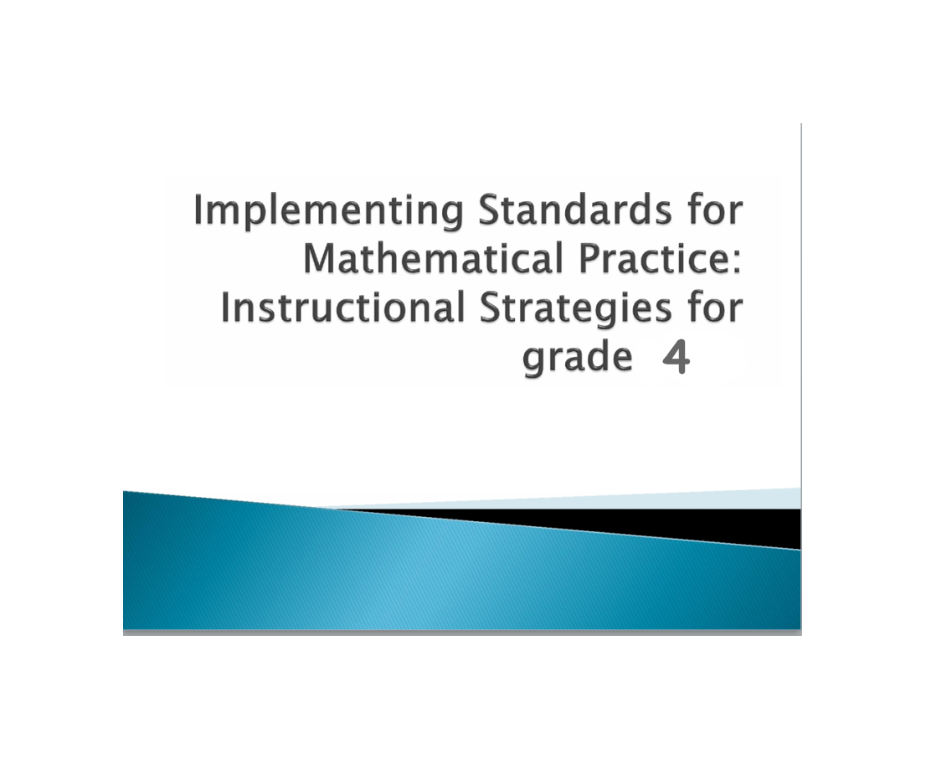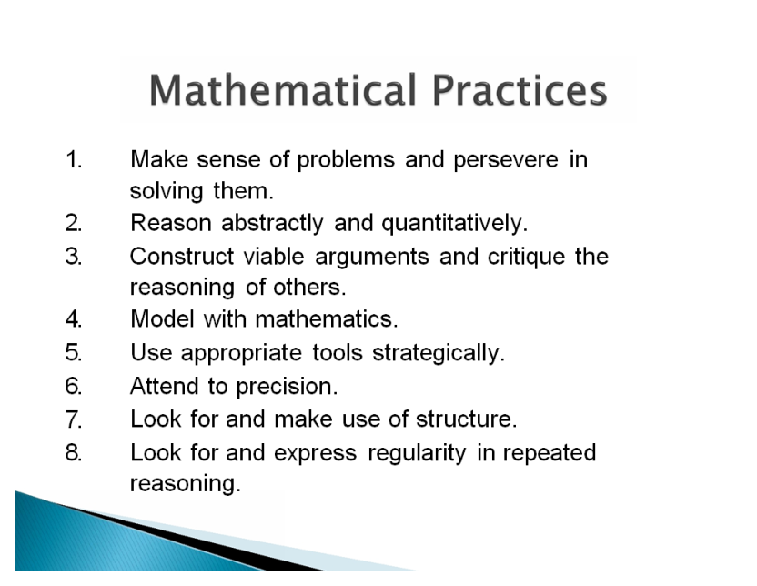

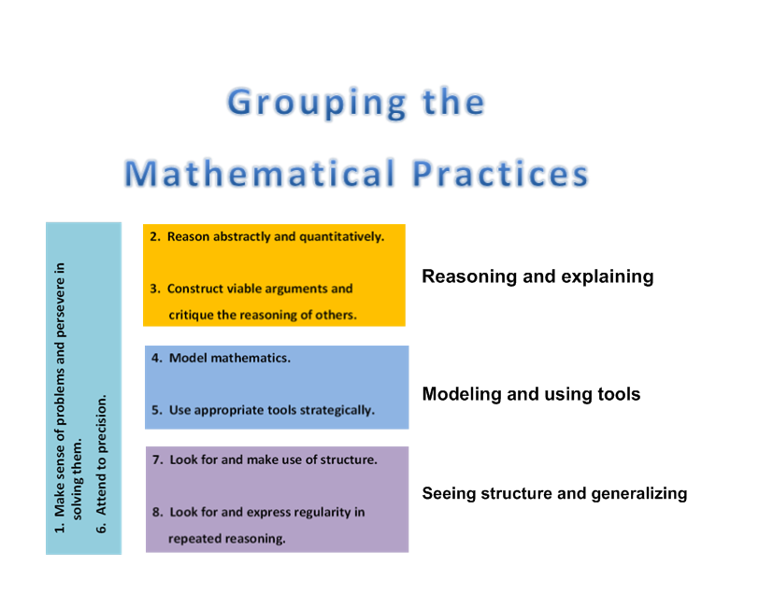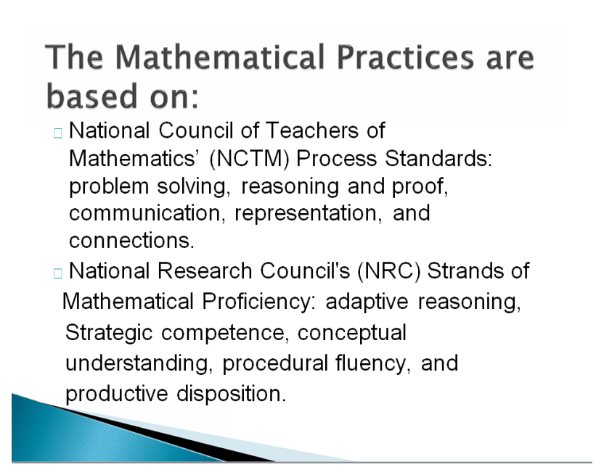

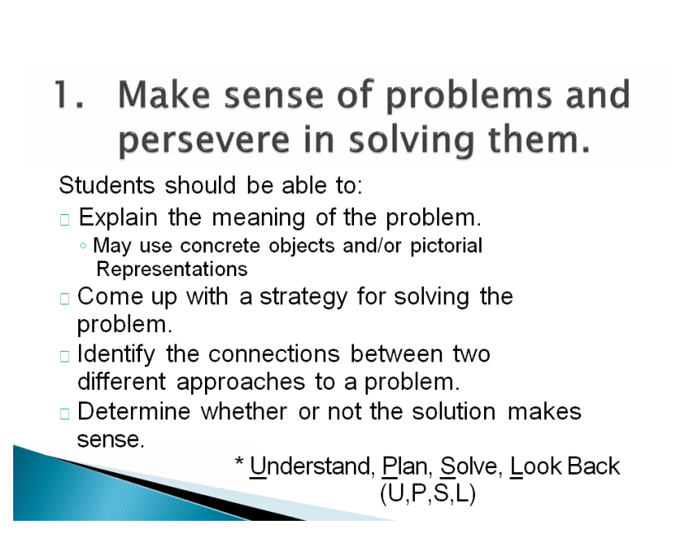

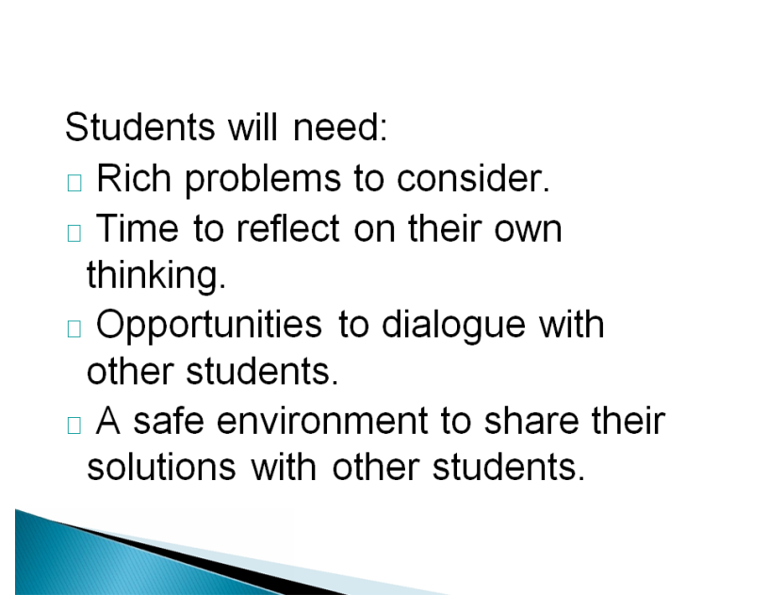

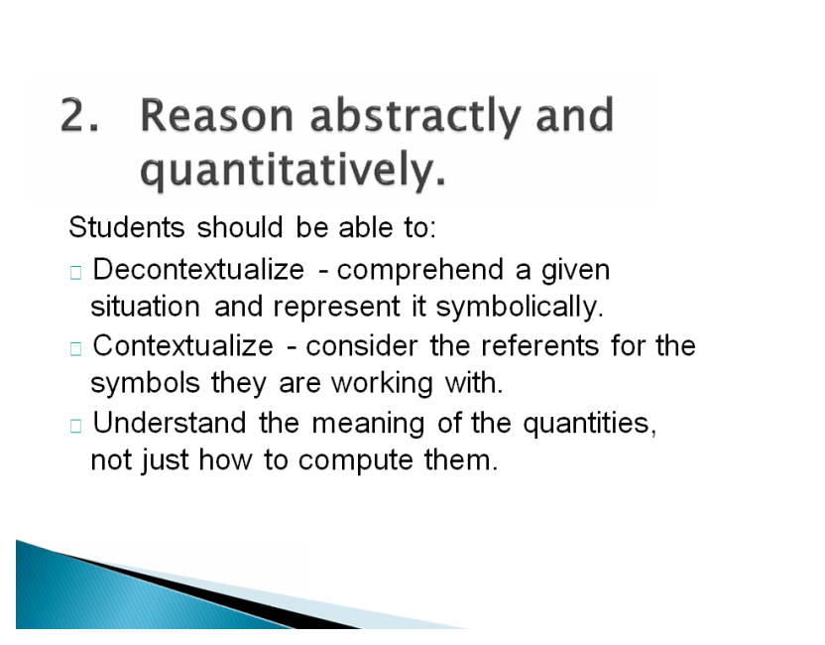

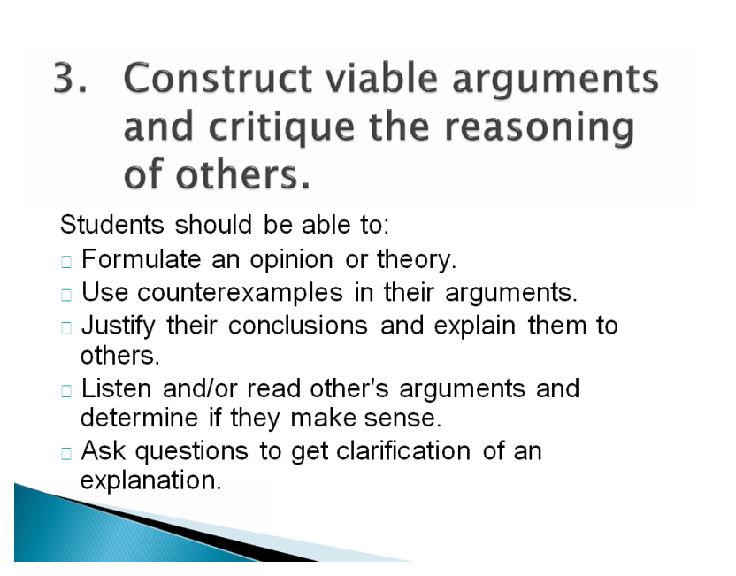

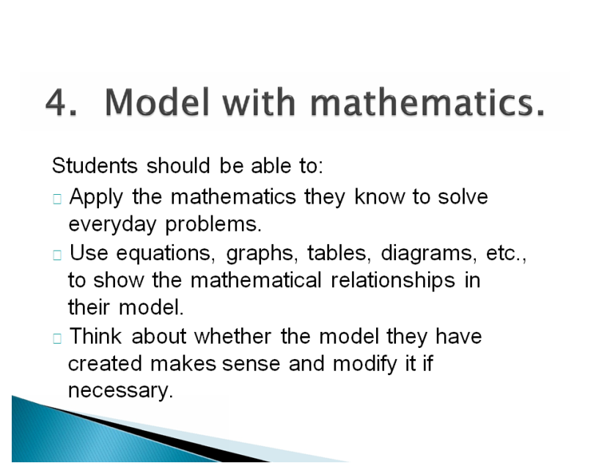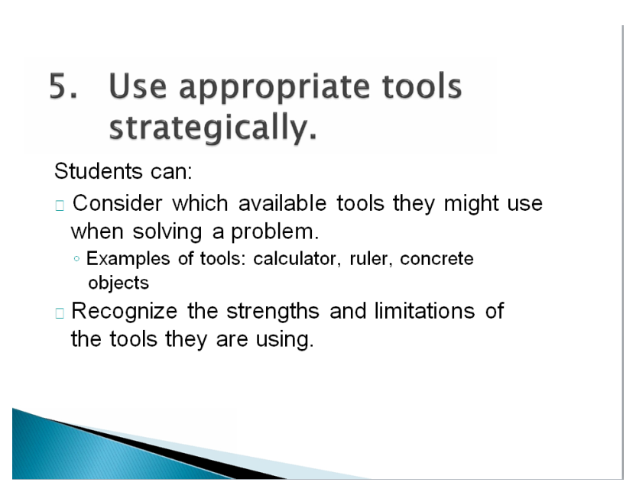

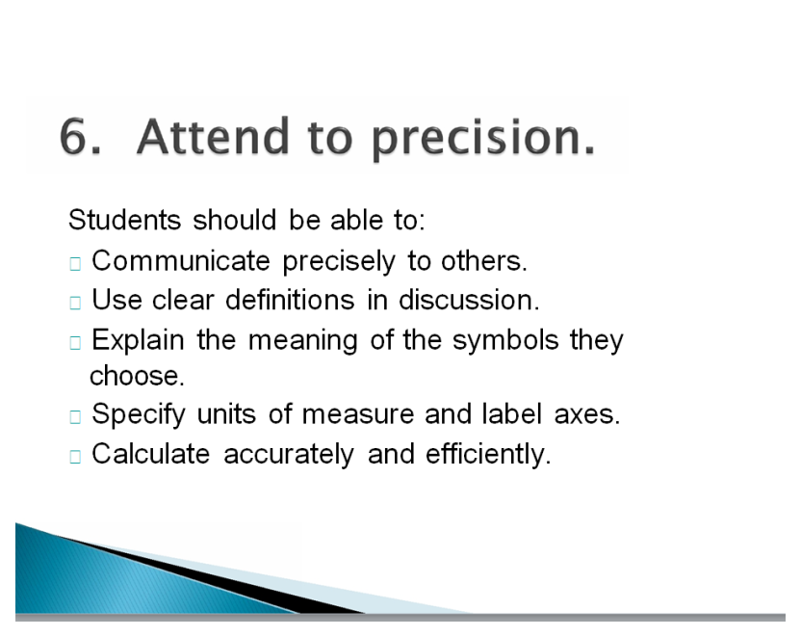

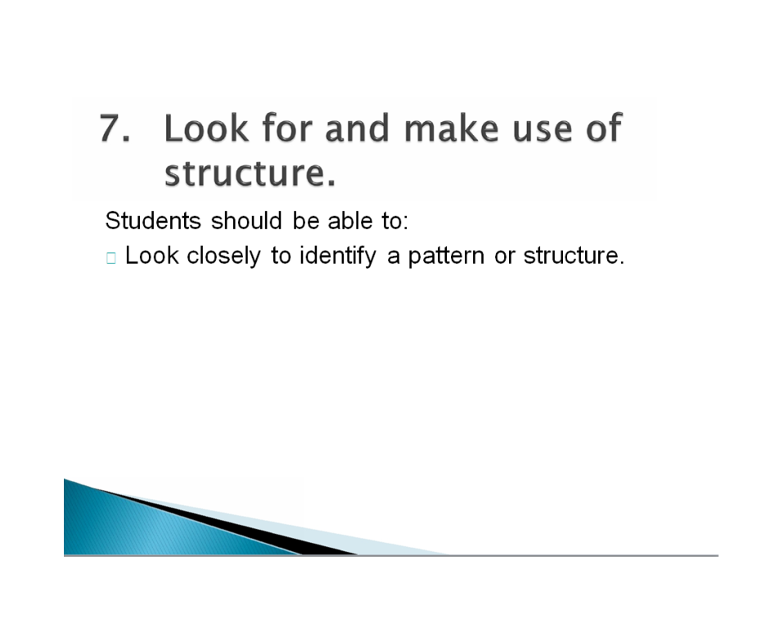

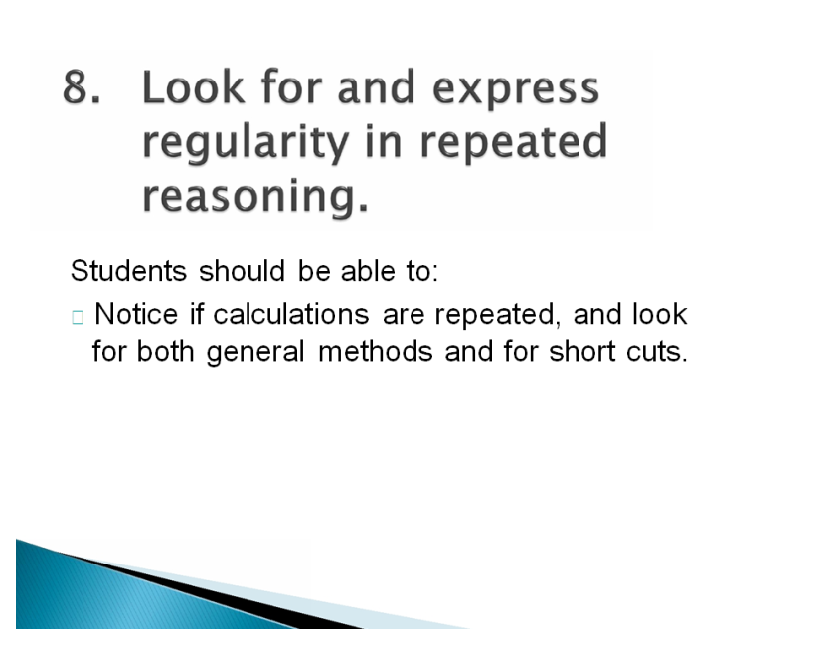

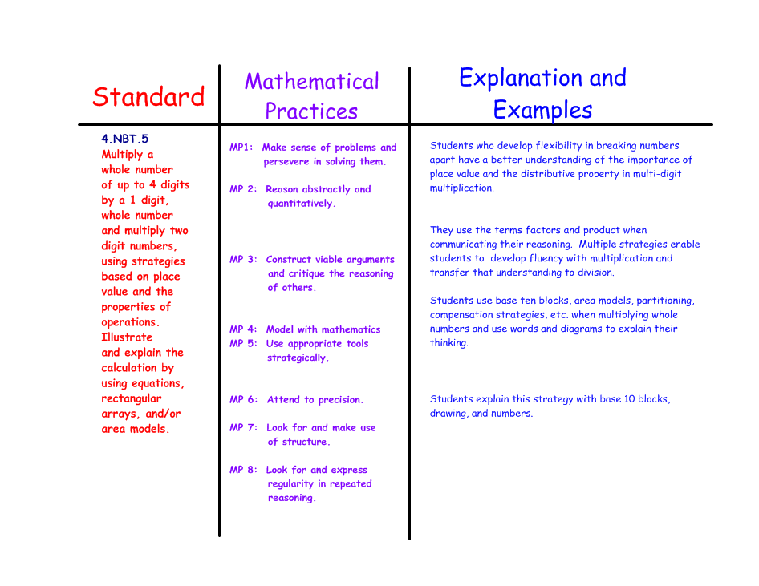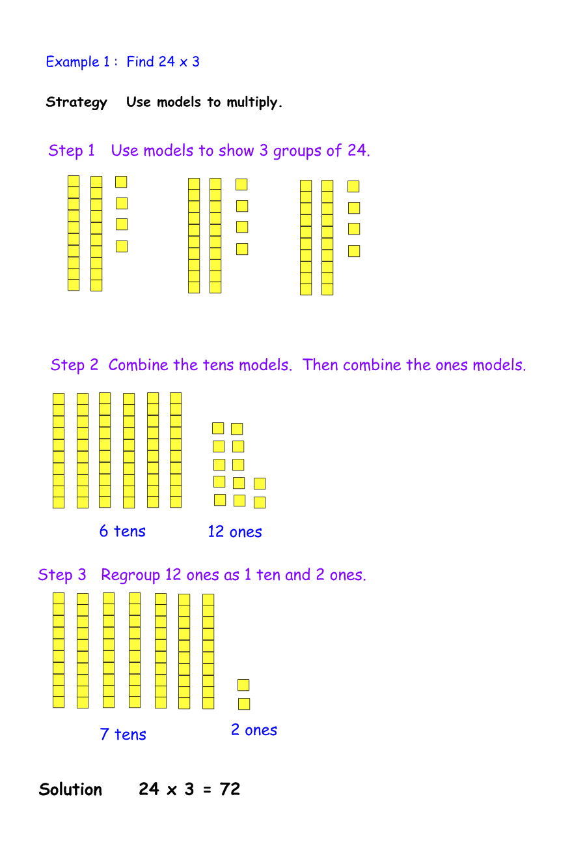

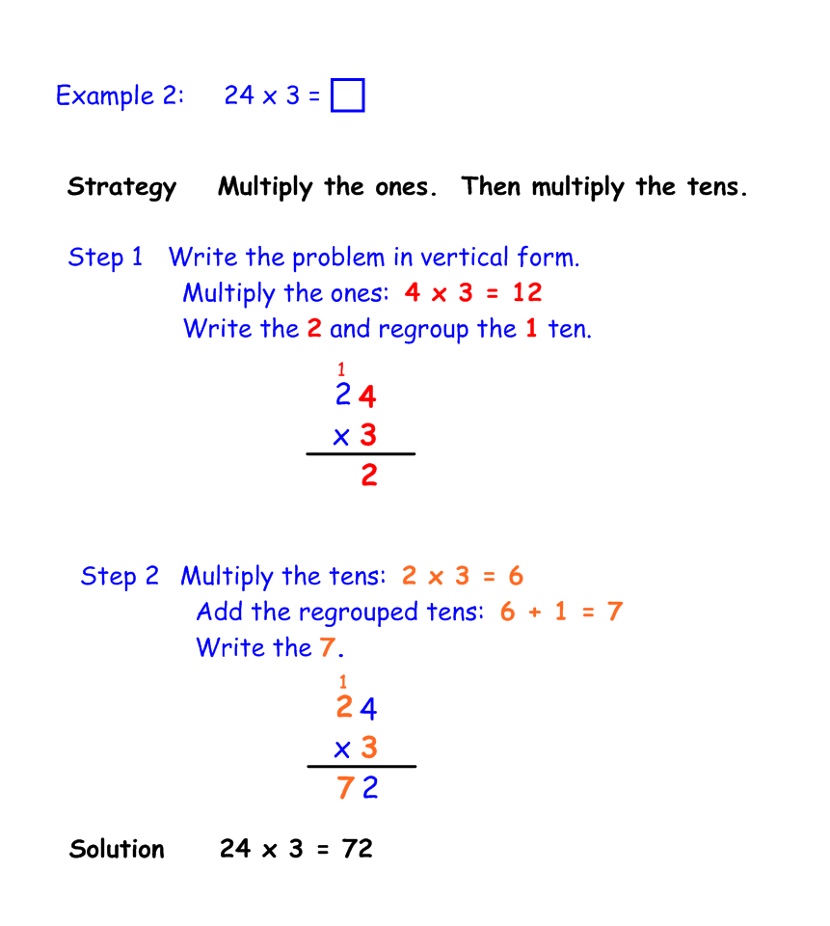

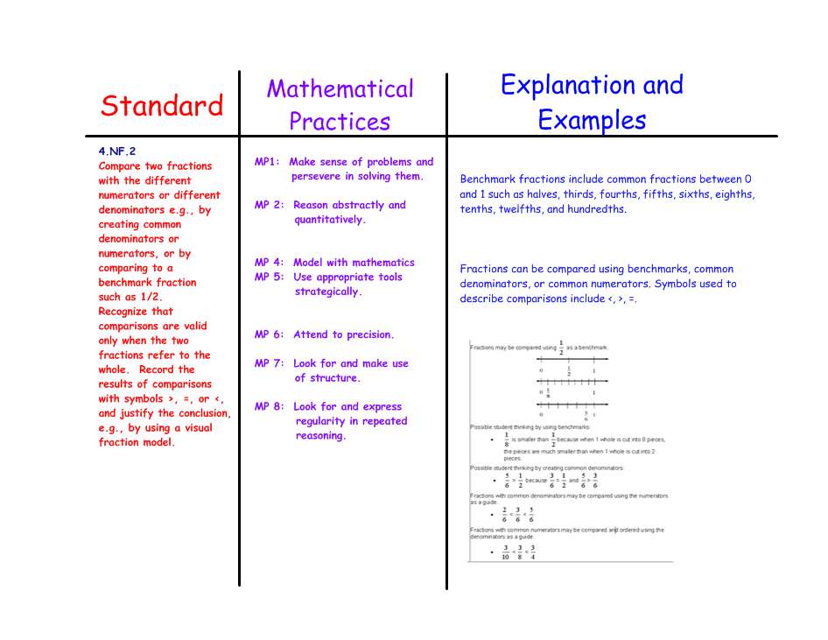

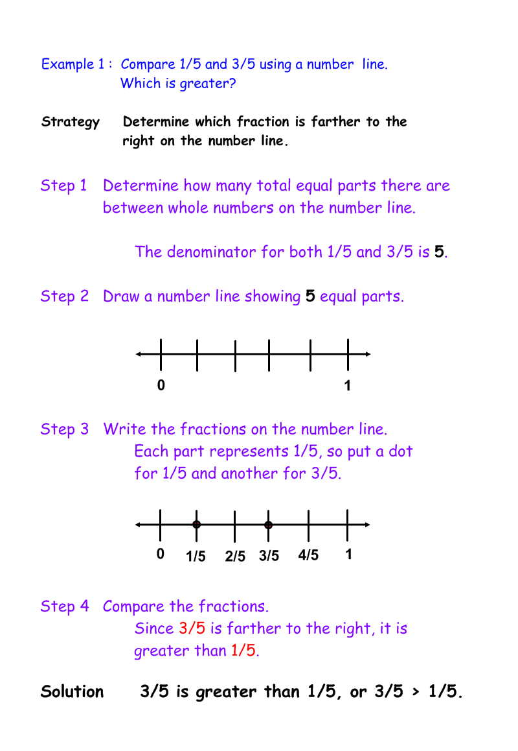

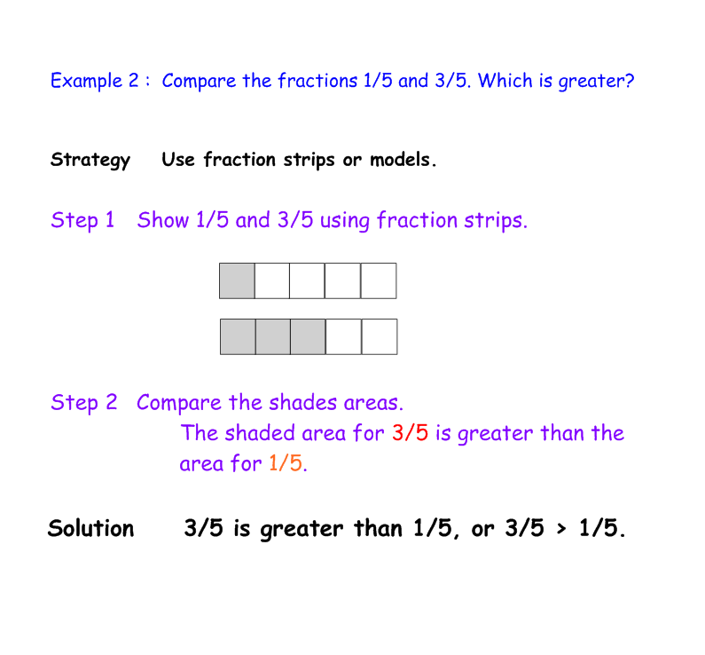

**Mathematics - Grade 4: Introduction**

In Grade 4, instructional time should focus on three critical areas: (1) developing understanding and fluency with multi-digit multiplication, and developing understanding of dividing to find quotients involving multi-digit dividends; (2) developing an understanding of fraction equivalence, addition and subtraction of fractions with like denominators, and multiplication of fractions by whole numbers; (3) understanding that geometric figures can be

analyzed and classified based on their properties, such as having parallel sides, perpendicular sides, particular angle measures, and symmetry.

1. Students generalize their understanding of place value to 1,000,000, understanding the relative sizes of numbers in each place. They apply their understanding of models for multiplication (equal-sized groups, arrays, area models), place value, and properties of operations, in particular the distributive property, as they develop, discuss, and use efficient, accurate, and generalizable methods to compute products of multi-digit whole numbers. Depending on the numbers and the context, they select and accurately apply appropriate methods to estimate or mentally calculate products. They develop fluency with efficient procedures for multiplying whole numbers; understand and explain why the procedures work based on place value and properties of operations; and use them to solve problems. Students apply their understanding of models for division, place value, properties of operations, and the relationship of division to multiplication as they develop, discuss, and use efficient, accurate, and generalizable procedures to find quotients involving multi-digit dividends. They select and accurately apply appropriate methods to estimate and mentally calculate quotients, and interpret remainders based upon the context.

2. Students develop understanding of fraction equivalence and operations with fractions. They recognize that two different fractions can be equal (e.g., 15/9 = 5/3), and they develop methods for generating and recognizing equivalent fractions. Students extend previous understandings about how fractions are built from unit fractions, composing fractions from unit fractions, decomposing fractions into unit fractions, and using the meaning of fractions and the meaning of multiplication to multiply a fraction by a whole number.

3. Students describe, analyze, compare, and classify two-dimensional shapes. Through building, drawing, and analyzing two-dimensional shapes, students deepen their understanding of properties of two-dimensional objects and the use of them to solve problems involving symmetry.

**Mathematical Practices**

1. Make sense of problems and persevere in solving them.

2. Reason abstractly and quantitatively.

3. Construct viable arguments and critique the reasoning of others.

4. Model with mathematics.

5. Use appropriate tools strategically.

6. Attend to precision.

7. Look for and make use of structure.

8. Look for and express regularity in repeated reasoning.

**Grade 4 Overview**

**Operations and Algebraic Thinking**

• Use the four operations with whole numbers to solve problems.

• Gain familiarity with factors and multiples.

• Generate and analyze patterns.

**Number and Operations in Base Ten**

• Generalize place value understanding for multidigit whole numbers.

• Use place value understanding and properties of operations to perform multi-digit arithmetic.

**Number and Operations—Fractions**

• Extend understanding of fraction equivalence and ordering.

• Build fractions from unit fractions by applying and extending previous understandings of operations on whole numbers.

• Understand decimal notation for fractions, and compare decimal fractions.

**Measurement and Data**

• Solve problems involving measurement and conversion of measurements from a larger unit to a smaller unit.

• Represent and interpret data.

• Geometric measurement: understand concepts of angle and measure angles.

**Geometry**

• Draw and identify lines and angles, and classify shapes by properties of their lines and angles.

**Operations & Algebraic Thinking 4.OA**

**Use the four operations with whole numbers to solve problems.**

1. Interpret a multiplication equation as a comparison, e.g., interpret 35 = 5 × 7 as a statement that 35 is 5 times as many as 7 and 7 times as many as 5. Represent verbal statements of multiplicative comparisons as ultiplication equations.

2. Multiply or divide to solve word problems involving multiplicative comparison, e.g., by using drawings and equations with a symbol for the unknown number to represent the problem, distinguishing multiplicative comparison from additive comparison.

3. Solve multistep word problems posed with whole numbers and having whole-number answers using the four operations, including problems in which remainders must be interpreted. Represent these problems using equations with a letter standing for the unknown quantity. Assess the reasonableness of answers using mental computation and estimation strategies including rounding.

**Gain familiarity with factors and multiples.**

4. Find all factor pairs for a whole number in the range 1–100. Recognize that a whole number is a multiple of each of its factors. Determine whether a given whole number in the range 1–100 is a multiple of a given one-digit number. Determine whether a given whole number in the range 1–100 is prime or composite.

**Generate and analyze patterns.**

5. Generate a number or shape pattern that follows a given rule. Identify apparent features of the pattern that were not explicit in the rule itself. *For example, given the rule “Add 3” and the starting number 1, generate terms in the resulting sequence and observe that the terms appear to alternate between odd and even numbers. Explain informally why the numbers will continue to alternate in this way.*

**Number & Operations in Base Ten 4.NBT**

**Generalize place value understanding for multi-digit whole numbers.**

1. Recognize that in a multi-digit whole number, a digit in one place represents ten times what it represents in the place to its right. *For example, recognize that 700 ÷ 70 = 10 by applying concepts of place value and division.*

2. Read and write multi-digit whole numbers using base-ten numerals, number names, and expanded form. Compare two multi-digit numbers based on meanings of the digits in each place, using >, =, and < symbols to record the results of comparisons.

3. Use place value understanding to round multi-digit whole numbers to any place.

**Use place value understanding and properties of operations to perform multi-digit arithmetic.**

4. Fluently add and subtract multi-digit whole numbers using the standard algorithm.

5. Multiply a whole number of up to four digits by a one-digit whole number, and multiply two two-digit numbers, using strategies based on place value and the properties of operations. Illustrate and explain the calculation by using equations, rectangular arrays, and/or area models.

6. Find whole-number quotients and remainders with up to four-digit dividends and one-digit divisors, using strategies based on place value, the properties of operations, and/or the relationship between multiplication and division. Illustrate and explain the calculation by using equations, rectangular arrays, and/or area models.

**Number & Operations—Fractions 4.NF**

**Extend understanding of fraction equivalence and ordering.**

1. Explain why a fraction *a*/*b* is equivalent to a fraction (*n* × *a*)/(*n* × *b*) by using visual fraction models, with attention to how the number and size of the parts differ even though the two fractions themselves are the same size. Use this principle to recognize and generate equivalent fractions.

2. Compare two fractions with different numerators and different denominators, e.g., by creating common denominators or numerators, or by comparing to a benchmark fraction such as 1/2. Recognize that comparisons are valid only when the two fractions refer to the same whole. Record the results of comparisons with symbols >, =, or <, and justify the conclusions, e.g., by using a visual fraction model.

**Build fractions from unit fractions by applying and extending previous understandings of operations on**

**whole numbers.**

3. Understand a fraction *a*/*b* with *a* > 1 as a sum of fractions 1/*b*.

a. Understand addition and subtraction of fractions as joining and separating parts referring to the same whole.

b. Decompose a fraction into a sum of fractions with the same denominator in more than one way, recording each decomposition by an equation. Justify decompositions, e.g., by using a visual fraction model.

*Examples: 3/8 = 1/8 + 1/8 + 1/8 ; 3/8 = 1/8 + 2/8 ; 2 1/8 = 1 + 1 + 1/8 = 8/8 + 8/8 + 1/8.*

c. Add and subtract mixed numbers with like denominators, e.g., by replacing each mixed number with an equivalent fraction, and/or by using properties of operations and the relationship between addition and subtraction.

d. Solve word problems involving addition and subtraction of fractions referring to the same whole and having like denominators, e.g., by using visual fraction models and equations to represent the problem.

4. Apply and extend previous understandings of multiplication to multiply a fraction by a whole number.

a. Understand a fraction *a*/*b* as a multiple of 1/*b*. *For example, use a visual fraction model to represent 5/4 asthe product 5 × (1/4), recording the conclusion by the equation 5/4 = 5 × (1/4).*

b. Understand a multiple of a/b as a multiple of 1/b, and use this understanding to multiply a fraction by a whole number. *For example, use a visual fraction model to express 3 × (2/5) as 6 × (1/5), recognizing this product as 6/5. (In general, n × (a/b) = (n × a)/b.)*

c. Solve word problems involving multiplication of a fraction by a whole number, e.g., by using visual fraction models and equations to represent the problem. *For example, if each person at a party will eat 3/8 of a pound of roast beef, and there will be 5 people at the party, how many pounds of roast beef will be needed? Between what two whole numbers does your answer lie?*

**Understand decimal notation for fractions, and compare decimal fractions.**

5. Express a fraction with denominator 10 as an equivalent fraction with denominator 100, and use this technique to add two fractions with respective denominators 10 and 100.2 *For example, express 3/10 as 30/100, and add 3/10 + 4/100 = 34/100.*

6. Use decimal notation for fractions with denominators 10 or 100. *For example, rewrite 0.62 as 62/100; describe a length as 0.62 meters; locate 0.62 on a number line diagram.*

7. Compare two decimals to hundredths by reasoning about their size. Recognize that comparisons are valid only

when the two decimals refer to the same whole. Record the results of comparisons with the symbols >, =, or <, and justify the conclusions, e.g., by using a visual model.

**Measurement & Data 4.MD**

**Solve problems involving measurement and conversion of measurements from a larger unit to a smaller unit.**

1. Know relative sizes of measurement units within one system of units including km, m, cm; kg, g; lb, oz.; l, ml; hr, min, sec. Within a single system of measurement, express measurements in a larger unit in terms of a smaller unit. Record measurement equivalents in a two-column table. *For example, know that 1 ft is 12 times as long as 1 in. Express the length of a 4 ft snake as 48 in. Generate a conversion table for feet and inches listing the number pairs(1, 12), (2, 24), (3, 36), ...*

2. Use the four operations to solve word problems involving distances, intervals of time, liquid volumes, masses of objects, and money, including problems involving simple fractions or decimals, and problems that require expressing measurements given in a larger unit in terms of a smaller unit. Represent measurement quantities using diagrams such as number line diagrams that feature a measurement scale.

3. Apply the area and perimeter formulas for rectangles in real world and mathematical problems. *For example, find the width of a rectangular room given the area of the flooring and the length, by viewing the area formula as a multiplication equation with an unknown factor.*

**Represent and interpret data.**

4. Make a line plot to display a data set of measurements in fractions of a unit (1/2, 1/4, 1/8). Solve problems involving addition and subtraction of fractions by using information presented in line plots. *For example, from a line plot find and interpret the difference in length between the longest and shortest specimens in an insect collection.*

**Geometric measurement: understand concepts of angle and measure angles.**

5. Recognize angles as geometric shapes that are formed wherever two rays share a common endpoint, and understand concepts of angle measurement:

a. An angle is measured with reference to a circle with its center at the common endpoint of the rays, by considering the fraction of the circular arc between the points where the two rays intersect the circle. An angle that turns through 1/360 of a circle is called a “one-degree angle,” and can be used to measure angles.

b. An angle that turns through *n* one-degree angles is said to have an angle measure of *n* degrees.

6. Measure angles in whole-number degrees using a protractor. Sketch angles of specified measure.

7. Recognize angle measure as additive. When an angle is decomposed into non-overlapping parts, the angle measure of the whole is the sum of the angle measures of the parts. Solve addition and subtraction problems to find unknown angles on a diagram in real world and mathematical problems, e.g., by using an equation with a symbol for the unknown angle measure.

**Geometry 4.G**

**Draw and identify lines and angles, and classify shapes by properties of their lines and angles.**

1. Draw points, lines, line segments, rays, angles (right, acute, obtuse), and perpendicular and parallel lines. Identify these in two-dimensional figures.

2. Classify two-dimensional figures based on the presence or absence of parallel or perpendicular lines, or the presence or absence of angles of a specified size. Recognize right triangles as a category, and identify right triangles.

3. Recognize a line of symmetry for a two-dimensional figure as a line across the figure such that the figure can be folded along the line into matching parts. Identify line-symmetric figures and draw lines of symmetry.

|  |  |  |  |  |
| --- | --- | --- | --- | --- |
| Monday  September 5 | Tuesday  September 6 | Wednesday  September 7 | Thursday  September 8 | Friday  September 9 |
| NYSS  CC | NYSS  CC | NYSS 4.N.3, 4.N.4, 4.N.5  CC 4.NBT.1 | NYSS 4.N.3, 4.A.2  CC 4.NBT.2 | NYSS 4.N.3, 4.A.2  CC 4.NBT.2 |
|  | First Day of School | *Read and write whole #s up to one-million  * Understand the base ten number system  * Recognize equivalent numbers by composing & decomposing numbers | * Write #s in standard, word, and expanded form  * Compare multi-digit #s using <, >, =, or ≠ | * Order multi-digit numbers from least to greatest or greatest to least |
| HSP #  Coach Lesson  Crosswalk Lesson | HSP #  Coach Lesson  Crosswalk Lesson | HSP #1.1  Coach Lesson 1  Crosswalk Lesson 1 | HSP #1.1 (# forms), 1.4  Coach Lesson 2  Crosswalk Lesson 2 | HSP # 1.5  Coach Lesson 2  Crosswalk Lesson 2 |
| Monday  September 12 | Tuesday  September 13 | Wednesday  September 14 | Thursday  September 15 | Friday  September 16 |
| NYSS 4.A.1  CC 4.OA.3 | NYSS 4.N.26  CC 4.NBT.3 | NYSS 4.N.26  CC 4.NBT.3 | NYSS 4.N.14, 4.N.26, 4.N.27  CC 4.OA.3 | NYSS 4.N.27  CC 4.OA.3 |
| * Evaluate and express relationships using open sentences with one operation  * Fact families | * Round multi-digit numbers to any place value | * Round multi-digit numbers to any place value | * Estimate sums and differences using rounding (do not use front end estimation or compatible numbers) | *Check reasonableness of an answer using estimation |
| HSP # 2.1  Coach Lesson 22 | HSP # 2.2  Coach Lesson 3  Crosswalk Lesson 14 | HSP # 2.2  Coach Lesson 3  Crosswalk Lesson 14 | HSP # 2.3  Crosswalk Lesson 15 | HSP # 2.5  Coach Lesson 21  Crosswalk Lesson 15 |
| Monday  September 19 | Tuesday  September 20 | Wednesday  September 21 | Thursday  September 22 | Friday  September 23 |
| NYSS 4.N.14  CC 4.NBT.4 | NYSS 4.N.14  CC 4.NBT.4 |  | NYSS 3.N.7, 4.N.14 | NYSS 4.A.1 |
| * Add and subtract four digit numbers | * Add and subtract four digit numbers | Spiral Test #1 | * Addition properties | * Evaluate and express relationships using open sentences with one operation in word problems |
| HSP # 2.6  Coach Lesson 4  Crosswalk Lesson 12, 13 | HSP # 2.6, p. 56  Coach Lesson 4  Crosswalk Lesson 12,13 |  | HSP # 3.1 | HSP # 3.2 |
| Monday  September 26 | Tuesday  September 27 | Wednesday  September 28 | Thursday  September 29 | Friday  September 30 |
| NYSS 4.A.1 | NYSS 4.A.4, 4.A.5 | NYSS 4.A.4, 4.A.5 |  |  |
| * Adding and subtracting equations | * Patterns  * Find a rule  * Using an input/output table for adding and subtracting only | * Patterns  * Find a rule  * Using an input/output table for adding and subtracting only | Rosh Hashanah | Rosh Hashanah |
| HSP # 3.3 | HSP # 3.5 | HSP # 3.5 |  |  |
| Monday  October 3 | Tuesday  October 4 | Wednesday  October 5 | Thursday  October 6 | Friday  October 7 |
| NYSS 4.N.16  CC 4.OA.1 |  | NYSS 4.N.16, 4.N.17  CC 4.OA.1, 4.OA.2 | NYSS 5.N.13, 5.N.14  CC 4.OA.4 | NYSS 4.N.16  CC 4.OA.1, 4.OA.2 |
| * Relating multiplication and division facts | Spiral Test #2 | * Relating multiplication and division facts | * Define factor so that students will identify the factors in a multiplication equation  * Finding the multiples of a given number | * Students will multiply and divide to 5  * Students will identify and list the factors and multiples as they learn their facts |
| HSP # 4.1  Coach Lesson 5  Crosswalk Lesson 3 |  | HSP # 4.2  Coach Lesson 9  Crosswalk Lesson 7 | HSP # 4.6 (multiples)  Crosswalk Lesson 11 | HSP # 4.3  Coach Lesson 5, 9  Crosswalk Lesson 3, 7 |
| Monday  October 10 | Tuesday  October 11 | Wednesday  October 12 | Thursday  October 13 | Friday  October 14 |
|  | NYSS 4.N.16  CC 4.OA.1, 4.OA.2 | NYSS 4.N.16  CC 4.OA.1, 4.OA.2 | NYSS 5.N.12  CC 4.OA.4 | NYSS 4.N.15  CC 4.OA.3 |
| Columbus Day | * Students will multiply and divide to 10  * Students will identify and list the factors and multiples as they learn their facts | * Students will multiply and divide to 12  * Students will identify and list the factors and multiples as they learn their facts | * Students will define prime and composite numbers  * Students will identify prime and composite numbers | * Choosing an operation when problem solving |
|  | HSP # 4.4  Coach Lesson 5, 9  Crosswalk Lesson 3, 7 | HSP # 4.5  Coach Lesson 5, 9  Crosswalk Lesson 3, 7 | HSP # 14.3  Crosswalk Lesson 11 | HSP # 4.7 |

|  |  |  |  |  |
| --- | --- | --- | --- | --- |
| Monday  October 17 | Tuesday  October 18 | Wednesday  October 19 | Thursday  October 20 | Friday  October 21 |
| NYSS 4.A.1 | NYSS 4.A.1  CC 4.AO.3 | NYSS 4.N.13  CC 3.OA.9 | NYSS 3.N.7  CC 4.NBT.5 | NYSS 4.A.1  CC 4.OA.3 |
| * Choosing an operation when problem solving | * Finding missing factors | * Multiplication rules using even and odd factors | * Properties of multiplication | * Multiplication and division expressions |
| HSP # 4.7  Coach Lesson 20 | HSP # 4.8, p. 110 | HSP # p. 112  Coach Lesson 6 | HSP # 5.1  Coach Lesson 6 | HSP # 5.2  Coach Lesson 22 |
| Monday  October 24 | Tuesday  October 25 | Wednesday  October 26 | Thursday  October 27 | Friday  October 28 |
| NYSS 4.A.1, 4.N.17  CC 4.OA.3, 4.OA.2 | NYSS 4.A.2, 4.A.3 | NYSS 4.A.2, 4.A.3 | NYSS 4.A.4, 4.A.5  CC 4.OA.5 | NYSS 4.A.4, 4.A.5  CC 4.OA.5 |
| * Multiplication and division equations | * Exploring inequalities  * Open sentences with inequalities | * Exploring inequalities  * Open sentences with inequalities | * Number patterns  * Find a rule  * Using an input/output table for adding and subtracting only | * Number patterns  * Find a rule  * Using an input/output table for adding and subtracting only |
| HSP # 5.4 | HSP # 5.6  Coach Lesson 23 | HSP # 5.6  Coach Lesson 23 | HSP # 5.7, p. 140 & 143  Crosswalk Lesson 17 | HSP # 5.7, p. 140 & 143  Crosswalk Lesson 17 |

|  |  |  |  |  |
| --- | --- | --- | --- | --- |
| Monday  October 31 | Tuesday  * There will be a Benchmark Exam in November.  November 1 | Wednesday  November 2 | Thursday  November 3 | Friday  November 4 |
|  |  | NYSS 3.M.9 | NYSS 4.M.9  CC 4.MD.2 | NYSS 4.M.9  CC 4.MD.2 |
| * Review / catch-up day | Spiral Test #3 | * Telling time to the minute | * Elapsed time (not crossing AM/PM) | * Elapsed time (possibly crossing AM/PM) |
|  |  | HSP # 6.1 | HSP # 6.2  Coach Lesson 36 | HSP # 6.2  Coach Lesson 36  Crosswalk Lesson 29 |
| Monday  November 7 | Tuesday  November 8 | Wednesday  November 9 | Thursday  November 10 | Friday  November 11 |
| NYSS 4.M.10  CC 4.MD.2 |  | NYSS 4.M.10  CC 4.MD.2 | NYSS 4.S.3 |  |
| * Elapsed time (days and weeks using a calendar) | Election Day | * Elapsed time (days and weeks using the calendar) | * Graphing scales / intervals | Veterans Day |
| HSP # 6.3  Coach Lesson 36 |  | HSP # 6.3, p. 175  Coach Lesson 36 | HSP # 7.5  Coach Lesson 37 |  |

|  |  |  |  |  |
| --- | --- | --- | --- | --- |
| Monday  November 14 | Tuesday  November 15 | Wednesday  November 16 | Thursday  November 17 | Friday  November 18 |
| NYSS 4.S.5, 4.S.6 | NYSS 4.S.3, 4.S.6 | NYSS 4.S.3, 4.S.6 | NYSS 4.S.4 | NYSS 4.S.4 |
| * Making preditions based on a chart or a graph | * Bar graphs | * Double bar graphs | * Line graphs | * Students will create a line graph |
| HSP # 7.6  Coach Lesson 40 | HSP # 8.1  Coach Lesson 38 | HSP # 8.2  Coach Lesson 38 | HSP # 8.5  Coach Lesson 41 | HSP # 8.6  Coach Lesson 41 |
| Monday  November 21 | Tuesday  November 22 | Wednesday  November 23 | Thursday  November 24 | Friday  November 25 |
| NYSS 4.S.3, 4.S.6 |  | NYSS 4.N.15  CC 4.OA.3 |  |  |
| * Students will choose the correct graph | Spiral Test #4 | * Students will solve multi-step word problems | Thanksgiving  Recess | Thanksgiving  Recess |
| HSP # 8.8 |  | * Use your own materials  Coach Lesson 20 |  |  |

|  |  |  |  |  |
| --- | --- | --- | --- | --- |
| Monday  November 28 | Tuesday  November 29 | Wednesday  November 30 | Thursday  December 1 | Friday  December 2 |
| NYSS 4.N.16, 4.N.18, 4.N.20  CC 4.NBT.5 | NYSS 4.N.16, 4.N.18, 4.N.20  CC 4.NBT.5 | NYSS 4.N.16, 4.N.18, 4.N.20  CC 4.NBT.5 | NYSS 4.N.16, 4.N.18, 4.N.20  CC 4.NBT.5 | NYSS 4.N.16, 4.N.18, 4.N.20  CC 4.NBT.5 |
| * Multiplication patterns | * Estimate products | * Multiply 2-digit times 1-digit numbers | * Multiply 2-digit times 1-digit numbers | * Multiply 3-digit times 1-digit numbers  * Multiply 4-digit times 1-digit numbers  * Multiplying money |
| HSP # 9.1  Crosswalk Lesson 10 | HSP # 9.2 | HSP # 9.3  Coach Lesson 7 | HSP # 9.4  Coach Lesson 7  Crosswalk Lesson 4 | HSP # 9.5  Crosswalk Lesson 4 |
| Monday  December 5 | Tuesday  December 6 | Wednesday  December 7 | Thursday  December 8 | Friday  December 9 |
| NYSS 4.N.16, 4.N.18, 4.N.20  CC 4.NBT.5 | NYSS 4.N.16, 4.N.18, 4.N.20  CC 4.NBT.5 |  | NYSS 4.N.1, 4.N.16, 4.N.20  CC 4.NBT.5 | NYSS 4.N.20  CC 4.NBT.5 |
| * Multplying with 0 | * Multiplication patterns | Parent/Teacher  Conferences | * Multiplication patterns | * Multiplying by tens |
| HSP # 9.6  Crosswalk Lesson 4 | HSP # p.265 |  | HSP # 10.1  Coach Lesson 11  (multiplication only) | HSP # 10.2  Coach Lesson 11  (multiplication only) |

|  |  |  |  |  |
| --- | --- | --- | --- | --- |
| Monday  December 12 | Tuesday  December 13 | Wednesday  December 14 | Thursday  December 15 | Friday  December 16 |
| NYSS 4.N.20, 4.N.27  CC 4.NBT.5, 4.AO.3 | NYSS 4.N.19  CC 4.NBT.5 | NYSS 4.N.19  CC 4.NBT.5 | NYSS 4.N.13  CC 3.OA.9, 4.NBT.5 | NYSS 4.N.13  CC 4.NBT.5 |
| * Estimating products | * Multiplying 2-digit times 2-digit numbers | * Multiplying 2-digit times 2-digit numbers | * Properties of multiplication | * Properties of multiplication (introduce the Distributive Property) |
| HSP # 10.3  Coach Lesson 21  (multiplication only) | HSP # 10.6  Coach Lesson 8  Crosswalk Lesson 4 | HSP # 10.6  Coach Lesson 8  Crosswalk Lesson 4 | Crosswalk Lesson 5 | Crosswalk Lesson 6 |
| Monday  December 19 | Tuesday  December 20 | Wednesday  December 21 | Thursday  December 22 | Friday  December 23 |
| NYSS 4.N.15  CC 4.OA.3 | NYSS 4.N.15  CC 4.OA.3 | NYSS 4.N.19  CC 4.NBT.5 |  |  |
| * Solving multi-step word problems | * Solving multi-step word problems | * Review multiplying 2-digit times 2-digit numbers | Review concepts and/or problem solving strategies | Holiday Recess |
| HSP # 10.9 | HSP # 10.9 | HSP # p. 297 |  |  |

|  |  |  |  |  |
| --- | --- | --- | --- | --- |
| Monday  * There will be a Benchmark Exam in January.  December 26 | Tuesday  December 27 | Wednesday  December 28 | Thursday  December 29 | Friday  December 30 |
|  |  |  |  |  |
| Holiday Recess | Holiday Recess | Holiday Recess | Holiday Recess | Holiday Recess |
|  |  |  |  |  |
| Monday  January 2 | Tuesday  January 3 | Wednesday  January 4 | Thursday  January 5 | Friday  January 6 |
|  | NYSS 4.N.21  CC 4.NBT.6 | NYSS 4.N.21  CC 4.NBT.6 | NYSS 4.N.21  CC 4.NBT.6 | NYSS 4.N.21  CC 4.NBT.6 |
| Description:  Holiday Recess | * Division with remainders | * 2-digits divided by a 1-digit number | * 2-digits divided by a 1-digit number | * Problem solving using division |
|  | HSP # 11.1 | HSP # 11.3 | HSP # 11.3 | HSP # 11.4 |
| Monday  January 9 | Tuesday  January 10 | Wednesday  January 11 | Thursday  January 12 | Friday  January 13 |
| NYSS 4.N.21  CC 4.NBT.6 | NYSS 4.N.20  CC 4.NBT.6 | NYSS 4.N.20, 4.N.27  CC 4.NBT.6, 4.OA.3 | NYSS 4.N.22  CC 4.NBT.6 | NYSS 4.N.22  CC 4.NBT.6 |
| * Problem solving using division | * Division patterns | * Estimating quotients (no compatible numbers) | * Interpreting remainders | * Interpreting remainders |
| HSP # 11.4 | HSP # 11.5  Coach Lesson 11  Crosswalk Lesson 10 | HSP # 11.6  Crosswalk Lesson 16 | HSP # 12.1  Coach Lesson 10 | HSP # 12.1  Coach Lesson 10 |
| Monday  January 16 | Tuesday  January 17 | Wednesday  January 18 | Thursday  January 19 | Friday  January 20 |
|  | CC 4.NBT.6, 4.OA.3 | CC 4.NBT.6, 4.OA.3 | CC 4.NBT.6, 4.OA.3 |  |
| Description:  Martin Luther King Day | * Divide greater numbers (dividing 3-digit numbers by a 1-digit number) | * Dividing greater numbers with remainders | * Dividing greater numbers with remainders | Spiral Test #5 |
|  | HSP # 11.7  Crosswalk Lesson 8 | HSP # 11.7  Crosswalk Lesson 9 | HSP # 11.7  Crosswalk Lesson 9 |  |

|  |  |  |  |  |
| --- | --- | --- | --- | --- |
| Monday  January 23 | Tuesday  January 24 | Wednesday  January 25 | Thursday  January 26 | Friday  January 27 |
| NYSS 4.A.4  CC 4.OA.5 | NYSS 4.A.4  CC 4.OA.5 | NYSS 4.N.7 (5.N.5, 5.N.9)  CC 3.NF.2.a, 3.NF.2.b | NYSS 4.N.7, 4.N.8  CC 3.NF.2.a, 3.NF.2.b, 4.NF.1 | NYSS 4.N.7, 4.N.8  CC 3.NF.2.a, 3.NF.2.b, 4.NF.1 |
| * Number patterns | * Find a pattern | * Read and write fractions  (* Show an example and give a brief explanation of a mixed number) | * Equivalent fractions | * Equivalent fractions |
| HSP # 14.4  Coach Lesson 24  Crosswalk Lesson 17 | HSP # 14.5, p. 393 | HSP # 15.1  Coach Lesson 12 | HSP # 15.2  Coach Lesson 13 | HSP # 15.2  Crosswalk Lesson 18 |
| Monday  January 30 | Tuesday  January 31 | Wednesday  February 1 | Thursday  February 2 | Friday  February 3 |
| NYSS 4.A.2, 4.N.7, 4.N.9  CC 3.NF.2.a, 3.NF.2.b, 3.NF.3.d, 4.NF.2 |  | NYSS 4.N.23  CC 4.NF.3.a, 4.NF.3.b, 4.NF.3.d | NYSS 4.N.23  CC 4.NF.3.a, 4.NF.3.b, 4.NF.3.d | NYSS 4.A.1  CC 4.OA.3 |
| * Compare and order unit fractions with like denominators  * Compare fractions with unlinke denominators | Spiral Test #6  (may be removed due to Benchmark Assessment #2) | * Adding fractions with like denominators | * Subtracting fractions with like denominators | * Writing an equation |
| HSP # 15.3  Coach Lesson 14  Crosswalk Lesson 20 |  | HSP # 16.1  Crosswalk Lesson 21 | HSP # 16.2  Coach Lesson 15  Crosswalk Lesson 22 | HSP # 16.4 |

|  |  |  |  |  |
| --- | --- | --- | --- | --- |
| Monday  February 6 | Tuesday  February 7 | Wednesday  February 8 | Thursday  February 9 | Friday  February 10 |
| NYSS 4.N.10  CC 4.NF.6 | NYSS 4.N.10, 4.N.24  CC 4.NF.6, 4.NF.5 | NYSS 4.N.10, 4.N.24  CC 4.NF.6, 4.NF.5 | NYSS 4.N.24  CC 4.NF.5, 4.NF.6 | NYSS 4.N.24  CC 4.NF.5, 4.NF.6 |
| * Place value of decimals (tenths and hundredths)  * Use a place value chart and manilpulatives | * Changing fractions to decimals (tenths and hundredths) | * Changing fractions to decimals, using previous knowledge of equivalent fractions (Ex. 1/4 = 25/100 = .25) | * Equivalent decimals | * Equivalent decimals |
| HSP # 17.1  Coach Lesson 16  Crosswalk Lesson 25 | HSP # 17.1  Coach Lesson 16  Crosswalk Lesson 26 | HSP # 17.1 | HSP # 17.3  Coach Lesson 19 | HSP # 17.3  Crosswalk Lesson 26 |
| Monday  February 13 | Tuesday  February 14 | Wednesday  February 15 | Thursday  February 16 | Friday  February 17 |
| NYSS 4.N.11, 4.N.12  CC 4.NF.7 | NYSS 4.N.11, 4.N.12  CC 4.NF.7 | NYSS 4.N.25  CC 5.NBT.7 | NYSS 4.N.25  CC 5.NBT.7 | NYSS 4.M.8  CC 4.MD.2 |
| * Compare and order decimals to hundredths | * Problem solving | * Adding decimals | * Subtracting decimals | * Making change |
| HSP # 17.5  Coach Lesson 17  Crosswalk Lesson 27 | HSP # 17.6 | HSP # 18.3 | HSP # 18.4  Coach Lesson 18 | HSP # 18.6  Coach Lesson 35  Crosswalk Lesson 28 |

|  |  |  |  |  |
| --- | --- | --- | --- | --- |
| Monday  February 20 | Tuesday  February 21 | Wednesday  February 22 | Thursday  February 23 | Friday  February 24 |
|  |  |  |  |  |
| Winter Recess | Winter Recess | Winter Recess | Winter Recess | Winter Recess |
|  |  |  |  |  |
| Monday  February 27 | Tuesday  February 28 | Wednesday  February 29 | Thursday  March 1 | Friday  March 2 |
| NYSS 4.M.8  CC 4.MD.2 |  |  | NYSS 4.G.2  CC 4.G.2 | NYSS 4.G.2  CC 4.G.2 |
| * Making change | * Review decimals | Spiral Test #7 | * Points, lines, rays | * Parallel, intersecting, perpendicular lines |
| HSP # 18.6, p. 500  Coach Lesson 35  Crosswalk Lesson 28 | HSP # p. 503 |  | HSP # 19.1  Coach Lesson 26  Crosswalk Lesson 37 | HSP # 19.3  Coach Lesson  Crosswalk Lesson |

|  |  |  |  |  |
| --- | --- | --- | --- | --- |
| Monday  * There will be a Benchmark Exam in March.  March 5 | Tuesday  March 6 | Wednesday  March 7 | Thursday  March 8 | Friday  March 9 |
| NYSS 4.G.1  CC 4.G.1 | NYSS 4.G.1  CC 4.G.1 | NYSS 3.G.2, 5.G.11  CC 4.G.3 | NYSS 4.A.4  CC 4.OA.5 | NYSS 4.G.5 |
| * Polygons | * Classifying quadrilaterals | * Similar/congruent  * Lines of symmetry | *Geometric patterns | * Three-dimensional figures  * Faces, edges, vertices |
| HSP # 19.4  Coach Lesson 28  Crosswalk Lesson 38 | HSP # 19.6  Coach Lesson 27  Crosswalk Lesson 38 | * Use your own materials for similar/congruent  Crosswalk Lesson 39 | HSP # 20.6  Coach Lesson 24  Crosswalk Lesson 17 | HSP # 21.1  Coach Lesson 30 |
| Monday  March 12 | Tuesday  March 13 | Wednesday  March 14 | Thursday  March 15 | Friday  March 16 |
| NYSS 4.G.5 | NYSS 4.M.1, 4.M.2  CC 4.MD.1 | NYSS 4.M.1, 4.M.2  CC 4.MD.1 | NYSS 4.M.3  CC 4.MD.2 | NYSS 4.M.2 |
| * Drawing three-dimensional figures | *Measure to the whole inch and ½ inch | *Measure to the whole inch, ½ inch, and nearest ¼ of an inch | * Equivalent units of length (inches, feet, yards, miles) | * Metric length (whole cm & meter) |
| HSP # 21.2 | HSP # 22.1  Coach Lesson 31  Crosswalk Lesson 32 | HSP # 22.1  Coach Lesson 31  Crosswalk Lesson 32 | HSP # 22.2  Crosswalk Lesson 32 | HSP # 22.6  Coach Lesson 32 |

|  |  |  |  |  |
| --- | --- | --- | --- | --- |
| Monday  March 19 | Tuesday  March 20 | Wednesday  March 21 | Thursday  March 22 | Friday  March 23 |
| NYSS 4.M.4, 4.M.5  CC 4.MD.1 | NYSS 4.M.4, 4.M.5  CC 4.MD.1 | NYSS 4.M.6, 4.M.7  CC 4.MD.1 | NYSS 4.M.6, 4.M.7  CC 4.MD.1 |  |
| * Mass | * Mass | * Capacity | * Capacity | Spiral Test #8 |
| HSP # 22.8  Coach Lesson 33 | HSP # 22.8  Coach Lesson 33  Crosswalk Lesson 30 | HSP # 22.9  Coach Lesson 34 | HSP # 22.9  Coach Lesson 34  Crosswalk Lesson 31 |  |
| Monday  March 26 | Tuesday  March 27 | Wednesday  March 28 | Thursday  March 29 | Friday  March 30 |
| NYSS 4.G.3  CC 3.MD.8 | NYSS 5.G.1  CC 4.MD.3 | NYSS 4.G.4  CC 3.MD.5.a, 3.MD.5.b, 3.MD.6 | NYSS 4.G.4  CC 3.MD.5.a, 3.MD.5.b, 3.MD.6 | NYSS 4.G.3  CC 3.MD.8 |
| * Perimeter | * Perimeter | * Area using models | * Area using models | * Relating perimeter and area |
| HSP # 23.1 | HSP # 23.1  Crosswalk Lesson 33 | HSP # 23.4  Coach Lesson 29 | HSP # 23.4  Coach Lesson 29 | HSP # 23.6 |

|  |  |  |  |  |
| --- | --- | --- | --- | --- |
| Monday  April 2 | Tuesday  April 3 | Wednesday  April 4 | Thursday  April 5 | Friday  April 6 |
| NYSS 3.S.2 | NYSS 4.S.5 | NYSS 4.N.15 |  |  |
| * Data outcomes | * Making predictions | * Problem solving using an organized list | Spring Recess | Spring Recess |
| Coach Lesson 37, 39 | Coach Lesson 40 | HSP # 24.2 |  |  |
| Monday  April 9 | Tuesday  April 10 | Wednesday  April 11 | Thursday  April 12 | Friday  April 13 |
|  |  |  |  |  |
| Spring Recess | Spring Recess | Spring Recess | Spring Recess | Spring Recess |
|  |  |  |  |  |

|  |  |  |  |  |
| --- | --- | --- | --- | --- |
| Monday  April 16 | Tuesday  April 17 | Wednesday  April 18 | Thursday  April 19 | Friday  April 20 |
| NYSS 4.G.7  CC 4.G.1 | NYSS 4.G.8  CC 4.G.1 | NYSS 3.S.1 |  |  |
| * Indentify points and rays with angles | * Classify angles (acute, right, obtuse, or straight) | * Investigations from data | Spiral Test #9 | Review for NYS Assessment |
| HSP # 23.4  Coach Lesson 27  Crosswalk Lesson 37 | HSP # 19.2  Coach 27  Crosswalk Lesson 37 | HSP # 7.1  Coach Lesson 37 |  |  |
| Monday  April 23 | Tuesday  April 24 | Wednesday  April 25 | Thursday  April 26 | Friday  April 27 |
|  |  |  |  |  |
| Review for NYS Assessment | Review for NYS Assessment | Review for NYS Assessment | Review for NYS Assessment | Review for NYS Assessment |
|  |  |  |  |  |

|  |  |  |  |  |
| --- | --- | --- | --- | --- |
| Monday  April 30 | Tuesday  May 1 | Wednesday  May 2 | Thursday  May 3 | Friday  May 4 |
|  |  |  |  |  |
| Review for NYS Assessment | Review for NYS Assessment | Review for NYS Assessment | Review for NYS Assessment | Review for NYS Assessment |
|  |  |  |  |  |
| Monday  May 7 | Tuesday  May 8 | Wednesday  May 9 | Thursday  May 10 | Friday  May 11 |
|  |  |  |  |  |
| Review for NYS Assessment | Review for NYS Assessment | NYS Assessment | NYS Assessment |  |
|  |  |  |  |  |

|  |  |  |  |  |
| --- | --- | --- | --- | --- |
| Monday  May 14 | Tuesday  May 15 | Wednesday  May 16 | Thursday  May 17 | Friday  May 18 |
| NYSS 5.M.6  CC 4.MD.5.a, 4.MD.5.b, 4.MD.6, 4.MD.7 | NYSS 5.M.6  CC 4.MD.5.a, 4.MD.5.b, 4.MD.6, 4.MD.7 | NYSS 5.M.6  CC 4.MD.5.a, 4.MD.5.b, 4.MD.6, 4.MD.7 | NYSS 5.M.6  CC 4.MD.5.a, 4.MD.5.b, 4.MD.6, 4.MD.7 | NYSS 5.M.6  CC 4.MD.5.a, 4.MD.5.b, 4.MD.6, 4.MD.7 |
| * Intentify acute, right, obtuse, and straight angles | * Use a protractor to measure angles | * Use a protractor to measure angles | * Use a protractor to draw angles | * Use a protractor to draw angles |
| Use additional materials for the week... | HSP # 19.2  Crosswalk Lesson 35 | Crosswalk Lesson 35 | HSP # 19.2  Crosswalk Lesson 35 | Crosswalk Lesson 35 |
| Monday  May 21 | Tuesday  May 22 | Wednesday  May 23 | Thursday  May 24 | Friday  May 25 |
| NYSS 5.N.22  CC 4.NF.3.b, 4.NF.3.c | Foundations for Grade 5 | NYSS 5.N.22  CC 4.NF.3.b, 4.NF.3.c | NYSS 5.N.22  CC 4.NF.3.b, 4.NF.3.c | NYSS 5.N.22  CC 4.NF.3.b, 4.NF.3.c |
| * Adding and subtracting fractions and mixed numbers without regrouping | * Converting mixed numbers to improper fractions and vice-versa | * Adding fractions and mixed numbers with regrouping | * Subtracting fractions and mixed numbers with regrouping | * Review adding and subtracting fractions and mixed numbers |
| HSP # 16.5  Crosswalk Lesson 23 – Examples 1, 2, 4 | HSP # 15.4 | HSP # 16.5  Crosswalk Lesson 23 – Example 3 | HSP # 16.5  Crosswalk Lesson 23 – Coached Example | HSP # 16.5  Crosswalk Lesson 23 |

|  |  |  |  |  |
| --- | --- | --- | --- | --- |
| Monday  May 28 | Tuesday  May 29 | Wednesday  May 30 | Thursday  May 31 | Friday  June 1 |
|  | NYSS 5.N.13, 5.N.14  CC 4.OA.4 | NYSS 5.N.13, 5.N.14  CC 4.OA.4 | NYSS 5.N.12  CC 4.OA.4 | CC 4.NF.4.a, 4.NF.4.b, 4.NF.4.c |
| Memorial Day | * Define factor so that students will identify the factors in a multiplication equation  * Finding the multiples of a given number | * Continue to identify and differentiate between factors and multiples | * Students will define prime and composite numbers  * Students will identify prime and composite numbers | * Multiplying fractions and whole numbers |
|  | HSP # 4.6  Crosswalk Lesson 11 |  | HSP # 14.3  Crosswalk Lesson 11 | HSP #  Crosswalk Lesson 24 |
| Monday  June 4 | Tuesday  June 5 | Wednesday  June 6 | Thursday  June 7 | Friday  June 8 |
| CC 4.NF.4.a, 4.NF.4.b, 4.NF.4.c | CC 4.MD.4 | CC 4.MD.4 |  |  |
| * Multiplying fractions and whole numbers | * Line plots | * Line plots | Review needed concepts | Review needed concepts |
| HSP p. 452  Crosswalk Lesson 24 | HSP # 7.4  Crosswalk Lesson 36 | HSP # 7.4  Crosswalk Lesson 36 |  |  |
| Monday  June 11 | Tuesday  June 12 | Wednesday  June 13 | Thursday  June 14 | Friday  June 15 |
|  |  |  |  |  |
| Review needed concepts | Review needed concepts | Review needed concepts | Review needed concepts | Review needed concepts |
|  |  |  |  |  |
| Monday  June 18 | Tuesday  June 19 | Wednesday  June 20 | Thursday  June 21 | Friday  June 22 |
|  |  |  |  |  |
| Review needed concepts | Review needed concepts | Review needed concepts | Review needed concepts | Last Day of School |
|  |  |  |  |  |