INTEGRATING ART AND FORENSIC SCIENCE
A course titled “the Art of Perception” is offered to New York City police officers at the Metropolitan Museum of Art. The course designed by Amy Herman, an art historian and direct of educational development for the New York City public television station ,WNET. The ground rules of the course.
- The students cannot say “obviously” or “clearly.” The rationale, what is clear or obvious to you may not be to others.
- Students must look with hands behind their backs. The rationale, no pointing requires greater use of descriptions.
- Tell what you see.
- There are no wrong answers.
- Students pair up to describe what they see and what they think is going on for different paintings or photographs. Or students sit back to back and one describes the scene for the other.
- After students give their observations and conclusions, the story behind the artwork is revealed by the teacher.

The photos included the shooting at Kent State.
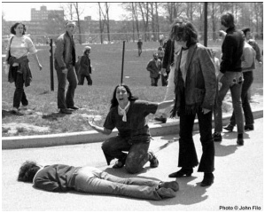
http://www.historymania.com/american_history/Kent_State_shootings

Samson Captured by the Philistines by Guercino
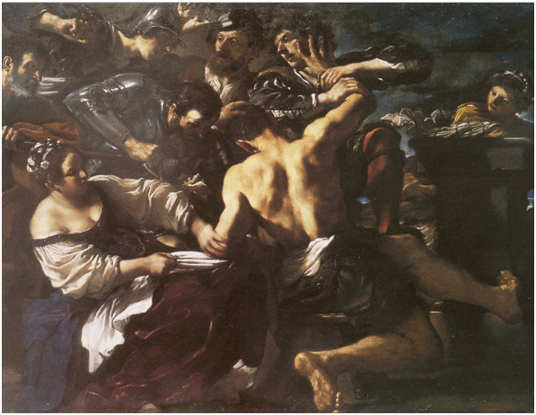
http://www.artbible.info/art/large/442.html

Others paintings of interest
A lady taking tea by Jean-Baptiste-Simeon Chardin
Supper at Emmaus by Rembrandt
The photo of Mt. Pelee 1902 nuees ardentes
Opportunity Makes the Thief by Paul Charles Chocarne-Moreau
Grand Canyon of the Yellowstone by Thomas Moran
Mount Fuji by Katsushika Hokusai ((1760-1849) and A Wave
Nocturne by Vincent van Gogh From pictures you can see the exact place this was taken and the time of year by the position of the moon and stars.
Old man in Sorrow by van Gogh others the Ravine, Head of a Man, self-portrait
In A Pair of Boots (1887), van Gogh the boots, are worn, evidence the tongue of the boot is broken the laces are twisted and mangled. The metal cleats have a pattern.

“Teaching Cops to See” Smithsonian, October, 2009 pages 48 to 52
http://www.smithsonianmag.com/arts-culture/Teaching-Cops-to-See.html

