Resources for Teaching and Learning About Change
By: Kelly Dodd

University of North Carolina at Wilmington
EDN 334- Dr. Crawford
March 20, 2011
The Apple Pie Tree
By: Zoe Hall

Citation:
Hall, Z. (1996). The apple pie tree. New York, NY: The Blue Sky Press.

Target Audience: Kindergarten-1st grade

Overview: The Apple Pie Tree is a children’s book about the changing seasons. Two sisters describe the changes in their apple tree throughout the seasons of the year. They describe the physical changes of the tree and how they relate to the changes in the weather. The book ends with the author’s personal apple pie recipe.
Application: In my unit, How and Why Things Change, students will be exploring the concept of change and why things change. This book can be used as an introduction to the unit of change. The book will be read aloud to the class and will be followed by a discussion on change. I will ask the students what changes took place in the book. How did the apple tree change over the course of the year? Then, the students will be given a sheet of paper that will be divided into four squares. The students will draw what the apple tree will look like in each season based on the descriptions provided in the book. The students will share their pictures with the class and describe the changes in the apple tree that occur due to the changes in seasons.
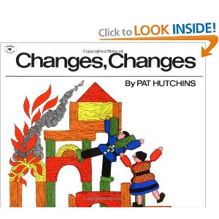

Changes, Changes
By: Pat Hutchins
Citation:
Hutchins, P. (1971). Changes, changes. New York, NY: Simon & Schuster.
Target Audience: Kindergarten-2nd grade
Overview: This is a wordless picture book that uses blocks and block people to tell a story about change and dealing with change. The block couple builds a home together but the house catches fire and they have to decide what to do. The story follows the block people throughout the changes they experience and how they handle the changes.
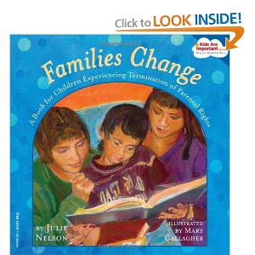
Application: This book can be used later on in the unit once the students understand the concept of change. This book is a unique way of showing change without words. The students can analyze the pictures on each page and discuss what has changed from the last page. Therefore, the student’s interpretation of the pictures will become the words to the story. Once the class has discussed the changes throughout the book, the class will discuss how the people in the book handled the changes they were presented with. Could the characters prevent the changes that occurred? If so, how? How could they have handled the changes differently? How would different reactions to change affect the outcome of the story? The students will follow this discussion with an activity. The students will create their own wordless story strip and share it with the class.

Families Change
By: Julie Nelson
Citation:
Nelson, J.S. (2007). Families change. Minneapolis, MN: Free Spirit Publishing Inc.
Target Audience: Ages 4-10
Overview: This is a book about changes that children experience within their families. It describes how a new baby in the family will bring about change but also how adoption and foster families cause change. This book is intended to reassure the children who experience these changes that it is not their fault and that their families, old and new, dearly love them. This book also contains resources for adults to utilize if students are struggling with these changes.
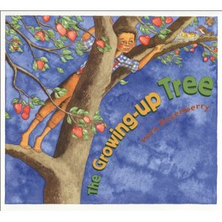
Application: This is a very important topic to discuss in relation to change. Each student will come from a diverse family background. This book will be presented as a way to ensure every student that all families are different and all families will experience change. After reading the book, the students can share stories about their families if they feel comfortable doing so. This will allow each student to understand that their classmates do not necessarily have families exactly like their own. Then, each student can create a book about their family and who lives in their home. The students will be reassured that they are loved and they are safe with their families. After the students have completed their books about their families, which may take several days, they will have the opportunity to share them with the class.

The Growing-Up Tree
By: Vera Rosenberry
Citation:
Rosenberry, V. (2003). The growing-up tree. New York, NY: Holiday House.
Target Audience: Preschool-2nd grade
Overview: This book documents the entire life of a boy. He is a newborn baby in the beginning of the book and his mother plants an apple tree for him. As he grows up, the apple tree also grows. The story follows the life of the boy as he grows up, gets married, has children and they have children. It tracks the circle of life and the changes that occur throughout life.
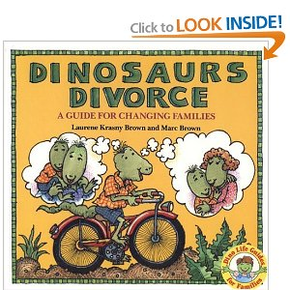
Application: This book may be used in accordance with The Apple Pie Tree. It follows a similar theme but focuses more on the characters in the book rather than the tree itself. If possible, the students could bring in pictures of their parents or grandparents when they were younger along with a current picture. They can discuss the changes that their parents/grandparents have experienced over the course of their lives including physical changes, environmental changes, family changes, job changes, etc. The students will be able to share as much as they know. Then, the students can begin to think about the changes that they will experience as they age. They can classify these changes as things they have control over versus things they do not have control over.

Dinosaurs Divorce
By: Marc Brown
Citation:
Brown, M., & Brown, L.K. (1986). Dinosaurs divorce. USA: Brown Books for Young Readers.
Targeted Audience: Ages 4-8
Overview: This book helps children understand divorce. This book discusses why parents’ divorce, what it means for the children, what life is like after the divorce, etc. It also includes a list of terms that the children are likely to hear throughout the process and their definitions.
Application: This book can be used alongside Families Change as a way to explain another type of change within families. It is important that children understand what their classmates or friends may be going through when parents divorce. After reading this book the class will discuss that divorce is not the child’s fault and that the parent’s still love the child very much and that will not be something that changes. Then, the class will draw a picture of their parents or guardians and write down things they like to do with each of their parents. The students can share what they’ve written and understand that they can still do these things with their parents despite the changes that are occurring. They can brainstorm other aspects that will not change as well.

Window
By: Jeannie Baker
Citation:
Baker, J. (1991). Window. New York, NY: Greenwillow Books.
Targeted Audience: Ages 4-8
Overview: This is a wordless picture book in which a mother is standing at the window holding her newborn baby. As the pages turn the baby grows and the view from the window also changes. The land outside the window gets developed and even the window itself begins to show signs of aging.
Application: This wordless picture book is a great example of change. As the book is presented the students can point out the things that have changed from the previous page. They can discuss how the people have changed and also how the scene outside the window has changed. After reading the book, the class can discuss how they think the changes probably affected the lives of the characters looking out the window. Who decided on those changes? What were the results of those changes? Has anybody noticed similar changes in their neighborhoods? How much time passed in order for these changes to occur? After the discussion, the students could draw a picture of what they see out of their window and decide if their view will change over time or stay exactly the same.
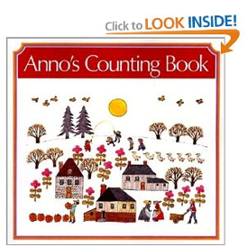
Anno’s Counting Book
By: Mitsumasa Anno
Citation:
Anno, M. (1992). Anno's counting book. Tokyo, Japan: HarperCollins Publishers.
Targeted Audience: Ages 4-8
Overview: This is a wordless picture book that also depicts change. The book begins with an almost barren landscape and as each page is turned, the landscape becomes more and more busy. Trees, trucks, people, and houses all find their way onto the landscape. The book is set up so that the objects are added in numerical order. For example, it begins with one tree, then on the next page you may find two trucks. Therefore, students are counting the exact changes that are taking place in the pictures.
Application: This book can be used in the introductory lesson of change. As the pages turn the teacher can ask the students what has changed from the last page and the number of new items on the page. As the students look at the last page they can try to recall what was in the original picture on the first page. This book can be easily integrated with math as the students count and add the new objects from each page. The students can discuss the passing of time and it’s affect on the changes. The students will also try to determine which season is being depicted on each page and what clues they use to find the answer.

The Little House
By: Virginia Lee Burton
Citation:
Burton, V.L. (1978). The little house. San Diego, CA: Houghton Mifflin Books for Children.
Targeted Audience: Ages 4-8
Overview: This book can be used along with Window because it has a similar theme. The story is told from the house’s point of view. The house is built on a lot of land with lots of fields and flowers surrounding it in all directions. As time goes on, the land is developed and the house no longer has a view of the sky or the moon because of the buildings that have been built up around it.
Application: This book can be used as the “voice” of the Window. The students can compare and contrast the similarities and differences in the two books and whether or not the house with the window would have felt the same as the little house. After reading this book, the class could watch the beginning of the movie Up! and compare and contrast how that house may feel too. Then, the students could create a chart about the changes that occurred and what changes could have been prevented and the impact that would have made on the environment. The students could brainstorm what other aspects of the community would have been affected by these changes and whether the changes were positive or negative.

How Changing Weather Effects The Way People Behave
By: Luisa Courtien
William H. Holmes Elementary School
Citation:
Courtien, L. (2008, March 27). How changing weather effects the way people behave. Retrieved from http://questgarden.com/62/90/5/080323181241/index.htm.
Target Audience: Kindergarten-2nd grade
Overview: This is a WebQuest about changing weather and it’s effects on people’s behavior. This is a useful tool in relating change to the idea of cause and effect. The changes in people’s behavior are a direct result of changes in weather. The students will research a month of the year and the weather that occurred during that month. They will create drawings to describe the weather and the things people do differently because of the weather.
Application: The students will work with a partner to research the weather during three days of a specific month. Then they will brainstorm the activities that people may participate in due to these weather conditions and present their findings to the class. This WebQuest can also be expanded into discussions about how changes in technology have affected people’s behavior.

Colonial America and You
By: Nicole Swagerty, The Phoenix Elementary
Citation:
Swagerty, N. (2006, September 10). Colonial america and you. Retrieved from http://questgarden.com/34/19/4/060829202740.
Target Audience: Kindergarten-2nd grade
Overview: This WebQuest focuses on how life has changed from colonial times until now. The children will explore how clothing, games, school, chores and food have all undergone changes.
Application: This WebQuest has students research what life was like in these five specific categories in colonial times. They will be in groups of five so that each child will be responsible for a different category. Each child will create a Venn diagram to compare and contrast the differences and similarities between then and now as it pertains to their category. The group will then present their findings to the class. This WebQuest can also lead to a discussion about how the communities as a whole have changed. The teacher can lead the entire class in creating a Venn Diagram about the similarities and differences in the communities from colonial times until now.

