Title: What are dimensions? | Subject & Grade: 8
Topic: Exploring Nets (Math Makes Sense 4.1) | Designer(s): Devin Byrka

“Big Ideas” of the Lesson (Enduring understandings connected to PLOs)
- Students will understand...
  - How 3D shapes are related to 2D nets
  - What 1D, 2D and 3D actually mean
Student Outcomes (Important skills, knowledge, or processes)
- Students will be able to...  - Identify nets  - Use nets to create 3D objects | - Students will know…  - What nets are  - The terms face, edge, vertex, and congruent

Assessment
Students can check their homework questions by looking in the back of the text.
Homework will be checked next class, and a short quiz (attached) will be given at the start of the block to check for understanding.

Materials and Resources
Dice, paper, scissors, rulers, tape, net templates (attached) for dice.
Computer on wheels for video and/or powerpoint.
Math Makes Sense 8 Textbook

Stage | Timing | Teacher Activity | Student Activity
Mental Set | 10 min | How many of you have seen a 3D movie recently? What does 3D actually mean? What is 2D? What is 1D?  Google Presentation: https://docs.google.com/present/edit?id=0AWCDv8UEk4PLZGQzNHd3NW5fMTNkendjMjJncQ&hl=en&authkey=CKWsrOwL  Flatland movie trailer introduces students to the idea that 2D and 3D are radically different.  Ask students to think of their favourite video games. Are they in 2D or 3D?  Where do we see prisms in our everyday lives? The pyramids, packaging for video games, food, and electronics. Presentation finishes with a short video of a Compaq assembly line, showing how the boxes are assembled. | Listen, contribute ideas as teacher asks questions.
Sharing the Objective / Purpose aka “Why are we doing this?” | 2 min | The world is in 3 dimensions, but our books can only show 2 dimensions. Packaging for products starts with a 2D piece of material and is converted into a 3D box. | Listen to stated objective, ask questions as needed.
Model / Demo | 2 min | Use a net template to create a die which has equal sums of opposite sides. | Students observe and ask questions as needed.
Check for Understanding | 1 min | Make sure everyone understands how to make a die. | Respond.
Collaboration | 10 min | Use the supplied net templates to make dice where opposite sides have the same sum (of 7).  Note: This is essentially question 13 from the text. | In pairs, students make dice from 3 separate nets.
Input/Information | 7 min | Explain with examples:  -nets  -face, edge, vertex, congruent | Students write down definitions and examples.
Practice:  - Independent | 30 min | Assign homework questions, using new tiered system, and give plenty of time to practice.  Students continue to work in their groups, and are allowed to talk to each other if it is math related.  Homework Questions: | Students begin homework, asking questions if they are stuck.  Anytime a student asks a question, write it on the board/overhead.  Note: Students must complete Tier 1 before moving on to Tier 2.
 |  | Tier 1: 4 (C*), 5 (C*), 6, 8, 9ab, 12, 14
 |  | Tier 2: 7,10,11
 |  | Tier 3: 13 (C*), 15, 16, 17
Closure | 3 min | When you go home today, or the next time you go shopping, look at the boxes and packaging around you and mentally ‘unwrap’ them into their net forms. Remind them of quick quiz next day. | Students listen and give responses as appropriate.

Note (C*) means Collaborative question, which will be done either in pairs, in small groups, or as a class.

Net Templates for Cubes:

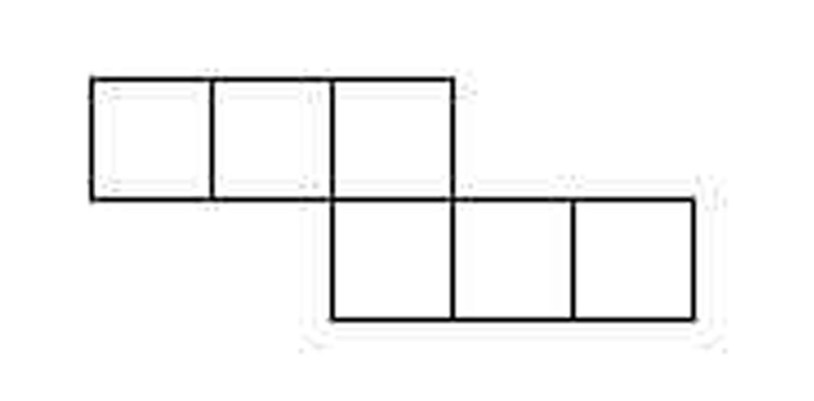
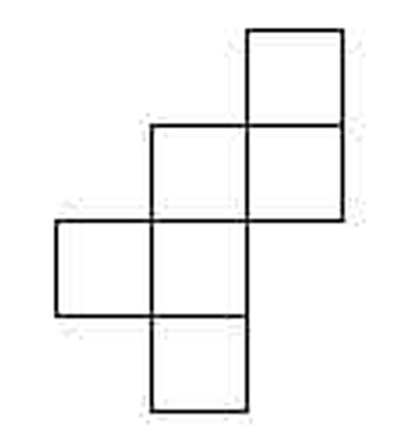
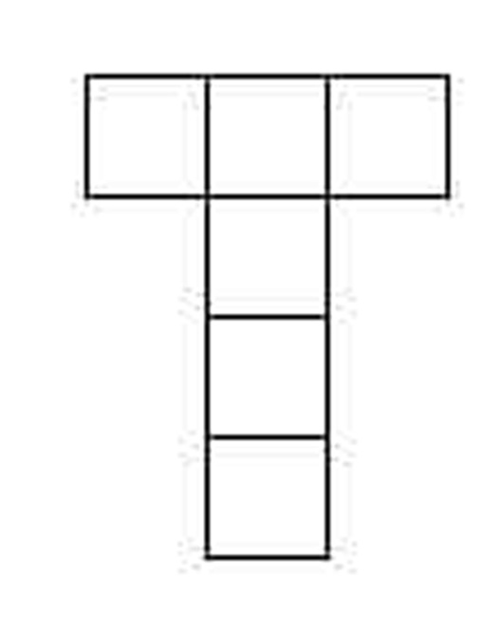

Math Quiz 4.1 – Exploring Nets Name:

- In the space provided, draw a net for the rectangular prism shown below and label each face.
How many faces does it have? ____________
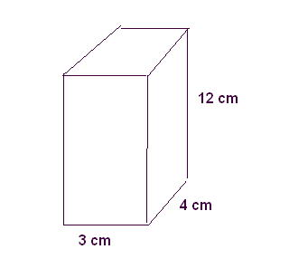

- Draw a net for the square pyramid shown below, and label each face.

How many faces does it have? _____________

