East Meadow School District

Curriculum Area Project

Title: Living Environment Lab Manual

Completed: October, 5th 2011

Authors:

Christy Sullivan

Colleen Fitzpatrick

Ken Nyer

Grade Level: 9-10

Subject: Science/Biology/Living Environment

Abstract/Rationale

This CAP is titled the “The Living Environment Lab Manual” which is designed to be incorporated into the Living Environment classrooms, for mostly grades 9 and 10. The goal of this cap is to provide Living Environment teachers with labs that help them reinforce the concepts taught in the lecture part of their class. The labs also enable students to meet the NYS lab time requirement of 1200 minutes. The Labs developed are fun for the students, connect to the curriculum and are modified to meet the needs of our diverse student population. We incorporated a variety of lessons that coincide with the different units covered throughout the year. As successive Caps are completed new labs that we find helpful will be added to the appropriate units in the lab manual. Internet links and activities have been added that coincide with the curriculum. Teachers within our department have been encouraged to share their ideas and any activities they feel will add to the success of this lab manual. The labs focus on concepts tested in the NYS Living Environment regents. The CAP was developed using the Living Environment standards (Standards 1 and Standards 4.1.1, 4.2.1, 4.3.1, 4.4.1, 4.5.1, 4.6.1 and 4.6.2) set forth by New York State. This CAP is for part two of the lab manual so the basic structure might change as successive parts of the CAP are completed.

## Hour Allotment

Each participant was allotted 30 hours to complete this CAP. Below you will find the breakdown of how the hours were spent.

|  |  |
| --- | --- |
| **Task** | **Hour(s) Spent per Participant** |
| Preparing Materials – CAP Procedures | 5 hours |
| Researching and preparing appropriate lessons to be utilized by teachers and students | 5 hours |
| Researching and organizing labs to meet NYS standards | 5 hours |
| Typing and formatting labs for the manual | 10 hours |
| Organizing manual into appropriate sections | 5 hours |
| Total Hours | 30 Hours (per participant) |

***Table of Contents***

**Topics Page #**

**Safety**

**Lab Safety………………………………………………………………….55 – 58**

**Tools**

**Microscope (Development of Cell Theory)…………………………….. 147 – 153**

**Testing pH …………………………………………………………….....104 – 107**

**Microscope Diagram w/fill-ins……………………………………….....146**

**Scientific Method**

**Steps of the Scientific Method……………………………………………59 – 64**

**Graphing Variables………………………………………………………..4 – 8**

**Biochemistry**

**Organic Compounds………………………………………………………38 – 41**

**Protein Indicator ……………………………………………………….....51 – 54**

**Building Molecules/Compounds………………………………………. .108 – 110**

**Monomers and Macromolecules………………………………………....111 – 117**

**Enzymes (Toothpick-ase) ………………………………………… …….118 – 126**

**Ecology**

**Scavenger Hunt……………………………………………………............14 – 18**

**Symbiotic Relationships…………………………………………………..65 – 75**

**Human Impact…………………………………………………………….79 – 82**

**Photosynthesis……………………………………………………………..88 – 91**

**Automobile Emissions ……………………………………………………99 – 101**

**Cells**

**Photosynthesis vs. Cellular Respiration …………………………………..1 – 3**

**Cellular Respiration ………………………………………………………..9**

**Mitosis (Candy) ……………………………………………………………10 – 13**

**Mitosis (Stage Flip Book)………………………………………………….19 -20**

**Meiosis (Stage Flip Book)…………………………………………............21 – 27**

**Human Check Cells (Microscope)………………………………………...85 – 87**

**Cellular Respiration ………………………………………………………..97 – 98**

**Mitosis in Onion Root Tip ………………………………………………...102 – 103**

**Mitosis in Real Cells ……………………………………………………….131 – 135**

**Aerobic Respiration Map …………………………………………………..136 – 138**

**Genetics**

**Species Chromosome Number……………………………………….…….28 – 30**

**Structure of DNA……………………………………………………………42 – 48**

**Gene Mutations……………………………………………………………..31 – 35**

**Gel Electrophoresis and Analysis…………………………………………..83 – 84**

**Punnett Squares …………………………………………………………….76 – 78**

**DNA 🡪 RNA ……………………………………………………………….92 – 96**

**Plastic Eggs Genetics ………………………………………………………139 - 142**

**Body System**

**Circulatory System …………………………………………………………36 – 37**

**Reproductive/Endocrine (Menstrual Cycle) ……………………………127 - 130**

**NYS Labs**

**Making Connections Lab Report ………………………………………..49 – 50**

**Making Connections Pulse Rate Charts…………………………………145**

**Diffusion Lab Group Responsibilities Chart ……………………………144**

**Biodiversity Data Chart …………………………………………………..143**

**INTERNET CONNECTIONS**

|  |  |  |
| --- | --- | --- |
| **Topic** | **Type of Media** | **Website** |
| **Genetic Mutations** | **Video** | [**http://www.authorstream.com/Presentation/science208-73485-mutation-mutations-science-powerpoint-technology-ppt/**](http://www.authorstream.com/Presentation/science208-73485-mutation-mutations-science-powerpoint-technology-ppt/) |
| **Metric System of Measurement** | **Video** | [**http://www.youtube.com/watch?v=DQPQ_q59xyw**](http://www.youtube.com/watch?v=DQPQ_q59xyw) |
| **Gel Electrophoresis** | **Student Simulation** | **http://learn.genetics.utah.edu/content/labs/gel/** |
| **Ecology**  **Overpopulation** | **Video** | <http://www.metacafe.com/watch/80129/christmas_island_red_crabs/> |
| **Ecology**  **Pesticides/**  **Endangered species** | **Video** | <http://www.bing.com/videos/watch/video/bald-eagle-off-endangered-species-list/17w3if5d3> |

**Works Cited**

|  |  |  |  |
| --- | --- | --- | --- |
| **Author** | **Website/Source** | **Right to use work** | **Date Retrieved** |
| [Mrs. Tracy Trimpe](mailto:ttrimpe@sciencespot.net) developed in March 1999 | The Science Spot  http://sciencespot.net/index.html | http://sciencespot.net/Pages/faq.html | 7/21/10 |
| Mrs. Stephanie Fazio  Last revised in June 2010 | Ms. Fazio's Living Environment Webpage  http://www.nylearns.org/webpage/default.aspx?SID=P0&UID=27674 | http://www.nylearns.org/webpage/default.aspx?SID=P0&UID=27674 | 08/3/2010 |
| Pam Freitag | Directly from person | Verbal | 11/2/10 |
| Kerin Myer | Directly from person | Verbal | 11/2/10 |
| Miller & Levine | Textbook (Biology Pearson Ed) | Textbook Permission  for educators | 9/10/10 |
| Christy Sullivan | Directly from person | Verbal | 9/10/10 |
| Ken Nyer | Directly from person | Verbal | 9/10/10 |
| Ms. Blanarovich | Website *Minisink Valley High School* | On website and lab | 10/1/10 |
| James M. Buckley | Living Environment Topic Sequence and Links | http://creativecommons.org/licenses/by-nc-sa/3.0/ | 9/20/11 |
| Colleen Fitzpatrick | Directly from person | Verbal | 9/20/11 |
| Unknown | 1. bhhsbiologylambert.wikispaces.com/.../**Cell**+**Theory**+**Lab**.../**Cell**+**Theory**+**Lab**-honors-bio-11.doc | 1. bhhsbiologylambert.wikispaces.com/.../**Cell**+**Theory**+**Lab**.../**Cell**+**Theory**+**Lab**-honors-bio-11.doc | 9/10/11 |
| Ken Nyer | (Modified from *http://www.huntington.org/Education/FIBR/download/2004/04PlantCell.pdf)* | (Modified from http://www.huntington.org/Education/FIBR/download/2004/04PlantCell.pdf) | 9/10/11 |

**Name______________________ Date___________**

Photosynthesis vs. Cellular Respiration

*Follow the instructions below to complete your diagrams on photosynthesis and respiration*

**Part 1**

**Step 1**: Fill in the **equation for photosynthesis** and answer the following questions.

____________ + ____________ + ____________ 🡪____________ + ____________

|  |  |
| --- | --- |
| What are the reactants for photosynthesis?   1. _________________ 2. _________________ 3. _________________ | What are the products for photosynthesis?   1. _________________ 2. _________________ |

**In which organelle does the process of photosynthesis occur?**__________________________

**Stages of photosynthesis and where each occurs:**

Stage 1 - __________________________ and occurs in the_____________________

Stage 2 - __________________________ and occurs in the ____________________

**Why is the process of photosynthesis important for the stability of ecosystems**? ________________________________________________________________________________________________________________________________________________________________________________________________________________________________________________

**Step 2: Fill in the equation or aerobic and anaerobic respiration and answer the following questions.**

Aerobic

____________ + ____________ 🡪____________ + ____________+ ____________

|  |  |
| --- | --- |
| Reactants   1. __________________ 2. ___________________ | Products   1. ___________________ 2. ___________________ 3. ___________________ |

What can be inferred about the reactants and products of aerobic respiration and photosynthesis? ________________________________________________________________________________________________________________________________________________________________

**Name 2 organism that do aerobic respiration** ___________________ and ________________.

**Remember there are _______ types of anaerobic respiration**

**Anaerobic (Lactic Acid Fermentation)**

____________ 🡪____________ + ____________

**Name 1 organism can perform lactic acid fermentation?**_____________________________

**Anaerobic (Alcoholic Fermentation)**

____________ 🡪____________ + ____________+ ____________

**Name 1 organism can perform alcohol fermentation?**_____________________________

**List 3 differences between aerobic and anaerobic respiration.**

**1)**__________________________________________________________________

**2)**__________________________________________________________________

**3)**__________________________________________________________________

**Why is the process of respiration important for organisms**? __________________________________________________________________________________________________________________________________________________________________________________________________________________

**Step 3: Get a piece of construction paper and colored pencils.**

**Step 4: Use all the information about photosynthesis from step 1 to create a visual teaching tool for other students on one side of the construction paper.**

**Step 5: Use all the information about cellular respiration from step 2 to create a visual teaching tool for other students on the other side of the construction paper.**

**Step 6: BE CREATIVE**

**Graphing Lab**

Name____________________________ Date: _____________

1. Scientists were trying to figure out whether fertilizer affects the growth of tomatoes. The data table below shows the average diameter of ripe tomatoes from plants grown with different amounts of fertilizer. **Construct a line graph using this data**

|  |  |
| --- | --- |
| **Amount of Fertilizer (g)** | **Average Diameter of Tomatoes (cm)** |
| 0 | 7 |
| 20 | 8 |
| 40 | 9 |
| 60 | 10 |
| 80 | 9 |
| 100 | 8 |

What is the independent (manipulated) variable? ______________________________________

What is the dependent (responding) variable? _________________________________________



1. Scientists were trying to figure out if the length of a bar would change when heated from 0 degrees Celsius to 250 degrees Celsius. Their findings were recorded in the data table below

|  |  |
| --- | --- |
| **Temperature (degreed Celsisus)** | **Length of bar (cm)** |
| 0 | 100.0 |
| 50 | 100.1 |
| 100 | 100.3 |
| 150 | 100.4 |
| 200 | 100.5 |
| 250 | 100.7 |

What is the independent (manipulated) variable? ______________________________________

What is the dependent (responding) variable? _________________________________________



1. The data table below shows the number of hours the flowers of different types of plants remain open each day.

|  |  |
| --- | --- |
| **Flower** | **Number of Hours Open** |
| Morning glory | 6 |
| California poppy | 7 |
| Dandelion | 13 |
| Pumpkin flower | 4 |
| Moon flower | 16 |

Use the information in the data table to **construct a bar graph** on the grid provided.

**Number of Hours Flowers Remain Open**

|  |  |  |  |  |  |  |  |  |  |  |  |  |  |  |
| --- | --- | --- | --- | --- | --- | --- | --- | --- | --- | --- | --- | --- | --- | --- |
|  |  |  |  |  |  |  |  |  |  |  |  |  |  |  |
|  |  |  |  |  |  |  |  |  |  |  |  |  |  |  |
|  |  |  |  |  |  |  |  |  |  |  |  |  |  |  |
|  |  |  |  |  |  |  |  |  |  |  |  |  |  |  |
|  |  |  |  |  |  |  |  |  |  |  |  |  |  |  |
|  |  |  |  |  |  |  |  |  |  |  |  |  |  |  |
|  |  |  |  |  |  |  |  |  |  |  |  |  |  |  |
|  |  |  |  |  |  |  |  |  |  |  |  |  |  |  |
|  |  |  |  |  |  |  |  |  |  |  |  |  |  |  |
|  |  |  |  |  |  |  |  |  |  |  |  |  |  |  |

1. The data table below shows the average daily temperature for 10 days for 2 New York State cities: Albany and New York City

**Average Daily Temperature**

|  |  |  |
| --- | --- | --- |
| **Day** | **Albany Temperature (deg F)** | **New York City Temperature (F)** |
| 1 | 77 | 81 |
| 2 | 79 | 85 |
| 3 | 80 | 87 |
| 4 | 72 | 88 |
| 5 | 76 | 84 |
| 6 | 81 | 80 |
| 7 | 84 | 76 |
| 8 | 85 | 74 |
| 9 | 85 | 70 |
| 10 | 77 | 65 |

What is the independent (manipulated) variable? ______________________________________

What is the dependent (responding) variable? _________________________________________



1. The following data represents the measurement taken of a cup of hot coffee cooling off (deg C) with respect to time (min). Using the graph paper attached, create a line graph using this data.

|  |  |
| --- | --- |
| **Time (min)** | **Temp (deg C)** |
| 0 | 100 |
| 4 | 78 |
| 8 | 66 |
| 12 | 60 |
| 16 | 54 |
| 20 | 48 |
| 24 | 42 |
| 28 | 38 |
| 32 | 34 |
| 36 | 34 |
| 40 | 30 |
| 44 | 28 |
| 48 | 27 |
| 52 | 26 |
| 56 | 26 |
| 60 | 26 |
| 64 | 26 |
| 68 | 26 |
| 70 | 26 |

**Name_______________________________**

**Partners Name______________________**

**Lab – How Does Exercise Affect Disposal of Wastes From Cellular Respiration**

**Directions:**

1. Label two test tubes A and B. Put 10 ml of water and a few drops of bromothymol blue solution in each test tube. Carbon Dioxide causes bromothymol blue to turn yellow or green.
2. Your partner will time you during this step. When your partner says “go”, slowly blow air through a straw into the bottom of test tube A.

*CAUTION – DO NOT INHALE THROUGH THE STRAW*

1. When the solution changes color, your partner should say “stop” and then record how long the color change took.
2. Jog in place for 2 minutes. *CAUTION – Do not do this if you have a medical condition that interferes with exercise. If you feel faint or dizzy, stop immediately and sit down.*
3. Repeat steps 2-4 using test tube B.
4. Trade roles with your partner. Repeat steps 1 through 5.
5. Include a formal lab write up on loose leaf paper.

**Date:**

|  |  |  |
| --- | --- | --- |
|  | **Test Tube A** | **Test Tube B** |
| **Time before bromothymol blue changed color** |  |  |

**Analyze and Conclude:**

1. How did exercise affect the time it took the solution to change color?
2. What process in your body produces carbon dioxide? How does exercise affect this process?

**Mitosis Candy Lab**

Name______________________________ Date:

Per: Living Environment

*Directions:*

1. Each student will receive an index card labeled with an activity that occurs during **1 of the phases** of mitosis (See Attached).
2. Students will decide which phase of mitosis their index card is referring to.
3. All students who have the same phase will meet and fill out the top portion of the “**Mitosis Activity Sheet”.**
4. Using the poster board, the bag of supplies, and your knowledge of mitosis, you and your group will construct a poster board representing your specific phase of mitosis.
5. As you construct your poster board, your group **must** fill in the bottom portion of the “**Mitosis Activity Sheet”.**
6. The poster board must be labeled (include a large title that has the name of your phase of mitosis, and each part of the cell should be **visibly** labeled)
7. Each group will present their poster board to the class.
8. At the conclusion of the activity, each member of the group will complete questions regarding mitosis.

***Grade will be based on:

* Accuracy of information
* Group Participation
* Creativity and Display
* Effort
* Presentation
* Summary Questions

Names___________________________________________ Date:

**Mitosis Activity Sheet**

**Our Cell Phase is:** _____________________

* _________________ is one of the phases of mitosis. During this phase:_______

________________________________________________________________________________________________________________________________

________________________________________________________________

________________________________________________________________

________________________________________________________________

________________________________________________________________

________________________________________________________________

________________________________________________________________________________________________________________________________

**Diagram Legend:** Write in the blank space what each object in your diagram represents. For example: Pipe Cleaner 🡪Spindle Fibers.

Red Rope: _________________ Blue Ribbon: _________________

Circular Mints: _________________ Black Ribbon: _________________

Good and Plenty: Pipe Cleaner: _________________

*Pink*: _________________ Marshmallow Hearts: _____________

*White*: _________________ Cheerios: _________________

Straw: Paper Clips: _________________

*Specify Color*: _________________ Glitter Glue: _________________

Green Beads_________________INDEX CARDS (Each phrase should be cut out and pasted on a separate index card

Chromosomes duplicate themselves

Centrioles duplicate themselves

The cell is in this phase 90% of the time

Chromatin condenses and becomes visible

as double stranded chromosomes (sister chromatids)

attached together by centromeres

Spindle fibers begin to form

Nuclear membrane of nucleus disappears and

centrioles migrate to the poles

Spindle fibers line up double stranded

chromosomes (sister chromatids) at the equator

Double stranded chromosomes

(sister chromatids) line up at the equator

Spindle fibers attach to chromosomes centromeres

One set of single stranded chromosomes

are pulled to opposite poles by spindle fibers

Sister chromatids are being pulled apart to

either side of the cell.

In animal cells, “furrowing” occurs. The

cell membrane begins to pinch in at the equator

In plant cells, a cell plate forms at the equator

In animal cells, pinching of the cell membrane begins

Nuclear membrane begins to REFORM

Spindle Fibers go away

Cells are splitting cytoplasm and other organelles

Chromosomes turn back into chromatin

2 IDENTICAL cells have formed

Name______________________________ Date:

Living Environment Period:

Ecology Scavenger Hunt

**Skills:** Identify abiotic and biotic factors in their natural habitats

**Objectives**:

* Identify organisms found in the field
* Classify organisms found in the field.

**Purpose:** In this lab, you will be given a list of items to look for in a site that the class will visit. You will identify living organisms that you will find. You will also observe the living organisms that you find. In addition, you will observe and make note of the environment in which each item was found.

**Background:** At some time in your life, you may have collected natural objects such as seashells, rocks, leaves, and insects. Although you may have learned a lot about the physical appearance and structures of the specimens collected, you may not have observed the environment in which you collected them.

A scavenger hunt is an activity in which you try to find as many items as possible from a list of objects. In order to find some of the items on your scavenger hunt list, you will have to know about their habitats, classifications and life cycles.

**Procedure:**

1. The scavenger hunt list is on page 6. Your teacher will tell you which items you may expect to find in the area you will visit. You will not collect any material in the field. All observations will be made in such a way that habitats are disturbed as little as possible.
2. Before going on the scavenger hunt, do background research on the animals, plants, and fungi that you may expect to find.
   1. Describe the habitat you are going to visit

____________________________________________________________________________________________________________________________________

__________________________________________________________________

__________________________________________________________________

__________________________________________________________________

* 1. Distinguish between a producer, a consumer and a decomposer

___________________________________________________________

___________________________________________________________

___________________________________________________________

___________________________________________________________

1. Learn all you can about the organisms you find. Record your findings in the table below

|  |  |  |  |
| --- | --- | --- | --- |
| **Organism** | **Plant, animal or fungus** | **Producer, consumer, or decomposer** | **Poisonous (Y/N)** |
|  |  |  |  |
|  |  |  |  |
|  |  |  |  |
|  |  |  |  |
|  |  |  |  |
|  |  |  |  |
|  |  |  |  |
|  |  |  |  |
|  |  |  |  |
|  |  |  |  |
|  |  |  |  |

1. Take care not to disturb the surrounding environment during your hunt. When you examine items, follow the “rule of six” – do not take one to examine unless there are six more within six feet. This rule generally leaves enough organisms to reproduce.
   1. Why should you follow the “rule of six”?

__________________________________________________________________

1. Examine live animal specimens only if you can release them unharmed into the same habitat. Do not examine any vertebrates without your teacher’s approval
2. Your teacher will schedule the time for the hunt. Follow your teacher’s instructions about when to start and stop hunting. When you find an item on your list, enter it on your data table. Observe and make not of other organisms and unusual features in the area in the appropriate column in your data table.

**Analysis:**

1. Write a description of the biotic and abiotic factors in the habitat you studied.

________________________________________________________________________

________________________________________________________________________

________________________________________________________________________

________________________________________________________________________

1. Construct a food chain from the animals and plants on your list of finds.

________________________________________________________________________

________________________________________________________________________

1. Construct a food web from the animals and plants on the list. Draw your web in the space below.
2. How might the environment of the habitat you studied change by next year and influence this lab for next year’s biology students?

________________________________________________________________________

________________________________________________________________________

1. Instead of investigating a field, how do you think your findings would be affected if you investigated a pond and the area surrounding it? What organisms might you find?

________________________________________________________________________

________________________________________________________________________

________________________________________________________________________

________________________________________________________________________

Scavenger Hunt Items

1. Something unusual
2. A bone
3. An echinoderm – **“spiny skin” and 5 fold symmetry**
4. An arachnid – **spider**
5. A nonflying insect
6. A mollusk – **snail or slug**
7. An annelid – **segmented worm**
8. A nematode – **round worm**
9. A flying insect
10. A pupa **(resting stage between a larva and an adult)**
11. A larva – **immature insect**
12. Something round
13. Something soft
14. Something white
15. Something that makes noise
16. A feather (detached from a bird)
17. Conifer Pinecone
18. Seven pieces of trash or litter left by humans
19. Something beautiful
20. Chewed plant part (not chewed by humans)
21. An owl pellet
22. A fungus from a tree
23. A fungus from the ground
24. A gall – **abnormal outgrowth of plant tissue**

***You must take a **good picture** of at least 25 items

1. A monocot leaf – **has parallel veins in leaf**
2. A dicot leaf – “**branching” veins in leaf**
3. Scat – **Animal droppings**
4. Something large
5. Something straight
6. A wind dispersed seed
7. An animal dispersed seed
8. 50 of any item
9. A Thorn
10. An example of camouflage
11. A solar energy trap
12. An animal track
13. A frond – **large divided leaf (fern)**
14. A palmate leaf – **leaf resembling an open hand**
15. A symbiotic relationship between 2 organisms
16. Flower
17. Seed
18. Something red
19. Something biotic
20. A producer
21. A consumer
22. Something abiotic
23. Food chain of three organisms
24. Primary consumer
25. A host

***The above circled items **must be** part of your 25 items

**The Phases of Mitosis**

**Name_______________________________________ Period_________**

*Directions: Draw a cell that contains 3 chromosomes (****Be careful!! In which stage are the chromosomes visible?)***

|  |  |
| --- | --- |
| Interphase | Prophase |
| Metaphase | Anaphase |
| Telophase | Cytokenesis |
|  |  |

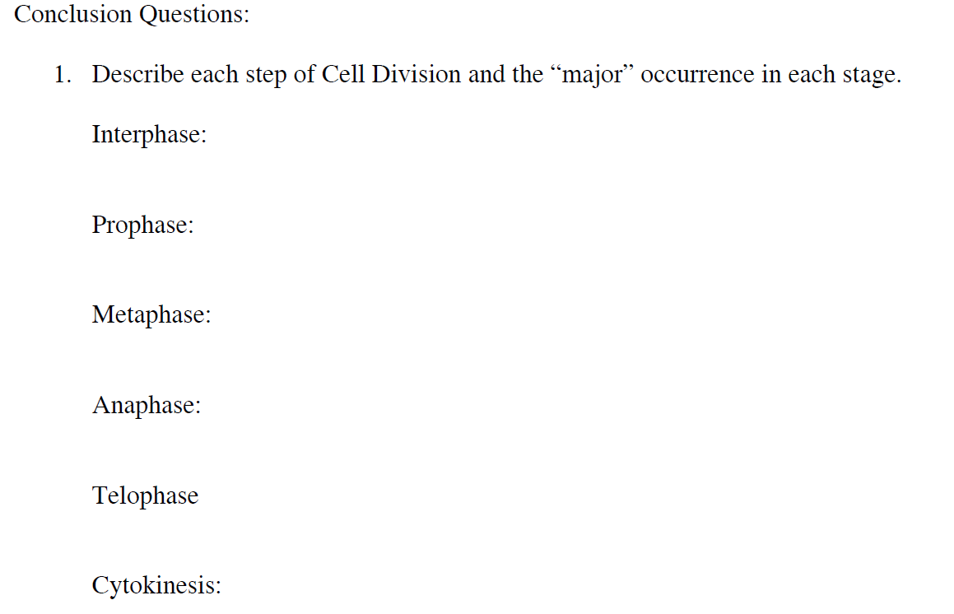

2. How do the daughter cells compare to the parent cell after mitosis?

3. Which cells in the human body undergo mitosis?

4. Why is mitosis important for an individual that has cut their hand open?

5. The 3 phases of interphase are:

**Meiosis Flip Book**

Name_______________________ Date:

**Your task** is to create an ‘index card’ flip book that shows the following ‘basic’ steps of Meiosis.

On the front of each card: label the step with the appropriate title (Interphase, Prophase, etc) at the top of the card, and draw a colored picture of the phase at the bottom of the card. On the back of each card: Write the title and description of what happens in each stage (copy the titles and description EXACTLY as they are listed below. Hand draw and color each cell picture neatly and accurately. Make each cell the same “size” and “color”  
  
___ **Card 1**: **The Cover**: Put the underlined title: “The Phases of Meiosis”, along with your name, date, and period.   
  
___ **Card 2: Interphase**: The time before meiosis. The cells may appear inactive during this stage, but they are quite the opposite:   
* This is the longest period of the complete cell cycle.  
* The cells enlarge, preparing for meiosis.  
* The DNA replicates, or copies itself.  
* The cell grows and makes structures to use during the rest of the cell cycle.  
  
___ **Card 3: Prophase 1**:  
* This is the first phase of meiosis.  
* The chromatin in the nucleus condenses and becomes visible chromosomes. Each replicated (copied) chromosome is made of two chromatids, both with the same genetic information.   
* Spindle fibers begin to form around the centrioles.  
* The nuclear membrane breaks down.  
* The centrioles are moving to opposite ends of the cell.  
* Homologous chromosomes come together (synapsis)  
* The exchange of genes between homologous chromosomes occurs during “crossing over”.  
  
___ **Card 4: Metaphase 1:**   
* The centromere attaches the duplicated chromosomes to the spindle fibers.  
* * Spindle fibers line up chromosomes with their homologous partner at the center of the cell   
  
___ **Card 5: Anaphase 1:**   
* Each homologous chromosome pair is pulled toward opposite ends of the cell.  
* The spindle fibers are getting shorter.

___ **Card 6: Telophase 1 and Cytokinesis:**  
* The nuclear membrane forms around the chromosomes.  
* The spindle fibers that have pulled them apart disappear.  
* The cell membrane is beginning to pinch in.  
* The cell begins to divide into two cells.  
* The paired chromatids are still joined.   
* Each cell contains one member of each homologous chromosome pair.  
  
___ **Card 7: Prophase 2:**  
* Each cell contains one member of each homologous chromosome pair.

\*\****The chromosomes are not copied again between the 2 cell divisions.***  
  
  
___ **Card 8: Metaphase 2:**   
* The centromere attaches the chromatids to the spindle fibers.   
* Spindle fibers line up all chromosomes at the center of the cell.   
  
___ **Card 9: Anaphase 2:**   
* The chromatids separate, and are pulled apart and begin moving to the cell poles.  
* The spindle fibers are getting shorter.  
* The chromatids arrive at the poles (opposite ends of the cell).  
  
___ **Card 10: Telophase 2 and Cytokinesis:**  
* The nuclear membrane forms around the chromosomes.  
* The spindle fibers that have pulled them apart disappear.  
* The cell membrane is beginning to pinch in  
*\* * The result: Four new cells have formed from the original single cell. Each new cell has half the number of chromosomes present in the original cell. They are Haploid*

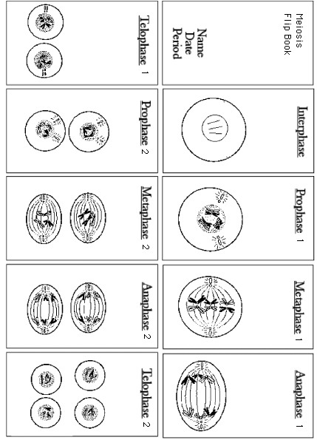

|  |  |
| --- | --- |
|  |  |
|  |  |
|  |  |

|  |  |
| --- | --- |
|  |  |
|  |  |
|  |  |

**Analysis and Interpretation**

1. How many chromatids are present in the cell during prophase 1? __________________
2. What is the haploid number at the end of meiosis? ______________________________
3. In the process of meiosis, how many nuclei are produced from the nucleus of each parent cell? ___________________________________________________________________
4. Are the newly produced cells haploid or diploid? ________________________________
5. State 1 way metaphase 1 differs from metaphase 2 _______________________________ ________________________________________________________________________________________________________________________________________________
6. State 1 way anaphase 1 differs from anaphase 2 _________________________________ ________________________________________________________________________ ________________________________________________________________________
7. In mitosis, replication of chromosomes precedes each cell division. In meiosis, two cell divisions take place without a replication of chromosomes between them. What is the significance? ____________________________________________________________ ________________________________________________________________________________________________________________________________________________
8. Meiosis is sometimes called reduction division. What does this mean and why is it important to a species? _____________________________________________________ ________________________________________________________________________________________________________________________________________________
9. Why is it significant that the four newly formed cells differ in chromosome content? ____ ________________________________________________________________________________________________________________________________________________

**Haploid vs. Diploid Graphing Activity**

**Name___________________________ Date:**

**Living Environment Per:**

**Directions:**

**Part A – Complete all tables**

**Table 1**

|  |  |  |
| --- | --- | --- |
| **Species** | **Haploid Number** | **Diploid Number** |
| Donkey |  | 62 |
| Dove |  | 78 |
| Hedgehog | 44 |  |
| Kangaroo |  | 12 |
| Mosquito | 3 |  |
| Pea |  | 14 |
| Pineapple |  | 50 |
| Red Fox |  | 34 |
| Turkey | 41 |  |
|  |  | 46 |
| Snail |  | 24 |
| Tiger | 19 |  |
| Potato | 24 |  |

**Table 2** Fill in the table with **increasing haploid number**

|  |  |  |
| --- | --- | --- |
| **Species** | **Haploid Number** | **Diploid Number** |
|  |  |  |
|  |  |  |
|  |  |  |
|  |  |  |
|  |  |  |
|  |  |  |
|  |  |  |
|  |  |  |
|  |  |  |
|  |  |  |
|  |  |  |
|  |  |  |
|  |  |  |

**Table 3** Fill in the table with **decreasing** diploid number

|  |  |  |
| --- | --- | --- |
| **Species** | **Haploid Number** | **Diploid Number** |
|  |  |  |
|  |  |  |
|  |  |  |
|  |  |  |
|  |  |  |
|  |  |  |
|  |  |  |
|  |  |  |
|  |  |  |
|  |  |  |
|  |  |  |
|  |  |  |
|  |  |  |

**PART II**

1. Create a **BAR GRAPH** depicting the **HAPLOID** number of each species using **TABLE 1**
2. Create **ANOTHER BAR GRAPH** depicting the **DIPLOID** number of each species **USING TABLE 1**

**Questions:**

1. Dogs have 78 chromosomes in their diploid cells. How many chromosomes are in their haploid cells?
2. How many *pairs* of chromosomes do dogs have in their somatic cells?
3. Cats have 38 chromosomes in their diploid cells . How many chromosomes are in their haploid cells?
4. Horses have 32 chromosomes in their sex cells. How many chromosomes are in their somatic cells?
5. How many pairs of homologous chromosomes do horses have in their somatic cells?
6. What types of cells are haploid? What types of cells are diploid?

Name_____________________________ Date:

**Lab – Gene Mutations**

A **gene mutation** is a change in the sequences of bases within a gene. There are three types of gene mutations: 1)Substitution; 2)Deletion; 3) Addition. In this lab, we will investigate these mutations and determine what effect they have on the polypeptide chain they produce.

**From Normal Gene to Normal Polypeptide Chain**

1. Randomly select 18 base cards and bring them to your work area.
2. Make a short gene by arranging 15 of the bases in a straight line on your desk – You must have the DNA sequence “ACT” be the last 3 bases of your sequence because it is a stop codon. DO NOT use the stop codon anywhere else in your gene. Other than that, you may choose any order of bases you want for your gene. Set aside the three extra base cards to be used later.

Copy down the **DNA Sequence** that you’ve just made:

__________________________________________________________________

Write the RNA sequence for this gene:

__________________________________________________________________

Using the RNA Codon-Amino Acid Chart, write the amino acid sequence for the gene:

__________________________________________________________________

**RNA Codon-Amino Acid Chart**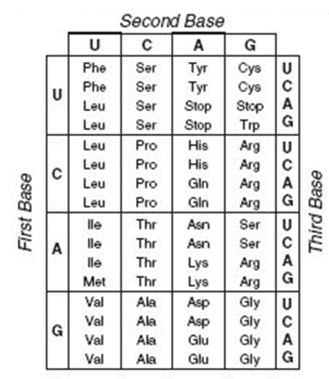

**Simulating Mutations**

****All of the mutations that you simulate will occur at the **5th** base position***

1. Simulate **substitution** by replacing the 5th base in the normal gene with one of the bases that you set aside in step 2.  
     
   Copy down the new, **mutated** DNA sequence that you’ve just made:

______________________________________________________________________

Write the new mRNA sequence:

______________________________________________________________________

Write the new amino acid sequence:

______________________________________________________________________  
This is the new polypeptide chain made from the mutated gene.

How many amino acids are different from the original, normal polypeptide chain?______

What new amino acids were included in this polypeptide chain that were not present in the original polypeptide chain? ______________________________________________

1. **RETURN THE GENE BACK TO ITS ORIGINAL, DNA SEQUENCE**
2. Simulate **deletion** by removing the base in the 5th position (do **NOT** add any other base). All other bases should shift over one position to the left.

Copy down the new, **mutated** DNA sequence that you’ve just made:  
________________________________________________________________________

Write the new mRNA sequence:

______________________________________________________________________

Write the new amino acid sequence:

______________________________________________________________________  
This is the new polypeptide chain made from the mutated gene.

How many amino acids are different from the original, normal polypeptide chain?______

What new amino acids were included in this polypeptide chain, that were not present in the original polypeptide chain? ______________________________________________

1. **RETURN THE GENE BACK TO ITS ORIGINAL, DNA SEQUENCE**
2. Simulate **addition** by inserting an extra base in the 5th position (do **NOT** remove any original base). All of the other bases should shift over one position to the *right.*

Copy down the new, **mutated** DNA sequence that you’ve just made:  
________________________________________________________________________

Write the new mRNA sequence:

______________________________________________________________________

Write the new amino acid sequence:

______________________________________________________________________  
This is the new polypeptide chain made from the mutated gene.

How many amino acids are different from the original, normal polypeptide chain?______

What new amino acids were included in this polypeptide chain, that were not present in the original polypeptide chain? ______________________________________________

**Analysis and Questions**

1. What are the three types of gene mutations? _________________________________
2. Do all three mutations produce the exact same results? Which mutation caused the most drastic change in your amino acid sequence (polypeptide chain) _____________ _____________________________________________________________________
3. What happened to the amino acid sequence of the polypeptide chain when the **substitution mutation** occurred? _________________________________________ ____________________________________________________________________
4. What happened to the amino acid sequence of the polypeptide chain when the **deletion mutation** occurred? _____________________________________________ _____________________________________________________________________
5. What happened to the amino acid sequence of the polypeptide chain when the **addition mutation** occurred? ____________________________________________ _____________________________________________________________________
6. What would happen to the polypeptide chain if a mutation produced a STOP codon at the beginning of a gene?_________________________________________________ _____________________________________________________________________
7. Why do addition and deletion mutations cause more of a drastic change in the amino acid sequence than a substitution mutation? _________________________________ _____________________________________________________________________
8. When would a substitution mutation cause no change in the resulting polypeptide chain? ______________________________________________________________ ____________________________________________________________________
9. From what you observed in this lab, why do you think addition and deletion mutations are called “Frame-shift mutations”? _______________________________ _____________________________________________________________________

**Nitrogen Bases**

|  |  |  |  |  |  |
| --- | --- | --- | --- | --- | --- |
| A | C | T | G | A | C |
| T | G | A | C | T | G |
| A | C | T | G | A | C |

**The Circulatory System Investigations**

Understanding the way in which your heart, blood vessels and blood function to deliver nutrients & oxygen, remove wastes, fight infections, etc. is key to realizing why keeping your heat healthy is so important. The human heart is considered a closed circulatory system, because the blood is confined to vessels (arteries, veins, capillaries). Your heart and circulatory system are working 24/7 for you – beating upwards of 3 billion times during the course of your life and circulating nearly 5 liters of blood every minute! You will be investigating and working to understand the inner world of your heart and associated structures in the lab.

|  |  |
| --- | --- |
|  | The heart’s job is to pump blood to the various parts of your body. In doing so, it only pumps blood in a unidirectional manner – or put in highway terms, it is a one way road of blood flow.  1. You are a red blood cell in the **Left Ventricle** – describe the path you take as you leave here and travel around the body and eventually make your way back to the left ventricle. Name all of the structures you would pass through – don’t include valves.  Left Ventricle 🡪________________ 🡪Arteries 🡪Capillaries 🡪__________________ 🡪 Vena Cava 🡪 _____________ 🡪________________ 🡪 ________________ 🡪 Lungs 🡪 ________________ 🡪________________ 🡪 End a the Left Ventricle |

2. Color the areas of the heart above and associated vessels that carry oxygenated (oxygen rich) blood RED and the areas with deoxygenated (oxygen poor) blood BLUE

3. What prevents blood from flowing in more than 1 direction? ______________________________

4. What is meant by a “closed circulatory system”? _______________________________________

**Your Heart and How it Beats**

Doctors will often listen to your heartbeat to ensure that your heart is working properly. **Get one of the stethoscopes**. Clean the ear pieces, and then listen to your heartbeat. To listen, place the chest piece over where the heart is. Remember, your heart is positioned in the center of your chest slightly tilted to the left.

5. Record what you hear ____________________________________________________________ ________________________________________________________________________________

6. What is responsible for the LUB-DUB sounds you are hearing? ____________________________ ________________________________________________________________________________

7. Determine your resting heart rate by counting how many LUB –DUBs are heard in 15 seconds and multiply that number by 4 for beats per minute. My resting heart rate in 1 minute is _____ beats.

8. Run in place, do jumping jacks, or exercise for one minute then listen again right away and take your heart rate as well. My active heart rate = ______ beats per minute.

9. Was there any difference in the resting heart rate versus the active heart rate? Explain why or why not? _______________________________________________________________________ _______________________________________________________________________________

**Blood Pressure**

Examine the graph below and answer the following questions. Blood pressure refers to the force of the blood on the walls of the arteries. Systolic blood pressure is the pressure exerted as the heart pumps. The Diastolic blood pressure is the pressure exerted as the heart relaxes.

|  |  |
| --- | --- |
|  | 1. What is systolic pressure? ________________ _____________________________________ 2. What is diastolic pressure? ________________ ______________________________________ 3. In which area on the chart is blood pressure the highest? Why?_________________________ ______________________________________ 4. Since the pressure in veins is so low, what do they have to prevent blood from flowing backwards? ___________________________ |

**Blood Vessels**

Three different types of blood vessels carry blood throughout the body. Complete the table below

|  |  |  |  |
| --- | --- | --- | --- |
|  | Arteries | Capillaries | Veins |
| Function (with regard to carrying blood) |  |  |  |
| Diameter (Large, medium, small) |  |  |  |
| Allow diffusion of oxygen, nutrients across their cell layers? (Yes or No) |  |  |  |
| Pressure within the vessel (High, low, lowest) |  |  |  |

**Name__________________ Living Environment**

***Use your organic compound chart to complete the project below.***

1. What is a compound?
2. What makes a compound organic?
3. How many organic compounds will you be analyzing today?
4. What is a monomer (building blocks)?
5. What is a polymer?
6. What is the life process that builds compounds called?
7. Digestion
8. Synthesis
9. Respiration
10. Transport
11. What is the process that breaks down compounds?
12. Reproduction
13. Transport
14. Digestion
15. Synthesis

**Organic Compound Project**

**Procedure:**

1. Each group needs to obtain 4 pieces of computer paper.
2. Measure each piece of paper 8 ½” X 8 ½” (using a ruler).
3. Cut the extra off – so that you have a perfect square.
4. Fold each square in half and then in half again. This should make the big square have 4 squares inside of it.
5. Make sure your creases are VERY sharp.
6. Take each piece of paper separately. Unfold it and create a tab on one of the squares by cutting on the dotted lines (see diagram)

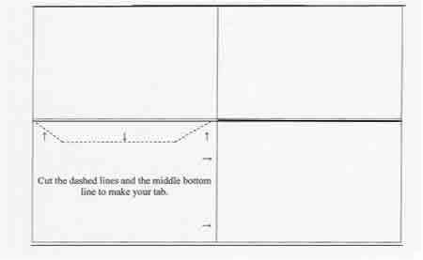

1. At the top of the page, in big letters, put the title of the page. The four titles are: **Carbohydrates, Lipids, Proteins, and Nucleic Acids.**
2. On the left side of the page, below the title, write the elements that are in the compound.
3. Under that, write a list of examples where this compound can be found.
4. On the right hand side, write the function of the organic compound.
5. Below that, write the building block.
6. On the lone bottom square, draw a picture of where this compound can be found or an example of this compound (Example – Protein – Draw a picture of an enzyme, or of a food that is high in protein)

. **\*\*\*\*BE SURE TO DRAW THE PICTURE DIAGNOLLY!!!!!\*\*\*\***

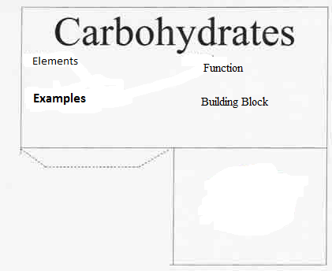

1. Once all four pages have been completed, it is time to glue and fold.
2. With the folds well creased, swing the picture square over on top of the tab **(ask your teacher to show you)**
3. Using the glue stick, glue the picture to the tab.
4. Do this for all of the pages
5. Each piece of paper should now look like a miniature stage (two walls and a floor (picture). Use glue sticks and glue the pages together so that pictures are on the floor and the information is pointed outwards.

**Post Lab Questions:**

1. **What did you use as an example for lipids?**
2. **What did you use for an example of nucleic acid?**
3. **What did you use for an example of carbohydrates?**
4. **What did you use for an example of proteins?**
5. **Why are proteins important (functions)?**
6. **Proteins function based on their …**
7. **Color**
8. **Shape**
9. **Arrangement of amino acids**
10. **Both b & c**

**Discovering DNA Structure**

**Tish** [**Taylor**](http://www.woodrow.org/teachers/alumni.cgi?field0=Program/Year;query0=BI94;field1=Last+Name;query1=Taylor)  
1994 Woodrow Wilson Biology Institute

**Introduction**

Instead of giving students copious notes and diagrams on the structure of DNA, why not let them discover the structure?

**Teacher Information**

**Background Information:** In this paper lab students will work in cooperative groups of four and manipulate paper nucleotides to discover the structure of DNA. When you have finished with this lab, you will have a great model of DNA that you can hang on the ceiling; it will reach to the floor and then some probably. This paper model can serve as a continual illustration as you discuss mitosis, amino acid sequences and protein synthesis. Students enjoy this lab and you save many frustrating moments trying to teach your students DNA structure.

**Materials:** copies of the student pages of "Discovering DNA Structure" (1/student); paper nucleotides (1/student) (enlarge the nucleotides so that each nucleotide fits on one sheet of paper); tape.

**Teacher Preparations:** Enlarge the nucleotides so that ONE nucleotide will fit on ONE sheet of paper. Each student will get one giant nucleotide to color and cut out. Color coding should be left on the sheet. Make sure that you prepare enough nucleotides so that 1/4th of each class represents each of the four DNA nucleotides. When assigning the cooperative learning groups of four, give one student an adenine nucleotide, one student a cytosine nucleotide, etc. When the groups come together the next day, each nucleotide will be represented.

**Extension:** Have your students learn the DNA SONG. When they learn and sing this little song, they know the structure of DNA. This would make a good follow-up to this lab. This song is to the tune of "Row, Row, Row Your Boat." Your students will have a lot of fun with this one. You might have them sing it in rounds, or have a contest between classes.

We love DNA  
Made of nucleotides.  
Sugar, phosphate and a base  
Bonded down one side.

Adenine and thymine  
Make a lovely pair.  
Cytosine without guanine  
Would feel very bare.

Oh-h-h, de-oxy-ri-i-bo  
Nu-u-cleic acid  
RNA is ri-i-bo  
Nu-u-cleic acid

**STUDENT PAGE  
Discovering DNA Structure**

**D = deoxyribo  
N = nucleic  
A = acid**

DNA contains the information for carrying out the activities of the cell. How this information is coded or passed from cell to cell was at one time unknown. To break the code, today you will do a paper lab to determine the structure of DNA and show how the genetic code is carried. Each member of your group has a molecule called a NUCLEOTIDE. DNA is made up of repeating units of nucleotides.

1) Look at your nucleotide and the nucleotides of the other members of your group. What are the THREE common parts of a nucleotide?

________________

________________

________________

2) What is the ONE part of a nucleotide that differs among the four DIFFERENT nucleotides in your group?

_____________________

3) List the four different kinds of nitrogen bases.

_______________________

_______________________

_______________________

_______________________

1. Manipulate the nucleotide pieces until you find the best fit. Join the nucleotide molecules in your group together like a puzzle. Use tape to connect and reinforce the molecules. Place you group’s DNA molecule on a piece of construction paper. You now have a molecule of DNA.

In the space below, explain WHERE the nucleotide molecules connect to each other.

______________________________________________________________________________________________________________________________________________________________________________________________________________________________________________________________________

5) A real DNA molecule consists of THOUSANDS of these pairs of nucleotides. What is the pairing arrangement of nitrogen bases?

_________ pairs with __________and ____________ pairs with ____________

1. Are there always going to be an EQUAL number of adenine and thymine nucleotides in a molecule?

(Yes / No)

Why? ___________________________________________________________________

1. Are there always going to be an EQUAL number of guanine and cytosine molecules in a molecule of DNA?

(Yes / No)

Why? _____________________________________________________________________

8) Scientists abbreviate the nitrogen bases by using the first letter of each base. So,

A always binds to ____  
 G always binds to ____

9) In the space below, use the letters to show the sequence (order) of the bases in the DNA molecule that your group constructed. Begin at the top left side of your molecule.

|  |
| --- |
| **Your Groups DNA Molecule** |
|  |

The structure of DNA is actually in a DOUBLE HELIX arrangement.

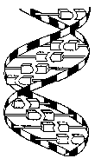

DOUBLE HELIX means that the two long chains of nucleotides are arranged in a spiral like a twisted ladder.

10) The sides (or "uprights") of the ladder are made up of alternating _____________ and _____________ molecules. The steps (or "rungs") of the ladder are made of _______________ held together by HYDROGEN BONDS.

**Student Page (Enlarge to one nucleotide per page)  
DNA Nucleotides**

**Color the nucleotides using the following key:**

|  |  |
| --- | --- |
| Deoxyribose = red | Phosphate = blue |
| A (Adenine) = green | C (Cytosine) = yellow |
| G (Guanine) = purple | T (Thymine) = orange |

**Cut out your nucleotides 🡪 On the next two pages**

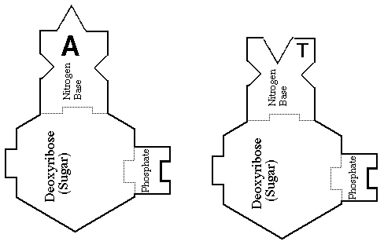

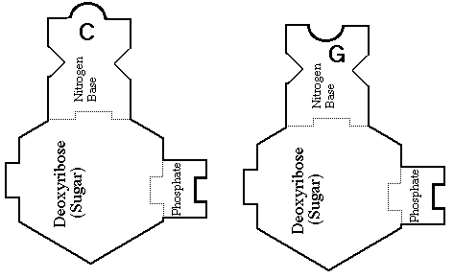

**Making Connections NYS Lab (Student Written Report Organizer)**

Name___________________________ Date___________

**Final Report**

**Title:** ______________________________________________________________

**Hypothesis:** __________________________________________________________________________________________________________________________________________________________

**Methods & Materials (Experiment):** _________________________________________________________________________________________________________________________________________________________________________________________________________________________________________________________________________________________________________________________________________________________________________________________________

**\*\*\*DO YOUR EXPERIMENT\*\*\***

**Data Collected (Make a Chart Below)**

**Discussion & Conclusions:**

**__________________________________________________________________________________________________________________________________________________________________________________________________________________________________________________________________________________________________________________________________________________________________________________________________________________**

**Suggestions for Improvement:**

**_______________________________________________________________________________________________________________________________________________________________________________________________________________________________________________________________________________________________________________________________________________**

**Suggestions for Further Research:**

**__________________________________________________________________________________________________________________________________________________________________________________________________________________________________________________________________________________________________________________________________________________________________________________________________________________**

Name____________________________ Date______________

Living Environment Lab

**Discovering Where Proteins Are Found**

**Important Functions of Proteins (Do-Now)**

**1) ______________________________**

**2)______________________________**

**3)______________________________**

**4)______________________________**

**5)______________________________**

**Introduction:**

Your physical traits, from the shape of your ears to the color of your eyes, are determined by the proteins in your body. The rate of chemical reactions that keep you alive are controlled by proteins called enzymes. Proteins have many important functions, which you outlined above. Some of these proteins are made in your cells through chemical reactions. Proteins are also present in the food that you eat.

**Problem:**

How can you find out whether a food contains proteins?

**Materials per group:**

* 6 test tubes
* 1 test tube rack
* 1 glass marking pencil
* Test tube stoppers
* 1 (100 mL graduated cylinder filled with water)
* 1 (10 mL graduated cylinder)
* Protein testing solution A
* Protein testing solution B
* Small sample of eggs
* Small sample of cottage cheese
* Small sample of butter
* Small sample of tuna
* Small sample of milk
* Small sample of cooking oil

**Procedure:**

1. Place a **small** sample of each of the foods listed on the chart into a separate test tube. Use the glass-marking pencil to label each sample.
2. Add 5mL of water to sample in test tube. Stopper and shake to mix with water.
3. Add **5 drops of Protein Testing Solution A**, and then add **5 drops of Protein Testing Solution B.**
4. Seal the test tube with a stopper and shake. Observe what happens. **A pink or purple color indicates the presence of a protein.** If you do not see any color change, no protein is present. Record your observations in the Data Table.
5. Repeat steps 2-4 for the rest of the food samples (5 test tubes)
6. Have someone from the group write your results on the board (Chart)
7. Clean you lab set-ups using the wire brushes provided
8. Turn test tubes upside down in rack for drying
9. Put all your lab supplies back exactly the way they were before you began using them.

10) Wash your hands

11) Start the post-lab questions

**Pre-Lab Questions:**

1. A chemical test using a substance called an indicator can be used to find out if a food contains protein. What indicator will you use in this investigation?

__________________________________________________________________________

__________________________________________________________________________

2) How can an indicator show that protein is present in a food? __________________________________________________________________________

3) Can an indicator show that a food does not contain protein? If so, how?

__________________________________________________________________________

4) What measuring tool will you use to measure 5mL of water?

_________________________________________________________________________

5) Get into your groups and select a job 🡪 Write the person’ name next to their job.

|  |  |
| --- | --- |
| **Job** | **Name** |
| 1) Getting lab equipment (See material  above) |  |
| 2) Filling Test tubes w/ food samples &  Labeling test tubes (follow step 1) |  |
| 3) Mixing samples w/water and protein  solutions A&B (follow step 2 and 3) |  |
| 4) Writing results on board & Cleaning  set-ups (follow steps 6 – 9) |  |

**DATA TABLE**

|  |  |
| --- | --- |
| **Food Sample** | **Protein Present (Yes or No)** |
| **1) Eggs** |  |
| **2) Cottage cheese** |  |
| **3) Butter** |  |
| **4) Tuna** |  |
| **5) Milk** |  |
| **6) Cooking oil** |  |

**Post-Lab Questions:**

1) Which foods contained proteins? ______________________________________________________________________________________________________________________________________________________________________________________________________________________________

1. How can your data table be used to classify the tested foods?

____________________________________________________________________________________________________________________________________________________

1. An iodine solution will change color if it is added to food that contains starch. Design an experiment to determine if a food contains starch, protein or both. HINT 🡪 Think about the experiment you just did.

____________________________________________________________________________________________________________________________________________________

1. In this type of experiment, what is the meaning of a substance testing positive or negative?

____________________________________________________________________________________________________________________________________________________

1. Can the biuret reagent tell you how much protein (grams of protein) is in a sample of food?

____________________________________________

1. Why are proteins important? ________________________________________________
2. Proteins function based on their…
3. Shape
4. Color
5. Arrangement of Amino Acids
6. Both a & c

Name: __________________________________ Date Completed: _____________________________

Class: ____________ Lab Minutes: _______________ Teacher: _______________________________

**Safety in the Biology Laboratory**

*This lab was created by Ms. Blanarovich from Minisink Valley High School. Credit is given for this activity to Ms. Blanarovich.*

**Background:** If there is one thing that can ruin a biology laboratory experiment or experience, it is the simple act of an accident or incident affecting a student, class, or the entire school. As such, there are certain rules and regulations that MUST be followed to ensure that everyone and everything remains safe. Completing the laboratory is a good way to make yourself aware of the hazards that may exist and be proactive with respect to your well-being and the safety of your fellow students.

**Purpose:** The purpose of this laboratory experience is:

-to make certain you know and agree to follow the rules and regulations that help keep the biology laboratory a safe place to work and gain knowledge.

-to identify hazards and to implement a plan to react and respond to a hazardous condition if it presents itself.

-to agree with your teacher and your school that you will make your laboratory experience a positive learning time where you can gain valuable knowledge that supports the classroom curriculum.

-to agree that you will complete the 1,200 minutes of lab as well as the required New York State Education Department’s mandated laboratory experiences in a timely fashion.

**Materials**: The following materials are needed to complete this laboratory experience:

lab papers pencil, pens

**Procedure:** The following procedure is utilized to perform this experience:

1. The following list of regulations and precautions will be followed in our laboratory. Read each safety rule.
2. Give a reason as to why that rule is important and then initial in the space provided indicating your will observe and obey this rule when you are working in the Biology laboratory. Safety in the laboratory must be a primary concern to both student and teacher.
3. Lab Completion Agreement: Read and sign the attached laboratory completion agreement.

|  |  |
| --- | --- |
| Rule | Why is it Important? |
| At the beginning of most laboratories, your instructor will engage in a pre-lab discussion. Many safety procedures will be discussed during these discussions. Listen attentively and follow these procedures -- "an ounce of prevention is worth a pound of cure". |  |
| Keep all books, papers, and other flammable  materials away from hot plates or dangerous chemicals. |  |
| Tie back long hair when you are working with an open flame. Pipe cleaners, rubber bands, and string are useful for this purpose. |  |
| Do NOT mix chemicals or perform unscheduled (unsanctioned) experiments without your teacher's approval |  |
| Never use chemicals from an unlabeled container. Do not taste, smell, or touch chemicals unless specifically instructed by your teacher to do so. |  |
| Wear safety goggles during experiments involving heating or hammering or while using acids or bases. If you do not have goggles on, stay away from students that are experimenting. |  |
| It is also expected that you will wear goggles while doing dissections. |  |
| Point the open end of a test tube or flask away from yourself and others while heating it. Never heat a closed container. |  |
| Use squeeze bottles and droppers only for their intended purpose. |  |
| A common accident is picking up red hot materials. Take proper precautions against this. |  |
| No material should be left in the sinks; i.e. paper, beakers, etc. |  |
| Discard all waste matter in the appropriate containers. |  |
| Never place pencils, pens, or other materials in your mouth. |  |
| NEVER return excess chemicals back to their container. |  |
| Be certain that all laboratory equipment and materials are returned to their appropriate storage areas at the end of the laboratory period. |  |
| Keep volatile liquids and reagents away from heating sources. |  |
| Know where all laboratory safety equipment is located in case you need it. |  |
| Most chemical spills are best handled by washing the affected area with water as quickly as possible. Call your teacher for assistance if necessary. Severe spills may require the removal of clothing. |  |
| In an emergency situation an all too common response is panic. If you observe another student in trouble, tell them what to do, and assist them in doing it. |  |
| You are responsible for keeping your laboratory  area and completely neat and clean. |  |

**Laboratory Completion Agreement**

The Living Environment offers a variety of laboratory exercises on current concepts in biology often using state of the art scientific equipment and technology. Various teaching techniques and materials will be employed to provoke student interest and enhance student understanding. Numerous laboratory methods will be utilized in demonstrations and student experiments. Safety instruction will be given and safe practices will be stressed in all laboratory work. Students will exercise critical thinking for solving problems and interpreting laboratory results.

**STUDENT LABORATORY CONTRACT**

I, ___________________________________________, a student at The Scholars’ Academy, have thoroughly read the Laboratory Safety Rules and Guidelines and do hereby agree to follow all safety rules and procedures given therein. I will conduct myself in a safe and conscientious manner in the laboratory. I will not perform any unauthorized lab procedure. I understand that misbehavior in the lab or failure to follow safe lab procedures could cause a serious accident. I further understand that a violation of these rules could result in my not being allowed to participate in future lab exercises.

Student Signature: ______________________________________ Date: ___________________

**\*\*\*\*\*\*\*\*\*\*\*\*\*\*\*\*\*\*\*\*\*\*\*\*\*\*\*\*\*\*\*\*\*\*\*\*\*\*\*\*\*\*\*\*\*\*\*\*\*\*\*\*\*\*\*\*\*\*\*\*\*\*\*\*\*\*\*\*\*\*\*\*\*\*\*\*\*\*\*\*\*\*\*\*\*\*\*\*\*\*\*\*\*\*\*\*\*\*\*\*\*\*\*\*\*\*\*\*\*\*\*\*\*\*\*\*\*\*\*\*\*\*\*\*\*\*\*\*\*\*\*\*\*\*\*\*\*\*\*\*\*\*\*\*\*\*\***

**Questions:** The following can be concluded from performing this laboratory experience:

Why was this experience given to you?

____________________________________________________________________________________________________________________________________________________________________________________________________________________________________________________________________________________________________________________________________________________________

What did you learn by completing this experience?

____________________________________________________________________________________________________________________________________________________________________________________________________________________________________________________________________________________________________________________________________________________________

Describe a situation that could arise in lab. How would you respond to it?

____________________________________________________________________________________________________________________________________________________________________________________________________________________________________________________________________________________________________________________________________________________________

**Analysis Questions:** Answer the following questions in the spaces provided:

It is crucial that you understand a few things about this classroom. As such,

* + - 1. How do you exit this room in case of a fire or fire drill? What if the entrance is blocked?

____________________________________________________________________________________________________________________________________________________________________________________________________________________________________________________________________________________________________________________________________________________________

* + - 1. Describe at least three things that you would recognize as being hazards that could exist? What would you do about correcting the hazard?

____________________________________________________________________________________________________________________________________________________________________________________

Name: __________________________________ Date Completed: _____________________________

**The Scientific Method**

*This lab was created by Ms. Blanarovich from Minisink Valley High School. Credit is given for this activity to Ms. Blanarovich.

**Essential Question:**

Why is it essential for scientists to conduct controlled experiments?

**Introduction:**

Scientists conduct experiments in order to test their hypotheses and answer their questions. A well-designed experiment must have a control. A controlled experiment has at least two groups. There is a control group and an experimental group. The control group is used for comparison. The experimental group is the group that gets tested. The results of the experimental group are compared to the results of the control group. The control group should be as identical as possible to the experimental group. The only difference is that the control group is not tested or changed. When an experiment does not have a control group then the scientist is unable to figure out the reason for any changes observed during the experiment.

**Purpose:**

The purpose of this lab is to:

* Analyze a scientific experiment
* Identify mistakes in a scientific experiment
* Improve a scientific experiment
* Expand scientific vocabulary
  + Hypothesis
  + Control
  + Data
  + Variable
  + Valid
  + Conclusion

**Hypothesis:**

A well-designed experiment always has a control group. A controlled experiment is able to test the hypothesis and answer the experimental questions. Without a control group, it is not possible to determine the cause of any changes observed during the experiment.

**Materials:**

The materials needed for this lab are as follows:

* Pictures of puppies of different sizes
  + Experiment # 1: One puppy
  + Experiment # 2: One very big and the other very little puppy Props
  + Experiment # 3: 2 identical toy dogs
* Pet food & jar of vitamins for demonstration

**Procedures:**

1. Teacher reads experiment # 1 to class using props.
2. Class discusses possible answers to questions for experiment # 1.
3. Teacher reads experiment # 2
4. In lab groups, students discuss and answer questions for experiment # 2.
5. Repeat steps c) and d) for experiment # 3.

**A Dogged Investigation**

Mr. Curiosa loved to observe the world around him. He was very inquisitive and was always asking questions about what he saw, heard, smelled, tasted and felt. He liked to figure out the answers to his questions by doing experiments.

**Experiment # 1:**

On his birthday Mr. Curiosa’s wife gave him a puppy. He named it Bluebell. He noticed that Bluebell did not like to eat store-bought puppy chow. So, he set out to make a better dog food. Mr. Curiosa did some reading on dogs and their dietary requirements and he made a special vitamin mixture. He began adding the vitamins to his dog’s pet food.

After a year, Mr. Curiosa was very pleased with the way Bluebell had grown, and he showed pictures of the dog to his friends.

“That’s nothing”, one friend said, “What did the dog look like before you started giving it your special food?”

So Mr. Curiosa brought pictures of the dog when it was a tiny puppy. By comparing pictures, you could see that the puppy had indeed grown.

“That’s still nothing”, the friend replied. “All puppies grow; it probably had nothing to do with your new vitamin mixture.”

Mr. Curiosa realized that his friend was right. His experiment had not proven that his new vitamin formula worked.

**Questions for Experiment # 1:**

1. Using some of the steps of the scientific method, describe Mr. Curiosa’s first experiment:
2. Observation (what observations did Mr. Curiosa make that lead to his experiment):

________________________________________________________________________________________________________________________________________________________________________________________________________________________________________________________________________

1. Question (What was Mr. Curiosa’s main question?):

________________________________________________________________________________________________________________________________________________________________________________________________________________________________________________________________________

1. Hypothesis (What was Mr. Curiosa’s hypothesis?):

________________________________________________________________________________________________________________________________________________________________________________________________________________________________________________________________________

1. Procedure/methods (What did Mr. Curiosa do? What data did he collect?):

________________________________________________________________________________________________________________________________________________________________________________________________________________________________________________________________________

1. Results (What were Mr. Curiosa’s findings?)

________________________________________________________________________________________________________________________________________________________________________________________________________________________________________________________________________

1. Conclusions (What did Mr. Curiosa conclude from his experiment?)

________________________________________________________________________________________________________________________________________________________________________________________________________________________________________________________________________________________________________________________________________________________________

**Experiment #2**

Like a dedicated scientist, Mr. Curiosa did not give up. He persevered with his efforts to demonstrate that he had made a better, healthier dog food. He wanted to prove that his special formula worked.

Sometime later, his son brought home a Black Labrador puppy named **Coal**. So, Mr. Curiosa went to his local dog shelter and brought home an adorable, puppy that looked like a dachshund. He named this puppy **Dirt**. Thus began his second experiment.

Mr. Curiosa added his special vitamin mixture to some commercial dog food and labeled it ‘**A**’. Then he took the same commercial dog food but this time he did not add any of his vitamins. He labeled this dog food ‘**B**’. Coal received food **A** and Dirt received food **B**.

For an entire year Mr. Curiosa made sure that each dog got their own food. He brought the dogs to his company picnic and proudly showed them off. **Coal**, the black Labrador, had grown twice as big as **Dirt** who was part Dachshund.

“You think you made some fancy dog food, huh?” one friend said. “You can not prove that your special dog food is better. Labradors always grow bigger than Dachshunds! His larger size had nothing to do with your fancy dog food.”

Mr. Curiosa realized that his friend was right. He had made a mistake in his second experiment.

**Questions for Experiment # 2:**

1. Which one of the steps in the scientific method did Mr. Curiosa improve on in his second experiment?

_____________________________________________________________________________________________________________________________________________________________________________________________________________________­­­­­­­­­­­­­­­­­­­­­­­­­­___________________________________________________

1. What did Mr. Curiosa do differently?

________________________________________________________________________________________________________________________________________________________________________________________________________________________________________________________________________

1. Why was this change important?

________________________________________________________________________________________________________________________________________________________________________________________________________________________________________________________________________

1. Why were Mr. Curiosa’s results inconclusive?

________________________________________________________________________________________________________________________________________________________________________________________________________________________________________________________________________________________________________________________________________________________________

**Experiment # 3:**

So, Mr. Curiosa went back to work. He vowed he would design an experiment so that no one would question the results. He wanted everyone to believe and trust his conclusions.

This time around, he invested some of his savings and bought twin, male beagle puppies. They were from the same litter. One he called **Wrinkles** and the other he called **Freckles**. For a whole year, **Wrinkles** ate only food **A** (+ special vitamins) and **Freckles** ate only food **B** (- special vitamins). They drank the same water and got the same amount of exercise every day. Their daily lives were very much the same. Mr. Curiosa weighed the dogs every week and recorded their weights.

This year’s picnic was a great success. Mr. Curiosa brought his dogs and a scale. His friends were very impressed. Wrinkles was larger and his fur was beautiful and shiny. Freckles was cute, too. However, it was obvious that he had not grown as well as Wrinkles. Mr. Curiosa weighed both dogs and sure enough Wrinkles weighed two kilograms more than Freckles. Even Mr. Curiosa’s boss was impressed. This time, all of his co-workers believed that his special vitamin formula really worked.

Within six months, Mr. Curiosa had a contract with a commercial pet food company to market his special vitamin formula worldwide. He had fancy business cards that said, “Mr. George Curiosa, Experimental Canine Dietician”. He was a very satisfied scientist (and wealthy, too!).

To this day, both Wrinkles and Freckles are doing fine. Once the experiment was over, Freckles got the special dog food as well!

**Questions for Experiment # 3:**

1. What improvements did Mr. Curiosa make this time?

________________________________________________________________________________________________________________________________________________________________________________________________________________________________________________________________________

1. Why were these changes important?

________________________________________________________________________________________________________________________________________________________________________________________________________________________________________________________________________

1. Explain whether or not Mr. Curiosa’s conclusions were valid this time:

________________________________________________________________________________________________________________________________________________________________________________________________________________________________________________________________________

1. In what ways could he have improved this experiment even further?

________________________________________________________________________________________________________________________________________________________________________________________________________________________________________________________________________

**Analysis Questions:**

1. What qualities make a good scientist? ______________________________________________________________________________________________________________________________________________________________________________________________________________________________________________________________________________
2. How does Mr. Curiosa demonstrate these traits?

____________________________________________________________________________________________________________________________________________________________________________________

1. What is an experimental control?

___________________________________________________________________________________________________________________________________________________________________________________________________________________________________________________________________________

1. In experiment # 3, which dog was the control group and which dog was the experimental group?

___________________________________________________________________________________________________________________________________________________________________________________________________________________________________________________________________________

1. What is a variable?

________________________________________________________________________________________________________________________________________________________________________________________________________________________________________________________________________

1. List the variables in experiment # 3:

________________________________________________________________________________________________________________________________________________________________________________

1. Mr. Curiosa kept records of Freckle’s and Wrinkle’s body weights. What term is used to refer to these measurements?

_________________________________________________________________________________________

**Name______________________________ Date _______**

**Ecology**

**Symbiosis (Symbiotic Relationships)**

***Complete questions and try to identify the type***

***of symbiotic relationship each pair of organisms displays.***

1. **List three ways that organisms interact within an ecosystem.**
2. **Animals that feed exclusively on herbivores are known as**

**________________________________.**

1. **Animals that feed exclusively on producers are known as**

**__________________________________________.**

1. **Animals that feed on herbivores and producers are known as**

**__________________________________.**

1. **Which type of organism creates energy (sugar) for the rest of the ecosystem?**
2. **Consumers**
3. **Producers**
4. **Heterotrophs**
5. **Decomposers**
6. **How do decomposers help an ecosystem stay balanced?**

**_____________________________________________________________**

1. **Define Commensalism.**

**_____________________________________________________________**

**_____________________________________________________________**

1. **Define Parasitism.**

**_____________________________________________________________**

**_____________________________________________________________**

1. **Define Mutualism.**

**_____________________________________________________________**

**_____________________________________________________________**

1. **What is an organic compound? ___________________________________________________________**

**___________________________________________________________**

**Provide an example of an organic compound? _____________________**

**Provide an example of an inorganic compound? _____________________**

***Identify the relationships below using the terms commensalism,***

***parasitism, mutualism, or no relationship. Descriptions of the relationships will be provided if the relationship is unclear.***

1. **Humans and domesticated dogs. ___________________________**

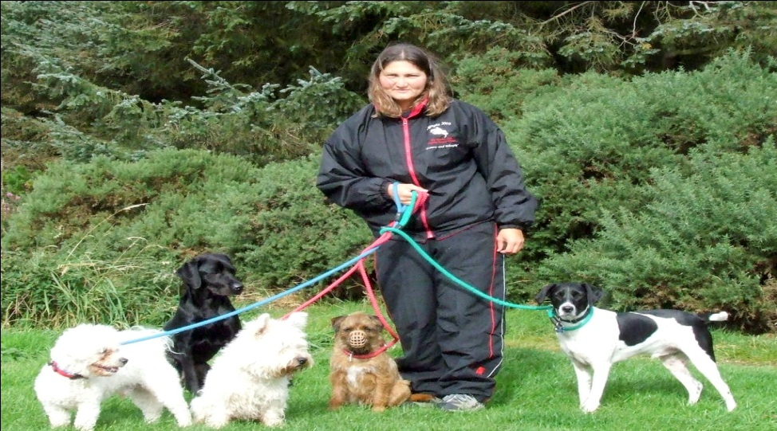

1. **Lichen (composed of fungi and algae). ________________________**

**Algae makes food (sugar) and fungi attaches and absorbs nutrients from the environment through the process of _______________.**

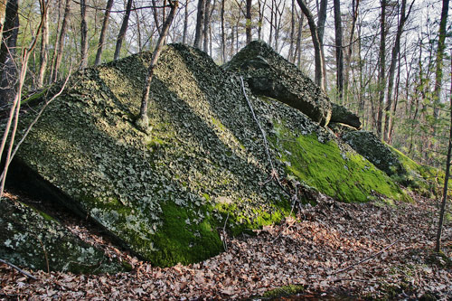

1. **Tapeworms and humans. __________________________**

**Tapeworms infect human’s intestines and use the nutrients from the human’s food.**

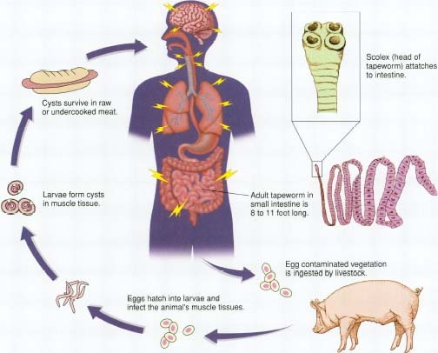

1. **Sea anemones and clownfish. ______________________________**

**Sea anemone protects clownfish from predators and provides a habitat and the clownfish cleans the sea anemone and provides it with better water circulation.**

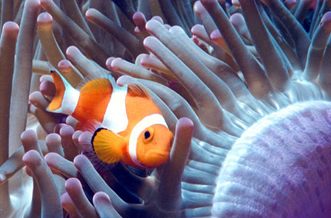

1. **Blood fluke and humans. ________________________________**

**The fluke is a type of flatworm that lives off the blood of humans. The f**

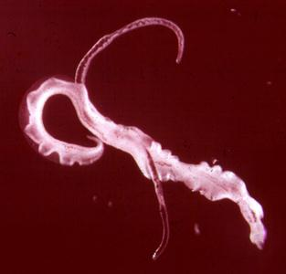

1. **Bird living in a tree. ______________________________**

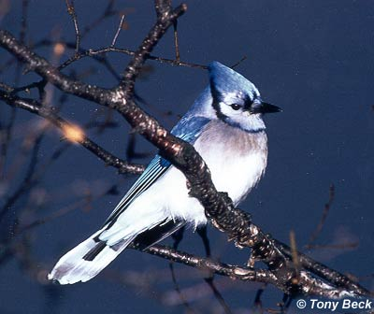

1. **Flowering plants and bees. _____________________________________**

**Bees transfer pollen to other plants for plant reproduction (cross-pollination) and bees get nectar from the flowers and convert it into honey.**

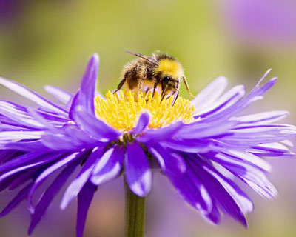

1. **Spider monkey living in a tree. ________________________________**

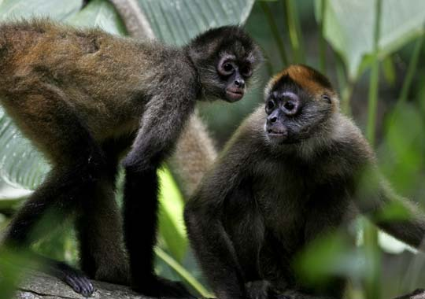

1. **Anglerfish and bioluminescent bacteria. ___________________________**

**Bacteria live inside fish (shelter) and the bacteria have chemical reactions that provide light for the fish. This light allows the anglerfish to attract prey.**

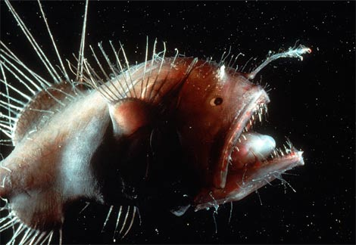

1. **Whales and barnacles. _______________________________**

**Barnacles are filter feeders that attach and live on whales. They don’t have to compete with other filter feeders attached to the bottom of the ocean floor. They don’t hurt the whale they just live on them.**

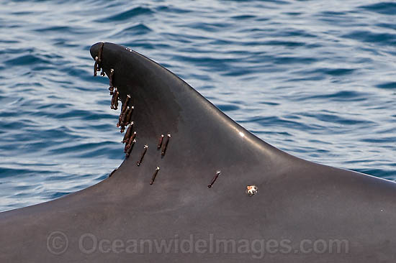

1. **Tics and deer. _________________________________**

**Tics feed off the blood of the deers.**

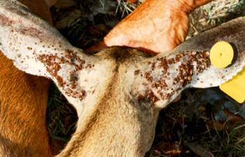

1. **Fleas and dogs. _________________________________________**

**Fleas feed off the blood of dogs.**



1. **Sharks and remora. __________________________________**

**The remora (small fish) hangout under the shark and feed on the left overs. The shark is not bothered by the remoras.**

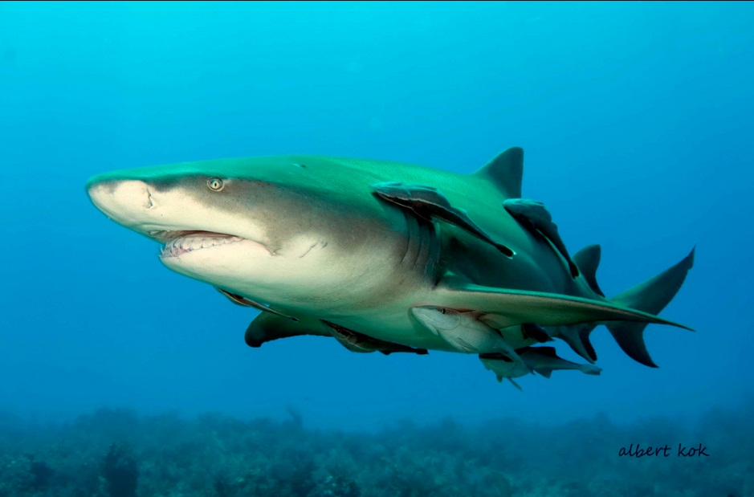

1. **Humans and intestinal bacteria. ______________________________**

**Humans have bacteria living in their intestines that produce important compounds for humans such as, vitamins and enzymes. They also help maintain the pH of the digestive tract.**

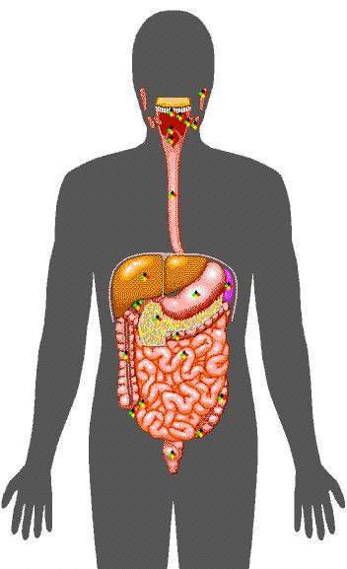

1. **Deep sea tubeworms & thermophilic bacteria. ___________________**

**Bacteria live inside the tubeworms and are producers that use chemosynthesis to produce energy. The tubeworms provide the bacteria with a habitat (place to live) and the bacteria make energy for the tubeworms.**

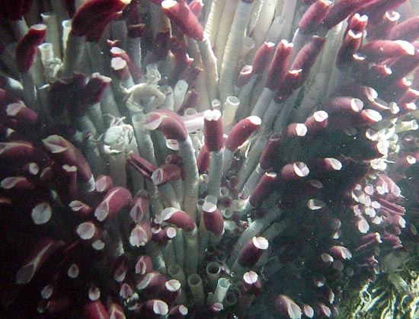

1. **Malaria protists and human. ________________________________**

**The malaria protists infect humans through mosquito vectors. Once the protists enter the human they destroy their red blood cells.**

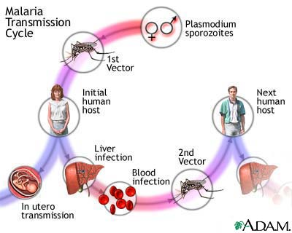

**Post Lab Questions:**

1. **From relationship number 12 identify the**

**Parasite _________________**

**Host ____________________**

1. **How many mutual relationships did you find? __________________**
2. **How many relationships of commensalism did you find? _____________**
3. **How many parasitic relationships did you find? ___________________**

**Genetics Practice Problems**

Name__________________________

1. For each genotype, indicate whether it is heterozygous (HE) or homozygous (HO)

|  |  |  |  |
| --- | --- | --- | --- |
| AA _______ Bb ______ Cc ______ Dd ______ | Ee ______ ff ________ GG ______  HH ______ | Ii ______ Jj ______ kk ______ Ll ______ | Mm ______ nn ______ OO ______ Pp ______ |

2. For each of the genotypes below, determine the phenotype.

|  |  |
| --- | --- |
| *Purple flowers are dominant to white flowers* PP ___________________________ Pp ___________________________ pp ___________________________ | *Brown eyes are dominant to blue eyes*  BB ___________________________  Bb ___________________________  bb ___________________________ |
| *Round seeds are dominant to wrinkled* RR ___________________________ Rr ___________________________ rr ___________________________ | *Bobtails are recessive (long tails dominant)* TT ___________________________ Tt ___________________________ tt ___________________________ |

3. For each phenotype, list the possible genotypes. (Remember to use the letter of the dominant trait)

|  |  |
| --- | --- |
| *Straight hair is dominant to curly.* ____________ straight ____________ straight ____________ curly | *Pointed heads are dominant to round heads.* ____________ pointed ____________ pointed ____________ round |

4. Set up the square for each of the crosses listed below. The trait being studied is extra fingers or toes (dominant) and normal number of fingers and toes (recessive)

|  |  |  |
| --- | --- | --- |
| Tt x tt | http://www.biologycorner.com/resources/punnett_blank.gif | What percentage of the offspring will have extra toes? ___________ |
| Tt x Tt | http://www.biologycorner.com/resources/punnett_blank.gif | What percentage of the offspring will have extra toes? ___________ |
| TT x tt | http://www.biologycorner.com/resources/punnett_blank.gif | What percentage of the offspring will have extra toes? ___________ |

Practice with Crosses. Show all work!

5. A TT (tall) plant is crossed with a tt (short plant).   
What percentage of the offspring will be tall? ___________

6. A Tt plant is crossed with a Tt plant. What percentage  
of the offspring will be short? ______

7. A heterozygous round seeded plant (Rr) is crossed with a  
homozygous round seeded plant (RR). What percentage of   
the offspring will be homozygous (RR)? ____________

8. A homozygous round seeded plant is crossed with a homozygous   
wrinkled seeded plant. What are the genotypes of the parents?   
__________ x __________

What percentage of the offspring will also be homozygous? ______________

9. In pea plants purple flowers are dominant to white flowers.   
If two white flowered plants are cross, what percentage of their   
offspring will be white flowered? ______________

10. A white flowered plant is crossed with a plant that is   
heterozygous for the trait. What percentage of the   
offspring will have purple flowers? _____________

11. Two plants, both heterozygous for the gene that controls  
flower color are crossed. What percentage of their offspring  
will have purple flowers? ______________  
What percentage will have white flowers? ___________

12. In guinea pigs, the allele for short hair is dominant.   
What genotype would a heterozygous short haired guinea pig have? _______  
What genotype would a purebreeding short haired guinea pig have? _______  
What genotype would a long haired guinea pig have? ________

13. Show the cross for a pure breeding short haired guinea pig  
and a long haired guinea pig.  
What percentage of the offspring will have short hair? __________

14. Show the cross for two heterozygous guinea pigs.  
What percentage of the offspring will have short hair? ________  
What percentage of the offspring will have long hair? _______

Name_________________________ Date_____________________

**Human Impact on Ecosystems**

1. List some ways, in the chart below, that humans affect ecosystems.

|  |  |
| --- | --- |
| **Negative** | **Positive** |
|  |  |
|  |  |
|  |  |
|  |  |
|  |  |
|  |  |
|  |  |

1. What are resources? ____________________________________________________________________________________________________________________________________________________
2. Which type of resource will eventually run out? (Renewable or Nonrenewable)
3. List 10 resources that are important to humans.

__________________________________________________________________________________________________________________________________________________________________________________________________________________________________________________________________________________________________________________________________________________________________________________

1. What is the carrying capacity of an ecosystem? ________________________________

__________________________________________________________________________

__________________________________________________________________________

**U.S. & World Population Clocks**

**You are here:** [**Census.gov**](http://www.census.gov/)

[Skip top of page navigation](http://www.census.gov/main/www/popclock.html#SKIP2#SKIP2)

[**Population Clocks**](http://www.census.gov/main/www/popclock.html)

**U.S. 307,925,597**  
**World 6,796,786,166**  
16:42 UTC (EST+5)

Nov 13, 2009

**World Population Growth**

|  |  |
| --- | --- |
| **Year** | **Population** |
| **1** | **200 million** |
| **1000** | **275 million** |
| **1500** | **450 million** |
| **1650** | **500 million** |
| **1750** | **700 million** |
| **1804** | **1 billion** |
| **1850** | **1.2 billion** |
| **1900** | **1.6 billion** |
| **1927** | **2 billion** |
| **1950** | **2.55 billion** |
| **1955** | **2.8 billion** |
| **1960** | **3 billion** |
| **1965** | **3.3 billion** |
| **1970** | **3.7 billion** |
| **1975** | **4 billion** |
| **1980** | **4.5 billion** |
| **1985** | **4.85 billion** |
| **1990** | **5.3 billion** |
| **1995** | **5.7 billion** |
| **1999** | **6 billion** |
| **2006** | **6.5 billion** |
| **2009** | **6.8 billion** |
| **2011** | **7 billion** |
| **2025** | **8 billion** |
| **2050** | **9.4 billion** |

**Look over The change in human population outlined above.**

1. Graph the change in human population from year ____________ to _____________.
2. What is the independent variable? __________________________
3. What is the dependent variable? ___________________________
4. How has the human population changed? ____________________________________
5. List 3 factors that contribute to this change in human population?

____________________________________________________________________________________________________________________________________________________

__________________________________________________________________________

1. If the human population continues to grow at the current rate, how might the availability of resources change?

_______________________________________________________________________________________________________________________________________________________________________________________________________________________________________

1. How many people do you think Earth can support? ______________________________________________________________________________________________________________________________________________________________________________________________________________

**Name___________________________ Date_________________**

**The Arizona Hedgehog Cactus: Endangered Species or Not?  
Gel Electrophoresis and Analysis - Lab Sheet**

**Assignment:** After participating in the classroom dramatization of the process of gel electrophoresis and the post-activity discussion, answer the following questions.

1. What is gel electrophoresis?
2. Why do scientists use gel electrophoresis?

3. What is the function of each of the following in gel electrophoresis of DNA?

* Agarose gel:
* Electric current:
* "Wells" in the gel:

4. Toward which pole (positive or negative) does DNA migrate when electric current is run through the gel? _____________ Why do the DNA molecules move toward this pole?

5. What would happen to the DNA fragments if you forgot to turn the current off?

4. Describe how different sized DNA fragments are separated by the gel matrix.

5. Examine the diagram of an agarose gel below and answer the following questions.  
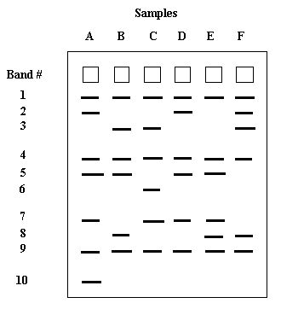

* What do the bands in the drawing of the agarose gel represent?
* Which band(s) traveled slowest?
* Which band(s) traveled fastest?
* On the above drawing, label the positive and negative ends of the gel.
* How many bands are shared in common by all of the individuals?
* Are there any bands which are unique to only one individual? ____ If so, which one?

**The Human Cheek Cell**

**Procedure:**

1. Put a drop of methylene blue on a slide. Caution: methylene blue will stain clothes and skin.  
2. Gently scrape the inside of your cheek with the flat side of a toothpick. Scrape lightly.  
3. Stir the end of the toothpick in the stain and throw the toothpick away.  
4. Place a coverslip onto the slide  
5. Use the SCANNING objective to focus. You probably will not see the cells at this power.  
6. Switch to low power. Cells should be visible, but they will be small and look like nearly clear purplish blobs. If you are looking at something very dark purple, it is probably not a cell  
7. Once you think you have located a cell, switch to high power and refocus. (Remember, do NOT use the coarse adjustment knob at this point)

1. List the 3 parts of the Cell Theory

______________________________________________________________

______________________________________________________________

______________________________________________________________

2. Describe or define each of the following

--cell membrane _______________________________________________________

--cytoplasm ___________________________________________________________

--nucleus _____________________________________________________________  
  
--organelle ____________________________________________________________

--diffusion ____________________________________________________________

--nutrients ____________________________________________________________

--waste ______________________________________________________________

--osmosis _____________________________________________________________

3. Sketch the cell at low and high power. **Label the nucleus, cytoplasm, and cell membrane of a single cell**. Draw your cells to scale.

|  |  |
| --- | --- |
| circle Low Power | circle High Power |

4. Why is methylene blue necessary?

5. The light microscope used in the lab is not powerful enough to view other organelles in the cheek cell. What parts of the cell were visible.

6. List 2 organelles that were NOT visible but should have been in the cheek cell.

7. Is the cheek cell a eukaryote or prokaryote cell? How do you know?

8. Keeping in mind that the mouth is the first site of chemical digestion in a human. Your saliva starts the process of breaking down the food you eat. Keeping this in mind, what organelle do you think would be numerous inside the cells of your mouth?

9. How are plant cells different than animal cells?

10. Name 3 nutrients that our cells need.

11. How does DNA help your cells function?

**Name_____________________ Date__________**

**Photosynthesis**

**1) What are autotrophs/producers?**

**___________________________________________________**

**___________________________________________________**

**___________________________________________________**

**2) Where does photosynthesis occur?**

**___________________________________________________**

**3) Write the chemical reaction for photosynthesis below.**

**__________**

**4) Why is photosynthesis necessary for the stability of ecosystems?**

**___________________________________________________**

**___________________________________________________**

**___________________________________________________**

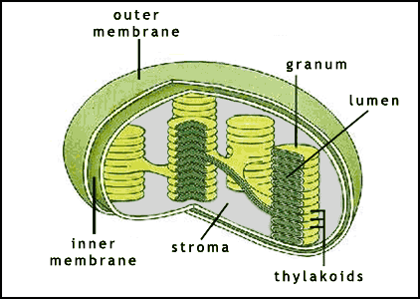

**5) How many stages do the chemical reaction photosynthesis**

**involve?**

**a) 10**

**b) 3**

**c) 4**

**d) 2**

**6) What is the name of these stages?**

**___________________________________________________**

**___________________________________________________**

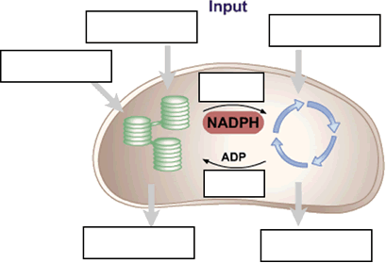

**7) Where does the light-dependent stage occur? ______________**

**8) Where does the light-independent stage occur? _____________**

**9) Which product is produced from the light-dependent stage?**

**________________________**

**10) Which product is produced from the light-independent stage?**

**_______________________**

**11) Which molecule/compound allows the chloroplast to absorb and**

**use the sun’s energy?**

**__________________________________**

**12) Draw and label your own chloroplast on an index card without**

**using your notes.**

**Name:______________________**

**(modified from www.biologyjunction.com/DNA.doc)**

**DNA -  The Double Helix**

Recall that the nucleus is a small spherical, crucial part in a cell.  It is often called the "control center" because it controls all the activities of the cell including cell reproduction, and heredity. Chromosomes are microscopic, threadlike strands composed of the chemical DNA (short for deoxyribonucleic acid).  In simple terms, DNA controls the production of proteins within the cell.  These proteins in turn, form the structural units of cells and control all chemical processes within the cell.  Think of proteins as the the building blocks for an organism, proteins make up your skin, your hair, parts of individual cells. How you look is largely determined by the proteins that are made. The proteins that are made is determined by the sequence of DNA in the nucleus.

In 1953, James Watson and Francis Crick established the structure of DNA.  The shape of DNA is a double helix, which is like a twisted ladder. The sides of the ladder are made of alternating sugar and phosphate molecules.  The sugar is deoxyribose. **Color all the phosphates pink (one is labeled with a "p").   Color all the deoxyriboses blue (one is labeled with a "D")** .

The rungs of the ladder are pairs of 4 types of nitrogen bases.    The bases are known by their coded letters A, G, T, C.   These bases always bond in a certain way.  Adenine will only bond to thymine.  Guanine will only bond with cytosine. This is known as the "Base-Pair Rule". The bases can occur in any order along a strand of DNA. The order of these bases is the code the contains the instructions. For instance ATGCACATA would code for a different gene than AATTACGGA. A strand of DNA contains millions of bases. (For simplicity, the image only contains a few.)

**Color the thymines orange and label each thymine with a letter “T”. http://biologycorner.com/resources/thymine.gif  
Color the adenines green and label each adenine with a letter “A”. http://biologycorner.com/resources/adenine.gif  
Color the guanines purple, and label each guanine with a letter “G”. http://biologycorner.com/resources/guanine.gif  
Color the cytosines yellow, and label each cytosine with a letter “C”.** http://biologycorner.com/resources/cytosine.gif

Note that that the bases attach to the sides of the ladder at the sugars and not the phosphate.

The DNA helix is actually made of repeating units called nucleotides. Each nucleotide consists of three molecules: a sugar (deoxyribose), a phosphate which links the sugars together, and then one of the four bases: adenine, guanine, thymine and cytosine. **Color the nucleotides using the same colors as you colored them in the double helix.**

The two sides of the DNA ladder are held together loosely by hydrogen bonds. The DNA can actually "unzip" when it needs to replicate - or make a copy of itself. DNA needs to copy itself when a cell divides, so that the new cells each contain a copy of the DNA. Without these instructions, the new cells wouldn't have the correct information. The hydrogen bonds are represented by small circles. **Color the hydrogen bonds grey**.

**Messenger RNA**

So, now, we know the nucleus controls the cell's activities through the chemical DNA, but how?  It is the sequence of bases that determine which protein is to be made.  The sequence is like a code that we can now interpret.  The sequence determines which proteins are made and the proteins determine which activities will be performed.  And that is how the nucleus is the control center of the cell.  The only problem is that the DNA is too big to go through the nuclear pores.  So a chemical is used to to read the DNA in the nucleus.  That chemical is messenger RNA.   The messenger RNA  (mRNA) is small enough to go through the nuclear pores.  It takes the "message" of the DNA to the ribosomes and "tells them" what proteins are to be made.  Recall that proteins are the body's building blocks. Imagine that the code taken to the ribosomes is telling the ribosome what is needed - like a recipe.

Messenger RNA is similar to DNA, except that it is a single strand, and it has no thymine. Instead of thymine, mRNA contains the base Uracil. In addition to that difference, mRNA has the sugar ribose instead of deoxyribose. RNA stands for **Ribonucleic Acid**. Color the mRNA as you did the DNA, except:  
**Color the ribose black, and the uracil brown**. http://biologycorner.com/resources/uracil.gif

|  |  |
| --- | --- |
| **DNA - The Double Helix** |  |
| **DNA NUCLEOTIDES** | |

**DNA Replication**

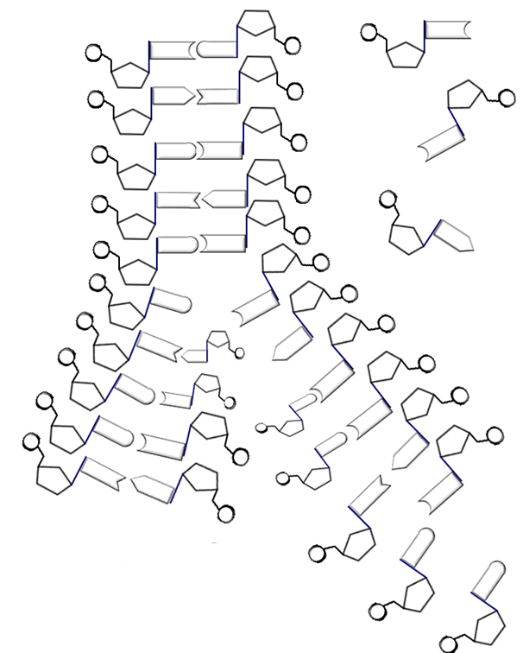

Name  ______________________________________

1.  Write out the full name for DNA. _____________________________________________

2.  What are genes made up of?_______________________________________________

3.  Where in the cell are chromosomes located? _______________________________________________________

4. What two scientists established the structure of DNA? __________________________________________________________

5. What are the 3 types of RNA? ___________________________________________________________

6.  What is the shape of DNA? ______________________________________

7. What are the sides of the DNA ladder made of? ________________________________________

8.  What are the "rungs" of the DNA ladder made of? _______________________________________________________

9.  What sugar is found in DNA? _______________________ In RNA? ____________________

10.  How do the bases bond together in DNA?   A  bonds with  _____      G  bonds with  _______

11. How do the bases bond together in RNA?   A  bonds with  _____      G  bonds with  _______

12. DNA is made of repeating units called _______________________________________________________

13.  Why is RNA necessary to act as a messenger?  Why can't the code be taken directly from the DNA? ____________________________________________________________________________________________________________________________________________________________________________________

14.  Where are proteins made in a cell? ___________________________________________________

15. Explain the purpose of DNA replication: _____________________________________________________ _________________________________________________________________________________________

16. During DNA replication, what is needed to “unzip” the double helix? ______________________________

17.  Why is DNA called the "Blueprint of Life"? __________________________________________________ ____________________________________________________________________________________________________________________________________________________________________________________

Name______________________________ Partners ____________

**(Modified from Pearson Text Book)**

**Problem:** How does exercise affect disposal of wastes from cellular respiration?

**Hypothesis:**

**Directions:**

1. Label two test tubes A and B. Put 10 ml of water and 5 drops of bromothymol blue solution in each test tube. Carbon Dioxide causes bromthymol blue to turn yellow or green.
2. Your partner will time you during this step. When your partner says “go”, slowly blow air through a straw into the bottom of test tube A.

***CAUTION – DO NOT INHALE THROUGH THE STRAW***

1. When the solution changes color, your partner should say “stop” and then record how long the color change took.
2. Jog in place for 2 minutes.
3. Repeat steps 2-4 using test tube B.
4. Trade roles with your partner. Repeat steps 1 through 5.

**Observation Table:**

|  |  |  |
| --- | --- | --- |
| **Your Results** | Test Tube A |  |
| Test Tube B |  |

|  |  |  |
| --- | --- | --- |
| **Your Partner’s Results** | Test Tube A |  |
| Test Tube B |  |

**Analysis:**

1. What is the function of the respiratory system? ___________________________________________
2. What caused the bromothymol blue solution to change color?
3. Compare the time it took the bromothymol blue solution to change color before exercise and after exercise. _________________________________________________________
4. What is the manipulated variable in this experiement? ________________________ ________________________________ _________________________________________________________
5. What process in your body produces carbon dioxide? ____________________
6. Draw a picture depicting the carbon and oxygen cycle

Name_______________________________ Date:

**Investigating the emissions of different automobiles**

**Pre-lab Questions:**

1. What are the makes and models of your family’s cars?

__________________________________________  
__________________________________________

__________________________________________

__________________________________________

__________________________________________

1. Of your family’s cars, which do you believe is the most environmental friendly? _____________________________________________
2. What are the makes and models of your dream cars?

__________________________________________

__________________________________________

__________________________________________

__________________________________________

__________________________________________

1. Copy your dream vehicles and your families vehicles in the chart below
2. Complete the chart by filling in 30 random vehicles.
3. Go to <http://www.epa.gov/autoemissions> for the Air Pollution Score, and Greenhouse Gas Score of each vehicle.
4. Calculate the average Air Pollution and Greenhouse Gas score.

|  |  |  |
| --- | --- | --- |
| Make & Model of Vehicle | Air Pollution Score | Greenhouse Gas Score |
|  |  |  |
|  |  |  |
|  |  |  |
|  |  |  |
|  |  |  |
|  |  |  |
|  |  |  |
|  |  |  |
|  |  |  |
|  |  |  |
|  |  |  |
|  |  |  |
|  |  |  |
|  |  |  |
|  |  |  |
|  |  |  |
|  |  |  |
|  |  |  |
|  |  |  |
|  |  |  |
|  |  |  |
|  |  |  |
|  |  |  |
|  |  |  |
|  |  |  |
|  |  |  |
|  |  |  |
|  |  |  |
|  |  |  |
|  |  |  |
| AVERAGE RATINGS |  |  |

**Conclusion:**

1. What are some harmful effects of air pollution? _________________________________________________________________ ____________________________________________________________________________________________________________________________________
2. What is your family’s average Air Pollution Score?_____________________________
3. What is your family’s average Greenhouse Gas Score?___________________________
4. What is the average Air Pollution Score of your dream cars?_____________________
5. What is the average Greenhouse Gas Score of your dream cars?___________________
6. From the list that you compiled, which vehicle would be the best option for your family to purchase in order to help the environment?__________________________________
7. Aside from buying more efficient vehicles, what are some other things people can do to help reduce the amount of air pollution? ________________________________________________________________________________________________________________________________________________________________________________________________________________________________________________________________________

Name___________________________ Date:

(Modified from *http://www.huntington.org/Education/FIBR/download/2004/04PlantCell.pdf)*

**Lab: Mitosis in Onion Root Tips Introduction:**

All new cells come from previously existing cells. New cells are formed by the process of cell division which involves both replication of the cell’s nucleus and division of the cytoplasm (cytokinesis) to form two genetically identical daughter cells. There are two types of nuclear division: mitosis and meiosis. Mitosis typically results in new somatic (body) cells. To study the stages of mitosis, you need to look for tissues where there are many cells in the process of mitosis. In plants, this restricts your search to growing tips, such as the onion root tip.

|  |  |  |
| --- | --- | --- |
| **Phases of mitosis (in order)** | **Use this column to draw sketches of the what you see in the microscope** | **Use this column to describe what is occurring** |
|  |  |  |
|  |  |  |
|  |  |  |
|  |  |  |
|  |  |  |
|  |  |  |

Answer the following questions:

1. Why are you **unable** to see chromosomes during interphase?
2. What would happen if the DNA did not duplicate during interphase?
3. A human body cell has 46 chromosomes. After mitosis has occurred, how many chromosomes would you expect to find in each of the 2 new cells?
4. How do daughter cells compare to the parent cell after mitosis?
5. What might happen if the process of mitosis skipped anaphase?
6. How might telophase/cytokinesis look differently if you were observing an animal cell instead of a plant cell?
7. Label the following: Centromere, sister chromatids, genes

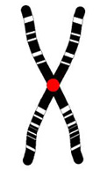

1. Which cells in the human body undergo mitosis?
2. Why is mitosis important for an individual that has cut their hand open?

**Name: ___________________________________________________________________ Date: ____________**

**Lab - Comparing Acids and Bases**

**Introduction:**

Many common substances are either acids or bases. Some acids, like stomach acid are necessary for our health, while others, like sulfuric acid are dangerous and can cause burns and other injuries. Baking soda is a common, weak base used in our homes, while sodium hydroxide, a strong base, is hazardous to skin and eyes.

Our world would be very different if we did not have acids and bases. Most of the food we eat is acid and our stomach produces very strong acids. The acids help us digest our food. One of the few foods that we eat that is basic is beans and we all know the results of that! Our blood has a pH of about 7.3 which helps our red blood cells to carry oxygen throughout our body! If the pH of water is too high or basic, minerals can settle out of the water causing our water pipes to clog and give us low water pressure. If the pH of our water is too low, or acidic, plumbing fixtures and our hot water heaters can be damaged.

To determine if a particular substance is acidic, basic or neutral in the laboratory, a scientist will test the pH of this substance. A common tool that is used to test pH is pH paper. pH paper is an indicator – a substance that **changes color** to indicate the presence of a particular substance. The change in color of the pH paper can be compared to a scale supplied with the pH paper. It provides a fast way to determine if a substance has acidic or basic properties.

How can we determine the strength of an acid or base? The pH of a substance is a measurement that indicates whether the substance is acidic, neutral or basic. pH is measured on a scale which ranges from 0 to 14. Using an indicator like pH paper gives an actual pH value. A pH of 7 is considered neutral (like water). Substances with a pH below 7 are acidic and those with a pH above 7 are basic, or alkaline.

Many common household solutions contain acids and bases. In this experiment, you will use pH paper to determine the pH values of various common household substances.

**Problem**:

What is the pH of some common household items that humans come in contact with?

**Pre-Lab Questions:**

1. What is an indicator?
2. What indicator will be used in today’s lab?
3. What is the difference in pH between an acid and a base?
4. In the procedure, you will need to guess what an unknown substance is by wafting. Why is it important to waft an unknown chemical?
5. Why is it important to not switch pipettes of the dropper bottles that the unknown substance is in?
6. A solution with a pH of 9 is
7. Acidic
8. Basic
9. Neutral
10. Saline
11. Some digestive enzymes work best in an acidic environment. This pH range would most likely be
12. 6 – 8
13. 12 – 14
14. 1 – 3
15. 8 – 10
16. Which of the following substances would most likely be the strongest base?
17. Bleach
18. Blood
19. Milk
20. Orange juice

**Safety Concerns:**

1. Tasting a lab chemical is very dangerous and you don't want to taste a liquid to determine whether it is an acid or not.
2. Be sure to waft the substances. DO NOT smell directly.
3. Use care with unknown substances – Do not spill them or get the substance on your clothes.

**Materials**

pH paper

Known Acid

Known Base

Known Neutral

10 – 12 Unknown Substances

Paper Towel

**Procedure:**

1. You will be testing 15 different samples in this lab. You will start with an assigned sample which will be rotated between lab groups.
2. First, without testing pH, you will use your powers of observation to try to guess what household substance you have a sample of.
3. On the data table, you will record your “Guess of what the sample is” and “Guess of what the pH is”.
4. To test for pH, place a piece of paper towel on your lab table/desk.
5. Take one strip of pH paper and place one to two drops of your first solution on the pH paper. Wait about 5-10 seconds to observe the color change.
6. Compare this color change with the pH color chart.
7. Record the pH number in the “Actual pH” column on your data table.
8. Be sure to keep the correct dropper with the appropriate sample.
9. Once you have tested all 15 samples, determine if the sample is actually acidic, basic or neutral using the tested pH value.
10. Together as a class, we will determine the last column on your data table (“What the actual sample is”).
11. At the end of the lab, throw out all test strips and the paper towels.
12. Return all samples and other materials to the proper place.

**Analysis Questions:**

1. Define an acid? Define a base? Give an example of each.
2. What is a buffer?
3. What are some factors that can affect the pH of drinking water?
4. What do you think the pH of human blood is? Explain your answer.
5. Why are medications like Milk of Magnesia or Tums such a good remedy for heartburn?

**Name _____________________________ Date_____________**

**Biology – Regents Ms. Fitzpatrick**

**Create a Molecule**

**Purpose:** Students will demonstrate their ability to correctly construct viable organic compounds from their building blocks (elements). The students must know the correct chemical and structural formulas for each of the compounds in question.

**Grading Rubric**:

1. The atoms must be neatly cut and properly colored.
2. Each compound must contain the proper number and position of each element making it up.
3. Any adjustments to the placement of the atom's valance electrons must be cleared with the teacher before the change is made. This may occur when trying to form a ring structure, or a double bonded end group.
4. Correctly answer the questions that follow.

**Materials**:

1. Template of atoms with valance electrons
2. Glue
3. Construction Paper
4. colors: red, blue, black, and yellow
5. scissors

**Procedure**:

1. Each group should receive the following number of each atom.

**O** = 12 **N** = 1

**H** = 24 **C** = 12

2. Cut each atom out along their outline (including the bonds as well).

3. Color the atoms accordingly:

**O** = Red **C** = Black **H** = Yellow

**N** = Blue **Bonds** = Brown.

4. Using the finished atoms, you will create a hanging mobile of one of the following compounds. (The teacher will assign the compound you will be making.)

1. **Glucose (linear)**

Chemical formula: C6H12O6

1. **Unsaturated fatty acid**

Chemical formula: C6H11COOH

1. **Saturated fatty acid**

Chemical formula: C6H13COOH

1. **Glycerol**

Chemical formula: C3H8O3

1. **Maltose (two glucose molecules)**

Chemical formula: C12H22O11

1. **Dipeptide (2 amino acids)**

Chemical Formula: C3H7N2(COOH)

**See the structural formulas below:**

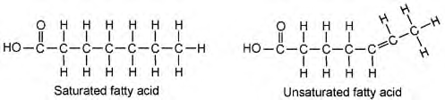**a)** Glucose **b)** Saturated Fatty Acid **c)** Unsaturated Fatty Acid

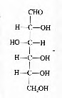

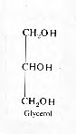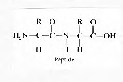**d)** Glycerol **e)** Peptide

1. Once you are assigned a compound, work with your lab partner to complete the compounds. To make your compound you will need to do the following:
   1. Place the atom in the correct place to make the structure of your assigned compound.
   2. Once you have the structure, transfer the compound to a piece of a construction paper.
   3. Glue the atoms in the appropriate place on the construction paper.
   4. Once the compounds are made, cut around the entire compound (removing excess construction paper).

**Questions**:

1. When combining the two glucose molecules together to form the sugar maltose, a molecule of ______________________ must be eliminated in order for this larger molecule to remain intact?
2. The above process of forming a larger molecule from its monomers is called

______________________ ____________________.

1. What are the major groups of organic compounds represented above (a-g)?

________________________________________________________________________

1. Which of the above compounds contains the element nitrogen?

____________________

1. Which of the above compounds is needed for the formation of fat?

**Name: ________________________________________________ Date: __________**

**Lab - Building Monomers of Macromolecules**

***Introduction:***

The term macromolecule by definition implies "large molecule". In the context of biochemistry, the term may be applied to the four large molecules that make up organisms --- nucleotides, proteins, carbohydrates, and lipids. Macromolecules are made of smaller subunits called monomers.

***Objective:***

Students will construct the basic components of organic molecular structure.

***Materials****:* 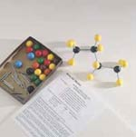

Introductory Molecular Model Set --- [82 V 1107; Ward's scientific](http://wardsci.com/product.asp_Q_pn_E_IG0011644_A_name_E_Introductory+Molecular+Model+Set)

***Task****:*

Construct each of the following monomers and answer the questions. *After constructing each monomer*, bring your lab sheet & model to the teacher to be approved and then break them down so the next model can be made.

**REMEMBER:**

1. Molecules are 3-dimensional so models will NOT ALWAYS BE FLAT!
2. When constructing a functional group (-OH, -COOH, -NH2) PUT BONDS BETWEEN ALL ELEMENTS!!

**Part A: Construct glucose.**

Correctly NUMBER the carbons on this picture.

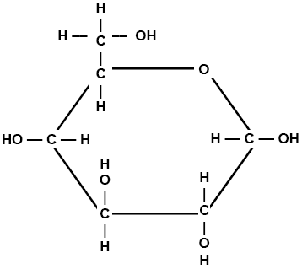

1. What is the chemical formula for glucose?

2. Glucose is a monomer for what macromolecule?

3. What other simple sugar(s) has the same chemical formula as glucose?

4. Simple sugars like glucose are called

_M __ ___ ___ ___ ___ ___ ___ ___ ___ ___ ___ ___ ___ _S_.

5. What is the function of carbohydrates for the body?

**Part B: Construct Glycine**

Place a BOX around the amino group on this picture.

Circle the carboxyl group on this picture.

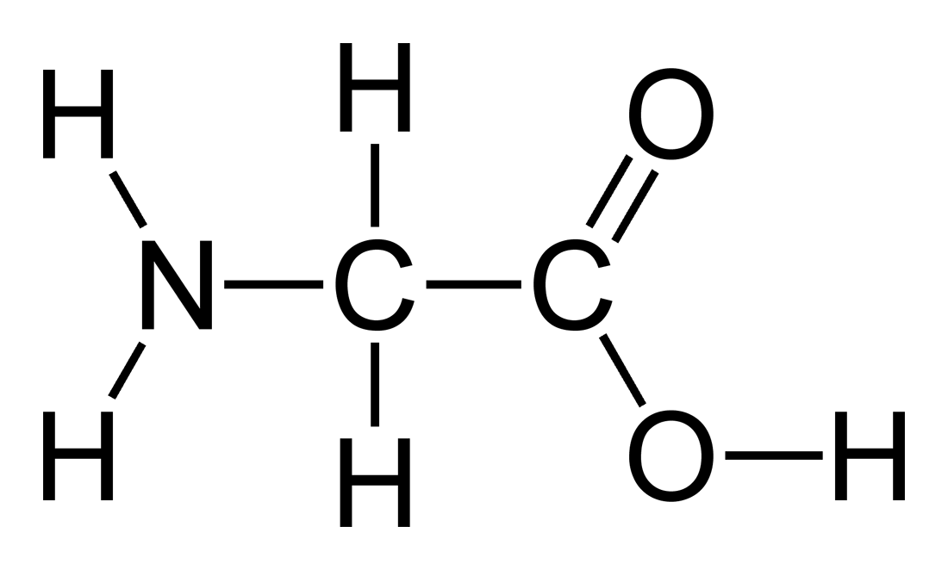

6. Glycine is what type of monomer? (Two words)

7. Name the 4 things attached to the center carbon in ALL amino acids.

A.

B.

C.

D.

8. How many amino acids exist?

9. What element is found in amino acid that isn’t found in simple sugars like glucose or fructose?

10. Amino acids join together to make what type of macromolecule?

11. What are some of the functions of proteins in the body? (List several)

**Part C: Construct Glycerol.**  
Place a CIRCLE around a hydroxyl group.

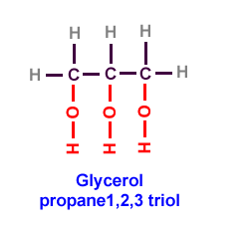

12. Glycerol is one of two molecules that make up a monomer known as

_T_ ___ ___ ___ ___ ___ ___ ___ ___ ___ ___ ___ _S_.

13. Besides glycerol, what 3 other molecules make up a triglyceride?

14. Glycerol and other organic compounds with an –ol ending are called ___________________.

15. Triglycerides are the monomers for what type of macromolecule?

16. Give 3 types of lipids and give their function.



**Part D: Construct a Fatty acid.**  
Place a BOX around the hydrocarbon chain in these pictures.

Circle the carboxyl group in both pictures.

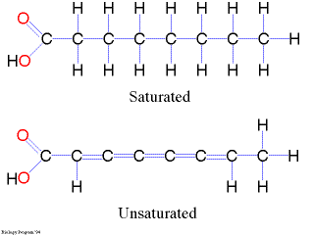

17. Fatty acids are made of long chains of _______________ atoms with attached ______________ atoms.

18. How many bond(s) does each carbon atom have?

19. How many bond(s) does each hydrogen have?

20. What 3 elements make up fatty acids?



**Part E: Construct Cytosine.**

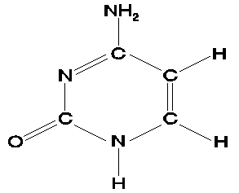

21. Cytosine is an example of a nitrogen base found on _______________ acids.

22. Name the 2 nucleic acids found in organisms.

23. List the name for the elements making up cytosine.

24. Name the other 3 nitrogen bases found on DNA.

25. What nitrogen base is found on RNA but not DNA?

*Name: ______________________________________________________________ Date: _______________________________*

*Toothpick-ase: Introduction to Enzymes*

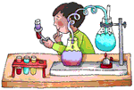

    Enzymes are used in all metabolic reactions to control the rate of reactions and decrease the amount of energy necessary for the reaction to take place. Enzymes are specific for each reaction and are reusable. Enzymes have an area called the active site to which a specific substrate will bond temporarily while the reaction is taking place. Enzymes are proteins that are used as catalysts in biochemical reactions. A catalyst is a factor that controls the rate of a reaction without itself being used up. In biological systems, enzymes are used to speed up the rate of a reaction. However, there are a number of factors that can affect the rate of an enzyme-facilitated reaction, in addition to the presence of the enzyme, amongst them are:

1. Substrate concentration
2. Temperature



Here is a set of quick activities designed to simulate how substrate concentration and temperature affect enzyme function. In the activities that follow:

* One person’s fingers are the enzyme TOOTHPICKASE
* The toothpicks are the SUBSTRATE
* Toothpickase is a DIGESTIVE ENZYME. It breaks down toothpicks into two units. To hydrolyse the toothpick, place a toothpick between the thumb and the first finger of each hand. Break the toothpick in two pieces.

*Materials:*100 toothpicks per team  
bowl  
clock/watch with a second hand  
Pencil

*Procedure:*

*Part A - rate of Product Formation in an Enzyme-Facilitated reaction*In this activity, the toothpicks represent a substrate and your thumbs and index fingers represent the enzyme, *toothpick-ase*. When you break a toothpick, the place where the toothpick fits between your fingers represents the active site of the enzyme*.*

1. Count out 100 unbroken toothpicks into a bowl on your desk.

2. Have one person in the group serve as the timer, have one person serve as the recorder, and have another person in your group act as the enzyme or toothpick-*ase*.

3. The person acting as the enzyme is to break toothpicks *without* looking at the bowl and all of its products (broken toothpicks). All broken toothpicks must remain in the bowl along with the unbroken toothpicks, & you cannot re-break a broken toothpick!.

4. The experiment is conducted in 10 second intervals.

5. WITHOUT LOOKING AT THE BOWL, break as many toothpicks as you can in 10 second intervals and record this on the data table. Broken toothpicks should be kept in the bowl with unbroken toothpicks because products & reactants mix in metabolic reactions. *DO NOT BREAK TOOTHPICKS ALREADY BROKEN!*

Remember when counting, two halves equal a whole broken toothpick!

6. Do another 10 seconds of breaking (total of 20 seconds now), and then count & record the number of toothpicks broken.

7. Do another 10 seconds (thirty seconds total now) more of breaking and count and record the number of toothpicks broken.

8. Continue breaking toothpicks for these total time intervals ( 60, 120, and 180 seconds). *REMEMBER TO ALWAYS THROW BROKEN TOOTHPICKS BACK IN THE PILE (*because products & reactants stay mixed in reactions)*, BUT DON’T RE-BREAK THEM* (the enzyme has already acted on the substrate*!)*

6. Graph the number of toothpicks broken as a function of time (10, 20, 30, 60, 120, & 180 seconds.) Be sure to title your graph and to label the x and y-axis.

*Data Table:*

|  |  |
| --- | --- |
| Total Time (seconds) | Number of toothpicks broken |
| 10 |  |
| 20  (additional 10 seconds) |  |
| 30  (additional 10 seconds) |  |
| 60  (additional 30 seconds) |  |
| 120  (additional 60 seconds) |  |
| 180  (additional 60 seconds) |  |

Graph Title: ____________________________________________________________



*Materials:*1 box toothpicks per team  
100 paper clips  
clock/watch with a second hand  
Pencil

*PART B: EFFECT OF SUBSTRATE CONCENTRATION ON REACTION RATE*

1. Remove the broken toothpicks from the shallow bowl. Place 100 paperclips in the empty bowl. The paper clips represent a “solvent” in which the toothpicks are “dissolved”. Different concentrations are simulated by mixing different numbers of toothpicks in with the paper clips.
2. For the first trial, place 10 toothpicks in the bowl with the paper clip. Mix them up. The enzyme has 20 seconds to react (break as many toothpicks as possible). Remember the enzyme breaks the toothpicks *without* looking at the bowl and all of the products (“broken toothpicks”) must remain in the bowl. Remember toothpicks can only be digested once; do not break toothpicks already broken! Record the number broken at a concentration of 10.
3. Remove the broken toothpicks and repeat with concentrations of 20, 30, 40, 50, 60, 70, 80, 90, and 100 toothpicks, each time mixing them with the 100 paper clips.
4. Graph the results.
5. Discuss your results and explain why the rates were different at different concentrations. Summarize the effect of substrate concentration on enzyme action.

Discussion & summary:

*Data Table:*

|  |  |  |
| --- | --- | --- |
| Time (seconds) | Toothpick Concentration | Number of toothpicks broken |
| 20 | 10 |  |
| 20 | 20 |  |
| 20 | 30 |  |
| 20 | 40 |  |
| 20 | 50 |  |
| 20 | 60 |  |
| 20 | 70 |  |
| 20 | 80 |  |
| 20 | 90 |  |
| 20 | 100 |  |

Graph Title: ____________________________________________________________



*Materials:*10 toothpicks per team  
ice & ice bucket  
clock/watch with a second hand  
Pencil

*PART C: EFFECT OF TEMPERATURE SUBSTRATE CONCENTRATION ON REACTION RATE*

1. Select 10 toothpicks. Time how long it takes to break the 10 toothpicks as fast as you can.
2. Place your hands in the pail of iced water for 10 minutes. Repeat step 1.
3. Calculate the rate of enzyme action in toothpicks per second. Compare the two rates.
4. Discuss your results and explain why the rates were different at different temperatures. Summarize the effect of temperature on enzyme action.

Discussion & summary:

*Analysis & conclusions:*

1. What happens to the reaction rate as the supply of toothpicks runs out?

2. What would happen to the reaction rate if the toothpicks were spread out so that the "breaker" has to reach for them?

3. What would happen to the reaction rate if more toothpicks (substrate) were added?

4. What would happen to the reaction rate if there were two "breakers" (more enzymes)?

5. What happens if the breaker wears bulky gloves (active site affected) when picking up toothpicks?

6. Explain what would happen to an enzyme-facilitated reaction if temperature were increased. Be sure to include the effect if temperature were increased to 100°C.

7. What is the optimal temperature (°C) for enzymes functioning in the human body?

Name: ___________________________________________ Date: _____

**Lab: The Human Menstrual Cycle**

**Problem**: How do hormone levels vary in the menstrual cycle?

**Procedure**:

1. Graph the following data into TWO data tables
   1. Put LH and FSH on one graph.
   2. Put Estrogen and Progesterone on a second graph.
2. Answer the questions that follow.

The relative hormone levels vary greatly during the 28 day human menstrual cycle. The table below shows the relative level of the four major hormones by day.

|  |  |  |  |  |
| --- | --- | --- | --- | --- |
| **Day** | **Luteinizing Hormone (LH)** | **Follicule Stimulating Hormone (FSH)** | **Estrogen** | **Progesterone** |
| 1 | 6 | 10 | 10 | 2 |
| 2 | 7 | 11 | 10 | 2 |
| 3 | 8 | 12 | 10 | 2 |
| 4 | 8 | 13 | 10 | 2 |
| 5 | 8 | 14 | 10 | 2 |
| 6 | 8 | 13 | 13 | 2 |
| 7 | 8 | 12 | 16 | 2 |
| 8 | 8 | 12 | 19 | 2 |
| 9 | 8 | 12 | 22 | 2 |
| 10 | 10 | 13 | 28 | 2 |
| 11 | 12 | 14 | 35 | 2 |
| 12 | 22 | 16 | 28 | 3 |
| 13 | 32 | 20 | 22 | 4 |
| 14 | 20 | 15 | 19 | 5 |
| 15 | 6 | 10 | 16 | 8 |
| 16 | 6 | 9 | 15 | 10 |
| 17 | 6 | 8 | 15 | 12 |
| 18 | 6 | 8 | 15 | 15 |
| 19 | 6 | 8 | 15 | 18 |
| 20 | 6 | 7 | 15 | 24 |
| 21 | 6 | 6 | 15 | 28 |
| 22 | 6 | 6 | 15 | 28 |
| 23 | 6 | 6 | 15 | 28 |
| 24 | 5 | 6 | 13 | 24 |
| 25 | 4 | 6 | 10 | 18 |
| 26 | 3 | 8 | 10 | 12 |
| 27 | 3 | 10 | 10 | 7 |
| 28 | 3 | 10 | 10 | 2 |

**Analysis and Conclusion Questions**

1. Estrogen levels are highest on day number? ____________
2. LH levels are highest on day number? ______________
3. Where are the following hormones produced:
   1. Estrogen - ____________________
   2. FSH - ________________________
   3. LH - _________________________
   4. Progesterone - _________________
4. Name 2 times in a woman’s adult life when menstruation ceases:

A - _________________

B - _________________

1. How long does the menstrual cycle last?
2. The release of an egg from the ovary is ________________.
3. Name ***3*** female parts used in the menstrual cycle:
   1. _______________
   2. _______________
   3. _______________

Using the below diagram to answer the following questions.

[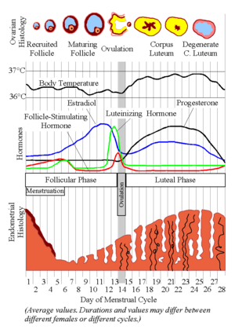](http://en.wikipedia.org/wiki/Image:MenstrualCycle2.png)

(Source: http://en.wikipedia.org/wiki/Image:MenstrualCycle2.png)

1. To which phases of the menstrual cycle do the following letters correspond to:

A – ____________________

B – ____________________

C – ____________________

D – ____________________

1. On which day(s) is fertilization most likely to occur?
2. When during the cycle does a woman menstruate?
3. How would the curve of progesterone change if the egg was fertilized?

Name: _____________________________________________________ Date: ____________________

**Mitosis in Real Cells**

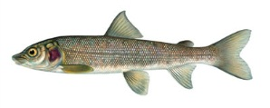

**Introduction:**

To study mitosis, biologists often look at particular cells. Remember, that mitosis occurs only in areas of growth, so finding a good spot to study it can be challenging. Two specimens are commonly used by biologists to study mitosis: the blastula of a whitefish and the root tip of an onion.

Plant cells and animal cells have a variety of cellular differences which contribute to the organismal differences we see daily. First and foremost is the existence of a cell wall for all plants, followed by the various plastids (including chloroplasts). Despite this, the process of mitosis does follow virtually identical pathways.

The whitefish embryo is a good place to look at mitosis because these cells are rapidly dividing as the fish embryo is growing. The onion root is also a good place because this is the area where the plant is growing. Remember that when cells divide, each new cell needs an exact copy of the DNA in the parent cell. This is why mitosis is only visible in cells that are dividing, like the whitefish embryo and the onion root tip.

Mitosis can take several hours to complete. Scientists will make slides of cells that should be undergoing mitosis in order to find a particular cell in any of the stages - prophase, metaphase, anaphase and telophase. Remember that most cells you see will be in interphase, that's the cells "resting" state. Your task is to look at actual slides and identify the stages of mitosis.

**Pre-lab Questions:**

1. Why is the whitefish used to study mitosis?
2. What are the four stages of mitosis?
3. How long does it take for mitosis to complete?
4. Why will most of the cells you view be in interphase?

**Example of Mitosis in the White Fish**

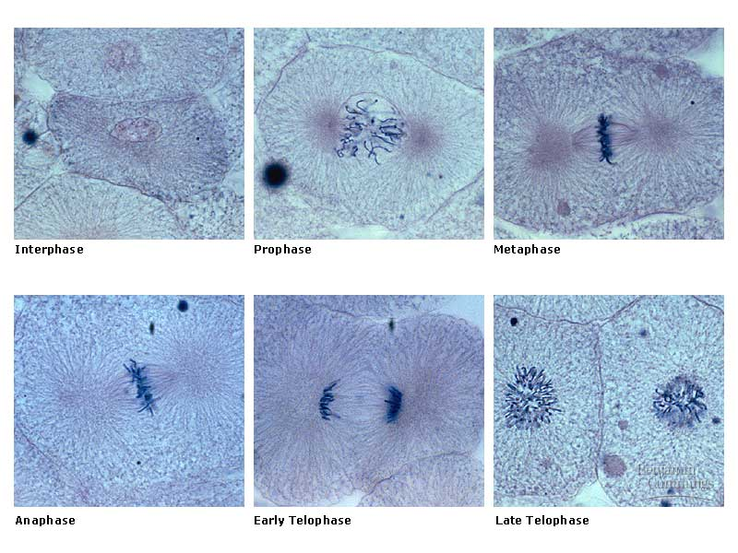

**Procedure**: Follow the instructions below and answer the following questions.

1. Get a microscope and a prepared slide of "Whitefish Blastula". Following proper microscope procedure, place the slide on the stage. View the slide under 100X and 400X.

a. How many individual sections do you find on the slide? On average, how many cells do you see in each section?

b. Estimate the average size of each cell.

2. Locate a cell during INTERPHASE. Examine it under high power. Draw in the box below an example of this stage.

c. Describe how the cell appears, particularly the nuclear region.

3. Now locate a cell undergoing PROPHASE. Using low power to find it first, then switching may be useful. Draw in the box below an example of this stage.

d. Is the nuclear membrane obviously present?

e. Describe the appearance of the nuclear region. How does it compare to interphase?

4. Now locate a cell at METAPHASE. Draw in the box below an example of this stage.

1. Describe the appearance of the chromosomes now.
2. Does the ASTER appear to be present at this time?
3. What is the Aster made of?
4. Do the SPINDLE FIBERS appear clearly?
5. What do the spindle fibers do?
6. Now locate a cell in ANAPHASE. Draw in the box below an example of this stage.
7. What is occuring in the cells now?
8. Locate a cell in TELOPHASE. Draw in the box below an example of this stage.
9. What two major actions occur during Telophase?
10. How can you tell visually when Telophase is occurring?
11. Locate a pair of DAUGHTER CELLS. Draw in the box below an example of this stage.

|  |  |
| --- | --- |
| 1. What characteristic of Daughter cells do you use to distinguish them from other cells. 2. Do the Daughter cells have a nucleus? |  |

**Review Questions**

1. What happens to the nuclear membrane during prophase?

2. When do spindle fibers appear and disappear during mitosis?

3. Compare the location of chromosomes during metaphase and anaphase.

4. During interphase, what is occurring in the cell?

5. Create a table, using each stage as a heading, and describe similarities and differences, at each stage, between plan cells and animal cells.

Name: ______________________________________ Date: _____________

Living Environment / Biology Ms. Fitzpatrick

**Aerobic Respiration Mapping Lab**

**Introduction:**

The cell is the basic unit of life. One of its responsibilities is to produce energy. Chemical energy, stored in the chemical bonds of glucose, is transferred into smaller, easy to use ATP molecules. The process that allows this to happen is called aerobic respiration. The process occurs in three distinct areas within the cell. The first part is called glycoloysis, which occurs in the cytoplasm. The second part, called the Krebs Cycle, occurs in the mitochondrial matrix. The final part, called the Electron Transport Chain (ETS), occurs in the inner mitochondrial membrane (cristae).

**Objectives:**

1. You will follow the process of aerobic respiration by cutting out the label parts and pasting hem, in the proper order, on the cell.
2. You will be able to determine the total number of ATP molecules produced by respiration for one glucose molecule.

**Materials:**

Scissors

Glue

Template of the cell

Labels for each step of aerobic respiration

**Procedure:**

1. Using scissors cut out all of the labels dealing with aerobic respiration.
2. Locate the cell template on the lab paper. Notice that it contains a nucleus and another rather large structure.

What is the name of this other cellular organelle?

___________________________________________________________

1. With glue, attach the label to this cellular organelle.
   1. What is its major function of this organelle in the cell?

____________________________________________________________________________________________________________________

* 1. Describe its physical structure.

____________________________________________________________________________________________________________________

1. Looking at the remainder of the labels, arrange them in proper order representing the steps of aerobic respiration. Then write out the word or words in the proper space below:
   1. Step 1: _________________________________________________
   2. Step 2: _________________________________________________
   3. Step 3: _________________________________________________
   4. Step 4: _________________________________________________
2. Attach the labels for the steps of aerobic respiration in the correct area on the cell template.

Conclusion Questions:

1. What is ATP?

____________________________________________________________________________________________________________________________________________________________________________________________________________________________________________________________

1. How many usable ATP molecules did the process of glycolysis produce?

____________________________________________________________________________________________________________________________________________________________________________________________________________________________________________________________

1. How many ATP molecules did the Krebs Cycle produce per on molecule of glucose?

____________________________________________________________________________________________________________________________________________________________________________________________________________________________________________________________

1. What was the total ATP production of the ETS?

______________________________________________________________________________________________________________________________

1. How many ATP molecules were produced from one molecule of glucose?

____________________________________________________________________________________________________________________________________________________________________________________________________________________________________________________________

1. How many pyruvic acids are produced from one glucose molecule?

____________________________________________________________________________________________________________________________________________________________________________________________________________________________________________________________

Name: _____________________________________ Date: __________________

Plastic Egg Genetics Period: _________________

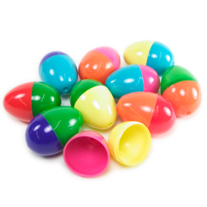

|  |  |
| --- | --- |
| **½ Egg Phenotype** | **½ Egg Genotype** |
| Purple | RR |
| Orange | Rr |
| Pink | rr |
| Blue | BB |
| Green | Bb |
| Yellow | bb |

**½ egg + ½ egg = 1 whole plastic egg**

**Directions:**

1. One your lab table, there will be a variety of plastic eggs.
2. Choose **one** egg, but do **NOT** open it yet!
3. Record the phenotype and genotype of your egg.
4. Place the genotypes of your egg into the Punnett Square.
5. Determine the phenotypes and genotypes of the **offspring**.
6. Open your egg – do your punnett square results match the bead color and quantity inside the egg?
   1. If **yes**, then place the egg back together and pick another one!!
   2. If **no**, check your work and make corrections.
7. Continue until you have completed  **5 different eggs**!
8. When all punnet squares are complete, complete the result chart and conclusion questions.

**Results:**

|  |  |  |  |
| --- | --- | --- | --- |
| **Egg** | **Cross** | **Percent**  **Genotype** | **Percent Phenotype** |
| Example |  |  |  |
| 1 |  |  |  |
| 2 |  |  |  |
| 3 |  |  |  |
| 4 |  |  |  |
| 5 |  |  |  |
| 6 |  |  |  |

**Conclusion:**

(Be sure to use complete sentences)

1. What does each **half** of the plastic egg represent?
   1. Zygote c. Parent’s DNA
   2. Genes for a specific trait from one parent d. Parent’s sex cells
2. Describe what the beads inside the egg represent. [Hint: what specific part of the offspring??]

______________________________________________________________________________ ______________________________________________________________________________ ______________________________________________________________________________

1. Determine what traits you obtained from the genes carried in your parents sex cells? Be specific.

­______________________________________________________________________________ ______________________________________________________________________________ ______________________________________________________________________________

1. Name 3 different alleles of eye color. ______________________________________________________________________________ ______________________________________________________________________________ ______________________________________________________________________________
2. Use the following words and place them **IN** the diagram below in size order.

chromosome, cell, gene, nucleus, DNA

|  |  |
| --- | --- |
| **½ Egg Phenotype** | **½ Egg Genotype** |
| Purple | RR |
| Orange | Rr |
| Pink | rr |
| Blue | BB |
| Green | Bb |
| Yellow | bb |

**½ egg + ½ egg = 1 whole plastic egg**

**NYS Biodiversity Lab Chart**

|  |  |  |  |  |  |  |  |
| --- | --- | --- | --- | --- | --- | --- | --- |
| **Species** | **Structural Char of Plants** | **Structural Char of Seeds** | **Microscopic Stem Structure** | **Paper Chromatography** | **Test for Enzyme M** | **Differences in Amino Acid Sequence** | **Gel Electrophoresis Banding Pattern** |
|  |  |  |  |  |  |  |  |
|  |  |  |  |  |  |  |  |
|  |  |  |  |  |  |  |  |
|  |  |  |  |  |  |  |  |

**New York State Diffusion Lab Group Responsibilities**

|  |  |  |
| --- | --- | --- |
| **Group #** | **Student** | **Job** |
|  |  |  |
|  |  |  |
|  |  |  |
|  |  |  |
|  |  |  |
|  |  |  |
|  |  |  |
|  |  |  |
|  |  |  |
|  |  |  |
|  |  |  |
|  |  |  |
|  |  |  |
|  |  |  |
|  |  |  |
|  |  |  |
|  |  |  |
|  |  |  |
|  |  |  |

|  |  |  |  |  |  |  |
| --- | --- | --- | --- | --- | --- | --- |
| Pulse Rate per minute (range of averages) | < 51 | 51 - 60 | 61-70 | 71-80 | 81-90 | >90 |
| Number of students in this range |  |  |  |  |  |  |

|  |  |  |  |  |  |  |
| --- | --- | --- | --- | --- | --- | --- |
| Activity Level | <60 | 61-70 | 71-80 | 81-90 | 91-100 | >100 |
| Resting |  |  |  |  |  |  |
| Exercising |  |  |  |  |  |  |

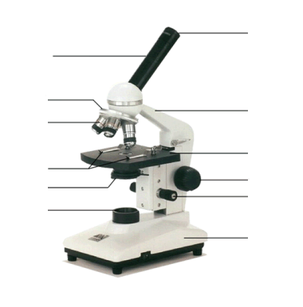

|  |  |
| --- | --- |
| **arm** - this attaches the eyepiece and body tube to the base. **base** - this supports the microscope. **body tube** - the tube that supports the eyepiece. **coarse focus adjustment** - a knob that makes large adjustments to the focus. **diaphragm** - an adjustable opening under the stage, allowing different amounts of light onto the stage. **eyepiece** - where you place your eye. **fine focus adjustment** - a knob that makes small adjustments to the focus (it is often smaller than the coarse focus knob). | **high-power objective** - a large lens with high magnifying power. **low-power objective** - a small lens with low magnifying power. **light source** - this directs light upwards onto the slide. **revolving nosepiece** - the rotating device that holds the objectives (lenses). **stage** - the platform on which a slide is placed. **stage clips** - metal clips that hold a slide securely onto the stage. |

**Name________________________ Date___________**

**The Cell Theory Lab**

**Use the timeline below and your knowledge of**

**biology to answer the following questions.**

INTRODUCTION:

Cells are the basic unit of life because they are the simplest structure that displays all the characteristics of life. Five different scientists’ work led to a very important Cell Theory. You will examine various samples of cells that were important to the contribution of the Cell Theory.

PURPOSE:

The purpose of this laboratory experience is to allow you to observe, compare and draw cells you view under the microscope. You will connect the advancements in science to the increase in technology. You will see how a theory is made.

PROCEDURE:

* Obtain a microscope from the cabinet. (carry the microscope carefully and correctly)
* Obtain the following slides for examination and comparison:
  + - Cork – label cell wall
    - Diatom
    - Onion (Plant) – label cytoplasm, cell wall and nucleus
    - Red blood cell – label cell membrane and cytoplasm
    - Sickle cell – label cell membrane and cytoplasm
    - Lung
    - Coal miners lung
    - Prepare your own cheek slide.- label nucleus, cell membrane, cytoplasm
* Using color pencils, draw each of the slides (in the data section of your lab) and label the parts listed after each specimen above. **Be sure to include the name and magnification of each slide.**
* Complete conclusion questions.

** **

**____________________________ ____________________________**

** **

**________________________________ _____________________________**

** **

**____________________________ ____________________________**

** **

**________________________________ _____________________________**

**Conclusions for Cell Microscope Lab**

1. How did observing the cork allow Robert Hooke to begin development of the cell theory?

____________________________________________________________________________

____________________________________________________________________________

2. How did observing the diatom help Anton Van Leeuwenhoek to contribute to the cell theory?

____________________________________________________________________________

____________________________________________________________________________

3. How did observing plant cells allow Matthias Schleiden contribute to the cell theory?

____________________________________________________________________________

____________________________________________________________________________

4. How did observing cheek cells allow Theodor Schwann to contribute to the cell theory?

____________________________________________________________________________

____________________________________________________________________________

5. How did Rudolf Virchow contribute to the cell theory?

____________________________________________________________________________

____________________________________________________________________________

6. How is structure of a cell related to its function?

____________________________________________________________________________

7. How does the size of a red blood cell contribute to its function?

____________________________________________________________________________

____________________________________________________________________________

8. Calculate the surface area : volume ratio of each of the cells of a 2 cm cuboidal and 7 cm cuboidal cell. (show all math).

____________________________________________________________________________

____________________________________________________________________________

9. How is the size of a cell related to how efficiently the cell brings in items it needs to maintain homeostasis?

____________________________________________________________________________

____________________________________________________________________________

10. Which two organelles are visible in the plant cell that are not in the animal cell?

____________________________________________________________________________

____________________________________________________________________________

11. Explain the proper way to make a wet mount slide?

____________________________________________________________________________

____________________________________________________________________________

12. Explain the proper way to focus a microscopic specimen?

____________________________________________________________________________

13. Our ocular lens magnifies 10x. If you are using a 40x objective lens, what would the total magnification?

____________________________________________________________________________

____________________________________________________________________________

14. Which type of electron microscope would be used for the following: a). the changes in shape of a living human white blood cell; b). the finest details of the surface texture of the human hair; c). the detailed structure of an organelle in a human liver cell.

____________________________________________________________________________

____________________________________________________________________________

____________________________________________________________________________

15. Describe the difference in appearance between a coal miners lung and a normal lung?

____________________________________________________________________________

____________________________________________________________________________

16. What is the major function of our lungs?

____________________________________________________________________________

____________________________________________________________________________

17. In which area of the lung does gas exchange occur?

____________________________________________________________________________

____________________________________________________________________________

