Name______________________ Date___________

Photosynthesis vs. Cellular Respiration
Follow the instructions below to complete your diagrams on photosynthesis and respiration
Part 1
Step 1: Fill in the equation for photosynthesis and answer the following questions.
____________ + ____________ + ____________ ____________ + ____________
What are the reactants for photosynthesis?  - _________________  - _________________  - _________________ | What are the products for photosynthesis?  - _________________  - _________________

In which organelle does the process of photosynthesis occur?__________________________

Stages of photosynthesis and where each occurs:
Stage 1 - __________________________ and occurs in the_____________________
Stage 2 - __________________________ and occurs in the ____________________
Why is the process of photosynthesis important for the stability of ecosystems? ________________________________________________________________________________________________________________________________________________________________________________________________________________________________________________
Step 2: Fill in the equation or aerobic and anaerobic respiration and answer the following questions.
Aerobic
____________ + ____________ ____________ + ____________+ ____________
Reactants  - __________________  - ___________________ | Products  - ___________________  - ___________________  - ___________________

What can be inferred about the reactants and products of aerobic respiration and photosynthesis? ________________________________________________________________________________________________________________________________________________________________

Name 2 organism that do aerobic respiration ___________________ and ________________.

**Remember there are _______ types of anaerobic respiration**

Anaerobic (Lactic Acid Fermentation)
____________ ____________ + ____________

Name 1 organism can perform lactic acid fermentation?_____________________________

Anaerobic (Alcoholic Fermentation)
____________ ____________ + ____________+ ____________

Name 1 organism can perform alcohol fermentation?_____________________________

List 3 differences between aerobic and anaerobic respiration.
1)__________________________________________________________________
2)__________________________________________________________________
3)__________________________________________________________________

Why is the process of respiration important for organisms? __________________________________________________________________________________________________________________________________________________________________________________________________________________

Step 3: Get a piece of construction paper and colored pencils.
Step 4: Use all the information about photosynthesis from step 1 to create a visual teaching tool for other students on one side of the construction paper.
Step 5: Use all the information about cellular respiration from step 2 to create a visual teaching tool for other students on the other side of the construction paper.
Step 6: BE CREATIVE

Graphing Lab
Name____________________________ Date: _____________

- Scientists were trying to figure out whether fertilizer affects the growth of tomatoes. The data table below shows the average diameter of ripe tomatoes from plants grown with different amounts of fertilizer. Construct a line graph using this data

Amount of Fertilizer (g) | Average Diameter of Tomatoes (cm)
0 | 7
20 | 8
40 | 9
60 | 10
80 | 9
100 | 8

What is the independent (manipulated) variable? ______________________________________
What is the dependent (responding) variable? _________________________________________

- Scientists were trying to figure out if the length of a bar would change when heated from 0 degrees Celsius to 250 degrees Celsius. Their findings were recorded in the data table below

Temperature (degreed Celsisus) | Length of bar (cm)
0 | 100.0
50 | 100.1
100 | 100.3
150 | 100.4
200 | 100.5
250 | 100.7

What is the independent (manipulated) variable? ______________________________________
What is the dependent (responding) variable? _________________________________________

- The data table below shows the number of hours the flowers of different types of plants remain open each day.
Flower | Number of Hours Open
Morning glory | 6
California poppy | 7
Dandelion | 13
Pumpkin flower | 4
Moon flower | 16

Use the information in the data table to construct a bar graph on the grid provided.

Number of Hours Flowers Remain Open

- The data table below shows the average daily temperature for 10 days for 2 New York State cities: Albany and New York City

Average Daily Temperature

Day | Albany Temperature (deg F) | New York City Temperature (F)
1 | 77 | 81
2 | 79 | 85
3 | 80 | 87
4 | 72 | 88
5 | 76 | 84
6 | 81 | 80
7 | 84 | 76
8 | 85 | 74
9 | 85 | 70
10 | 77 | 65

What is the independent (manipulated) variable? ______________________________________
What is the dependent (responding) variable? _________________________________________

- The following data represents the measurement taken of a cup of hot coffee cooling off (deg C) with respect to time (min). Using the graph paper attached, create a line graph using this data.
Time (min) | Temp (deg C)
0 | 100
4 | 78
8 | 66
12 | 60
16 | 54
20 | 48
24 | 42
28 | 38
32 | 34
36 | 34
40 | 30
44 | 28
48 | 27
52 | 26
56 | 26
60 | 26
64 | 26
68 | 26
70 | 26

Name_______________________________
Partners Name______________________
Lab – How Does Exercise Affect Disposal of Wastes From Cellular Respiration
Directions:
- Label two test tubes A and B. Put 10 ml of water and a few drops of bromothymol blue solution in each test tube. Carbon Dioxide causes bromothymol blue to turn yellow or green.

- Your partner will time you during this step. When your partner says “go”, slowly blow air through a straw into the bottom of test tube A.
CAUTION – DO NOT INHALE THROUGH THE STRAW

- When the solution changes color, your partner should say “stop” and then record how long the color change took.

- Jog in place for 2 minutes. CAUTION – Do not do this if you have a medical condition that interferes with exercise. If you feel faint or dizzy, stop immediately and sit down.

- Repeat steps 2-4 using test tube B.

- Trade roles with your partner. Repeat steps 1 through 5.

- Include a formal lab write up on loose leaf paper.
Date:
 | Test Tube A | Test Tube B
Time before bromothymol blue changed color

Analyze and Conclude:
- How did exercise affect the time it took the solution to change color?

- What process in your body produces carbon dioxide? How does exercise affect this process?

Mitosis Candy Lab
Name______________________________ Date:
Per: Living Environment

Directions:
- Each student will receive an index card labeled with an activity that occurs during 1 of the phases of mitosis (See Attached).
- Students will decide which phase of mitosis their index card is referring to.
- All students who have the same phase will meet and fill out the top portion of the “Mitosis Activity Sheet”.
- Using the poster board, the bag of supplies, and your knowledge of mitosis, you and your group will construct a poster board representing your specific phase of mitosis.
- As you construct your poster board, your group must fill in the bottom portion of the “Mitosis Activity Sheet”.
- The poster board must be labeled (include a large title that has the name of your phase of mitosis, and each part of the cell should be visibly labeled)
- Each group will present their poster board to the class.
- At the conclusion of the activity, each member of the group will complete questions regarding mitosis.

***Grade will be based on:
- Accuracy of information
- Group Participation
- Creativity and Display
- Effort
- Presentation
- Summary Questions

Names___________________________________________ Date:
Mitosis Activity Sheet

Our Cell Phase is: _____________________
- _________________ is one of the phases of mitosis. During this phase:_______
________________________________________________________________________________________________________________________________
________________________________________________________________
________________________________________________________________
________________________________________________________________
________________________________________________________________
________________________________________________________________
________________________________________________________________________________________________________________________________
Diagram Legend: Write in the blank space what each object in your diagram represents. For example: Pipe Cleaner Spindle Fibers.
Red Rope: _________________ Blue Ribbon: _________________
Circular Mints: _________________ Black Ribbon: _________________
Good and Plenty: Pipe Cleaner: _________________
Pink: _________________ Marshmallow Hearts: _____________
White: _________________ Cheerios: _________________
Straw: Paper Clips: _________________
Specify Color: _________________ Glitter Glue: _________________
Green Beads_________________
INDEX CARDS (Each phrase should be cut out and pasted on a separate index card
Chromosomes duplicate themselves
Centrioles duplicate themselves
The cell is in this phase 90% of the time
Chromatin condenses and becomes visible
as double stranded chromosomes (sister chromatids)
attached together by centromeres

Spindle fibers begin to form
Nuclear membrane of nucleus disappears and
centrioles migrate to the poles

Spindle fibers line up double stranded
chromosomes (sister chromatids) at the equator

Double stranded chromosomes
(sister chromatids) line up at the equator

Spindle fibers attach to chromosomes centromeres
One set of single stranded chromosomes
are pulled to opposite poles by spindle fibers

Sister chromatids are being pulled apart to
either side of the cell.

In animal cells, “furrowing” occurs. The
cell membrane begins to pinch in at the equator

In plant cells, a cell plate forms at the equator
In animal cells, pinching of the cell membrane begins
Nuclear membrane begins to REFORM
Spindle Fibers go away
Cells are splitting cytoplasm and other organelles
Chromosomes turn back into chromatin
2 IDENTICAL cells have formed

Name______________________________ Date:
Living Environment Period:

Ecology Scavenger Hunt
Skills: Identify abiotic and biotic factors in their natural habitats
Objectives:
- Identify organisms found in the field
- Classify organisms found in the field.

Purpose: In this lab, you will be given a list of items to look for in a site that the class will visit. You will identify living organisms that you will find. You will also observe the living organisms that you find. In addition, you will observe and make note of the environment in which each item was found.
Background: At some time in your life, you may have collected natural objects such as seashells, rocks, leaves, and insects. Although you may have learned a lot about the physical appearance and structures of the specimens collected, you may not have observed the environment in which you collected them.
A scavenger hunt is an activity in which you try to find as many items as possible from a list of objects. In order to find some of the items on your scavenger hunt list, you will have to know about their habitats, classifications and life cycles.
Procedure:
- The scavenger hunt list is on page 6. Your teacher will tell you which items you may expect to find in the area you will visit. You will not collect any material in the field. All observations will be made in such a way that habitats are disturbed as little as possible.
- Before going on the scavenger hunt, do background research on the animals, plants, and fungi that you may expect to find.
  - Describe the habitat you are going to visit
____________________________________________________________________________________________________________________________________
__________________________________________________________________
__________________________________________________________________
__________________________________________________________________
  - Distinguish between a producer, a consumer and a decomposer
___________________________________________________________
___________________________________________________________
___________________________________________________________

- Learn all you can about the organisms you find. Record your findings in the table below
Organism | Plant, animal or fungus | Producer, consumer, or decomposer | Poisonous (Y/N)

- Take care not to disturb the surrounding environment during your hunt. When you examine items, follow the “rule of six” – do not take one to examine unless there are six more within six feet. This rule generally leaves enough organisms to reproduce.
  - Why should you follow the “rule of six”?
__________________________________________________________________
- Examine live animal specimens only if you can release them unharmed into the same habitat. Do not examine any vertebrates without your teacher’s approval
- Your teacher will schedule the time for the hunt. Follow your teacher’s instructions about when to start and stop hunting. When you find an item on your list, enter it on your data table. Observe and make not of other organisms and unusual features in the area in the appropriate column in your data table.
Analysis:
- Write a description of the biotic and abiotic factors in the habitat you studied.
________________________________________________________________________
________________________________________________________________________
________________________________________________________________________
________________________________________________________________________
- Construct a food chain from the animals and plants on your list of finds.
________________________________________________________________________
________________________________________________________________________

- Construct a food web from the animals and plants on the list. Draw your web in the space below.
- How might the environment of the habitat you studied change by next year and influence this lab for next year’s biology students?
________________________________________________________________________
________________________________________________________________________

- Instead of investigating a field, how do you think your findings would be affected if you investigated a pond and the area surrounding it? What organisms might you find?
________________________________________________________________________
________________________________________________________________________
________________________________________________________________________
________________________________________________________________________

Scavenger Hunt Items
- Something unusual
- A bone
- An echinoderm – “spiny skin” and 5 fold symmetry
- An arachnid – spider
- A nonflying insect
- A mollusk – snail or slug
- An annelid – segmented worm
- A nematode – round worm
- A flying insect
- A pupa (resting stage between a larva and an adult)
- A larva – immature insect
- Something round
- Something soft
- Something white
- Something that makes noise
- A feather (detached from a bird)
- Conifer Pinecone
- Seven pieces of trash or litter left by humans
- Something beautiful
- Chewed plant part (not chewed by humans)
- An owl pellet
- A fungus from a tree
- A fungus from the ground
- A gall – abnormal outgrowth of plant tissue

***You must take a good picture of at least 25 items

- A monocot leaf – has parallel veins in leaf
- A dicot leaf – “branching” veins in leaf
- Scat – Animal droppings
- Something large
- Something straight
- A wind dispersed seed
- An animal dispersed seed
- 50 of any item
- A Thorn
- An example of camouflage
- A solar energy trap
- An animal track
- A frond – large divided leaf (fern)
- A palmate leaf – leaf resembling an open hand
- A symbiotic relationship between 2 organisms
- Flower
- Seed
- Something red
- Something biotic
- A producer
- A consumer
- Something abiotic
- Food chain of three organisms
- Primary consumer
- A host

***The above circled items must be part of your 25 items

The Phases of Mitosis
Name_______________________________________ Period_________
Directions: Draw a cell that contains 3 chromosomes (Be careful!! In which stage are the chromosomes visible?)
Interphase | Prophase
Metaphase | Anaphase
Telophase | Cytokenesis
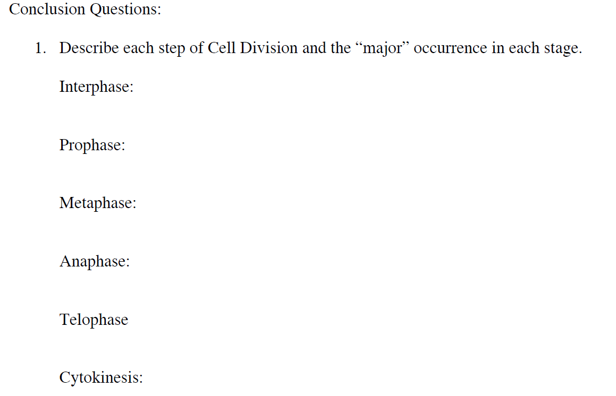

2. How do the daughter cells compare to the parent cell after mitosis?

3. Which cells in the human body undergo mitosis?

4. Why is mitosis important for an individual that has cut their hand open?

5. The 3 phases of interphase are:

Meiosis Flip Book
Name_______________________ Date:
Your task is to create an ‘index card’ flip book that shows the following ‘basic’ steps of Meiosis.
On the front of each card: label the step with the appropriate title (Interphase, Prophase, etc) at the top of the card, and draw a colored picture of the phase at the bottom of the card. On the back of each card: Write the title and description of what happens in each stage (copy the titles and description EXACTLY as they are listed below. Hand draw and color each cell picture neatly and accurately. Make each cell the same “size” and “color”
___ Card 1: The Cover: Put the underlined title: “The Phases of Meiosis”, along with your name, date, and period.
___ Card 2: Interphase: The time before meiosis. The cells may appear inactive during this stage, but they are quite the opposite:
* This is the longest period of the complete cell cycle.
* The cells enlarge, preparing for meiosis.
* The DNA replicates, or copies itself.
* The cell grows and makes structures to use during the rest of the cell cycle.
___ Card 3: Prophase 1:
* This is the first phase of meiosis.
* The chromatin in the nucleus condenses and becomes visible chromosomes. Each replicated (copied) chromosome is made of two chromatids, both with the same genetic information.
* Spindle fibers begin to form around the centrioles.
* The nuclear membrane breaks down.
* The centrioles are moving to opposite ends of the cell.
* Homologous chromosomes come together (synapsis)
* The exchange of genes between homologous chromosomes occurs during “crossing over”.
___ Card 4: Metaphase 1:
* The centromere attaches the duplicated chromosomes to the spindle fibers.
* * Spindle fibers line up chromosomes with their homologous partner at the center of the cell
___ Card 5: Anaphase 1:
* Each homologous chromosome pair is pulled toward opposite ends of the cell.
* The spindle fibers are getting shorter.
___ Card 6: Telophase 1 and Cytokinesis:
* The nuclear membrane forms around the chromosomes.
* The spindle fibers that have pulled them apart disappear.
* The cell membrane is beginning to pinch in.
* The cell begins to divide into two cells.
* The paired chromatids are still joined.
* Each cell contains one member of each homologous chromosome pair.
___ Card 7: Prophase 2:
* Each cell contains one member of each homologous chromosome pair.
**The chromosomes are not copied again between the 2 cell divisions.
___ Card 8: Metaphase 2:
* The centromere attaches the chromatids to the spindle fibers.
* Spindle fibers line up all chromosomes at the center of the cell.
___ Card 9: Anaphase 2:
* The chromatids separate, and are pulled apart and begin moving to the cell poles.
* The spindle fibers are getting shorter.
* The chromatids arrive at the poles (opposite ends of the cell).
___ Card 10: Telophase 2 and Cytokinesis:
* The nuclear membrane forms around the chromosomes.
* The spindle fibers that have pulled them apart disappear.
* The cell membrane is beginning to pinch in
* * The result: Four new cells have formed from the original single cell. Each new cell has half the number of chromosomes present in the original cell. They are Haploid

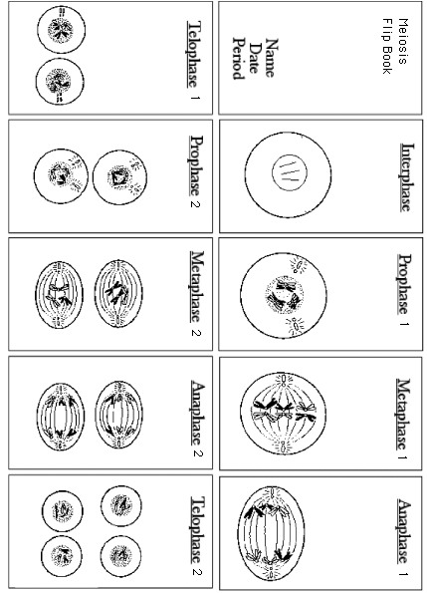

Analysis and Interpretation

- How many chromatids are present in the cell during prophase 1? __________________
- What is the haploid number at the end of meiosis? ______________________________
- In the process of meiosis, how many nuclei are produced from the nucleus of each parent cell? ___________________________________________________________________
- Are the newly produced cells haploid or diploid? ________________________________
- State 1 way metaphase 1 differs from metaphase 2 _______________________________ ________________________________________________________________________________________________________________________________________________

- State 1 way anaphase 1 differs from anaphase 2 _________________________________ ________________________________________________________________________ ________________________________________________________________________

- In mitosis, replication of chromosomes precedes each cell division. In meiosis, two cell divisions take place without a replication of chromosomes between them. What is the significance? ____________________________________________________________ ________________________________________________________________________________________________________________________________________________
- Meiosis is sometimes called reduction division. What does this mean and why is it important to a species? _____________________________________________________ ________________________________________________________________________________________________________________________________________________
- Why is it significant that the four newly formed cells differ in chromosome content? ____ ________________________________________________________________________________________________________________________________________________

Haploid vs. Diploid Graphing Activity
Name___________________________ Date:
Living Environment Per:
Directions:
Part A – Complete all tables

Table 1

Species | Haploid Number | Diploid Number
Donkey |  | 62
Dove |  | 78
Hedgehog | 44
Kangaroo |  | 12
Mosquito | 3
Pea |  | 14
Pineapple |  | 50
Red Fox |  | 34
Turkey | 41
 |  | 46
Snail |  | 24
Tiger | 19
Potato | 24

Table 2 Fill in the table with increasing haploid number
Species | Haploid Number | Diploid Number

Table 3 Fill in the table with decreasing diploid number

Species | Haploid Number | Diploid Number

PART II
- Create a BAR GRAPH depicting the HAPLOID number of each species using TABLE 1

- Create ANOTHER BAR GRAPH depicting the DIPLOID number of each species USING TABLE 1

Questions:

- Dogs have 78 chromosomes in their diploid cells. How many chromosomes are in their haploid cells?

- How many pairs of chromosomes do dogs have in their somatic cells?

- Cats have 38 chromosomes in their diploid cells . How many chromosomes are in their haploid cells?

- Horses have 32 chromosomes in their sex cells. How many chromosomes are in their somatic cells?

- How many pairs of homologous chromosomes do horses have in their somatic cells?

- What types of cells are haploid? What types of cells are diploid?

Name_____________________________ Date:
Lab – Gene Mutations
A gene mutation is a change in the sequences of bases within a gene. There are three types of gene mutations: 1)Substitution; 2)Deletion; 3) Addition. In this lab, we will investigate these mutations and determine what effect they have on the polypeptide chain they produce.
From Normal Gene to Normal Polypeptide Chain
- Randomly select 18 base cards and bring them to your work area.
- Make a short gene by arranging 15 of the bases in a straight line on your desk – You must have the DNA sequence “ACT” be the last 3 bases of your sequence because it is a stop codon. DO NOT use the stop codon anywhere else in your gene. Other than that, you may choose any order of bases you want for your gene. Set aside the three extra base cards to be used later.

Copy down the DNA Sequence that you’ve just made:
__________________________________________________________________

Write the RNA sequence for this gene:
__________________________________________________________________

Using the RNA Codon-Amino Acid Chart, write the amino acid sequence for the gene:
__________________________________________________________________

RNA Codon-Amino Acid Chart
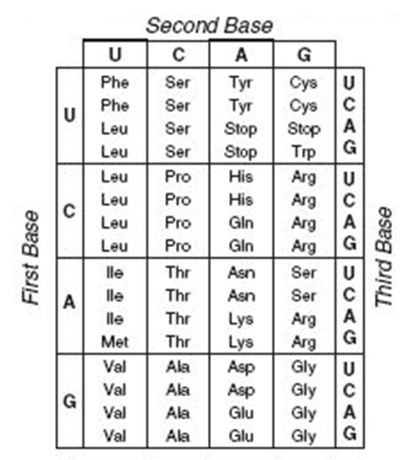

Simulating Mutations
****All of the mutations that you simulate will occur at the 5th base position***
- Simulate substitution by replacing the 5th base in the normal gene with one of the bases that you set aside in step 2.
Copy down the new, mutated DNA sequence that you’ve just made:
______________________________________________________________________

Write the new mRNA sequence:
______________________________________________________________________
Write the new amino acid sequence:
______________________________________________________________________
This is the new polypeptide chain made from the mutated gene.

How many amino acids are different from the original, normal polypeptide chain?______

What new amino acids were included in this polypeptide chain that were not present in the original polypeptide chain? ______________________________________________

- RETURN THE GENE BACK TO ITS ORIGINAL, DNA SEQUENCE
- Simulate deletion by removing the base in the 5th position (do NOT add any other base). All other bases should shift over one position to the left.
Copy down the new, mutated DNA sequence that you’ve just made:
________________________________________________________________________

Write the new mRNA sequence:
______________________________________________________________________
Write the new amino acid sequence:
______________________________________________________________________
This is the new polypeptide chain made from the mutated gene.

How many amino acids are different from the original, normal polypeptide chain?______

What new amino acids were included in this polypeptide chain, that were not present in the original polypeptide chain? ______________________________________________

- RETURN THE GENE BACK TO ITS ORIGINAL, DNA SEQUENCE
- Simulate addition by inserting an extra base in the 5th position (do NOT remove any original base). All of the other bases should shift over one position to the right.
Copy down the new, mutated DNA sequence that you’ve just made:
________________________________________________________________________

Write the new mRNA sequence:
______________________________________________________________________
Write the new amino acid sequence:
______________________________________________________________________
This is the new polypeptide chain made from the mutated gene.

How many amino acids are different from the original, normal polypeptide chain?______

What new amino acids were included in this polypeptide chain, that were not present in the original polypeptide chain? ______________________________________________

Analysis and Questions
- What are the three types of gene mutations? _________________________________
- Do all three mutations produce the exact same results? Which mutation caused the most drastic change in your amino acid sequence (polypeptide chain) _____________ _____________________________________________________________________
- What happened to the amino acid sequence of the polypeptide chain when the substitution mutation occurred? _________________________________________ ____________________________________________________________________
- What happened to the amino acid sequence of the polypeptide chain when the deletion mutation occurred? _____________________________________________ _____________________________________________________________________
- What happened to the amino acid sequence of the polypeptide chain when the addition mutation occurred? ____________________________________________ _____________________________________________________________________
- What would happen to the polypeptide chain if a mutation produced a STOP codon at the beginning of a gene?_________________________________________________ _____________________________________________________________________

- Why do addition and deletion mutations cause more of a drastic change in the amino acid sequence than a substitution mutation? _________________________________ _____________________________________________________________________
- When would a substitution mutation cause no change in the resulting polypeptide chain? ______________________________________________________________ ____________________________________________________________________

- From what you observed in this lab, why do you think addition and deletion mutations are called “Frame-shift mutations”? _______________________________ _____________________________________________________________________
Nitrogen Bases
A | C | T | G | A | C
T | G | A | C | T | G
A | C | T | G | A | C

The Circulatory System Investigations
Understanding the way in which your heart, blood vessels and blood function to deliver nutrients & oxygen, remove wastes, fight infections, etc. is key to realizing why keeping your heat healthy is so important. The human heart is considered a closed circulatory system, because the blood is confined to vessels (arteries, veins, capillaries). Your heart and circulatory system are working 24/7 for you – beating upwards of 3 billion times during the course of your life and circulating nearly 5 liters of blood every minute! You will be investigating and working to understand the inner world of your heart and associated structures in the lab.
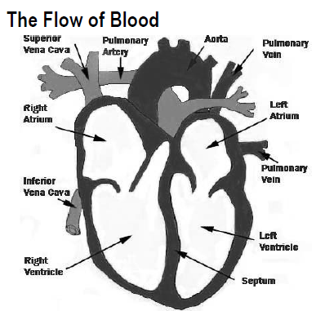 | The heart’s job is to pump blood to the various parts of your body. In doing so, it only pumps blood in a unidirectional manner – or put in highway terms, it is a one way road of blood flow.  1. You are a red blood cell in the Left Ventricle – describe the path you take as you leave here and travel around the body and eventually make your way back to the left ventricle. Name all of the structures you would pass through – don’t include valves.  Left Ventricle ________________ Arteries Capillaries __________________ Vena Cava _____________ ________________ ________________ Lungs ________________ ________________ End a the Left Ventricle
2. Color the areas of the heart above and associated vessels that carry oxygenated (oxygen rich) blood RED and the areas with deoxygenated (oxygen poor) blood BLUE
3. What prevents blood from flowing in more than 1 direction? ______________________________
4. What is meant by a “closed circulatory system”? _______________________________________

Your Heart and How it Beats
Doctors will often listen to your heartbeat to ensure that your heart is working properly. Get one of the stethoscopes. Clean the ear pieces, and then listen to your heartbeat. To listen, place the chest piece over where the heart is. Remember, your heart is positioned in the center of your chest slightly tilted to the left.
5. Record what you hear ____________________________________________________________ ________________________________________________________________________________
6. What is responsible for the LUB-DUB sounds you are hearing? ____________________________ ________________________________________________________________________________
7. Determine your resting heart rate by counting how many LUB –DUBs are heard in 15 seconds and multiply that number by 4 for beats per minute. My resting heart rate in 1 minute is _____ beats.
8. Run in place, do jumping jacks, or exercise for one minute then listen again right away and take your heart rate as well. My active heart rate = ______ beats per minute.
9. Was there any difference in the resting heart rate versus the active heart rate? Explain why or why not? _______________________________________________________________________ _______________________________________________________________________________
Blood Pressure
Examine the graph below and answer the following questions. Blood pressure refers to the force of the blood on the walls of the arteries. Systolic blood pressure is the pressure exerted as the heart pumps. The Diastolic blood pressure is the pressure exerted as the heart relaxes.
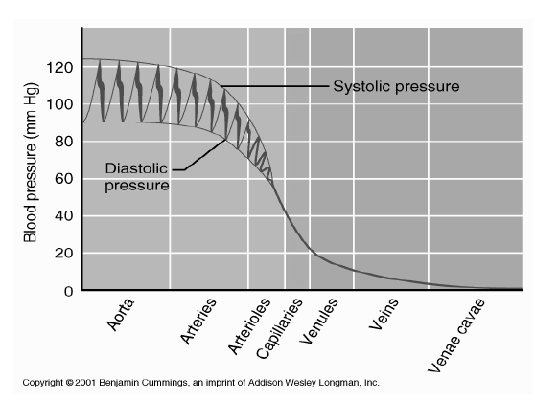 | - What is systolic pressure? ________________ _____________________________________  - What is diastolic pressure? ________________ ______________________________________  - In which area on the chart is blood pressure the highest? Why?_________________________ ______________________________________  - Since the pressure in veins is so low, what do they have to prevent blood from flowing backwards? ___________________________

Blood Vessels
Three different types of blood vessels carry blood throughout the body. Complete the table below
 | Arteries | Capillaries | Veins
Function (with regard to carrying blood)
Diameter (Large, medium, small)
Allow diffusion of oxygen, nutrients across their cell layers? (Yes or No)
Pressure within the vessel (High, low, lowest)

Name__________________ Living Environment
Use your organic compound chart to complete the project below.
- What is a compound?

- What makes a compound organic?

- How many organic compounds will you be analyzing today?

- What is a monomer (building blocks)?

- What is a polymer?

- What is the life process that builds compounds called?
- Digestion
- Synthesis
- Respiration
- Transport

- What is the process that breaks down compounds?
- Reproduction
- Transport
- Digestion
- Synthesis

Organic Compound Project
Procedure:
- Each group needs to obtain 4 pieces of computer paper.
- Measure each piece of paper 8 ½” X 8 ½” (using a ruler).
- Cut the extra off – so that you have a perfect square.
- Fold each square in half and then in half again. This should make the big square have 4 squares inside of it.
- Make sure your creases are VERY sharp.
- Take each piece of paper separately. Unfold it and create a tab on one of the squares by cutting on the dotted lines (see diagram)
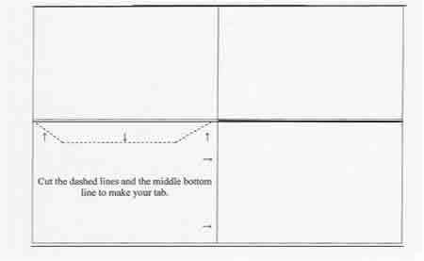
- At the top of the page, in big letters, put the title of the page. The four titles are: Carbohydrates, Lipids, Proteins, and Nucleic Acids.
- On the left side of the page, below the title, write the elements that are in the compound.
- Under that, write a list of examples where this compound can be found.
- On the right hand side, write the function of the organic compound.
- Below that, write the building block.
- On the lone bottom square, draw a picture of where this compound can be found or an example of this compound (Example – Protein – Draw a picture of an enzyme, or of a food that is high in protein)
. ****BE SURE TO DRAW THE PICTURE DIAGNOLLY!!!!!****
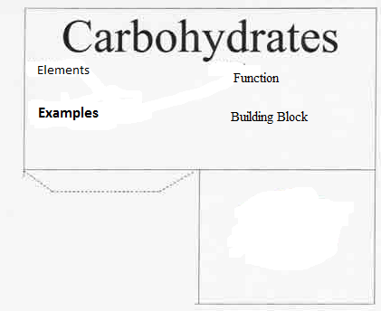
- Once all four pages have been completed, it is time to glue and fold.
- With the folds well creased, swing the picture square over on top of the tab (ask your teacher to show you)
- Using the glue stick, glue the picture to the tab.
- Do this for all of the pages
- Each piece of paper should now look like a miniature stage (two walls and a floor (picture). Use glue sticks and glue the pages together so that pictures are on the floor and the information is pointed outwards.

Post Lab Questions:
- What did you use as an example for lipids?

- What did you use for an example of nucleic acid?

- What did you use for an example of carbohydrates?

- What did you use for an example of proteins?

- Why are proteins important (functions)?

- Proteins function based on their …
- Color
- Shape
- Arrangement of amino acids
- Both b & c

Discovering DNA Structure
Tish Taylor
1994 Woodrow Wilson Biology Institute
Introduction
Instead of giving students copious notes and diagrams on the structure of DNA, why not let them discover the structure?
Teacher Information
Background Information: In this paper lab students will work in cooperative groups of four and manipulate paper nucleotides to discover the structure of DNA. When you have finished with this lab, you will have a great model of DNA that you can hang on the ceiling; it will reach to the floor and then some probably. This paper model can serve as a continual illustration as you discuss mitosis, amino acid sequences and protein synthesis. Students enjoy this lab and you save many frustrating moments trying to teach your students DNA structure.
Materials: copies of the student pages of "Discovering DNA Structure" (1/student); paper nucleotides (1/student) (enlarge the nucleotides so that each nucleotide fits on one sheet of paper); tape.
Teacher Preparations: Enlarge the nucleotides so that ONE nucleotide will fit on ONE sheet of paper. Each student will get one giant nucleotide to color and cut out. Color coding should be left on the sheet. Make sure that you prepare enough nucleotides so that 1/4th of each class represents each of the four DNA nucleotides. When assigning the cooperative learning groups of four, give one student an adenine nucleotide, one student a cytosine nucleotide, etc. When the groups come together the next day, each nucleotide will be represented.
Extension: Have your students learn the DNA SONG. When they learn and sing this little song, they know the structure of DNA. This would make a good follow-up to this lab. This song is to the tune of "Row, Row, Row Your Boat." Your students will have a lot of fun with this one. You might have them sing it in rounds, or have a contest between classes.
We love DNA
Made of nucleotides.
Sugar, phosphate and a base
Bonded down one side.
Adenine and thymine
Make a lovely pair.
Cytosine without guanine
Would feel very bare.
Oh-h-h, de-oxy-ri-i-bo
Nu-u-cleic acid
RNA is ri-i-bo
Nu-u-cleic acid

STUDENT PAGE
Discovering DNA Structure

D = deoxyribo
N = nucleic
A = acid
DNA contains the information for carrying out the activities of the cell. How this information is coded or passed from cell to cell was at one time unknown. To break the code, today you will do a paper lab to determine the structure of DNA and show how the genetic code is carried. Each member of your group has a molecule called a NUCLEOTIDE. DNA is made up of repeating units of nucleotides.
1) Look at your nucleotide and the nucleotides of the other members of your group. What are the THREE common parts of a nucleotide?
________________
________________
________________
2) What is the ONE part of a nucleotide that differs among the four DIFFERENT nucleotides in your group?
_____________________
3) List the four different kinds of nitrogen bases.
_______________________
_______________________
_______________________
_______________________

- Manipulate the nucleotide pieces until you find the best fit. Join the nucleotide molecules in your group together like a puzzle. Use tape to connect and reinforce the molecules. Place you group’s DNA molecule on a piece of construction paper. You now have a molecule of DNA.
In the space below, explain WHERE the nucleotide molecules connect to each other.
______________________________________________________________________________________________________________________________________________________________________________________________________________________________________________________________________
5) A real DNA molecule consists of THOUSANDS of these pairs of nucleotides. What is the pairing arrangement of nitrogen bases?
_________ pairs with __________and ____________ pairs with ____________
- Are there always going to be an EQUAL number of adenine and thymine nucleotides in a molecule?
(Yes / No)
Why? ___________________________________________________________________

- Are there always going to be an EQUAL number of guanine and cytosine molecules in a molecule of DNA?
(Yes / No)

Why? _____________________________________________________________________
8) Scientists abbreviate the nitrogen bases by using the first letter of each base. So,
A always binds to ____
G always binds to ____

9) In the space below, use the letters to show the sequence (order) of the bases in the DNA molecule that your group constructed. Begin at the top left side of your molecule.
Your Groups DNA Molecule

The structure of DNA is actually in a DOUBLE HELIX arrangement.
DOUBLE HELIX means that the two long chains of nucleotides are arranged in a spiral like a twisted ladder.
10) The sides (or "uprights") of the ladder are made up of alternating _____________ and _____________ molecules. The steps (or "rungs") of the ladder are made of _______________ held together by HYDROGEN BONDS.

Student Page (Enlarge to one nucleotide per page)
DNA Nucleotides
Color the nucleotides using the following key:
Deoxyribose = red | Phosphate = blue
A (Adenine) = green | C (Cytosine) = yellow
G (Guanine) = purple | T (Thymine) = orange
Cut out your nucleotides On the next two pages

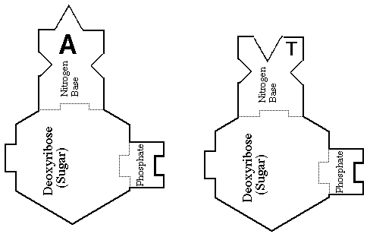

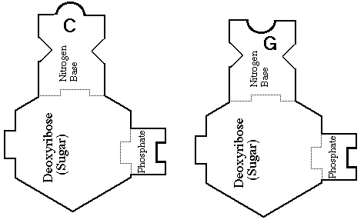

Making Connections NYS Lab (Student Written Report Organizer)
Name___________________________ Date___________

Final Report

Title: ______________________________________________________________

Hypothesis: __________________________________________________________________________________________________________________________________________________________

Methods & Materials (Experiment): _________________________________________________________________________________________________________________________________________________________________________________________________________________________________________________________________________________________________________________________________________________________________________________________________

***DO YOUR EXPERIMENT***

Data Collected (Make a Chart Below)

Discussion & Conclusions:
__________________________________________________________________________________________________________________________________________________________________________________________________________________________________________________________________________________________________________________________________________________________________________________________________________________

Suggestions for Improvement:
_______________________________________________________________________________________________________________________________________________________________________________________________________________________________________________________________________________________________________________________________________________

Suggestions for Further Research:
__________________________________________________________________________________________________________________________________________________________________________________________________________________________________________________________________________________________________________________________________________________________________________________________________________________

Name____________________________ Date______________
Living Environment Lab

Discovering Where Proteins Are Found

Important Functions of Proteins (Do-Now)

1) ______________________________
2)______________________________
3)______________________________
4)______________________________
5)______________________________

Introduction:
Your physical traits, from the shape of your ears to the color of your eyes, are determined by the proteins in your body. The rate of chemical reactions that keep you alive are controlled by proteins called enzymes. Proteins have many important functions, which you outlined above. Some of these proteins are made in your cells through chemical reactions. Proteins are also present in the food that you eat.

Problem:
How can you find out whether a food contains proteins?

Materials per group:
- 6 test tubes
- 1 test tube rack
- 1 glass marking pencil
- Test tube stoppers
- 1 (100 mL graduated cylinder filled with water)
- 1 (10 mL graduated cylinder)
- Protein testing solution A
- Protein testing solution B
- Small sample of eggs
- Small sample of cottage cheese
- Small sample of butter
- Small sample of tuna
- Small sample of milk
- Small sample of cooking oil
Procedure:

- Place a small sample of each of the foods listed on the chart into a separate test tube. Use the glass-marking pencil to label each sample.

- Add 5mL of water to sample in test tube. Stopper and shake to mix with water.

- Add 5 drops of Protein Testing Solution A, and then add 5 drops of Protein Testing Solution B.

- Seal the test tube with a stopper and shake. Observe what happens. A pink or purple color indicates the presence of a protein. If you do not see any color change, no protein is present. Record your observations in the Data Table.

- Repeat steps 2-4 for the rest of the food samples (5 test tubes)

- Have someone from the group write your results on the board (Chart)

- Clean you lab set-ups using the wire brushes provided

- Turn test tubes upside down in rack for drying

- Put all your lab supplies back exactly the way they were before you began using them.

10) Wash your hands

11) Start the post-lab questions

Pre-Lab Questions:

- A chemical test using a substance called an indicator can be used to find out if a food contains protein. What indicator will you use in this investigation?

__________________________________________________________________________
__________________________________________________________________________

2) How can an indicator show that protein is present in a food? __________________________________________________________________________

3) Can an indicator show that a food does not contain protein? If so, how?
__________________________________________________________________________
4) What measuring tool will you use to measure 5mL of water?
_________________________________________________________________________

5) Get into your groups and select a job Write the person’ name next to their job.

Job | Name
1) Getting lab equipment (See material
above)
2) Filling Test tubes w/ food samples &
Labeling test tubes (follow step 1)
3) Mixing samples w/water and protein
solutions A&B (follow step 2 and 3)
4) Writing results on board & Cleaning
set-ups (follow steps 6 – 9)

DATA TABLE

Food Sample | Protein Present (Yes or No)
1) Eggs
2) Cottage cheese
3) Butter
4) Tuna
5) Milk
6) Cooking oil

Post-Lab Questions:

1) Which foods contained proteins? ______________________________________________________________________________________________________________________________________________________________________________________________________________________________

- How can your data table be used to classify the tested foods?
____________________________________________________________________________________________________________________________________________________

- An iodine solution will change color if it is added to food that contains starch. Design an experiment to determine if a food contains starch, protein or both. HINT Think about the experiment you just did.
____________________________________________________________________________________________________________________________________________________

- In this type of experiment, what is the meaning of a substance testing positive or negative?
____________________________________________________________________________________________________________________________________________________

- Can the biuret reagent tell you how much protein (grams of protein) is in a sample of food?
____________________________________________

- Why are proteins important? ________________________________________________

- Proteins function based on their…
- Shape
- Color
- Arrangement of Amino Acids
- Both a & c

Name: __________________________________ Date Completed: _____________________________
Class: ____________ Lab Minutes: _______________ Teacher: _______________________________

Safety in the Biology Laboratory
This lab was created by Ms. Blanarovich from Minisink Valley High School. Credit is given for this activity to Ms. Blanarovich.

Background: If there is one thing that can ruin a biology laboratory experiment or experience, it is the simple act of an accident or incident affecting a student, class, or the entire school. As such, there are certain rules and regulations that MUST be followed to ensure that everyone and everything remains safe. Completing the laboratory is a good way to make yourself aware of the hazards that may exist and be proactive with respect to your well-being and the safety of your fellow students.

Purpose: The purpose of this laboratory experience is:
-to make certain you know and agree to follow the rules and regulations that help keep the biology laboratory a safe place to work and gain knowledge.
-to identify hazards and to implement a plan to react and respond to a hazardous condition if it presents itself.
-to agree with your teacher and your school that you will make your laboratory experience a positive learning time where you can gain valuable knowledge that supports the classroom curriculum.
-to agree that you will complete the 1,200 minutes of lab as well as the required New York State Education Department’s mandated laboratory experiences in a timely fashion.

Materials: The following materials are needed to complete this laboratory experience:
lab papers pencil, pens

Procedure: The following procedure is utilized to perform this experience:
- The following list of regulations and precautions will be followed in our laboratory. Read each safety rule.
- Give a reason as to why that rule is important and then initial in the space provided indicating your will observe and obey this rule when you are working in the Biology laboratory. Safety in the laboratory must be a primary concern to both student and teacher.
- Lab Completion Agreement: Read and sign the attached laboratory completion agreement.

Rule | Why is it Important?
At the beginning of most laboratories, your instructor will engage in a pre-lab discussion. Many safety procedures will be discussed during these discussions. Listen attentively and follow these procedures -- "an ounce of prevention is worth a pound of cure".
Keep all books, papers, and other flammable
materials away from hot plates or dangerous chemicals.
Tie back long hair when you are working with an open flame. Pipe cleaners, rubber bands, and string are useful for this purpose.
Do NOT mix chemicals or perform unscheduled (unsanctioned) experiments without your teacher's approval
Never use chemicals from an unlabeled container. Do not taste, smell, or touch chemicals unless specifically instructed by your teacher to do so.
Wear safety goggles during experiments involving heating or hammering or while using acids or bases. If you do not have goggles on, stay away from students that are experimenting.
It is also expected that you will wear goggles while doing dissections.
Point the open end of a test tube or flask away from yourself and others while heating it. Never heat a closed container.
Use squeeze bottles and droppers only for their intended purpose.
A common accident is picking up red hot materials. Take proper precautions against this.
No material should be left in the sinks; i.e. paper, beakers, etc.
Discard all waste matter in the appropriate containers.
Never place pencils, pens, or other materials in your mouth.
NEVER return excess chemicals back to their container.
Be certain that all laboratory equipment and materials are returned to their appropriate storage areas at the end of the laboratory period.
Keep volatile liquids and reagents away from heating sources.
Know where all laboratory safety equipment is located in case you need it.

Most chemical spills are best handled by washing the affected area with water as quickly as possible. Call your teacher for assistance if necessary. Severe spills may require the removal of clothing.
In an emergency situation an all too common response is panic. If you observe another student in trouble, tell them what to do, and assist them in doing it.
You are responsible for keeping your laboratory
area and completely neat and clean.

Laboratory Completion Agreement
The Living Environment offers a variety of laboratory exercises on current concepts in biology often using state of the art scientific equipment and technology. Various teaching techniques and materials will be employed to provoke student interest and enhance student understanding. Numerous laboratory methods will be utilized in demonstrations and student experiments. Safety instruction will be given and safe practices will be stressed in all laboratory work. Students will exercise critical thinking for solving problems and interpreting laboratory results.

STUDENT LABORATORY CONTRACT
I, ___________________________________________, a student at The Scholars’ Academy, have thoroughly read the Laboratory Safety Rules and Guidelines and do hereby agree to follow all safety rules and procedures given therein. I will conduct myself in a safe and conscientious manner in the laboratory. I will not perform any unauthorized lab procedure. I understand that misbehavior in the lab or failure to follow safe lab procedures could cause a serious accident. I further understand that a violation of these rules could result in my not being allowed to participate in future lab exercises.

Student Signature: ______________________________________ Date: ___________________

***************************************************************************************************************************************************

Questions: The following can be concluded from performing this laboratory experience:

Why was this experience given to you?
____________________________________________________________________________________________________________________________________________________________________________________________________________________________________________________________________________________________________________________________________________________________

What did you learn by completing this experience?
____________________________________________________________________________________________________________________________________________________________________________________________________________________________________________________________________________________________________________________________________________________________

Describe a situation that could arise in lab. How would you respond to it?
____________________________________________________________________________________________________________________________________________________________________________________________________________________________________________________________________________________________________________________________________________________________

Analysis Questions: Answer the following questions in the spaces provided:

It is crucial that you understand a few things about this classroom. As such,
      - How do you exit this room in case of a fire or fire drill? What if the entrance is blocked?
____________________________________________________________________________________________________________________________________________________________________________________________________________________________________________________________________________________________________________________________________________________________

      - Describe at least three things that you would recognize as being hazards that could exist? What would you do about correcting the hazard?
____________________________________________________________________________________________________________________________________________________________________________________

Name: __________________________________ Date Completed: _____________________________

The Scientific Method
*This lab was created by Ms. Blanarovich from Minisink Valley High School. Credit is given for this activity to Ms. Blanarovich.

Essential Question:
Why is it essential for scientists to conduct controlled experiments?

Introduction:
Scientists conduct experiments in order to test their hypotheses and answer their questions. A well-designed experiment must have a control. A controlled experiment has at least two groups. There is a control group and an experimental group. The control group is used for comparison. The experimental group is the group that gets tested. The results of the experimental group are compared to the results of the control group. The control group should be as identical as possible to the experimental group. The only difference is that the control group is not tested or changed. When an experiment does not have a control group then the scientist is unable to figure out the reason for any changes observed during the experiment.

Purpose:
The purpose of this lab is to:
- Analyze a scientific experiment
- Identify mistakes in a scientific experiment
- Improve a scientific experiment
- Expand scientific vocabulary
  - Hypothesis
  - Control
  - Data
  - Variable
  - Valid
  - Conclusion

Hypothesis:
A well-designed experiment always has a control group. A controlled experiment is able to test the hypothesis and answer the experimental questions. Without a control group, it is not possible to determine the cause of any changes observed during the experiment.

Materials:
The materials needed for this lab are as follows:
- Pictures of puppies of different sizes
  - Experiment # 1: One puppy
  - Experiment # 2: One very big and the other very little puppy Props
  - Experiment # 3: 2 identical toy dogs
- Pet food & jar of vitamins for demonstration

Procedures:
- Teacher reads experiment # 1 to class using props.
- Class discusses possible answers to questions for experiment # 1.
- Teacher reads experiment # 2
- In lab groups, students discuss and answer questions for experiment # 2.
- Repeat steps c) and d) for experiment # 3.

A Dogged Investigation

Mr. Curiosa loved to observe the world around him. He was very inquisitive and was always asking questions about what he saw, heard, smelled, tasted and felt. He liked to figure out the answers to his questions by doing experiments.

Experiment # 1:
On his birthday Mr. Curiosa’s wife gave him a puppy. He named it Bluebell. He noticed that Bluebell did not like to eat store-bought puppy chow. So, he set out to make a better dog food. Mr. Curiosa did some reading on dogs and their dietary requirements and he made a special vitamin mixture. He began adding the vitamins to his dog’s pet food.

After a year, Mr. Curiosa was very pleased with the way Bluebell had grown, and he showed pictures of the dog to his friends.

“That’s nothing”, one friend said, “What did the dog look like before you started giving it your special food?”

So Mr. Curiosa brought pictures of the dog when it was a tiny puppy. By comparing pictures, you could see that the puppy had indeed grown.

“That’s still nothing”, the friend replied. “All puppies grow; it probably had nothing to do with your new vitamin mixture.”
Mr. Curiosa realized that his friend was right. His experiment had not proven that his new vitamin formula worked.

Questions for Experiment # 1:
- Using some of the steps of the scientific method, describe Mr. Curiosa’s first experiment:

- Observation (what observations did Mr. Curiosa make that lead to his experiment):
________________________________________________________________________________________________________________________________________________________________________________________________________________________________________________________________________
- Question (What was Mr. Curiosa’s main question?):
________________________________________________________________________________________________________________________________________________________________________________________________________________________________________________________________________
- Hypothesis (What was Mr. Curiosa’s hypothesis?):
________________________________________________________________________________________________________________________________________________________________________________________________________________________________________________________________________
- Procedure/methods (What did Mr. Curiosa do? What data did he collect?):
________________________________________________________________________________________________________________________________________________________________________________________________________________________________________________________________________

- Results (What were Mr. Curiosa’s findings?)
________________________________________________________________________________________________________________________________________________________________________________________________________________________________________________________________________
- Conclusions (What did Mr. Curiosa conclude from his experiment?)
________________________________________________________________________________________________________________________________________________________________________________________________________________________________________________________________________________________________________________________________________________________________

Experiment #2
Like a dedicated scientist, Mr. Curiosa did not give up. He persevered with his efforts to demonstrate that he had made a better, healthier dog food. He wanted to prove that his special formula worked.
Sometime later, his son brought home a Black Labrador puppy named Coal. So, Mr. Curiosa went to his local dog shelter and brought home an adorable, puppy that looked like a dachshund. He named this puppy Dirt. Thus began his second experiment.

Mr. Curiosa added his special vitamin mixture to some commercial dog food and labeled it ‘A’. Then he took the same commercial dog food but this time he did not add any of his vitamins. He labeled this dog food ‘B’. Coal received food A and Dirt received food B.

For an entire year Mr. Curiosa made sure that each dog got their own food. He brought the dogs to his company picnic and proudly showed them off. Coal, the black Labrador, had grown twice as big as Dirt who was part Dachshund.
“You think you made some fancy dog food, huh?” one friend said. “You can not prove that your special dog food is better. Labradors always grow bigger than Dachshunds! His larger size had nothing to do with your fancy dog food.”

Mr. Curiosa realized that his friend was right. He had made a mistake in his second experiment.

Questions for Experiment # 2:
- Which one of the steps in the scientific method did Mr. Curiosa improve on in his second experiment?
________________________________________________________________________________________________________________________________________________________________________________________________________________________________________________________________________
- What did Mr. Curiosa do differently?
________________________________________________________________________________________________________________________________________________________________________________________________________________________________________________________________________

- Why was this change important?
________________________________________________________________________________________________________________________________________________________________________________________________________________________________________________________________________

- Why were Mr. Curiosa’s results inconclusive?
________________________________________________________________________________________________________________________________________________________________________________________________________________________________________________________________________________________________________________________________________________________________

Experiment # 3:
So, Mr. Curiosa went back to work. He vowed he would design an experiment so that no one would question the results. He wanted everyone to believe and trust his conclusions.
This time around, he invested some of his savings and bought twin, male beagle puppies. They were from the same litter. One he called Wrinkles and the other he called Freckles. For a whole year, Wrinkles ate only food A (+ special vitamins) and Freckles ate only food B (- special vitamins). They drank the same water and got the same amount of exercise every day. Their daily lives were very much the same. Mr. Curiosa weighed the dogs every week and recorded their weights.
This year’s picnic was a great success. Mr. Curiosa brought his dogs and a scale. His friends were very impressed. Wrinkles was larger and his fur was beautiful and shiny. Freckles was cute, too. However, it was obvious that he had not grown as well as Wrinkles. Mr. Curiosa weighed both dogs and sure enough Wrinkles weighed two kilograms more than Freckles. Even Mr. Curiosa’s boss was impressed. This time, all of his co-workers believed that his special vitamin formula really worked.

Within six months, Mr. Curiosa had a contract with a commercial pet food company to market his special vitamin formula worldwide. He had fancy business cards that said, “Mr. George Curiosa, Experimental Canine Dietician”. He was a very satisfied scientist (and wealthy, too!).

To this day, both Wrinkles and Freckles are doing fine. Once the experiment was over, Freckles got the special dog food as well!

Questions for Experiment # 3:
- What improvements did Mr. Curiosa make this time?
________________________________________________________________________________________________________________________________________________________________________________________________________________________________________________________________________
- Why were these changes important?
________________________________________________________________________________________________________________________________________________________________________________________________________________________________________________________________________

- Explain whether or not Mr. Curiosa’s conclusions were valid this time:
________________________________________________________________________________________________________________________________________________________________________________________________________________________________________________________________________

- In what ways could he have improved this experiment even further?
________________________________________________________________________________________________________________________________________________________________________________________________________________________________________________________________________

Analysis Questions:
- What qualities make a good scientist? ______________________________________________________________________________________________________________________________________________________________________________________________________________________________________________________________________________
- How does Mr. Curiosa demonstrate these traits?
____________________________________________________________________________________________________________________________________________________________________________________
- What is an experimental control?
___________________________________________________________________________________________________________________________________________________________________________________________________________________________________________________________________________
- In experiment # 3, which dog was the control group and which dog was the experimental group?
___________________________________________________________________________________________________________________________________________________________________________________________________________________________________________________________________________
- What is a variable?
________________________________________________________________________________________________________________________________________________________________________________________________________________________________________________________________________

- List the variables in experiment # 3:
________________________________________________________________________________________________________________________________________________________________________________
- Mr. Curiosa kept records of Freckle’s and Wrinkle’s body weights. What term is used to refer to these measurements?
_________________________________________________________________________________________

Name______________________________ Date _______
Ecology
Symbiosis (Symbiotic Relationships)

Complete questions and try to identify the type
of symbiotic relationship each pair of organisms displays.

- List three ways that organisms interact within an ecosystem.

- Animals that feed exclusively on herbivores are known as

________________________________.

- Animals that feed exclusively on producers are known as

__________________________________________.

- Animals that feed on herbivores and producers are known as

__________________________________.

- Which type of organism creates energy (sugar) for the rest of the ecosystem?
- Consumers
- Producers
- Heterotrophs
- Decomposers
- How do decomposers help an ecosystem stay balanced?

_____________________________________________________________

- Define Commensalism.

_____________________________________________________________

_____________________________________________________________

- Define Parasitism.

_____________________________________________________________

_____________________________________________________________

- Define Mutualism.

_____________________________________________________________

_____________________________________________________________

- What is an organic compound? ___________________________________________________________

___________________________________________________________

Provide an example of an organic compound? _____________________
Provide an example of an inorganic compound? _____________________
Identify the relationships below using the terms commensalism,
parasitism, mutualism, or no relationship. Descriptions of the relationships will be provided if the relationship is unclear.

- Humans and domesticated dogs. ___________________________

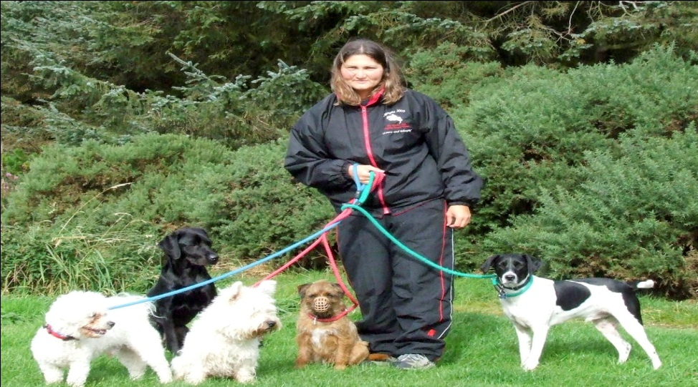

- Lichen (composed of fungi and algae). ________________________

Algae makes food (sugar) and fungi attaches and absorbs nutrients from the environment through the process of _______________.

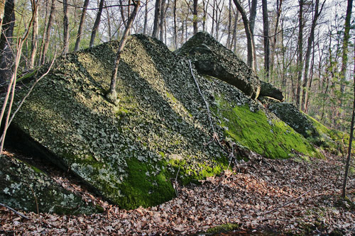
- Tapeworms and humans. __________________________

Tapeworms infect human’s intestines and use the nutrients from the human’s food.

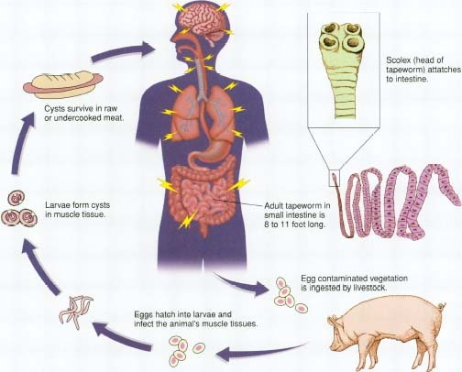

- Sea anemones and clownfish. ______________________________

Sea anemone protects clownfish from predators and provides a habitat and the clownfish cleans the sea anemone and provides it with better water circulation.
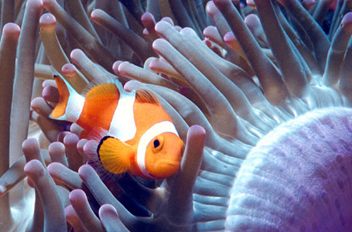
- Blood fluke and humans. ________________________________

The fluke is a type of flatworm that lives off the blood of humans. The f
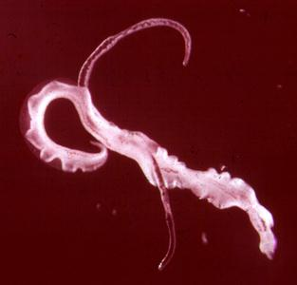

- Bird living in a tree. ______________________________

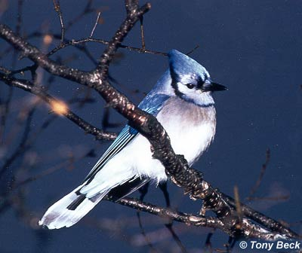

- Flowering plants and bees. _____________________________________

Bees transfer pollen to other plants for plant reproduction (cross-pollination) and bees get nectar from the flowers and convert it into honey.

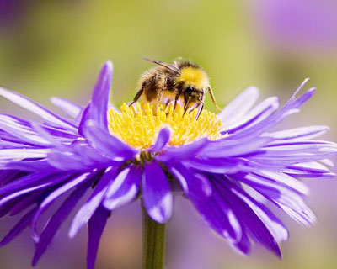

- Spider monkey living in a tree. ________________________________

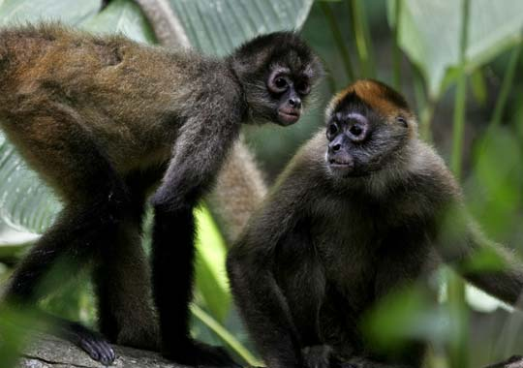

- Anglerfish and bioluminescent bacteria. ___________________________

Bacteria live inside fish (shelter) and the bacteria have chemical reactions that provide light for the fish. This light allows the anglerfish to attract prey.
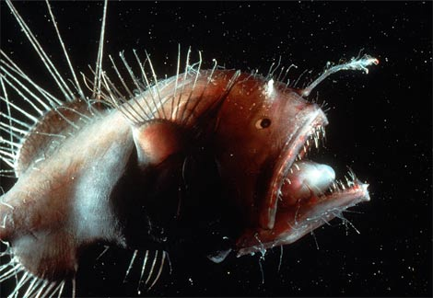

- Whales and barnacles. _______________________________

Barnacles are filter feeders that attach and live on whales. They don’t have to compete with other filter feeders attached to the bottom of the ocean floor. They don’t hurt the whale they just live on them.

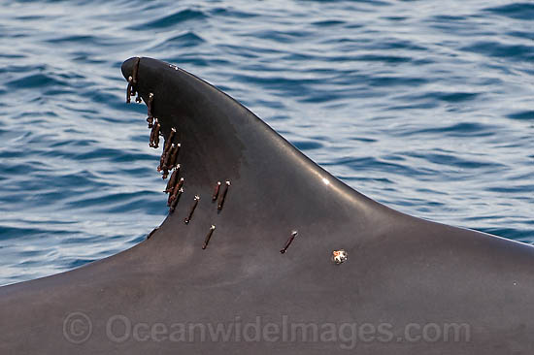
- Tics and deer. _________________________________

Tics feed off the blood of the deers.

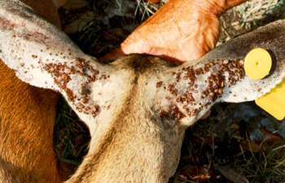

- Fleas and dogs. _________________________________________

Fleas feed off the blood of dogs.

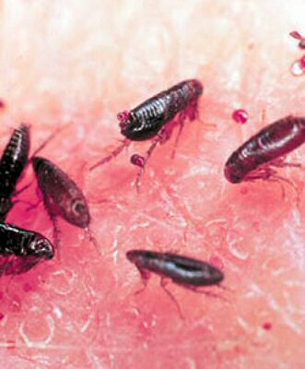

- Sharks and remora. __________________________________

The remora (small fish) hangout under the shark and feed on the left overs. The shark is not bothered by the remoras.

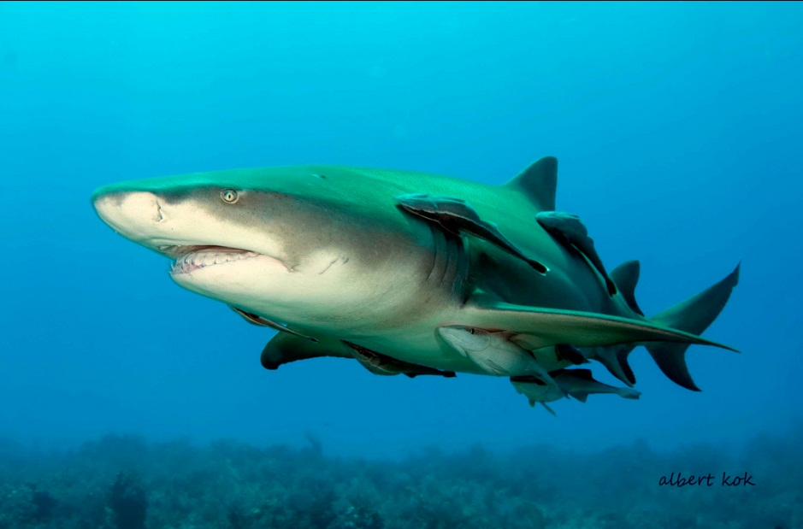

- Humans and intestinal bacteria. ______________________________

Humans have bacteria living in their intestines that produce important compounds for humans such as, vitamins and enzymes. They also help maintain the pH of the digestive tract.

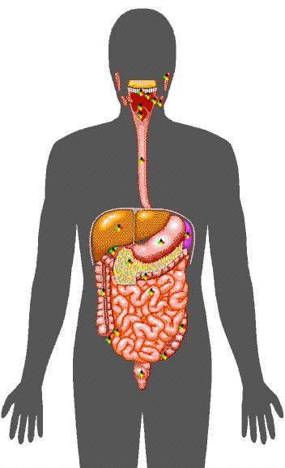
- Deep sea tubeworms & thermophilic bacteria. ___________________

Bacteria live inside the tubeworms and are producers that use chemosynthesis to produce energy. The tubeworms provide the bacteria with a habitat (place to live) and the bacteria make energy for the tubeworms.

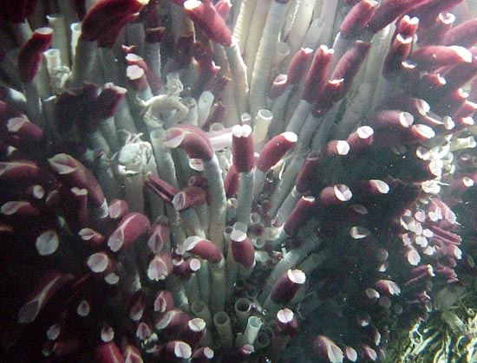

- Malaria protists and human. ________________________________

The malaria protists infect humans through mosquito vectors. Once the protists enter the human they destroy their red blood cells.

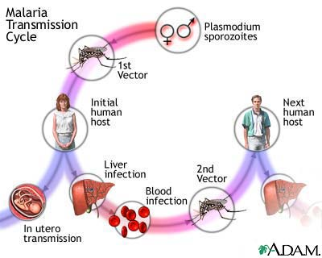
Post Lab Questions:

- From relationship number 12 identify the

Parasite _________________

Host ____________________

- How many mutual relationships did you find? __________________

- How many relationships of commensalism did you find? _____________

- How many parasitic relationships did you find? ___________________

