Curriculum Area Project

East Meadow School District

Grade 9

Interactive Lessons for Global History

2010-2011

Written by: Michelle Barnhill and Christina Luciano

East Meadow High School

Superintendent Louis R. DeAngelo

Principal Richard Howard

Table of Contents

|  |  |
| --- | --- |
| TOPIC | PAGE NUMBER |
| Abstract  Rational  Hunter or Farmer? | 3  3  4 |
| Hammurabi’s Code | 10 |
| Athens VS Sparta | 14 |
| Socrates on Trial | 20 |
| Julius Caesar | 25 |
| Magna Carta | 29 |
| The Qin Dynasty | 34 |
| Buddhism | 41 |
| Slavery | 45 |
| Alexander the Great | 51 |
| Mali | 58 |
| Native Americans | 65 |
| Age of Exploration | 70 |
| Bibliography | 76 |

Abstract

Interactive Lessons for Global History was created to aid ninth grade students learn Global History. This CAP is designed to help students meet the aim of the Global History learning standard that requires students to use a variety of intellectual skills to demonstrate the understanding of major ideas, eras, themes, developments, and turning points in world history and examine the broad sweep of history from a variety of perspectives.

Rational

Students often need a differentiated approach to instruction. They learn best by interacting rather than through verbal instruction. As a way to bring history alive, plays and supplemental readings will be created for various units. Some units will include: Ancient Civilizations, Chinese Dynasties, the Roman Empire, Greece, and Medieval Europe. Questions, activities, and short quizzes will accompany each lesson.

**Hunter or Farmer?**

**Aim**: How did life differ between hunters and gatherers?



**Do Now**: Look at the map below. Locate the continent where the first humans appeared.



Directions: After reading the play, answer the questions below in full sentences.

1. How did the Cro-Magnons differ from the Neanderthals? (Give 5 examples for each.)

|  |  |
| --- | --- |
| Cro-Magnons | Neanderthals |
|  |  |

1. How did the lives of nomads differ from farmers? (Give 4 examples for each.)

|  |  |
| --- | --- |
| Nomads | Farmers |
|  |  |

1. Why did Ogg refuse to change his life-style from hunter to farmer? ______________________________________________________________________________________________________________________________________________________________________
2. Why did Ulana feel her way of life was better than Ogg’s?

______________________________________________________________________________________________________________________________________________________________________

1. Why did Ogg finally decide to talk to Ulana and Lute? ______________________________________________________________________________________________________________________________________________________________________

**Summary**: Which lifestyle would you rather live, one of a nomad or farmer? Give 4 examples to why you picked that lifestyle. ________________________________________________________________________________________________________________________________________________________________________________________________________________________________________________________________________________________________________________________________________________________Hunter or Farmer?

Humanlike creatures have existed on the earth for millions of years. Fossils of the oldest human ancestors have recently been discovered in Africa. These apelike creatures lived over 4.4 million years ago. Earlier, also in Africa, scientists found the footprints and physical remains of beings that walked upright over 3.5 million years ago. Some 2.5 million years ago, humanlike creatures made the first known stone tools. These people had larger brains than any previously known human ancestors.

No one knows exactly when modern humans first appeared on the earth. Intelligent beings know as Neanderthals (named for the place in Germany where their remains were first found) appeared 200,000 years ago. The Neanderthals were short, heavyset, had short arms and legs, and walked with a forward leaning gait. They made tools of stone and blades of flint. The Neanderthals probably believed in an afterlife, since they buried food and tools with their dead.

Some scientists believe that our first truly human ancestor originated in Africa between 250,000 and 165,000 years ago. Some of these human ancestors probably left Africa about 115,000 years ago and began a slow migration across the earth. The best-known of these prehistoric people were the Cro-Magnons, who were named for the place in France where their remains were first found. The Cro-Magnons flourished between 40,000 and 10,000 years ago. They were taller and more slender than the Neanderthals, stood upright, and most important, had brains better able to make decisions and adapt to change. They made tools from animal horns and bones. They made fishhooks and harpoons for fishing; needles for sewing clothing of leather and animal skins; and knives and bows and arrows for hunting. They left striking examples of art in caves in France and Spain. Some believe that the more intelligent Cro-Magnons were better able to survive the great Ice Age than the Neanderthals. During the Ice Ages, the climate was much colder and drier than it is today. Much of northern Europe and North America was buried under great sheets of ice.

About 12,000 years ago, the last Ice Age ended. The world’s climate slowly grew warmer, the ice retreated, and the landscape and animals changed. Up to this time, humans had been nomads, they had no settled homeland. Instead people lived in small groups that followed and hunted the huge animals, such as mammoths and bison, and they gathered wild grains, fruits, and nuts.

By about 10,000 years ago, many human groups had settled down and were growing their own food. Some of these farmers had also begun to domesticate, care and and raise, once wild animals such as cattle and sheep. These early agricultural groups settled in fertile lands that good supplies of water. Some settled in the river valleys of the Middle East, Africa, and Asia. The hunters did not all turn immediately to farming or raising animals. Wild animals were still available, and hunting appealed to many people.

Adapted from *Enjoying Global History*

East Africa 7500 B.C.

**Ogg**: My name is Ogg, and I am a hunter. I usually walk a great distance each day to find my food. The animals often fight back, and I have been attacked and bitten many times by deer and goats. Twice I have come close to losing my life to lions. I continue to hunt for a living, even though many of my friends have given up. They have learned to plant crops and keep animals. They live in houses made of brick, stone, and grass.

**Narrator**: One day while returning from the hunt, Ogg happened to pass the field of his friends Ulana and Lute.

**Ulana**: Ogg, how tired you look! Your life is so hard and dangerous!

**Ogg**: I would rather hunt than work in a hot, dusty field.

**Ulana**: Look how well we live. We have a steady supply of meat, milk, vegetables, and wool. In fact, we have everything we need.

**Ogg**: But you pay a high price for these goods.

**Ulana**: What price?

**Ogg**: You are paying with your freedom. You must spend all of your time tending to your crops and animals. You are not free to come and go as you please.

**Ulana**: Your old friends are happy to live this way. We are not afraid, nor are we hungry. We all work together and help one another. Some till the soil. Others care for the animals. Still others make weapons and tools. We trade goods with people in other villages. You should give up the hunt and join us. You will have a better life.

**Ogg**: If I settle down and become a farmer, I will have to live according to the rules of the group. On the hunt, the only rules I have are my own. Besides, the hunt is exciting. I even enjoy the danger. No, I will not join with your group.

**Narrator**: Ogg left Ulana and continued to hunt for his food. But last week he returned from the hunt empty-handed every day. He was cold, tired, and hungry. For the first time, Ogg wanted comfort and security that Ulana and her people had. He soon decided to go speak to Ulana and Lute.

Adapted from *Enjoying Global History*

**Hunter or Farmer Quiz**

Directions: Read each statement carefully. Write CAPTIAL “T” for each statement that is true and CAPITAL “F” for each statement that is false.

______________No one knows exactly when the first modern humans appeared on earth.

______________The Neanderthals first appeared about one million years ago.

______________The Cro-Magnons left examples of art in caves.

______________ During the Ice Age, the climate was much colder and drier than it is today.

______________Cro-Magnons had a better ability to make decisions and adapt to change.

Hammurabi’s Code

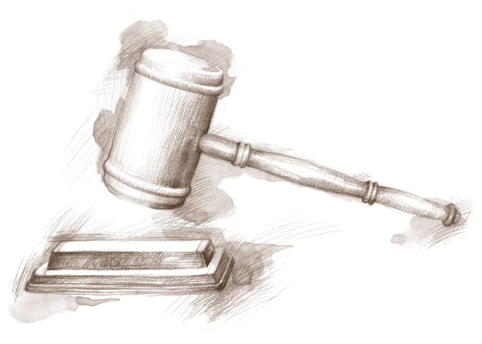

**Aim**: Why was it important for Hammurabi to have a written code of law?

**Do Now**:

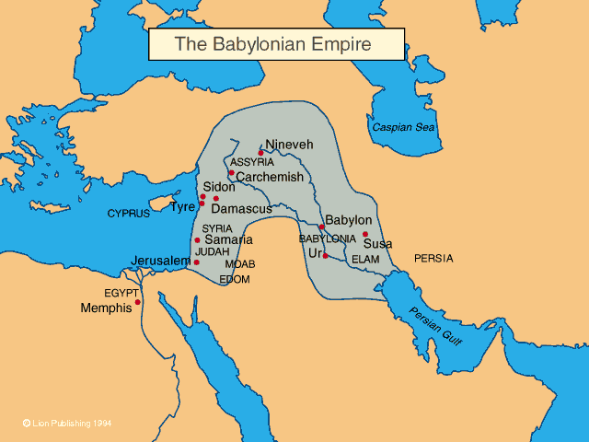

Locate Babylon on the map. How did the location help the city become so prosperous? ____________________________________________________________________________________________________________________________________________________

1. Why was King Hammurabi considered a great ruler? ______________________________________________________________________________________________________________________________________________________________________________________________________________________________________________________________________________
2. How were people who broke the law punished, according to the Hammurabi Code?

________________________________________________________________________________________________________________________________________________________________________________________________________________________________________________________________________

1. Why was Zakir executed?

______________________________________________________________________________________________________________________________________________________________________________________________________________________________________________________________________________

**Summary**: Why is it important to have a written code of law?

______________________________________________________________________________________________________________________________________________________________________________________________________________________________________________________________________________

**Crime and Punishment in Babylonia**

The city of Babylon was located near the point where the Tigris and Euphrates rivers flow closest to each other. Much of the trade of the civilized world of the period after 1900 B.C. moved through Babylon and the other cities of the Babylonian Empire. The Babylonians created a great center of business and trade. They mined copper, lead, iron, silver, and gold, and wove textiles of cotton and wool. Babylonian products were shipped throughout the Middle East and as far away as China and India. The caravans that arrived daily filled Babylon’s shops with goods from these parts of the world.

The Babylonians continued to use Sumerian cuneiform writing. They studied the stars and planets and developed the science of astronomy. In order to measure time, the Babylonians also invented the water clock and sundial.

The power of Babylonia grew, in part, because it had capable rulers. King Hammurabi was an especially able ruler. During his reign (1792-1759 B.C.), the laws were collected and organized into a written code that covered business contracts, farming methods, debts, wages, marriage, divorce, and the treatment of women. The Code of Hammurabi also specified punishments for a variety of crimes.

Our story takes place during the great king’s reign. Two business people, who are husband and wife, express their opinions about the punishments contained in the code.

**Babylon 1760 B.C.**

**Narrator**: Our story is set in a two-story mud-brick home. Bushum and Nasira are seated in the inner courtyard. The doors and windows of their large house are made of woven reeds set into wooden frames.

**Nasira**: Husband, I understand that your friend Zakir is in great trouble. Last month he was in charge of the royal estates. Today, he is in prison.

**Bushum**: Indeed, he is in great trouble. Zakir is going to be executed.

**Nasira**: That’s terrible. Why?

**Bushum**: King Hammurabi ordered Zakir to go to the city of Kish to oversee the harvest on the royal estates. Unfortunately, Zakir fell ill and could not travel, so he hired a friend to go in his place. The king was furious. Zakir was put on trial, was declared guilty, and was sentenced to die.

**Nasira**: Zakir never hurt anyone! Why must he die simply because he failed to make one trip to Kish? I say he should be fined and even put in jail. But he should not be executed.

**Bushum**: There is a good reason why Zakir is going to be executed. He violated the spirit of King Hammurabi’s law. The law says that whatever a person says he or she will do must be done efficiently, correctly, and professionally. An architect must be sure to build a house that will not collapse and hurt the owner. A doctor must not bring harm to a patient. A person who has a duty to perform- such as Zakir- cannot send someone else to do the job that is his or her responsibility alone.

Zakir’s fate disturbs you, Nasira. But you did not object when the thief who broke into our house last year was caught and sentenced to death..

**Nasira**: How can you compare the two crimes? The thief stole our property. Zakir stole nothing.

**Bushum**: All crimes must be punished. In the future, people like Zakir, will be more reliable and will carry out their superior’s orders. Others will be afraid to break into people’s houses and steal their possessions.

**Nasira**: I sometimes think our code of laws is too harsh. You remember what happened when young Ingil hit his father. They chopped off the boy’s hand!

**Bushum**: That will teach all people to respect their parents. It will be a long time before anyone in the neighborhood hits a parent.

**Nasira**: Perhaps he should have had a lighter sentence. Is it fair to mutilate a person for life for one wrongdoing?

**Bushum**: You are worried that the code is unfair. Under the code, all are responsible for their actions. If I am robbed and thief is never caught, the city must repay me for my loss because it failed to protect my property. What can be fairer than that?

**Nasira**: (Sighed) I know you believe the Code of Hammurabi does everything possible to discourage crime and wrongdoing. I dear the code is itself sometimes unfair and unjust.

**Postscript**

The Code of Hammurabi was an important milestone. Since the laws were written down, judges could decide someone’s guilt or innocence by looking at the written law instead of deciding for themselves what punishment should be passed.

Women held a high position in Babylonian society. They were allowed to go into business, and they had the same rights in business as men. A wife could return to her family if her husband mistreated her, and a divorced woman was allowed to keep her children.

Hammurabi did more than codify the laws. He increased farm production by enlarging the irrigation system and build granaries to store grain as protection against famine. Hammurabi also set up a system of fair prices and wages. The tax system was made fairer for the poor, and a government housing program was introduced.

Adapted from *Enjoying Global History*

**Athens VS Sparta**

**Aim:** Who would win: Athens or Sparta?



**Do Now:** Take the quiz below to determine whether you think more like an Athenian or a Spartan.

*1. Would you rather…*

A) have an orderly government in which the rules were created by the most experienced men

or

B) have a government that allows or free men to participate and make the rules

*2. Would you rather…*

A) have your money go towards military spending

or

B) have your money go towards beautification projects for your city

*3. Would you rather…*

A) have women that are equal to men

or

B) have women that are limited in their freedoms

*4. Would you rather…*

A) limit trade by using heavy rods for currency

or

B) encourage trade by having a common currency with other nations

*5. Would you rather…*

A) limit the colonization (taking over) of other nations

or

B) encourage the colonization (taking over) of other nations

If you chose choice A for more than half of the questions, you may be more Spartan minded.

If you chose choice B for more than half of the questions, you may be more Athenian minded.

Are you more like an Athenian or a Spartan?____________________

Based on the quiz, create a Venn Diagram below comparing Athens and Sparta.

The Peloponnesian War

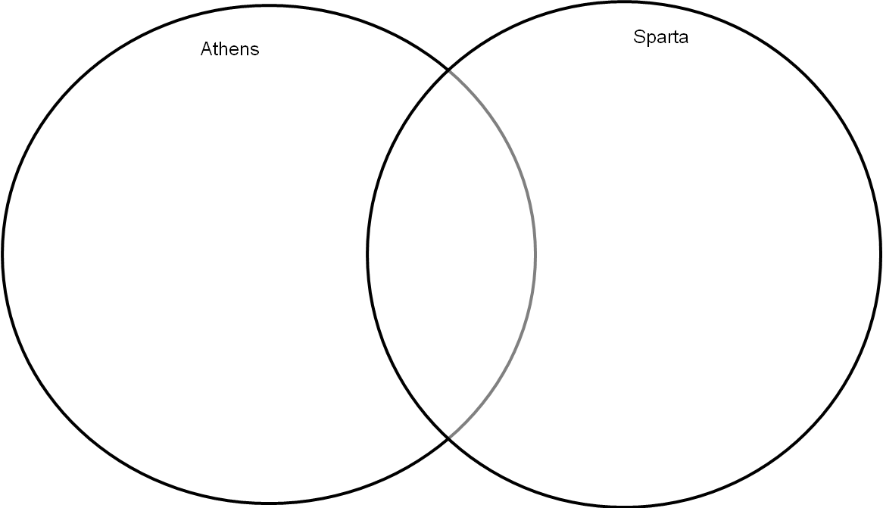

Following the Persian War, Athens grew in wealth and prestige and other city-states (especially Sparta) became very hostile. Athens became very powerful and controlled many of the other Greek city-states. Sparta resented Athens’ power and issued Athens and ultimatum (do this or else.): Athens had to free all the cities under its control or face a war. Athens refused. War between these two city-states grew inevitable. In 431 B.C.E. Sparta declared war on Athens. Sparta and their allies were known as the Peloponnesian League. Athens and their allies were the Delian League. Sparta had a strong army, but Athens had a strong navy (and hoped to avoid land wars).

Based on what you learned about Athens and Sparta, which polis (city-state) do you think will win the war? Explain.

________________________________________________________________________

________________________________________________________________________

Early in the war, it appeared that Athens would achieve victory…but…two unfortunate events changed the course of the war. First, a plague killed 1/3 of the Athenian population (including the Athenian leader Pericles) by 421 B.C.E. Second, In 413 B.C.E., the Spartans crushed an entire Athenian fleet that set out to destroy Syracuse, one of Sparta’s wealthiest allies. In 404 B.C.E. Athens was forced to surrender. In addition, Persia provided Sparta with financial funding so that they could build a stronger fleet and destroy Athens.

In what ways could a plague affect Athens’ ability to fight a war?

________________________________________________________________________

________________________________________________________________________

Why would Persia want to provide aid to Sparta in this war?

________________________________________________________________________

________________________________________________________________________

After the war, Sparta ruled all of Greece for a short time. Then, in the early 300s B.C.E., the city-state of Thebes- aided by Persia- emerged as the leader of Greece. However, the other Greek city-states refused to accept Theban leadership and fighting continued. By the mid-300s B.C.E., King Philip (Alexander the Greats father) conquered Greece and united them under the rule of Macedonia.

How might the Peloponnesian War have allowed for King Philip to conquer all of Greece?

________________________________________________________________________

________________________________________________________________________

Summary: Complete the questions relating to the following documents which relate to today’s lesson.

Document #1

The father did not have the right to bring up his children as he chose, but had to carry them to a place where the elders officially examined the infant; and if it was ill-born and deformed, the ordered that it be left to die. As soon as a boy was seven years old, it was ordered he be taken by the state and enrolled in military companies…

(Adapted from Plutarch, The Parallel Lives, Vol. 1, Second Century C.E.)

1) Which city-state is this document describing? _________________________________

2) What advantages to society might this model (way of doing things) provide? _____________________________________________________________________

3) What disadvantages to society does this model provide?

______________________________________________________________________

Document #2

It is true that we are called a democracy, for government is in the hands of the many and not the few. While the law secures equal justice to all alike in their private disputes, the claim of excellence is also recognized; and when a citizen in any way distinguishes himself, he is preferred for public service, not as a matter of privilege, but as a reward of merit.

1) Which city-state is being described in this paragraph?_____________________________

Our city is thrown open to the world, and we never expel a foreigner of prevent him from seeing or learning anything secret…we are lovers of the beautiful, yet with economy, and we cultivate the mind without loss of manliness…An Athenian citizen does not neglect the state because he takes care of his own household. We also regard a man who takes no interest in public affairs, not as harmless, but as a useless character…

2. How are people who do not participate in the democratic system of government viewed?

________________________________________________________________________

I have dwelt on the greatness of Athens in order to show you that we are contending for a higher prize than those who enjoy none of these privileges.

(The Funeral Oration of Pericles found in Thucydides’ Peloponnesian War, c. 400 BCE)

3. Who is Pericles referring to when he says “those who enjoy none of these privileges”?

Socrates on Trial



**Aim**: Why was Socrates put on trial?

**Do Now**:

Why are people put on trial?

____________________________________________________________________________________________________________________________________________________________

Are the outcomes of trials always fair?

____________________________________________________________________________________________________________________________________________________________

What does it mean if something is ‘just’?

____________________________________________________________________________________________________________________________________________________________

Read the following three quotes from Socrates and write what they mean in your own words. After putting the quote into your own words, state whether or not you agree with the quote.

Be as you wish to seem.

__________________________________________________________________________________________________________________________________________________________________________________________________________________________________________

The unexamined life is not worth living.

__________________________________________________________________________________________________________________________________________________________________________________________________________________________________________

He is a man of courage who does not run away, but remains at his post and fights against the enemy.

__________________________________________________________________________________________________________________________________________________________________________________________________________________________________________

**SOCRATES ON TRIAL**

|  |
| --- |
| Parts: Judge 1 Judge 2 Socrates Plato |

JUDGE 1: Good morning everyone. We are here today to put Socrates on trial for corrupting the youth of Athens by encouraging the youngster to challenge our fine government and our wonderful gods who have helped us through the best and worst of times.

JUDGE 2: (*looking at Socrates)* Please introduce yourself to the courtroom so that everyone here knows who you are.

SOCRATES: I am Socrates, a proud Athenian philosopher.

JUDGE 2: For how long have you lived in Athens?

SOCRATES: I have lived in Athens for my entire life, I am seventy years old now.

|  |
| --- |
| Right now, Socrates has an opportunity to take back what he said. He is facing a death sentence if he is convicted.  What are some reasons he might want to take back his teachings? ____________________________________________________________________  ____________________________________________________________________  What are some reasons that he might not take back what he has taught? ____________________________________________________________________  ____________________________________________________________________  What do you think he should do? ____________________________________________________________________ |

JUDGE 1: You are here because you are being accused of having corrupted the youth of Athens. You have been telling your students that our gods are just inventions, something created by the Athenian poets. This is a terrible crime punishable by death. Are you really teaching such values to your students?

SOCRATES: Yes, in fact this is what I am teaching my students. I stand by every word I have said to them. If I say one thing that I have said to them is false, they have no reason to believe anything that I have taught them. In addition, I disagree that the lessons I teach are criminal. In Athens, we value openness and free-thought. Since you are discouraging such values I must argue that you are the criminal.

JUDGE 1: It is not I who is on trial! I will ignore your statement and call a character witness to the stand. Plato, please take a seat. *(Plato walks up and takes a seat)*

JUDGE 1: Please introduce yourself to the court.

PLATO: I am Plato, I teach philosophy in Athens.

JUDGE 1: How do you know our defendant, Socrates?

PLATO: I am a proud student of his.

JUDGE 1: What are your impressions of the Athenian government?

PLATO: I, like Socrates, take issue with the way Athenian government functions. In my opinion, there should be a philosopher-king. The government in Athens needs to be restructured, it is just not working.

JUDGE 2: Well, that is merely an opinion, and a wrong one at that. What can you tell us about Socrates?

PLATO: He is an intellectual man, the wisest person I have ever known. He has taught me a lot by having me answer his thought-provoking questions. He is quite honest and moral.

JUDGE 1: Prove that he is honest and moral for the court. It appears that you are trying to pass off your opinions as facts. I am sure many people do not see Socrates as honest or moral. Teaching people to ask questions is quite dangerous- it can lead to chaos.

PLATO: Socrates always tries to do the right thing. For instance, a friend offered to help Socrates escape from prison if he is convicted to a crime, but Socrates refused to participate. Although he might not agree with the outcome, he respects the process that was used to arrive at the outcome. He will always take responsibility for his actions.

JUDGE 1: Thank you, you may leave the stand.

JUDGE 2: Socrates, many leaders in Athens suggested that you leave Athens before your arrest, but you chose to remain and face this court. I respect your decision and your dedication to your ideals. The judges have decided to spare your life, if you deny your ideas and promise to stop spreading them.

|  |
| --- |
| If you were Socrates, would you take this one last opportunity and deny your teachings? |

SOCRATES: Again, I will not take back a word that I have said. I stand by my ideas and beliefs and if I have no choice but to die as a symbol for others, I shall do so with pride. I chose to remain in Athens, rather than go into exile knowing that my fate is likely to be death. I would like you to consider the values that Athens’ holds when determining my outcome. Athens’ encourages people to think and be free; I feel that I am being punished for exercising these values.

JUDGE 2: I will be happy to hand down the verdict. Socrates you have been found guilty of neglecting the gods and for corrupting the youth of Athens by encouraging them to consider new ideas. You could have avoided such a horrible fate, but you chose not to. Your punishment will be DEATH! Like others before you who have been sentenced to death, you will drink from a cup of poison hemlock.

SOCRATES: I will gladly do that because I believe that all people should obey the law. I must reiterate that I do not believe that what I did was wrong and I do not agree with the law that is responsible for putting me to death. I do find it ironic that my form of death lies in tradition and old thought.

**Julius Caesar**



Aim: Julius Caesar: Hero or Villain?

Do Now: List three traits that make a leader a hero and three traits that make a leader a villain. Briefly explain how each of the traits you chose helps or hurts a leader.

|  |  |
| --- | --- |
| **HERO** | **VILLAIN** |
| 1) | 1) |
| 2) | 2) |
| 3) | 3) |

Based on the image shown on the overhead, answer the following questions:

1) What crime is about to take place here? ____________________________________________________________________________________________________________________________________________________________

2) Does everyone in this picture want the man dead? Explain.

____________________________________________________________________________________________________________________________________________________________3) Do you believe that the victim is an important person? Why?

____________________________________________________________________________________________________________________________________________________________4) Where is this crime about to take place?

____________________________________________________________________________________________________________________________________________________________

5) Why might government officials want to kill their own leader?

____________________________________________________________________________________________________________________________________________________________

**JULIUS CAESAR- HERO OR VILLAIN**

**Narrator #1:** Julius Caesar was one of Rome’s greatest generals and political leaders. He ruled Rome with Crassus and Pompey as a triumvirate (group of three persons will equal power) until he had the urge to advance his political career. He conquered Gaul (present-day France) which was ruled by the Celts and brought Gaul and the Celts under Roman rule. The power which Caesar obtained was viewed as a threat to the Roman Senate, this led to a civil war. When Caesar crossed the Rubicon to return to Italy he forced Pompey and his allies out of Italy and took over as a dictator for life.

**Plebeian #1:** Caesar will always be considered a military hero. He expanded Rome’s empire even further. He granted Roman citizenship to many of the conquered people outside of Italy. I was unemployed until Caesar became dictator. His public works program got me a job.

**Plebeian #2:** I was also unemployed prior to Caesar becoming dictator. My new boss was ordered to rid some of his slaves and hire more free laborers. Also, free grain is now distributed to those who need it. That is such an important social reform, now nobody will go hungry.

**Plebeian #1:** Caesar introduced the new calendar, also. It counts 365 days a year and an extra day every fourth year. We needed a calendar which was accurate.

**Brutus:** Look at the power which Caesar has taken. He has become a tyrant and I fear he is trying to proclaim himself king.

**Cassius:** We must kill him. According to ancient Roman law, anyone who plots themselves to become king could be killed without a trial.

**Narrator #2:** On March 15, 44 B.C. Julius Caesar was assassinated. His followers- Marc Antony, Octavian, and Marcus Lepidus defeated Cassius and Brutus and formed a new triumvirate. These three new leaders each commanded a separate part of the Roman world. This triumvirate did not last long. Lepidus was forced to retire from politics and Marc Antony and his Egyptian wife Cleopatra committed suicide because they feared Octavian would capture them and take over. Octavian became the undisputed ruler of Rome. His rule marked the beginning of the Roman Empire.

Julius Caesar was one of the most interesting men in history. He was assassinated at the peak of his power by people that he thought were his friends. The men who killed him thought that Caesar would destroy the republic of Rome. They thought that Caesar wanted to become a king. Others who supported Caesar felt that he restored order to Rome after a period of civil war and disorder. Whether Caesar was a hero or villain has been debated throughout history.

Based on the play- Julius Caesar: Hero of Villain? List the actions that make Caesar a hero and the traits that make Caesar a villain.

|  |  |
| --- | --- |
| **HERO** | **VILLAIN** |
|  |  |
|  |  |
|  |  |
|  |  |
|  |  |

Summary: Answer the following questions based on today’s lesson.

Overall, do you believe Julius Caesar was a hero or a villain? Explain.

________________________________________________________________________

________________________________________________________________________

If Julius Caesar had not been assassinated, how do you think his rule would have progressed?

___________________________________________________________________________________________________________________________________________________________

**Magna Carta**



**Aim: How did the Magna Carta help the common people of England?**

Do Now:

In what ways is the President’s power limited in the United States?

____________________________________________________________________________________________________________________________________________________________

Is it a good idea to limit the president’s power?

____________________________________________________________________________________________________________________________________________________________

Answer the following based on the play.

Why are people angry with King John?

____________________________________________________________________________________________________________________________________________________________

How does the Magna Carta limit the King’s power?

____________________________________________________________________________________________________________________________________________________________

How do you think King John felt about signing the Magna Carta?

____________________________________________________________________________________________________________________________________________________________

Which document in the United States limit’s the president’s power?

____________________________________________________________________________________________________________________________________________________________

**Forcing a King’s Hands**

In the early thirteenth century, England was ruled by King John. He didn’t seem to care about the average man and woman. His control was total. A person lived or died because of a nod of the head or a wave of the hand. Even the nobles, or upper classes, were afraid of the king. He was unpredictable. His ideas changed from day to day. The nobles’ lives, lands, and fortunes were in the king’s hands.

In 1215 the English nobles refused to stand any longer for John’s mistakes and taxes. They insisted that there must be limits to what an English kind could do. They forced John to sign the Magna Carta, the Great Charter. The powers of the kings were no longer absolute.

England 1215

PARTS:

|  |
| --- |
| Narrator Baron Howard Baron William Philipe Baron Edward Baron Roger |

NARRATOR: Philippe is a French traveler who enters the lounge of an English inn (hotel). The room is noisy and he does not know anyone there. He overhears a group of English nobles speaking about politics in England. He decides to head over to the table and join them.

PHILIPE: Good evening noble lords. May I join you at your table?

BARON HOWARD: Of course, please take a seat. I am assuming you are French, based on your accent and dress. We are honored to have you join us.

PHILIPE: Thank you so much, you are too kind. I have been hearing much about your King, John. What is happening? Everyone seems to be talking.

BARON ROGER: Of course everyone is talking. King John is a horrible king. The people are mad! We are not allowing his behaviors to continue.

PHILIPE: Is that what the Magna Carta is supposed to do- stop King John’s behaviors? What did he do that is so bad? Why would he sign a document that takes power away from him?

BARON ROGER: He did too many things unworthy of a king- he is lucky that he was not overthrown. He *had* to sign the Magna Carta. King John did not have a choice. The people are angry.

PHILIPE: Well, you still haven’t told me what he did.

BARON EDWARD: He has totally abused his power. He had his nephew murdered and he married his best friend’s fiancée. How do you feel about that? He is our king, he should set a good example for the people he leads.

PHILIPE: Those are terrible things, but how does that directly impact the people he rules? Shouldn’t kings have more power and rights than the rest of us?

BARON WILLIAM: Maybe kings should have more power because they are the rulers, but even their power should be limited. Just because a man is king does not mean he should be allowed to do whatever he pleases. He had no right to raise so many taxes and force people to pay them. His taxes are way too high for most people to afford and he does not care.

PHILIPE: But doesn’t a king have the right to raise taxes so that he can fight wars? He has been fighting us Frenchmen for years.

BARON EDWARD: Yes, he needed the money so that he can fight wars and lose more land to the French. Us Englishmen are tired of spending so much money to lose our troops and our land in wars that we no longer support.

PHILIPE: Your King John does not sound like a wise ruler and it seems that the people are rightfully unhappy. Why don’t you just get rid of him?

BARON HOWARD: It is not that simple. We pledged to support him and that is what we will do. King John went too far and he has to be brought back to reality. He has to understand there is a higher law and there are things that even a king can not do.

BARON WILLIAM: We had to remind him that the people have rights. If he did not agree to change his ways, we would have then gotten rid of him. That is why we had him sign the Magna Carta.

PHILIPE: But how does the Magna Carta stop King John from abusing his power? I still don’t understand.

BARON WILLIAM: I will explain. For example, the King used to be able to tax the people whenever he felt like it. Now the King can ask for taxes, but the Council must approve it. The Council is a group of barons, people like us.

PHILIPE: What else does the Magna Carta do?

BARON EDWARD: If we are to be fined, only people of our own class can fine us.

PHILIPE: How about the common people?

BARON EDWARD: Suppose merchants, free peasants, or even serfs do something wrong, now they may be fine only according to how serious their crimes are. Their neighbor’s will decide on the fines. But no one can take a free farmer’s land or a merchant’s goods. Nor can they take a serf’s farm tools.

PHILIPE: I get it- let the punishment fit the crime and do not take away a person’s means of support.

BARON EDWARD: Also, if a person commit’s a crime their trial will be held as soon as possible. Free peasants cannot be sent to jail without first being put on trial. When they are put on trial, they are judged by their peers. King John used to have the power to put people in jail without a trial- how terrible.

BARON HOWARD: The King is also not allowed to interfere with local government.

PHILIPE: I have to say, the Magna Carta is quite impressive but I still think King John should have been overthrown.

BARON ROGER: No, if he had been overthrown England would have been thrown into a civil war. Instead, we have a promise from the king that he will do the right thing. This keeps him in check and we avoided war. If he does not keep his promise then, he will likely be overthrown. I highly doubt it would come to that.

PHILIPE: Well said, I am most impressed.

Adapted from *Enjoying Global History*

The Qin Dynasty



**Aim- What did the Qin Dynasty accomplish?**

Do Now- What are some things the government does to create order, although it might anger many people? (some answers include: taxation, some laws that limit people’s rights, census polls)

Motivation- Show an image of the Terra Cotta soldiers. Have students list the traits that the leader who had these built must have possessed. Give students the following background information and notes on Emperor Shi Huang Di:

Emperor Shi Huang Di

- Ruled the Qin Dynasty in China (221-206 BC)

-Strong emperor- built roads, simplified Chinese writing, standardized weights and measures

-Had the Great Wall built to protect China from Northern invasions

-Eliminated dissent (opposition)

Lesson- Students will be given information regarding aspects of Emperor Shi Huang Di’s rule. The students will be put into groups and asked to create a short play debating the merits and short-falls of one of the Emperor’s policies after they fill-in the brainstorming chart. Later, they will perform their skit and the class will work together to discuss the positives and negatives of the policy presented in the skit. The class will then fill in their chart.

Summary- Have students discuss the answer to the aim question and whether or not they believe the Qin was a good or bad dynasty overall.

Aim- What did the Qin dynasty accomplish?

Do Now- What are some things the government does to create order, although it might anger many people? ____________________________________________________________________________________________________________________________________________________________

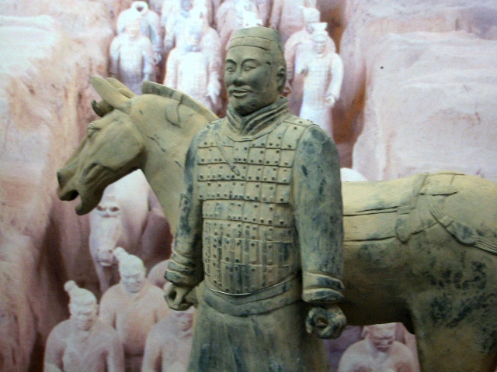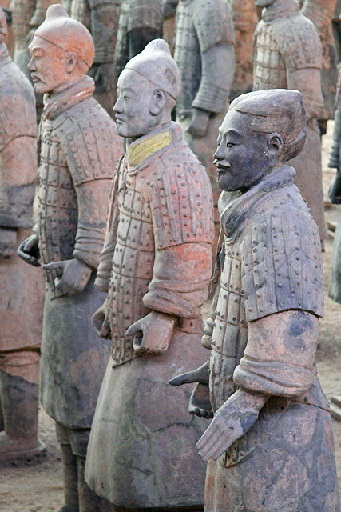

*Pictures courtesy of public domain photos*

Above is a picture of the Terra Cotta Soldiers. The Terra Cotta Warriors and Horses are the most significant archeological excavations of the 20th century. It was created under the rule of Shi Huang Di, China’s first emperor. Upon ascending the throne at the age of 13 (in 246 BC), [Shi](http://www.travelchinaguide.com/attraction/shaanxi/xian/terra_cotta_army/qin_shihuang_1.htm) Huang Di had peasants begin work on his tomb. It took 11 years to finish. It is believed that many buried treasures and sacrificial objects had accompanied the emperor in his afterlife. A group of peasants uncovered the Terra Cotta Soldiers while digging for a well nearby the royal tomb in 1974.

BOOK BURNING

INFORMATION

To prevent criticism, Emperor Shi Huang Di ordered hundreds of Confucian scholars be murdered. In addition, all “useless” books were ordered to be burned. This meant that Confucian books were not allowed in China because they disagreed with the ideas of Shi Huang Di. Practical books about medicine and farming were allowed. Emperor Shi Huang Di wanted all of the power and did not want people to question his policies.

|  |  |
| --- | --- |
| POSITIVES | NEGATIVES |
|  |  |

ASSIGNMENT

With your partners, write a script in which three peasants are arguing about Shi Huang Di’s book burning policies. Make sure at least one peasant opposes the policy and one supports it.

GREAT WALL OF CHINA

INFORMATION

Poor people in China were forced to work very hard on the building of the Great Wall, a defensive wall located in northern China. Peasants were forced to labor on this wall or face death. Many of the workers died while working on the wall because it was such difficult work and the winters that they had to work through were very cold. The wall was thousands of feet long and was meant to keep invaders out of China.

|  |  |
| --- | --- |
| POSITIVES | NEGATIVES |
|  |  |

ASSIGNMENT

With your partners, write a script in which three peasants are arguing about Shi Huang Di’s wall building policy. Make sure at least one peasant opposes the policy and one supports it.

CENTRALIZATION OF THE GOVERNMENT

INFORMATION

Emperor Shi Huang Di was a very strong ruler who managed to halt (stop) battles within China and create peace. He was an autocratic ruler (that meant that he did not share his power) who crushed dissent (people who disagreed with him). He built a highway of roads that united China, they were over 4,000 miles long. He standardized writing, laws, currency, and weights and measures throughout China. His harsh taxes allowed for him to create such far-reaching changes.

|  |  |
| --- | --- |
| POSITIVES | NEGATIVES |
|  |  |

ASSIGNMENT

With your partners, write a script in which three peasants are arguing about Shi Huang Di’s government policies. Make sure at least one peasant opposes the policies and one supports them.

_________________________________________________________________________________________________________________________________________________________________________________________________________________________________________________________________________

_________________________________________________________________________________________________________________________________________________________________________________________________________________________________________________________________________

_________________________________________________________________________________________________________________________________________________________________________________________________________________________________________________________________________

_________________________________________________________________________________________________________________________________________________________________________________________________________________________________________________________________________

_________________________________________________________________________________________________________________________________________________________________________________________________________________________________________________________________________

_________________________________________________________________________________________________________________________________________________________________________________________________________________________________________________________________________

_________________________________________________________________________________________________________________________________________________________________________________________________________________________________________________________________________

Buddhism



Aim - What is the goal of Buddhism?

Do Now: What are some reasons that cause people to feel unhappy?

____________________________________________________________________________________________________________________________________________________________

Assignment: Use pages _____ from Mastering Global History to fill in the chart below.

BELIEFS OF BUDDHISM

Founder:

Began in:

Grew out of the Hindu religion.

The Four Noble Truths are: The Eightfold Path tells Buddists to:

1)­­­­­_____________________ 1) __________________________

2)_____________________ 2) __________________________

3)_____________________ 3) __________________________

4)_____________________ 4) ___________________________

5) ___________________________

6) ___________________________

7) ___________________________

8) ___________________________

Aim- What is the goal of Buddhism?

**Ananda:** Master, you have explained to many people how to live a proper life. Can you please explain these rules to me so that I too can live in a proper manner?

**Buddha:** Of course I can. I call my rules commandments. These commandments include: never kill a living thing- that means you can not engage in any acts of warfare or even kill a bug on the street, never take what has not been given to you, do not tell lies, do not drink anything that will make you drunk. You should always live a pure, healthy, and wholesome life. These rules are meant to help you become a better person.

**Ananda:** But can even regular people, like myself, follow these rules and live this way?

**Buddha:** All of us can live this way. In fact, if a person hurts me, I will help that person. If I am abused, I will remain silent. The worse a person treats me, the better I will try to be.

**Ananda:** I really don’t think I can be like you, it is very difficult to be like that.

**Buddha:** Perhaps you don’t understand what I am trying to teach you. Let me give you an example of how to behave. Once a person insulted me, but I said nothing. Finally, I asked the person a question. ‘If a person refuses to accept a present that is offered, to whom does it belong?’ The person replied, ‘It belongs to the person who offered the present, of course.’ ‘Good,’ I said. ‘Therefore, I will not accept your nasty remarks. Keep them for yourself!’ You see, I did not insult the person, but I showed how foolish the person’s remarks and attitude were.

**Ananda:** I have another question for you. You were once a rich man, with all of the luxuries that anyone could ever hope for. You lived in a beautiful palace and had servants responding to your every need. You choose to give up everything you had and became poor and had nothing. Which way is better?

**Buddha:** Neither way is better. On one hand, if we think only of riches and possessions or live only for pleasure, we will never have time to search for the true meaning of life. n the other hand, those who have little or nothing are constantly concerned with survival and have neither the time nor the energy to seek enlightenment. We must have the time and the opportunity to look within ourselves so that we can achieve enlightenment and the way to truth.

**Ananda:** How can we find the Middle Way?

**Buddha:** The right attitude toward life is the basis for sound living. We must constantly seek to teach the true was to all persons. Everyone must learn to respect all living creatures, do good works, to help the poor and sick, and not to fight or steal.

**Ananda:** Do I have a chance of achieving nirvana? I want to experience the peace that you have.

**Buddha:** Of course you can achieve nirvana. But first, Ananda, you must want absolutely nothing. Devote yourself entirely to helping others. When you have lost interest in yourself and want nothing, you will be at peace. (Adapted from *Enjoying Global History*, an Amsco Publication)

Summary Assignment:

1) Choose five (5) rules of Buddhism and discuss how easily they can be followed in today’s world. Explain each of your answers.

|  |  |
| --- | --- |
| RULE | HOW EASY IS THIS RULE TO FOLLOW? |
|  |  |
|  |  |
|  |  |
|  |  |
|  |  |

2) Do you think that the rules Buddha preaches are good rules to live by? Explain.

____________________________________________________________________________________________________________________________________________________________

Slavery



Aim: What impact did slavery have on the Americas?

Do Now: You have just discovered an unknown island. It is large in size and has many natural resources; this means you can become wealthy if you play your cards right. What are some things that you are going to need so that your island can be profitable?

__________________________________________________________________________________________________________________________________________________________________________________________________________________________________________

· **Number of Slaves Transported by Each European Country**

|  |  |  |  |  |  |  |
| --- | --- | --- | --- | --- | --- | --- |
|  | **Country** |  | **Voyages** |  | **Slaves Transported** |  |
|  | Portugal (including Brazil) |  | 30,000 |  | 4,650,000 |  |
|  | Spain (including Cuba) |  | 4,000 |  | 1,600,000 |  |
|  | France (including West Indies) |  | 4,200 |  | 1,250,000 |  |
|  | Holland |  | 2,000 |  | 500,000 |  |
|  | Britain |  | 12,000 |  | 2,600,000 |  |
|  | British North America, U.S. |  | 1,500 |  | 300,000 |  |
|  | Denmark |  | 250 |  | 50,000 |  |
|  | Other |  | 250 |  | 50,000 |  |
|  | **Total** |  | **54,200** |  | **11,000,000** |  |

**Number of Slaves Delivered to Each Country / Destination**

|  |  |  |  |  |  |  |  |
| --- | --- | --- | --- | --- | --- | --- | --- |
|  | **Country / Destination** |  | **Slaves Delivered** |  |  | **%** |  |
|  | Brazil |  | 4,000,000 |  |  | 35.3 |  |
|  | Spanish Empire (including Cuba) |  | 2,500,000 |  |  | 22.1 |  |
|  | British West Indies |  | 2,000,000 |  |  | 17.7 |  |
|  | French West Indies (including Cayenne) |  | 1,600,000 |  |  | 14.1 |  |
|  | British North America & U.S. |  | 500,000 |  |  | 4.4 |  |
|  | Dutch West Indies (including Surinam) |  | 500,000 |  |  | 4.4 |  |
|  | Danish West Indies |  | 28,000 |  |  | 0.2 |  |
|  | Europe (including Portugal, Canary Islands, Madeira, Azores, etc. |  | 200,000 |  |  | 1.8 |  |
|  | **Total** |  | **11,328,000** |  |  | **100.0** |  |

Facts provided by: http://www.slaverysite.com/Body/facts%20and%20figures.htm

Answer the questions below based on the figures above.

|  |
| --- |
| 1. Which European nation transported the most slaves?  2. Which country had the most slaves delivered to them?  3. What does the answer above tell us about the country?  4. Why were so many slaves needed? |

Assignment:

Exposing the Truth About Slavery

It is the year 1600 and you are a newspaper reporter. Your assignment is to write an article exposing the horrors of slavery. You may use the “boiler plate” attached. In your article you must include at least two quotes from slaves and other people you interviewed (these can include merchants, slave owners, everyday citizens). You must also include one image that “exposes the truth” about slavery.

Summary:

|  |
| --- |
| What was the purpose of slavery?  _____________________________________________________________  _____________________________________________________________  What were the long-term effects of slavery?  _____________________________________________________________  _____________________________________________________________ |

**Information about Slavery**

Slavery existed in ancient times, but in the 1400s when the Europeans became involved in the Americas, slavery became much more harsh and wide-spread. Sugar plantations and tobacco farms in the Americas required large supplies of workers to make them profitable for their owners. When millions of Native Americans died while working on such plantations, the Europeans needed a new form of cheap labor and Africans began being used to do plantation work. There were four main reasons Africans were used to do work in the Americas. The first was that many Africans had already built up immunities to European diseases. Since they were already immune, they would not die if they were exposed to such diseases. Millions of Native Americans died when they were exposed to these European diseases. The second reason Africans were used was because many Africans already had experience farming and would be able to do the farming jobs immediately. Third, Africans were less likely to escape from slavery because they did not know their way around, as the Native Americans did. Lastly, their skin color made it easier to catch them if they escaped and tried to live among the others. The buying and selling of Africans for work in the Americas became known as the Atlantic Slave Trade. Almost 10 million slaves were transported to the Americas between 1500 and 1870. The Africans who were sent to the Americas were forced to leave their families and never see them again. Portugal, Spain, and England were all leaders in the slave trade. Many slave traders were denounced for enslaving other human beings. They pointed out that Africans were not Christians. Thus, enslaving non-Christians was acceptable to them. The voyage that brought captured Africans to the West Indies and later North and South America was known as the Middle Passage. This journey represented cruelty and abuse towards Africans. Africans were packed by European traders into the dark holds of large ships. Once on board, the Africans were whipped and beaten. Diseases spread quickly, killing many Africans. Many other Africans died from physical abuse and suicides by drowning. It is estimated that about 20% of the Africans aboard each slave ship perished. Those who survived the ocean voyage faced a very harsh life in the Americas. Survivors were auctioned off to the highest bidder. After being sold, slaves worked in mines, fields, or as domestic servants. Many lived on little food in small huts. They worked long days and were often beaten. Children born to slaves were considered slaves.

THE JOURNAL

January 12, 1600

EXPOSING THE HARSH TRUTH ABOUT SLAVERY

By:_______________________________

__________________________________________________________________________________________________________________________________________________________________________________________________________________________________________

__________________________________________________________________________________________________________________________________________________________________________________________________________________________________________

__________________________________________________________________________________________________________________________________________________________________________________________________________________________________________

__________________________________________________________________________________________________________________________________________________________________________________________________________________________________________

__________________________________________________________________________________________________________________________________________________________________________________________________________________________________________

Alexander the Great



AIM: Is Alexander worthy of the title “the Great”? Explain.

Do Now: What makes a person great? Give three characteristics of a great person.

1___________________________________________________________

2___________________________________________________________

3___________________________________________________________

Directions: After reading the story, answer the questions below.

1. Give three reasons to why King Philip of Macedonia was so successful.
   1. _________________________________________________
   2. _________________________________________________
   3. _________________________________________________
2. How did Alexander encourage the spread of Greek, or Hellenistic culture?

________________________________________________________________________________________________________________________________________________________________________________________________________________________________________________________________________

1. Describe the Hellenistic Culture.

________________________________________________________________________________________________________________________________________________________________________________________________________________________________________________________________________

1. How were the Greeks influenced by the east?

________________________________________________________________________________________________________________________________________________________________________________________________________________________________________________________________________

Summary: Why do you think Alexander was given the title “the Great”?

________________________________________________________________________________________________________________________________________________________________________________________________________________________________________________________________________

Extension Activity: A movie is being made on Alexander the Greats life as a military leader. You are to create the poster that will illustrate his career.

Activity: Listen to the song “Alexander the Great” by Iron Maiden. Read the lyrics and view the map provided.

[Chorus:]  
Alexander the Great  
His name struck fear into hearts of men  
Alexander the Great  
Became a God amongst mortal men  
  
A Phrygian King had bound a chariot yoke  
And Alexander cut the 'Gordian knot'  
And legend said that who untied the knot  
He would become the master of Asia  
  
Hellenism he spread far and wide  
The Macedonian learned mind  
Their culture was a western way of life  
He paved the way for Christianity  
  
Marching on, marching on  
The battle weary marching side by side  
Alexander's army line by line  
They wouldn't follow him to India  
Tired of the combat, pain and the glory  
  
Alexander the Great  
His name struck fear into hearts of men  
Alexander the Great  
He died of fever in Babylon

My son ask for thyself another  
Kingdom, for that which I leave  
is too small for thee"  
(King Philip of Macedonia - 339 B.C.)  
  
Near to the east  
In a part of ancient Greece  
In an ancient land called Macedonia  
Was born a son  
To Philip of Macedon  
The legend his name was Alexander  
  
At the age of nineteen  
He became the Macedon King  
And he swore to free all of Asia Minor  
By the Aegian Sea  
In 334 B.C.  
He utterly beat the armies of Persia  
  
[Chorus:]  
Alexander the Great  
His name struck fear into hearts of men  
Alexander the Great  
Became a legend 'mongst mortal men  
  
King Darius the third  
Defeated fled Persia  
The Scythians fell by the river Jaxartes  
Then Egypt fell to the Macedon King as well  
And he founded the city called Alexandria  
  
By the Tigris river  
He met King Darius again  
And crushed him again in the battle of Arbela  
Entering Babylon  
And Susa, treasures he found  
Took Persepolis the capital of Persia

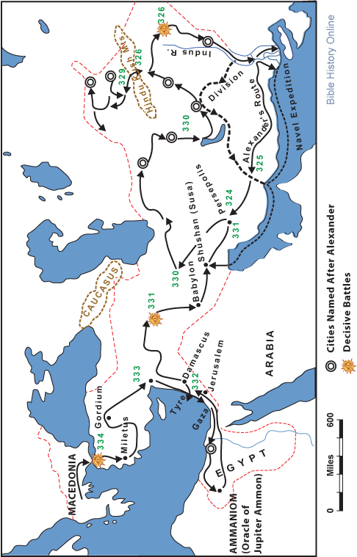

**In Idea that Tried to Conquer the World**

In the fourth century B.C., military power in the lands around the Aegean Sea shifted to the kingdom of Macedonia, to the north of Greece. When Philip became its king in 359 B.C., he knew that the Greek city-states were still divided, and their continued fighting among themselves had made them weak. Philip’s armies easily defeated Athens and Thebes in 338 B.C. Greece was finally united, but under the control of Macedonia.

Philip was an excellent organizer and politician. By the time of his death in 336 B.C., he had made Macedonia onto a world power. Philip created the military power and battle tactics with which his son Alexander would conquer much of the known world.

Alexander was born in 356 B.C. From an early age, he aspired to become a great military leader. His goal was to surpass his father’s victories-and he succeeded. Alexander had another great teacher-the Greek philosopher Aristotle. Philip engaged Aristotle to teach Alexander about Greek history, literature, and philosophy.

During his years in power, Alexander, who was called “Great”, spent most of his time on the battlefield or in preparation for the battle. His armies conquered lands as far east as the Indus River, including the Persian Empire that had threatened the Greeks in the fifth century. Alexander built some 20 cities, all of which he named Alexandria, in the lands he conquered. Each city was a center of Greek culture. Perhaps the most famous Alexandria was in Egypt. This city became a center of trade and learning.

Alexander’s victories opened the door for the spread of Hellenistic (Greek) culture and learning throughout the civilized world. The laws, calendar, and money of the Greeks were introduced wherever they went. Greek became the language of international trade and diplomacy throughout the civilized world. Alexander’s soldiers were encouraged to marry women in the lands they conquered and settle in new cities.

Alexander’s Story

Your name was Alexander, and you wanted to be remembered as the person who conquered and united the entire world as one great civilization.

As a boy, you tamed a wild horse that no one else could manage. You were able to do this because you were more observant and smarter than others. You realized that the horse was afraid of its shadow. So you made sure that when you trained it, the horse faced the sun. This experience helped convince you that if you were smarter than your enemies, you would emerge victorious whenever you went to war. You were determined never to be defeated on the battle field.

You were only 20 years old when you became the king of Macedonia. True to y our dream, you united the Greek cities and then went on to win smashing victories against the Persians. Even in victory you were clever. You married a Persian princess and ordered soldiers to marry Persian women. This made it easier for the Persian people to accept your rule.

At the same time, you helped to introduce Greek learning and culture to the Persian people. They learned the Greek language. Greek literature, art, culture, laws, and customs were introduced. This was only the beginning. It was your plan to spread the teachings of the Greek people all over the world.

Next, you marched into Egypt, conquered it, and introduced Greek ideas to the Egyptians. But even though you continued to fight and spread Greek culture, the people in the conquered lands kept their own culture as well. In fact, the conquering Greeks were soon influenced by cultures of the east. Some Greeks were attracted to eastern religions. Other learned new methods of commerce and trade from the eastern merchants. Greek scientists were inspired to use their knowledge to help solve practical problems. And Greek philosophers began to teach that people should no longer regard their only their fellow citizens as equals. People should, instead, regard men and women all over the world as their fellow citizens.

And even while Greek and eastern ideas were fusing and changing, you continued to conquer. Soon you were leading your troops into India, where you faced am army backed by hundreds of elephants. You won that great battle and urged your army onward to conquer new lands. But your troops had other ideas. They had been away from home for six years, and they were tired and homesick. They begged you to allow them to return home. Reluctantly, you gave your consent.

Your plan was to rest your troops and then gather them together for the final campaign to conquer the rest of the world. But in the Babylonia city of Susa you became ill with fever, and your condition quickly became hopeless. You were 33 years old when you died, and your dream of conquering the entire world died with you.

Your name is Alexander, and you wanted to be remembered as the person who conquered the entire world. You never did conquer the entire world, but 2,300 years after your death you are still remembered.

**Postscript**

As Alexander lay dying in Susa, he was asked who would rule his vast empire. “The strongest,” he replied. For many years, his followers fought among themselves for control of the empire. But no one person was strong enough to retain control of the empire. Power was divided, and large areas fell under the control of different dynasties.

The Hellenistic Age lasted approximately from the death of Alexander to the Roman conquest of Egypt in 31 B.C. Education became widespread. A great library was founded in Alexandria, Egypt, where the Bible was translated from Hebrew into Greek. Hellenistic philosophers south truths about nature of human existence and about the world. Mathematics and the sciences

Adapted from *Enjoying Global History*

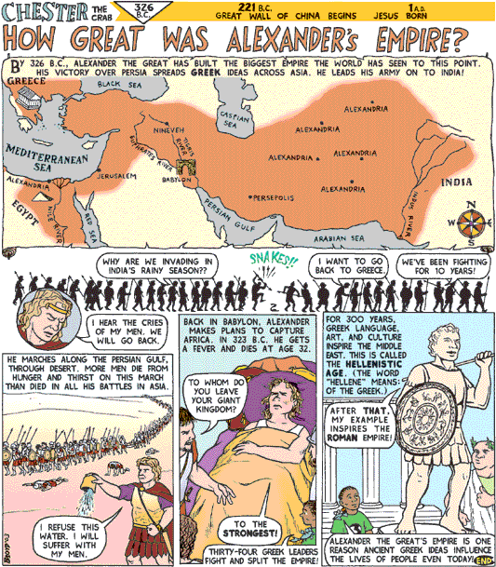

**Mali**



**AIM**: Why is Mali remembered as a successful empire?  
**Do Now:** List three things that make a successful empire?

Directions: Read the comic strips provided. After reading each comic strip, answer the questions provided.

[Who built the empire of Mali?](http://www.tihr.com/solutions/sol100101.htm)

____________________________________________________________________________________________________________________________________________________________

[Who was Mali's Mansa Musa?](http://www.tihr.com/solutions/sol100201.htm)

____________________________________________________________________________________________________________________________________________________________

[How did Mali's gold travel?](http://www.tihr.com/solutions/sol100301.htm)

____________________________________________________________________________________________________________________________________________________________

[Did Mali have religious freedom?](http://www.tihr.com/solutions/sol100401.htm)

____________________________________________________________________________________________________________________________________________________________

[What did Timbuktu school's provide?](http://www.tihr.com/solutions/sol100501.htm)

____________________________________________________________________________________________________________________________________________________________

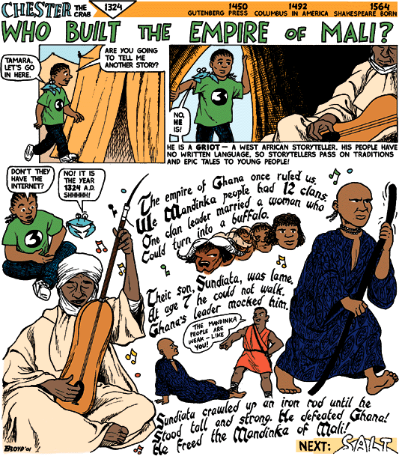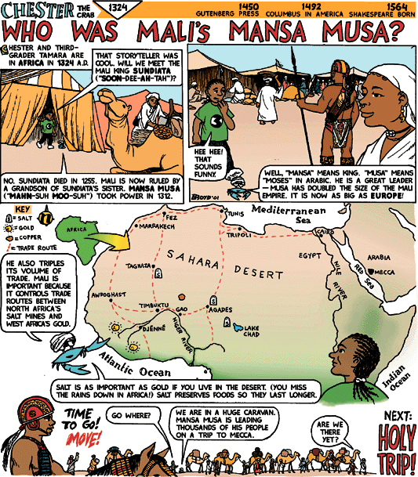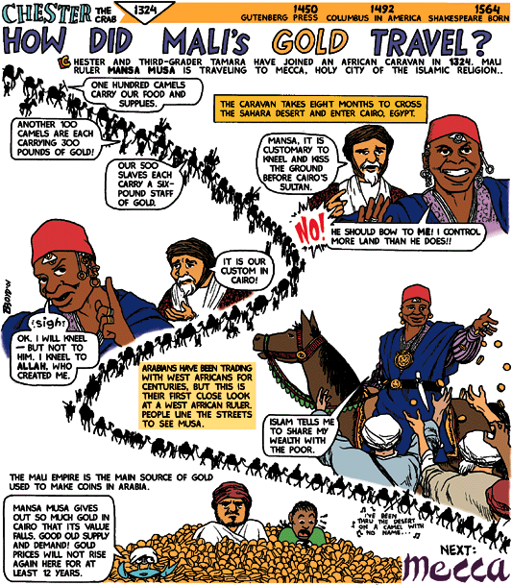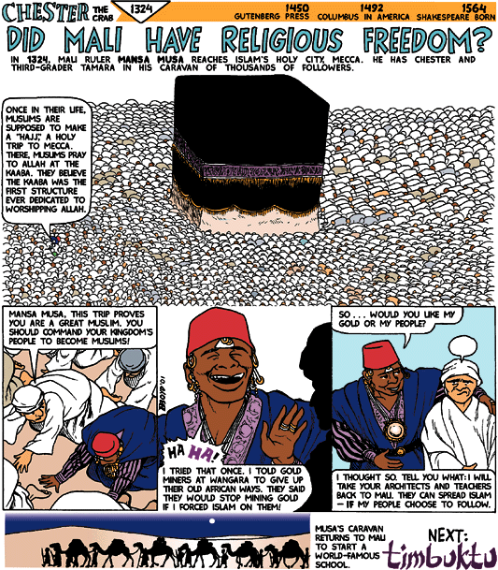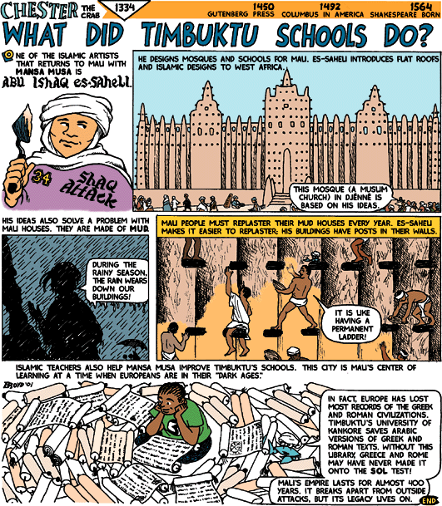

**Native Americans**



**AIM:** How were the Aztec, Mayans, and Inca advanced before the arrival of the Europeans?

|  |  |  |  |
| --- | --- | --- | --- |
|  | **Aztec** | **Mayans** | **Incas** |
| **Geography** |  |  |  |
| **Contributions** |  |  |  |
| **Social Structure** |  |  |  |
| **Religion** |  |  |  |
| **Decline** |  |  |  |

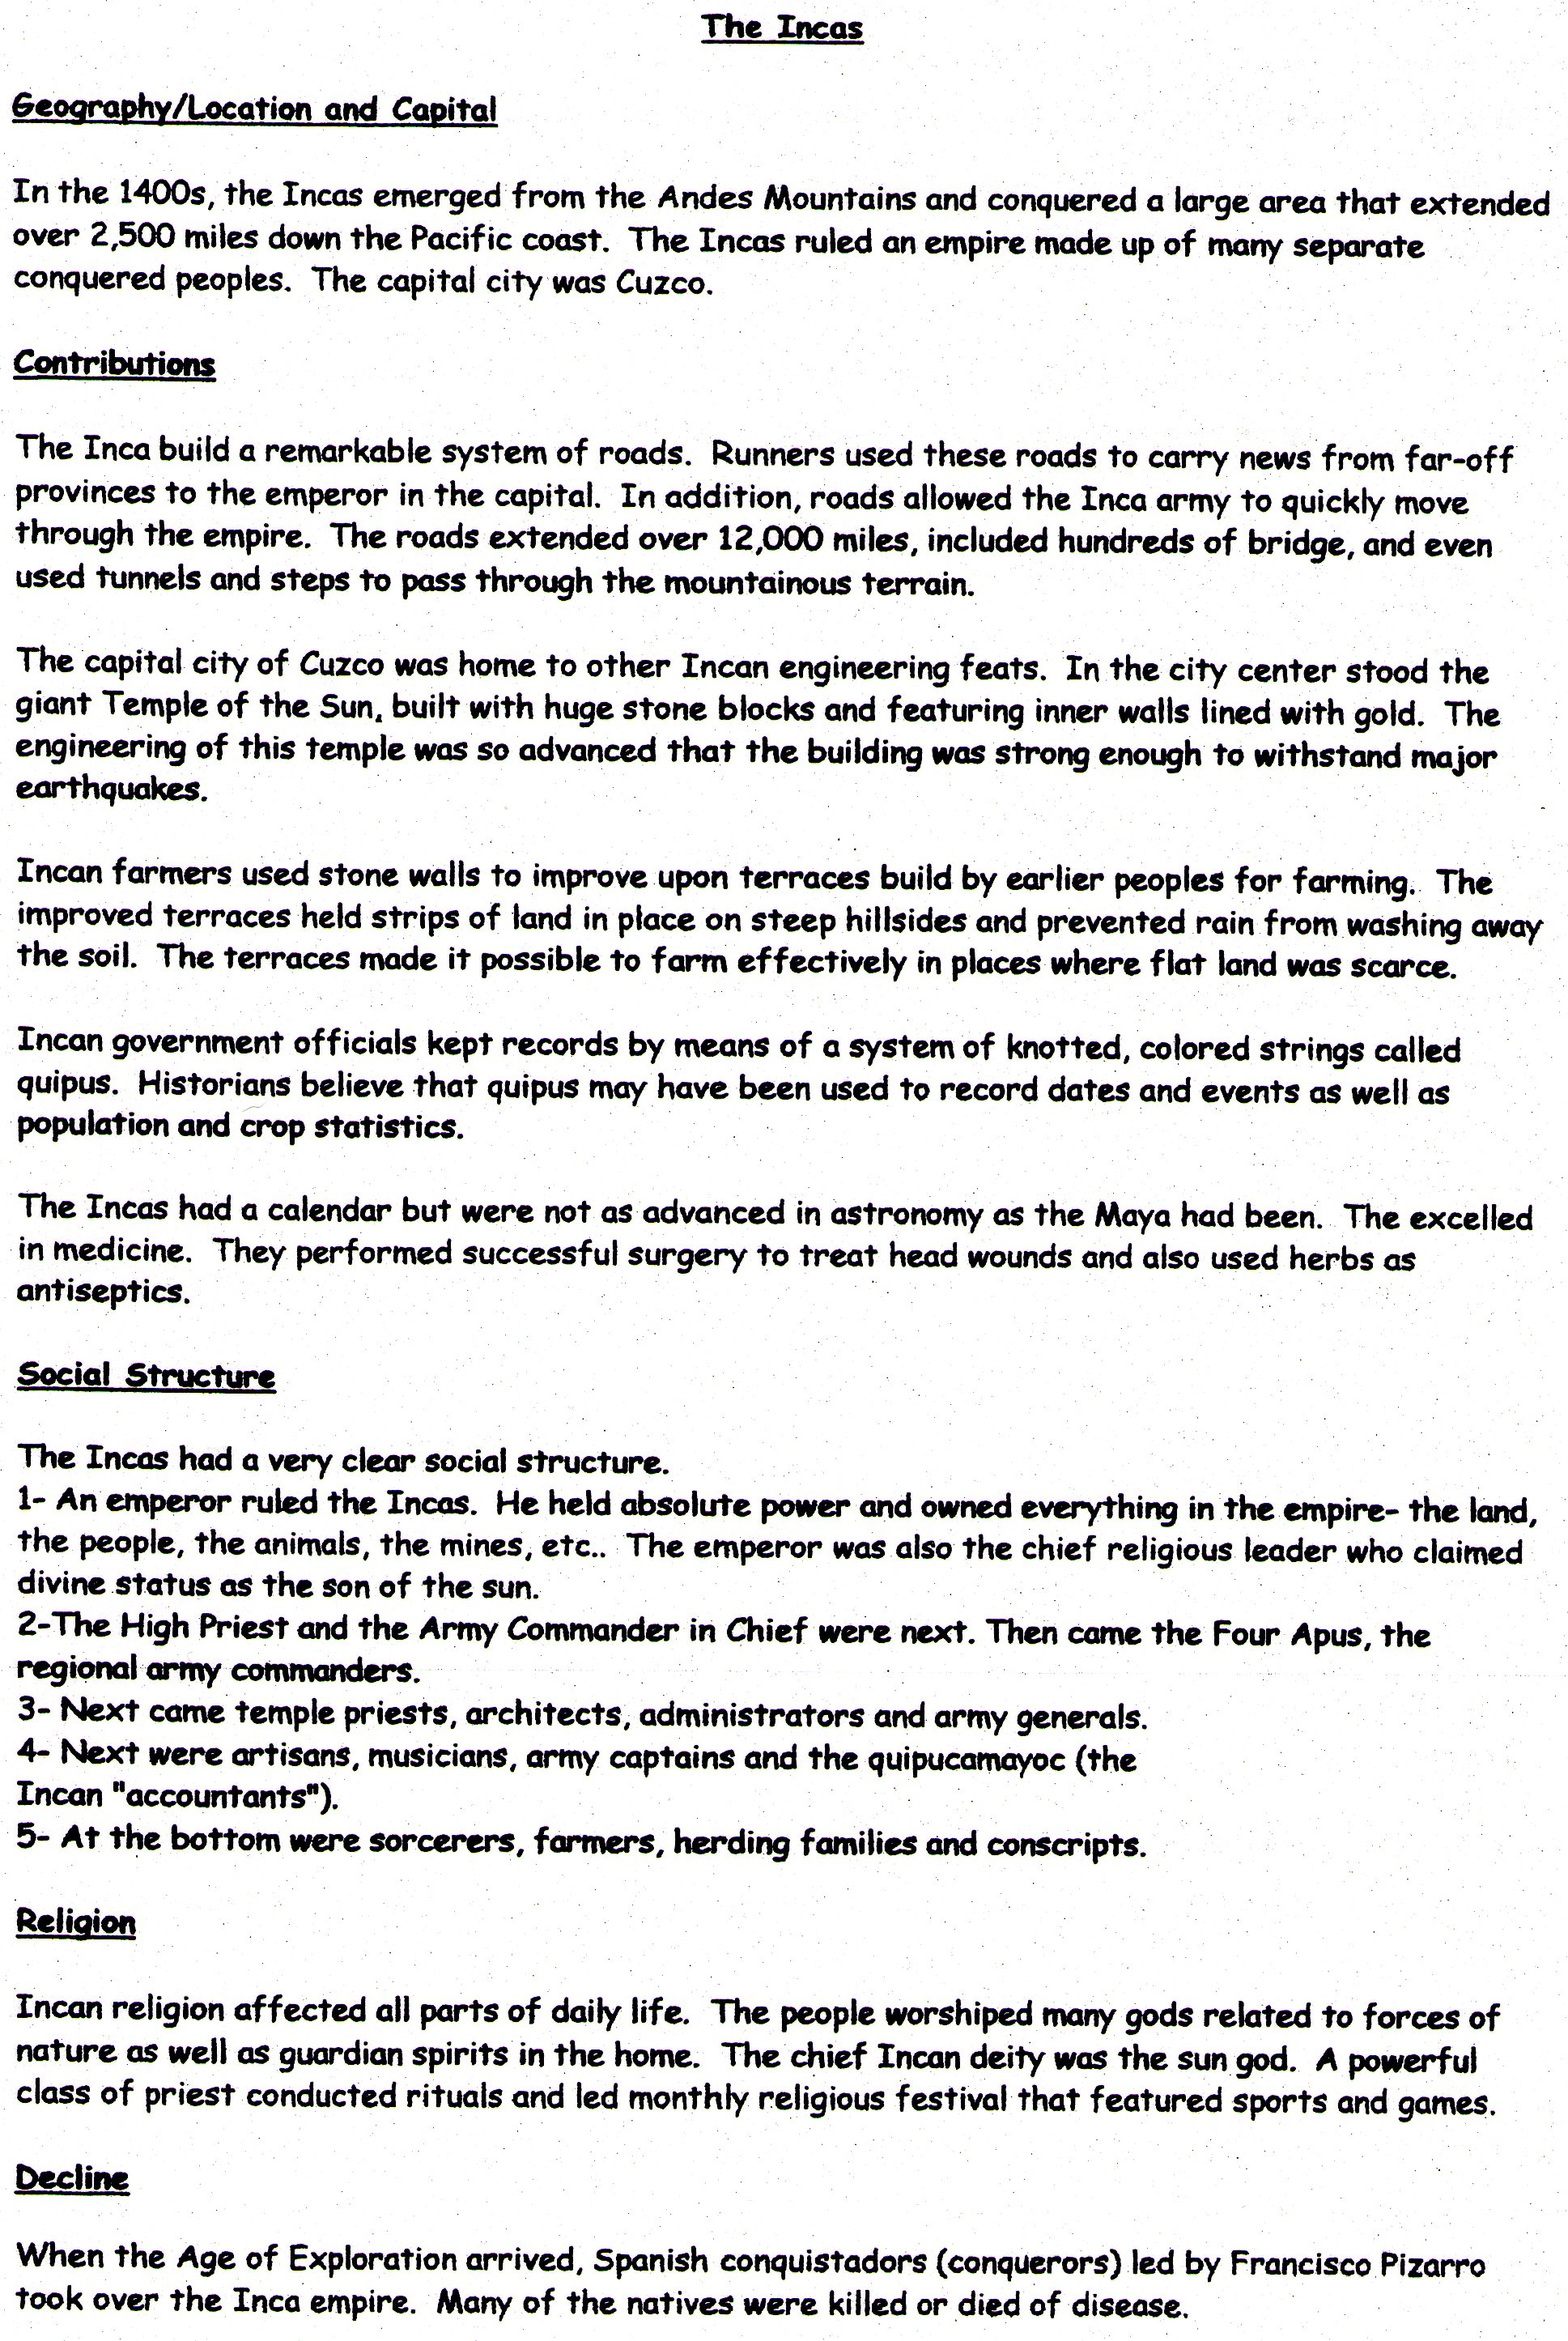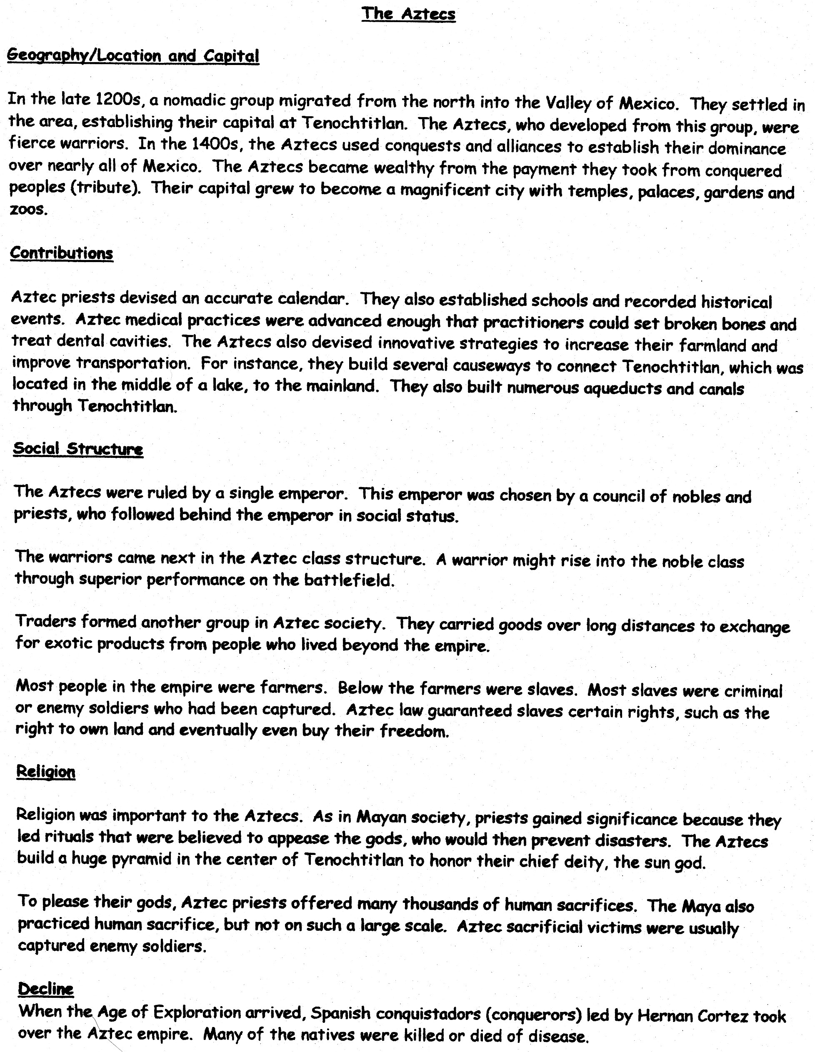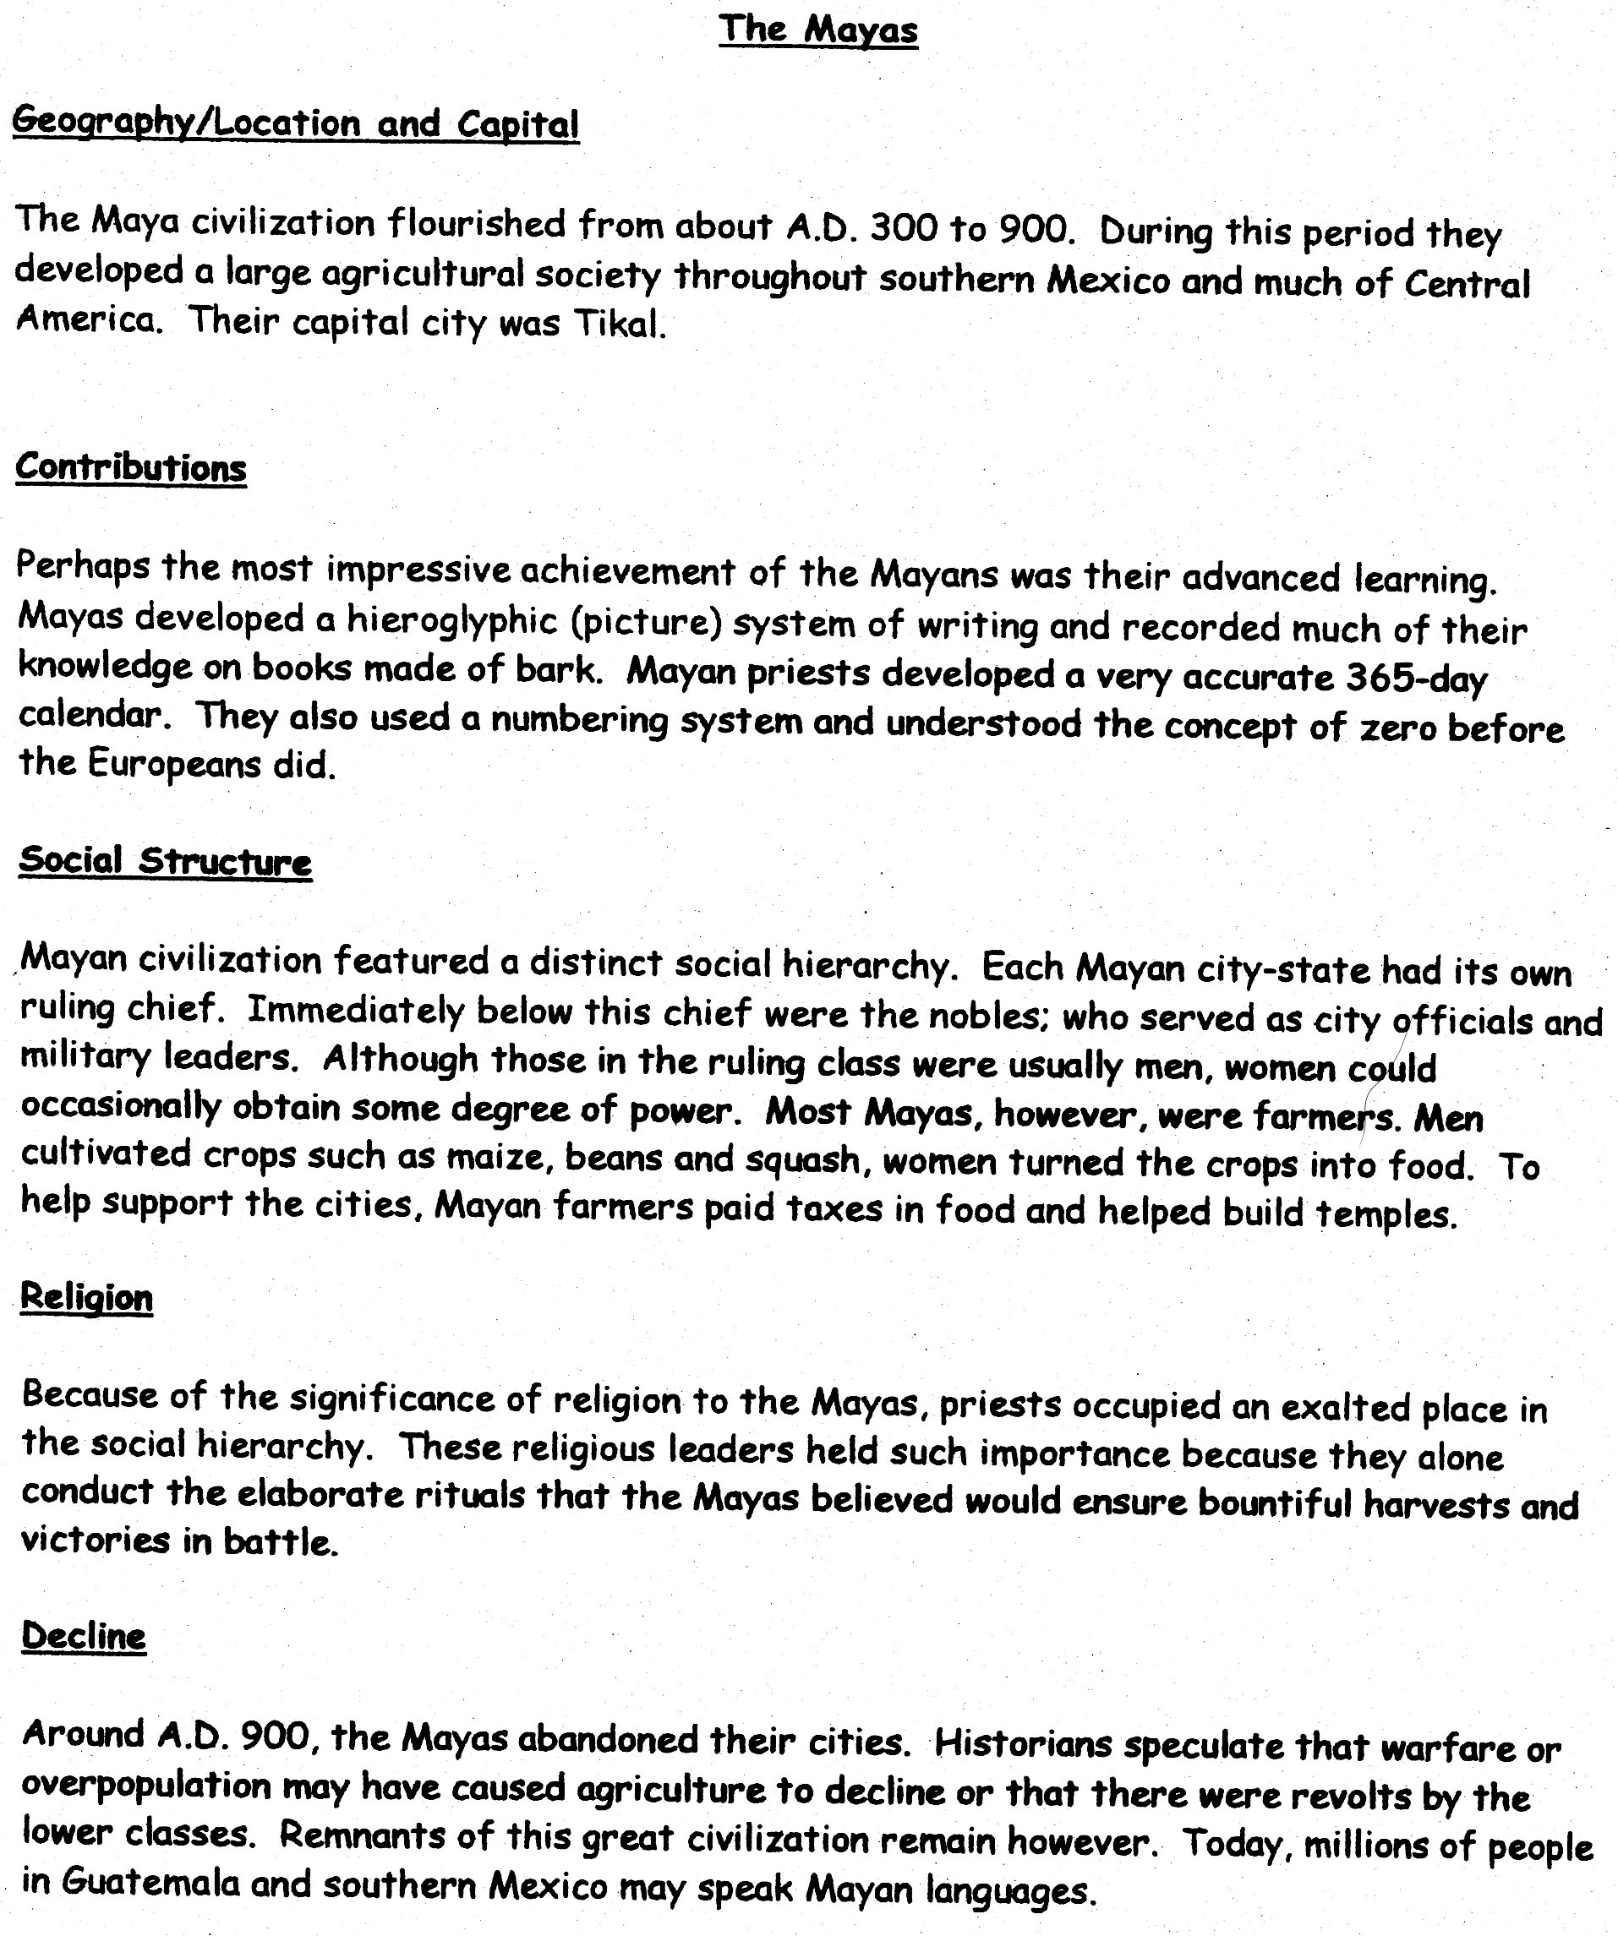

**Age of Exploration**



**AIM**: How did the search for new trade routes create a better understanding of the world?

**Do Now:** What comes to mind when you see the following words”

GOD:

GOLD:

GLORY:

How does the phrase, “God, Gold, and Glory” summarize the Europeans motives for exploration?

What technological advancements made the voyages possible?

**The Explorers**

**Marco Polo** (1254-1324) The First Renaissance Explorer

Marco Polo was born in Venice. At age 17, he journeyed to China with his father. The adventurers then spent the next 23 years in China, traveling and learning about the culture. When Polo returned he brought back a wealth of things and ideas: he displayed treasures of ivory, jade, porcelain, silk, and jewels. He introduced the Venetians to paper money, burning coal, and oil paints. His most notably legacy was the written account of his exploration, *The Travels of Marco Polo.*

**Prince Henry the Navigator** (1394-1460)

Portugal was the first European county of the Renaissance era to explore the seas in search of new sources of gold and spices. Prince Henry sent sailors to chart and map the western coast of Africa. During this time, the Portuguese built outposets on the African coasts. There, they traded for ivory and gold, and often human cargo-slaves.

**Vasco da Gama** (1460-1524)

Vasco da Gama was sent by the Portuguese king, Manuel I to find a new water route to Asia. The king was seeking to break the monopoly that Arab merchants held on the spice trade. His ships reached the southern tip of Africa, the Cape of Good Hope.

**Christopher Columbus** (1451-1506)

He is remembered as the first modern explorer to reach Western Hemisphere and establish contact between Europeans and the Americas. Columbus born in Italy, dreamed of being an explorer. He first asked for Portugal’s financial support but was unsuccessful. His ideas did appeal to Queen Isabella of Spain. On his first voyage, his men dropped anchor at San Salvador, an island near Cuba. They claimed the land for Spain and explored there for several months. When they returned home, the Queen was shown the “rich and strange” cargo: gold, cotton, parrots, and exotic plants. Indians were also brought back to be baptized.

**Ferdinand Magellan** (1480-1521)

The Portuguese explorer accomplished more than any other explorer in history. He commanded and exploration that sailed around the world and proved once and for all the earth was round. On March 16, 1521, the ships landed in Guam, where they had to seize fresh supplies. The ships continued to the Philippians. On April 27, 1521, Magellan was killed when he became involved in a rival with Filipino groups. Sebastian del Cano took control of the ships and returned with 17 men back to Spain, proving the earth was round. At first, only del Cano was praised for the expedition, later generations gave credit to Magellan for his vision, skills, and success.

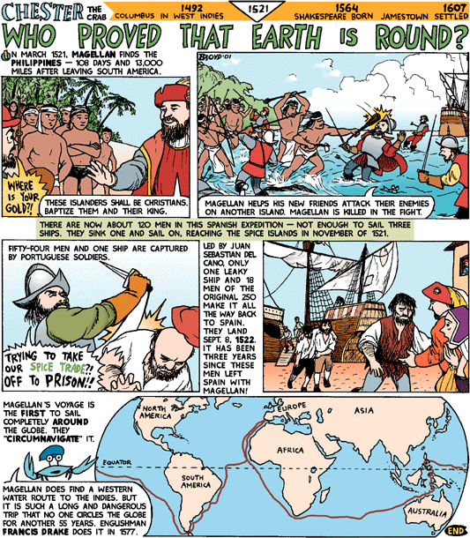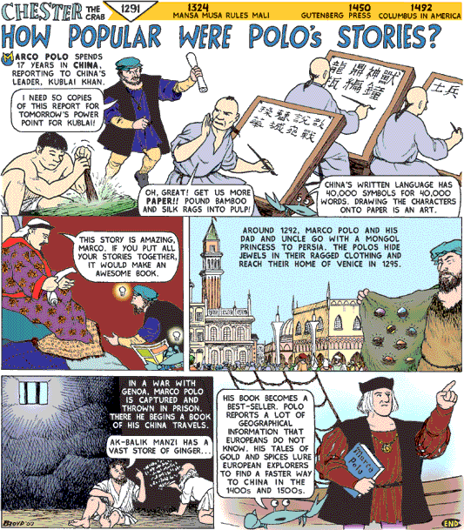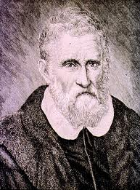

**Who’s Who of World Explorers**

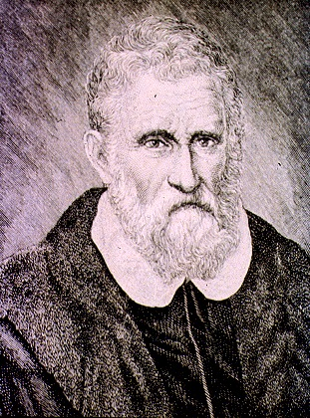

Marco Polo: Years _________ -- ___________ Nickname:



Main country explored:____________________

Brought back:__________________________________________________________________ _____________________________________________________________________________

Book Title: ____________________________________________________________________

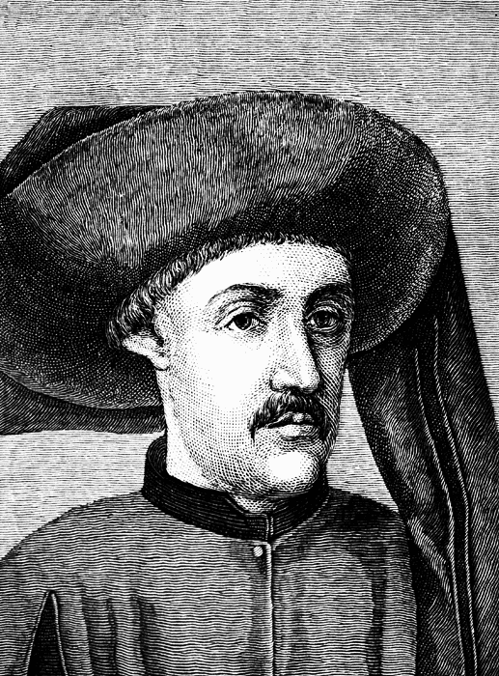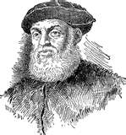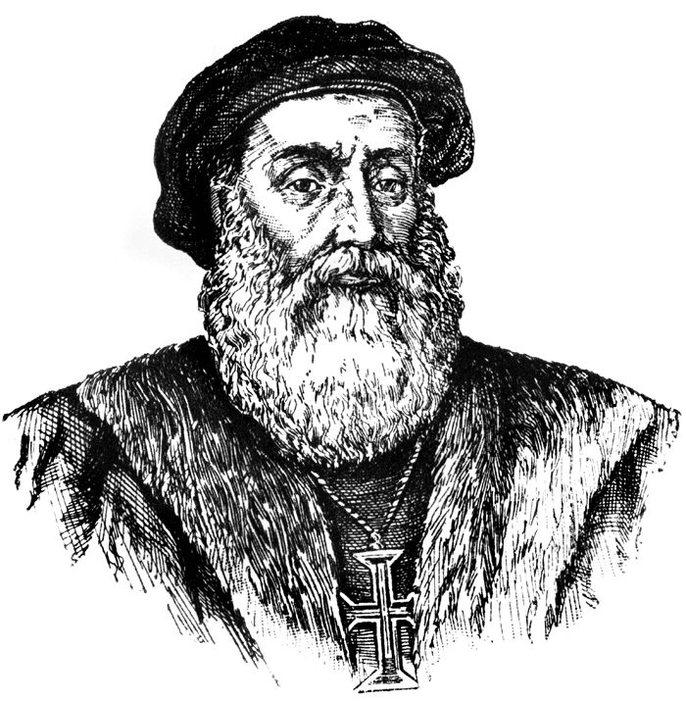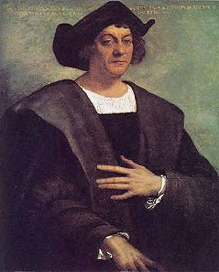

Prince Henry the Navigator Years ______________--_______________

Prince of_________________________. Searched for __________________________________

Extended the empire into_________________________________

Ferdinand Magellan Years ____________--____________

He accomplished more than any other explorer. A Portuguese explorer funded by ____________

He proved_____________________________________________________________

Vasco Da Gama Years______________--_______________

Sent to find_____________________ because ________________________________________ _______________________________________________________________________

His travels included______________________________________________________________ ________________________________________________________________________

Christopher Columbus: Years____________--___________

Biggest discovery________________________________

Funded By ______________________, the king and queen of____________________.

The year 1992 was the five hundredth anniversary of Columbus's discovery of America

Bibliography

Abraham, Henry and Pfeffer, Irwin, Enjoying Global History, An Amsco Publication, 1996.

Alexander the Great Empire Map <http://www.bible-history.com/maps>

Comics http://www.tihr.com/solutions/index.htm

Diamond, Jared, Guns, Germs, and Steel: The Fates of Human Societies, W.W. Norton & Company, 1999.

Iron Maiden, “Alexander the Great” Somewhere In Time, EMI Records, 1986

Map of the Babylonian Empire gods-word-first.org

Slavery Facts <http://www.slaverysite.com/Body/facts%20and%20figures.htm>