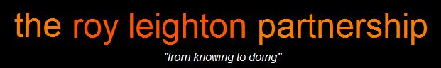

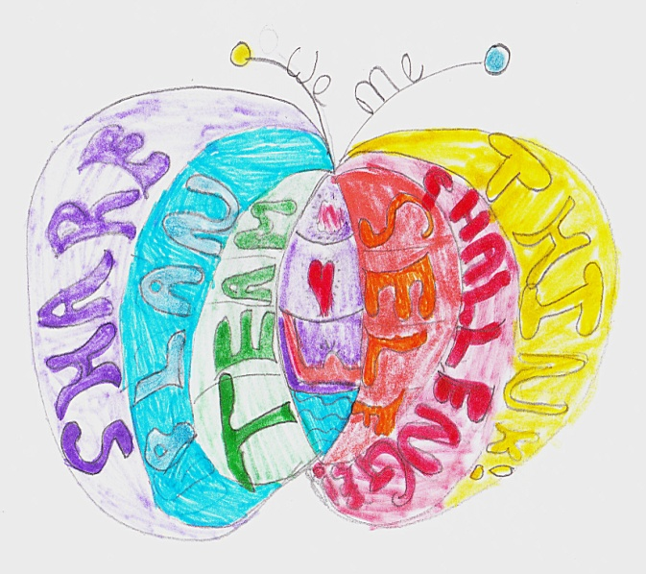
The Butterfly Model
A Brief Summary of the process and methodology

Self-organising systems have the capacity to create for themselves the aspects of organisation that we thought leaders [teachers] had to provide. Self-organising systems create structures and pathways, networks of communication, values and meaning, behaviours and norms. In essence, they do for themselves most of what we believed we had to do for them. Rather than thinking of organisation as an imposed structure, plan, design, or role, it is clear that in life, organisation arises from the interactions and needs of individuals who have decided to come together.
Margaret Wheately
Finding Our Way – Leadership For an Uncertain Time

Executive Summary
The Butterfly Model is built around a clear and repeatable process so that those involved in the planning and participation of learning events have a structured system to support and assess progress. The Butterfly Model provides the rigour of well-researched systems and proven creative and engaging pedagogic techniques. It is this capacity to support both students and teachers to move easily between the two camps of logic and play that make The Butterfly Model enjoyable, memorable and ultimately effective.
It is important to note that although, at a quick glance, this could appear to be an inflexible structure. It is not. It should be regarded as the menu, not the meal. The stages are the same but the content will invariable change and adapt according to what is happening, where it is taking place and who is involved.
The purpose of the clear stages is so that the whole school community (leadership, governors, staff, students, parents, local authorities etc) have a basis for discussion and debate. This model respects and seeks to support the professionalism, creativity, individuality and innovation of staff. It would be naïve and foolhardy to seek to impose closed and immature systems on open, creative, intelligent adults. Central to this model is the engagement and support of staff. Too often initiatives and interventions are presented to staff to make work with little, and very often, not prior participation in the planning.
It is inevitable that if a teacher feels under pressure to deliver in a closed, prescriptive way then this frustration and lack of flexibility will too often be passed onto the children. If the teacher is not trusted to teach using their own intuition, intellect, creativity and practical skills then it will be unlikely that the children will be able to learn in an independent manner. This frustration will always lead to a rejection of the ‘rules’ that have been imposed. Even if those rules make sense, unless the individual has been able to discover the relevance and benefit to their own lives they will, either at a low level of disruption or a high level of conflict, challenge the rules. Not only is this understandable, when you are seeking to develop independently thinking individuals it is to be encouraged.
Out moded mechanistic approaches to delivering any intervention, let alone such a complex and changeable one that is to be found in a classroom, are at best boring and do nothing to engage all learners and at worst destructive and turn too many children off learning. When we disregard or suppress the innovation and individuality of those around use we fail in many areas but two in particular:
- we do not cash in on ideas and solutions that others may have because we feel that we (the school leader or classroom teacher) should have all the answers
- we generate frustration from the very people we are trying to assist and then get frustrated ourselves by their inevitable bad behaviour
To quote again from Margaret Wheatley:
We fail to acknowledge these unstoppable forces of life whenever we, as leaders, try to direct and control those in our organisation. Life always pushes back against our demands. But instead of learning about life, we tend to see their ‘difficult’ behaviours as justification for a more controlling style of leadership [teaching]. Many of the failures and discontent in today’s organisations can be understood as the result of this denial of life’s forces and how life pushes back against a story that excludes it.
Too often we focus on the outcomes and not the process and barriers to achieving these outcomes. Just because someone is ‘teaching’ it is no guarantee that someone else is ‘learning’.
At the heart of the Butterfly Model is supporting students and staff to manage the inevitability of evolution. This is evolution, not change as change implies that what as gone before is flawed and needs removing. Evolution states that this is where you are based on your experiences and responses to those experiences. Not good or bad, just life. Understanding the dynamics or evolution is central to this method.
The Benefits
The gains to a school community using The Butterfly Model are:
- Curriculum develop – supports a consistency of approach to teaching and learning. Will support and enhance any current initiatives as the model focuses on the process not the content (the menu not the meal).

- Student learning - provides students with the ‘how’ of learning and not just the ‘what’ that will support them in becoming independent learners throughout their entire educational and learning life. Puts the emphasis on the child at the centre of the learning so that teachers can facilitate and observe the learning and will spend less time in lesson preparation.

- Staff CPD – provides a clear and creative model to support staff professional, and personal, development.

- Organisational change - the same process can be used to support whole school initiatives, staff development, governance, managing affective meetings, conflict resolution and will build respectful relationships.

- Legal and government requirements - Supports OFSTED criteria for affective teaching and learning as well as other government directives (Every Child Matters; Excellence and Enjoyment’ S.E.A.L.; the recommendations following The Rose Report; The [emerging] New Primary Curriculum).

- Communication - Provides a basis for effective dialogue with parents and teachers to support the link between home and school. Provides stability and rigour for staff, students, leadership and parents to manage effective change in present and future both at school and in life.

- Confidence – as opposed to arrogance. The repetition of managing the challenge of evolution builds resilience and genuine confidence that will last a life time. The difference between confidence and arrogance is simple: confident people give you energy arrogant people take it.

The Underlying Research
The two central models that form the basis of the planning and delivery of The Butterfly Model are:
- the evolution of the learning brain (the neurology)
- the evolution of the mature adult (the psychology)
The Neurology
We have, over the past years been working closely with paediatric neurologist Dr. Andrew Curran to apply the understanding of the mechanics of the brain to support the learning and happiness of children. All the stages of the butterfly are based on the natural development of the brain. There are three distinct stages of the evolution of the brain: reptilian, emotional, thinking. The stages of learning always go from bottom to top. This simple repetition in process (not content) provides both a clarity and understanding for children that gives them a simple (but not simplistic) framework to return to every time they are given a learning challenge.

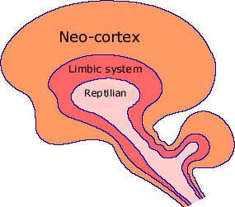

Reptilian or survival/primitive brain will be asking the question ‘what’s the point?’
Limbic or emotional brain will be asking the question ‘who am I with and do I feel safe and what is my role and status in this group?’
Neo-cortex or thinking brain will want to know what are the rules (left hemisphere); is it a creative challenge (right hemisphere); how are we learning, building relationships, celebrating our success, planning for the future based on these new skills (whole brain).

According to Dr. Curran there is a simple four step algorithm to support the learning of all children all the time.
The learning algorithm
UNDERSTANDING

ESTEEM

CONFIDENCE

LEARNING

If a child feels that they are understood or that they are in an environment with people that want to listen and understand them then they will naturally create a sense of self-esteem.
If a child has a feeling of esteem they with have the confidence to try new things and open themselves to challenges and change.
If they are open to challenges and change they will learn.
If children do not have regular (daily) exposure to healthy, loving, creative challenges their brains do not develop in a balanced and mature way.
Below is an extreme example of the brains of two children one (on the left) is the brain of a three year old child that has been loved, stimulated and encouraged. The brain on the right is that of a three year old child who has suffered serious neglect.

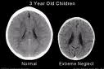

I think this picture most clearly represents what damage can be done to children and adults when they are stifled in their learning, maturity and creativity. This model seeks to address the conflicts that miscommunication can breed. When these barriers to relationships are challenged with compassion and logic we will go someway to generating an environment where teachers want to teach and children want to learn.
It is possible to look at the negative and troubling behaviours in our organisations today as the clash between the forces of life and the forces of domination, between the new story and the old. Once we realise that we cannot ever extinguish these creative forces, that it is impossible to deny the life that lives in our organsiations, we can begin to search for new ways of being together.
Margaret Wheatly

The Psychology
There are several sources that underpin The Butterfly Model approach but the system that best represents the marrying of all these elements, and acts as the touchstone for all our activities can be found in the work and thinking of Dr. Clare W. Graves. His system is known as “The Emergent Cyclical Levels of Existence Theory” (ECLET). This term has, over recent years, been refined to the more manageable (and memorable) model of Spiral Dynamics.
Spiral Dynamics – A summary by Clare W. Graves
“Briefly, what I am proposing is that the psychology of the mature human being is an unfolding, emergent, oscillating, spiraling process marked by progressive subordination of older, lower-order behaviour systems to newer, higher-order systems as man's existential problems change. These systems alternate between focus upon the external world, and attempts to change it, and focus upon the inner world, and attempts to come to peace with it, with the means to each end changing in each alternatively prognostic system. Thus, man tends, normally, to change his psychology as the conditions of his existence change. Each successive state, or level of existence, is a state through which people pass on the way to other states of equilibrium. When a person is centralised in one state of existence, he has a total psychology which is particular to that state. His feelings, motivations, ethics and values, biochemistry, degree of neurological activation, learning systems, belief systems, conception of mental health, ideas as to what mental illness is and how it should be treated, preferences for and conceptions of management, education, economic and political theory and practice, etc., are all appropriate to that state.”
Or, simply put, if a person’s world changes they are going to have to adjust their thinking or behaviour; and vice versa. Effectively managing this constant problem-based reality is what drives the development of children to become healthy, balanced adults. When we desire to keep things as they are, and not engage with the dynamic and ever-changing reality of evolution, we jeopardise the effectiveness and happiness of individuals and organisations.
A summary of the Gravesian Levels of Human Existence is set out in the table below. The table reads from bottom to top:
World View |  | Level of Human Existence | Thinking/Behaviour
H | All things are dependent on each other for survival | Interdependent | Global, holistic | U
G | The world is complex | Interconnected | Systems thinking | T
F | We are all equal | Community | Empathy, collaboration | S
E | Full of opportunities | Enterprise | Working for personal reward in the medium and long term | R
D | The world is in chaos | Order | Hierarchy, rules, structure | Q
C | Only the strong survive | Self | Impulsive, power, instant gain | P
B | Unsafe, mysterious, strange forces around us | Tribal | Family, icons, rituals | O
A | No world view at this level | Survival | Eat, sleep, sex | N

The application of Spiral Dynamics to teaching and learning
Graves’ work not only helps us to find a way to think about the complexities of different worldviews but also provides a framework for tracking the evolution of these drives and a scaffold on which to stand while analysing situations and planning the most appropriate actions. He made much of how this model could be used in the management of organisations as well as assisting individuals in becoming more open, healthy and balanced adults. Graves warned about the need to keep a balance between recognising the importance of intellectual rigour and analysis whilst keeping sight on basic humanity, creativity and compassion.
When all levels are healthy and open, then organisations - and the individuals within those organisations - share not only a vision, but have a shared model for dialogue and understanding, which leads to progress. When any individual, organisation or culture becomes fixed and closed at one level, conflict will inevitably be generated by this suppression of the natural process of evolution. The question is not so much ‘where am I?’ but rather ‘am I open or closed?’ to learning, change and understanding?
To return to Graves:
"I am not saying in this conception of adult behaviour that one style of being, one form of human existence is inevitably and in all circumstances superior to or better than another form of human existence, another style of being. What I am saying is that when one form of being is more congruent with the realities of existence, then it is the better form of living for those realities. And what I am saying is that when one form of existence ceases to be functional for the realities of existence then some other form, either higher or lower in the hierarchy, is the better form of living. I do suggest, however, and this I deeply believe is so, that for the overall welfare of total man's existence in this world, over the long run of time, higher levels are better than lower levels and that the prime good of any society's governing figures should be to promote human movement up the levels of human existence."
The chart below shows the application of this model in managing the stages of the programmes and projects that we deliver.

As with the Gravesian model, the table reads from bottom to top.
Lesson Stages | Level of Human Existence | Focus
Stage 7 | Interconnected (Think) | Review the lesson. What went well. Even better if...?
Stage 6 | Community (Share) | Sharing the success, outcomes and achievements .
Stage 5 | Enterprise (Challenge) | The learning experience
Stage 4 | Order (Plan) | What is the lesson plan?
Stage 3 | Self (Me) | What is the individual learning and behavioural challenge for the student? What is their gain to being there?
Stage 2 | Tribal (Team) | Who are they working with and how are they going to work with each other?  What values are they going to have to develop?  What are the rules that need to be established if the class are going to succeed in the task?
Stage 1 | Survival | What is the basic aim of the lesson/learning and how can it aid the survival of the student intellectually, emotionally/creatively, practically and spiritually/intuitively?

For more on Graves go to www.clarewgraves.com
From The Futurist, 1974, pp. 72-87. Edited with embedded comments by Edward Cornish, World Future Society
From Happy Families, Steve Bowkett, Tim Harding, Trish Lee & Roy Leighton, 2008 pp, 105

