**CASTLE LEARNING ASSIGNMENT 17A**

1.  What is the ratio of orange blocks to the total number of blocks shown?

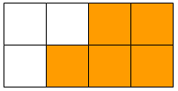

Answer: _______ to _______

2.  Half of the students at Lee Elementary buy school lunch. How would this value look as a percent?

Answer: _______ %

3.  Which number is a ratio in simplest form?

1. 
2. 
3. 
4. 

4.  What decimal value could be represented by the arrow on the number line?

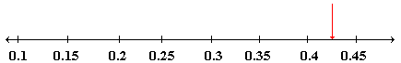

1. 0.29
2. 0.35
3. 0.43
4. 0.49

5.  Solve.



1. 
2. 
3. 
4. 

6.  The Ortiz family drove 425.8 miles on Monday, 375 miles on Tuesday, and 487.5 miles on Wednesday to arrive on vacation in New Orleans. What was the total number of miles that they drove in the three days?

1. 940.8
2. 950.8
3. 1,283.8
4. 1,288.3

7.  What is the decimal value of the following?

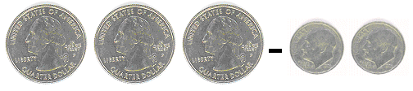

1. 0.95
2. 0.73
3. 0.65
4. 0.55

8.  Answer **Y** for **Yes** or **N** for **No**.

Is the number 54 divisible by 3?

Answer:  _______

9.  In which city is the amount of snow closest to 2 inches?

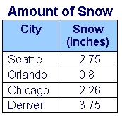

1. Seattle
2. Orlando
3. Chicago
4. Denver

10.  Which of the following fractions is equal to the decimal number 0.35?

1. 
2. 
3. 
4. 

11.  What fraction of one dollar does a quarter represent?



1. 
2. 
3. 
4. 

12.  What percent of the circles are shaded? %



Answer: _______%

13.  Miguel finished his homework in 45.8 minutes. Wanda finished 8 minutes before Miguel. How long did Wanda take to do her homework?

1. 53.8 minutes
2. 46.6 minutes
3. 45.0 minutes
4. 37.8 minutes

14.  Sheryl rolls a standard 6-sided number cube. What is the probability that it comes up 1? Express your answer as a fraction in simplest form.

Answer: _______

|  |
| --- |
|  |

15.  Cora is ordering a new car. The dealer pointed out several options: two types of seats, 6 kinds of detailing, and 3 sound systems. How many different option packages does Cora have to choose from?

Answer:  _______