**CASTLE LEARNING ASSIGNMENT 7A**

1. Which of the following decimal values is the *smallest*?

1. 0.4
2. 1.4
3. 4.4
4. 5.4

2. On the number line below, which letter could refer to the number 3.2?

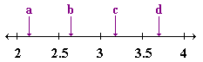

1. *a*
2. *b*
3. *c*
4. *d*

3. Which of the following statements is *false*?

1. 6.05 = 6.5
2. 2.9 = 2.900
3. 14.70 = 14.7
4. 33.03 = 33.030

4.  Josie was thinking of a decimal number between 0.589 and 0.605. Which number could she be thinking of?

1. 0.53
2. 0.592
3. 0.606
4. 0.61

5.  Add: 134.56 + 75 + 22.59

1. 157.90
2. 231.05
3. 232.15
4. 907.15

6.  What is the perimeter of the rectangle?

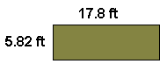

1. 152 ft
2. 94.48 ft
3. 47.24 ft
4. 23.62 ft

7.  What fraction is equivalent to the decimal 0.41?

1. 
2. 
3. 
4. 

8.  A bag of licorice contains 10 pieces. Johnny and Crystal split the licorice evenly. What fraction will they each receive?

1. 
2. 
3. 
4. 

9.  Here are the results from a survey of 100 people and their favorite ice cream:

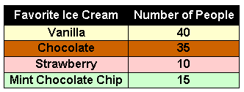

In *simplest terms*, what fraction of the people surveyed like Mint Chocolate Chip Ice Cream the best?

1. 
2. 
3. 
4. 

10. Write  in simplest terms.

Answer: _______

11.  Which of the following is a prime number?

1. 6
2. 9
3. 3
4. 4

12.  Which number is *not* divisible by 5?

1. 10
2. 35
3. 27
4. 100

13.  The number 3 is *not* a factor of ...

1. 21
2. 15
3. 27
4. 38

14.  A 5-pound bag of bread flour is on sale this week for $2.05. What is the price per pound?

1. $0.32
2. $0.38
3. $0.41
4. $0.48

15.  Happy Days Child Center employs 6 teachers to care for 36 students. What is the student-to-teacher ratio at Happy Days?

1. 6 : 1
2. 6 : 2
3. 36 : 1
4. 36 : 2