CASTLE LEARNING ASSIGNMENT 1A

1. Add: 134.56 + 75 + 22.59
- 157.90
- 231.05
- 232.15
- 907.15

2. What is the result when you multiply 6 and 2.8?
- 168
- 128
- 16.8
- 12.8

3. The population of Mesa, Arizona, in 2002 was 426,841.
Which statement is true about the number 426,841?
- The place value of the 2 is 100,000.
- There are 6 ten thousands.
- The digit in the thousands place is odd.
- A 4 is in the hundred thousands place.

4. Write the number for nine thousand, six.
Answer: _____________________

5. Which of the following is written in expanded form?
- 4,064,273,901
- eighty-six million, three hundred fifty-two thousand, ninety-nine
- 2,000,000 + 300,000 + 60,000 + 1,000 + 900 + 40 + 2
- None of the above

6. Write the number for: seven hundred seventy-four million, six hundred twenty-nine thousand, three hundred fifteen.
Answer: ____________________

7. Which is a correct estimate of 39 × 41?
- 40 × 40
- 30 × 40
- 40 × 50
- 50 × 50

8. 5 × 3 = 3 × 5 is an example of the ________ property of multiplication.
- distributive
- commutative
- multiple
- factor

9. What would be the correct decimal placement for the following multiplication?

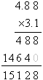

- 1.5128
- 15.128
- 151.28
- 1512.8

10. What is the name of the point shown on the graph?
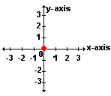

- x-axis
- y-axis
- origin
- coordinate plane

11. What are the coordinates of point R?
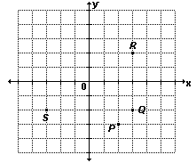

- (2,3)
- (3,2)
- (4,3)
- (3,4)

12. What shape is shown in the coordinate plane above?

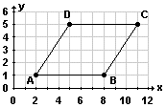

- square
- rectangle
- parallelogram
- triangle

13. What is the perimeter of the square?
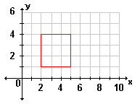

Answer: __________ units

14. The Women’s 100 meter-run results were posted in the June edition of the Track & Field Newsletter. The scores were: 11.9, 11.5, 11.4, 11.0 (all in seconds). If the times were posted in order from shortest to longest time, which would be correct?
- 11.9, 11.5, 11.4, 11.0
- 11.5, 11.4, 11.0, 11.9
- 11.0, 11.4, 11.5, 11.9
- 11.4, 11.5, 11.9, 11.0

15. On the number line below, which letter could refer to the number 6.8?
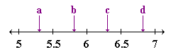

- a
- b
- c
- d

