Linear Regression Lesson Plan

Mathematics Course: Math 2 (10th)

Title of Lesson: - Application of the process of linear regression for curve fitting
using appropriate technology.

Unit: - Unit 6 – Linear and Quadratic regression.

Purpose within unit (include information to help place this lesson within the unit):
Exploration and Direct Instruction.
Question # 1, 2 of Traveling on the Turnpike Learning Task Part 1 help students to explore the given data and understand that for the given set of data the curve of best fit is a line.
Question # 3, 4, 5 of the Traveling on the Turnpike Learning Task Part 1 can be used to teach how to use technology to write the equations of different lines of best fit. Students are taught how to use the Graphing calculator to get the equation of Linear Regression line and Median – Median line

Georgia Performance Standard (specific; include number and wording)

MM2D2. Students will determine an algebraic model to quantify the association between two
quantitative variables.
- Gather and plot data that can be modeled with linear and quadratic functions.
- Understand and apply the process of linear and quadratic regression for curve fitting
using appropriate technology.
MM2 P1. Students will be able to use technology to find the line of best fit and the linear
regression equation.

Objective for This Class Period: (What students will know/be able to do when they leave class that they did not know/were not able to do when they arrived – this day/ this class period)

Students should be able to list the data points in tables, graph the scatter plot, draw the line of best fit and get the equation of line of best fit ( linear regression line or median – median line) using graphic calculator, when they leave the class.

Essential Question(s)

How do you determine the line of best fit using linear and quadratic regression for data using technology?

Resources (including attached activity sheets or link to resource, additional materials needed, etc.)

Student edition of Turnpike learning task part 1, Graphing calculator.

Timing outline

5-Question Mixed Review

One question from each unit. (EOCT Released Items)

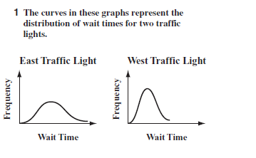
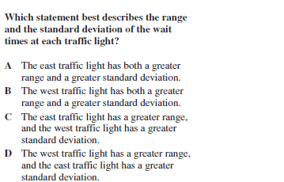 Key A

2.
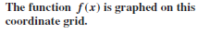
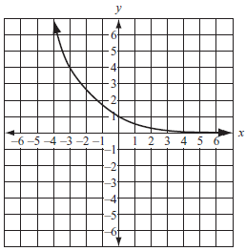
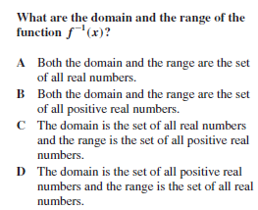 Key D
3.
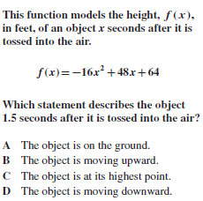 Key C

4.
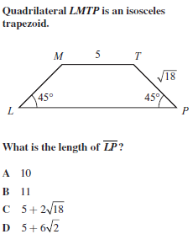 Key B

5.
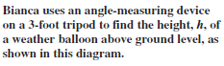
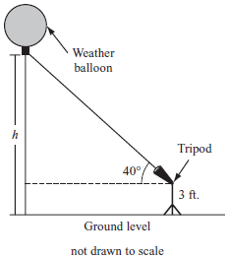

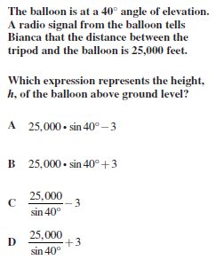 Key B

Lesson Guide (a bulleted or numbered outline of the lesson that must include the items listed below).
- Activating Strategy
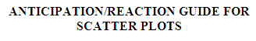
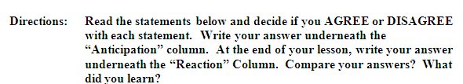
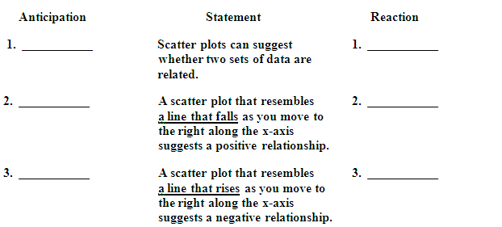

5 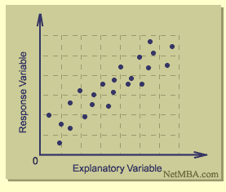
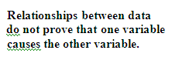
- Multiple representations, including hands-on activities
Road Rage Activity
This lesson is designed to use remote – controlled cars, allowing students to relate mathematics to a physical activity. It is strongly recommended that you have enough cars to provide one car for every four students. If a class set of cars cannot be obtained, ask students to bring in battery – operated remote controlled cars, or use two remote controlled cars and large groups for the data collection process. Although larger groups can be used, it is best to divide the class into groups of four so that each student has one role. If larger groups are used, student roles can be rotated. If no cars can be obtained, the activity can be modified to use the sample data provided in the Road Rage Answer Key (attachment).
Before beginning the activity in class, find a location appropriate for students to use the remote controlled cars. A hallway approximately 125 feet long with natural divisions, such as tiles, allows for easy measurement and data collection. If the hallway does not have divisions, use colored masking tape to mark equal intervals, and have students estimate the distance between the units. For example, in 3 seconds, a car can travel the length of 10 cement blocks. In this case, 1 cement block represents 1 interval of distance. If each cement block is measured, then the number of blocks can be converted to length in inches. Counting units simplifies the measurement because the cars move quickly and it is very time consuming to physically measure the distance. Alternately, you could use a football field for this activity, provided you do not use miniature remote controlled cars, which are only about 2 inches long.
Divide students into groups of 4, each student should have a role, as outlined on the Road Rage Activiy Sheet (attachment). You can assign these roles or allow students to choose roles. Students could keep their roles for the duration of the lesson, or rotate so each student assumes multiple roles. Provide a stopwatch and a randomly selected remote controlled car to each group. Discuss an overview of the steps students will complete in the activity:
- Collect data by racing the car.
- Graph your data and find the line of best fit to determine the speed of the car.

- Technology (including photos, video clips, Smart files, PowerPoint, calculator use, etc.)

Power point on Graphing Calculator tips. (Attachment)

- Questions throughout – more open than closed
- Which scatter plot suggests a positive relationship?
- How do you draw a line of best fit? Or what do you need to look for when you draw a line of best fit?
- For which value of the correlation coefficient does a line become the best fitting curve?
- When outliers are present which of which of the following is better as a line of best of fit?
- Visual regression line b. Median – Median Line c. Least square regression Line.

- Evidence of learning (assessment) – how you’ll know they got it; formative and summative

Formative Assessment
Revisit the Anticipation Guide.
Question number # 9, 10 of student edition of Traveling on the Turnpike Learning Task Part 1.
Summative Assessment
Unit 6 Test

