**Symmetry of Functions - Lesson Plan**

**Mathematics Course: ___ 8th Math _X_ Math 1 (9th) ___ Math 2 (10th)**

**Title of Lesson** __Logo Symmetry Learning Task___________

**Unit** _5 – Algebra in Context___________________________

**Purpose within unit (include information to help place this lesson within the unit)**:

__x__ Exploration ____ Direct Instruction ____ Culminating Task

**Georgia Performance Standard**

MM1A1. Students will explore and interpret the characteristics of functions, using graphs, tables, and simple algebraic techniques.

c. Graph transformations of basic functions including vertical shifts, stretches, and shrinks, as well as reflections across the x- and y-axes.

d. Investigate and explain characteristics of a function: domain, range, zeros, intercepts, intervals of increase and decrease, maximum and minimum values, and end behavior

MM1A2. Students will simplify and operate with radical expressions, polynomials, and rational expressions.

a. Simplify algebraic and numeric expressions involving square root.

b. Perform operations with square roots.

**Objective for This Class Period**:

1. Students will learn how to differentiate between even and odd functions graphically and algebraically.
2. Students will learn how to apply transformations of basic functions to create designs

and logos.

**Essential Question(s)**

**1. How do you determine if a function has symmetry?**

**2. How do you determine if a function is even, odd, or neither?**

**3. How to use transformations of basic functions in graphing art?**

**Resources** (including attached activity sheets or link to resource, additional materials needed, etc.)

* TI-84 graphing calculators, graph paper
* Unit 5 Logo Symmetry Learning Task (GaDOE SE # 2, #3, #5, #6)

**Timing outline - 45-50 minutes**

**5-Question Mixed Review**

**Mathematics Course: Math 1 (9th)**

**Title of Lesson: Symmetry of functions.**

**Unit: 5**

**Purpose within unit: Exploration and Direct Instruction**

**Time duration: 45-50 minutes**

**Resources: Graph paper, color pencils, Ti-84 calculator,**

**Math I learning task.**

***Georgia Performance Standard***

***MM1A1. Students will explore and interpret the characteristics of functions, using graphs, tables, and simple algebraic techniques.***

*h. Determine graphically and algebraically whether a function has symmetry and whether it is even, odd or neither.*

*c. Graph transformations of basic functions including vertical shifts, stretches, and shrinks, as well as reflections across the x- and y-axes.*

***Objective for This Class Period****:*

1. Students will learn how to differentiate between even and odd functions graphically and algebraically.
2. Students will learn how to apply transformations of basic functions to create designs

and logos.

**Lesson Essential Questions**

**1. How do you determine if a function has symmetry?**

**2. How do you determine if a function is even, odd, or neither?**

**3. How to use transformations of basic functions in graphing art?**

**Mixed Review**

1. This graph represents the function *f* (*x*)=−*x*2 +2*x* +3.



1. Identify the domain and the range of the function.
2. Identify the coordinates of the vertex. State whether the function has a maximum or minimum value.
3. Identify the zeros of the function and explain what they are.

2. Graph *f* (*x*) = *x* +2, *f* (*x*)= *x*2 +2, and *f* (*x*)= *x* +2 . Describe how adding 2 to each parent function value affects the corresponding parent graph.

**Lesson Guide**

Activating strategies.

1. KWL—Have students list what they know about symmetry. During the class discussion, the teacher will list responses from students on the board. Based upon the responses, the teacher will assess where instruction should begin on symmetry.
2. With a partner, have students use graphic organizer to identify and explain the symmetries they see in each logo.

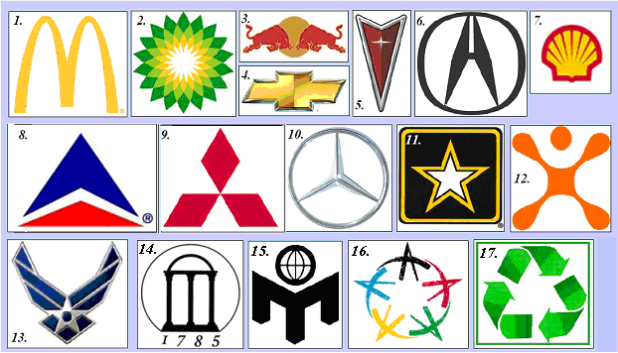

Multiple representation.

The activity you are about to do is called a card sort. You are given a set of cards that contain statements, equations, and graphs each of which is associated with a particular kind of symmetry.

You are to place each numbered card in the appropriate column on the page labeled *Symmetry Card Sort Table*. (You might want to cut the cards apart.)

When you decide where to place a card, **justify your reasoning** using **words, pictures, graphs, tables, or algebraic notation**. You have several blank cards. Use these cards and

**Ti-84 calculator** to create a graph, equation, or statement to match **each** category.

**Exploration and demonstration of odd and even functions.**

Jessica, a manager at Uniform Universe, immediately noticed the design error when she saw some of the prototype uniforms. The sergeant’s insignia was upside down from the correct insignia for a U.S. sergeant, which is shown at the right. Jessica checked the description that had been sent by the foreign contractor. She immediately realized how to fix the insignia. So, she emailed the foreign supplier to point out the mistake and to inform the company that the error could be corrected the by reflecting each of the functions in the *x*-axis.

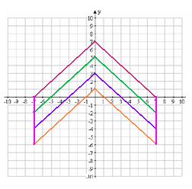

Ankit, an employee at the foreign textile company, e-mailed Jessica back and included the graph at the right to verify that Uniform Universe would be satisfied with the new formulas.

* + 1. What type of symmetry does the incorrect insignia have?
    2. If it is symmetric about a point, line, or lines, write the associated coordinates of the point or equation(s) for the lines of symmetry.
    3. Does the corrected insignia have the same symmetry?
    4. Write the mathematical description of the design for the U.S. sergeant insignia, as shown in the graph above. Verify that your mathematical description yields the graphs shown.
    5. Let *f* denote any one of the functions graphed in the British sergeant’s insigniz or the U.S. sergeant’s insignia. Compare *f*(1) and *f*(–1), *f*(2.5) and *f*(–2.5), *f*(3.7) and *f*(–3.7). If *x* is a number such that 0  *x* 7, how do *f*(*x*) and *f*(– *x*) compare?
    6. Let *a* be a constant other than the number 0 and let *g* denote the function whose formula is given by *g*(*x*) = *ax*2. You studied the shapes of these graphs in Unit 1. Look back at some examples for particular choices of *a*. What type of symmetry do these graphs have? If *x* is a positive number, how do *g*(*x*) and *g*(– *x*) compare?

1. We call a function *f* an **even function** if, for any number *x* in the domain of *f*, – *x* is also in the domain and *f*(– *x*) = *f*(*x*).
   1. Suppose *f* is an even function and the point (3, 5) is on the graph of *f*. What other point do you know must be on the graph of *f*? Explain.
2. Suppose *f* is an even function and the point (– 2, 4) is on the graph of *f*. What other point do you know must be on the graph of *f*? Explain.
3. If (*a*, *b*) is a point on the graph of an even function *f*, what other point is also on the graph of *f*?
4. What symmetry does the graph of an even function have? Explain why.
5. 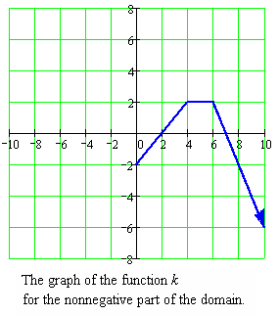Consider the function *k*, which is an even function. Part of the graph of *k* is shown to the right. Using the information that *k* is an even function, complete the graph for the rest of the domain.
6. Now, we will use some functions involving square root and some linear functions to create another logo. The functions are listed in the table below. The logo is the shape completely enclosed by the graphs of the functions. Thus, in order to draw the logo, you will need to find the points of intersections among the graphs. Once you have the points of intersections, you can determine how to limit the domain of each function to specify the boundary of the logo. You are also asked to specify the relationship of the other graphs to the graph of  and to find the range for each function after you have restricted the domain.

|  |  |  |  |
| --- | --- | --- | --- |
| Function | Relation of the graph to graph of (i) | Domain | What is the range of the function with limited domain? |
| (i) $y=2\sqrt{x}$ |  |  |  |
| (ii) $y=2\sqrt{-x}$ | Reflection through |  |  |
| (iii) $y=-2\sqrt{x}$ | Reflection through |  |  |
| (iv) $y=-2\sqrt{-x}$ | Rotation of |  |  |
| (v) $y=4$ | Intersects at ( __, __) |  |  |
| (vi) $y=-4$ | No intersection |  |  |

**Assignment for presentation.**

1. Create a logo using any combination of vertical shifts, vertical stretches or shrinks, reflection through the *x*-axis, or reflection through the *y*-axis of the basic functions listed below as well as horizontal and vertical lines.

*f*(*x*) = *x*, *f*(*x*) = *x*2, *f*(x) = *x*3, *f*(*x*) = , *f*(*x*) = |*x*|, and *f*(*x*) = .

Your logo should be aesthetically appealing and must include the following:

* at least one of the functions from the list of basic functions
* at least four different equations
* at least two examples of vertical shifts, vertical stretches and/or shrinks
* at least one reflection
* at least one type of symmetry
  + Explain how your logo meets each of the requirements listed above.
  + Identify any important points, lines, and or angles associated with your logo’s symmetry.

**Assessment (Symmetry of functions)**

Name___________________________________ Period_______ Date______________

* 1. In Mathematics I, you have studied six basic functions:

*f*(*x*) = *x*, *f*(*x*) = *x*2, *f*(x) = *x*3, *f*(*x*) = , *f*(*x*) = |*x*|, and *f*(*x*) = 

Classify each of these basic functions as even, odd, or neither. ( Justify your answer graphically

or algebraically).

* 1. For each basic function you classified as even, let *g* be the function obtained by shifting the graph down five units, and determine whether *g* is even, odd, or neither.
  2. For each basic function you classified as odd, let *h* be the function obtained by shifting the graph up three units, and determine whether *h* is even, odd, or neither.