Lesson Plan

Mathematics Course: Math 2 (10th)

Title of Lesson “I Like to Use My Imagination”

Unit 1 (Quadratic Functions)

Purpose within unit (include information to help place this lesson within the unit):
Direct Instruction
Georgia Performance Standard(s)
MM2N1. Students will represent and operate with complex numbers.
a. Write square roots of negative numbers in imaginary form.
b. Write complex numbers in the form a + bi.
c. Add, subtract, multiply and divide complex numbers.
Objective for This Class Period: In this lesson, students will learn to recognize what complex numbers in standard form look like and what they mean. More specifically, they will learn, in detail, about the imaginary portion of the complex number. They will learn to recognize that i equals the square root of negative 1 and how to manipulate i. They will learn how to perform the basic operations of addition, subtraction, and multiplication on complex numbers in the form a + bi. Students will be required to make connections of the similarities of operating with complex numbers and binomials.

Essential Question(s):
How do you write complex numbers?
How do you add, subtract, and multiply complex numbers?
Resources (including attached activity sheets or link to resource, additional materials needed, etc.)

Irrational Cartoon.png
Activity Sheet

Timing outline 1 or 2 50 minute periods

5-Question Mixed Review

Lesson Guide (a bulleted or numbered outline of the lesson that must include the items listed below).
- Activating Strategy
5 minute Lesson Opener with Cartoon on screen that students have to write about and share.
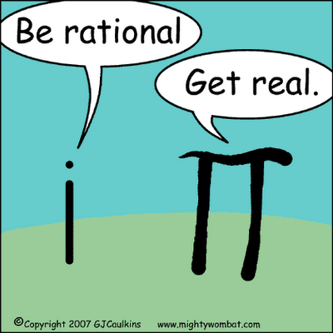

- Note times given for different parts of this lesson in the attached Teacher Guide.
Teacher Guide references technology for this lesson which is optional dependent on the technology available for a specific classroom. Assessments, exercises, and higher level thinking through discovery and investigation are noted in the Teacher Guide and utilized in the Activity Sheet.
Irrational cartoon.png from http://davidsonmath.pbworks.com/Math-Cartoons
Thanks to UNC Wilmington for providing free online math content on this topic.

