I Like to Use My Imagination Teacher Guide

Why Complex Numbers
In the following narrative, it would be helpful for the students to either use technology (graphing calculators) themselves, or to see the parabolas on a big screen using TI SmartView or similar technology. As a last resort, the teacher may draw the two parabolas on a board or easel paper so the students can see the need for complex numbers. This is not the main focus of the lesson and should not be given more than five minutes of class time for presentation.
Teacher Presentation
Why do we need new numbers?
The hardest thing about working with complex numbers is understanding why you might want to. Before introducing complex numbers, let's backup and look at simpler examples of the need to deal with new numbers.
If you are like most people, initially number meant whole number, 0,1,2,3,... Whole numbers make sense. They provide a way to answer questions of the form "How many ... ?" You also learned about the operations of addition and subtraction, and you found that while subtraction is a perfectly good operation, some subtraction problems, like 3 - 5, don't have answers if we only work with whole numbers. Then you find that if you are willing to work with integers, ...,-2, -1, 0, 1, 2, ..., then all subtraction problems do have answers! Furthermore, by considering examples such as temperature scales, you see that negative numbers often make sense.
Now we have fixed subtraction we will deal with division. Some, in fact most, division problems do not have answers that are integers. For example, 3 ÷ 2 is not an integer. We need new numbers! Now we have rational numbers (fractions).
There is more to this story. There are problems with square roots and other operations, but we will not get into that here. The point is that you have had to expand your idea of number on several occasions, and now we are going to do that again.
The "problem" that leads to complex numbers concerns solutions of equations.
Equation 1: x² - 1 = 0.
Equation 1 has two solutions, x = -1 and x = 1. We know that solving an equation in x is equivalent to finding the x-intercepts of a graph; and, the graph of y = x² - 1 crosses the x-axis at (-1,0) and (1,0).
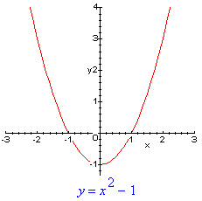
Equation 2: x² + 1 = 0
Equation 2 has no solutions, and we can see this by looking at the graph of y = x² + 1.
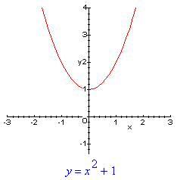
Since the graph has no x-intercepts, the equation has no solutions. When we define complex numbers, equation 2 will have two solutions.
Borrowed from http://www.uncwil.edu/courses/mat111hb/Izs/complex/complex.html
Define i as the square root of -1, show what i^2, i^3, and i^4 equal and have students investigate the patterns for powers of i and develop strategies for simplifying higher powers of i.

Do first portion of Activity Sheet 5 – 10 minute timed activity
Students should notice the pattern developing that every cycle of 4 powers repeats itself. If this is not evident to the class, a five minute explanation of this pattern will need to be explained.
Define Complex Numbers in the form a + bi
Definition: A complex number is one of the form a + bi, where a and b are real numbers. a is called the real part of the complex number, and b is called the imaginary part.
Two complex numbers are equal if and only if their real parts are equal and their imaginary parts are equal. I.e., a+bi = c+di if and only if a = c, and b = d.
Example
2 - 5i.
6 + 4i.
0 + 2i = 2i.
4 + 0i = 4.
Since students are already familiar with binomials, it should be explained to students that for the purpose of adding, subtracting, and multiplying complex numbers, the complex number should be treated as a single variable binomial with i as the variable. The only exception to this rule is when multiplying two complex numbers, the power of i will have to be evaluated before the expression is fully simplified.
Students will complete the Activity Sheet, one section at a time, with the teacher providing feedback. Students may work in groups or work at the board dependent on time and teacher preference.

The last problem on the multiplication part requires an observation and conjecture to be made by the students. This should lead to the discovery of the complex conjugate, which should lead in to the next lesson that logically follows, which is dividing complex numbers.

The 5 question mixed review can be used as a Ticket Out the Door or homework.

