Bell Ringer Name:___________________________

1. Calculate the slope of this line.
Is the slope of the line positive, negative, zero, or undefined?
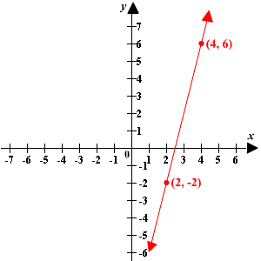
2. Find the slope of the line passing through the points (1, 2) and (9, 4). Is the slope of the line positive, negative, zero, or undefined?

3. Graph the line containing the points (5, 3) and (-4, 3)

4. What is the slope-intercept form of a line?

5. Write this equation in slope-intercept form. 3x + 2y = 12

