What is slope?
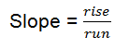 Slope = y2-y1
X2-X1

Find the slope of the line connecting the points (-4, 1) and (4, -5) by graphing and by using the formula.
Dale Graham and Linda Meyer

