Slope Between Two Points
In this lesson, the slope of a line segment connecting two point will be measured and a general formula for finding the slope will be developed and used.
The line segment shown below connects the points (1, 2) and (3, –2). As we look at this diagram from left to right, the segment slopes downward. We will define a negative number to describe the downward slope and how steeply this line segment slopes. To do this, we notice that the vertical distance (rise -- actually a "fall") between these points is -4 and the horizontal distance (run) is 2. A ratio of vertical to horizontal distances is
We say that the slope of the segment connecting the points (1, 2) and (3, –2) is – 2.
If a segment connects the point (1, 2) to the point (– 3, 0), we notice that from left to right, the segment slopes upward: the slope will be positive. We calculate the slope again, using the ratio of the vertical distance to the horizontal distance or .
To summarize, the slope is a number which describes the change between two points. It is written as a ratio of the vertical to the horizontal distances between the points and can be found by calculating these distances and making a fraction referred to as .
Generalized results about the slope between two points:
The general formula for the slope between two points is slope = .
To find the vertical and horizontal distances between the two points, sometimes this can be seen by looking at the graph, but the vertical and horizontal distances between two points can always be found by subtracting the coordinates of the two points.
We have rise = and run = giving us the vertical and horizontal distances when the coordinates of the two points are .
Important facts to remember:
- If a line segment slopes upward from left to right, the slope is positive.
- If a line segment slopes downward from left to right, the slope is negative.
- If a line segment is horizontal, the slope is 0 (zero).
- If a line segment is vertical, the slope is undefined.
Let's practice:
- What is the slope of the segment connecting the points (3, –4) and (–2, 6)?
We calculate the .
- What is the slope of the segment connecting the points (3, 7) and (1, 7)?
We calculate the . This line segment is horizontal. Any horizontal line has a slope of 0.
- What is the slope of the segment connecting the points (4, 9) and (4, 3)?
We calculate the . This slope is undefined since the denominator is 0 and we cannot divide by zero. The line segment is vertical. For any vertical line, the slope is undefined.
- If the slope of a segment connecting the points (x, 5) and (2, -4) is 6, what is the value of x?
We calculate the .
We can solve this equation by multiplying both sides by 2 - x, yielding .
If , then -21 = -6x and .
Examples
What is slope of the segment connecting the points (– 2, 7) and (4,6)?
What is your answer?

If the slope of the segment connecting the points (x, 3) and (9, 14) is 4, what is the value of x?
What is your answer?

If the slope of the segment connecting the points (x, 5) and (2, 9) is undefined, what is the value of x?
What is your answer?

Using Slope and y-Intercept to Graph Lines (page 1 of 2)
Given two points (x₁, y₁) and (x₂, y₂), the formula for the slope of the straight line going through these two points is:
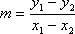
...where the subscripts merely indicate that you have a "first" point (whose coordinates are subscripted with a "1") and a "second" point (whose coordinates are subscripted with a "2"); that is, the subscripts indicate nothing more than the fact that you have two points to work with. Note that the point you pick as the "first" one is irrelevant; if you pick the other point to be "first", then you get the same value for the slope:
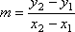
(If you're not sure that the two formulas above give exactly the same values, no matter the pair of points plugged into them, then pick some points and try them out. See what you get.)
The formula for slope is sometimes referred to as "rise over run", because the fraction consists of the "rise" (the change in y, going up or down) divided by the "run" (the change in x, going from left to the right). If you've ever done roofing, built a staircase, graded landscaping, or installed gutters or outflow piping, you've probably encountered this "rise over run" concept. The point is that slope tells you how much y is changing for every so much that x is changing. Pictures can be helpful, so let's look at the line y = ( ²/₃ )x – 4; we'll compute the slope, and draw the line.
To find points from the line equation, we have to pick values for one of the variables, and then compute the corresponding value of the other variable. If, say, x = –3, then y = ( ²/₃ )(–3) – 4 = –2 – 4 = –6, so the point (–3, –6) is on the line. If x = 0, then y = ( ²/₃ )(0) – 4 = 0 – 4 = –4, so the point (0, –4) is on the line. Now that we have two points on the line, we can find the slope of that line from the slope formula:
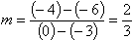
Let's look at these two points on the graph:  Copyright © Elizabeth Stapel 1999-2009 All Rights Reserved |  | 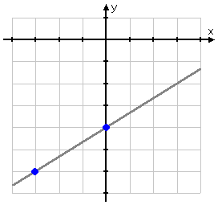
In stair-stepping up from the first point to the second point, our "path" can be viewed as forming a right triangle: |  | 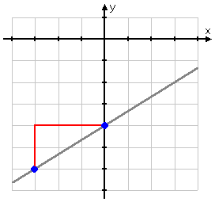
The distance between the y-values of the two points (that is, the height of the triangle) is the "y₂ – y₁" part of the slope formula. The distance between the x-values (that is, the length of the triangle) is the "x₂ – x₁" part of the slope formula. Note that the slope is ²/₃, or "two over three". To go from the first point to the second, we went "two up and three over". This relationship between the slope of a line and pairs of points on that line is always true.
To get to the "next" point, we can go up another two (to y = –2), and over to the right another three (to x = 3):  With these three points, we can graph the line y = ( ²/₃ )x – 4. |  | 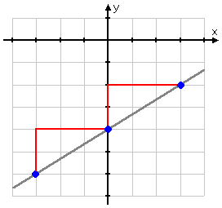
(If you're not sure of that last point, then put 3 in for x, and verify that you get –2 for y.)

Let's try another line equation: y = –2x + 3. We've learned that the number on x is the slope, so m
= –2 for this line. If, say, x = 0, then y = –2(0) + 3 = 0 + 3 = 3. Then the point (0, 3) is on the line. With this information, we can find more points on the line. First, though, you might want to convert the slope value to fractional form, so you can more easily do the "up and over" thing. Any number is a fraction if you put it over "1", so, in this case, it is more useful to say that the slope is m = ^{–2}/₁. That means that we will be going "down two and over one" for each new point.
We'll start at the point we found above, and then go down two and over one to get to the next point: |  | 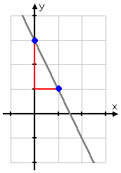
Go down another two, and over another one, to get to the "next" point on y = –2x + 3: |  | 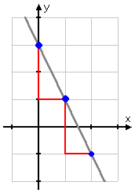
Then the point (2, –1) is also on this line; with three points, we can graph the line.

Return to the Lessons Index | Do the Lessons in Order | Get "Purplemath on CD" for offline use | Print-friendly page
Using Slope and y-Intercept to Graph Lines (page 2 of 2)
Given a point on the line, you can use the slope to get to the "next" point by counting "so many up or down, and then so many over to the right". But how do you find your first point? Take a look back at the graph of the first line and its equation: y = ( ²/₃ )x – 4 crossed the y-axis at y = –4, so the equation gave us the y-intercept. The second line did too: the graph of y = –2x + 3 crossed the y-axis at y = 3. This relationship always holds true: in y = mx + b, "b" gives the y-intercept, and "m" is the slope. We can use this fact to easily graph straight lines:
- Graph the equation y = ( ³/₅ ) x – 2 from the slope and y-intercept.
From the equation, I know that the slope is m = ³/₅, and that the line crosses the y-axis at
y = –2. Copyright © Elizabeth Stapel 2006-2008 All Rights Reserved
I'll start by plotting this first point:
From this point, I go up three and over five:
Then I go up another three and over another five to get my third point:
With three points, I can draw my line:
As a stylistic note, you should probably pencil in the "up and over", if you are using this technique for graphing your straight line. That way, your instructor will know where your points came from. Also, if you are going to graph this way (instead of doing a T-chart of points), you will need to do your graph very neatly. If your scale on your axis is at all inconsistent or if your axes are at all crooked, this method will not work!

Problem: 1
Plot the points (–3, –2) and (7, 1) and draw a line through them. Is the slope of the line positive, negative, zero, or undefined? Explain without calculating.

Problem: 3
Plot the points (5, –2) and (1, 6) and draw a line through them. Is the slope of the line positive, negative, zero, or undefined? Explain without calculating.

Problem: 5
Plot the points (5, 2) and (5, 5) and draw a line through them. Is the slope of the line positive, negative, zero, or undefined? Explain without calculating.

Problem: 7
Plot the points (4, 3) and (–2, –1). Draw the line passing through both these points. Then find the slope using the rise and run.

Problem: 9
Plot the points (–4, 3) and (1, 5). Draw the line passing through both these points. Then find the slope using the rise and run.

Problem: 11
Find the slope.
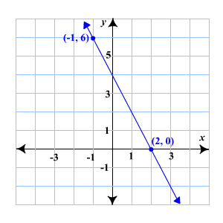

Problem: 13
Find the slope.
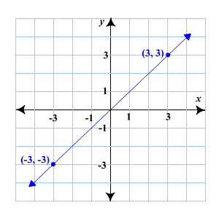

Problem: 15
Find the slope of the line passing through the points (1, 2) and (9, 4).

Problem: 17
Determine the slope of the line with equation y = 6x + 1. Specify if the line has no slope.

Problem: 19
Determine the slope of the line with equation y = 9 – 3x. Specify if the line has no slope.

Problem: 21
Determine the slope of the line with equation 5x + 4y = 20. Specify if the line has no slope.

Problem: 23
Determine the slope of the line with equation 2x – 3y =15. Specify if the line has no slope.

Problem: 25
Determine the slope of the line with equation y = 5. Specify if the line has no slope.

Problem: 27
Write the slope of the line.
What do you think of when you hear the term, slope? Do you think of a skier, skiing down a large mountain?
Or, maybe you think of the sliding board at the playground.
Whatever you are thinking, it's probably something that's on an incline! When we study slope in Algebra we are going to study the incline and other characteristics of a line on a graph.

Slope is a very important concept to understand in Algebra. Therefore, I've created three different lessons to help you gain a full understanding.
We will start here with defining and calculating slope by analyzing a graph. Then we will move on to graphing slope and finally to using slope intercept form to create your graph.
Start here from the beginning, or move onto the concept of slope that you need help with!

What is Slope in Algebra?

Slope is used very often in Mathematics. It can be used to actually find how steep a particular line is, or it can be used to show how much something has changed over time. We calculate slope by using the following definition.
In Algebra, slope is defined as the rise over the run. This is written as a fraction like this:
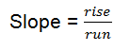

Rules for Calculating the Slope of a Line
• Find two points on the line.
• Count the rise (How many units do you count up or down to get from one point to the next?) Record this number as your numerator.
• Count the run (How many units do you count left or right to get to the point?) Record this number as your denominator.
• Simplify your fraction if possible.
IMPORTANT NOTE:
• If you count up or right your number is positive.
• If you count down or left your number is negative.

Let's look at an example:

Example 1
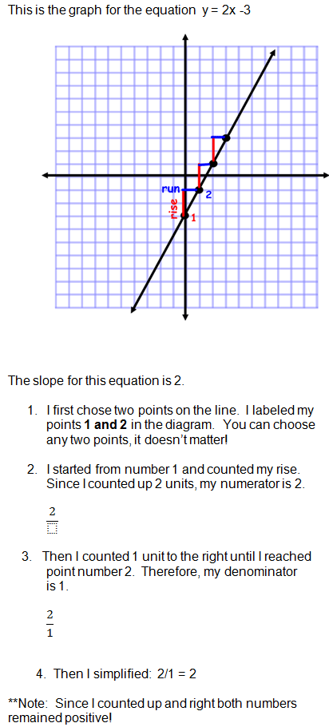

Example 2
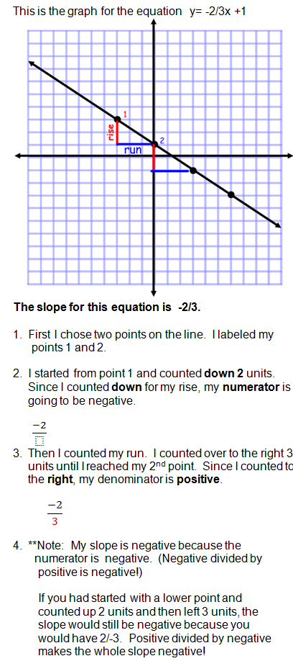

Your turn to practice calculating slope!
Remember, choose two points and calculate your rise over run! Don't forget to look for negative slopes: If you count down or left!

Your Turn to Calculate Slope!

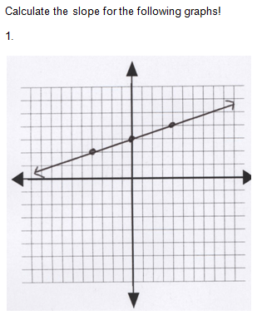
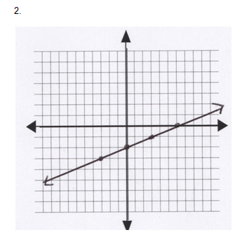
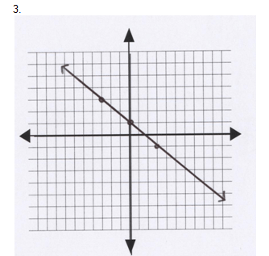
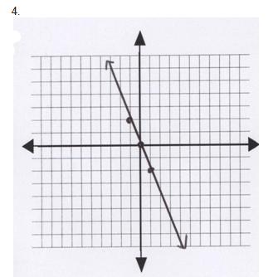
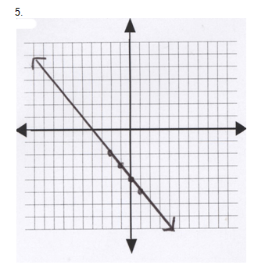

Answer Key for Calculating Slope

1. The slope of the line is 1/4.
2. The slope of the line is 1/3.
3. The slope of the line is -2/3
4. The slope of the line is -2.
5. The slope of the line is -1.

Great Job! Just remember that slope is a fraction: rise/run. Calculate your rise and then your run! If your rise is downhill it is negative. If your run is to the left it is also negative!
You can choose any two points on the line to calculate your slope! The slope is constant throughout the whole line.
Now you are ready to move onto Graphing Slope!

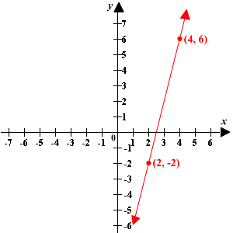

Problem: 29
Graph the line containing the points (–5, 3) and (6, –4) and compute its slope.

Problem: 31
Graph the line containing the points (–3, 7) and (5, 0) and compute its slope.

Problem: 33
Graph the line containing the points (0, 6) and (–5, –4) and compute its slope.

Problem: 35
Compute x, if the slope of the line containing the points (6, 2) and (x, 8) is 3.

Problem: 37
Compute y, if the slope of the line containing the points (–5, y) and (3, 5y) is 9.

Problem: 39
A jet airplane climbs 19.6 ft for every 40 ft it moves horizontally.
Find the slope of the line as a percent.

Problem: 41
A line contains points (a, –b) and (b, –a) where a b. Find the slope.

- Math Videos
- Algebra Help
- Geometry Help
- Calculus Help
- Science Help
- Link To Us
- Site Map

