Bell Ringer Name:___________________________

1. Calculate the slope of this line.
Is the slope of the line positive, negative, zero, or undefined?
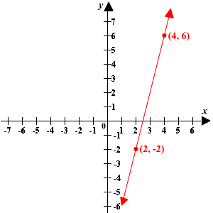
2. Find the slope of the line passing through the points (1, 2) and (9, 4). Is the slope of the line positive, negative, zero, or undefined?

3. Plot the points (–2, -2) and (-2, 6). Draw the line passing through both these points. Then find the slope using the rise and run.
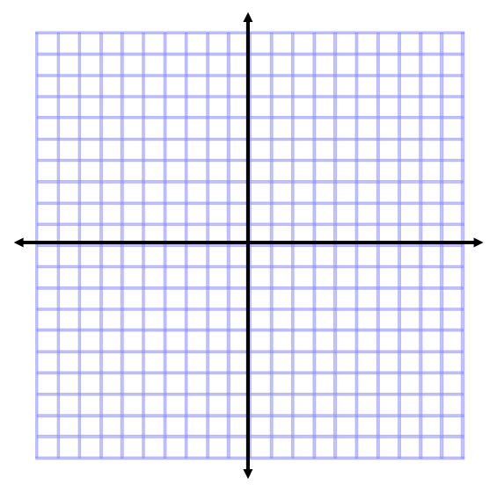

4. What is slope of the segment connecting the points (– 2, 7) and (4, 6)? Is the slope of the line positive, negative, zero, or undefined?

