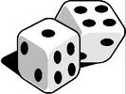

Playing the Multiplication Game
In the Addition Game, players score points based on the sum of the numbers rolled on two number cubes. In the Multiplication Game, scoring depends on the product of the numbers rolled.

Multiplication Game Rules:
- Player A and Player B take turns rolling two number cubes.
- If the product of the numbers rolled is odd, Player A scores 1 point.
- If the product of the numbers rolled is even, Player B scores 1 point.
- The player with the most points after 36 rolls wins.

