**Centimeter Dot Paper**

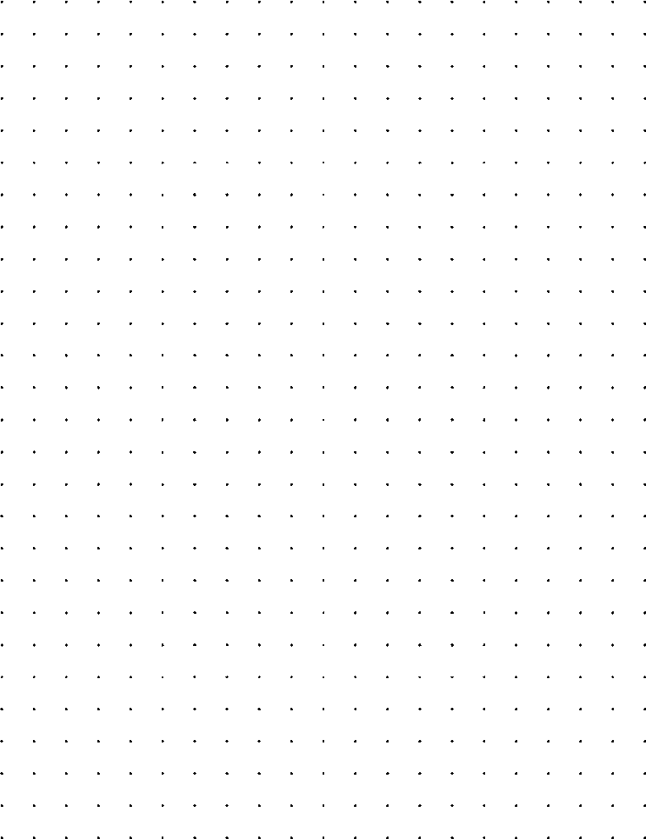

2