Lesson Plan

Mathematics Course: _x__ 8th Math ___ Math 1 (9th) ___ Math 2 (10th)

Title of Lesson Multiplying and Dividing Square Roots

Unit 2

Purpose within unit (include information to help place this lesson within the unit):
____ Exploration __x__ Direct Instruction ____ Culminating Task

Georgia Performance Standard (specific; include number and wording)
GPS:M8N1. Students will understand different representations of numbers including square roots, exponents and scientific notation.
g. Simplify, add, subtract, multiply and divide expressions containing square roots.

Objective for This Class Period: (What students will know/be able to do when they leave class that they did not know/were not able to do when they arrived – this day/ this class period)
Students will be able to multiply and divide expressions containing square roots.

Essential Question(s)
How do I multiply and divide square roots?

Resources (including attached activity sheets or link to resource, additional materials needed, etc.)
Bell Ringer- 4 question mixed review
Activating Strategy
Multiplying and dividing square roots graphic organizer
Practice Problems
Ticket Out the Door

Timing outline
Bell ringer- 3 question mixed review- 5 minutes
Discuss the mixed review and activating strategy- 10 minutes
Begin the lesson using the graphic organizer. Use a transparency of the graphic organizer on an overhead or SmartBoard for your discussion and guided practice. Ask propping questions during the guided practice to insure student comprehension- 15 minutes
Students should complete practice problems using both multiplication and division of square roots- 20 minutes
Assess the lesson using the Ticket Out the Door- 5 minutes

5-Question Mixed Review
** See page with this title

Lesson Guide (a bulleted or numbered outline of the lesson that must include the items listed below).
- Activating Strategy ** See page with this title
- Multiple representations, including hands-on activities ** See pages with these titles

- Technology (including photos, video clips, Smart files, PowerPoint, calculator use, etc.)
Use transparency of Graphic Organizer on overhead projector or use SmartBoard
- Questions throughout – more open than closed ** Contained in the lesson
- Evidence of learning (assessment) – how you’ll know they got it; formative and summative
Assessment- Ticket Out the Door ** See page with this title

Four Question Mixed Review

Name ______________________________ | Date _______________________

Use the following square root problem to label the coefficient (1), the radical (2) and the radicand (3).

Place the numbers in the correct circle.

4$\text{√}$28

Is the problem in simplest form? ________________

Why or why not? ___________________________________________________________

___________________________________________________________________________

Activating Strategy

Write the first 10 perfect squares.

1. ________ | 2. ________ | 3. ________ | 4. ________ | 5. ________
6. ________ | 7. ________ | 8. ________ | 9. ________ | 10. ________

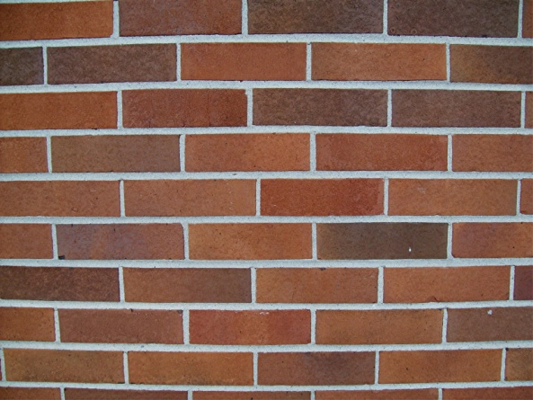 | This section of the brick wall outside Lowndes High School has an area of 49 square feet. Write the perfect square for this situation.  ______ X ______ = ______

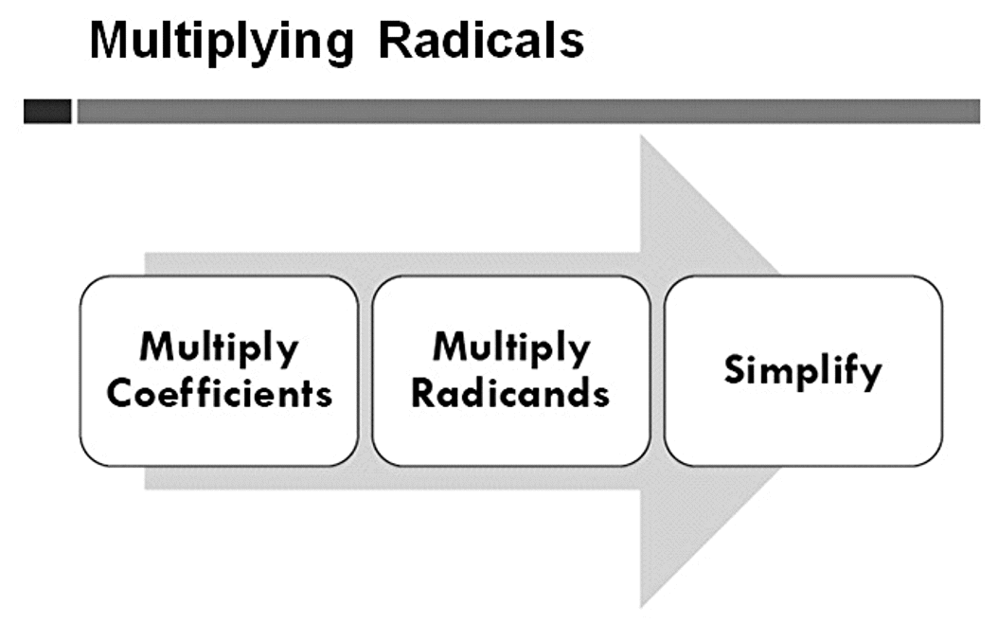

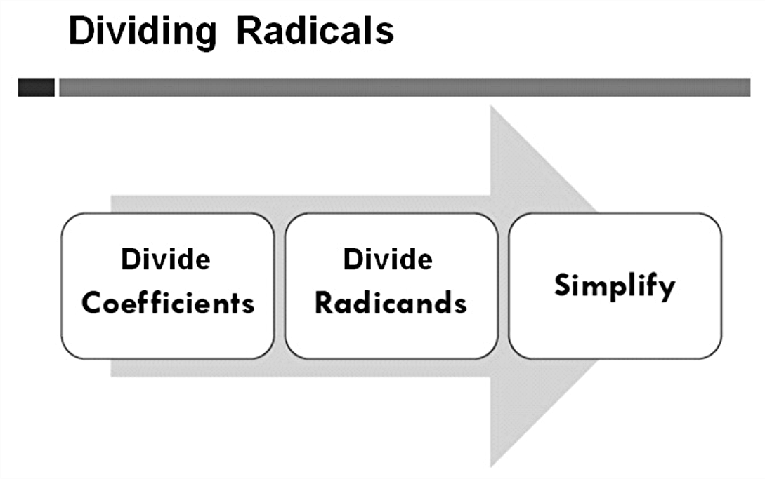

How do you multiply square roots?

Multiply the coefficients 2$\text{√}$3 $\text{∙}$ 3$\text{√}$2 (2 $\text{∙}$ 3 = 6)

Write your results for the multiplication of the coefficients in front of the radical.

6$\text{√}$

Multiply the radicands 2$\text{√}$3 $\text{∙}$ 3$\text{√}$2 (3 $\text{∙}$ 2 = 6)

Write your results for the multiplication of the radicands under the radical.

$\text{√}$6

The final result is 6$\text{√}$6

Try these.

1. 3$\text{√}$7 $\text{∙}$ 2$\text{√}$5

2. 5$\text{√}$3 $\text{∙}$ 3$\text{√}$7

3. 4$\text{√}$5 $\text{∙}$ 2$\text{√}$6

How do you divide square roots?

Divide the coefficients 21$\text{√}$15 $\text{÷}$ 3$\text{√}$5 (21 $\text{÷}$ 3 = 7)

Write your results for the division of the coefficients in front of the radical.

7$\text{√}$

Multiply the radicands 21$\text{√}$15 $\text{÷}$ 3$\text{√}$5 (15 $\text{÷}$ 5 = 3)

Write your results for the division of the radicands under the radical.

$\text{√}$3

The final result is 7$\text{√}$3

Try these.

1. 14$\text{√}$6 $÷$ 2$\text{√}$3

2. 10$\text{√}$20 $\text{÷}$ 5$\text{√}$2

3. 24$\text{√}$6 $\text{÷}$ 8$\text{√}$3

Ticket Out the Door

Name ____________________________

Show your work.

1. $\text{√}$3 $\text{∙}$ $\text{√}$3 = ______

2. 2$\text{√}$6 $\text{∙}$ 3$\text{√}$5 = ______

3. $\text{√}$7 = ______
$\text{√}$16

4. The number underneath the radical is called the ______________________.

5. The number in front of the radical is called the _______________________.

