How to Make an Apple Pie and See the World:
A Creative Arts Unit

Sarah Wostbrock
ECMT 6020
Dr. Barbara Hubbard
Summer 2009

Table of Contents

Unit Introduction …………………………………………………………………………... page 3

Me on the Map, Day One ……………………………………………………… ………… page 5

Wheat from Italy, Day Two. ………………………………………………………………. page 9

A Chicken from France, Day Three ……………………………………………………..page 13

Cinnamon from Sri Lanka, Day Four ……………………………………… …………..page 17

A Cow from England, Day Five……………………………………………… ...……….page 21

Salt from the Sea & Sugar from Jamaica, Day Six………………………… ………....page 25

Apples from Vermont, Day Seven………………………………………………………...page 30

Home Again, Home Again, Jiggedy-Jig, Days Eight & Nine…………………………page 34

Let’s Make Pie, Day Ten…………………………………………………………………..page 38

Reflection…………………………………………………………………………………….page 42

How to Make an Apple Pie and See the World

Unit Introduction
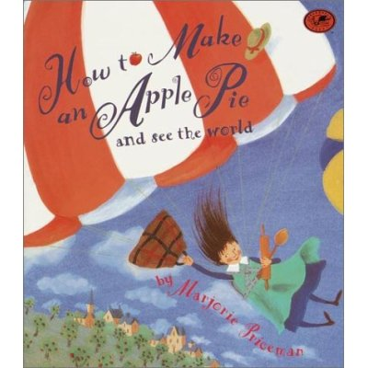

This unit began its conceptualization both as a fond childhood memory and an inspiration from National Geographic’s recent geography awareness campaign, My Wonderful World. It is stated that only nineteen percent of young Americans own a map, and that half of them couldn’t locate New York on it if they did. In a quickly globalizing world, there is a dangerous possibility that our students could be left behind if a greater emphasis is not place on geographic awareness in the classroom.
However, geography is more than just being able to name and locate places and features on a map. It is a study of connections, cultures, environments, economics and language. As an adult, I look back fondly on the time my mother and I “toured the world” and made apple pie. Working through Majorie Priceman’s book with a globe, we tracked our progress through the continents, picked up our ingredients, and learned a little about each place we stopped at along the way such as the Sri Lankan rainforests where cinnamon is harvested.
The following lesson plans compose an interdisciplinary unit, chiefly English Language Arts and Social Studies, which intends to recreate that experience for young students while incorporating the seven layers of performing and non-performing arts—dance, drama, music, literature, photography, sculpture, and visual arts. Literature and photography will be integrated daily, as a text will be read aloud and photographs displayed for each “country” the class stops to visit. The rest of the arts will be strategically spread throughout the lessons, along with related science experiments and mathematical concepts.

Me on the Map
Day One
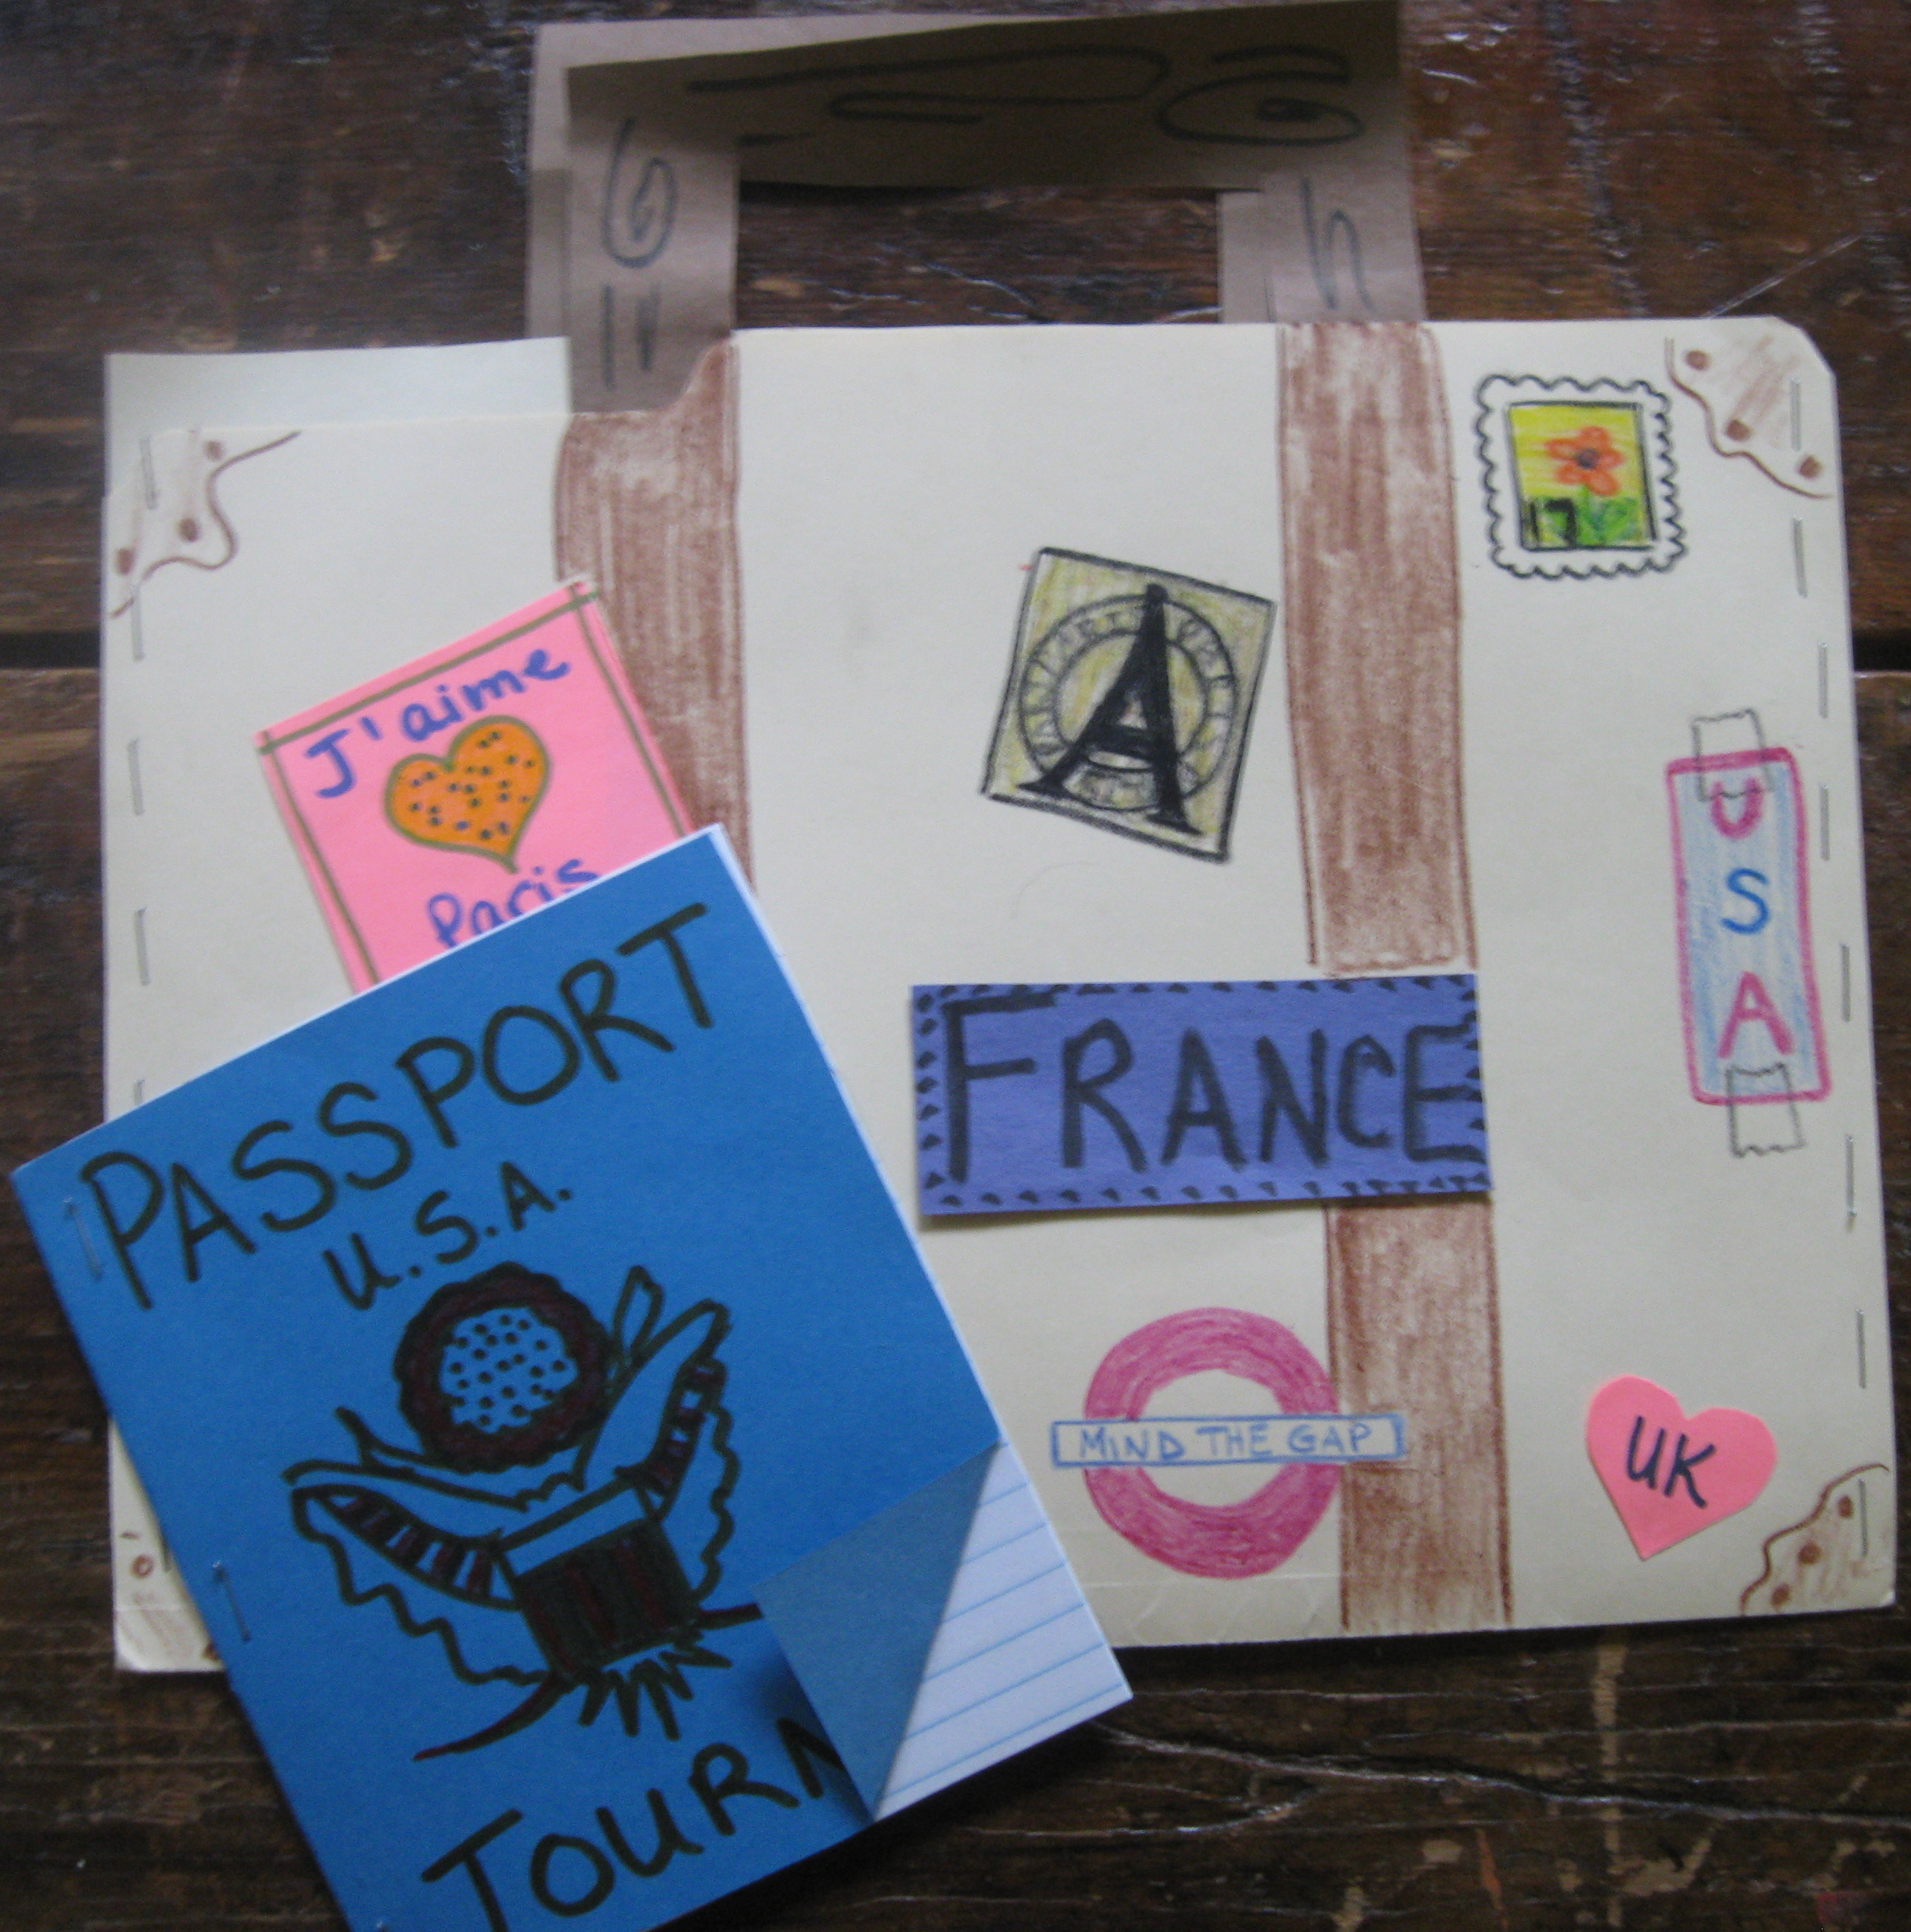

Relevance:
ELA1R6 The student uses a variety of strategies to understand and gain meaning from grade-level text. The student
a. Reads and listens to a variety of texts for information and pleasure.
b. Makes predictions using prior knowledge.
c. Asks and answers questions about essential narrative elements (e.g., beginning middle- end, setting, characters, problems, events, resolution) of a read-aloud or independently read text.
d. Retells stories read independently or with a partner.
e. Distinguishes fact from fiction in a text.
f. Makes connections between texts and/or personal experiences.

ELA1W2 The student writes in a variety of genres, including narrative, informational, persuasive and response to literature.

SS1G2 The student will identify and locate his/her city, county, state, nation, and continent on a simple map or a globe.

SS1G3 The student will locate major topographical features of the earth’s surface.
a. Locate all of the continents: North America, South America, Africa, Europe, Asia, Antarctica, and Australia.
b. Locate the major oceans: Arctic, Atlantic, Pacific, and Indian.

Prerequisites:
This unit lesson is designed for a standard first-grade class of eighteen to twenty-two students. Students should be prepared to participate in both whole-group discussions and small group/partner activities. Before beginning, students will have had a brief introduction to map-reading skills as well as the division of the world into major continents and oceans.

Goals:
- Students will become familiar with the text How to make apple pie and see the world
- Students will understand that the world is divided up into regions called continents and oceans
- Students will understand where they live in that world
- Students will practice using persuasive writing to convince others their home is the best

Objectives:
- Students will correctly give the names of the city/county, state, country, and continent where they live
- Students will recite or sing the names of 7 continents and 4 oceans
- Students will compose a brief, persuasive journal entry, 3-5 sentences in length, at the end of class

Evaluation:
- Students will correctly give the names of the city/county, state, country, and continent where they live when called upon
Students will be informally evaluated daily by their portfolio (the “suitcase”)
- Students will compose a brief, persuasive journal entry, 3-5 sentences in length

Materials / Equipment:
- Stork, R. (Writer), & Lancet, L., M. Manucci, and E. Wiseman (Directors). (1996). How to make an apple pie and see the world [118]. In L. Burton (Producer), Reading Rainbow. Public Broadcasting Service.
- Large piece of paper with a map of the world drawn or printed on it, laminated.
- Construction Paper Labels for continents (North America, South America, Europe, Asia, Australia, Africa, Antarctica, Atlantic Ocean, Pacific Ocean, Indian Ocean, Arctic Ocean)
- Thumbtacks
- Yarn
- Small map of home world (1 per student)
- Plain file folders (1 per student)
- Colored file folders, cut in fourths (1 per every 2 students) and filled with notepaper
- Craft supplies (markers, crayons, etc)

Procedures:
Introductory Activities
- Create a travel atmosphere for children to enter into as you begin this unit. Display How to make an apple pie and see the world in a prominent “place of honor”—on a bulletin board, your desk, etc. Hang a large, laminated map of the world on the wall, bring in suitcases from home as props/decoration, post a sign on your door reading: “US Passport Office,” play world music or airport sound effect loops (check royalty free sites), but most of all be creative. Your students will take their cues from you.
- As students walk in, greet them with a “suitcase” (made out of a file folder, see above image). Tell them, “We will be traveling the world for the next few weeks, so you will need this suitcase to collect souvenirs in.” Allow students time to decorate suitcases
Development Activities
- Video: Watch Reading Rainbow, episode 118, How to make an apple pie and see the world.
- Geography: Afterwards, walk students over the big wall map and
  - Ask them if they remember some of the places the main character went on her trip (Italy, France, Sri Lanka, England, Jamaica, Vermont).
    - Review and label Continents and Oceans with students.
  - Music: Teach the Continent and Ocean song (sound file attached):
    - North America, South America, Europe, Asia, and Australia, Africa, Antarctica, these are the continents. Indian, Arctic, and the Atlantic, and the Pacific are the oceans, Indian, Arctic, and the Atlantic and the Pacific are oceans.
Sing and point to indicated regions as you go.
  - Remind students that the main character in our book started on the journey around the world from her home but, since we are about to go on the same journey, we will have to start from our homes. Discussion:
    - Where do you live? Have students share their addresses or neighborhoods. What city is that?
    - Does anyone know what county we’re in?
    - What state are we in? Discuss home state and pass out small maps. Students put a star in the general area of their home and write their own address.
    - What country do we live in? Locate on wall map.
    - What continent is that? Locate on wall map.
  - Glue a picture or have students draw the school on the wall map. Write school address and mark with a thumbtack. Tie a long piece of yarn around the tack.
  - Call upon individual students to give the names of the city/county, state, country, and continent where they live.
Closing Activities
- Pass out passport journals. A passport is a document people keep when they travel to record where they’ve been. Every time they go to a new country, they get a new stamp. If they don’t have a passport, the new country usually won’t let them in, even to visit. We are going to use our passports to record our journey in writing, and every time we enter a new country we will write something and earn a stamp (use an actual stamp or sticker work too).
- Journal Entry (persuasive): “My home is best” Students write 3-5 sentences describing their home or neighborhood and explaining why it is the best place to live.

Accommodations for Mainstreamed Students:
Students with special needs may
- Choose to write from a list of country facts pre-written by the teacher instead of generating their own
- Write fewer sentences
- Have longer time allotments for assignments

Enrichment:
- Read: Ladoux, Rita. (2002). Georgia: Hello U.S.A. Minneapolis, MN: Lerner Publishing Group, Inc. (or similar book corresponding to your home state)

Follow-up:
- Students travel by steamboat Europe and Italy to learn about supply and demand

Wheat from Italy
Day Two
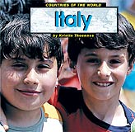
Relevance:
ELA1R6 The student uses a variety of strategies to understand and gain meaning from grade-level text. The student
a. Reads and listens to a variety of texts for information and pleasure.
b. Makes predictions using prior knowledge.
c. Asks and answers questions about essential narrative elements (e.g., beginning middle- end, setting, characters, problems, events, resolution) of a read-aloud or independently read text.
d. Retells stories read independently or with a partner.
e. Distinguishes fact from fiction in a text.
f. Makes connections between texts and/or personal experiences.

ELA1W2 The student writes in a variety of genres, including narrative, informational, persuasive and response to literature.

SS1E3 The student will describe how people are both producers and consumers.

SS1G3 The student will locate major topographical features of the earth’s surface.
a. Locate all of the continents: North America, South America, Africa, Europe, Asia, Antarctica, and Australia.
b. Locate the major oceans: Arctic, Atlantic, Pacific, and Indian.

Prerequisites:
This unit lesson is designed for a standard first-grade class of eighteen to twenty-two students. Students should be prepared to participate in both whole-group discussions and small group/partner activities. Before beginning, students will have had a brief introduction to map-reading skills as well as the division of the world into major continents and oceans. Students must also keep their portfolios caught up from previous lesson(s) as this information is necessary to tracking their progress across the world.

Goals:
- Students will become familiar with the text How to make apple pie and see the world
- Students will participate in a brainstorming and mapping of different types of transportation.
- Students will understand how producers are different from consumers
- Students will learn about and view photos of Italy
- Students will experience differences and similarities in song and dance from another cultures
- Students will practice using informative writing to define concepts

Objectives:
- Students will develop at least two categories for sorting types of transportation while working with a partner
- Students will select and write 2 informative facts from the reading on Italy.
- Students will compose a brief, informative journal entry defining the terms producer and consumer, 3-5 sentences in length

Evaluation:
Students will be informally evaluated daily by their portfolio (the “suitcase”)
- Students will select and write 2 informative facts from the reading on Italy.
- Students will compose a brief, informative journal entry, 3-5 sentences in length

Materials / Equipment:
- Priceman, M. (1994). How to make an apple pie and see the world. New York: Alfred A. Knopf, Inc.
- Thoennes, Kristin. (1999). Countries of the world: Italy. Mankato, MN: Capstone Press.
- Wheat berries/wheat grass/or other similar grain
- Index cards
- Large wall map
- Thumbtacks
- Yannucci, L. (2009). Mama Lisa’s world Italy: Children’s songs and nursery rhymes. Retrieved July 3, 2009, from http://www.mamalisa.com/?t=es&p=888&c=120.
- Student suitcases
- Student passport/journals

Procedures:
Introductory Activities
- Getting There: Read aloud How to make an apple pie and see the world, focusing on the first 7 pages. Observe how the main character travels to get her first ingredient (in a steam boat). Brainstorms with students different means of transportation around the world. What examples are found in the book? Then discuss with students how we could sort these ideas (land, water, air/wheels, no wheels/fast, slow) and create a bubble map that can be displayed throughout the next two weeks. Do not choose category criteria for students. Group students in pairs and allow them to think creatively. There are no wrong answers.
Development Activities
- Economics: Discuss with students:
  - What country did our main character travel to first to get the wheat?
  - Why couldn’t she get wheat from her own house. (talk about the idea of producers and consumers and have students come up with a definition for both—write on board)
  - What else can you think of that comes from Italy?
- Geography:
  - Afterwards, walk students over the big wall map
    - Review continents and oceans.
    - Draw or paste a steamboat crossing the Atlantic
    - Locate Italy and press in a thumbtack, stretch yarn from “home position” and wrap around second thumbtack to track progress.
    - Ask students “Which ocean did we cross,” “What continent did we leave?” and “What continent are we on now?
    - Students repeat this activity with markers or crayons on their own personal map.
  - Read Countries of the world: Italy aloud to students. Highlight only important facts if time is short.
- Break Time!
  - Music and Dance: Teach students and play the Italian children’s version of Ring-Around-the-Rosie—Giro, Giro Tondo. Music available on Yannucci’s website. Prompt students to discuss how Giro, Giro, Tondo is like and different from our version of Ring-Around-the-Rosie.

Giro, Grio Tondo
Giro giro tondo
casca il mondo
casca la terra
tutti giù per terra!

English Translation
Turn, turn around
The world is falling down
The earth is falling down
Everybody's sitting down!

At the end every child sits on the floor = terra = earth.

Closing Activities
- Students write 2 facts about Italy on the back of a notecard and tape wheat sample on the front. Place “ingredient” in the suitcase.
- Pass out passport journals and stamp.
- Journal Entry (informative): “Economics” Students write 3-5 sentences describing what both a consumer and a producer are and giving an example of each. Ex) A producer is someone who makes things and sells them. People in Italy make spaghetti sauce and sell it to stores. Consumers buy things. I am a consumer. I buy spaghetti sauce to eat on my noodles!

Accommodations for Mainstreamed Students:
- Have a collection of facts already listed under “Italy” on a poster board that students can choose and copy from
- Students may write few sentences or have more allotted time for journaling.

Enrichment:
Foreign language ties, Italian. Use the Italian substitutions for these words with students throughout the course of the day:
- Ciao (hello)
- Arrivederci (goodbye)
- Grazie (please)
- Prego (thank you)

Follow-up:
Students travel by train to France to learn about the life cycle of a chicken and the parts of an egg.

A Chicken from France
Day Three
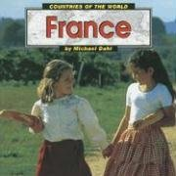
Relevance:
ELA1R6 The student uses a variety of strategies to understand and gain meaning from grade-level text. The student
a. Reads and listens to a variety of texts for information and pleasure.
b. Makes predictions using prior knowledge.
c. Asks and answers questions about essential narrative elements (e.g., beginning middle- end, setting, characters, problems, events, resolution) of a read-aloud or independently read text.
d. Retells stories read independently or with a partner.
e. Distinguishes fact from fiction in a text.
f. Makes connections between texts and/or personal experiences.

ELA1W2 The student writes in a variety of genres, including narrative, informational, persuasive and response to literature.

SS1G3 The student will locate major topographical features of the earth’s surface.
a. Locate all of the continents: North America, South America, Africa, Europe, Asia, Antarctica, and Australia.
b. Locate the major oceans: Arctic, Atlantic, Pacific, and Indian.

S1L1 Students will investigate the characteristics and basic needs of plants and animals.
d. Compare and describe various animals—appearance, motion, growth, basic needs.

Prerequisites:
This unit lesson is designed for a standard first-grade class of eighteen to twenty-two students. Students should be prepared to participate in both whole-group discussions and small group/partner activities. Before beginning, students will have had a brief introduction to map-reading skills as well as the division of the world into major continents and oceans. Students must also keep their portfolios caught up from previous lesson(s) as this information is necessary to tracking their progress across the world.

Goals:
- Students will become familiar with the text How to make apple pie and see the world
- Students will observe the growth and appearance of an egg as it changes into a chicken.
- Students will learn about and view photos of France.
- Students will practice using narrative writing to describe an imaginary event.

Objectives:
- Students will correctly label 3 parts of an egg.
- Students will construct a sculpture in small groups representing a symbol of France, the Eiffel Tower, out of cheese cubes and toothpicks
- Students will select and write 2 informative facts from the reading on France.
- Students will compose a brief, narrative journal entry describing an imaginary train ride, 3-5 sentences in length

Evaluation:

Students will be informally evaluated daily by their portfolio (the “suitcase”)
- Students will correctly label 3 parts of an egg.
- Students will select and write 2 informative facts from the reading on France.
- Students will compose a brief, narrative journal entry, 3-5 sentences in length.
- Students will construct a sculpture in small groups representing a symbol of France, the Eiffel Tower, out of cheese cubes and toothpicks

Materials / Equipment:
- Priceman, M. (1994). How to make an apple pie and see the world. New York: Alfred A. Knopf, Inc.
- Dahl, M. (1999). Countries of the world: France. Mankato, MN: Capstone Press.
- Museum of Science and Industry. (2009). Baby chicks hatching. Retrieved July 4, 2009, from http://www.msichicago.org/online-science/videos/video-detail/activities/the-hatchery/
- Large egg drawn on a poster board with major parts labeled (see Enchanted Learning. (2009). All about chickens. Retrieved July 4, 2009, from http://www.enchantedlearning.com/subjects/birds/info/chicken.shtml)
- Egg shapes cut out of construction paper (1 per student)
- 1 large egg and empty bowl.
- Large wall map
- Thumbtacks
- Cheese cubes
- Toothpicks
- Student suitcases
- Student passport/journals
- SETE. (2006) Hector at the Eiffel Tower. Retrieved July 3, 2009, from http://www.tour-eiffel.fr/teiffel/uk/ludique/espace_enfant/index.html

Procedures:
Introductory Activities
- Transportation: Re-read aloud How to make an apple pie and see the world, focusing on pages 8-11. Note that this time the main character travels on a train. Refer back to transportation bubble map. Stop and allow students to share any train experiences, real or from books or movies.
Development Activities
- Science: Discuss with students:
  - What country has our main character traveled to now to get an egg?
  - But she didn’t collect an egg for her pie, she got a chicken instead. How does that work. (lead students into a discussion on life cycles: eggchickchickenegg
  - Break open an egg over a bowl and discuss the 3 key components of a chicken egg—shell, white, and yolk and their purposes
    - Which one becomes the chick?
    - Which one is food for the growing chick?
    - Which one protects the chick?
  - Pass out construction paper egg shapes and have students draw and label their own shells, white and yolks. Put up large poster board diagram for a reference.
  - Watch Baby chicks hatching.
- Geography:
  - Read Countries of the world: France aloud to students. Highlight only important facts if time is short. Be sure to focus on the Eiffel Tower, however.
  - Afterwards, walk students over the big wall map
    - Review continents and oceans.
    - Draw or paste a train between Italy and France
    - Locate France and press in a thumbtack, stretch yarn from last tack and wrap around the new one to track progress.
    - Ask students “What continent are we on still?
    - Students repeat this activity with markers or crayons on their own personal map.
- Break Time!
  - Sculpture: cheese is a favorite food of the French. Divide students into small groups and have them construct Eiffel Towers out of cheese cubes and toothpicks. Take photos for portfolio

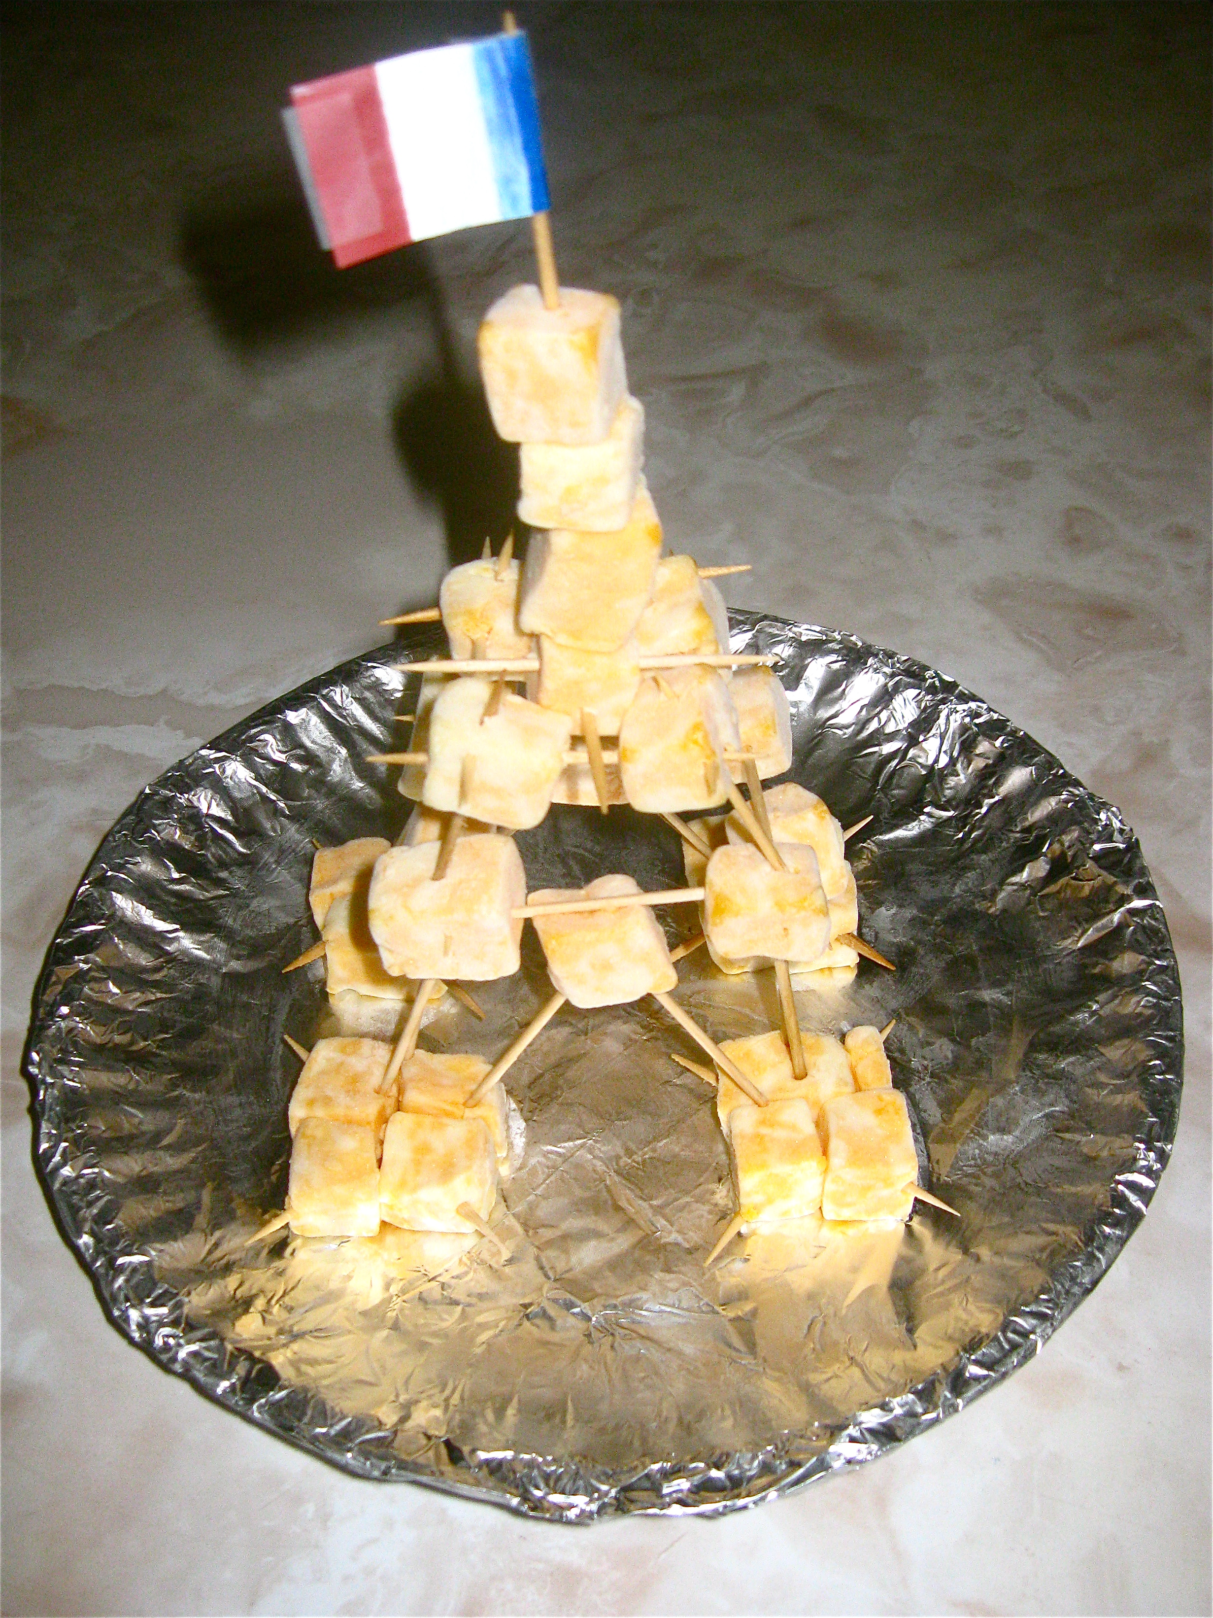

Closing Activities
- Students write 2 facts about France on the back of their egg. Place “ingredient” in the suitcase.
- Pass out passport journals and stamp.
- Journal Entry (narrative): “My train ride!” Students use their imaginations and write 3-5 descriptive sentences telling about their imaginary train ride from Italy to France. What did it sound like? Feel like? Look like? Smell like?

Accommodations for Mainstreamed Students:
Students with special needs may
- Choose to write from a list of country facts pre-written by the teacher instead of generating their own
- Write fewer sentences
- Have longer time allotments for assignments

Enrichment:
Virtual tourism. Students travel to visit the Eiffel Tower in small groups or as individuals, using the Hector at the Eiffel Tower website. There, students can play 1 of 6 games related to the famous structure.

Follow-up:
Students travel past/through Africa to Asia and Sri Lanka in an unknown boat to learn about spices and culture.

Cinnamon from Sri Lanka
Day Four
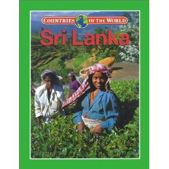
Relevance:
ELA1R6 The student uses a variety of strategies to understand and gain meaning from grade-level text. The student
a. Reads and listens to a variety of texts for information and pleasure.
b. Makes predictions using prior knowledge.
c. Asks and answers questions about essential narrative elements (e.g., beginning middle- end, setting, characters, problems, events, resolution) of a read-aloud or independently read text.
d. Retells stories read independently or with a partner.
e. Distinguishes fact from fiction in a text.
f. Makes connections between texts and/or personal experiences.

ELA1W2 The student writes in a variety of genres, including narrative, informational, persuasive and response to literature.

SS1G3 The student will locate major topographical features of the earth’s surface.
a. Locate all of the continents: North America, South America, Africa, Europe, Asia, Antarctica, and Australia.
b. Locate the major oceans: Arctic, Atlantic, Pacific, and Indian.

Prerequisites:
This unit lesson is designed for a standard first-grade class of eighteen to twenty-two students. Students should be prepared to participate in both whole-group discussions and small group/partner activities. Before beginning, students will have had a brief introduction to map-reading skills as well as the division of the world into major continents and oceans. Students must also keep their portfolios caught up from previous lesson(s) as this information is necessary to tracking their progress across the world.

Goals:
- Students will participate in a choral read of How to make apple pie and see the world
- Students will become aware of inquiry and research as tools to discovering new information.
- Students will learn about and view photos of Sri Lanka.
- Students will practice using narrative writing to create a metaphor.

Objectives:
- Students will select and write 2 informative facts from the reading on Sri Lanka.
- Students will compose a brief, narrative journal entry creating a metaphor for themselves as a spice, 3-5 sentences in length

Evaluation:
Students will be informally evaluated daily by their portfolio (the “suitcase”)
- Students will select and write 2 informative facts from the reading on Sri Lanka.
- Students will compose a brief, narrative journal entry, 3-5 sentences in length.

Materials / Equipment:
- Priceman, M. (1994). How to make an apple pie and see the world. New York: Alfred A. Knopf, Inc.
- Guruswamy, K., S. Marsh, and K. Brown-Carpenter. (2002). Countries of the world: Sri Lanka. Chicago, IL: Gareth Stevens Publishing.
- Rotner, S. (1998). Boats Afloat. New York: Scholastic.
- Cinnimon sticks (1 per student)
- Other varied spices such as ginger, vanilla, allspice, cloves, garlic, curry
- Index cards
- Large wall map
- Thumbtacks
- Student suitcases
- Student passport/journals

Procedures:
Introductory Activities
- Getting There: Have students choral read How to make an apple pie and see the world, focusing on pages 11-13. Note that this time the main character travels on a boat again but the text does not tell us what type of boat.
Development Activities
- Inquiry and Research: Discuss with students:
  - What are the characteristics you note in the boat illustration on page 11.
    - What does it have? What does it not have? Describe its size.
  - Use the photographs in Boats afloat and the clues gathered from the illustration in How to make an apple pie and see the world to decide as a class what type of boat this must be. Students do not have to all choose the same answer.
- Geography:
  - Read Countries of the world: Sri Lanka aloud to students. Highlight only important facts if time is short.
  - Afterwards, walk students over the big wall map
    - Review continents and oceans.
    - Locate Sri Lanka and press in a thumbtack, stretch yarn from last tack and wrap around the new one to track progress. To get there, the boat will need to either travel around the horn of Africa, or cut through the Suez Canal. Students pretend to be the Captain and crew of the ship and make a decision. Add thumbtacks and string yarn accordingly.
    - Point out to students that we have now traveled from Europe, through or around Africa and are now where? (Asia)
    - Draw or paste sailboat somewhere between Sri Lanka and France.
    - Students repeat this activity with markers or crayons on their own personal map.
- Break Time!
  - Culinary Arts: Remind students that the reason we are in Sri Lanka today is because we are gathering cinnamon for our apple pie.
    - Ask if anyone knows what cinnamon is
    - Pass cinnamon sticks out and let students smell and taste them
    - Spices usually smell very good but don’t taste good on their own. But, if you mix them into a dish you are making, they make the food taste delicious!
    - Pass around other spices and allow students to experience different smells from around the world. Explain that spices grow in many different places around the world like Sri Lanka and sometimes they can be very expensive because they have to travel so far to get to us.
Closing Activities
- Students write 2 facts about Sri Lanka on the back of an index card and tape or glue their cinnamon stick to the front. Place “ingredient” in the suitcase.
- Pass out passport journals and stamp.
- Journal Entry (narrative): “If I were a spice, I would be….”

Accommodations for Mainstreamed Students:
Students with special needs may
- Choose to write from a list of country facts pre-written by the teacher instead of generating their own
- Write fewer sentences
- Have longer time allotments for assignments

Enrichment:
Awareness Task: Review spices such as vanilla, curry, cinnamon, and ginger. Try a blind “smell test” to see how many scents students can recall.

Follow-up:
Students travel back to Europe and England to learn how whole milk transforms into butter.

A Cow from England
Day Five
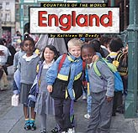
Relevance:
ELA1R6 The student uses a variety of strategies to understand and gain meaning from grade-level text. The student
a. Reads and listens to a variety of texts for information and pleasure.
b. Makes predictions using prior knowledge.
c. Asks and answers questions about essential narrative elements (e.g., beginning middle- end, setting, characters, problems, events, resolution) of a read-aloud or independently read text.
d. Retells stories read independently or with a partner.
e. Distinguishes fact from fiction in a text.
f. Makes connections between texts and/or personal experiences.

ELA1W2 The student writes in a variety of genres, including narrative, informational, persuasive and response to literature.

SS1G3 The student will locate major topographical features of the earth’s surface.
a. Locate all of the continents: North America, South America, Africa, Europe, Asia, Antarctica, and Australia.
b. Locate the major oceans: Arctic, Atlantic, Pacific, and Indian.

S1CS1 Students will be aware of the importance of curiosity, honesty, openness, and skepticism in science and will exhibit these traits in3 their own efforts to understand how the world works.

Prerequisites:
This unit lesson is designed for a standard first-grade class of eighteen to twenty-two students. Students should be prepared to participate in both whole-group discussions and small group/partner activities. Before beginning, students will have had a brief introduction to map-reading skills as well as the division of the world into major continents and oceans. Students must also keep their portfolios caught up from previous lesson(s) as this information is necessary to tracking their progress across the world.

Goals:
- Students will read the text How to make apple pie and see the world with a partner
- Students will exhibit curiosity and openness as they explore how milk becomes butter—a part of understanding how the world around them works
- Students will learn about and view photos of England
- Students will practice using writing as a way to respond to literature and illustrations.

Objectives:
- Students will form at least 1 hypothesis, speculating on how milk can become butter.
- Students will select and write 2 informative facts from the reading on England.
- Students will compose a brief response to literature, 3-5 sentences in length

Evaluation:
Students will be informally evaluated daily by their portfolio (the “suitcase”)
- Students will select and write 2 informative facts from the reading on England.
- Students will compose a brief, response to literature, 3-5 sentences in length.

Materials / Equipment:
- Priceman, M. (1994). How to make an apple pie and see the world. New York: Alfred A. Knopf, Inc.
- Deady, K. (1999). Countries of the world: England. Minkato, MN: Capstone Press.
- Flatted individual milk cartons (1 per student)
- Public Broadcasting System (PBS) Kids. (2005). Butter. Zoom. Retrieved June 29, 2009, from http://pbskids.org/zoom/activities/sci/butter.html
- Heavy whipping cream in secure Tupperware containers
- Crackers or rolls
- Index cards
- Large wall map
- Thumbtacks
- Student suitcases
- Student passport/journals

Procedures:
Introductory Activities
- Getting There: Divide students into groups of two to partner-read How to make an apple pie and see the world. Back as a whole group, point out to students that the text does not explicitly tell us how the main character traveled from Sri Lanka to England. Use picture clues and geography clues to discover which form of transportation the story implies. (The answer is a red car which presents and interesting geographical dilemma. How does the car get across the English Channel? )
Development Activities
- Geography:
  - On the big wall map
    - Locate England and press in thumbtack/string along yarn
    - Label England and the English Channel. You may want to include either the tunnel or a ferry transporting cars across the waterway to explain how a car could travel from France to England.
    - For information on and photos of the English Channel Tunnel (the “Chunnel”) view with students on the overhead or Smart Board, http://library.thinkquest.org/04oct/00450/chunnel.htm
    - Students repeat this activity with markers or crayons on their own personal map.
- Science:
  - Point out to students that we got a cow to make milk for our pie, but our recipe calls for butter. How do we get butter from milk? Allow students to speculate and form hypotheses.
  - Pull up the Zoom website on the overhead or Smart Board and explain the science behind butter. Shaking causes fat and protein molecules to run into each other stick together until the cream/milk is separated into a thin, liquid buttermilk and solid butter. (If this doesn’t make sense to students, try playing “butter” in an area of the playground—a form of tag. “It” runs until he tags someone, who then has to hold his hand and run with him until all players form a long chain.
  - Try it: pour 2 cup of whipping cream into two Tupperware’s or jars (1 c. in ea.) and let students begin shaking. The process will take about 10 minutes.
  - As students shake, read aloud Countries of the world: England.
- Break Time!
  - When butter hardens, rinse with cold water and serve on crackers or rolls. Take photos for portfolios.
Closing Activities
- Students write 2 facts about England on the back of an index card and tape or glue it to an empty milk carton. Place “ingredient” in the suitcase.
- Pass out passport journals and stamp.
- Journal Entry (response to literature):
  - Look at the illustration and read the text: “You’ll know she’s an English cow from her good manners…”
  - Answer 1 of the following questions:
    - What do you think are good manners? Why are good manners important? Can cows have good manners? How can you tell from the illustration that this cow has good manners?

Accommodations for Mainstreamed Students:
Students with special needs may
- Choose to write from a list of country facts pre-written by the teacher instead of generating their own
- Write fewer sentences
- Have longer time allotments for assignments

Enrichment:
Language enrichment: explore words in British English that differ from American English. Some examples include:
- Lorry (truck)
- Biscuit (cookie)
- Crisp (chip)
- Petrol (gas)
- Flat (apartment)
- Lift (elevator)
- Nappy (diaper)
- Sweets (candy)

Follow-up:
Students travel to North America and Jamaica by banana boat to learn about sugar cane and evaporation.

Salt from the Sea and Sugar from Jamaica
Day Six
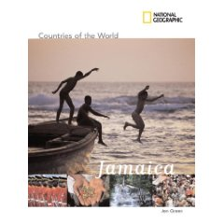
Relevance:
ELA1R6 The student uses a variety of strategies to understand and gain meaning from grade-level text. The student
a. Reads and listens to a variety of texts for information and pleasure.
b. Makes predictions using prior knowledge.
c. Asks and answers questions about essential narrative elements (e.g., beginning middle- end, setting, characters, problems, events, resolution) of a read-aloud or independently read text.
d. Retells stories read independently or with a partner.
e. Distinguishes fact from fiction in a text.
f. Makes connections between texts and/or personal experiences.

ELA1W2 The student writes in a variety of genres, including narrative, informational, persuasive and response to literature.

SS1G3 The student will locate major topographical features of the earth’s surface.
a. Locate all of the continents: North America, South America, Africa, Europe, Asia, Antarctica, and Australia.
b. Locate the major oceans: Arctic, Atlantic, Pacific, and Indian.

S1CS1 Students will be aware of the importance of curiosity, honesty, openness, and skepticism in science and will exhibit these traits in3 their own efforts to understand how the world works.

S1E2 Students will observe and record changes in water as it relates to weather.
Elements:
d. Determine that water in an open container disappears into the air over time, but water in a closed container does not.

Prerequisites:
This unit lesson is designed for a standard first-grade class of eighteen to twenty-two students. Students should be prepared to participate in both whole-group discussions and small group/partner activities. Before beginning, students will have had a brief introduction to map-reading skills as well as the division of the world into major continents and oceans. Students must also keep their portfolios caught up from previous lesson(s) as this information is necessary to tracking their progress across the world.

Goals:
- Students will retell the text How to make apple pie and see the world with a partner
- Students will exhibit curiosity and openness as they explore the process of evaporation—a part of understanding how the world around them works
- Students will learn about and view photos of Jamaica
- Students will practice using writing as a way to express scientific understandings.

Objectives:
- Students will select and write 2 informative facts from the reading on Jamaica.
- Students will make and record a hypothesis predicting with container of water—covered or uncovered—will evaporate first, 3-5 sentences in length.

Evaluation:
Students will be informally evaluated daily by their portfolio (the “suitcase”)
- Students will select and write 2 informative facts from the reading on Jamaica.
- Students will make and record a hypothesis predicting with container of water—covered or uncovered—will evaporate first, 3-5 sentences in length

Materials / Equipment:
- Priceman, M. (1994). How to make an apple pie and see the world. New York: Alfred A. Knopf, Inc.
- Stone, V. National Geographic countries of the world: Jamaica. (2008). National Geographic Children’s Books.
- Small cane sticks (if possible, locate real sugar cane so students can taste the sweetness. Sometimes available at Savannah’s Bamboo and Coastal Gardens)
- Growing Sugar Cane on St. Croix. Discovery Education (2006). Retrieved July 6, 2009, from Discovery Education: http://streaming.discoveryeducation.com/
- Salt water, from the ocean or a home mixture from salt and tap water that students prepare
- Bag of sea salt
- 2 shallow containers, 1 covered and 1 uncovered
- Black paper (1 per students)
- Paint brushes
- Index cards
- Hot plate or burner
- Pot
- Large wall map
- Thumbtacks
- Student suitcases
- Student passport/journals

Procedures:
Introductory Activities
- Getting There:
  - Divide students into partners to practice retelling the story How to make an apple pie and see the world to each other.
  - Back as a whole group, read students the page where the main character uses yet another type of transportation—a banana boat—to get to her next destination, Jamaica. Allow students to discuss what is a banana boat? How do they think it got its name. Is there more than one type of banana boat? Share the following images with students showing a banana boat from the 1800s transporting travelers along with fruit, and a banana boat used for pleasure trips in the Caribbean today.
  - If time allows, use a graphic organizers to compare and contrasts the two boats. Old, new. For work, for fun. Carried bananas, shaped like a banana. Both boats. Both used in the Caribbean. Etc.

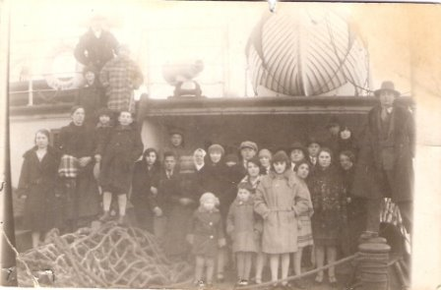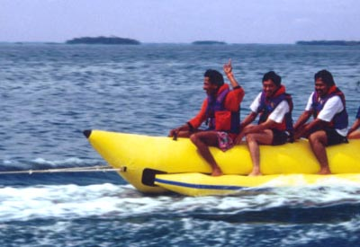

Development Activities
- Geography:
  - On the big wall map
    - Locate destination Jamaica and press in thumbtack/string along yarn. Label Jamaica.
    - Point out that again we are crossing the Atlantic and changing continents.
    - Students sing continents and oceans song.
    - Students repeat this activity with markers or crayons on their own personal map.
    - Reading National Geographic countries of the world: Jamaica
- Science:
  - Read to students the section of the book where the main character scoops up water from the sea to make salt. Lead students in a verbal exploration of this concept. Where do you think salt comes from. Could salt come from the sea? Have you ever gotten ocean water in your mouth at the beach? What does it taste like? If there is salt in ocean water, how could our main character separate it from the water?
  - Show students the back of sea salt—explain, this salt came out of the sea
  - Mix salt with warm water until no more salt crystals can be absorbed and salt starts settling to the bottom. Let students taste the water—does it taste like the ocean?
  - Divide water between the two shallow containers and the pot.
  - Ask students to look in the last few pages of the book to see if they can find out how the main character get salt from her jar of ocean water. (there is an illustration of her setting water outside in shallow pan.) Explain to students that when water heats up, it evaporates and goes into the air. This can happen with the sun, or with a electricity like a stove.
  - Take two shallow pans outside and cover one. Ask students to guess which pan the water will evaporate from most quickly (the uncovered pan) and why. This experiment could take weeks, so set pans in a protected location and check daily with students for results.
  - Speed up the evaporation process by heating third portion of salt water in a pot on a burner. Boil away water until only a very small amount of VERY salty water remains. Let cool and pour into cups. Students paint this water liberally over black sheets of paper and set paper to dry. In a day or two, salt crystals will form! Take photos for portfolio
- Break Time!
  - Watch a short clip on how sugar cane is turned into sweet drinks, Growing Sugar Cane, while students chew or suck on the cane itself (if available)
Closing Activities
- Students write 2 facts about Jamaica on the back of an index card and tape or glue it to a piece of cane. Place “ingredient” in the suitcase.
- Pass out passport journals and stamp.
- Journal Entry (scientific):
  - Students record their predictions about which container of water will evaporate first—covered or uncovered.

Accommodations for Mainstreamed Students:
Students with special needs may
- Choose to write from a list of country facts pre-written by the teacher instead of generating their own
- Write fewer sentences
- Have longer time allotments for assignments

Enrichment:
Plan a field or weekend trip to Savannah’s Bamboo and Coastal Gardens to see what cane looks like and how it grows in person.

Follow-up:
Students travel back to the U.S.A. and Vermont to go apple picking and begin writing their own story.

Apples from Vermont
Day Seven
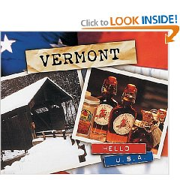
Relevance:
ELA1R6 The student uses a variety of strategies to understand and gain meaning from grade-level text. The student
a. Reads and listens to a variety of texts for information and pleasure.
b. Makes predictions using prior knowledge.
c. Asks and answers questions about essential narrative elements (e.g., beginning middle- end, setting, characters, problems, events, resolution) of a read-aloud or independently read text.
d. Retells stories read independently or with a partner.
e. Distinguishes fact from fiction in a text.
f. Makes connections between texts and/or personal experiences.

ELA1W2 The student writes in a variety of genres, including narrative, informational, persuasive and response to literature.

SS1G3 The student will locate major topographical features of the earth’s surface.
a. Locate all of the continents: North America, South America, Africa, Europe, Asia, Antarctica, and Australia.
b. Locate the major oceans: Arctic, Atlantic, Pacific, and Indian.

M1P4 Students will make connections among mathematical ideas and to other disciplines.
c. Recognize and apply mathematics in contexts outside of mathematics.

M1D1 Students will create simple tables and graphs, and interpret them.
a. Interpret tally marks, picture graphs, and bar graphs.
b. Pose questions, collect, sort, organize and record data using objects, pictures, tally marks, picture graphs, and bar graphs.

Prerequisites:
This unit lesson is designed for a standard first-grade class of eighteen to twenty-two students. Students should be prepared to participate in both whole-group discussions and small group/partner activities. Before beginning, students will have had a brief introduction to map-reading skills as well as the division of the world into major continents and oceans. Students must also keep their portfolios caught up from previous lesson(s) as this information is necessary to tracking their progress across the world.

Goals:
- Students will discover there are many types of apples in the world
- Students will relate mathematics to other areas of life by using a bar graph to show their class’s favorite brand of apple.
- Students will learn about and view photos of Vermont
- Students will practice using writing as a way to express themselves through poetry.

Objectives:
- Students will create an accurate mathematical representation, translating data from tally marks to a bar graph
- Students will select and write 2 informative facts from the reading on Vermont.
- Students will compose a brief poem, or 5 minutes of equivalent writing.

Evaluation:
Students will be informally evaluated daily by their portfolio (the “suitcase”)
- Students will create a bar graph representing the class’s favorite brand of apple.
- Students will select and write 2 informative facts from the reading on Vermont.
- Students will compose a brief poem on apples or a related topic.

Materials / Equipment:
- Priceman, M. (1994). How to make an apple pie and see the world. New York: Alfred A. Knopf, Inc.
- Pelta, K. (2001). Hello U.S.A: Vermont. Minneapolis, MN: Lerner Publishing Group, Inc.
- 5+ brands of apples, sliced (1 slice of each per student)
- Apple graphing sheet (1 per student)
- Peanut butter, small bowls or plates
- Index cards
- Large wall map
- Thumbtacks
- Student suitcases
- Student passport/journals

Procedures:
Introductory Activities
- Getting There: Simulate a plane ride back from Jamaica to the United States by standing in rows and putting out arms for wings as you read through the final pages of How to make an apple pie and see the world. Suddenly you remember that you do not have any apples for your pie! Students should be well familiar with the story plot by now as they pretend to parachute down to the ground to collect apples from Vermont.
Development Activities
- Geography:
  - On the big wall map
    - Locate Vermont and press in thumbtack/string along yarn
    - As students what continent are we on? What country are we in? Which state?
    - Label Vermont and the United States.
    - Students repeat this activity with markers or crayons on their own personal map.
- Science/Math:
  - Discuss apples facts with the students from the back cover of How to make an apple pie and see the world. There are so many different types of apples in the world!
  - Allows students to taste-test 5+ types of apples, choosing their favorites.
  - Write names of apples on the board and call up a students to tally the students’ favorite brands
  - Referring to the tally marks, have students create individual bar graphs depicting the class’s favorite apple type.
  - In addition, the teacher can graph the results on the Smart Board using http://nces.ed.gov/nceskids/createAgraph/
- Break Time!
  - Have an apple and peanut butter snack while teacher reads aloud Vermont
Closing Activities
- Students write 2 facts about Vermont on the back of an index card and draw (or paste a cut-out of) an apple on the back. Place “ingredient” in the suitcase.
- Pass out passport journals and stamp.
- Journal Entry (poetry):
  - Write a poem about an apple, 5 minutes.

Accommodations for Mainstreamed Students:
Students with special needs may
- Choose to write from a list of country facts pre-written by the teacher instead of generating their own
- Write fewer sentences
- Have longer time allotments for assignments

Enrichment:
Be a travel agent! Use online resources such as Google Maps to see how many hours it would take to travel by car to Vermont from your school. What would you need to bring on a trip like that?

Follow-up:
Students travel home to make vanilla ice cream and write their own short story.

Home Again, Home Again, Jiggedy-Jig
Days Eight & Nine
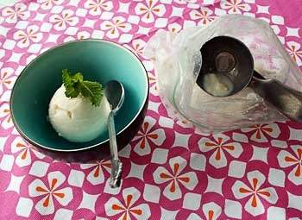
Relevance:
ELA1R6 The student uses a variety of strategies to understand and gain meaning from grade-level text. The student
a. Reads and listens to a variety of texts for information and pleasure.
b. Makes predictions using prior knowledge.
c. Asks and answers questions about essential narrative elements (e.g., beginning middle- end, setting, characters, problems, events, resolution) of a read-aloud or independently read text.
d. Retells stories read independently or with a partner.
e. Distinguishes fact from fiction in a text.
f. Makes connections between texts and/or personal experiences.

ELA1W2 The student writes in a variety of genres, including narrative, informational, persuasive and response to literature.
a. Begins to capture a reader's interest by writing a personal story.
b. Begins to maintain a focus.
c. Adds details to expand a story.
d. Begins to use organizational structures (beginning, middle, end, and sequence of events) and strategies (transition words and time cue words).
f. Begins to develop a sense of closure.
g. May include oral or written prewriting (graphic organizer).
h. May include a draft that is revised and edited.

SS1G3 The student will locate major topographical features of the earth’s surface.
a. Locate all of the continents: North America, South America, Africa, Europe, Asia, Antarctica, and Australia.
b. Locate the major oceans: Arctic, Atlantic, Pacific, and Indian.

S1CS1 Students will be aware of the importance of curiosity, honesty, openness, and skepticism in science and will exhibit these traits in3 their own efforts to understand how the world works.

Prerequisites:
This unit lesson is designed for a standard first-grade class of eighteen to twenty-two students. Students should be prepared to participate in both whole-group discussions and small group/partner activities. Before beginning, students will have had a brief introduction to map-reading skills as well as the division of the world into major continents and oceans. Students must also keep their portfolios caught up from previous lesson(s) as this information is necessary to tracking their progress across the world.

Goals:
- Students will explore how different resources come from different global locations
- Students will compose and illustrate their own short story, following the format of How to make an apple pie and see the world, telling how they traveled to get the remaining ingredients needed to make vanilla ice cream.

Objectives:
- Students will conduct guided and independent research to discover where vanilla is grown and where ice can be found in large quantities on the globe.
- Students will follow the steps of the writing process—brainstorm, outline, draft, revise, edit, and publish—to create a short story telling of their imaginary journey to collect vanilla beans and ice, 5-10 sentences in length.

Evaluation:
Students will be informally evaluated daily by their portfolio (the “suitcase”)
- Students will follow the steps of the writing process—brainstorm, outline, draft, revise, edit, and publish—to create a short story telling of their imaginary journey to collect vanilla beans and ice, 5-10 sentences in length.

Materials / Equipment:
- Priceman, M. (1994). How to make an apple pie and see the world. New York: Alfred A. Knopf, Inc.
- Essence of Life, Ltd. (2009). Where does vanilla come from? Retrieved July 9, 2009, from http://www.vanillabazaar.com/index.php?c=diffvanilla
- Heale, J. (2008) Cultures of the World: Madagascar. Tarrytown, NY: Marshal Cavendish Children’s Books. (multiple copies if possible)
- Graphic organizer of choice for students to outline with.
- Paper and pencils
- Crayons/markers/watercolors for illustrations
- Kaboose. (2009). Homemade ice cream in a bag. Retrieved July 3, 2009, from http://crafts.kaboose.com/ice-cream-in-a-bag.html
- Ice cream ingredients (single serving only/ times by number of students in class)
  - 1 T. sugar
  - ½ c. milk or cream
  - ¼ t. vanilla
  - 6 T. rock salt
  - 1 pint-sized ziplock
  - 1 gallon-sized ziplock
  - ice cubes

Procedures:
Introductory Activities (Day One)
- Getting There: Read aloud from How to make an apple pie and see the world. “Remember that apple pie is delicious topped with vanilla ice cream, which you can get at the market. But if the market happens to be closed…YOU CAN EAT IT PLAIN!” Invite students to brainstorm: What if you were the main character and you didn’t want to eat your pie plain after all? What could you do?
- This lesson is a great way to introduce students to inquiry-based learning. Share a vanilla ice cream recipe with the class (see Homemade ice cream in a bag). Look over the ingredients. What have we already collected from around the world these past two weeks. What new ingredients would we have to locate in order to make vanilla ice cream? (vanilla and ice). Where do you think we could get these? How could you find out? (Research)
- Explain to students that they are going to write a short story telling how they travel to collect the last two ingredients—ice and vanilla—to make vanilla ice cream.
- We can all probably use our imaginations to think where we might get ice from (take some suggestions from students: the North Pole, the South Pole, a glacier, the mountains, the school freezers, etc.) but where does vanilla come from. Pass around bottle and let students smell the spice.
- Use this opportunity to label Antarctica and Africa on the wall map
- Guided research: Explore the nature and origins of vanilla using online research, where does vanilla come from?
- Independent research: students look through books on Madagascar, Mexico, or Tahiti to decide where they will get their vanilla from and what the country is like.
- Model a sequencing graphic organizer with students and have them complete their own. The organizer should include these elements:
  - Introduction: Explain the problem, needs vanilla ice cream but the market is closed
  - Means of transportation to first location
  - Description of first location and ingredient obtained
  - Means of transportation to second location
  - Description of second location and ingredient obtained
  - Means of transportation home
  - Conclusion, making/eating the ice cream.
  - Student begin composing a first draft
Development Activities
- Students finalize first draft as teacher (and any additional support such as a parent or parapro) circulates and helps students revise and edit writing.
- Rewrite short story on “neat sheets” or notebook paper with best handwriting, including editing and revisions.
Closing Activities
- Visual Arts: students illustrate short stories using crayons, markers, or watercolors.
- If time allows, proceed to the enrichment activity—making homemade ice cream.

Accommodations for Mainstreamed Students:
Students with special needs may
- Need additional scaffolding from the teacher during the writing process
- Require longer time-allotments for writing
- Write shorter selections

Enrichment:
- Experiment with temperature and physical change by making homemade vanilla ice cream as a class.
- Track students’ stories on the wall map.

Follow-up:
Students share their writing from the author’s chair and make an apple pie using fraction and measurement skills

Let’s Make Pie!
Day Ten
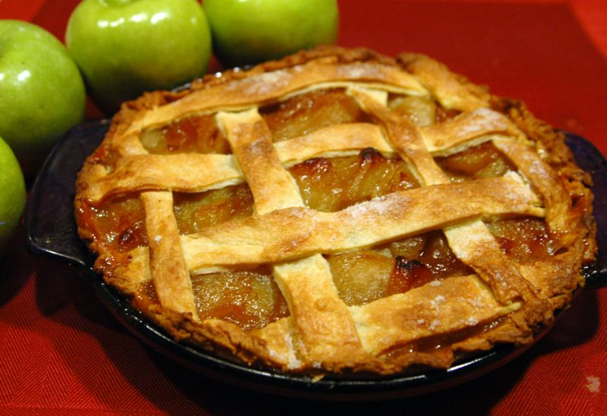
Relevance:
ELA1R6 The student uses a variety of strategies to understand and gain meaning from grade-level text. The student
a. Reads and listens to a variety of texts for information and pleasure.
b. Makes predictions using prior knowledge.
c. Asks and answers questions about essential narrative elements (e.g., beginning middle- end, setting, characters, problems, events, resolution) of a read-aloud or independently read text.
d. Retells stories read independently or with a partner.
e. Distinguishes fact from fiction in a text.
f. Makes connections between texts and/or personal experiences.

M1D1 Students will create simple tables and graphs, and interpret them.
a. Interpret tally marks, picture graphs, and bar graphs.
b. Pose questions, collect, sort, organize and record data using objects, pictures, tally marks, picture graphs, and bar graphs.

M1N4 Students will count collections of up to 100 objects by dividing them into equal parts and represent the results using words, pictures, or diagrams.
c. Identify, label, and relate fractions (halves, fourths) as equal parts of a whole using pictures and models.
d. Understand halves and fourths as representations of equal parts of a whole

Prerequisites:
This unit lesson is designed for a standard first-grade class of eighteen to twenty-two students. Students should be prepared to participate in both whole-group discussions and small group/partner activities. Before beginning, students will have had a brief introduction to map-reading skills as well as the division of the world into major continents and oceans. Students must also keep their portfolios caught up from previous lesson(s) as this information is necessary to tracking their progress across the world. For this lesson in particular, students must have some prior knowledge of fractions—parts and wholes.

Goals:
- Students will experience math outside of the traditional “mathematical field” by cooking with fractions and measurement while assembling an apple pie.
- Students will “publish” their work by sharing short stories from the author’s chair.

Objectives:
- Students will record the fractions used in apple pie both by shading the correct parts of a whole and writing the fraction numerically on a recipe worksheet.
- Students will publish their work by reading their own short stories aloud.

Evaluation:
Students will be informally evaluated daily by their portfolio (the “suitcase”)
- Completed portfolio, including
  - Recipe Worksheet, and
  - Completed and illustrated short story

Materials / Equipment:
- Priceman, M. (1994). How to make an apple pie and see the world. New York: Alfred A. Knopf, Inc.
- 2 c. flour
- 1 ¼ t. salt
- 1 box of butter
- ½ cup ice water
- 1 egg yolk
- 6 apples, peeled and sliced
- ¾ c. sugar
- 1 t. cinnamon
- bowl and mixing spoon
- rolling pin, wax paper
- pie pan
- Recipe Worksheets (1 per student)
- Plates and forks

Procedures:
Introductory Activities
- Review fractions with students on the whiteboard by dividing and shading shapes and then reminding students how to represent these parts with numbers. What does the top number stand for (how many shaded parts). And the bottom number? (parts of the whole)
Development Activities
- Make Apple Pie! (see recipe below)
  - Pass out recipe worksheets to students Tell them the ingredients are listed but they are going to have to record the amounts themselves to complete the recipe and make the pie.
  - As you make the pie and measure the ingredients, students
    - divide the shapes on their worksheet into fractions
    - shade the appropriate amount of fraction parts
    - and write the fraction numerically
    - Note: remember that 1 cup of butter = 2 sticks or ½ box of butter.
  - Estimation: when you go to add apples to the pie, as students to estimate how many apples it takes to fill the pie. Showing students a whole apple (not pre-sliced) may help them conceptualize this.
    - Students mark an estimation by coloring in apples on the recipe worksheet
    - Students mark the correct number of apples (6) on the recipe worksheet
  - Bake!

APPLE PIE
(adapted from How to make an apple pie and see the world)
Crust
- 2 cups flour
- 1 t. salt
- ½ box of butter (2 sticks)
- ½ cup ice water
- 1 egg yolk
Combine flour and salt in a bowl. Quickly rub small pieces of cold butter into the flour mixture with fingers until bits are the size of peas. Add water, spoonfuls at a time until dough is moistened. Stir until mixture forms a loose ball. Divide dough in half and make two equal patties. Place one patty between sheets of wax paper and roll into a 12 in. circle with a bottle or rolling pin. Place in pie pan. Roll out top crust the same way. Set aside
Filling
- 6 apples, sliced and peeled
- ¾ c. sugar
- 1 t. cinnamon
- ¼ t. salt
- 2 T. butter
Preheat oven to 425. In a large bowl mix together sugar, cinnamon, and salt. Toss the apples into the sugar mixtures, coating well. Pour into pan (don’t forget to estimate!) and dot with butter. Cover apples with top crust and pinch edges together. Cut some vents in the top crust. To glaze, mix an egg yolk (review parts of the egg as you separate it) with 1 T. water and brush across. Bake 45 minutes.

- Author’s Chair:
  - While the pie bakes, students share their short stories from a special chair set up in classroom. Reading aloud something they are familiar with will strengthen their fluency.
- Break Time!
  - When the apple pie is ready, serve, eat, and celebrate what students have learned and created over the past 2 weeks.
Closing Activities
- Students turn in complete portfolios/suitcases, including finished story for grading.

Accommodations for Mainstreamed Students:
Some students with special needs may:
- Require extra fraction review before completing the Recipe Worksheet

Enrichment:
Supplemental Literature
- Hall, Z. (1996). The apple pie tree. New York: Blue Sky Press.
- Thompson, L. (2007). The apple pie that papa baked. New York: Simon & Schuster Children’s Publishing.
- Langston, L. (2005). Mile high apple pie. Glens Fall, NY: Red Fox Books.

Reflection
In reflection, I feel that the preparation of this unit really summarizes all that I have learned in Language Arts-Creative Activities this semester. When I first began to brainstorm the unit, I thought that integrating four subject contents and seven areas of the arts into one cohesive set of lesson plans would be an impossibly daunting task. Specific art forms—such as sculpture and dance with which I have no background experience—worried me in particular. How can I potentially teach something to my students that I do not understand myself? I wondered.
However, as I continued coming to class lectures, taking notes from guest speakers, and reading our texts, ideas formed, preconceived notions changed, and How to make an apple pie and see the world began to practically write itself. What I discovered about myself was that I held too closely to a rigid, classical ideas of the arts and this, in turn, curbed my creativity. For example, incorporating dance into my lesson plans did not mean that I had to discover how to teach students the exact steps to a ballet or a waltz, but rather “dance” could broadly mean forming shapes with the body or moving cooperatively to a rhythm such as in games like Ring-Around-the-Rosie.
Needless to say, loosening my idea of the creative arts was an eye-opening experience for me. Through this class and the creation of this unit, I have come to realize that cooking, puppetry, pattern-blocks, and even writing with shaving cream can all be considered a form of art when incorporated into the classroom; and I hope to use these—and many more ideas—in the future.

National Geographic Society. (2007). My wonderful world. Retrieved June 29, 2009 from http://www.mywonderfulworld.org/index.html
Priceman, M. (1994). How to make an apple pie and see the world. New York: Alfred A. Knopf, Inc.

