How You Can Use Career Bytes with Your Kids
Career Bytes videos are short (5-minute) video interviews of career professionals designed to communicate the essentials of technology-engaged careers. Working with kids on Career Bytes videos to discover what it takes to be an astronaut, business person, or a rock star is a project that can be fun and full of 21st century learning.
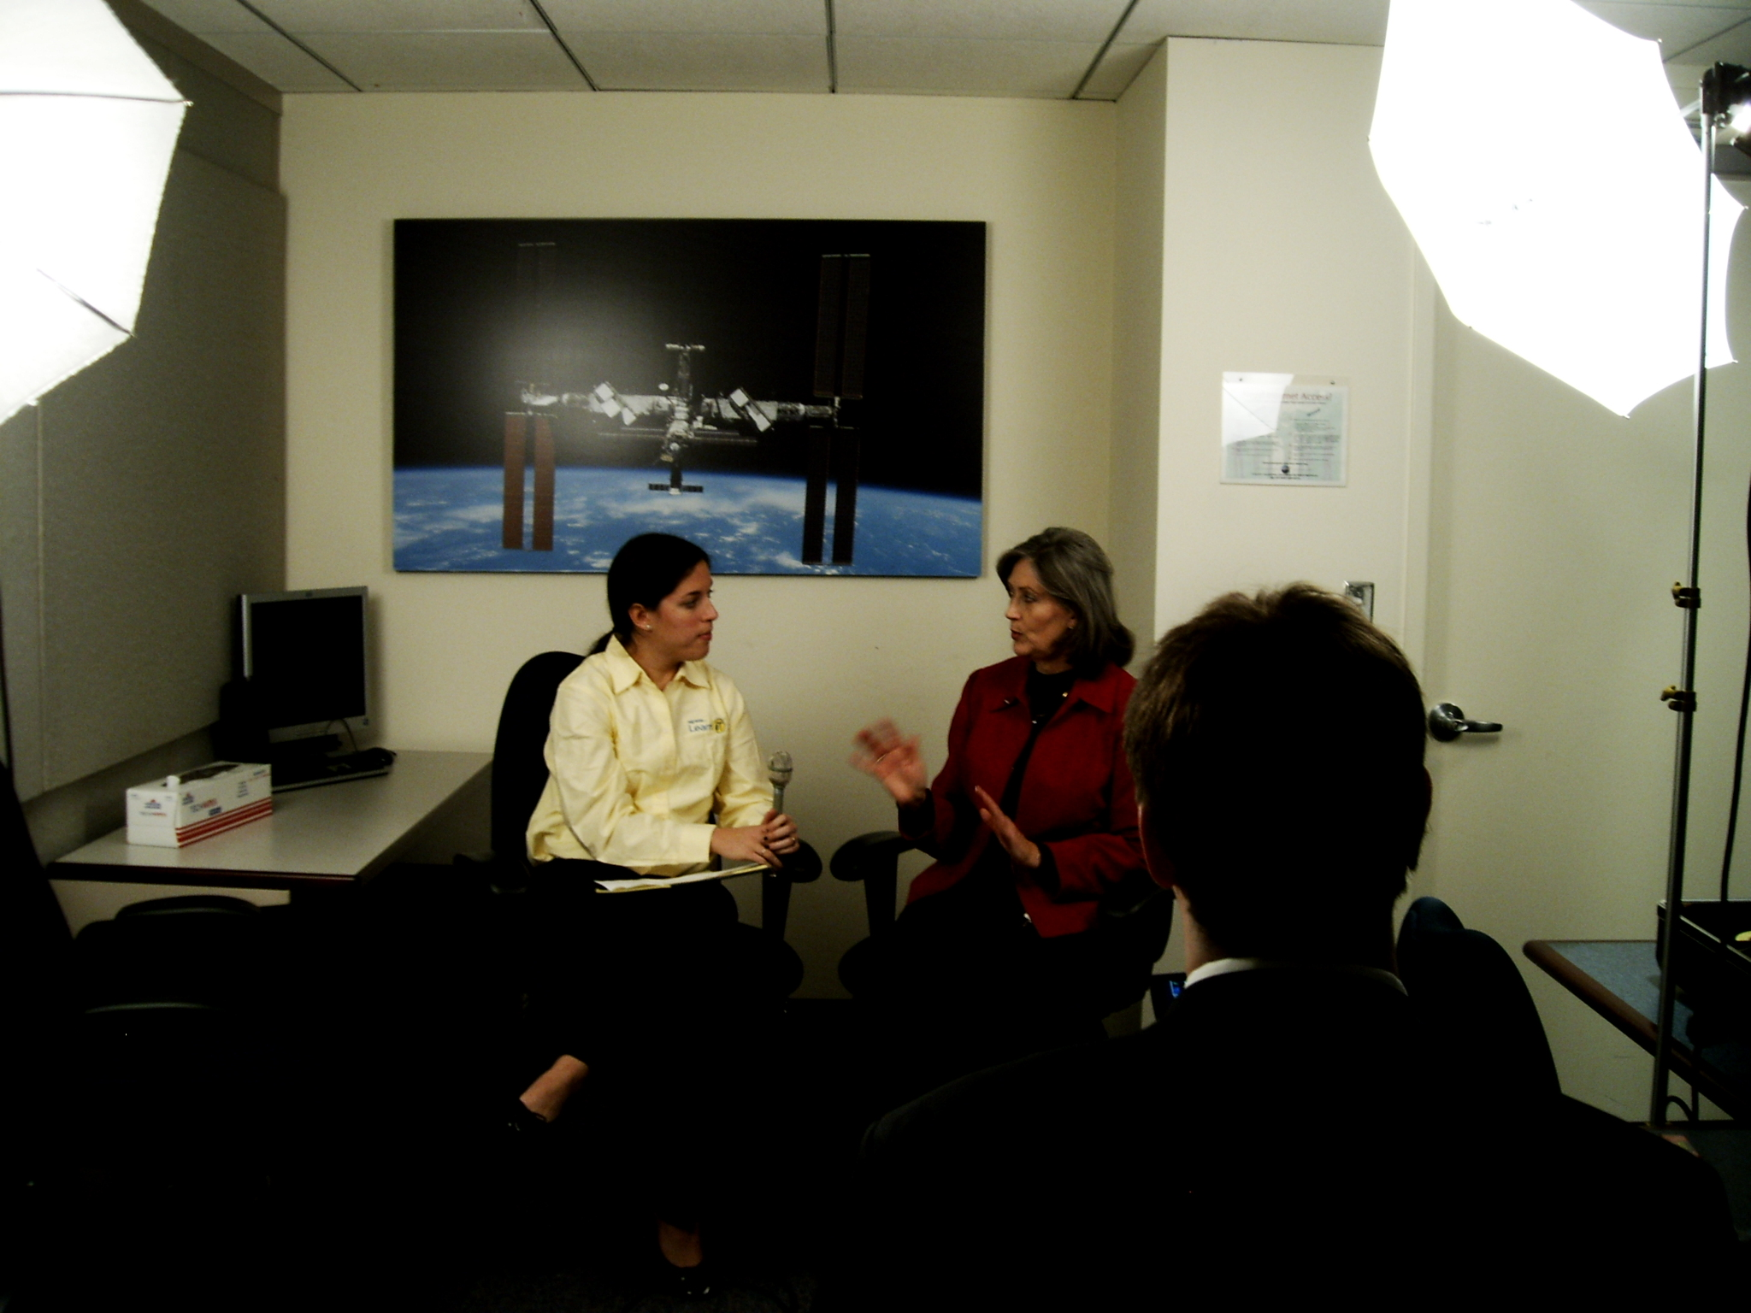  Nortel LearniT interns film a video interview with Dr. Joyce Winterton, NASA Assistant Administrator for Education |  | This engaging learning adventure lets kids investigage a wide range of topics, all in one project, including:  - technology-related careers  - the world of work  - video production  - techniques for interviewing and researching  - teamwork  - completing a project from beginning to end!
 | The Creating Career Bytes Toolkit has everything you'll need to get your budding professionals started. On the Nortel LearniT web site at http://nortellearnit.org/LearniT/careerbyteslearning, you'll find:  - web pages explaining the process (preproduction, production, and postproduction) and showing how Nortel LearniT interns created Career Bytes for this Toolkit  - this downloadable step-by-step guide  - downloadable handout, checklists, and guidelines  - videos explaining why and how to make your own Career Bytes project  - links to Nortel LearniT Career Bytes videos

