
Whyville is the only learning-based virtual world for boys and girls. Most of Whyville’s users are between the ages of 8 and 15. Whyville was created by educators and scientists from Cal Tech and is the safest virtual world site on the Internet, far exceeding the standards established by the Children’s Online Privacy Protection Act (COPPA).
The community has its own economy, newspaper, e-mail and chatting system, and interactive games. Whyvillians create their own unique identity, navigate through the community, chat with other users, and engage in activities to raise their salary.
Above all, they learn.

Welcome to Whyville!
By now you should have your teacher account, and your students should be registering under your account using your special URL:
. (format = www.whyville.net/class/username )

In this first teaching guide, we will introduce you to the information and functionality you will need to become a full-functioning member of our community. We would encourage you to take the Whyville tour on your own before working through this document. The tour is designed to provide an overview of many of these features.

Guide #1
1 Welcome to Whyville!
2 The Welcome Page
3 The Satchel
3 Y-Mail
4 The Whyville Times
4 Chatting
6 Creating Your Avatar!

You have your account, now let’s get started !!

An Introduction
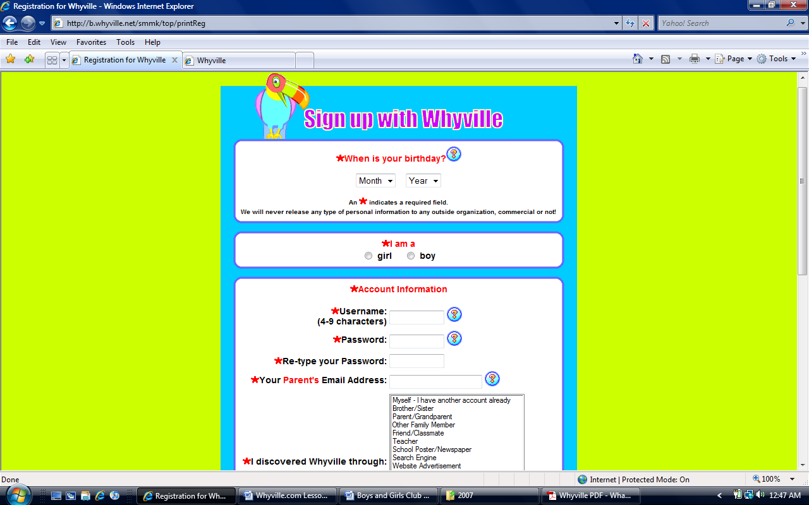
The functionality you see was developed specifically to support informal use of the site by children NOT necessarily using Whyville as part of their classroom activities. Therefore, we are particularly interested in receiving your feedback and suggestions on ways in which the features described here can be enhanced or extended with respect to classroom instruction.

We want your feedback !

Getting to know Whyville
Teaching Guide #1
Numedeon, Inc. 300 S. Raymond #7 Pasadena, CA 91105
Christopher Murphy chris@whyville.com (704) 892-4638

Exercise 1: The Welcome Page
The Welcome Page is the first page each Whyvillian visits after he or she signs in. From the Welcome Page, you can access every aspect of Whyville. Below you will find arrows pointing out the most important links from the Welcome Page. It is important that your students become well familiarized with this page to access such things as the Navigation Bus, their Satchel, their Y-Mail Inbox, and the Whyville Times. The Welcome Page also gives a calendar of events for the coming week and news about exciting features of and additions to the Whyville community. There is also a very helpful FAQ that student’s should browse to better understand the community of Whyville. In the near future, the Welcome page will also provide a space for you to post information of interest to your own students.

The Weekly Calendar and Featured Events
The Satchel – Gives users access to their Salary Ledger, Address Book, and any other Journals and goods they have accumulated.
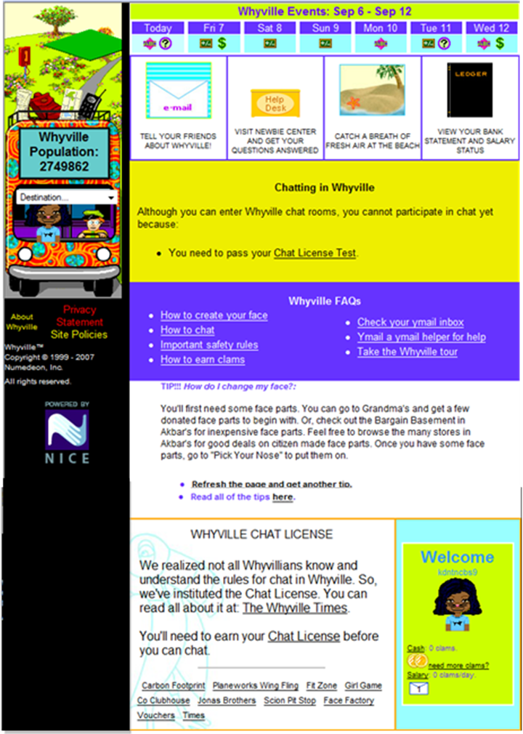
The Y-mail Inbox – Where Whyvillians can come to check their exclusive y-mail account and keep in touch with their Whyville friends.
The Bus Navigation Menu – A drop-down menu that provides links to every destination within Whyville
The Whyville Times
The Chat License Test – Must be passed by all Whyvillians to earn the right to chat with others.
Special Events, Announcements and Surveys– this area is frequently updated to notify our users of brand new content.
FAQ – A valuable resource for new members of the community.
Some Things to Do:
- Find the Calendar and see what’s going on in Whyville this week! What is an event you would like to attend?
- Which of the FAQ’s are the most interesting to you?

The Satchel is the red backpack located on top of the Navigation Bus on the left side of the screen. Inside your satchel is an itemized list of all your Whyville possessions, including face parts, trophies, game logs, bank statement, salary ledger, and importantly, your class roster.

Exercise 2: The Satchel

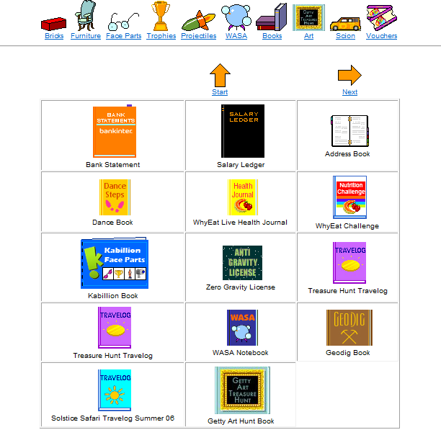
As a reward for participating in Whyville’s activities and completing its educational games, each user earns a salary every time he or she visits the site. The greater their participation within Whyville, the higher the salary. In effect, a students overall salary is a mechanism for measuring their engagement in Whyville. The Satchel contains a Bank Statement, which accounts for a user’s earnings and expenses. Users have the ability to transfer their funds between a checking and savings account or open up a CD to earn interest.
The Satchel also contains a Salary Ledger that keeps track of a user’s progress in all of Whyville’s games and activities. As a teacher, you can access the Ledger of each of your individual students through the class roster in your satchel. Soon you will also be able to directly compare the level of accomplishment of all the students registered in your class..

Some Things to Do:
- Click on your Bank Statement. How many clams do you have? How did you earn them?
- Click on the Salary Ledger and look at the games. Which one will you want to try first and why?

Exercise 3: Y-mail
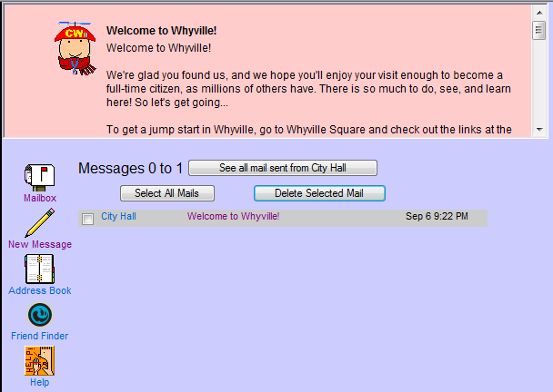
Y-mail is Whyville’s very own internal e-mail system. Users can send Y-mails to their Whyville friends, but cannot send or receive Y-mails from outside sources. Our users utilize Y-mail to its fullest capacity to keep in touch with the friends they meet in Whyville, organize virtual parties and social gatherings, and receive messages from “City Hall” about new events and happenings in the Whyville community.
In order to send out Y-mails, a user must add the intended recipient to his or her Address Book. To do this, either double-click on that person’s avatar in chat and select “Y-mail” or go to the City Records page, type in the user’s name, and double-click the avatar’s picture. Once at the y-mail screen, make sure you select “Add recipient to address book.”

Some Things to Do:
- Read the “Welcome” e-mail from City Hall. Do you have any questions?
- Add three of your classmate’s to your “Address Book”.
- Go explore Whyville and add a new friend to your “Address Book”.

Exercise 4: The Whyville Times

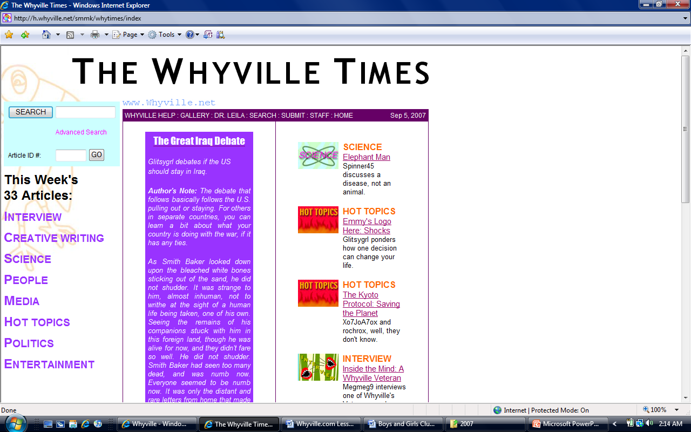
The Whyville Times is Whyville’s very own newspaper comprised entirely of articles written by our users. We take hundreds of submissions each week for the weekly newspaper and e-mail a copy to all of our members. The paper is also a great archive for helpful advice and hints to get you started in Whyville.
One possible exercise for your students is a writing contest using the Whyville Times. The Times would read all submission and choose one or two articles to publish. (see the Supplemental Activity: Whyville Times Lesson Plan for more info)

Through the use of overhead chat bubbles, Whyvillians can communicate with each other anywhere they go. However, new citizens will not immediately be able to chat. As part of its strict safety measures, Whyville wants to make sure its citizens understand the rules of the community and how to chat safely. There are several restrictions put on new members before they are allowed to chat feely.

Exercise 5: Learning to Chat in Whyville
- Waiting Three Days: For the first three days a user signs on to the site, chat is more restricted and he or she will often be asked to rephrase their entry. This is meant not only to teach users the appropriate ways to chat, but also to keep out those whose only intention is to hop on the site and create trouble.
- Chat License Test: Every Whyvillian must accurately complete the Chat License Test in order to unlock their ability to chat. The test assures that new members are aware of Whyville’s rules that prohibit the sharing of personal information, using abusive language, misrepresenting themselves, and asking or giving out passwords or outside web links. The test is a great way to give students a lesson about Internet safety and is required in Whyville to proceed any further. We recommend going through it during your first introductory computer class.
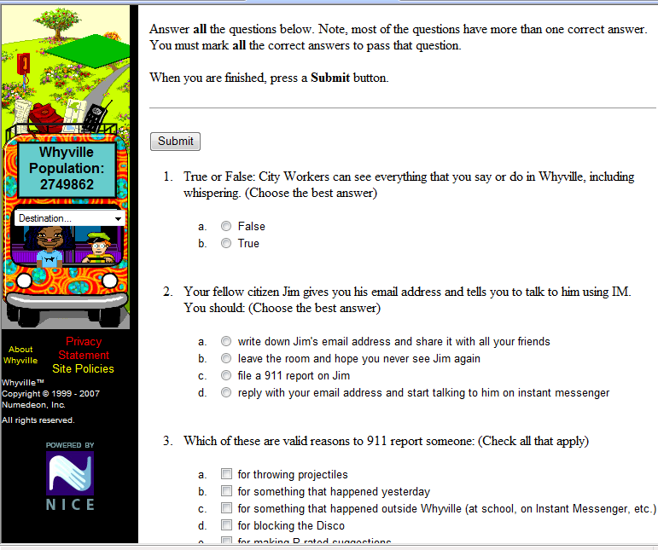
Some Things to Do:
- Find an article in the current issue that interests you, read it, and share it with a friend.
- Read an article, rate it, and comment on it in the BBS.

Exercise 5: Learning to Chat in Whyville (continued)

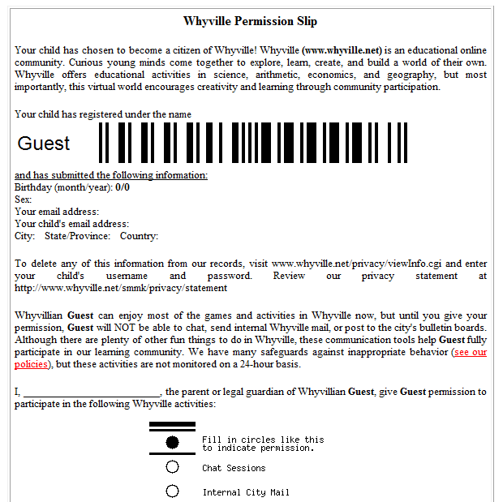
- Parental Permission Slips: For every user under the age of 13, Whyville requires a signed parental permission slip for them to participate in chat. Parents must fax this permission slip to our corporate office where we then unlock the character’s ability to chat. The first couple of lesson plans are structured so that your students won’t need the ability to chat to progress. This should give them enough time to send in their permission slips or bring them into the classroom so that a teacher may collect them and send them in as a class.

Permission slips can be found at:
http://b.whyville.net/smmk/certs/viewPermission

Once the three criteria are met (waiting three days, chat license test, and parental permission slip), the user then has the ability to chat freely and fully participate in the Whyville community. If he or she breaks any rules, there are several punishments in place, including suspended chat privileges and banishment from the community. The users are also able to police themselves. By double-clicking on any other avatar, they are given the ability to Silence them (no longer sees any chat from that avatar), Vaporize them (no longer sees the avatar at all), or 911 Report them (a report is sent to our community managers who review the transcripts and take any necessary action). You should go over these policing options with your class so that they are aware of the many safeguards in place.

Exercise 7: Creating Your Avatar!
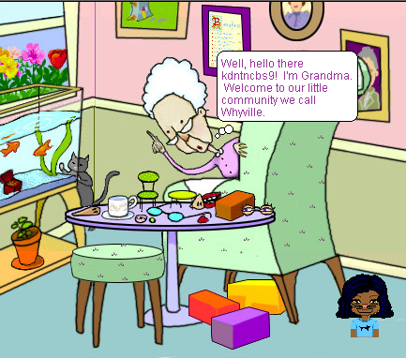

Now the fun begins! Now that your students have familiarized themselves with the basics of Whyville, it is time for them to begin creating their avatar. To start, each student should only have a basic round head and a pair of sunglasses. It is now time for them to discover the thousands of face parts located around Whyville that they can use to create their very own unique avatar.
To begin, your students should have already earned 25 clams for passing the Chat License Test. In future lessons we will present more ways for the students to earn clams, but for now they have 25 clams to spend however they wish. We suggest ending class by letting them explore Whyville and visiting the following places to receive or buy face parts and create their avatar.
Grandma’s – The matriarch of Whyville can be found on the Bus Navigation Menu. Grandma is always there to help out new users by giving them their first face parts, for free! Enter Grandma’s house and wait for her to invite you to some goodies and enjoy!

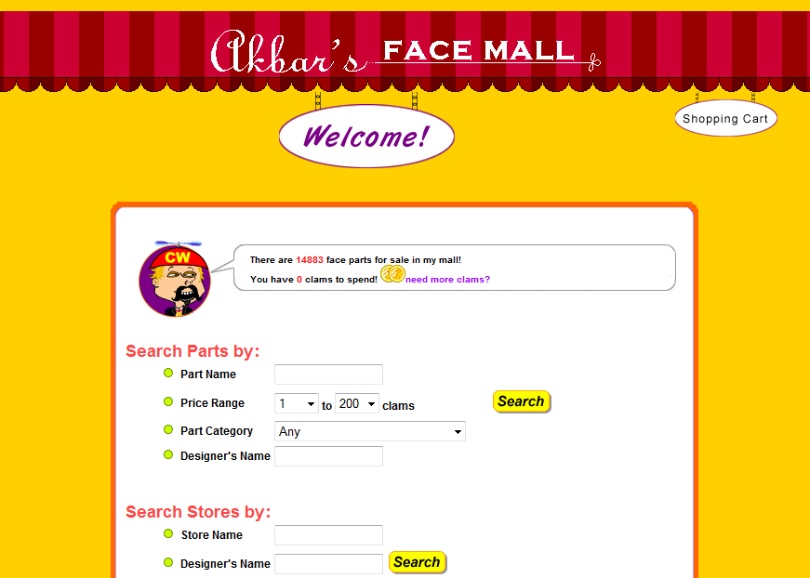
Akbar’s Face Mall – The most popular store in Whyville can be found on the Bus Navigation Menu. With thousands of user-created face parts to choose from, Akbar’s is a one-stop shop for picking out your favorite face parts. Prices range from cheap to outrageous and kids spend hours here searching for those perfect parts for their avatars.

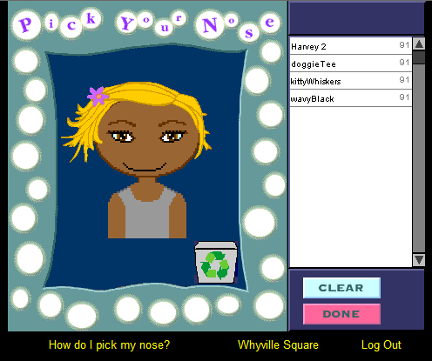
Pick Your Nose – Once you’ve secured a collection of face parts, you can outfit your avatar by visiting the Pick Your Nose section of Whyville. Users will see a list of face parts they’ve bought or been given and can place them on their avatar to create their very own Whyvillian.
Coming in Teacher Guide #2!
1 Earning Clams
2 Educational Games for Clams
3 The Cafeteria…food and fun

