

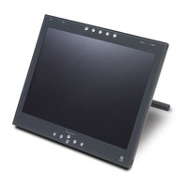


Cheryl Capozzoli
District Instructional Technology Mentor/Web Coordinator
Susquehanna Township School District
3550 Elmerton Ave.
Harrisburg, PA 17109
717.657.5100 Ext. 176
ccapozzoli@hannasd.org
http://www.hannasd.org

Getting Started

- Location of Software and Tools
- SMART Control Panel
- Orienting the SMART Board or Sympodium
- SMART Floating Tools
- SMART Notebook Tools
- Notebook Gallery
  - Inserting Gallery Images and Flash Interactives
  - Add/Import and Downloading Gallery Collections
- Ink Aware Options
  - Recognizing written words
  - Ink Aware is other Applications
- Downloading Standards based Lessons From SMART

I. Location of SMART Tools and Notebook

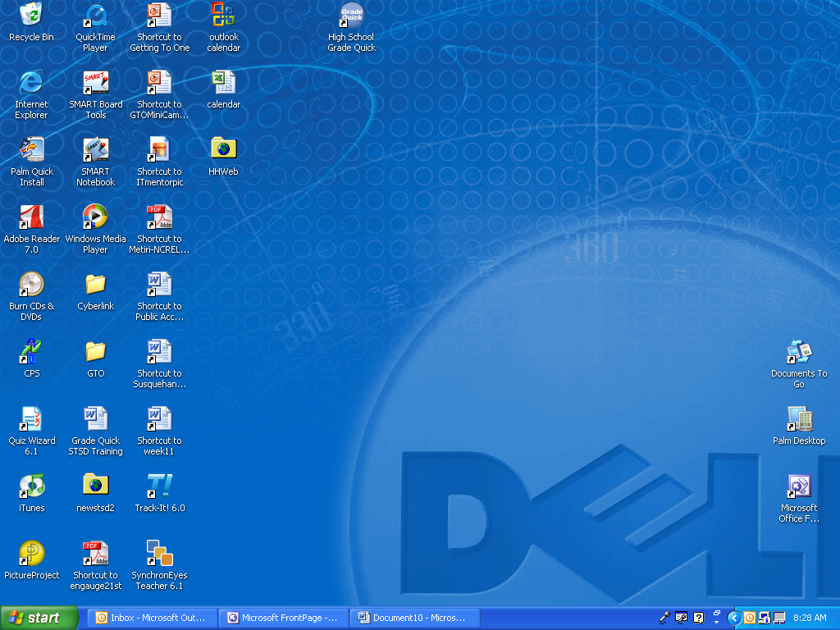
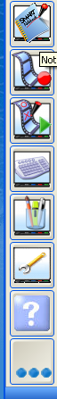

You should
see these on
your desktop.

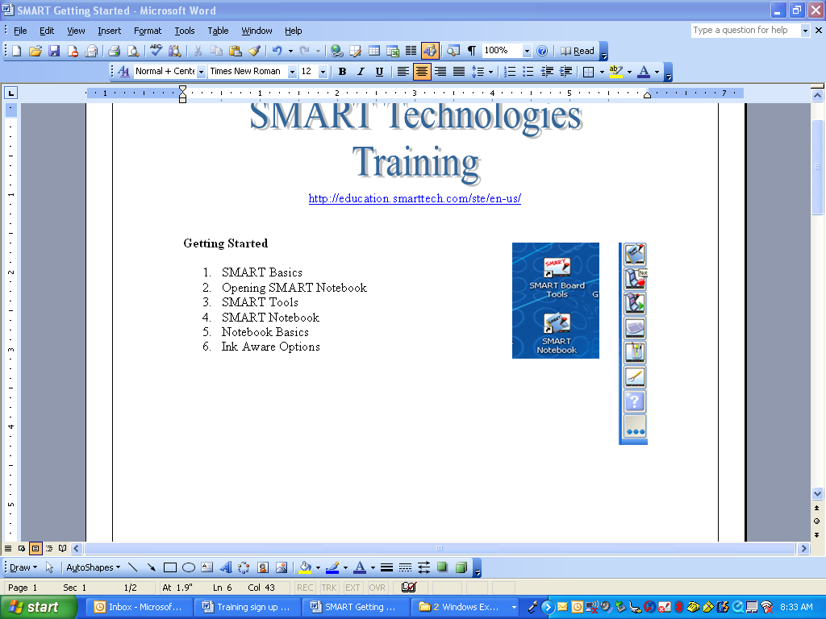
SMART Tools

- SMART Control Panel
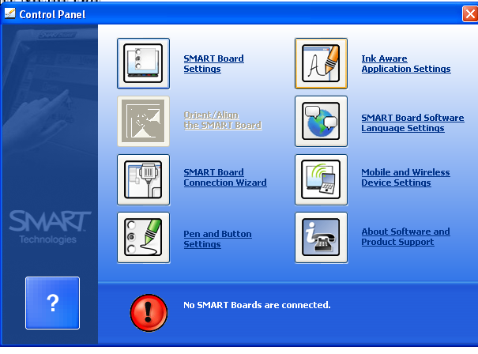

- Orienting the Board

  - Choose SMART Board Settings.
  - Choose Orientation/Alignment settings in the drop down menu.
  - Choose Standard or Fine Point - (Note Fine point gives you the most precise pen and eraser alignments)
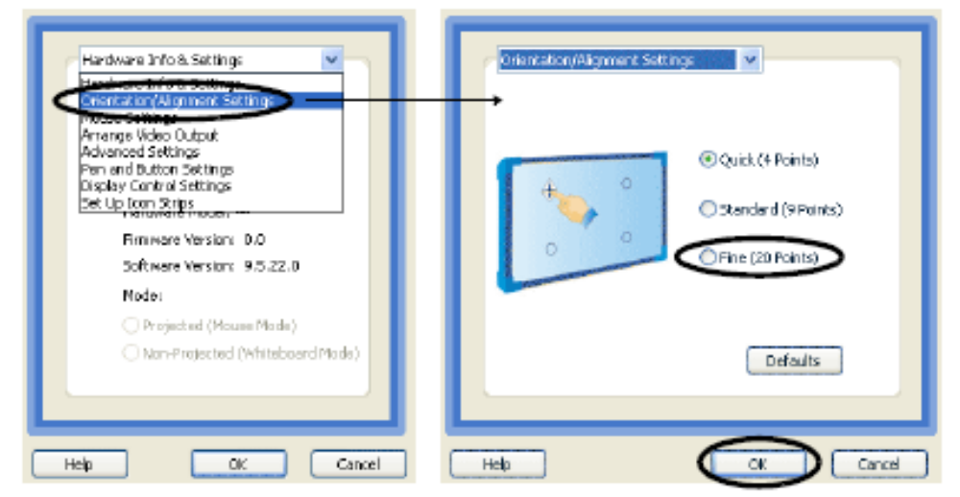

- Floating Tools
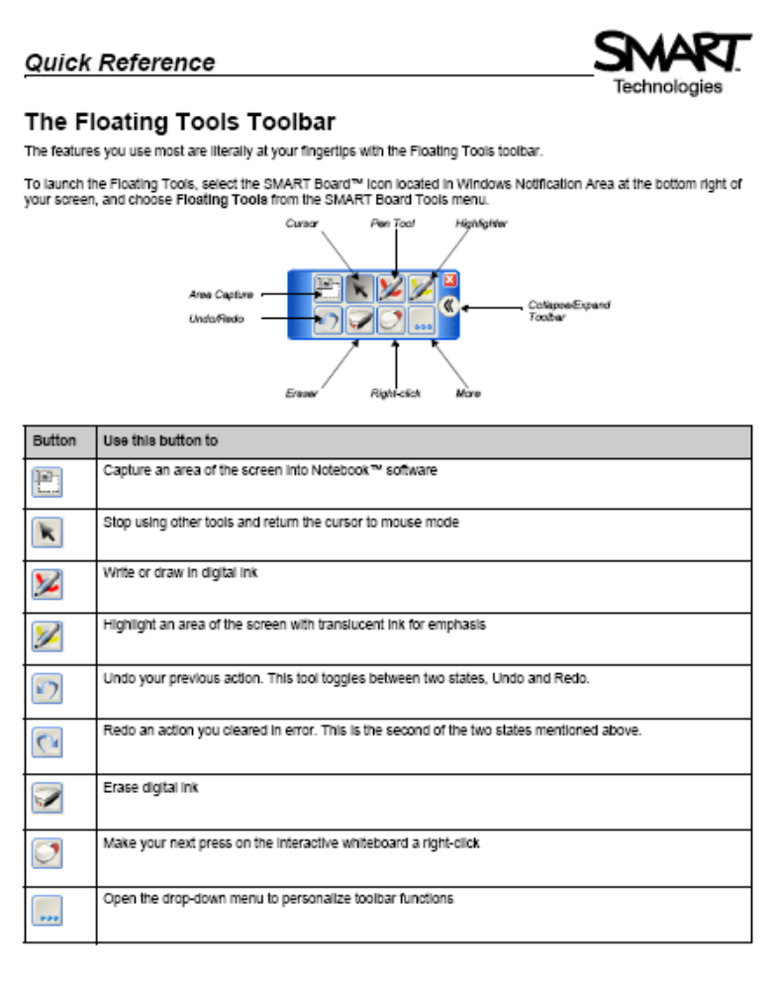

- SMART Notebook Tools
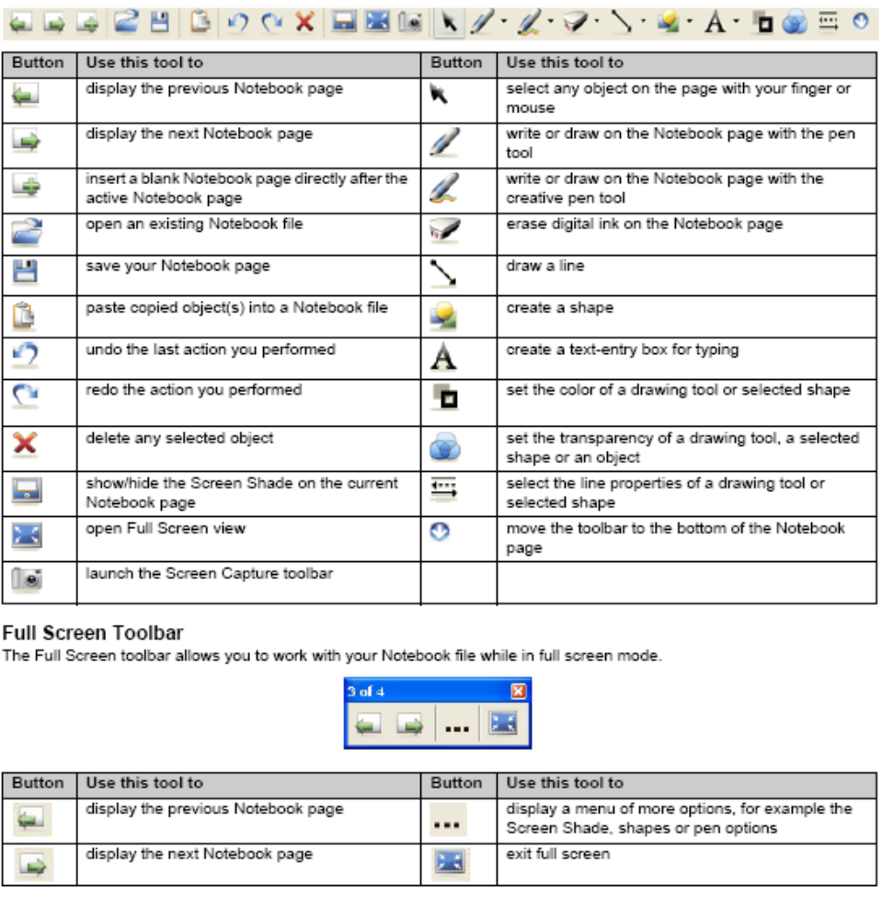

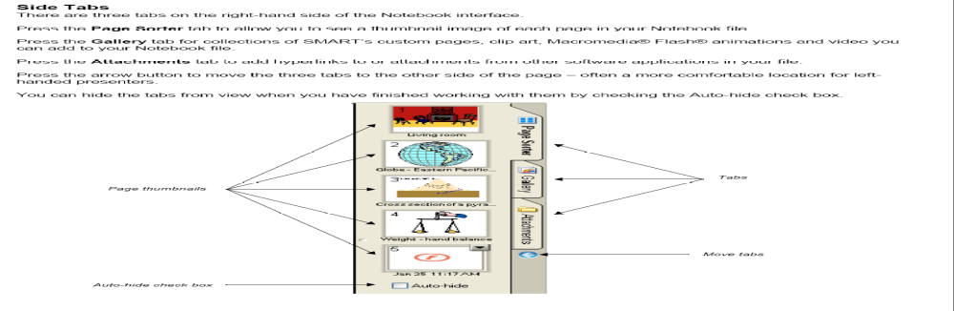

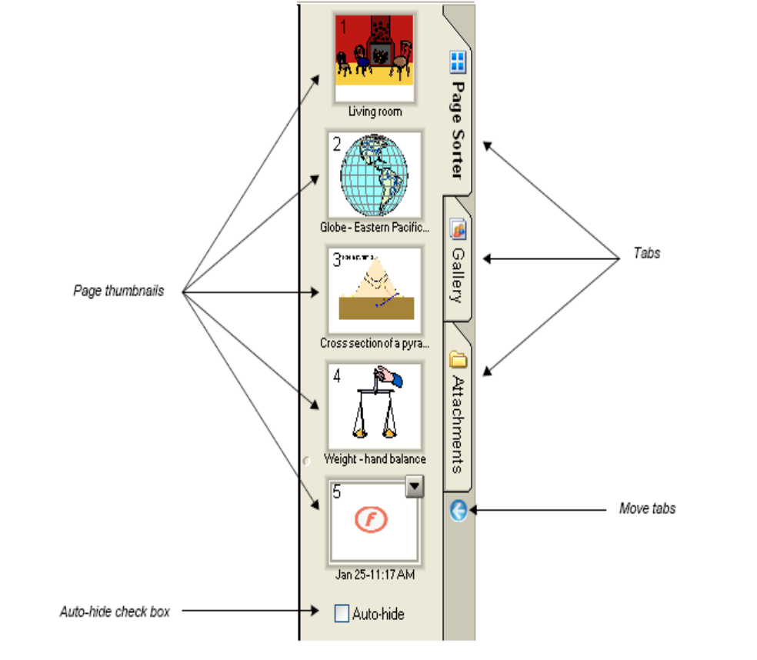

- SMART Notebook Gallery
  - Click on the Gallery Tab
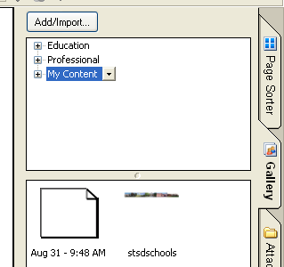
  - Categories – Education, Professional, and My Content (you can add more gallery images here)

  - Open a gallery collection and drag the image to your workspace.

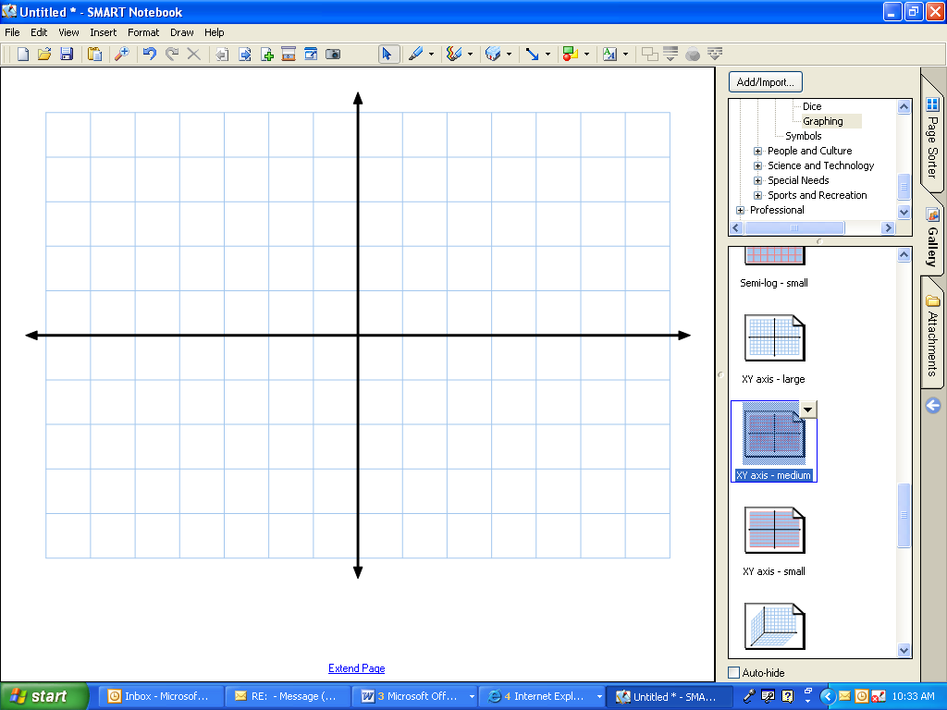

You can add as many images as you’d like. Keep in mind that you can add pages and save them as in a PowerPoint presentation.

  - Add/Import – More Gallery Collections Online!!!

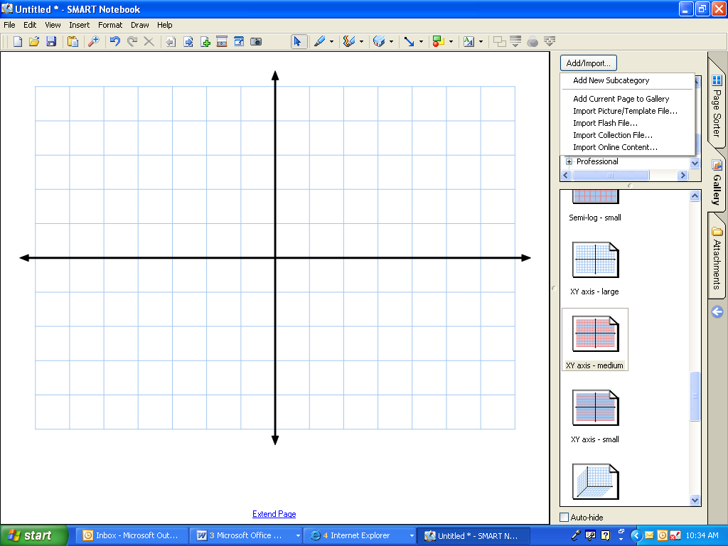

- Go to Import Online Content
- Choose a category, select the gallery, and download the .xbc file to your desktop.
- Go to Add/Import again choose Import Collection File
- Locate your downloaded collection.
- Walla you are done adding the collection and it’s ready to use.

(The EDCompass online community has moved. We have moved to our new education solutions site. Please bookmark the new site: www.education.smarttech.com)

- Ink Aware
  - Written words can be recognized by selecting the word with your pointer tool and clicking on the drop down menu.

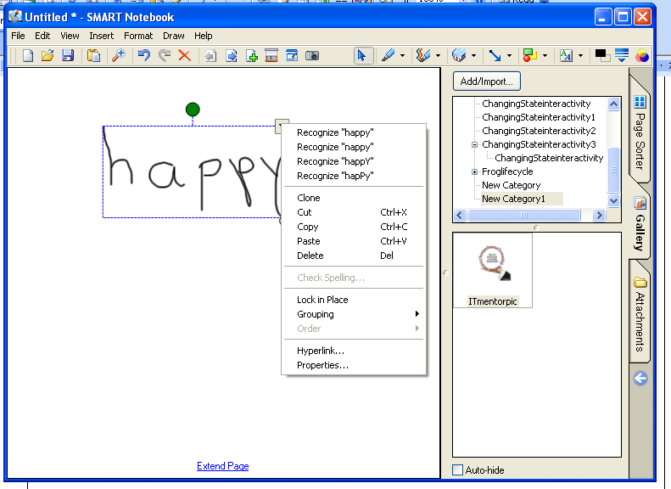

  - Word, PPT, Excel, FP, and more applications have Ink Aware Options.
    - Go to View menu
    - Choose Toolbars and select SMART Aware Toolbar
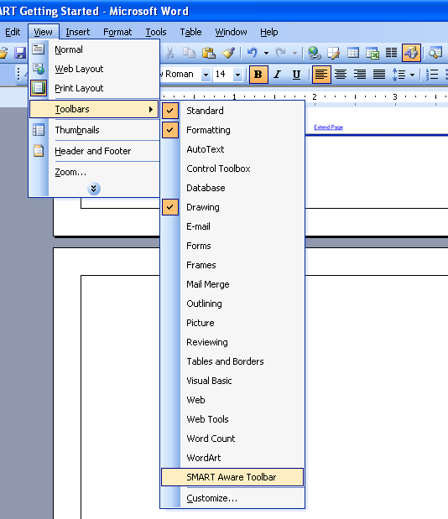
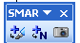
    - Insert a Image, Text, or Screen Capture to Notebook.

- Downloading Standard Based Lessons from START
  - Go to http://www.smarttech.com/ and click on Education.
  - Go to Educator Resources – click Notebook software activities
  - Choose USA and browse by curriculum standard, subject and grade level, or view all.
  - Make your selections
  - Download the XBK file to your desktop or user folder and open it

SMART Links
For Educators
http://education.smarttech.com/ste/en-us/
Other Training Manuals and Quick tutorials
http://www.smarttech.com/trainingcenter/windows/trainingmaterials.asp
Lessons and Activities
http://www.education.smarttech.com/ste/en-US/Ed+Resource/Lesson+activities/Notebook+activities/Standards+Search+US.htm
Notes Page

