Introduction to the Science of Applied Technologies

Welcome to the Study of Electronics and Associated Technologies.

If the thirty-six inches of a yard stick was used to represent the length of time that man has been on the Earth, the length of time that electronics and associated technologies has been with us could be represented by a sixteenth of an inch. A broadcast radio receiver of the 1930's was as large as a console color television. Today that same radio could be put in a wrist watch. The technological revolution has affected every aspect of human existence. The way we communicate, transport, manufacture, relax and heal ourselves has changed because of the developments in electronics. The rate of this change has rapidly accelerated.

Electronics is no longer a subject to be independently studied. It has become an area that must be understood and used by almost every technology, trade or profession. The computer age now touches every aspect of our lives.

The purpose of this text is to help the reader use electronics and associated technologies as a medium to assist in becoming an educated, informed and skilled person. Technology will be studied as a science that can be applied to many processes.

Science is the systematic study of knowledge and facts.
Technology is the application of the principles of science.

Matter, Energy and the Law of Charges

Everything that occupies space and has mass is matter and can take on many forms. Liquids, solids and gasses are all different states or conditions that matter may be found to exist. Not all things that have mass and occupy space can be easily identified by touch, sight or smell. Sometimes analysis is required to determine the characteristics of some matter.

Regardless of the state or form that matter takes, it can be categorized into two groups. One group is the element, which may be divided yet maintain all of its characteristics until only one atom is present. The other group is the compound, which may be divided yet maintain its characteristics until only one molecule is present.

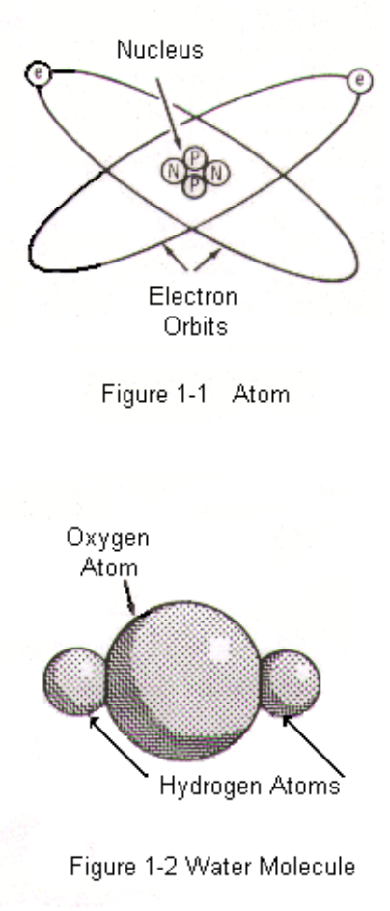
An atom is an extremely small particle invisible to the naked eye. The word atom comes from the Greek atomos , meaning indivisible. Only in recent times has sophisticated equipment allowed scientists to see atoms and prove their structure and existence. The characteristics of an atom or element is determined by the number of protons and neutrons found in its center or nucleus.
Copper is an element, which means that a chunk of it could be repeatedly cut up and divided until only one atom is left. Aluminum, gold, silver and iron are all elements. Until recent years, the only elements known to man were natural. With advancement in technology and the development of particle accelerators, artificial elements are being created. Neptunium and plutonium are examples of manmade elements.

Atoms consist of a center, or nucleus composed of positively charged ( + ) protons and neutrally charged ( 0 ) neutrons. Negatively charged ( - ) electrons orbit the around the nucleus as shown in figure 1-1.

Because of its abundance in nature, water might be considered a natural element. Water is not an element, but rather a member of the second grouping of matter, compounds. A compound is a mixture of two or more natural elements. Water, sugar and salt are all compounds. As shown in figure 1-2, water is a mixture of two hydrogen atoms and one oxygen atom. Interestingly, oxygen on its own is the most important component of the air that mammals must breathe, yet all creatures with lungs would drown if they tried to live in oxygen rich water without returning to the surface for air. Water may be used to extinguish a fire, but if the hydrogen is separated from the oxygen it would burn extremely hot and fast. In fact, hydrogen and oxygen are used to fuel the main rocket engines of the space shuttle.

Hydrogen can be separated from the oxygen in water by passing an electric current through a mixture of water and sulfuric acid. Automobile batteries must be properly vented or hydrogen will collect and explode when exposed to sparks.

Activity 1-A1 will outline a procedure to generate hydrogen through chemical means. This activity must be performed only as a demonstration by an instructor, as improper handling can be hazardous.

The Law of Charges states that like charges repel and unlike charges attract.

Atoms that possess more electrons than protons are negatively charged. Those with fewer electrons than protons are positively charged. If an object is negatively charged and put in close proximity to another negatively charged object, both objects will repel one another. Two positively charged objects will also repel each other. A positively charged object will, however, attract a negatively charged object.
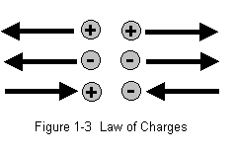

Activity 1-A2 will show how to make an electroscope. With this homemade electroscope, a student can then complete the activity experiments that will help learn how to test for the presence of an electrostatic charge.

Sources of Electricity

Electricity is created by storing or moving electrons. If one body has a great number of stored electrons and another possesses a large deficiency, the pressure caused by the difference (potential difference) develops an electromotive force.

Electromotive force is often referred to as EMF and is measured in volts. EMF can be stored much like air in a balloon, or it can be created by converting mechanical, chemical, solar, pressure or thermal energy into electricity. The only natural electricity is static electricity like that found in lightning. All else must be converted from other sources of energy.

Chemical

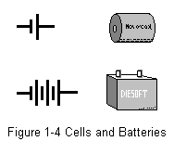A battery is used to convert chemical energy into electricity. Sometimes, a flashlight cell is incorrectly referred to as a battery. A cell is a single voltage producing unit, whereas the battery is a group of cells that are connected so the output can be maximized. Figure 1-4 shows the symbol and a pictorial of a cell and battery. When two or more cells are inserted into a flashlight, they may then be considered a battery. An automobile battery is made up of six individual cells resulting in a total output of 12.6 volts. There are two types of chemical cells, primary and secondary. An alkaline cell is a primary cell which destroys itself in the process of creating an EMF. Unless it is a special type of alkaline cell, it may not be recharged and may be used only once. The secondary cell like the ones found in the auto battery or the nicad cell found in many portable telephones, are rechargeable and my be reused many times.

Activity 1-3A Uses the Electronic Work Bench to help learn the schematic symbol for a direct current source of EMF. It also helps a student learn how to measure the voltage in a circuit using a voltmeter.

Activity 1-4A demonstrates how a voltage may be measured from a chemical cell that is made from common household materials.

There are several types of primary and secondary cells. Zinc-carbon, alkaline, mercury, silver oxide and lithium are examples of primary cells. Lead-acid and nickel-cadmium cells are rechargeable devices.

The zinc-carbon cell is one of the oldest primary cells in use and is referred to as a dry cell. Most primary cells are dry and are typically composed of a container which serves as one of the electrodes filled by an electrolyte chemical which has another electrode suspended within it. The container in the zinc-carbon cell is the negative electrode and is made of zinc. The positive electrode is made of carbon and it is suspended in a paste mixture of carbon, manganese dioxide and ammonium chloride which is mixed with water. Each chemical in the electrolyte performs a specific job. The carbon reduces the internal resistance within the cell and the manganese dioxide acts as a depolarizing agent which removes hydrogen by combining it with oxygen. The water in the paste is formed as a by product of the chemical reaction that creates the EMF. While the basic make up of the zinc-carbon cell (figure 1-5) has changed little over the years, much progress has been made in the case design which helps reduce the device damaging leakage that once occurred. A very close cousin to the Carbon-zinc cell is the alkaline cell. It is more expensive to manufacture and delivers the same 1.5 volts per unit as the carbon zinc; however, it will maintain its maximum output for a longer period of time. An additional advantage of the alkaline cell is its extended storage life.

The lead-acid cell is a common example of a secondary or rechargeable cell. While the electrical energy in a primary cell comes from a reaction from the chemicals and materials used in its construction, the energy in a secondary cell is placed in the cell by depositing it by electrical means through a process called charging.

When the cell is fully charged, the plates of sponge lead and lead peroxide are relatively pure and the sulfuric acid electrolyte is more acid than water. The electrolyte is a chemical medium within the cell that promotes the transfer of electrons within that cell. As the cell discharges, lead sulphate is formed on the plates making them less pure. The acid in the electrolyte decreases and the water content increases. This process is reversed by connecting a power source to the cell to recharge it. In the fully charged cell, the electrolyte is more dense because of the numbers of electrons stored and the electron increase as the water, H2O is converted into sulfuric acid, H2SO4.
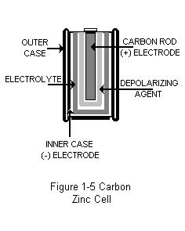

There are many variations of the lead-acid cell that enable it to perform many duties. The most common use is in the automobile battery. Although changes in the materials used in the cases, separators and insulators of the battery make it somewhat more reliable, the basic design of this old workhorse has remained the same for over 60 years.

Mechanical

Wind, water, steam and gasoline or diesel engines are commonly used to drive alternators or generators to convert mechanical energy into electrical energy. When the lines of force within a magnetic field are cut by a wire or a coil of wire, electrical pressure is created and the result is an electrical current. 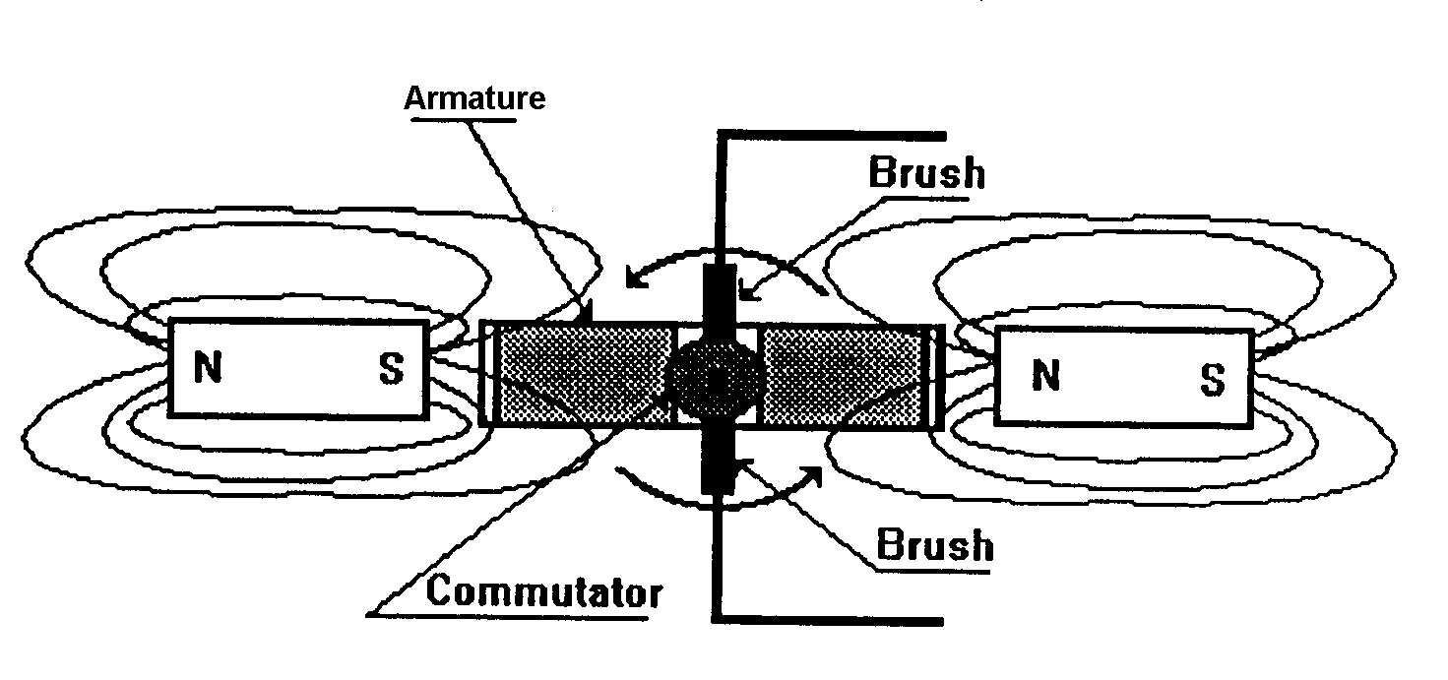 Figure 1-7 A Simple Generator

The current is then carried out of the moving coils to the non-moving parts of the generator through the commutator and brushes, where it can be utilized in the load. A load is a device or arrangement of devices that consume the energy produced by the source of EMF. The mechanical source of electricity is the largest source of commercially produced power. Where the chemical source offers portability, the mechanical source offers the advantage of quantity.
Solar

A relatively new source of electromotive force is the solar cell. Although limited by current technology to the amount of electricity it can economically produce, it provides a source of useable energy wherever the sun shines. It's only fuel requirement is light and it leaves no pollution. The disadvantage of this source is the cost of producing the solar cell. Because of its reliability and portability, solar energy is used to power most satellites that orbit the earth.

The photovoltaic cell is made of a base plate which has a layer of selenium bonded to it. A barrier layer is then placed between the selenium and a transparent electrode which forms the negative pole of the cell. The selenium cell is used to detect the presence of light by producing a very small amount of electricity that signals an electrical circuit. This is the device used to turn lights on when it turns dark and off when the sun rises in the morning. They are also used in motion detectors.

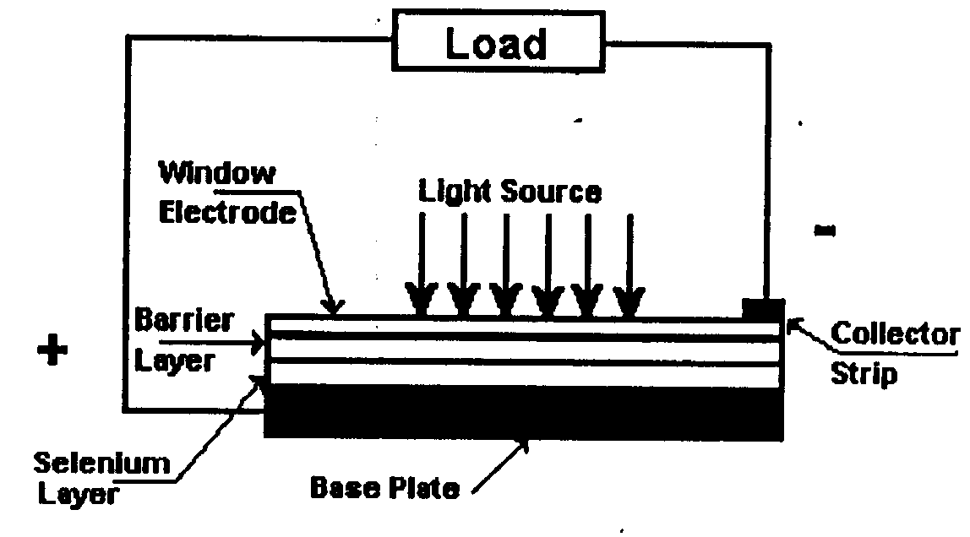
Figure 1-8 The Photovoltaic (Selenium) Cell

The solar cell that produces the electricity for satellites and solar powered calculators is the silicon photovoltaic cell. This cell is constructed of a sandwich made up of two types of silicon material similar to what makes up transistors and the LED's or light emitting diodes used in indicator displays of stereo tape decks. A light source shines on an active cell surface that covers the silicon sandwich. This causes an ionization of atoms in a specific part of this sandwich called the depletion region. Ionization is the process of forcing an atom to gain or loose an electron. Through ionization, electrons are liberated to flow into a circuit. Under full light conditions, the silicon solar cell can develop from .5 to .8 volts. This amount varies with the type of material used in the active cell surface and the wavelength of the light to which it is exposed. Since the cell has no chemical reactions associated with the production of electricity, it can be used indefinitely or until physical damage occurs.

Pressure

Quartz, Tourmaline and Rochelle salts are crystals that, when exposed to pressure, will develop electricity. The action that produces electricity from pressure is called the piezoelectric effect. Although the currents produced by applying a vibrating pressure on these carefully ground and shaped pieces of rock like substances are very small, they serve a very important function. By sandwiching a crystal between two pieces of metal, then linking it to a diaphragm, sound waves can vibrate against the apparatus and be converted into electrical signals that can be amplified, recorded, or sent by wire or radio waves to another location.
Like other sources of electricity, this one may be reversed. If an electrical signal
is placed on this metal and crystal device, it will vibrate. When it is cut and ground to exact dimensions, it will vibrate at a very specific rate. When a computer operates at 33 or 66 megahertz, its speed is very accurately controlled by a circuit which has at its heart, a crystal. A radio signal is held to a specific location on the dial by the precision of a vibrating crystal.

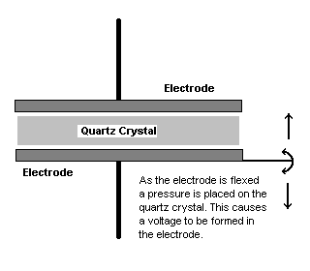

Figure 1-10
Electricity From Pressure
The Piezo-Electric Effect

Thermal

When two dissimilar metals are joined together and heated, free electrons are forced from the thermally active part of the device to the cooler end. This causes a potential difference or voltage to be created. The resulting device is called a thermocouple. If a Copper wire is twisted around a piece of steel bailing wire, a thermocouple results. Although this experimental unit will produce a measurable voltage, it will not produce electricity in cost effective or useable amounts. Special alloys or mixtures of metals are used in commercially produced thermal-electric devices. Nickel-platinum, chromel-alumel and iron-constantan are special materials developed to produce electricity without deteriorating with use. By placing a number of thermocouples in connected arrays called thermopiles, the relatively small amounts of electricity created by each unit may be combined to develop useable levels of current.

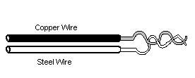

Figure 1-11 Thermocouple

Natural Electricity

Natural electricity is not useable and it cannot be harvested or controlled. In fact, the electricity know as static electricity is much more a nuisance and a hazard than anything considered helpful. It causes injury and fire in the form of lightening. It creates discomfort and a shocking sensation to a person who walks across a carpeted floor and touches something. A static charge is created by friction either by rubbing dissimilar material over each other, or by colliding air masses. Computer components and electronic devices can be destroyed by an un-controlled discharge of static electricity.

The word static means at rest. Electrostatic means electricity at rest. When a charge is created by accumulating electrons on a body, static electricity exists. Actually, static electricity causes no pain, discomfort or injury, but when the potential becomes so great that the electrons jump from one body to another, a potentially painful discharge occurs. Lightening is a discharge. The spark that jumps from a person to a door knob after he or she walks across a carpet is a discharge. ESD, or electrostatic discharge, must be prevented by special packaging and handling precautions. The presence of a static charge may be indicated by an electroscope like the one constructed in activity 1-A-2. The accumulation of electrons creates something called an electrostatic or dielectric field.

