CURRICULUM GUIDE
For the teaching of

21st Century Pathways
(Writing and Presenting in the Digital Age)

Fall 2018

Curriculum Writer
Melanie Sirof, W.C. Mepham High School

Curriculum Coordinator
Mary Donnelly
District English Chairperson

Bellmore-Merrick
Central High School District

Board of Education

Nina Lanci Wendy Gargiulo
President Vice President

Marion Blane
Edward Corona
John Ferrara
Janet Goller
Dr. Nancy Kaplan
Gina Piskin
Claire Neufeld

Administration

John DeTommaso
Superintendent of Schools

Dr. Mara Bollettieri
Deputy Superintendent

Kate Freeman
Michael Harrington
Assistant Superintendents

21st Century Pathways

This curriculum guide was created in preparation of a new high school elective: 21st Century Pathways. This self-guided course is designed to help students identify their passions and to guide them through the exploration of how to pursue a life that includes application of those passions. In addition to discovering their natural talents and personal affinities, students will engage in independent research and be exposed to career opportunities not typically in their field of vision. Students will develop vital 21st Century skills such as long-term and short-term goal setting, presentation literacy, and effective communication. This course is designed to help students define success, identify what Sir Ken Robinson calls their element and to research the myriad jobs that exist in the world that may fit their talents, passions, and life goals.

The class is built around journals called “Life Books,” which is a catch-all for all writing-to-think assignments. The Life Book is meant to serve as a place to think during class and a source of inspiration once the coursework is completed. Most lessons are envisioned as “View/Respond/Engage” where we as a class watch or read a common piece then respond to it personally and then apply it to our lives as we discuss all of our possible futures. Class is designed to be conversation based and introspective as each student is presented the opportunity to imagine and pursue their own Pathways.

This curriculum guide contains a number of lessons loosely formatted as minilessons that can be easily adapted for classroom use. The common elements seen in most (but not all) of these minilessons are “teaching point”, “view”, “engage”, “respond”, and “summation.” Most attachments are hyperlinked to Internet locations. In some lessons, teacher script is provided.

Table of Contents

Unit of Study | Sample Lessons
THINKING OUTSIDE THE BOX | 1 – The Jobs You Know  2a – That’s a Job? Part 1  2b - That’s a Job? Part 2
TAKING STOCK | 3a - Who You are At Heart, Part 1  3b - Who You are At Heart, Part 2  4 – Mind Mapping & Mind Mapping Me
FINDING YOUR ELEMENT | 5 - What Exactly is “The Element”  6 - How Do I Find My Element  7 - The Hum, The Zone
FUTURES PLANNING &  SKILLS | 8a - Where Will You Be, and How Will You Get There? Part 1  8b - Where Will You Be, and How Will You Get There? Part 2  8c - Where Will You Be, and How Will You Get There? Part 3  8d - Where Will You Be, and How Will You Get There? Part 4  9 - How do Professionals Fill Their Days  10 - Soft vs Hard Skills
FANNING THE FLAMES | 11 - What Does It Mean to Practice Something  12 - How did the 100 Day Project Change You?  13 - What are the Keys to Great Conversation?

Standards Addressed in this Curriculum

Where noted, lessons in this curriculum project align with New York State Next Generation Learning Standards for Literacy 6-12 Anchor Standards for Reading and Writing (NYS “Next Gen”) and/or New York State Learning Standards for Career Development and Occupational Studies (CDOS).

LESSON 1

Unit of Instruction: Thinking Outside the Box
Lesson Topic: The Jobs You know…

Teaching Point: Who are the people in your neighborhood?

Standard(s) Addressed in this Lesson:
- CDOS Standard 1 – Career Development: Students will be knowledgeable about the world of work, explore career options, and relate personal skills, aptitudes, and abilities to future career decisions.
- NYS “Next Gen” - Integration of Knowledge and Ideas; S7: Integrate and evaluate content presented in diverse media and formats, including across multiple texts.

The Lesson
View: Who Are the People in Your Neighborhood?
Respond: In 60 seconds, list all the jobs you know.
Push: List the jobs of your mom/dad/aunt/uncle/sister’s cousin’s brother.
Move students into groups to try to grow their lists: (5-8 mins)
Engage: Put an asterisk next to all of the jobs you can imagine yourself doing in your lifetime.
Put a second * next to the ones you can imagine doing happily.
Student-Focused Workshop Time: Talk students through “a day in the life” of a teacher. Then have students choose the jobs that appeal to them most. In their notebooks, imagine carefully “a day in the life” of their top 3.

Share: Student pair & share.

LESSON 2a

Unit of Instruction: Thinking Outside the Box
Lesson Topic: That’s a Job?! (A.k.a the jobs you don’t know).

Teaching Point: How many jobs are there in the world?

Standard(s) Addressed in this Lesson:
- CDOS Standard 1 – Career Development: Students will be knowledgeable about the world of work, explore career options, and relate personal skills, aptitudes, and abilities to future career decisions.
- NYS “Next Gen” - Integration of Knowledge and Ideas; S7: Integrate and evaluate content presented in diverse media and formats, including across multiple texts.

The Lesson
View: Watch immunity challenge from Survivor
Respond: List all the jobs it took to create that immunity challenge. (Share)
Engage: What do these people have to be good at in order to do their job?
  - What was the last concert/live show you attended (does not have to be professional).
  - Write down all the jobs required to make that show happen.
WHY DON’T WE KNOW ABOUT THESE JOBS?!
Say: Because our parents don’t have these jobs (how does geography affect what jobs we know about? how does education affect what jobs we know about? How does our socio-economic level factor in to what jobs we know about?) Now that you know how many people it takes to create a job, if any job in the world could be yours, what would you want to do?

Summation:
Be on the lookout out in the real world, for jobs that you never knew existed.

LESSON 2b

Unit of Instruction: Thinking Outside the Box
Lesson Topic: That’s a job?! A.k.a the jobs you don’t know.

Teaching Point: How many jobs are there in the world?

Standard(s) Addressed in this Lesson:
- CDOS Standard 1 – Career Development: Students will be knowledgeable about the world of work, explore career options, and relate personal skills, aptitudes, and abilities to future career decisions.
- NYS “Next Gen” – Key Ideas and Details, S1: Read closely to determine what the text says explicitly/implicitly and make logical inferences from it; cite specific textual evidence when writing or speaking to support conclusions drawn from the text.

The Lesson
View/Respond: Hand out empty product boxes (food/toys/bath products) to groups of students.
Students are to write down all of the jobs it took to get that product to their hands.
Engage: What kind of degree/schooling/training do you imagine each of these people need? (What does it take to be a taste tester or flavor creator? What type of education do you need for product packaging and marketing? etc)
Article: How Dr. Pepper Develops Drink Flavors
Note: Hyperlinked article is also included on next page
Summation:
Who knew you needed a science degree to make soda?! Who knew “flavorist” was a job?! There are jobs out there we are not exposed to, and thereby know nothing about. Don’t let what you don’t know limit your potential for success and fulfillment.

Dr Pepper's Product Genius Explains How New Soda Flavors Are Created
Business Insider
Kim Bhasin
Sep. 27, 2012, 6:46 PM

Dr. David Thomas is a flavor genius.
Thomas is the executive vice president of research and development at Dr Pepper Snapple Group, and he's in charge of creating the next big-time products for the beverage giant.
"Taste is king," Thomas told us. "We know that. So what we really need to do is create products that start with the consumer and end with the consumer."
It's all about connecting the science and technology that the company has developed with the insights it has learned about what people want.
To come up with a product like Dr Pepper Cherry, Thomas said that they may put 40 prototypes together, then test all the qualitative and quantitative data they can get. Then there's the descriptive analysis, with the feedback going back to developers. Then comes location tests and tests with consumers.
Finally, they narrow it down to the top five, and ultimately whittle it down to the final one, which gets launched.
It's an incredibly complex world, assured Thomas. To get a feel for what it takes to get the job done, all you have to do is look at Thomas, his staff and their facilities.
Thomas' background is in ingredients. He has a masters and a PhD in food science, and knows all about "flavor biochemistry."
He has a team of "flavorists." These are scientists trained in the flavor industry, which Thomas described as a "blending of art and science." They help put the actual flavors together.
There are also "sensory scientists," who lead the analysis of the products regarding consumer preferences and tasting. Products get their own lexicons, because the analysts need to be consistent when describing flavors.
The R&D site is right inside the Dr Pepper Snapple Group headquarters in Plano, TX, which is valuable because it lets the team respond nimbly, said Thomas.
And there's even a state-of-the-art pilot plant with the ability to emulate all the commercial-scale processes needed ensure that a product can be made on a large scale — a fundamentally important part of a product launch. On the other side of the wall there's a major, full-scale manufacturing center where they can do trials when the product is deemed ready.
"Quality by manufacturing meets quality by design," said Thomas. "It's pretty easy to put a beverage together in a beaker, but it's another thing when there's a 100-gallon batch tank."
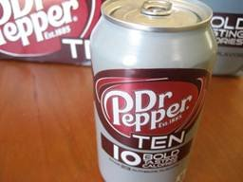
The latest breakthrough for Thomas and his team involves the company's line of 10-calorie beverages. The first of them, Dr Pepper TEN, has seen success since hitting the market in 2011.
Dr Pepper has "cracked the code" on "no aftertaste and more full-bodied mouth feel," declares Thomas proudly.
"We hear it all the time that we've got great tasting diet — one of the best tasting diets," he says. "We know there's new technology being developed. That we can make advancements."
Something like Dr Pepper TEN — and its in-testing 10-cal compatriots 7-Up, Sunkist, A&W, Canada Dry and RC — needs to be marketed very carefully though.
"We're trying to thread the needle with [Dr Pepper TEN]," says Thomas.
That drink had a male-oriented marketing campaign that attempted to get men away from thinking of a low-calorie offering as "diet." The new 10-cal drinks will be marketed to a broader audience.

LESSON 3a

Unit of Instruction: Taking Stock
Lesson Topic: Who You are At Heart
Teaching Point: “Yes &” in improv, in this class, & in life. How many of you are “Yes” people? How about “No” people?

Standard(s) Addressed in this Lesson:
- CDOS Standard 1 – Career Development: Students will be knowledgeable about the world of work, explore career options, and relate personal skills, aptitudes, and abilities to future career decisions.
- NYS “Next Gen” - Integration of Knowledge and Ideas; S7: Integrate and evaluate content presented in diverse media and formats, including across multiple texts.
- NYS “Next Gen” – Text Types and Purposes; S4: Develop personal, cultural, textual, and thematic connections within and across genres through responses to texts and personal experiences.

The Lesson
Quick Write: How does being a ‘yes’ person or a ‘no’ person impact your life?

View: Galen Emmanuel’s TEDxBellingham Talk (12 minutes)

Respond: What impact would applying this “Yes &” principal have on your life?

Engage: Think about a time you were told “No” and you let it stop you. Imagine for a few minutes what would have happened if you had not been told no at that moment. If instead you were told, “Yes AND…”
Think about the last time you shut someone down and said no when you could have said yes. What do you think would have happened had you said yes?
Write about one or both of these experiences.
Whole class share (volunteers)

Summation: Are there limitations to this? Ie, should a parent tell a kid who doesn’t have the gift of natural grace that “yes! You CAN be a dancer for The New York City Ballet AND you will be the best dancer they ever had!”

LESSON 3b

Unit of Instruction: Taking Stock
Lesson Topic: Who You are At Heart

Teaching Point: “Yes &” in improv, in this class, & in life. How many of you are “Yes” people? How about “No” people?

Standard(s) Addressed in this Lesson:
- CDOS Standard 1 – Career Development: Students will be knowledgeable about the world of work, explore career options, and relate personal skills, aptitudes, and abilities to future career decisions.
- NYS “Next Gen” – Text Types and Purposes; S4: Develop personal, cultural, textual, and thematic connections within and across genres through responses to texts and personal experiences.

The Lesson
Respond: Quick Write:
How does society define success? How do you know? (discuss)
What is your definition of success? (hold these answers & see below)

Engage: Let’s try it “Yes &”
In a circle, students will give a short answer to “what is success?” and the class will respond to each one with “yes!” and the next person to go will say “yes, AND” and add his/her own definition.

Take a look at how some highly successful people view success
How Successful People Define Success 2017 Business Insider

Summation: What is the takeaway if there are 20 different definitions for success?
Which ones are most important in your life?
Success is not always all or nothing, but prioritizing is important.

Optional Extension Activity:
Students create “Success Boards” Using Art paper, colored pencils, markers etc. No white space allowed, feel free to use sketches, drawings, magazine cut outs, text etc.

Summation: Now that you know what success is for you, what can you do to find it?

LESSON 4

Unit of Instruction: Finding Your Element
Lesson Topic: Mind Mapping & Mind Mapping Me

Teaching Point: What is mind-mapping and how might it help me find my Pathway? (Completing both parts of this lesson may take 2-3 days)

*This class will benefit from in-room computers or the computer lab.

Standard(s) Addressed in this Lesson:
- CDOS Standard 1 – Career Development: Students will be knowledgeable about the world of work, explore career options, and relate personal skills, aptitudes, and abilities to future career decisions.
- NYS “Next Gen” – Text Types and Purposes; S4: Develop personal, cultural, textual, and thematic connections within and across genres through responses to texts and personal experiences.

The Lesson
View: “Solving Global Warming” and “Mind Maps” Mind maps from 10 Really Cool Mind Mapping Examples Note: see samples included with this lesson.

Respond: Have student respond in discussion or in their Life books:
- How does note making that looks like this differ than the note making you are used to?
- What might be the benefits of this kind of note making?
Way more fun! Interesting to look at. Allows you to organize information in a way outlines can’t
- What might be the drawbacks?
Looks difficult. Looks like you have to be artistic.

Part I: Mind Mapping

Engage: Have students sign up for the free “How to Mind Map” Online eLearning program from
imindmap. This course takes them through the why and the how of Mind Mapping. At the end of the free course, they are taken through the tasks of Mind Mapping their week and Mind Mapping their resume. Ample time to accomplish these practice maps would be given more time.

Part II: Mind Mapping Me

Engage: Students spend time creating Mind Maps of who they are right now. This Mind Map should be seen as fluid and evolving, with students frequently adding new information to it as the year progresses.

Summation: Mind-mapping mimics the brain’s way of thinking and can help you not only take notes in your classes, but also to think through your life and your decisions. Discuss possibilities of future jobs that might be added to the map. Do you want to do similar jobs to what you have done so far in your life? Or do you want to pursue something different? Add wants and desires to the resume mind map.
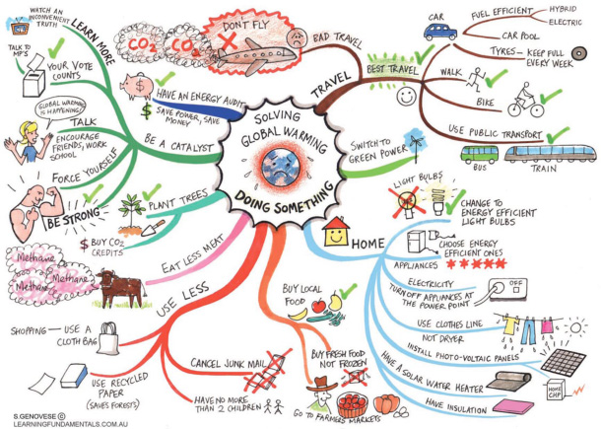
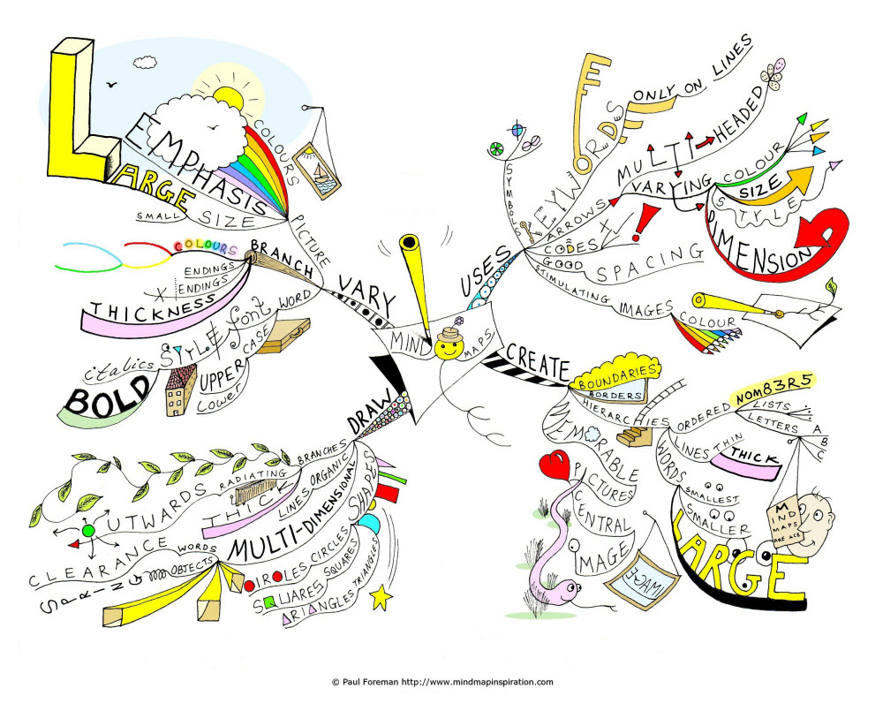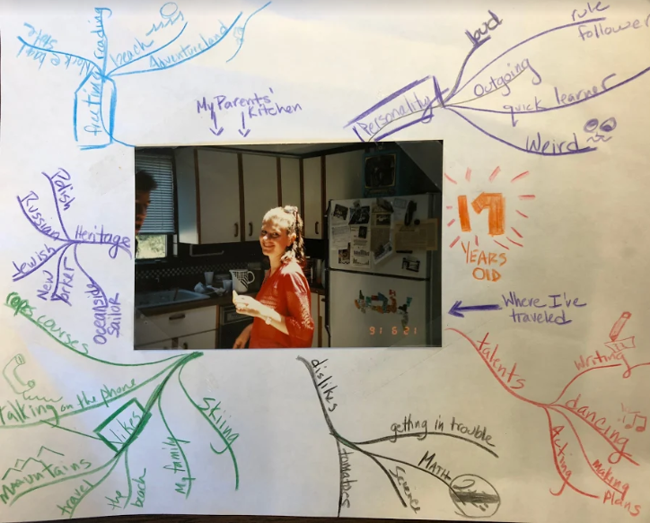
Sample from a 17 year old student

LESSON 5

Unit of Instruction: Finding Your Element
Lesson Topic: What Exactly is “The Element”?

Teaching Point: Defining “The Element”

Standard(s) Addressed in this Lesson:
- CDOS Standard 1 – Career Development: Students will be knowledgeable about the world of work, explore career options, and relate personal skills, aptitudes, and abilities to future career decisions.
- NYS “Next Gen” - Integration of Knowledge and Ideas; S7: Integrate and evaluate content presented in diverse media and formats, including across multiple texts.
- NYS “Next Gen” – Text Types and Purposes; S4: Develop personal, cultural, textual, and thematic connections within and across genres through responses to texts and personal experiences.

The Lesson
View: Ken Robinson on The Element

Respond: Stop video at the following moments to have students respond in their life books to the following questions:
- @2:30 - How does Robinson define “The Element”? Where your aptitude meets what you like to do.
- @15:00 Discuss: What are the places that excite you the same way the gym excited Bart Conner?
- @16:30 Share: (this question is preemptive) Why is it so important to get good grades? How old were you when your parents first started talking about college/post graduation plans?
- @18:50 Stop Video. Discuss: Does college start in Kindergarten? If not, when? What are the problems with this model? What are the realities?

Engage: What are the takeaways for you? Are you like the pianist who didn’t love playing but did it anyway? Like Bart Conner who made his talent his life’s work?

Summation: Begin to notice and note the things you are good at and the things you like to do most as we continue to search for our “Element.”

LESSON 6

Unit of Instruction: Finding Your Element
Lesson Topic: How Do I Find My Element?

Teaching Point: Students will learn how to do free-association writing to examine below surface-level thoughts

Standard(s) Addressed in this Lesson:
- NYS “Next Gen” – Text Types and Purposes; S4: Develop personal, cultural, textual, and thematic connections within and across genres through responses to texts and personal experiences.

The Lesson
View: Teacher models a 5 minute “guided freewrite” Which is writing “asmuchasyoucan asfastasyoucan” paying no attention to spelling, grammar, sensors in your brain that tell you, “That’s dumb” or “I don’t know what to write.” Let the work surprise you. (Sample teacher write, with purposefully uncorrected errors, included with this lesson).

Anytime you feel like you’ve run out of things to say, repeat the phrase “I am someone who…” (see sample next page)

Respond: Students participate in their own 10 minute free write. Then pair and share.

Engage: Keep a list of the people around you who are good at the things you are good at.

Guided Freewrite Sample:

I am someone who likes to talk. I will talk to anyone who will listen, mostly about things that I think are important. I don’t like to be wrong and I don’t particularly like to argue. If someone starts to argue with me, I usually let it go. Let them think their thing, and I;ll think mine. I am someonen who likes to be outdoors when the weather is good, and even when the weather is a liittle bit cold. I just like having the sky above me and the mouintains. I am definitely a mountain girl. Man I’m spelling lots of things wrong her e and lots of typoes….I am someone who likes to read deeply and someone who will abandon a book if it’s not good. I like swapping titles with other readers, but mostly because I wan t them to read what I told them to read, I don’t really read what they told me to read very pftenm. When I read I need quiet and when I read a good book, the entire world falls away I will ignore my fasmily and my job if the book I am reading is that good. I have never read a book, well, I rarely read a book that I enjoy the ending to. Everyone is great at writing to the climax, but after the conflict is resolve...meh. SO I abandon books ¾ of the way through on the regular. I am someone who like s to travel to places that have big nature (canyons, mountains, rivers). I am someone who is good at seeing the good in others and accepting my own faults and other people’s imperfections. I understand that mistakes are part of life.

LESSON 7

Unit of Instruction: Finding Your Element
Lesson Topic: The Hum, The Zone

Teaching Point: Which class of the day goes the fastest for you? Slowest? Why? What does it mean when someone says “I was in the Zone!”

Standard(s) Addressed in this Lesson:
- CDOS Standard 1 – Career Development: Students will be knowledgeable about the world of work, explore career options, and relate personal skills, aptitudes, and abilities to future career decisions.
- NYS “Next Gen” - Integration of Knowledge and Ideas; S7: Integrate and evaluate content presented in diverse media and formats, including across multiple texts.
- NYS “Next Gen” – Text Types and Purposes; S4: Develop personal, cultural, textual, and thematic connections within and across genres through responses to texts and personal experiences.

The Lesson
View:
- Flow Video, Brad Stulberg
- Shonda Rhimes TED Talk (Rhimes is the creative mogul behind Grey’s Anatomy, Scandal, How to Get Away with Murder.)

Respond: As you view the videos, take notes on what inspires you, what stands out. What are the takeaways? This will guide discussion.

Engage: What is your hum? (You probably have several)
Life Book Prompt: Describe your hum in detail. What does it feel like, sound like? Look like?

Summation: Students will be asked to be mindful of next time they are in “the zone” and journal about it.

LESSON 8a

Unit of Instruction: Futures Planning & Skills
Lesson Topic: Where Will You Be, and How Will You Get There? Part 1

Teaching Point: Today we will learn visualization techniques using guided meditation.

Standard(s) Addressed in this Lesson:
- NYS “Next Gen” - Integration of Knowledge and Ideas; S7: Integrate and evaluate content presented in diverse media and formats, including across multiple texts.
- NYS “Next Gen” – Text Types and Purposes; S4: Develop personal, cultural, textual, and thematic connections within and across genres through responses to texts and personal experiences.

The Lesson
Engage: Lead students in guided meditation.
- Turn out the classroom lights.
- Have students close their eyes and listen carefully as you read slowly through the guided meditation (script included below).
Engage: In your life book, write about any part of your journey. WHat did you see? Where did you go? What did you imagine?

Summation: Have volunteers share out. Guide the conversation between past and present ask how many students had difficulty imagining the future. Why is it so difficult to imagine the future? Tomorrow in class we will begin to imagine our futures.

Guided Meditation
“Bring your attention to your breath as you breathe in and out. No need to try to change your breath, just pay attention to it the way it is right now. Relax your shoulders; let the stress melt out of your body. Notice the weight of your body in the chair. The feel of the floor beneath your feet. The feel of the desk under your hands or the weight of your hands on your legs. Notice the place where your back touches the back of the chair. Now, take a deep breath in and hold it for a beat before you exhale deeply. Take another deep breath in, and Exhale.

In a moment we are going to take three deep breaths and on the third inhale, we will be transported five years into the past. Where were you and who were you 5 years ago. If you are a senior, you were just starting middle school, Juniors, you were the oldest elementary school kids. Sophomores, you were a mighty fifth grader. Deep breath in. One. and Exhale. One more breath here as a high school student. and Exhale, on this next breath, take it deeeeep and when you exhale you will begin to see yourself five years ago.

What are you wearing?
What do you like to do when your friends are over?
Are you riding bikes? Getting your homework done? Dancing? Skateboarding? Playing board games with your family? What were you like in school? What do you recall about your teacher?

Take a moment to look around. Let time s l o w down around you. Take a slow stroll from wherever you are right now and stand outside your childhood bedroom door. Put one palm flat on the door in front of you, and on your next breath, open the knob and let the door swing open.

Take a look around. What does your bed look like? What colors are your walls? Is your room tidy or disastrous or somewhere in between. Are there trophies around your room from soccer when you were three? Are there posters on your wall? Stuffed animals on your bed? Books on your end table? What does your room tell you about the kid that you were? Stay here in the quiet room for a few moments (give 15 seconds or so of silence). Make a mental picture of this moment because we are about to travel somewhere else.

In a few moments we’re going to take three breaths and on the first breath we are going to get ready for the journey, buckle up, if you will. On the second breath we will be transported right back here to this room, but we aren’t staying long. On the third breath we are going to transport ourselves five years into the future. Sophomores, you will be graduated from BMCHSD and possibly in your junior year of college. Juniors, you will be in your Senior year of college. If you are not taking the college route, some of you will be in the first two years of your career. Those of you heading to the military, boot camp is over. Seniors, you’ll be college graduates who are beginning internships or traveling before you settle into a career. Some of you heading back to grad school. You are still in your childhood bedroom, take a step out of there and close the door. Take your first deep breath and get ready for your time travel back to the present. Deep breath in again and exhale as you return to the classroom for a moment, keep your eyes closed for the third breath in and now exhale as you race to the future.

Where are you now? At work? School? Can you picture your bedroom? your apartment? You are somewhere between 20 and 23 years old. Are you still living at home? What state are you in? Let’s take another visit to your living quarters as a 20something. Is it a dorm room? An apartment with roommates? Walk back to that bedroom door and turn the knob. Now what does the room look like? Probably no stuffed animals. Maybe no school books on the desk. What do you imagine your life to be at 23?

Okay. This has been a long journey. Let’s head back to where we started. Start to feel your toes in your shoes beneath the desk. Wiggle your fingers to bring you back to the here and now. Feel yourself sitting comfortably in your chair. As your bring your attention back to your breathing, take a moment or two and when you are comfortable, open your eyes. Welcome Back.

LESSON 8b

Unit of Instruction: Futures Planning & Skills
Lesson Topic: Where Will You Be, and How Will You Get There? Part 2

Teaching Point: Students will continue to use visualization techniques to imagine their futures.

Standard(s) Addressed in this Lesson:
- NYS “Next Gen” – Text Types and Purposes; S4: Develop personal, cultural, textual, and thematic connections within and across genres through responses to texts and personal experiences.

The Lesson
Motivation:
  - What’s the difference between “I have a 5k run this weekend” and “I run”?
  - Discuss noun vs verb. We have control over a verb. Noun simply exists outside of our influence.
  - What part of speech is “Future?”
    - What does it mean that it’s a noun? (You can hold it, feel it, consider it.)
    - What happens if we think of “future” as a verb? Something we do?

Respond: Why is it so difficult to imagine our futures?

- View: Ari Wallach’s TEDx Talk
- View: Artem Nedoshepa’s Headlights Video

Respond: Discussion of the short term plan and the plan long time plan.

View: Post the quote, “In the long run, we only get what we aim at” by Henry David Thoreau

Respond: What does this quote from the headlights video from yesterday mean?

Engage: Let’s start aiming:
As of today answer the following questions:
- What do you spend your days doing?
Have students fill out schedule for a typical weekday and a typical weekend day.
- What is your current financial responsibility?
- What relationships do you value most?
- Where do you live?
- Where have you travelled?
LESSON 8c

Unit of Instruction: Futures Planning & Skills
Lesson Topic: Where Will You Be, and How Will You Get There? Part 3

Teaching Point: Share the concept of the “Around the World Ticket” as explained by NomadicMatt

Standard(s) Addressed in this Lesson:
- CDOS Standard 1 – Career Development: Students will be knowledgeable about the world of work, explore career options, and relate personal skills, aptitudes, and abilities to future career decisions.
- NYS “Next Gen” - Integration of Knowledge and Ideas; S7: Integrate and evaluate content presented in diverse media and formats, including across multiple texts.
- NYS “Next Gen” – Text Types and Purposes; S4: Develop personal, cultural, textual, and thematic connections within and across genres through responses to texts and personal experiences.

The Lesson
Respond: Ask students the following questions to drive instruction How do you save up for a trip like this? (for a loooong time!)

Say: Imagine you want to put in a “10 year futures planner” Travel around the world. You’d also want to put in the 4 year slot “saving for travelling around the world” Then, if some of my friends are planning to go to Mexico on Spring Break after Sophomore year of college, I can think about whether I want to spend money on that, or put that money towards my bigger trip ideas. OR I can think small. If I know I want to travel around the world before I turn 30, I can start saving all my change for the next 12 years and open a bank account called “round the world”

Engage: Have students journal about what they would like to do “5 years from now” and “10 years from now”, as if they were completing a 10 year futures planner.

Summation: Have students place some of their goals on the board. Then have class share ideas for “what can I do today to work towards these goals.”

LESSON 8d

Unit of Instruction: Futures Planning & Skills
Lesson Topic: Where Will You Be, and How Will You Get There? Part 4

Teaching Point: Futures planners can help guide our daily decisions

Standard(s) Addressed in this Lesson:
- CDOS Standard 1 – Career Development: Students will be knowledgeable about the world of work, explore career options, and relate personal skills, aptitudes, and abilities to future career decisions.
- NYS “Next Gen” - Integration of Knowledge and Ideas; S7: Integrate and evaluate content presented in diverse media and formats, including across multiple texts.
- NYS “Next Gen” – Text Types and Purposes; S4: Develop personal, cultural, textual, and thematic connections within and across genres through responses to texts and personal experiences.

The Lesson
View: Chloe Kim in each of these clips has already won gold. What does she do with each of her “victory laps”?
- Chloe Kim X-Games
- Chloe Kim 2018 Olympic Gold

Respond: What do you imagine would be on Chloe Kim’s Futures Planner? Say: If her only goal was Gold at the Olympics or the X Games, she would not have risked injury on her last runs; she would have played it safe and taken her victory lap.

Engage: Go back to student schedules. Say: Highlight in one color places where you are already working towards one of your futures. ie school leads you to “how do you spend your days” future. Hanging out with your friends works towards “relationships I value,” and babysitting leads to “financial responsibilities.”

Highlight with another color places in your day you might have time to work towards one of your futures. ie, grandma is a relationship I value, I usually spend four hours in the afternoon playing Fortnite, I could probably have dinner with Grandma and cut back to 3 hours of Fortnite.”

Now list all the (realistic) things you can do today to help towards one goal in each category. ( ie I know in 5 years I want to be a student at a school that has a great veterinary program. This week I can research which schools in the US have that.)

Summation: Not every day and not every dollar is going to be dedicated to attaining these futures. But if you keep the planner in a place you can revisit it a few times a year, it can act as a guide and help you make some of your more important decisions. Chloe Kim may never have put up that perfect score run, or made snowboarding history if she didn’t have long term goals.

LESSON 9

Unit of Instruction: Skills
Lesson Topic: How do Professionals Fill Their Days? (3 Days)

Teaching Point: Over the course of the next 2 -3 days (or however long it takes), students will learn about “a day in the life” of people who work in various careers.

Standard(s) Addressed in this Lesson:
- CDOS Standard 2- Integrated Learning Students will demonstrate how academic knowledge and skills are applied in the workplace and other settings.
- NYS “Next Gen” - Integration of Knowledge and Ideas; S7: Integrate and evaluate content presented in diverse media and formats, including across multiple texts.
- NYS “Next Gen” - Research to Build and Present Knowledge; S5: Conduct short as well as more sustained research based on focused questions to demonstrate understanding of the subject under investigation.

The Lesson
View:
A Day in the Life of an Ichtyologist

Respond: Write a response in the Life Book

Engage: Students engage with ConnectED Studios “Day in the Life” series by watching at least 5 videos of jobs that already interest them and 5 videos in subjects they don’t know much about. Keep notes in the Life Book regarding videos that interest you the most.
LESSON 10

Unit of Instruction: Skills
Lesson Topic: Soft vs. Hard skills.

Teaching Point: Today the teacher will share a personal anecdote as a motivation to share what his/her day is like. Note: A sample from the curriculum writer follows in the Motivation: “A Day in the life of BMCHSD.”
Standard(s) Addressed in this Lesson:
- CDOS Standard 1 – Career Development: Students will be knowledgeable about the world of work, explore career options, and relate personal skills, aptitudes, and abilities to future career decisions.
- CDOS Standard 3a-Universal Foundation Skills: Students will demonstrate mastery of the foundation skills and competencies essential for success in the workplace.
- NYS “Next Gen” - Integration of Knowledge and Ideas; S7: Integrate and evaluate content presented in diverse media and formats, including across multiple texts.

The Lesson:
Motivation: Say: My son went in for PT on his arm (baseball, pitcher) and the Physical Therapist while showing him all of the band exercises talked to him about his favorite players, his favorite teams, middle school etc. Then I watched him walk over to an elderly woman who was recovering from hip surgery, he had her make small circles with her leg and asked about her family and how her granddaughter’s graduation was. Typical day in the life…what skills did this PT have? (medical knowledge, personal relationships).
Engage: (15 minutes Group Work) Choose someone who works in school: Think through the whole day of being them at Mepham: Social Worker, Psychologist, Food Service, Security Monitor, What skills do they need to have?
Now divide the skills into:
- Skills that can be learned in school/ on the job training/ from books/internet.
- Skills that are social/ interpersonal/ personality skills.

The teacher will introduce the concept of soft skills and hard skills and lead students in a discussion using the chart included with this lesson.
Respond: In your Life Notebook, answer these questions:
- Which skills do you think are important to an employer? Why?
- What soft skills do you have? (leadership, communication) Which ones need work? (plays well with others?)
Summation: Soft skills are an important consideration when considering careers.
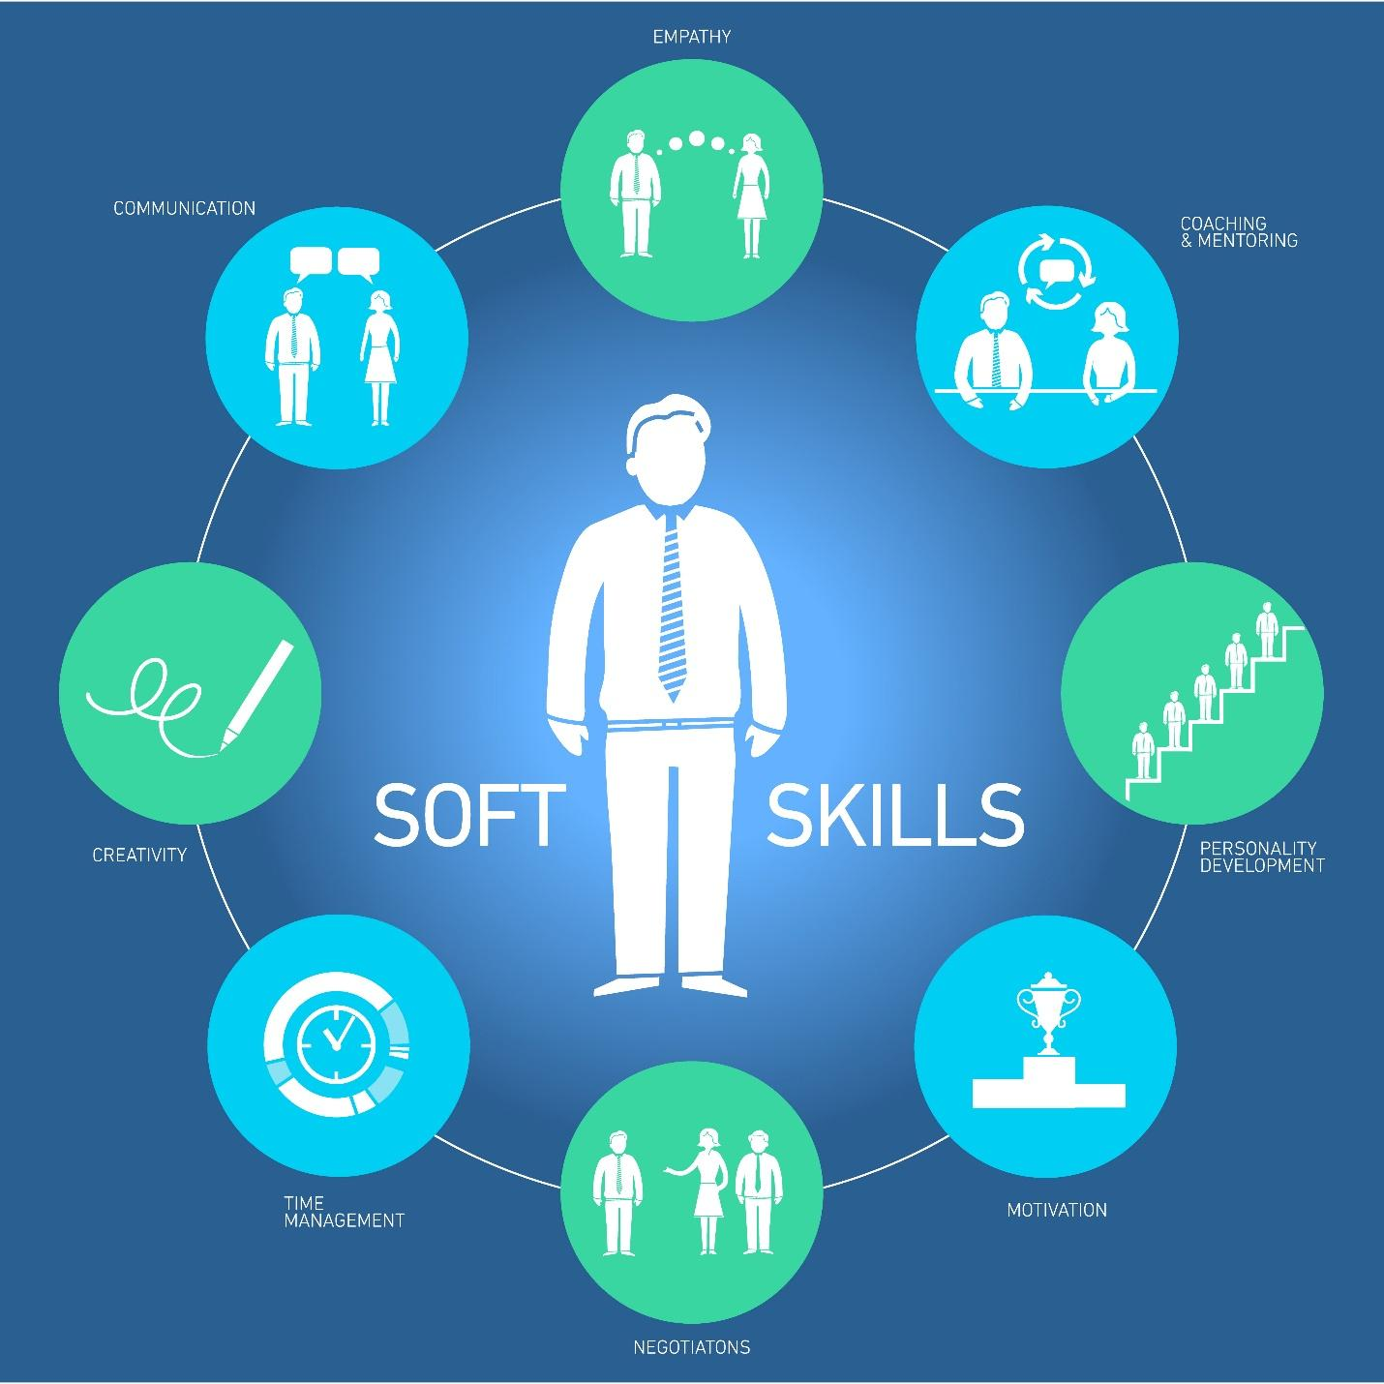
https://elearningindustry.com/soft-skills-key-everyones-employability-career-progression

LESSON 11

Unit of Instruction: Fanning the Flames
Lesson Topic: What does it mean to practice something?

Teaching Point: What do you or people you know practice? How often? Why?

Standard(s) Addressed in this Lesson:
- CDOS Standard 3a-Universal Foundation Skills: Students will demonstrate mastery of the foundation skills and competencies essential for success in the workplace.
- NYS “Next Gen” - Integration of Knowledge and Ideas; S7: Integrate and evaluate content presented in diverse media and formats, including across multiple texts.

The Lesson
View: Watch the first 5:55 of Mentor Me (Malcolm Gladwell edition).
10,000 hours = 416 days straight of practice.
= nearly 2.5 years of 12 hour/ day practice
= 7 years of 4 hour/day practices EVERY DAY
Michael Phelps, during peak training (see video), works out 5-6 hours a day six days a week, that’s 36 hours a week.

Respond: What is the purpose of practice? Gives you a place to fail, to learn, to try without judgement.

Engage: Artists know the value of practice, musicians, athletes, pilots know the value of practice. It allows us to mess up, to learn, to dedicate ourselves to something.
Check out the 100 Day Project. We don’t quite have 100 days together, but let’s brainstorm some ideas for a month-long project…(20 days is the time it takes to break or create a habit, one month of school is about 20 school days.)

Have students view and add their thoughts to the “What could you do with 100 days of making” brainstorm sheet (included with this lesson).

Say: Every day* for the next month in class we will spend the first 10 minutes on the hundred day project. What will yours be?

*Each day students are given time to create.

Optional: Just for fun - Pick one person’s 100 day project and have the whole class try it.
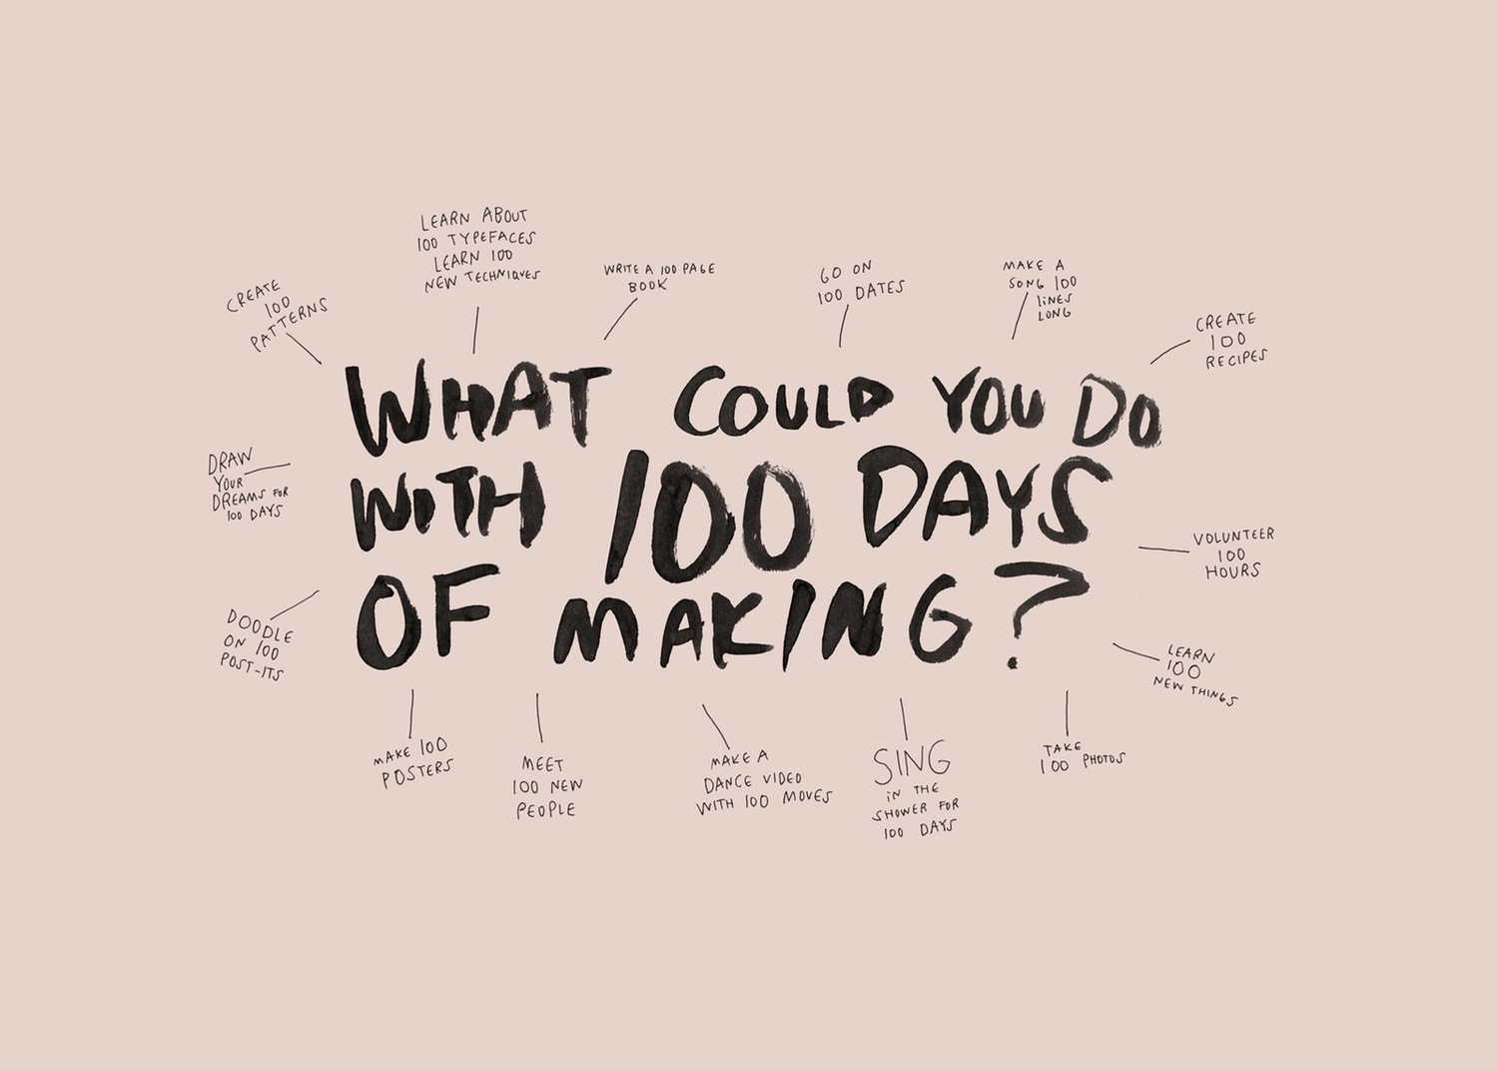
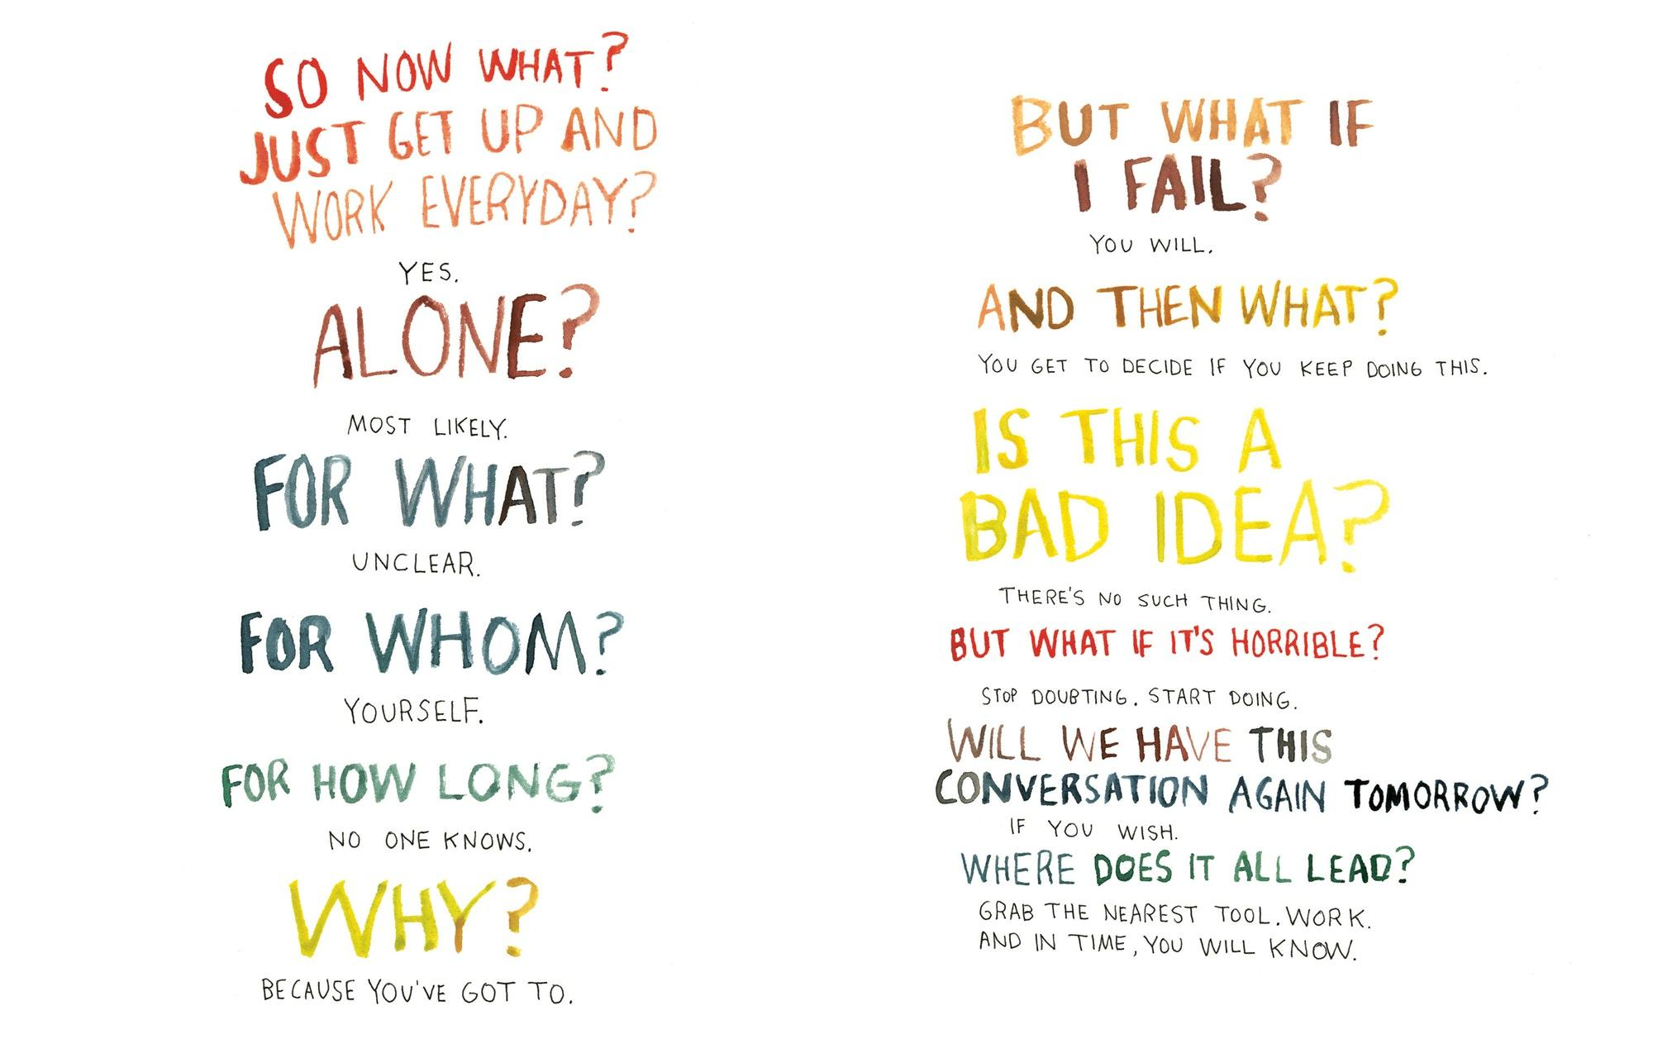
LESSON 12

Unit of Instruction: Fanning the Flames
Lesson Topic: How did the 100 Day Project Change You?

Teaching Point: Students will think critically about the work done on their 100 Day project

Standard(s) Addressed in this Lesson:
- CDOS Standard 1 – Career Development: Students will be knowledgeable about the world of work, explore career options, and relate personal skills, aptitudes, and abilities to future career decisions.
- CDOS Standard 3a-Universal Foundation Skills: Students will demonstrate mastery of the foundation skills and competencies essential for success in the workplace.
- NYS “Next Gen” - Integration of Knowledge and Ideas; S7: Integrate and evaluate content presented in diverse media and formats, including across multiple texts.

The Lesson:
View: Have students lay out all 20 days of their 100 Day project and open to a clean page in their Life Journal that will stay by their project. Have the class museum around the room looking at each person’s project.

Respond: Students respond by leaving notes for their classmates as they view each others’ journey.

Engage: Students return to their seats and write a reflection in their own Life Books: What changes did you notice in your own work? What changes did you notice in your actions/thoughts?

Summation: Practicing on a small scale, and practicing regularly allows you the room you need to learn, to make mistakes, to try without pressure. You can refine a skill or learn a skill by committing to the 100 day project.

LESSON 13

Unit of Instruction: Fanning the Flames
Lesson Topic: What are the Keys to Great Conversation?

Teaching Point: What is the last great conversation you remember having? Tell us about it. What made the conversation you had with all your friends in the basement last Friday night so good?

Standard(s) Addressed in this Lesson:
- CDOS Standard 1 – Career Development: Students will be knowledgeable about the world of work, explore career options, and relate personal skills, aptitudes, and abilities to future career decisions.
- CDOS Standard 3a-Universal Foundation Skills: Students will demonstrate mastery of the foundation skills and competencies essential for success in the workplace.
- NYS “Next Gen” - Integration of Knowledge and Ideas; S7: Integrate and evaluate content presented in diverse media and formats, including across multiple texts.

The Lesson
View: Celeste Headlee’s Tedx Talk

Respond: Students make notes in their Life Book as they listen to author, journalist, former host of National Public Radio, shows including Tell Me More, Talk of the Nation, All Things Considered and Weekend Edition. What are her 10 keys to good conversation?
Don't multitask.
Don't pontificate.
Use open-ended questions.
Go with the flow.
If you don't know, say that you don't know.
Don't equate your experience with theirs.
Try not to repeat yourself
Stay out of the weeds.
Listen.
Be brief.

Discuss good conversation: Good conversation has give and take and uses phrases like “tell me more about that!” “What do you mean?” “So, what you are saying is…”

Engage: Who are you going to have this great conversation with? List people you know or almost know (a friend of a friend of a friend) who has a job you would be interested in doing Find them! Use the Interview Me! handout as a guide (included with this lesson), but not as a script, to find out more about this job.

Summation: After the project is due, have students bring in their audio file and transfer the conversation into notes. Follow up with an Interview Me presentation day.

Interview Me!
(One Day You May Want my Job!)

For this project you will find someone you have never spoken to in detail about their job. This should be a person who has a job you are curious about, one you may want to do one day.

Notice there is very little space after each question. This should be a conversation not a Q&A. Talk with this person and talk well, be interested, be a good listener, be active in the conversation. Instead of making notes as you chat, record the whole conversation so you can put notes together at a later date.

Be prepared to be AMAZED by something this person has to teach you.

Possible Questions:
What is your job title?
What do you spend your days doing (please get specifics!)?
What schooling or education did you need to get this job?
Tell me what kind of student you were in high school.
How did you get this job? Tell me the story of how you got your start in this field.
What do you like most about your job? What do you like least about it?
What was the best advice anyone gave you? Who gave it to you? What advice would you give me?

