Jack and Jill

Jack and Jill went up the hill
To fetch a pail of water.
Jack fell down and broke his crown,
And Jill came tumbling after.

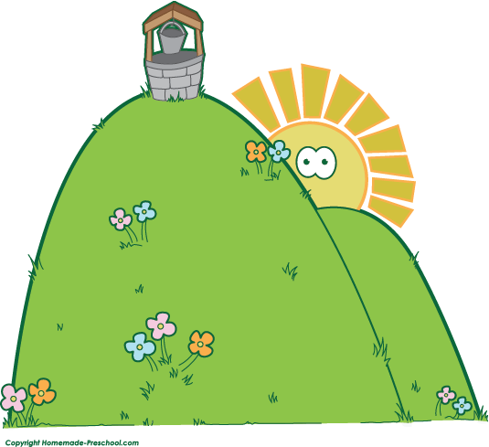

Identify problems in the story
Water is not easily accessible. | There isn’t enough water in the town/village for everyone, so people have to travel to get water.
The pail is too small to get enough water. | No one is on the hill to help people who can’t make it to the top.
Jack and Jill are too injured to get water for themselves.

What problem will you solve? | What is your solution? | What materials will you need?
1. Water is not easily accessible.  2. Water is not easily accessible. | 1. We will design a pulley system to get water from the well so that people don’t have to climb the hill.  2. We will design a pipe system to get water from the well to the bottom of the hill so that no one has to climb the hill to get water. | 1. rope, a large bucket, pulleys, support beams, wood, shovels, concrete  2. shovels, pipes, a spigot, etc.

