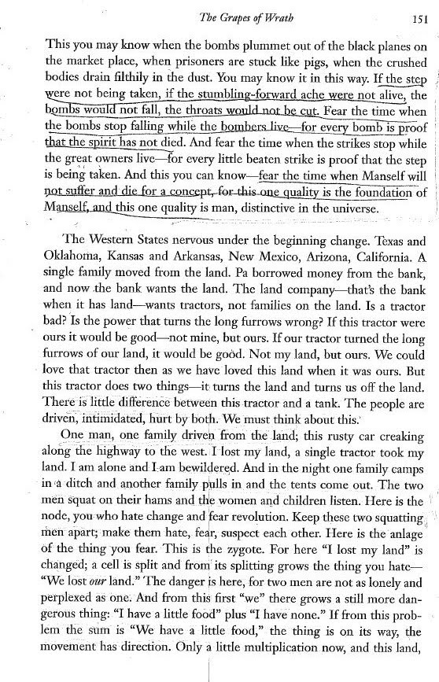

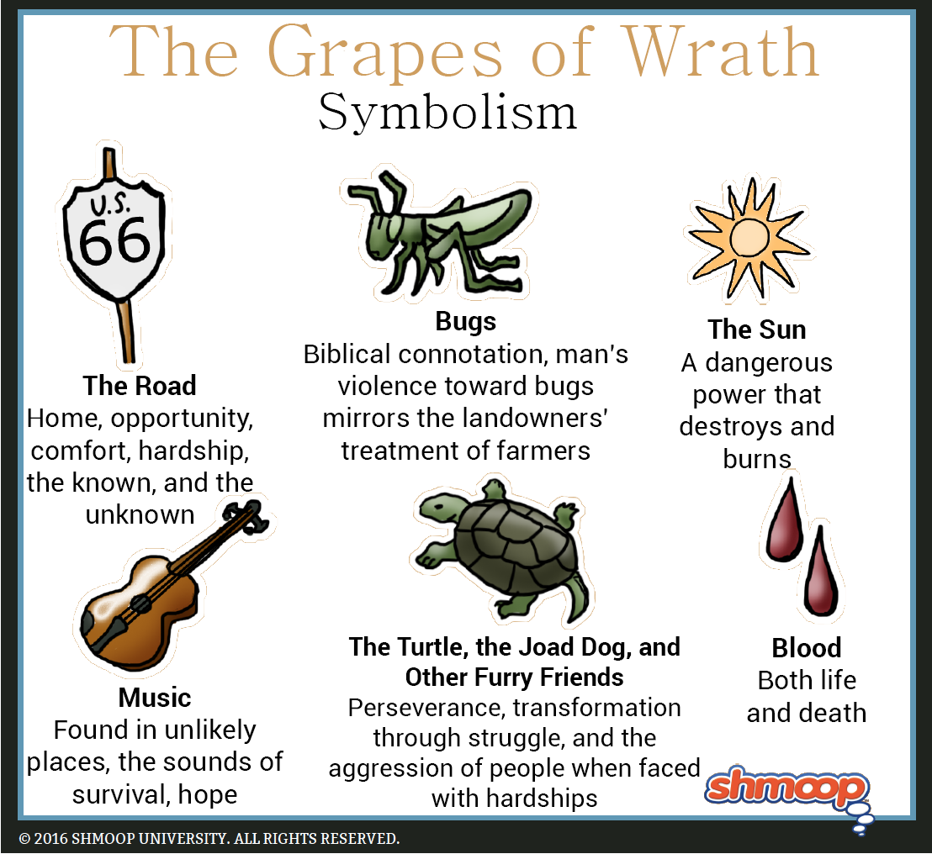

https://quizlet.com/73489561/grapes-of-wrath-flash-cards/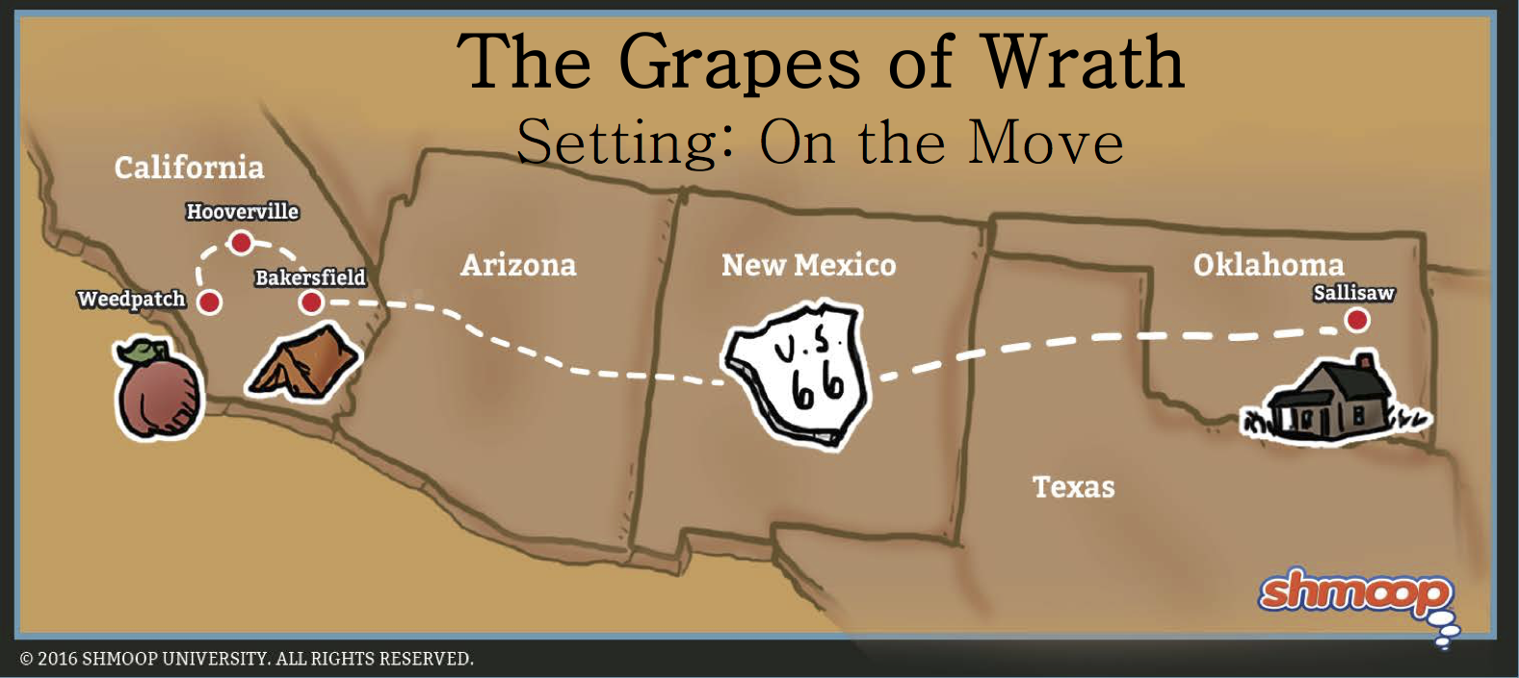

Link to quote analysis, elements of figurative language, theme
https://quizlet.com/73489561/grapes-of-wrath-flash-cards/

