Stations 2 & 3

Donatello
- Donatello was the 1st great sculptor of the Renaissance
- Donatello revived the classical (Greco-Roman) style of sculpture that were realistic & could be viewed from all sides
- Donatello’s “David” was the 1st large, free-standing human sculpture of the Renaissance

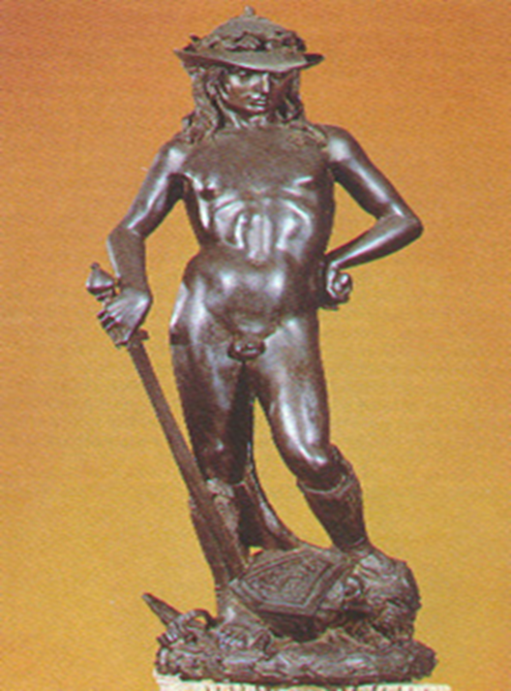Donatello

Michelangelo
- Michelangelo was one
of the most famous Renaissance artists:
- He was a painter, sculptor, architect,
& poet
- His sculptures & paintings showed realism, detail of
the human body, & expression to show personality & emotion

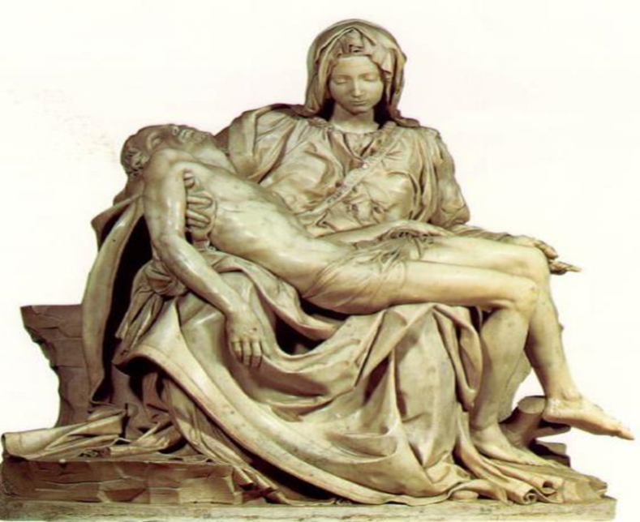
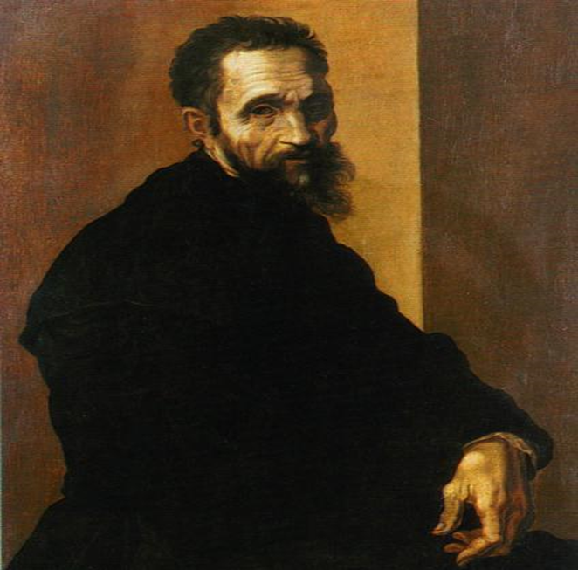
Michaelangelo

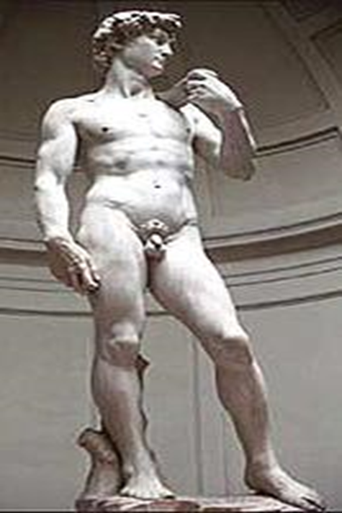

“Pieta” – Top Right
“David” – Bottom
Right

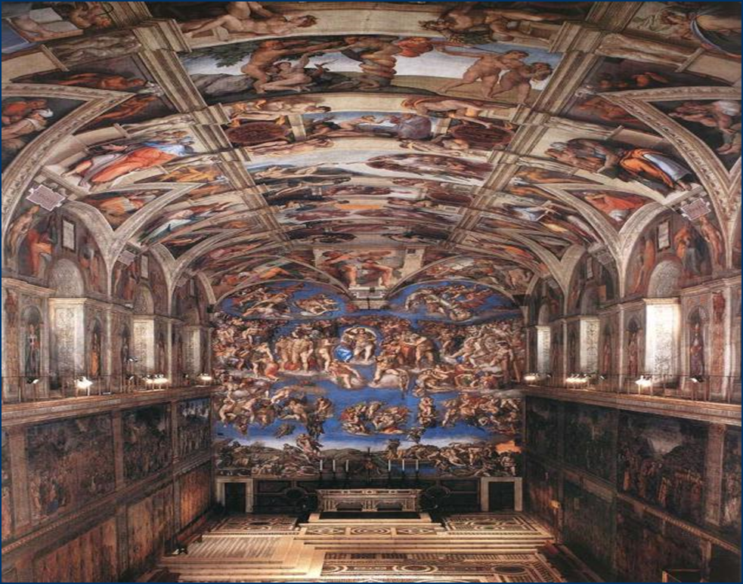
Michaelangelo’s
“Sistine Chapel”

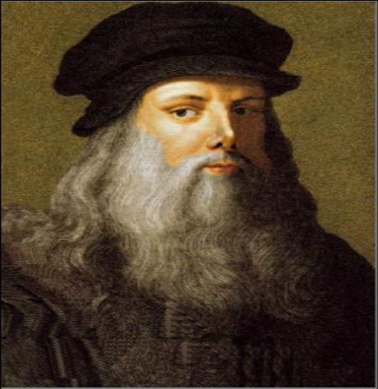
Leonardo da Vinci
Leonardo da Vinci was a
true “Renaissance Man”
- He was a painter &
sculptor whose art was known for incredible realism & emotion
He was also an inventor
& scientist whose sketches reveal observations about human anatomy & new engineering technology

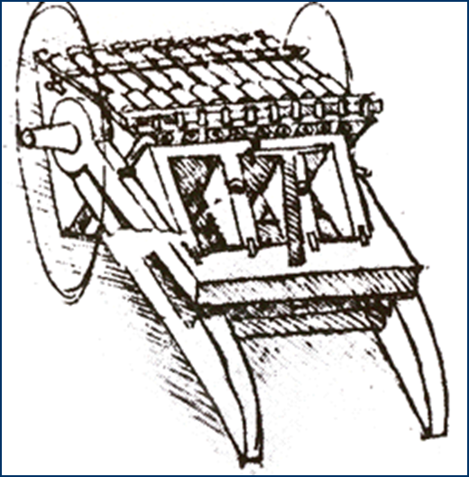
Leonardo’s Inventions
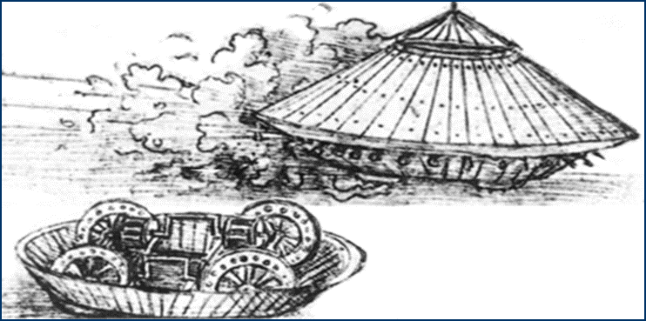

Da Vinci’s
“Last Supper”
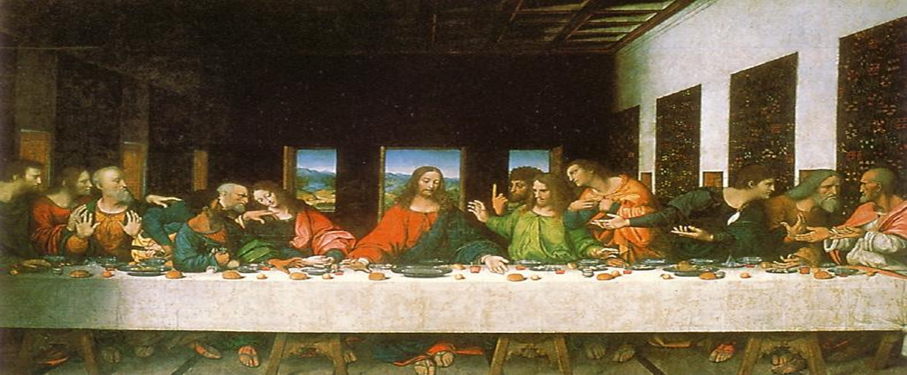

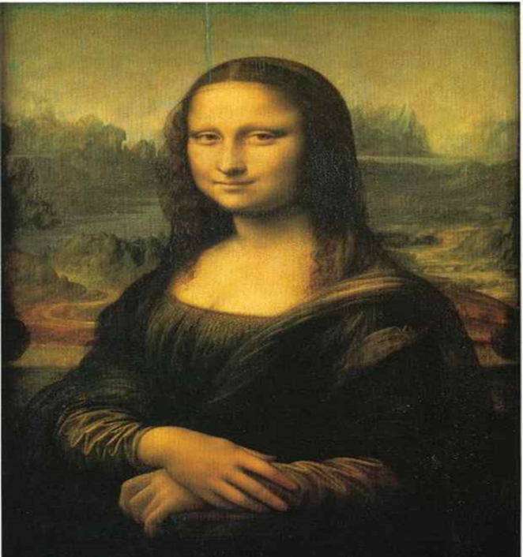

Mona Lisa

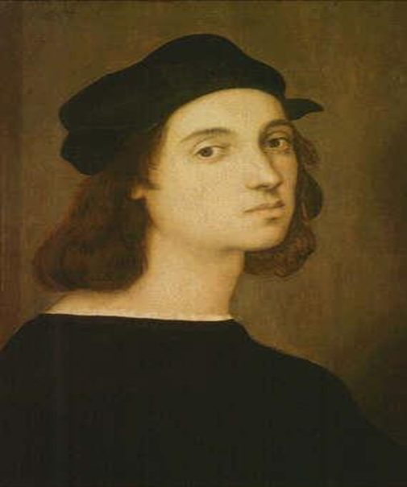
Raphael
- Raphael “perfected” Renaissance painting
- He improved perspective and realism by studying Leonardo & Michelangelo
- Raphael became the favorite painter of the Pope because of his amazing detailed paintings showing
a combination of famous Greeks & Romans along with Renaissance people
Raphael’s “Betrothal
of the Virgin”

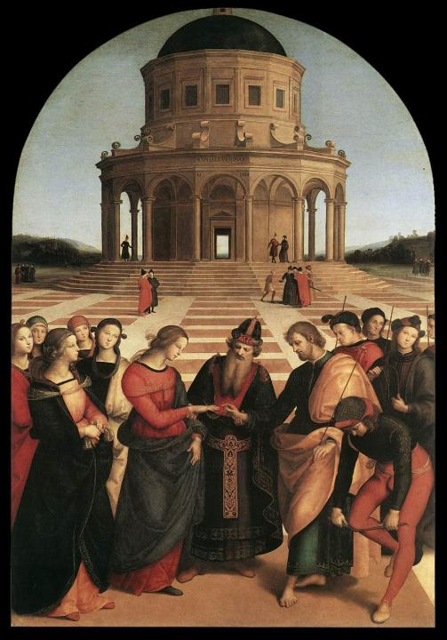

Rafael’s “School of Athens”
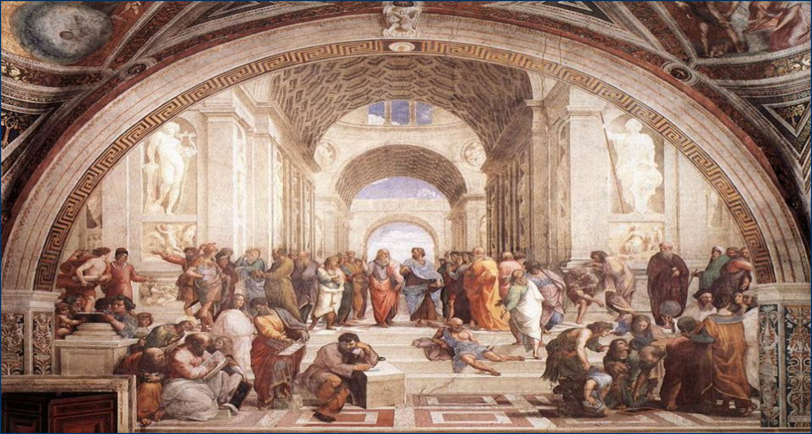

Filippo Brunelleschi
- Brunelleschi was Florence’s greatest architect:
- He studied the Roman Pantheon when he built the Cuppolo of Maria del Fiore cathedral in Florence
- The dome inspired modern building designs
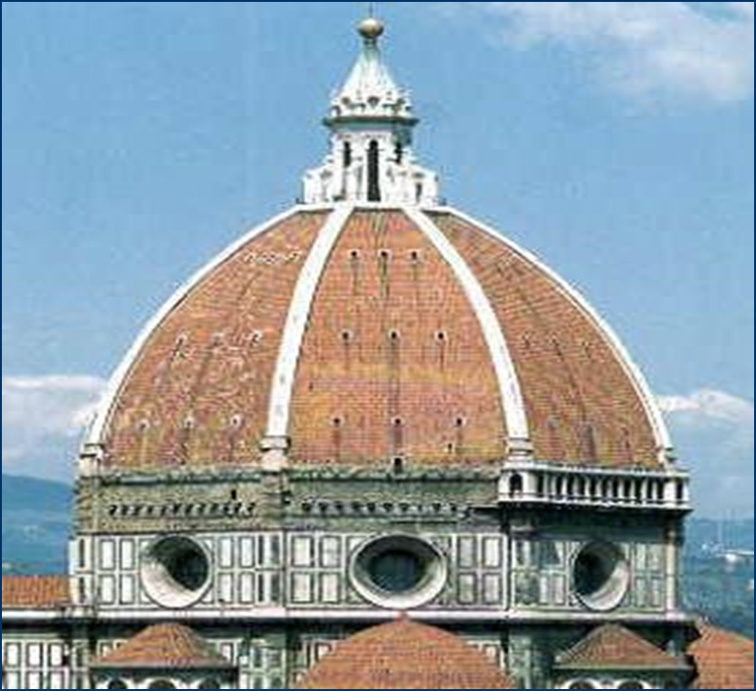
Il Duomo, France
US Capital Washington, D.C.

