Name _______________________
Date _______________ Bl _____

The Italian Renaissance
(choose your favorite piece of art, architecture, or literary quote from the Renaissance and print and paste or draw it below
and explain in 3-5 sentences its significance to the Italian Renaissance).
STATION 1A: Trade in the Renaissance—Trace the growth of trade during the High Middle Ages and Renaissance  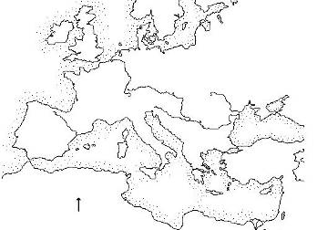  SSWH9a. Explain the social, economic, and political changes that contributed to the rise of Florence. | 1. Who did Italian merchants trade with during the High Middle Ages & Renaissance?  2. What “luxury” products did merchants bring to Italy?  3. How might the growth of trade in Europe help bring about the rise of the Renaissance in Italy?  4. How does geography influence the rise of Florence as a city-state?
STATION 1B: Population Changes in the Renaissance—Use the data provided to chart the population changes in 3 Italian city-states  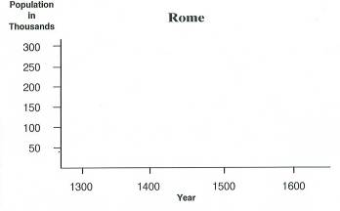  KEY: Identify each City State with a Color below.  Venice:  Florence:  Rome:  SSWH9 a. Explain the social, economic, and political changes that contributed to the rise of Florence.  Map/Globe Skills: 6, 7, 8, 10, 11  Info Processing: 1, 7, 8, 9, 11, 12 | 1. Which city-state had the most people by 1600?  2. Which city-state had the largest population growth from 1300-1600?  3. What trend do all these Italian city-states have in common?  STATION 1C:  Does the data from Station 1 support the reading in 1C? Explain why it does or does not using specific evidence from your text and the data (goal 4-5 sentences below):

STATION 3: Classical, Middle Ages, &. Renaissance Art—Examine the chart and images provided to answer each question below:
A. Identify each as “Classical,” “Medieval,” or “Renaissance” (Each sentence may describe more than 1 style)  ________ 1. Figures in art look perfect, realistic  ________ 2. Art was used to teach people about the Catholic Church  ________ 3. Gold was often the main color used  ________ 4. Backgrounds were deep & used perspective to show distance  ________ 5. Stain-glassed windows  ________ 6. Did not show emotion  ________ 7. Showed important people, not ordinary daily life  ________ 8. Showed nudity  ________ 9. Showed people moving  ________ 10. Art showed religious themes  ________ 11. Used light to show depth  SSWH9b. Identify artistic and scientific achievements of the Renaissance.  Info Processing: 1, 8, 10, 11, | B. Renaissance or Medieval Art? Determine which era fits each picture. See teacher for answers!  1. ____________________________________  2. ____________________________________  3. ____________________________________  4. ____________________________________  5. ____________________________________  C. Examine the 5 pages of art and architecture. After examining and discussing with your team, answer the following questions:  1. What is “perspective” as it relates to Renaissance Art?  2. Explain three key differences between Medieval Art and Renaissance Art.  3. How does Brunelleschi’s Dome exemplify the ideals of the Renaissance?  4. Is humanism found in the art and architecture of the Renaissance? Explain why or why not using at least two pieces of evidence from the pictures given in this station (goal 5-8 sentences below):
STATION 4: Spreading of Ideas  1. Read each of the informational texts in the folder.  2. For each of the following people, create a Frayer Model:  a. Johannes Gutenberg  b. Galileo Galilei  c. Nicolaus Copernicus  d. Erasmus  3. Describe how Renaissance scientists and writers were able to spread their ideas and why they believed it was important to do so:  SSWH9 a. Explain the social and economic changes that contributed to the rise of Florence.  SSWH9b. Identify artistic and scientific achievements of the Renaissance.  SSWH9d. Explain the importance of Gutenberg and the invention of the printing press  Info Processing: 1, 5, 8, 11, 15 | Frayer Model for these Key Figures:
  Contribution(s) to the Renaissance:
  Name of Key Figure
  Consequences of Ideas/Invention:
  Benefits of  Ideas/Invention for Society: | How do the contributions of this figure impact our world today?
Use the space below and on the back of this paper to complete all Frayer models.

STATION 5 - A: Social Classes in the Renaissance—Examine the readings & pictures, and complete the chart below  Who are the “grandi”?  Who are the “popolo grassi”?  Who is the “middle class”?  Who are the “working class”  SSWH9a. Explain the social, economic, and political changes that contributed to the rise of Florence.  Info Processing: 1, 3, 11 | 1. Who are the “new rich” in Florence?  2. Which group (in your opinion) most deserves to rule over the people of Florence? Give two justifications for your decision.  3. How is the social structure during the Renaissance different from the social structure of the Middle Ages?  4. Is the societal structure of the United States like the one in Florence? Below, draw another pyramid, explain who would be in each of these categories in our society and who you think should have the most power in our society today?
STATION 5- B: Middle Ages vs. Renaissance Outlook on Life—Read 5-B. Complete the sentences for each. What does each of the
readings make you think, feel, and wonder (ask some questions). Your goal is 2 statements per quote circle:
Peasant in the Middle Ages
Renaissance Man

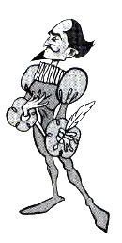
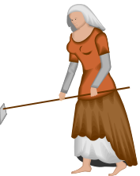

SSWH9a. Explain the social and economic changes that contributed to the rise of Florence.

Info Processing: 1, 4, 5, 11,
I think…
I feel…
I wonder…
I think…
I feel…
I wonder…

Station 6: Politics and Power:
Using the documents given, complete the following activities.

1. Why do you think Cosimo Medici is considered the “Godfather of the Renaissance?” (3-5 sentences)

2. Complete a KIDS chart on “Patronage.” An example is given in the packet.
K (Key word) | Patronage
I (Important Info)
D (Drawing)
S (Sentence – This should be an original sentence)

5. How did the government of Florence support the Renaissance?

SSWH9a. Explain the economic and political changes that contributed to the rise of Florence.
Info Processing: 8, 9,
STATION 7: Leonardo da Vinci—Leonardo was a great artist & inventor. Guess what each of inventions is. Confirm your answers by looking on the back of each picture (Hint: Leonardo wrote backwards!!)
A. What do you think it is? ____________________________________ (Confirm your answer)

B. What do you think it is? ____________________________________ (Confirm your answer)

C. What do you think it is? ____________________________________ (Confirm your answer)

D. Using your text and an internet search, figure out why Leonardo Da Vinci was considered the ultimate “Renaissance Man.” List the factors here:

E. Who would be a Renaissance Man or Woman in our society today?. Add a page to the back of this packet with a collage of pictures OR a hand-drawn representation of your modern-day Renaissance Man/Woman. At the very bottom of the page, justify your answer with a thesis (argumentative statement) as to why that person is a Renaissance Man/Woman.

SSWH9b. Identify artistic and scientific achievements of the Renaissance
Info Processing: 16, 4, 11, 8,

STATION 2: Renaissance Artists  1. Read each of the small excerpts on the Renaissance Artists. Pay special attention to their art. Complete a Frayer Model on each of the key artists.  2. Choose one artist to complete a biographical poem for.  To write the biographical poem, follow this format:  Line 1: Four adjectives describing the person  Line 2: Relative (Son, Daughter, Husband, Wife) of…  Line 3: Resident of (city and/or country)…  Line 4: Who lived from (year to year)  Line 5: Who studied….  Line 6: Whose talents included …  Line 7: Who believed…  Line 8: Who is remembered for…  Line 9: First and Last name  Example:  Honest, tall, courageous, thin  Husband of Mary and son of illiterate parents  Resident of Washingtion, D.C.  Who lived from 1809 to 1865  Who on his own studied grammar, mathematics, and law  Whose talents included leadership, good judgment, and speaking  Who believed the Union should be saved above all  Who is remembered for his insight, the Emancipation Proclamation, and missing the end of a play  Abraham Lincoln | Frayer Model for these Key Figures:  SSWH9b. Identify artistic and scientific achievements of the Renaissance.  Info Processing: 1, 4, 11, 15,
  Contribution(s) to the Renaissance:
  Name of Key Figure
  How does their art embody humanism?
  What are special features of their type of art (geometry, perspective, etc)? Give examples. | How do the contributions of this figure impact our world today?
Use the space below and on the back of this paper to complete all Frayer models. Write the biographical poem, as a group, on an anchor chart to put around the classroom.

STATION 3
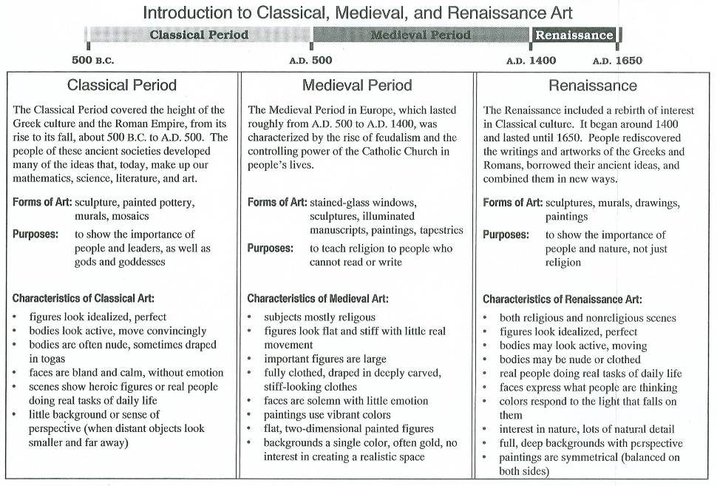

STATION 3 Middle Ages vs. Renaissance Art

#1 #2 #3
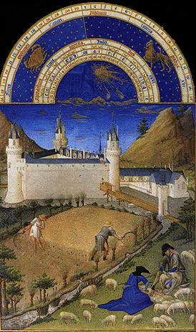
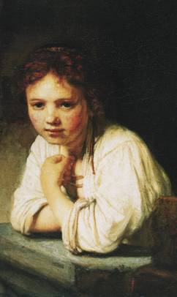
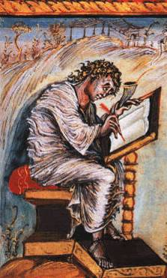

#4 #5
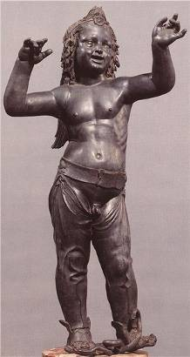
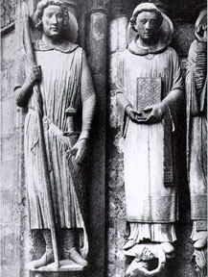

STATION 4

Insert Brunelleschi dome reading here

STATION 5
Social Classes in the Renaissance

Within Renaissance city states like Florence, competition among different social classes was intense. There were four major social groups in Florence, which is relatively representative of other city-states in Italy at the time. Those social classes included:

- The grandi—the “old money” nobles who had moved into the city to take part in its growing wealth and prestige. These families were old, and used to ruling. They saw it as their birthright to be the rulers of the city, and believed that only their experience would be effective in managing the people of Florence.

- The popolo grasso—Florence’s “new rich”—bankers, merchants, traders, saw themselves as the legitimate rulers because it was their money and activities that had contributed to the growing wealth of the city, and they employed most people in Florence. Therefore, they thought they should run the place.

- The shopkeepers, artisans, and small traders—because they were the largest group of business people, who controlled trade inside the city, had contact on a daily basis with the most citizens of Florence, and as a group processed huge sums of money, saw themselves as the true local leaders. Their interests were local, their business was local, their customers were local, and their money was local. This made them, in their own eyes, the ultimate citizens of Florence and, therefore, they felt they should lead.

- Working class—These people made up the 30,000 textile workers of Florence, as well as supplying labor in other industries, including the spice, silk, and porcelain trades run by the grandi and the popolo grasso. These people felt that, as the biggest single segment of the population, and as the engines of the economy (without labor, everything would shut down) they should be the leaders of Florence.
STATION 2

Population Changes in Renaissance (1300 to 1600)

During the High Middle Ages and Renaissance, European city-states began to undergo significant population changes. The northern Italian city-states of Florence, Venice, and Rome are excellent examples. Use the information in the chart below to complete the table o your handout. You will plot the population for each city from 1300 to 1600. It would be advisable to use three different colors on this chart, one for each city-state. When finished, answer the questions provided.

 | 1300 | 1400 | 1500 | 1600
Florence | 90,000 | 60,000 | 110,000 | 190,000
Rome | 40,000 | 25,000 | 50,000 | 110,000
Venice | 200,000 | 110,000 | 115,000 | 150,000

STATION 6
Middle Ages vs. Renaissance—Outlook on Life

Outlook on life:
Middle Ages: During the tough times of the Middle Ages, most Western Europeans were focused on their Roman Catholic religion and the afterlife. They lived their lives according to the rules of the Catholic Church in hopes of reaching Heaven when they died.

Renaissance: By the 1300’s, especially in Italy, a shift had taken place. People were more focused on enjoying their lives while they were on Earth, although most people still practiced Roman Catholicism. Artists, writers and other individuals were eager to be known and remembered as individuals. Fame became a reward for talent and wealth. Wealthy merchants were willing and able to spend money on portraits of themselves or relatives. Autobiographies began to be written because people believed that their lives were interesting and important not just to themselves, but to others.

Education:
Middle Ages: The Middle Ages are often referred to as the Dark Ages. This is how the scholars of the Renaissance viewed the Middle Ages. They thought that Western Europe has been living in darkness and ignorance since the fall of the Roman Empire. Many people had forgotten how to read and write. Priests and monks were typically the most educated people because they operated schools, maintained libraries and copied books.

Renaissance: Humanists during the Renaissance loved and studied the writings of ancient Greece and Rome. They believed in the potential of all humans and that education was the way to enable people to reach their full potential. Renaissance artists and thinkers wanted to learn more about the world around them, including the human body and how it worked

Clothing:
Middle Ages: In the Middle Ages, devoutly religious people proved their devotion to their religion by wearing poor, rough clothing and living on the plainest foods. This was modeled by the monks living in monasteries.

Renaissance: Humanists suggested that a person might love and enjoy life without offending God. In Renaissance Italy, almost everyone with money openly enjoyed luxurious fabrics, fine music, tasty foods and beautiful surroundings; in fact, clothing itself became a work of art.
STATION 1
Trade in the Renaissance

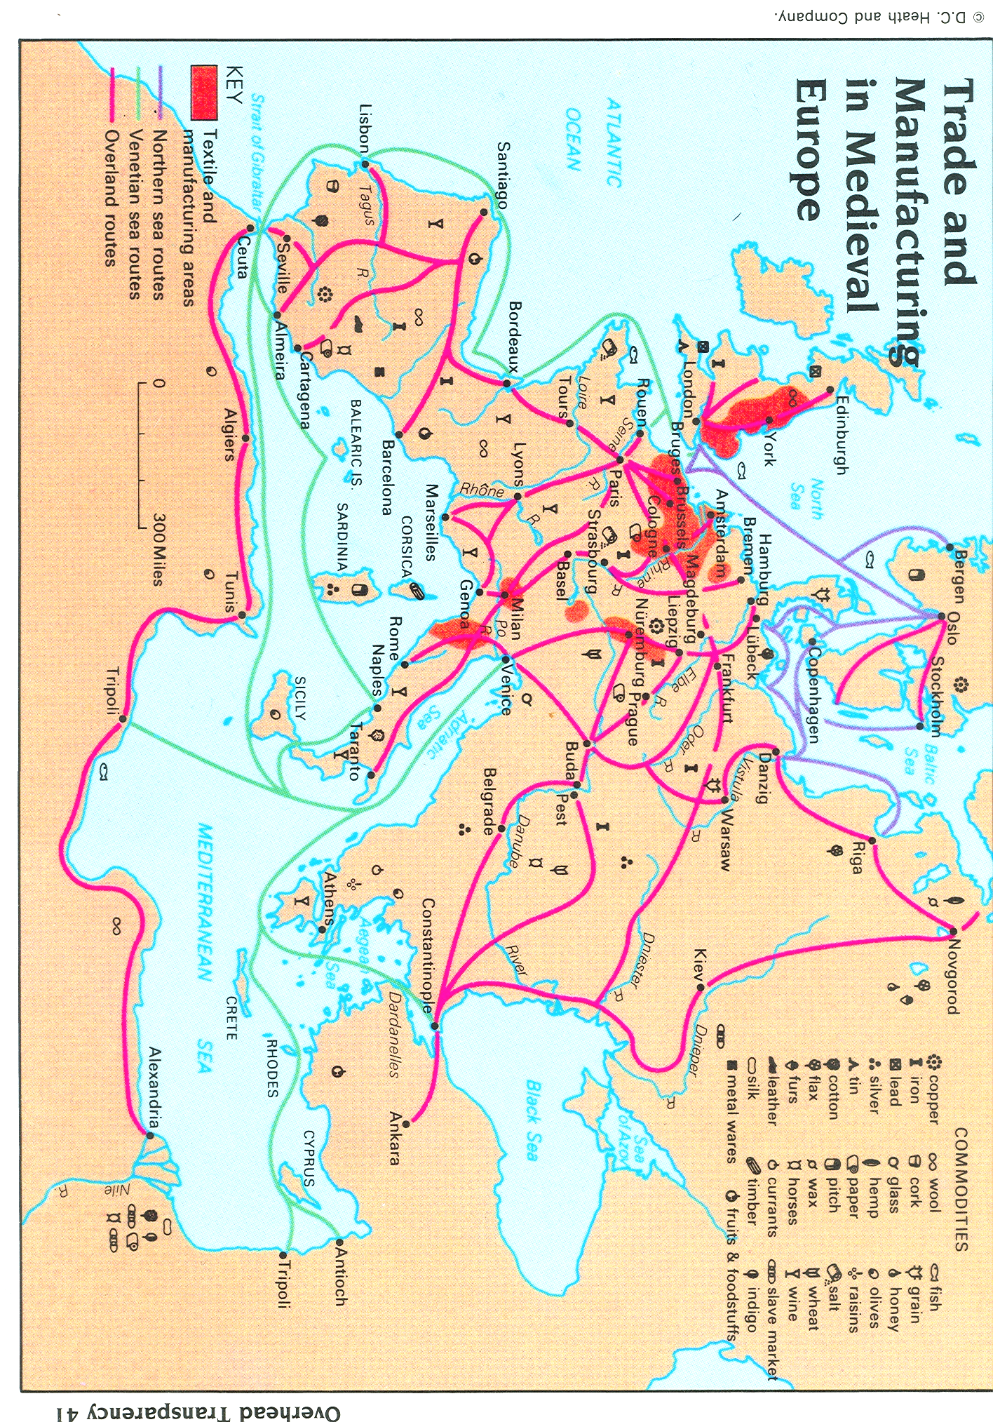
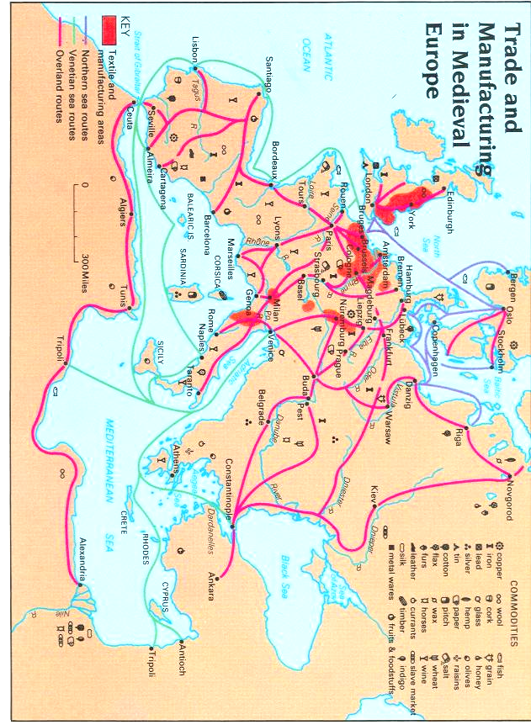
STATION 7
Leonardo da Vinci’s Inventions #1

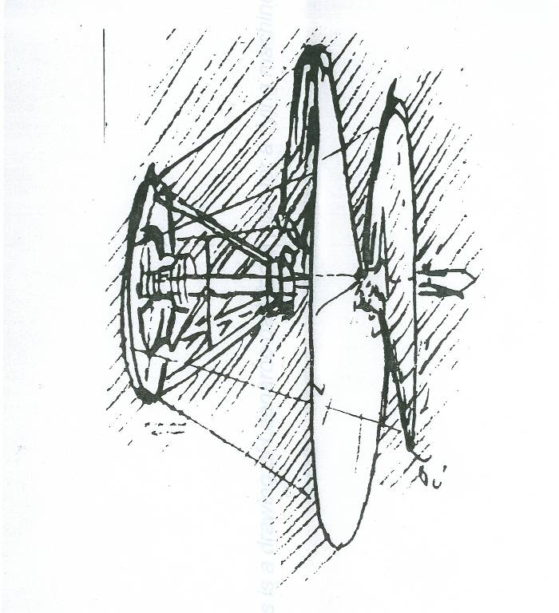
Leonardo da Vinci’s Inventions #1

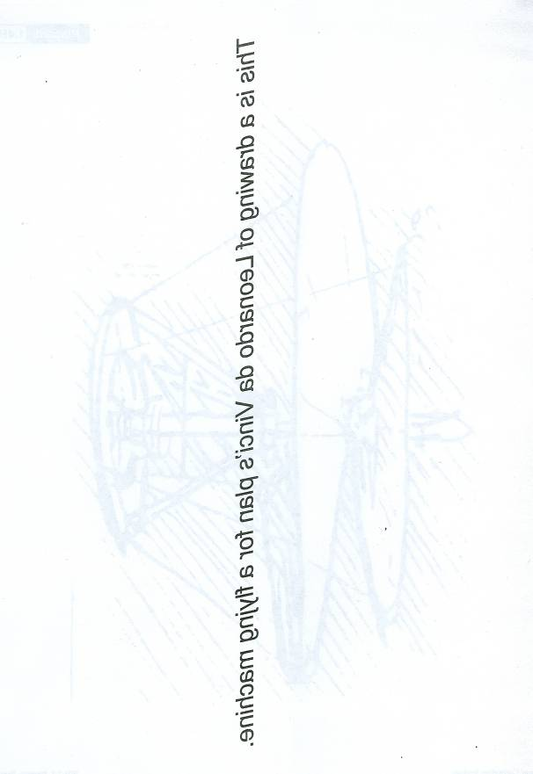
STATION 7
Leonardo da Vinci’s Inventions #2

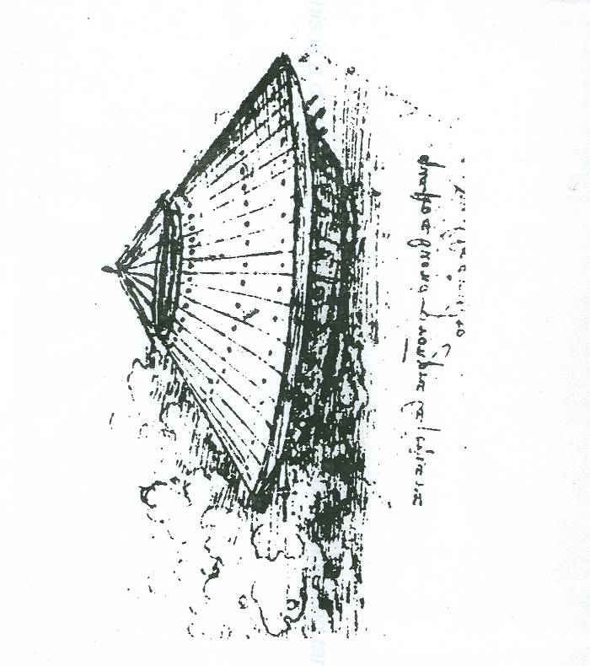
Leonardo da Vinci’s Inventions #2

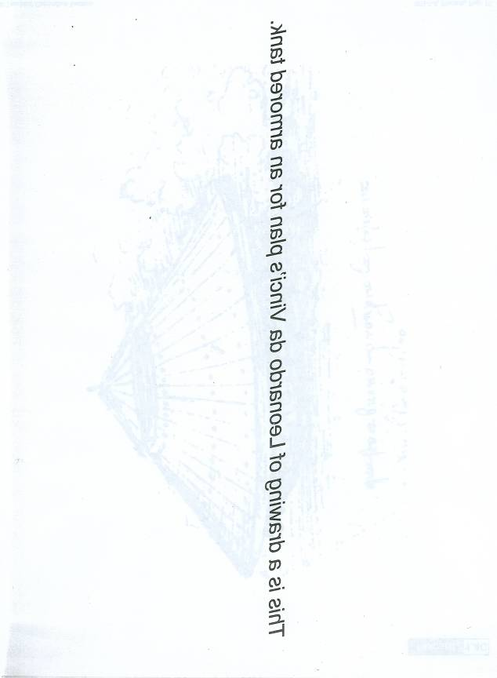
STATION 7
Leonardo da Vinci’s Inventions #3

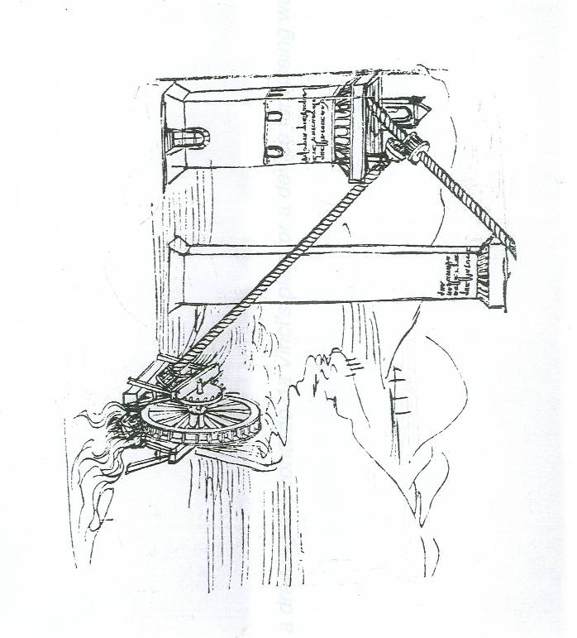
Leonardo da Vinci’s Inventions #3

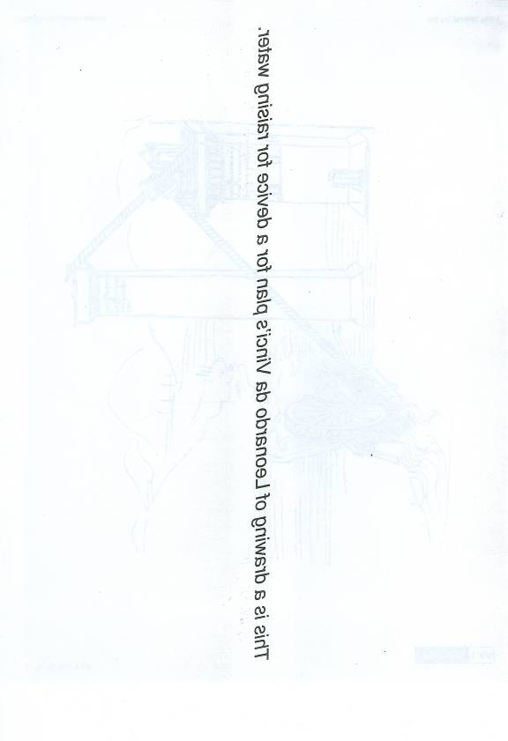

STATION 8
The powerful Medici Family

Giovanni Medici was born but his cousin Vieri gave him a job in the family business, the Medici Bank. Giovanni ran the Rome branch of the Medici Bank so well that he took over the entire enterprise when Vieri retired. Giovanni chose his banking clients carefully; he demanded loyalty, as well as profit. In 1410, Giovanni Medici helped an old friend (and former pirate), Baldassare Cossa, become Pope of the Roman Catholic Church. When Cossa became Pope (Pope John XXIII), he gave the Medici Bank full authority to handle the money of the Roman Catholic Church. Giovanni became “God’s banker” and grew very powerful.
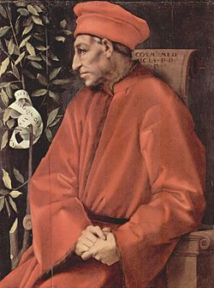
Giovanni’s son, Cosimo de Medici, was trained in banking from a young age. Unlike his father, Cosimo was more eager to learn about things other than banking. As a young man he attended lectures in classical philosophy and literature and became one of the first generation of Humanists. Cosimo encouraged his father to invest their wealth in art projects to benefit the city of Florence.

After his father’s death, Cosimo assumed leadership of the Medici Bank. He used his wealth and power to rule Florence. In addition, Cosimo invested in art and learning, helping transform Florentine into the leading Renaissance city. During his lifetime, he commissioned artists such as Lippi, Donatello, Michelozzo and Gozzoli to create magnificent works of art to show off the wealth of Florence but also his power as ruler of the city. Cosimo’s power made him the “Godfather of the Renaissance. “

