INQUIRY BASED LESSON PLANS
Teacher: 5th Grade  Whitney Quattlebaum | Expected length of lesson/unit: 3 weeks | Lesson Topic: Citizenship Business and the Government | Unit: 2

 | Standards-Based Instructional Focus | Targeted Content Standards/  Element:  (Include the entire standard) | SS5CG1Explain how a citizen’s rights are protected under the U.S. Constitution. (Week 1)  a. Explain the responsibilities of a citizen.  b. Explain the concept of due process of law and describe how the U.S. Constitution protects a citizen’s rights by due process.  SS5CG2 Explain the process by which amendments to the U.S. Constitution are made. (Week 2)  a. Explain the amendment process outlined in the Constitution.  b. Describe the purpose for the amendment process.
 |  | Targeted Literacy Skills or Standards: (include as many as your lesson incorporates) | ELAGSE5RI9: Integrate information from several texts on the same topic in  order to write or speak about the subject knowledgeably.  ELAGSE5W2: Write informative/explanatory texts to examine a topic and convey ideas and information clearly.  ELAGSE5SL5: Include multimedia components (e.g., graphics, sound) and visual displays in presentations when appropriate to enhance the development of main ideas or themes.
 |  | Targeted SS Matrices: (include as many as your lesson incorporates) | Information Processing Skills: 3. Identify issues and/or problems and alternative solutions. (M)  10. Analyze artifacts (M)  15. Determine adequacy and/or relevancy of information (M)  16. Check for consistency of information (M)  17. Interpret political cartoons (D)
 |  | Inquiry Question (or what you would like the students answer)?  (*Teachers may present the question or require students to develop questions and narrow down to this one). | The measurable objective for this lesson is that the students should be able to explain how citizen’s rights are protected under the U.S. Constitution. By the end of the lessons, students will be able to explain the responsibilities of a citizen as well as the concept of due process of law. Students must be able to describe how the U.S. Constitution protects citizens’ rights by due process.  Why is she behind the bars? (What is a responsible citizen?)  What does due process mean?  Inquiry question: What are the rights and responsibilities of a responsible citizen?
 |  | Key Vocabulary:  Words important for understanding content and skills (ex: Tier 2 and 3 words) | Tier 1  Responsibility  Citizen | Tier 2  Amendment  U.S. Constitution | Tier 3  Due Process
 | Learning Targets  (I-Can Statements)  ***At the end of the week, what will students know and what will students be able to do? |  | Foundational:  I can explain the responsibilities of a citizen.  I can explain the concept of due process of law.  I can describe how the U.S. Constitution protects a citizen’s right by due process.  I can explain the amendment process as outlined in the Constitution.  I can describe the purpose for the amendment process.  Mastery:  Explain the responsibilities of a citizen.  Explain the concept of due process of law.  Describe how the U.S. Constitution protects a citizen’s right by due process.  Explain the amendment process as outlined in the Constitution.  Describe the purpose for the amendment process.  Extension:  Students will create a scenario that reflects an example of how the responsibilities of a citizen connect to due process of law.  Directions for the 5E Portion: Attach all 5E resources to the back of this plan in order of use. Please indicate how long you plan for each session to take. Include in your description a notation of the literacy standards or Social Studies Matrices for the activity which they align with.
 | ENGAGE  Describe how the teacher will capture students’ interest.  What kind of questions should the students ask themselves after the engagement? |  | Day 1: (30 minutes)  Students will be shown a political cartoon on due process (see attached). Students will Think, Pair, Share to develop questions they have about the picture. Using the Question Formation Technique (thick, thin questions; open-ended questions, etc.) students will develop a range of different questions and as a class discuss which questions are closed (having yes or no answers) and which questions are open (having more than one answer). Below, is a list of questions the students could develop:  1. Why is she behind the bars?  2. Why does the lady have a scale?  3. Why are the two men outside the bars and the woman inside the bars?  4. What does the sign mean on the bars?  5. Are the men angry?  6. What does detaining mean?  7. What does due process mean?  9. Why does the old man on the right have a thumbs up?  Teacher and students evaluate the questions, looking for the question(s) that the students most want to learn about. As a class, with direction from the teacher, questions 1 and 7 are chosen:  Why is she behind the bars? (What is a responsible citizen?)  What does due process mean?  Help the kids form a question with all of these in mind:  Inquiry question: What are the rights and responsibilities of a responsible citizen?  ELAGSE5SL5  Information Processing Skills: 3, 10, 16
 | EXPLORE  Describe what hands-on/minds-on activities students will be doing.  List “big idea” conceptual questions the teacher will use to encourage and/or focus students’ exploration |  | Day 2: (30 minutes)  To clarify misconceptions and to begin focus on specific learning targets the following activity will be completed:  Students will explore, in groups of 3-4, some items that are related to due process law. In bags, the following items can be used: picture of handcuffs, voter registration card, a picture of a judge, a gavel, a balance/scale.  As a whole group, introduce the graphic organizer: I See, I Think, I Wonder (see attached). Students will then split into different groups to work on the activity with their graphic organizer and bags. Students will begin by exploring the items in their bags as the teacher walks around the room to ask students questions about the items.  Next, students will write down the things that “I See” on their graphic organizer. As students are working, the teacher will discuss with different students their observations.  Once students have completed “I See” portion of the graphic organizer, students will work on the “I Think” section of the graphic organizer. Ask them to write at least two sentences about how the learning target questions are connected to the items in the basket. Teacher will facilitate the classroom during this time reminding students to connect questions and clarify any questions that may arise.  Lastly, students will complete their “I Wonder” portion of the graphic organizer. Students will be asked to create questions they have about the items in the basket and write it in the “I Wonder” section of the graphic organizer. Remind students that their questions need to connect to the items in the basket with the lesson questions from the political cartoon on due process. Once students have completed their questions, they will share their questions and discuss if it aligns with the learning targets.  Information Processing Skills: 3, 10, 15, 16
 | EXPLAIN  Student explanations should precede introduction of terms or explanations by the teacher. What questions, resources, or strategies will the teacher use to help students connect their exploration to the concept under examination?  List higher order thinking questions which teachers will use to solicit student explanations and help them to justify their explanations.  Describe how the teacher will clarify the content or skill. |  | Day 3: (30 minutes)  Students will watch the BrainPop video: Bill of Rights. The video will be stopped at the part that discusses Due Process. The teacher will expand upon how this is a portion of the constitution.  Students will then work in groups and/or partners to complete the following activity. They will be given a picture to represent due process and its definition. Students will plan out a scenario that involves a situation where due process would have to take place.  Students will act their scenario out in front of the class. Other classmates will select one scenario that was presented to explain how it represents the concepts of due process of law. The teacher will help clarify any misconceptions that may take place during this time.  (As an alternative students can present to other groups of students instead of whole group for time. The teacher will walk around to different groups to help answer questions and clarify any misconceptions that may take place.)  ELAGSE5SL5  ELAGSE5W2  Information Processing Skills: 3, 10, 15
 | ELABORATE  Describe how students will develop a more sophisticated understanding of the concept.  What vocabulary will be introduced and how will it connect to students’ observations?  How will students make real-life connections? |  | Day 4: (30 minutes)  As a whole group, students will revisit the learning target questions to decide if they have enough knowledge to explain the responsibilities of a citizen and explain the concepts of due process of law.  Different citizens’ rights will be displayed around the classroom (see attached). Students will rotate around the classroom to each poster displaying citizens’ rights. They will discuss with their group and write in their journal the responsibilities go along with each right.  After the activity is completed, the teacher will lead a class discussion identifying a responsibility that students came up with for each right that was displayed on the wall. (Limit based on time). Teacher will provide sentence stems (see below) for students as they share their answers, reminding them to make connections to their learning target? What is due process? What is a responsible citizen?  Sentence stem ideas:  1. ____________is important to my everyday life because ________________.  2. If it wasn’t for due process, then __________________________________.  3. In order for me to be a responsible citizen I must _____________________.  ELAGSE5RI9  Information Processing Skills: 3, 10, 15
 | EVALUATE  How will students be evaluated THROUGHOUT the lesson?  How will students demonstrate that they have mastered the learning target(s)? |  | Day 5: (30 minutes)  Students will exhibit understanding of the lesson’s objectives by completing a quiz (see attached) identifying due process and the responsibilities of a citizen.  ELAGSE5W2  Information Processing Skills: 16

Day 1:
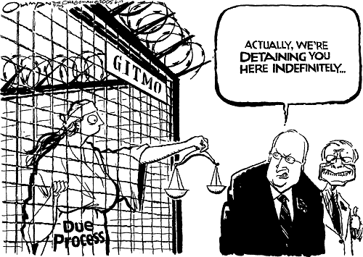

Day 2: (These templates can be found by Google Image Search)
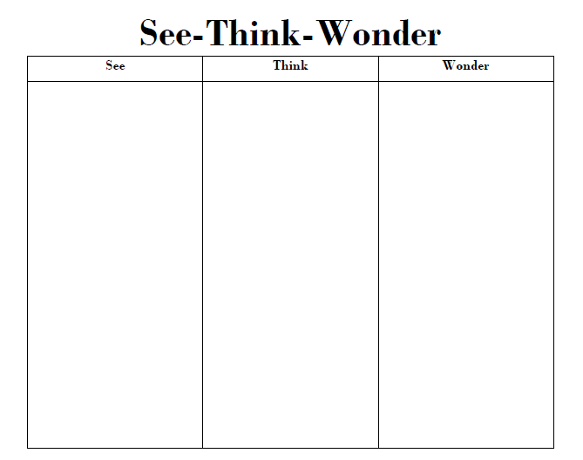
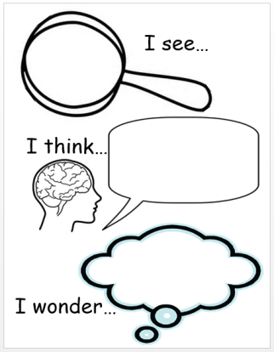

Day 3: (Picture)
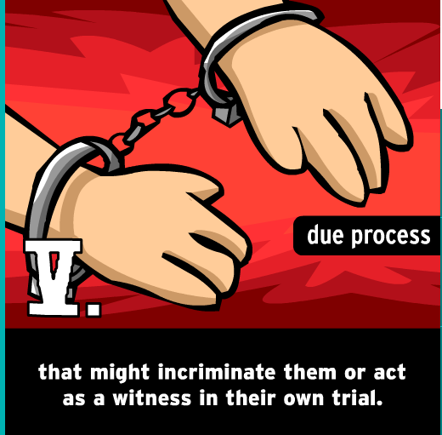

Day 4: (Rights)
1. Freedom of expression
2. Freedom of religion
3. Right to be treated equally
4. Right to be treated fairly by your government
5. The right to vote and run for public office

Day 5: (Quiz)

Name__________________________________________________ Date_________________________

Due Process and Citizenship Quiz

1. Explain the responsibilities of a citizen.
__________________________________________________________________________________________

__________________________________________________________________________________________

__________________________________________________________________________________________

__________________________________________________________________________________________

__________________________________________________________________________________________

2. Explain the concept of due process of law.
__________________________________________________________________________________________

__________________________________________________________________________________________

__________________________________________________________________________________________

__________________________________________________________________________________________

__________________________________________________________________________________________

3. Describe how the U.S. Constitution protects a citizen’s rights by due process.
__________________________________________________________________________________________

__________________________________________________________________________________________

__________________________________________________________________________________________

__________________________________________________________________________________________

__________________________________________________________________________________________

4. Create a scenario that reflects an example of how the responsibilities of a citizen connect to due process of law. (Extension)
__________________________________________________________________________________________

__________________________________________________________________________________________

__________________________________________________________________________________________

__________________________________________________________________________________________

__________________________________________________________________________________________

