STANDARDS-BASED LESSON PLANS - Subject Area:
Teacher: Rebekkah Bullard | Expected length of lesson: 4 days (30 min lessons) | Lesson Topic: George Washington Carver | Unit:

 | Standards-Based Instructional Focus | Targeted Content Standards/  Element:  (Include the entire standard) | SS1H1 Read about and describe the life of historical figures in American history.  a. Identify the contributions made by these figures: George Washington Carver (science)
 |  | Targeted Literacy Skills or Standards: (include as many as your lesson incorporates) | ELAGSE1L1: Demonstrate command of the conventions of standard English grammar and usage when writing or speaking.  j. Produce and expand complete simple and compound sentences in response to questions and prompts (declarative, interrogative, imperative, and exclamatory).  ELAGSE1W8: With guidance and support from adults, recall information from experiences or gather information from provided sources to answer a question.
 |  | Targeted SS Matrices: (include as many as your lesson incorporates) | Information Processing 3.identify issues and/or problems and alternative solutions  5. identify main idea, detail, sequence of events, and cause  and effect in a social studies context
 |  | Inquiry Question (or what you would like the students answer)?  (*Teachers may present the question or require students to develop questions and narrow down to this one). | The measurable objective for this lesson is that students should be able to identify the contributions of George Washington Carver. By the end of the lessons they will be able to give specific examples of items that he invented and how these inventions helped people. The lesson objective aligns with standard and is posted on the board for students to reference throughout the lesson.  How did George Washington Carver help people?  Why was he famous?
 | Learning Targets  (I-Can Statements)  ***At the end of the week, what will students know and what will students be able to do?  ***Include Learning Targets for the Content, Literacy Standard/Skill, and SS Matrices. |  | Foundational:  Mastery:  Read about the life of George Washington Carver.  Describe the life of George Washington Carver.  Identify contribution made by George Washington Carver.  Extension:  Compare and contrast the inventions and contributions of George Washington Carver to Ben Franklin.  Directions for the 5E Portion: Attach all 5E resources to the back of this plan in order of use. Please indicate how long you plan for each session to take. Include in your description a notation of the literacy standards or Social Studies Matrices for the activity which they align with.
 | ENGAGE  Describe how the teacher will capture students’ interest.  What kind of questions should the students ask themselves after the engagement? |  | Day 1 (20-25 minutes)  Students will be shown pictures (see images attached) of George Washington Carver. Students will Think, Pair, Share to develop questions they have about the pictures. Using the Question Formation Technique, students will develop a range of different questions and as a class we will discuss which questions are closed (having a yes or no answer) and which questions are open (having more than one correct answer). Below, are a list of the questions the students would develop:  - How does George Washington Carver make peanuts?  - Does the scientist have an idea?  - How did he help people?  - How did George Washington Carver make potatoes?  - How does the potatoes grow?  - How does George Washington become president?  - How did he make all kinds of plants and vegetables?  - Does he eat the peanuts?  - Why was he famous?  Teacher and students evaluate the questions, looking for the question(s) that the students most want to learn about. As a class, with direction from the teacher, questions number 3 and 9 are chosen:  How did George Washington Carver help people?  Why was he famous?
 | EXPLORE  Describe what hands-on/minds-on activities students will be doing.  List “big idea” conceptual questions the teacher will use to encourage and/or focus students’ exploration |  | Day 2 (20-30 minutes)  Students will explore, in groups of 3-4, some of George Washington Carver’s inventions. Each group will be given a basket of items to make observation about. In each basket, there are different items that George Washington Carver invented from peanuts and sweet potatoes.  As a whole group, introduce the graphic organizer: I see, I think, I wonder (see attached). Then dismiss students to their stations giving them their graphic organizer (I see, I think, I wonder) and a pair of science goggles. Once students are in their groups, begin the lesson by asking students to look, smell, and touch the items (lotion, soap, vinegar, pen, vegetable oil, etc…) that are in the basket. While students investigate the items in the basket walk around the classroom and ask students questions about what items they think are in the basket.  Next, have students to work together to write down the items that they see in the ‘I see’ section of the graphic organizer (enlarged version is displayed on the active board). Remind students that they need to write down their observations in complete sentences. As students are working, occasionally stop and have one or two students share their observations.  When students have finished their ‘I see’ portion of the graphic organizer, direct them to the ‘I think’ section of the graphic organizer. Ask them to write at least two sentences about how the learning target questions are connected to the items in the basket. As students work, walk around the classroom and remind to students to tie their ‘I think’ statement to the learning target and help address any confusion. As students are working, occasionally stop and have one or two students share their observations.  Finally, when students have completed their ‘I think’ portion of the graphic organizer, direct their attention to the ‘I wonder’ section. Ask students to create a question that they have about the items in the basket and write it in the ‘I wonder’ section of their graphic organizer. Remind students that their question needs to connect the items in the basket with the lesson questions about George Washington Carver. As students write their questions, remind them that they are composing an interrogative sentence and they need to use the proper punctuation. As students finish, have them share the questions they developed and discuss if it aligns with the Learning Targets.  (ELAGSE1L1)
 | EXPLAIN  Student explanations should precede introduction of terms or explanations by the teacher. What questions, resources, or strategies will the teacher use to help students connect their exploration to the concept under examination?  List higher order thinking questions which teachers will use to solicit student explanations and help them to justify their explanations.  Describe how the teacher will clarify the content or skill. |  | Day 3 (20-30 minutes)  Read aloud the George Washington Carver book on Raz-kids (see link below).  https://www.razplus.com/search/#doSearch=Search&searchTerms=george%2Bwashington%2Bcarver&searchView=list  Other books could be substituted for this Raz-kids book.  A Weed is a Flower: The Life of George Washington Carver by Aliki  A Picture Book of George Washington Carver by David A. Adler  The Little Plant Doctor by Jean Marzollo  After read aloud, dismiss students to their desk by giving them the George Washington Carver bubble map graphic organizer (see attached). Students will turn and talk to a partner to develop a fact about Carver they learned from the read aloud, previous days’ inquiry lesson, or their own prior knowledge. When students have finished their discussion call on specific students to share one fact. As students share, write the class answer on the active board bubble map so that students can copy the answer onto their own graphic organizer if needed. Once students have completed their first bubble, repeat this process for the next two bubbles. After completing the first three bubbles on the graphic organizer together, instruct students to work with their partner to fill in the last three bubbles on the graphic organizer together.  Remind students that they must add only facts, events, or contributions of George Washington Carver to their graphic organizer. As students work in pairs, walk around the classroom correcting any misunderstandings, reminding students to use correct sentence structure, and to tie their writing to George Washington Carver.  (ELAGSE1L1 and ELAGSE1W8 and Information Processing 3 and 5)
 | ELABORATE  Describe how students will develop a more sophisticated understanding of the concept.  What vocabulary will be introduced and how will it connect to students’ observations?  How will students make real-life connections? |  | Day 4 (15-20 minutes)  As a whole group, students to will share what they have learned in the previous days’ inquiry lesson and determine if they have learned enough to answer the learning target question. This ties into the lesson’s objective by getting the students to decide if they have enough knowledge to identify the contributions of George Washington Carver.  Dismiss students to their desks, where the baskets from the first days’ lessons are laid out. Ask students to choose an item from the basket and determine how that item is important in their everyday life. Have students Think, Pair, Share their ideas with a partner. Once students have had an opportunity to discuss their thoughts with their partner, select students to orally explain how the item they have chosen is important your life. Record each answer on the activity board. Provide sentence stems (see below) for students as they share their answers, reminding them to make connections to the learning target: How did George Washington Carver help people?  Sentence stem ideas:  - _______________ is important in my everyday life because __________________.  - If George Washington Carver had not invented ____________________ I would not be able to _________________.  (ELAGSE1W8 and Information Processing 3)
 | EVALUATE  How will students be evaluated THROUGHOUT the lesson?  How will students demonstrate that they have mastered the learning target(s)? |  | Day 5 (20-30 minutes)  Students will exhibit understanding of the lesson’s objectives by completing a quiz (see attached) identifying the contributions of George Washington Carver. The quiz contains two parts. In part one, students must draw an object that George Washington Carver invented and explain why this invention made Carver famous. In part two, students must draw and explain a way in which Carver helped people. Answers will vary and allowing students to both draw and write allows them to demonstrate their mastery of the content standard.  (ELAGSE1L1 and ELAGSE1W8 and Information Processing 3)

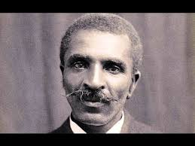
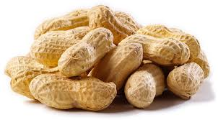
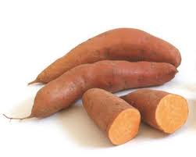
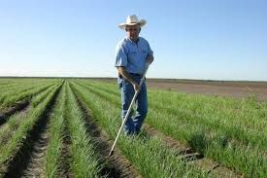

Name _______________________________________ Date _______________

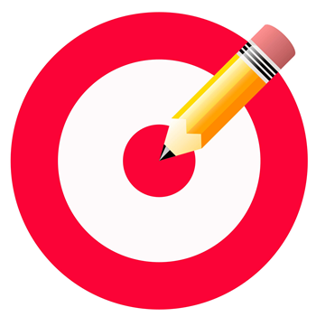How did George Washington Carver help people?
Why was he famous?
I see…

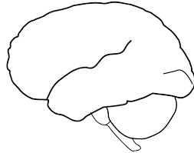
I think…
I wonder…

Name _______________________________________ Date _______________

How did George Washington Carver help people?
Why was he famous?

Name ________________________________________ Date _______________

George Washington Carver Quiz

Draw an object that George Washington Carver invented. Write a sentence explaining your drawing.

- George Washington Carver was famous because ______________________________

______________________________________________________________________

Draw an image of how George Washington Carver helped people. Write a sentence explaining your drawing.

2) George Washington Carver helped people by __________________________________

______________________________________________________________________

