American Inventors:
Write 3-5 facts for each inventor using the information at your stations.

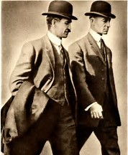
Wright Brothers

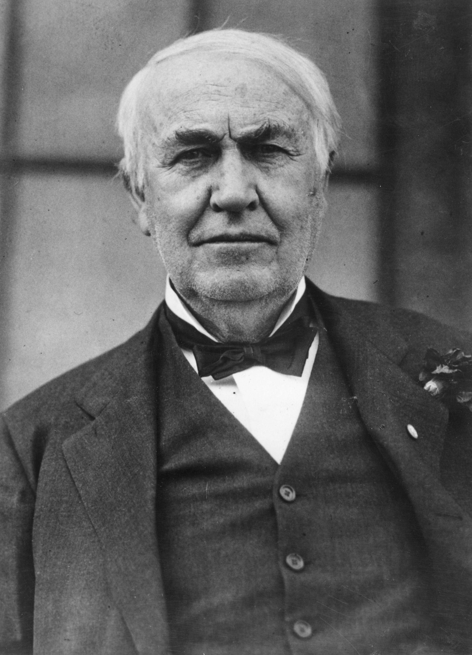
Thomas Edison
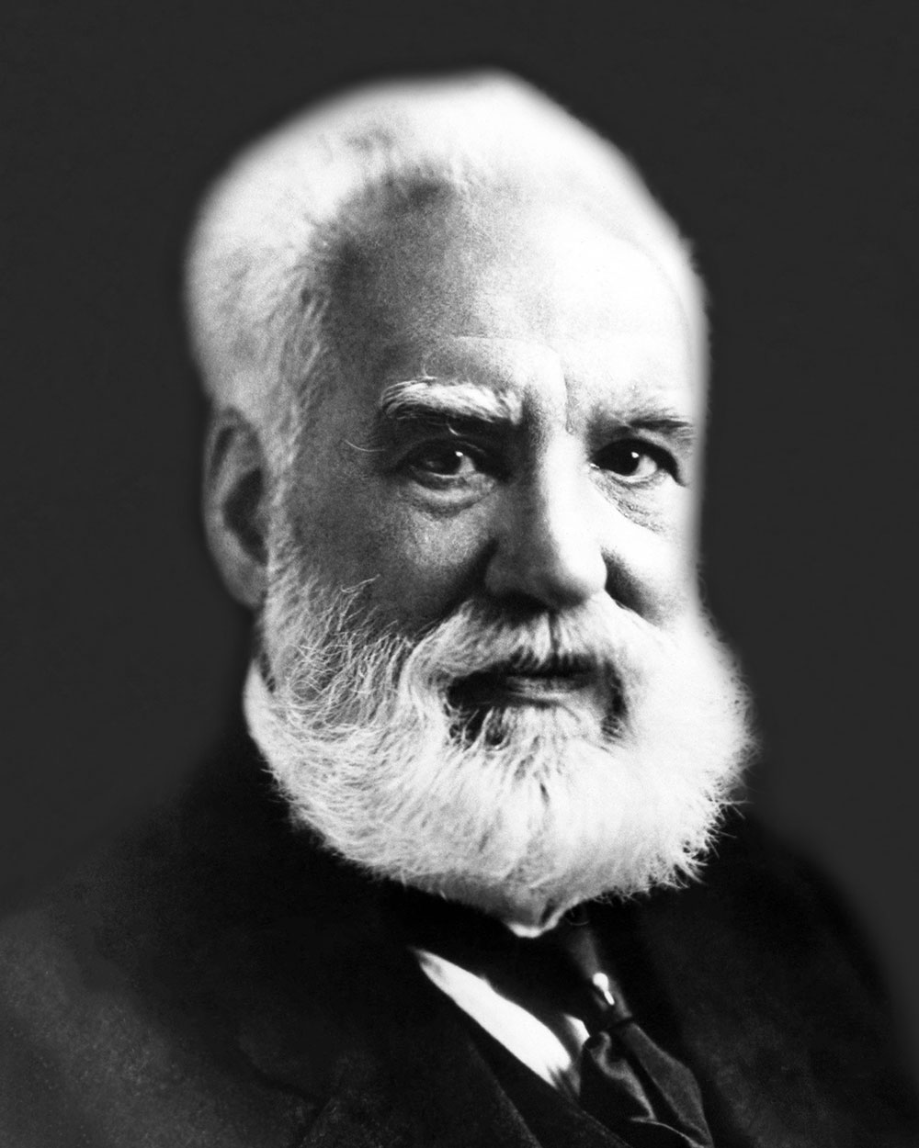
Alexander Graham Bell
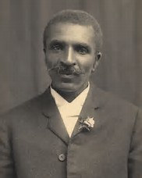
George Washington Carver

Wright Brothers

George Washington Carver

Alexander Graham Bell

Thomas Edison

Wright Brothers Facts
- Conducted the world’s first airplane flight in 1903
- This event took place in Kitty Hawk, North Carolina.
- Began aviation and space exploration industries
- “If birds can glide for long periods of time, then… why can't I?”

George Washington Carver Facts
- Known for his work in botany (study of plants)
- Experimented to find new ways to use plants
- Taught farmers about the benefits of crop rotation
- “Young people, I want to beg of you always keep your eyes open to what Mother Nature has to teach you. By so doing you will learn many valuable things every day of your life.”

Alexander Graham Bell Facts
- Invented the telephone in 1876
- Became interested in the science of sound because both his mother & wife were deaf
- Formed Bell Telephone Company in 1877, which later became AT&T
- "Mr. Watson - come here - I want to see you."

Thomas Edison Facts
- Invented the first working light bulb in 1879
- Invented phonograph, a device to record sound
- Invented kinescope, a camera-like device that created the first motion pictures
- “Being busy does not always mean real work. The object of all work is production or accomplishment and to either of these ends there must be forethought, system, planning, intelligence, and honest purpose, as well as perspiration. Seeming to do is not doing.”

Alexander Graham Bell
ASSESSMENT:
1. In two to four sentences, explain how each inventor impacted American life with their invention.
Wright Brothers

Thomas Edison
George Washington Carver
2. Explain which inventor you think has made the greatest impact on American life. Support your answer with at least two pieces of evidence from your research. Use the back of this page.

