**Georgia’s Regions Evaluation**

**Directions:** Use the map below to distinguish the different regions of Georgia. The map should be the same colors as your candy map. Label the map including a compass rose, the map key, then answer the question.

___________________________________________________________(map title)

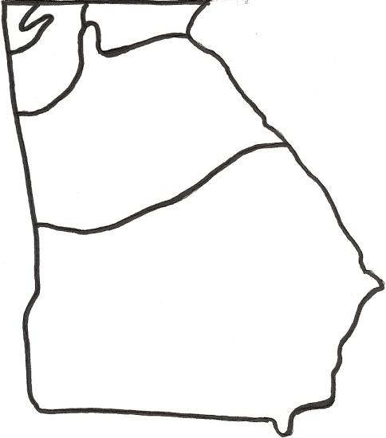

Map Key:

_____________________

_____________________ 

_____________________ 

_____________________ 

_____________________ 

Compass Rose:

**Writing Task:** Use another sheet of paper if you need more space to write. For each region:

a. Describe why you chose the particular candy/color for each region of your map.

b. Explain at least 2 characteristics that make that region different from the others.

______________________________________________________________________________

______________________________________________________________________________

______________________________________________________________________________

______________________________________________________________________________

______________________________________________________________________________

______________________________________________________________________________

______________________________________________________________________________