INQUIRY BASED LESSON PLANS
Teacher:  Keeley Beckman | Expected length of lesson:  20 minutes-4 days | Lesson Topic: Community Helpers | Unit:

 | Standards-Based Instructional Focus | Targeted Content Standards/  Element:  (Include the entire standard) | SSKE1: Describe the work that people do such as: police officer, fire fighter, soldier, mail carrier, farmer, doctor, teacher, etc.
 |  | Targeted Literacy Skills or Standards: (include as many as your lesson incorporates) | ELAGSEKRI1: With prompting and support, ask and answer questions about key details in a text.  ELAGSEKRI7: With prompting and support, describe the relationship between illustrations and the text (how the illustrations support the text).  ELAGSEKW2: Use a combination of drawing, dictating, and writing to compose informative/explanatory texts in which they name what they are writing about and supply some information about the topic
 |  | Targeted SS Matrices: (include as many as your lesson incorporates) | Information Processing Skill 1: Compare similarities and differences
 |  | Inquiry Question (or what you would like the students answer)?  (*Teachers may present the question or require students to develop questions and narrow down to this one). | - By the end of the lesson, the students should be able to demonstrate their understanding of community helpers. By day 5, they will be able to provide an explanatory writing piece. The teacher will review the questions daily before each lesson.  - What are community helpers?  - How are they a help to our community?
 |  | Key Vocabulary:  Words important for understanding content and skills (ex: Tier 2 and 3 words) | Similarities  Differences  Community  Explanatory  Narrative
 | Learning Targets  (I-Can Statements)  ***At the end of the week, what will students know and what will students be able to do? |  | Foundational:  Mastery: I can read decodable texts about community helpers.  I can identify community helpers.  I can describe the job of a community helper.  Extension: I can compare and contrast the jobs of community helpers (firefighter and a doctor).  Directions for the 5E Portion: Attach all 5E resources to the back of this plan in order of use. Please indicate how long you plan for each session to take. Include in your description a notation of the literacy standards or Social Studies Matrices for the activity which they align with.
 | ENGAGE  Describe how the teacher will capture students’ interest.  What kind of questions should the students ask themselves after the engagement? |  | Day 1 (15-20 minutes)  - Students will listen to different sounds and try to describe what they are hearing. (Ex: a siren to represent a firefighter or police officer, a doctor asking a child to take their temperature, and/or a drill to represent a construction worker)  - After the students have heard the sounds, the teacher will pull up a slideshow of different helpers to start a discussion. (Power point attached)  - Where would you hear this particular sound?  - Have you heard this sound before?  - What does this person do?  - If time permits, have the students match the sounds or an object to each helper (a stethoscope to a doctor, a ruler to a teacher, etc.)
 | EXPLORE  Describe what hands-on/minds-on activities students will be doing.  List “big idea” conceptual questions the teacher will use to encourage and/or focus students’ exploration |  | Day 2: 20 minutes  - The teacher will call the students to the carpet. The teacher will have a large bag in front of her; the students should not be able to see into the bag. The teacher will pass the bag around to each student and have them pull something out of the bag. (Note: If you don’t have enough community helper related objects for each student, use large colored pictures) As the students pull the objects out, have them identify the object and identify who would use the object. If you have a toothbrush, they should be able to say that a dentist would use this. Ask the students what is the importance of these tools? Would they be able to do their job without these items? Could they trade tools? For example, would a thermometer be useful for a police officer? Who would it be useful for?  - Now that the students have seen physical representations, have the students go back to their groups. Put the students with a partner (or they could do it individually depending on your supplies), and give them a small baggie. Have the students match the community helpers with their correct objects.
 | EXPLAIN  Student explanations should precede introduction of terms or explanations by the teacher. What questions, resources, or strategies will the teacher use to help students connect their exploration to the concept under examination?  List higher order thinking questions which teachers will use to solicit student explanations and help them to justify their explanations.  Describe how the teacher will clarify the content or skill. |  | Day 3: 20 minutes:  - The teacher will call the students to the carpet to view a brain pop video about community helpers.  [https://jr.brainpop.com/socialstudies/communities/communityhelpers/]  As a class, the students will take the quiz that is at the end of the video. The teacher will read the questions/answers aloud and the students will tell the teacher their answers.  - The teacher will have their students get into their class groups. (Note below)  - The groups can be differentiated or you can group the students yourself.  - I will list my groups and the activities that they will be completing. Each group will begin by selecting a community helper card from a container. (These can be written on a notecard. You can include a picture and the name of the helper)  - Hawks: Using their card, the students will come up with facts about their helper and write them on an anchor chart. (Use one chart per group) They will create a bubble map and use a word bank to help them write about 4-5 facts in their bubble map.  - Jaguars: Using their card, these students will use magazines to find things related to their community helpers. They should be able to write a word and/or discuss with the parapro how these pictures relate to the community helper.  - Falcons: Using their card, these students will draw pictures that describe the helper that they selected. They should be able to draw at least 3-4 pictures and have a discussion with the teacher.  - After the students have worked for about 10 minutes, call the students back to the carpet to discuss what they’ve done at their groups.
 | ELABORATE  Describe how students will develop a more sophisticated understanding of the concept.  What vocabulary will be introduced and how will it connect to students’ observations?  How will students make real-life connections? |  | Day 4: 25 minutes:  - The teacher will begin using the upstairs reading method. The teacher will have several notecards with the name, picture, and job description of a community helper. The teacher will say the name and the students will repeat the name. The teacher will show the picture and the students will say the name. The teacher will read the description and the students will say the name. Do this for each community helper.  - The students will go back to their groups with a decodable reader about community helpers. If you don’t have these decodables (shown in the resourced below) you can read a story whole group about community helpers and then have the students split into their groups to begin writing. Once again, these are differentiated groups. Both the Hawk and the Jaguar group should be able to read the book independently. (These are my upper and mid groups) After reading the story they will begin writing in their journals about their community helper. The Hawk group should be able to write at least 4 sentences on their topic. The Jaguar group can write about 3-4, and they can use a word bank if needed. The Falcon group will get the story read to them. The teacher will have 2-3 starter sentences for them and they will fill in the blank. (Example: A person who helps clean your teeth is a _______)
 | EVALUATE  How will students be evaluated THROUGHOUT the lesson?  How will students demonstrate that they have mastered the learning target(s)? |  | Day 5: 20 minutes:  - The teacher should have sent home a notice at least a week in advance about the students dressing up as their favorite community helper. The students will come up to the front and describe what they are dressed as and what that person does. If the student doesn’t dress up, they will still come up to the front and describe their favorite community helper and explain why.

Day 1 Materials: A sample PowerPoint is attached with links to the sounds as well as the photos.

Day 2 Materials: The supplies for this day include a bag filled with community helper items, this is something you would have to bring from home or ask parents to send in items.

Day 3 Materials: Here is the link to the brain pop video; you must have an account to watch the video. https://jr.brainpop.com/socialstudies/communities/communityhelpers/].

Day 4 Materials: Here is an example of the upstairs reading.

Front: for students to see Back: for teacher to read
- A firefighter is a community helper that helps put out fires. Students - Say firefighter.
- Firefighters wear protective clothing to prevent burns. Students - say firefighter.
- A firefighter uses a water hose to put out fires. Students – say firefighter.
- A firefighter also rides on a firetruck. Students – say firefighter.

Firefighter
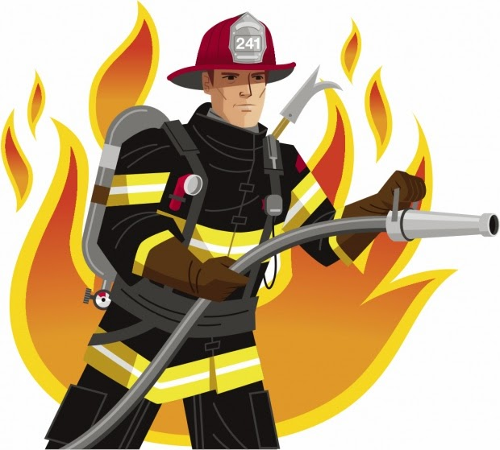

Also during day 4 the students break into groups to read decodable/emergent readers. I will include pictures of what they may look like. These books are already in our classroom but not all teachers have these. If you don’t have these decodables you can read a story whole group about community helpers and then have the students split into their groups to begin writing. There are also readers on Teacher Pay Teacher on Community Helpers if you are in need of more resources.

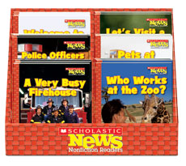 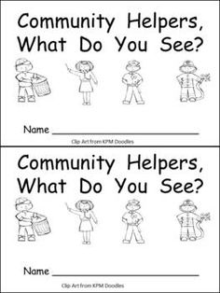.

Day 5 Materials: N/A

