Not just Words
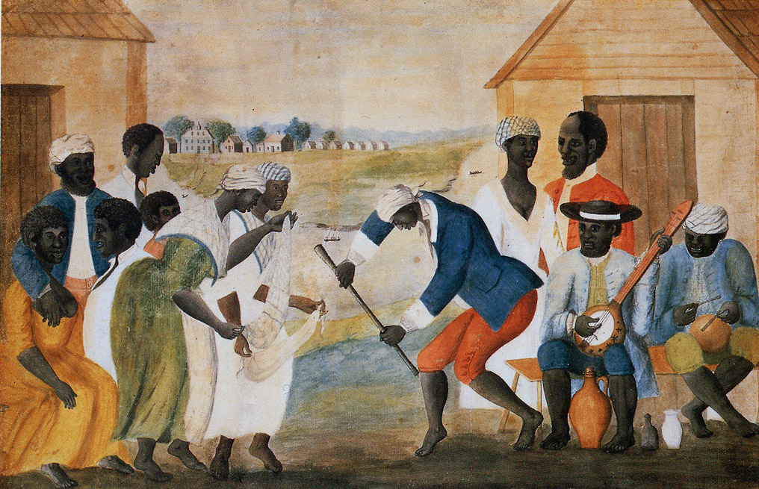
Big Idea: music traditions reflect deeper cultural meaning

Student Learning Assessment
Learning Objectives | Assessment Criteria
Student experience Gullah music traditions, including clapping patterns, ring shouts dances, songs, and explore the deeper meaning. | Participates in class activities including clapping, singing, dancing and discussion.

Instructions: Music is playing while student enter. MacIntosh County Shouters, Slave Shout Songs from the coast of Georgia, Smithsonian Folkways CD

Clapping along with Gullah Clapping video https://www.youtube.com/watch?v=IimNm1tPsCY

Dana demonstrates ring shout dance. Students join in.
Dana demonstrated stick pounding and then hands out sticks to pound.

Stick pounding video https://www.youtube.com/watch?v=mQlg-UomM8k

Discussion: explore deeper meaning symbolism. Circle/rice pounding/affirming life, etc.

Day 2 Watch and discuss - The Ringshout & the Birth of African-American Religion https://www.youtube.com/watch?v=KmmTMg3e5Uo

