Connected
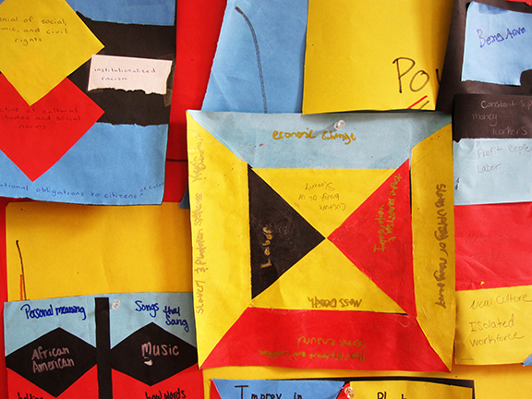
Big Idea: It’s all connected

Student Learning Assessment
Learning Objectives | Assessment Criteria
Students make and follow the connections between diverse “viewable” culture expressions, across time and change, and with semi- and hidden cultural values. | Participates in class activities

Instructions
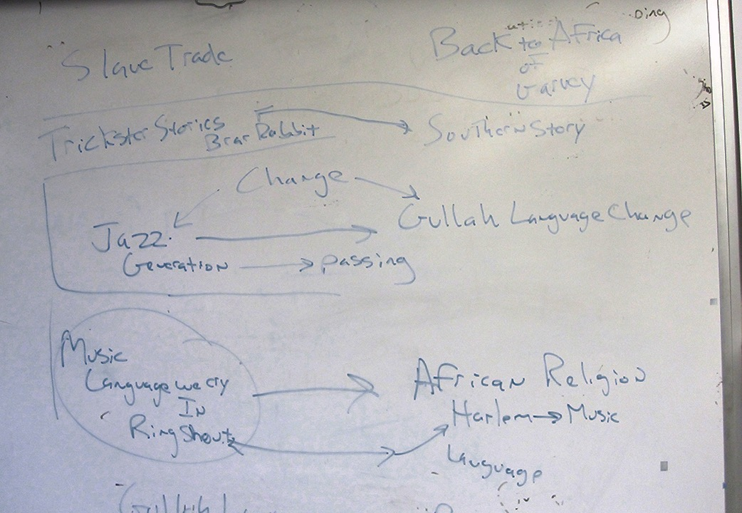
Small groups brainstorm cultural aspects covered in class (as specific as possible i.e. the song Kneebone Bend. Group items by one of the 3 cultures studied, West African, Gullah, Harlem.
Group also brainstorm semi-hidden and hidden cultural worldview concepts i.e. Asymmetry, value of music and movement.

In full group, individual items are placed on the cultural iceberg overlaid with grid.

 | West Africa | Gullah | Harlem
V  I  S  I  B  L  E | 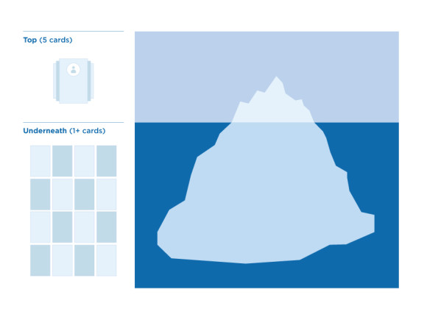
S
E
M
I
H
I
D
D
E
N

Physical lines are drawn between connected items. Ongoing Discussion.

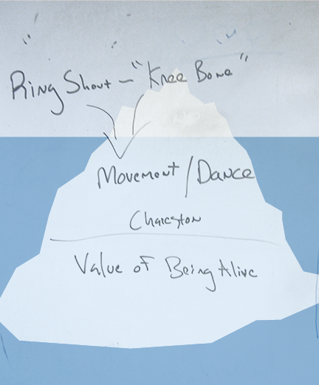
Some examples of additional items added and connected– Gullah clap, rhythm, Harlem Renaissance embracing African American history, Zora Neal Hurston, Annasi, Br’er Rabbit Ring Shout, Praise House, Cotton Club, Langston Hughes, kente cloth, Rice, pounding rice, red rice and beans, chicken and waffles, asymmetry, music as expression, jazz, blues, religion, religious songs, freedom, life after death, bold colors…

