East Meadow Union Free School District

Curriculum Area Project
2015 – 2016
Elementary Health Activities: Grade K - 2

Project Facilitator: Bryan Horrmann
Writers: Kerri Staton, Rachel Barry and Deidre O’Regan
Superintendent of Schools: Mr. Leon J. Campo
Administrator: Kristi Detor, Director of Health, Physical Education and Athletics
Subject Area: Health Education

-

HEALTH EDUCATION
CURRICULUM K - 2

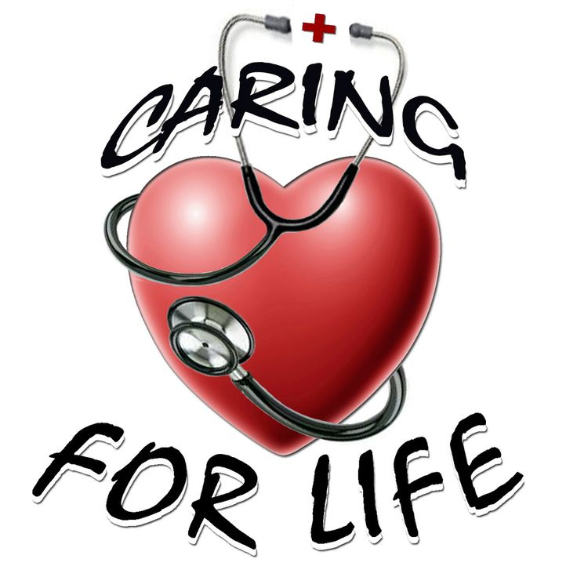

Table of Contents

Correlation with Instructional Objectives and the New York State Standards (Benchmark) refer to Health Literacy Competency Based Curriculum packet.

Abstract……………………………………………………………………………………………1
Rationale…………………………………………………………………………………………..2
National Health Learning Standards……………………………………………………………3-5
New York State Learning Standards……………………………………………………………6-7

Kindergarten Lesson Plans and General Objectives (pages 8-24)
Lesson/Activities/Reading 1- Hygiene………………………………………………………...9-12
Lesson/Activities/Reading 2- Safety…………………………………………………………13-20
Lesson/Activities/Reading 3- Nutrition………………………………………………………21-24
First Grade Lesson Plans and General Objectives (pages 25-40)
Lesson/Activities/Reading 1- Hygiene……………………………………………………….26-31
Lesson/Activities/Reading 2- Safety…………………………………………………………32-36
Lesson/Activities/Reading 3- Nutrition………………………………………………………37-40
Second Grade Lesson Plans and General Objectives (pages 41-55)
Lesson/Activities/Reading 1- Hygiene……………………………………………………….42-44
Lesson/Activities/Reading 2- Safety…………………………………………………………45-47
Lesson/Activities/Reading 3- Nutrition………………………………………………………48-55
Additional Reading Materials for Grades K-2
……………………………………………………………………………………………………56
Citations
...………………………………………………………………………………………………….57

Abstract

Health Education is perhaps the single most important pursuit in life. Good physical, emotional, mental, and social health are essential to enjoying life and living to the fullest. The East Meadow School District kindergarten through second grade curriculum will help students examine their lifestyle, analyze healthy choices, and practice life skills that will achieve and maintain optimum health in accordance with the New York State Common Core standards. This involves choosing behaviors that help prevent illness and accidents, promote health for oneself, and others and/or improve the quality of the environment.
The East Meadow K-2 curriculum will provide an overview of current facts and issues of health. Students will learn to differentiate between healthy behaviors and harmful or risk behaviors. The purpose of designing a Health Education curriculum is to teach the process of healthful living. It is designed to promote responsible decision-making and provide students with life management skills that could last a lifetime.

Rationale

Health literate students have the functional knowledge, life skills, and the ability to enhance personal and community resources. Health education is a lifelong process that enables us to live healthier, more productive lives. Habits and skills are learned about early in life. Children continue to be challenged on a daily basis, with personal choices that can affect their current health status. Many of these choices will also have a major impact on their lifelong goals as well as their future health. It is the goal of this project to provide our younger students with the most cutting edge functional knowledge and teaching strategies to enable our students to have the skills to make health-promoting decisions and maintain positive health status throughout their lives.
The curriculum outline for kindergarten, first and second grade has been paced with the middle school health curriculum so there will be a logical flow of learning as students mature and progress through each level of their early elementary education and health. A comprehensive overview was written for each topic to further explain the big picture and calibrate the unit with the Common Core Standards and New York State Health Learning Standards.

National Health Learning Standards
Elementary Health Education
Health Education Standard 1:
Students will comprehend concepts related to health promotion and disease prevention.

Performance Indicators:
As a result of health instruction in Health Education, Students will:
- Describe relationships between personal and health behaviors and individual well-being.
- Identify indicators of mental, emotional, social and physical health during childhood.
- Describe the basic structure and functions of the human body systems.
- Describe how the family influences personal health.
- Describe how physical, social, and emotional environments influence personal health.
- Identify common health problems of children.
- Identify health problems that should be detected and treated early.
- Explain how childhood injuries and illnesses can be prevented or treated.

Health Education Standard 2:
Students will demonstrate the ability to access valid health information and health-promoting products and services.

Performance Indicators:
As a result of health instruction in Health Education, students will:
- Identify characteristics of valid health information and health promoting products and services.
- Demonstrate the ability to locate resources from home, school, and community that provide valid health information.
- Explain how media influences the selection of health information, products and services.
- Demonstrate the ability the locate school and community health helpers.

Health Education Standard 3:
Students will demonstrate the ability to practice health-enhancing behaviors and reduce health risks.

Performance Indicators:
As a result of health instruction in Health Education, students will:
- Identify responsible health behaviors
- Identify personal health needs
- Compare behaviors that are safe to those that are risky or harmful.
- Demonstrate strategies to improve or maintain personal health.
- Develop injury prevention and management strategies for personal health.
- Demonstrate ways to avoid and reduce threatening situations.
- Apply skills to manage stress.

Health Education Standard 4:
Students will analyze the influence of culture, media, technology and other factors on health.

Performance Indicators:
As a result of health instruction in Health Education, students will:
- Describe how culture influences personal health behaviors.
- Explain how media influences thoughts, feelings and health behaviors.
- Describe ways technology can influence personal health.
- Explain how information from school and family influences health.

Health Education Standards 5:
Students will demonstrate the ability to use interpersonal communication skills to enhance health.

Performance Indicators:
As a result of health instruction in Health Education, students will:
- Distinguish between verbal and non-verbal communication.
- Describe characteristics needed to be responsible friend and family member.
- Demonstrate healthy ways to express needs, wants and feelings.
- Demonstrate ways to communicate care, consideration and respect of self and others.
- Demonstrate attentive listening skills to build and maintain healthy relationship.
- Demonstrate refusal skills to enhance health.
- Differentiate between negative and positive behaviors used in conflict situations.
- Demonstrate non-violent strategies to resolve conflicts.

Health Education Standard 6:
Students will demonstrate the ability to use goal setting and decision-making skills to enhance health.

Performance Indicators:
As a result of health instruction in Health Education, students will:
- Demonstrate the ability to apply a decision-making process to health issues and problems.
- Explain when to ask for assistance in making health-related decisions and setting health goals.
- Predict outcomes of positive health decisions.
- Set a personal health goal and track progress toward its achievement.

Health Education Standard 7:
Students will demonstrate the ability to advocate for personal, family and community health.

Performance Indicators:
As a result of health instruction in Health Education, students will:
- Describe a variety of methods to convey accurate health information and ideas.
- Express information and opinions about health issues.
- Identify community agencies that advocate for healthy individuals, families, and communities.
- Demonstrate the ability to influence and support others in making positive health choices.

NEW YORK STATE LEARNING STANDARDS
Elementary Health Education

Standard 1: Personal Health and Fitness
Students will understand human growth and development and recognize the relationship between behaviors and healthy development. They will understand ways to promote health and prevent disease and will demonstrate and practice positive health behaviors.

Performance Indicators:
Students will
- Know how basic body systems work and interrelate in normal patterns of growth and development
- Possess basic knowledge and skills which support positive health choices and behaviors
- Understand how behaviors such as food selection, exercise, and rest affect growth and development.
- Recognize influences which affect health choices and behaviors
- Know about some diseases and disorders and how they are prevented and treated
- Practice and support others in making healthy choices

Standard 2: A Safe and Healthy Environment
Students will demonstrate personally and socially responsible behaviors. They will care for and respect themselves and others. They will recognize threats to the environment and offer appropriate strategies to minimize them.

Performance Indicators:
Students will
- Understand basic safety rules
- Recognize potentially dangerous situations and know how to avoid or reduce their risk
- Know some personal and social skills which contribute to individual safety
- Recognize characteristics of the environment that contribute to health

Standard 3: Resource Management
Students will understand the influence of culture, media, and technology in making decisions about personal and community health issues. They will know about and use valid health information, products, and services. Students will advocate for healthy families and communities.

Performance Indicators:
Students will
- Identify characteristics of valid health information and health promoting products and services and know where to locate them
- Understand how culture contributes to individual family and community beliefs and practices affecting health
- Know to access help when illness, injury, or emergency situations occur
- Recognize how the media influences health choices

Health Education Curriculum

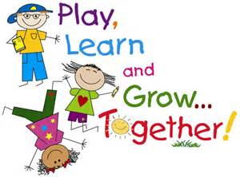

Kindergarten

Learning Content: Hygiene
Essential Question: What can we do to stop spreading germs?
Big Idea: Staying Healthy
Vocabulary: Germs, Spread, Promise
National Standards:
- Standard #1: Students will comprehend concepts related to health promotion and disease prevention to enhance health.
- Standard #2: Students will analyze the influence of family, peers, culture, media, technology, and other factors on health behaviors.
- Standard #3: Students will demonstrate the ability to access valid information, products, and services to enhance health.
- Standard #4: Students will demonstrate the ability to use interpersonal communication skills to enhance health and avoid or reduce health risks.
- Standard #5: Students will demonstrate the ability to use decision-making skills to enhance health.
- Standard #6: Students will demonstrate the ability to use goal-setting skills to enhance health.
- Standard #7: Students will demonstrate the ability to practice health-enhancing behaviors and avoid or reduce health risks.
- Standard #8: Students will demonstrate the ability to advocate for personal, family, and community health.
New York State Standards:
- Standard 1: Personal Health and Fitness
  - Students will understand human growth and development and recognize the relationship between behaviors and healthy development. They will understand ways to promote health and prevent disease and will demonstrate and practice positive health behaviors.
- Standard 2: Safe and Healthy Environment
  - Students will acquire the knowledge and ability necessary to create and maintain a safe and healthy environment.
- Standard 3: Resource Management
  - Students will understand and be able to manage their personal and community resources.

Resources Needed:
- Book – “Miss Bindergarten Stays Home from Kindergarten” by Joseph Slate
- Water in spray bottle
- Food coloring to see water(optional)
- Handout
- Hand washing station

Suggested Time Allowance: 20-30 minutes
Grade Level: K
Activities / Procedures
- Read book and discuss
- Activity
- Discuss why and how to wash hands
- Demonstration by students
- Students complete sequencing activity

Lesson Content:
Read story – “Mrs. Bindergarten Stays Home from Kindergarten” By Joseph Slate.
Questions:
- Do you think Miss Bindergarten and the children could have gotten sick from each other?
- How do you think the germs spread from one person to another?
- Do you think there was a way that they could have stopped the spread of the germs?

Activity:
Talk with students about what happens when we sneeze or cough into our hands. To demonstrate, spray water on students’ hands to simulate coughing into hand. Remind students that the water on their hands is just like the germs when we cough or sneeze. Now have the students walk around the room and touch the table, chair, door handle, etc. and see that they have left their water marks. As students move around room and touch objects and surfaces, any time the object or surface it wet it shows that “germs” are present.

Questions:
- How many students were exposed to germs during this activity?
- What can we do to limit this sharing of germs?
Hand Washing
We wash our hands to prevent the passage of germs to others. Germs are small so we cannot see them, but they can make us sick. We should wash our hands when:
- When they are dirty
- After using the restroom
- Before eating or drinking
- After playing with animals
- Before playing with younger children
We should wash our hands in the following way:
- Use warm water to wet hands
- Use soap to lather and make bubbles
- Sing “Happy Birthday” two times
- Rinse with warm water
- Dry hands thoroughly

Students will be supervised while washing their hands and then go to their seat to fill out their promise to stay healthy by washing their hands.

Citation: “Mrs. Bindergarten Stays Home from Kindergarten” By Joseph Slate.

Weekly Writing Focus: List steps of Hand Washing

Culminating Question: Why is it important to wash your hands?

I ________________ promise to do my job of staying healthy by:

Washing My Hands

Directions: Cut out images and place them in order.
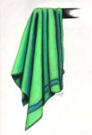
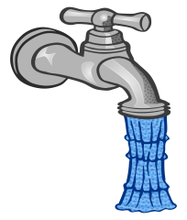
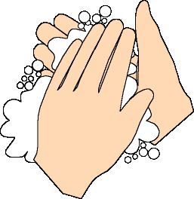

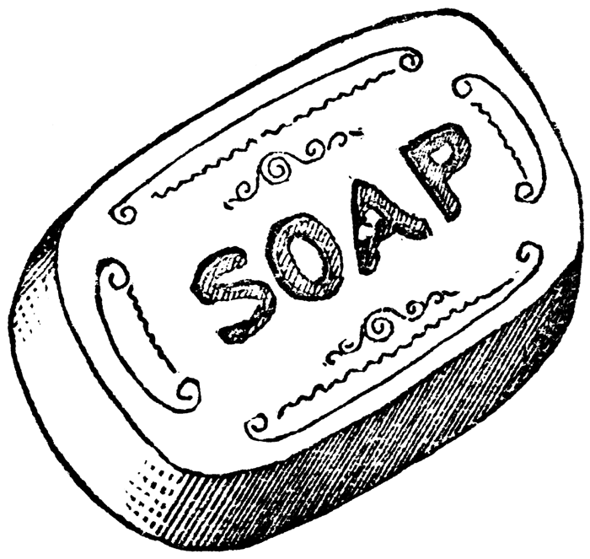

Kindergarten
Story: Rainbow Crow
Rainbow Crow
(Lenni Lenape Tribe)
retold by
S. E. Schlosser
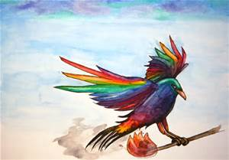
It was so cold. Snow fell constantly, and ice formed over all the waters. The animals had never seen snow before. At first, it was a novelty, something to play in. But the cold increased tenfold, and they began to worry. The little animals were being buried in the snow drifts and the larger animals could hardly walk because the snow was so deep. Soon, all would perish if something were not done.
"We must send a messenger to Kijiamuh Ka'ong, the Creator Who Creates By Thinking What Will Be," said Wise Owl. "We must ask him to think the world warm again so that Spirit Snow will leave us in peace."
The animals were pleased with this plan. They began to debate among themselves, trying to decide who to send up to the Creator. Wise Owl could not see well during the daylight, so he could not go. Coyote was easily distracted and like playing tricks, so he could not be trusted. Turtle was steady and stable, but he crawled too slowly. Finally, Rainbow Crow, the most beautiful of all the birds with shimmering feathers of rainbow hues and an enchanting singing voice, was chosen to go to Kijiamuh Ka'ong.
It was an arduous journey, three days up and up into the heavens, passed the trees and clouds, beyond the sun and the moon, and even above all the stars. He was buffeted by winds and had no place to rest, but he carried bravely on until he reached Heaven. When Rainbow Crow reached the Holy Place, he called out to the Creator, but received no answer. The Creator was too busy thinking up what would be to notice even the most beautiful of birds. So Rainbow Crow began to sing his most beautiful song.
The Creator was drawn from his thoughts by the lovely sound, and came to see which bird was making it. He greeted Rainbow Crow kindly and asked what gift he could give the noble bird in exchange for his song. Rainbow Crow asked the Creator to un-think the snow, so that the animals of Earth would not be buried and freeze to death. But the Creator told Rainbow Crow that the snow and the ice had spirits of their own and could not be destroyed.
"What shall we do then?" asked the Rainbow Crow. "We will all freeze or smother under the snow."
"You will not freeze," the Creator reassured him, "For I will think of Fire, something that will warm all creatures during the cold times."
The Creator stuck a stick into the blazing hot sun. The end blazed with a bright, glowing fire which burned brightly and gave off heat. "This is Fire," he told Rainbow Crow, handing him the cool end of the stick. "You must hurry to Earth as fast as you can fly before the stick burns up."
Rainbow Crow nodded his thanks to the Creator and flew as fast as he could go. It was a three-day trip to Heaven, and he was worried that the Fire would burn out before he reached the Earth. The stick was large and heavy, but the fire kept Rainbow Crow warm as he descended from Heaven down to the bright path of the stars. Then the Fire grew hot as it came closer to Rainbow Crows feathers. As he flew passed the Sun, his tail caught on fire, turning the shimmering beautiful feathers black. By the time he flew passed the Moon, his whole body was black with soot from the hot Fire. When he plunged into the Sky and flew through the clouds, the smoke got into his throat, strangling his beautiful singing voice.
By the time Rainbow Crow landed among the freezing-cold animals of Earth, he was black as tar and could only Caw instead of sing. He delivered the fire to the animals, and they melted the snow and warmed themselves, rescuing the littlest animals from the snow drifts where they lay buried.
It was a time of rejoicing, for Tindeh - Fire - had come to Earth. But Rainbow Crow sat apart, saddened by his dull, ugly feathers and his rasping voice. Then he felt the touch of wind on his face. He looked up and saw the Creator Who Creates By Thinking What Will Be walking toward him.
"Do not be sad, Rainbow Crow," the Creator said. "All animals will honor you for the sacrifice you made for them. And when the people come, they will not hunt you, for I have made your flesh taste of smoke so that it is no good to eat and your black feathers and hoarse voice will prevent man from putting you into a cage to sing for him. You will be free."
Then the Creator pointed to Rainbow Crow's black feathers. Before his eyes, Rainbow Crow saw the dull feathers become shiny and inside each one, he could see all the colors of the rainbow. "This will remind everyone who sees you of the service you have been to your people," he said, "and the sacrifice you made that saved them all."
And so shall it ever be.
"Native American Myths." Rainbow Crow: From Native American Myths at Americanfolklore.net. Web. 11 Dec. 2015.
Questions:
Why did the rainbow crow lose its bright colors and beautiful voice?
What did the rainbow crow do for the other animals on earth?
The rainbow crow sacrificed his colors and voice to save the other animals. Have you or do you know an example of someone sacrificing themselves for the community?
Is there any way you can protect your family or community like the Rainbow Crow?
Essential Question: How can you stay safe and protect you and your family?
Learning Content: Safety
Big Idea: Students will learn about appropriate times to call 9-1-1 for an emergency
Students will learn how to use 9-1-1.
Vocabulary: Safety, Emergency
National Standards:
- Standard #3: Students will demonstrate the ability to access valid information, products, and services to enhance health.
- Standard #7: Students will demonstrate the ability to practice health-enhancing behaviors and avoid or reduce health risks.
- Standard #8: Students will demonstrate the ability to advocate for personal, family, and community health.
New York State Standards:
- Standard 1: Personal Health and Fitness
  - Students will understand human growth and development and recognize the relationship between behaviors and healthy development. They will understand ways to promote health and prevent disease and will demonstrate and practice positive health behaviors.
- Standard 2: Safe and Healthy Environment
  - Students will acquire the knowledge and ability necessary to create and maintain a safe and healthy environment.
Resources Needed:
- Short Story Rainbow Crow
- Handout – 9-1-1 and Safety
Suggested Time Allowance: 10 – 20 min
Grade Level: Kindergarten
Lesson Content:
Teacher will read the short story (folklore) the Rainbow Crow. The Rainbow Crow made a sacrifice to its bright colors and beautiful voice. Students will be asked certain questions to see if they comprehended the story.
Why did the rainbow crow lose its bright colors and beautiful voice?
What did the rainbow crow do for the other animals on earth?
The rainbow crow sacrificed his colors and voice to save the other animals. Have you or do you know an example of someone sacrificing themselves for the community?
Is there any way you can protect your family or community like the Rainbow Crow?
It is very important to know how to use. Stress to kids that it is very important to know their name, street address and phone number (even though 9-1-1 numbers are traced). Even though it giving your personal information to a stranger is forbidden, a 9-1-1 operator is perfectly acceptable. Follow the directions from the 9-1-1 operator and DO NOT HANG UP until they tell you to do so.
Teacher asks: When are times you should call the police or fire department?
- Student Response: In an emergency. What is an emergency?
Teacher asks: When you need the police, fire department or an ambulance and there were no grown-ups around what number could you call for help?
- Student response: 9-1-1. There is a little activity to have kids practice
Activity: Teacher can put up a picture of an IPhone key pad. Have the students demonstrate pushing the numbers when dialing 9-1-1.
Teacher asks: What is important to remember when you are on the phone with the 9-1-1 operator?
-Student response: Your name. Your address. Explain the emergency. What is needed (police, ambulance, or fire department)?
*Explain all in a clear and loud response*
Teacher asks: Do you hang up when you are done talking? When do you end the phone call?
-Student response: NO. Phone calls should only end when the operator tells you to hang up the phone.
Operators can give you instructions to help you further or want to know when help arrives.

Activity: Oral Quiz (yes or no)

Teacher asks: When should you not call 9-1-1?
-Student response: When there are no emergencies. As a prank. For a game. As a joke. To practice calling?
Teacher asks: Why is it wrong to call 9-1-1 when there is no emergency?
-Student response: Because there are real emergencies where people need help. You could delay that help to those people who need it.

Homework:
Print out Identification Sheet. Students will complete this form with their parents so they can practice reciting their address and phone number.

Culminating Question: What is an emergency and when should you call for help?

Citation:
Dowshen, Steven. "Teaching Your Child How to Use 911." KidsHealth - the Web's Most Visited Site about Children's Health. The Nemours Foundation, 1 Apr. 2013. Web. 11 Dec. 2015.

Weekly Writing Focus (Optional Activity)
Write a step by step emergency plan when your class has a fire drill.

Personal Health and Safety Handout

Homework Directions: Complete the card in case there is an emergency. If possible, fill this card out with a parent or guardian. Both of you can discuss the importance of knowing emergency numbers, especially 9-1-1.
Personal Identification Card
Name:
Address:
Home Telephone Number:
Emergency Contact Name:
Emergency Contact Number:

Glue Picture of
Yourself

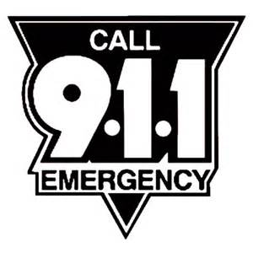
Color the Numbers to help you remember this important emergency number.

Situation | Call 9-1-1:  Yes or No
1) Your friend falls out of a tree and is hurt badly | Y | N
2) You see a stranger lurking around your house | Y | N
3) You are home alone and you are bored and lonely | Y | N
4) Your neighbor’s house is on fire | Y | N
5) You see a car accident where someone is hurt | Y | N
6) You have an argument with your best friend | Y | N
7) Your dog is limping | Y | N
8) You see someone breaking into a neighbor’s house. | Y | N
9) There is a fire in your fireplace | Y | N

9 – 1 – 1 Quiz

Teacher Discretion: If you want to make copies for your class you can.

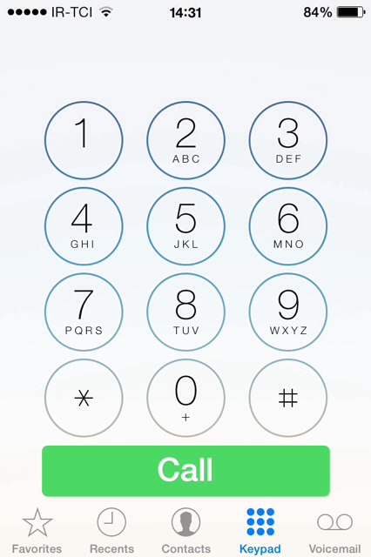
Practice Dialing 9-1-1

Kindergarten – Unit 5
Excerpt - Eat Healthy, Feel Great
(Excerpt from Eat Healthy, Feel Great)
When you were a little baby, the only food you needed was special milk. But as you grew bigger and busier, you started needing other good foods, too. Now you need foods that make you grow stronger, help you think better and give you more energy to play.
These are green-light foods. A green-light food means “go” and you can go ahead and eat all you want!
Some foods are okay to eat sometimes but they won’t keep you feeling great they way green-light foods do. These are yellow-light foods. A yellow light means slow down if you eat too many.
And some foods don’t do anything to help your body. Instead, they can hurt your body and make you feel too full to eat your green-light foods. These are red-light foods. A red-light means “stop,” and you should stop eating these foods.
Ingredients in yellow-light and red-light foods can trick you. They make the foods look good and taste good but they are still bad for you…

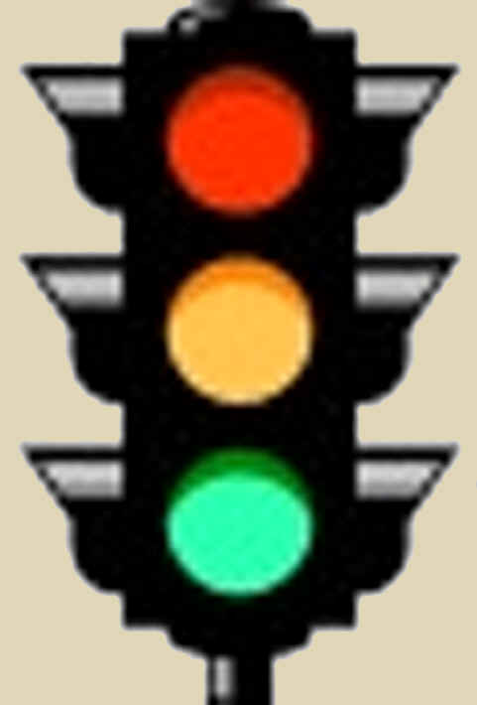

Learning Content: Nutrition Stoplight Activity
Essential Question: What are healthy foods and why should we eat them?
Big Idea: Students will be able to choose healthier options during the nutrition lesson and
everyday lives.
Vocabulary: Diet, Healthy, Unhealthy
National Standards:
- Standard #1: Students will comprehend concepts related to health promotion and disease prevention to enhance health.
- Standard #5: Students will demonstrate the ability to use decision-making skills to enhance health.
- Standard #8: Students will demonstrate the ability to advocate for personal, family, and community health.
New York State Standards:
- Standard 1: Personal Health and Fitness
  - Students will understand human growth and development and recognize the relationship between behaviors and healthy development. They will understand ways to promote health and prevent disease and will demonstrate and practice positive health behaviors.
- Standard 2: Safe and Healthy Environment
  - Students will acquire the knowledge and ability necessary to create and maintain a safe and healthy environment.
Resources Needed:
- Teacher – Story, Crayons, Handout
Suggested Time Allowance: As long as necessary (5 – 10 minutes)
Grade Level: Kindergarten
Activities / Procedures
- Lesson Content:

Teacher Directions: The classroom teacher will read the excerpt, “Eat Healthy, Feel Great.” At the conclusion of the excerpt, the teacher could as the following questions:

Teacher Questions: What colors are on a traffic light? What does green mean? What does yellow mean? What does red mean?
- What are some green light foods we could eat all of the time?
Student Response Examples: Vegetables, Fruits, Whole grains, milk, yogurt, water, etc.
- What are some yellow-light foods we could eat some of the time?
Student Response Examples: Sugar drinks, fast food, white bread, etc.
- What are some red-light foods that we want to avoid?
Student Response Examples: Candy, Cotton Candy, anything high in sugar, pizza, fried foods.
Students: GO back to their desks and they should receive the handout. They are going to need three different colors crayons (green, red and yellow).
- Green is the healthiest option
- Yellow is the cautious option
- Red is a really bad option

NOTE: Yellow and red are very similar. As long as the children color the healthiest options green is what we are looking for. You could even ask them why they colored some yellow and some red if you would like.
Culminating question:
Why should we eat healthy foods? AND/OR why should we stay away from unhealthy foods?
Additional Reading/Activity:
Unit 5: “Farms Around the World”
Discussion with Students with writing sample:
Why is it important to eat fresh foods that come from a farm? For their weekly writing focus students can write a fictional story about someone visiting a farm and eating fresh foods.

Citation: Sears, William, Martha Sears, Christie Watts. Kelly, and Renée Andriani. Eat Healthy, Feel Great. Boston: Little, Brown, 2002. Print.

Stoplight Foods Activity
Directions: Color THE HEALTHY FOODS GREEN AND THE UNHEALTHY FOODS YELLOW OR RED.
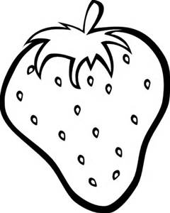
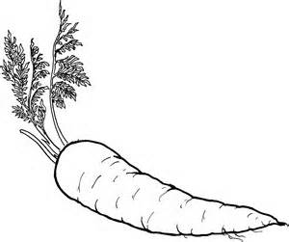
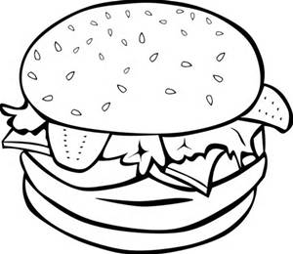

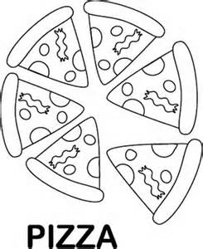
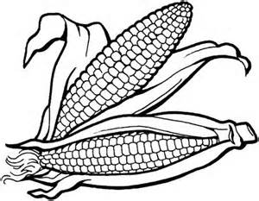
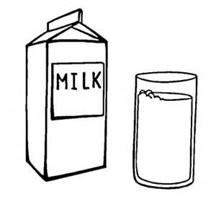

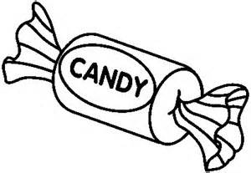
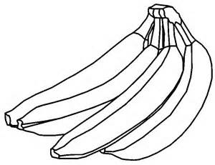

Health Education Curriculum

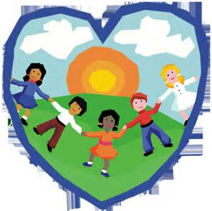
First Grade

Learning Content: Hygiene
Essential Question: Why is it important to brush your teeth?
Big Idea: Demonstrating how and why we brush our teeth; “Snip & Flip Toothbrush Writing Craftivity”
Vocabulary: Brushing, flossing, rinsing, avoiding, dentist
National Standards:
- Standard #1: Students will comprehend concepts related to health promotion and disease prevention to enhance health.
- Standard #2: Students will analyze the influence of family, peers, culture, media, technology, and other factors on health behaviors.
- Standard #3: Students will demonstrate the ability to access valid information, products, and services to enhance health.
- Standard #4: Students will demonstrate the ability to use interpersonal communication skills to enhance health and avoid or reduce health risks.
- Standard #5: Students will demonstrate the ability to use decision-making skills to enhance health.
- Standard #6: Students will demonstrate the ability to use goal-setting skills to enhance health.
- Standard #7: Students will demonstrate the ability to practice health-enhancing behaviors and avoid or reduce health risks.
- Standard #8: Students will demonstrate the ability to advocate for personal, family, and community health.
New York State Standards:
- Standard 1: Personal Health and Fitness
  - Students will understand human growth and development and recognize the relationship between behaviors and healthy development. They will understand ways to promote health and prevent disease and will demonstrate and practice positive health behaviors.
- Standard 2: Safe and Healthy Environment
  - Students will acquire the knowledge and ability necessary to create and maintain a safe and healthy environment.
- Standard 3: Resource Management
  - Students will understand and be able to manage their personal and community resources.

Resources Needed:
• Traceable toothbrush templates
• Blank toothbrush templates
• Assorted colors of construction paper
• Student scissors
• Markers/pens/pencils

Suggested Time Allowance: 30 minutes

Grade Level: First

Lesson Content: Oral hygiene

Activities / Procedures:
• Preparation: Teacher should photocopy, on a variety of colors of construction paper, the “______________ takes care of her/his teeth by…” worksheet.
- Students will then choose a color and fill in their name. This will be the toothbrush handle.
• Teacher will also have photocopied the “blank bristles” worksheet on white construction paper.
• Students rub glue on the top long rectangle and glue it to the back of the right hand side of the bottom of their toothbrush. Press hard so the “bristle” sticks firmly to the brush.
• Students should cut on the black lines and stop at the top long rectangle so they don’t cut their bristles off. Teacher should demonstrate.
• Children write (or trace) how they keep their teeth healthy—one example per strip. When they are done, they glue this bristle box to the back of the toothbrush, behind the cut bristles so that they have a flip booklet. The flip-up tabs should match the writing tabs.

*The directions are also on the attached worksheets to help answer any further questions!

Citation: www.teachwithme.com

Weekly Writing Focus: For homework, students should write and draw a story of what their experience at the dentist is like. They should begin with what happens when they get called in and end with when they leave!

Culminating Question: Why is important to keep our teeth clean? What would happen if we stopped brushing and flossing our teeth every day?

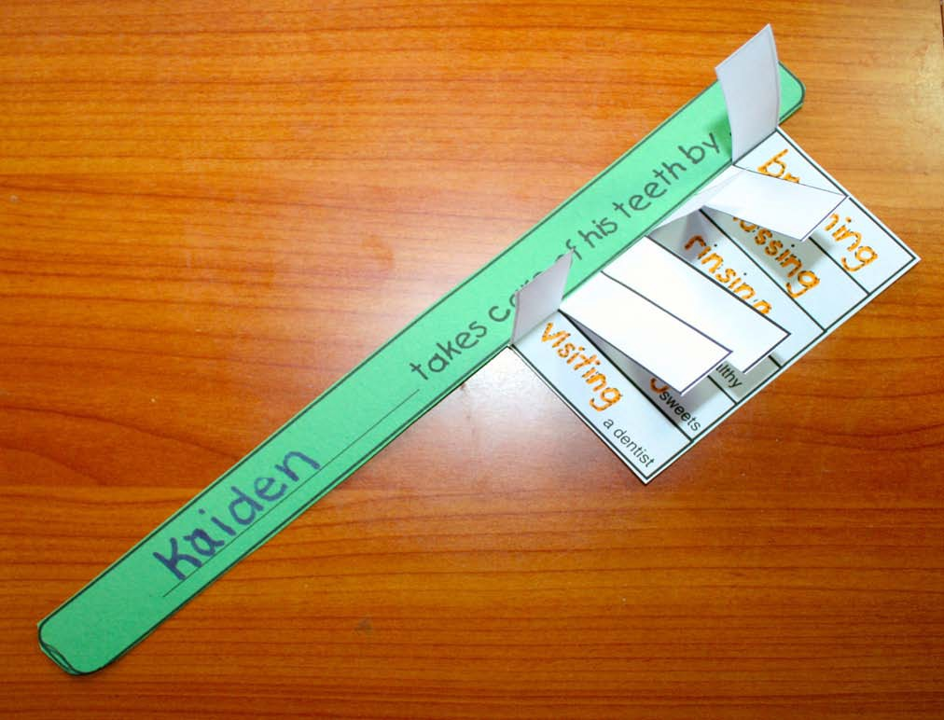
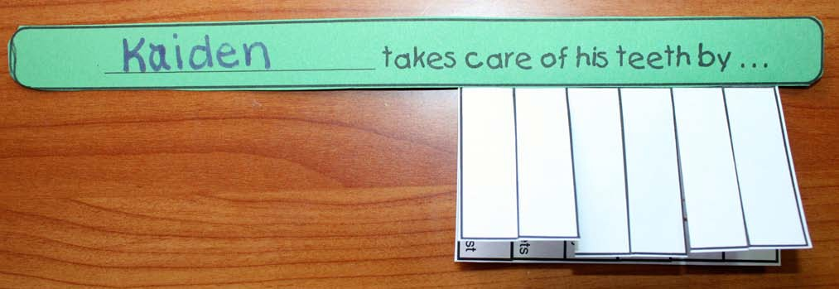

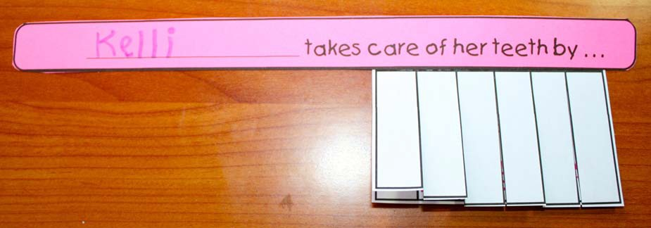
Snip & Flip Toothbrush Craftivity
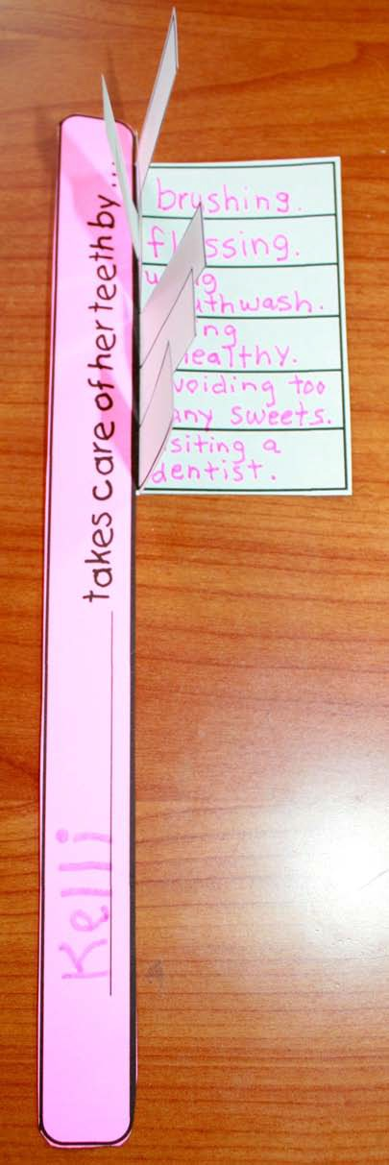
There’s a traceable template with answers, as well as a blank template where students fill in
their own thoughts.

___________________________ takes care of his teeth by…
___________________________ takes care of his teeth by…
___________________________ takes care of his teeth by…
___________________________ takes care of his teeth by…
___________________________ takes care of his teeth by…
___________________________ takes care of his teeth by…
___________________________ takes care of his teeth by…
___________________________ takes care of his teeth by…
___________________________ takes care of his teeth by…

Learning Content: Safety

Essential Question: What should I do if I am caught in a fire?

Big Idea: Students will be able to spell and define various fire safety terms, practice dialing 9-1-1, and understand what to do in case of a fire in their house.

Vocabulary Words: Emergency, crawl, flame, escape, sound, smoke

National Standards:
- Standard #1: Students will comprehend concepts related to health promotion and disease prevention to enhance health.
- Standard #2: Students will analyze the influence of family, peers, culture, media, technology, and other factors on health behaviors.
- Standard #3: Students will demonstrate the ability to access valid information, products, and services to enhance health.
- Standard #4: Students will demonstrate the ability to use interpersonal communication skills to enhance health and avoid or reduce health risks.
- Standard #5: Students will demonstrate the ability to use decision-making skills to enhance health.
- Standard #6: Students will demonstrate the ability to use goal-setting skills to enhance health.
- Standard #7: Students will demonstrate the ability to practice health-enhancing behaviors and avoid or reduce health risks.
- Standard #8: Students will demonstrate the ability to advocate for personal, family, and community health.

New York State Standards:
- Standard 1: Personal Health and Fitness
- Standard 2: Safe and Healthy Environment
- Standard 3: Resource Management

Resources Needed:
• Fire Safety Spelling/Vocabulary worksheet
• Dialing 9-1-1 worksheet
• Fire safety checklist homework
• Fire Escape Book template

Suggested Time Allowance: 20– 30 minutes

Grade Level: First

Lesson Content: Fire safety

Activities/Procedures: In this lesson, students will learn the spelling and definitions of five fire-related terms: crawl, flame, escape, sound, smoke. Each student will individually complete writing the spelling words on the right side of the “Fire Safety Spelling/Vocabulary” worksheet. Once students have finished writing their new terms, read each paragraph, one at a time, to the class. Ask students if they have ever heard any of those terms before and in what context. They should, through discussion, be able to develop their own definitions for the vocabulary words.

Next, hand out the “Dialing 9-1-1” worksheet. This is a review from Kindergarten—students should know to write “9-1-1” in the boxes provided. Discuss when to and when not to dial those three numbers. Define emergency.

Lastly, students should each be given a “Fire Escape Book”.
http://keepyourchildsafe.org/aspwpadmin/stattrack/downloads/fire-escape-mini-book.PDF
There is a copy attached as well. Students can color the pages of the book as you read them aloud as a class.

Citation: www.keepyourchildsafe.org

Weekly Writing Focus: Besides 9-1-1 list other people you can call or ask for help in an emergency.

Culminating Question: Why is it important to be prepared in case of an emergency?

What number do you call in an emergency?

Use the phone keypad below to show how you would dial:
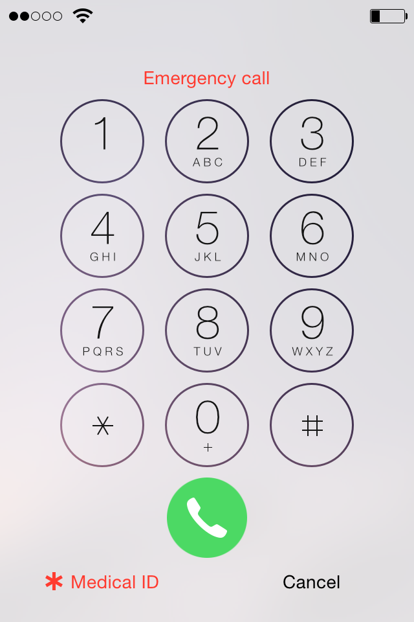

MY FIRE SAFETY HOMEWORK
Parents: Please help your child complete this homework and return it to class tomorrow. Thank you!

I had my parents set off the smoke alarm so I could hear what it sounded like, and it sounded…

I learned at least two ways out of my house. They are

I practiced rolling out of my bed and crawling to the door. It was

Now I am FIRE SAFE!

Name:

Name

Fire Safety Spelling/Vocabulary Worksheet

Directions: Practice writing the spelling words in the space on the right, then find an adult to read you the safety paragraphs when you are done.

CRAWL  Smoke rises, so in a fire you should always stay low where there is more oxygen and it is easier to breathe. Use the fire crawl if you have to, and get out as fast as you can! | 1. Crawl  2. _____________  3. _____________
FLAME  A small flame can get out of control fast and grow bigger in an instant, which is why kids should never play with fire or try to handle it on their own. | 1. Flame  2. _____________  3. _____________
ESCAPE  All kids should practice the escape routes from their house. Know at least two ways you can get out of every room in your house in the case of an emergency. | 1. Escape  2. _____________  3. _____________
SOUND  Do you know what your fire alarm sounds like? If not, have your parents set it off so you can hear it. Learn that sound; it means, “fire in the house—get out quick!” | 1. Sound  2. _____________  3. _____________
SMOKE  In an actual fire, there is no time to get dressed or gather your things. So if you wake up to the sound of your smoke alarm, it doesn’t matter if you’re in your pajamas or even naked—your only mission is to get out fast! | 1. Smoke  2. _____________  3. _____________

Learning Content: Nutrition (MyPlate, foods, and food groups)

Essential Question: What is MyPlate and how can we use it as a guide to make healthy eating choices?

Big Idea: Students will be able to understand the various food groups represented on MyPlate and identify at least one specific food from each food group that they like to eat.

Vocabulary Words: Fruit, vegetable, protein, grains, dairy

National Standards:
- Standard #1: Students will comprehend concepts related to health promotion and disease prevention to enhance health.
- Standard #2: Students will analyze the influence of family, peers, culture, media, technology, and other factors on health behaviors.
- Standard #3: Students will demonstrate the ability to access valid information, products, and services to enhance health.
- Standard #4: Students will demonstrate the ability to use interpersonal communication skills to enhance health and avoid or reduce health risks.
- Standard #5: Students will demonstrate the ability to use decision-making skills to enhance health.
- Standard #6: Students will demonstrate the ability to use goal-setting skills to enhance health.
- Standard #7: Students will demonstrate the ability to practice health-enhancing behaviors and avoid or reduce health risks.
- Standard #8: Students will demonstrate the ability to advocate for personal, family, and community health.

New York State Standards:
- Standard 1: Personal Health and Fitness
- Standard 2: Safe and Healthy Environment
- Standard 3: Resource Management

Resources Needed:
• MyPlate template
• Blank MyPlate worksheets
• Poster paper and/or SmartBoard or dry-erase board
• Food groups food sort worksheets
• Markers, crayons, colored pencils

Suggested Time Allowance: 20– 30 minutes

Grade Level: First

Lesson Content: Interpreting MyPlate

Activities/Procedures: In this lesson, students will learn what each of the sections of the MyPlate nutrition template means.

Begin by asking each student what their favorite food is and write their responses on the board.

Next, introduce MyPlate. Explain what each section of the plate means—discuss fruits, vegetables, grains, protein, and dairy. While discussing each portion of the plate, have students brainstorm examples of foods in each category and list them on the board. Upon completion of the discussion, there should be at least five food examples for each MyPlate category. Ask if anyone’s favorite food fits into one of the MyPlate food groups.

MyPlate Explanations:
Fruit: a sweet food, such as an apple, blueberry or orange, that has seeds and grows on a tree or a bush [be sure to explain not to eat anything you see on a tree or bush.
Vegetable: a plant that is grown with the intention to be eaten and provides vitamins, minerals, and other nutrients essential for growth (ex: carrots, broccoli, cabbage).
Grain: the seeds of plants commonly used for foods that comes in the form of wheat, corn and rice (ex: bread, pasta)
Protein: a substance found in foods that assist in muscle growth and strength (ex: lean meats, eggs, nuts)
Dairy: foods/substances that contain milk or milk products (yogurt, ice cream, cheese)

Discuss the importance of healthy eating and how various foods help our body function properly.

Lastly, give each student a blank MyPlate template. They should draw a meal containing their favorite food from each group (using the class brainstorm list to help them) to develop their own personal healthy and balanced plate. Hang these in the classroom.

Citation: www.brainpop.com, www.choosemyplate.gov

Weekly Writing Focus:
1) Read The Berenstain Bears and too Much Junk Food together, as a class, and discuss the effects of junk food on the body versus foods from MyPlate.
2) Food Groups Food Sort worksheet

Culminating Question: Why is important to make sure we eat foods from each section of MyPlate every day?

Name

Directions: Cut out the foods below and sort them by food group

GRAINS

VEGETABLES

FRUITS

PROTEIN

DAIRY

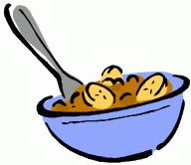

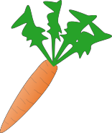

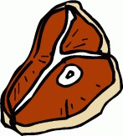

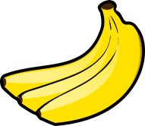

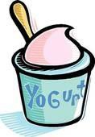

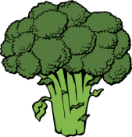

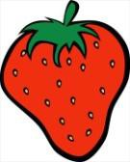

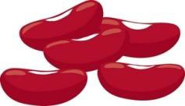

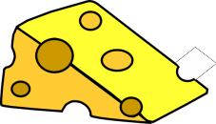

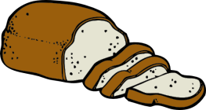

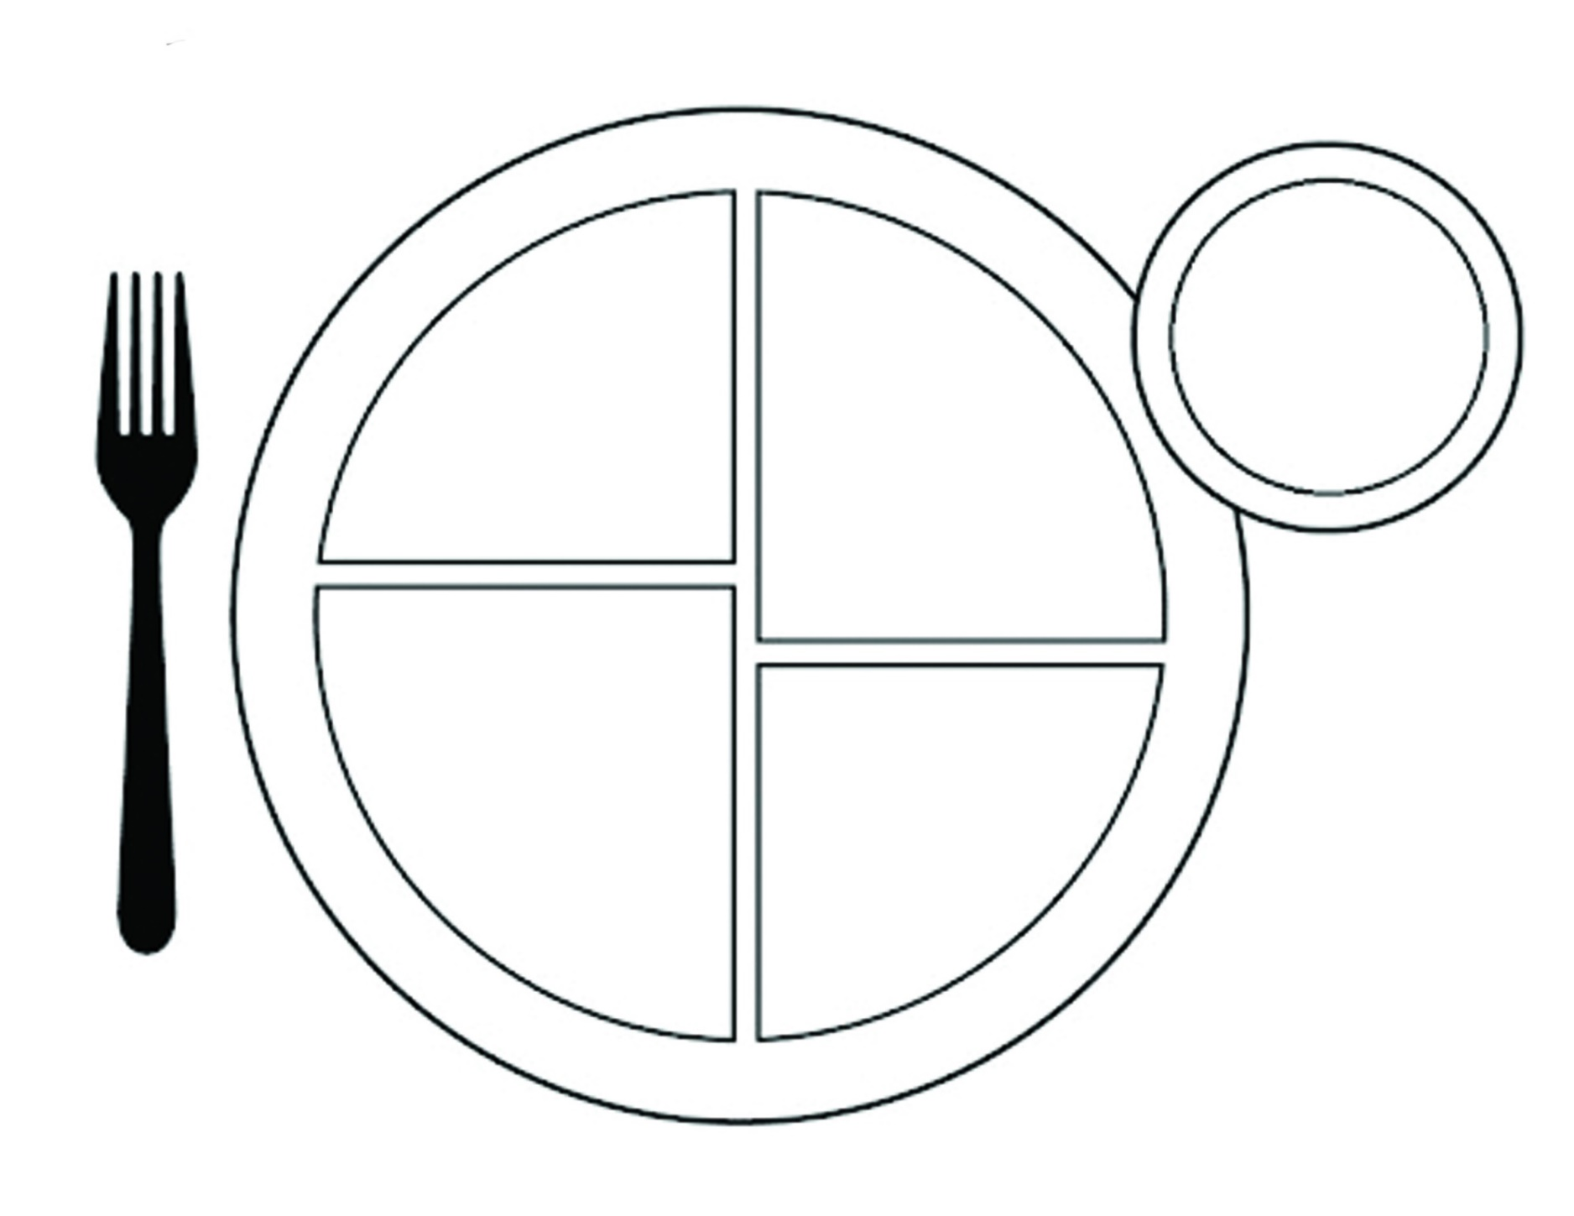

Health Education Curriculum

Second Grade

Learning Content: Hygiene
Essential Question: How can we protect ourselves from germs? What can we do to prevent spreading germs?
Big Idea: Proper hygiene against germs
Vocabulary: Germs, Hygiene, Skin, Protection
National Standards:
- Standard #1: Students will comprehend concepts related to health promotion and disease prevention to enhance health.
- Standard #2: Students will analyze the influence of family, peers, culture, media, technology, and other factors on health behaviors.
- Standard #3: Students will demonstrate the ability to access valid information, products, and services to enhance health.
- Standard #4: Students will demonstrate the ability to use interpersonal communication skills to enhance health and avoid or reduce health risks.
- Standard #5: Students will demonstrate the ability to use decision-making skills to enhance health.
- Standard #6: Students will demonstrate the ability to use goal-setting skills to enhance health.
- Standard #7: Students will demonstrate the ability to practice health-enhancing behaviors and avoid or reduce health risks.
- Standard #8: Students will demonstrate the ability to advocate for personal, family, and community health.
New York State Standards:
- Standard 1: Personal Health and Fitness
  - Students will understand human growth and development and recognize the relationship between behaviors and healthy development. They will understand ways to promote health and prevent disease and will demonstrate and practice positive health behaviors.
- Standard 2: Safe and Healthy Environment
  - Students will acquire the knowledge and ability necessary to create and maintain a safe and healthy environment.
- Standard 3: Resource Management
  - Students will understand and be able to manage their personal and community resources.

Resources Needed:
- 2 apples(any kind), a knife, 2 plates
- Teacher –PowerPoint, LCD machine, whiteboard, blackboard pens or chalk
- Student – Notebooks and pens/pencils/art supplies: colored pencils

Suggested Time Allowance: 5 – 10 Minutes across five days in class
Grade Level: 2
Lesson Content:
Review how to wash hands, when to use soap and water and for how long.
Teacher question: When should you wash your hands?
Student answer: As often as possible, after the bathroom, before and after eating, etc.
After group discussion:
Distribute the worksheet “How to wash my hands.” Have the students label the order the pictures should be in from 1-5 of hand washing the germs away. They can color the images after you confirm with the class that they are numbered correctly.
Begin the activity by having the students play outside in the dirt or in a bucket of dirt placed in the classroom. We are going to use our hands only and take a closer look at what happens to our hands after we play. What can we do to keep our hands clean? We are going to look at our hands with a magnifying glass. Discuss what they see when they look at their hands. After discussion, half the class will wash their hands with water only, the other half will use soap and water. Then look at their hands under the magnifying glass again.
Teacher question: What is the difference when you use soap to wash you?
Student answer: less dirt, clean, more germs removed, etc.
Activities / Procedures: Students know how to wash germs away, now we will do an experiment to show the students how much a negative effect germs can have on the body, how the skin helps protect us and why the skin needs to be taken care of.
Apple Observation: Print, Copy and Distribute the apple observation sheet with day 1-5 listed. *Easier if you start this task on a Monday
Your skin is an important layer of your body that helps to protect you. By observing two apples we will be able to see what happens to the skin when one has the shiny skin and the second apple we have peeled the skin off.
Teacher question: What do you think will happen to the apple that has no skin?
Student answer: Nothing, gets germs, changes color, etc.
Culminating Discussion
Observe the apples for the next 5 days. What will happen to these apples over time? How are they similar? How are they different? Will they be the same as they are right now after 5 days?
Additional discussion:
Watch the skin of the first apple as it is cut. This is what happens to your skin when you get a cut. Notice inside the apple it starts to turn brown. Why? Why is it important to wash a cut with soap and water and protect with a bandage?
Citation: http://kidshealth.org/classroom/prekto2/personal/hygiene/germs.pdf

Learning Content: Fire Safety
Essential Question: How can we create an evacuation plan at home in regard to fire safety?
Big Idea: Safety awareness (especially in school and at home)
Vocabulary: Safety, awareness, evacuation
National Standards:
- Standard #1: Students will comprehend concepts related to health promotion and disease prevention to enhance health.
- Standard #2: Students will analyze the influence of family, peers, culture, media, technology, and other factors on health behaviors.
- Standard #3: Students will demonstrate the ability to access valid information, products, and services to enhance health.
- Standard #4: Students will demonstrate the ability to use interpersonal communication skills to enhance health and avoid or reduce health risks.
- Standard #5: Students will demonstrate the ability to use decision-making skills to enhance health.
- Standard #6: Students will demonstrate the ability to use goal-setting skills to enhance health.
- Standard #7: Students will demonstrate the ability to practice health-enhancing behaviors and avoid or reduce health risks.
- Standard #8: Students will demonstrate the ability to advocate for personal, family, and community health.
New York State Standards:
- Standard 1: Personal Health and Fitness
  - Students will understand human growth and development and recognize the relationship between behaviors and healthy development. They will understand ways to promote health and prevent disease and will demonstrate and practice positive health behaviors.
- Standard 2: Safe and Healthy Environment
  - Students will acquire the knowledge and ability necessary to create and maintain a safe and healthy environment.
- Standard 3: Resource Management
  - Students will understand and be able to manage their personal and community resources.
Resources Needed:
- Teacher –PowerPoint, LCD machine, whiteboard, blackboard pens or chalk
- Student – Notebooks and pens/pencils
Suggested Time Allowance: 5 – 10 Minutes
Grade Level: 2
Activities / Procedures
Lesson Content:
Students have learned about fire safety in first grade. Review signs of fire, calling 911, and stop-drop-roll. Discuss: smoke detectors, exits (windows, doors) how to touch or open. Go over an escape plan. How to get out and where to meet your family when you get out of the house.
Activity: Hand students the “Fire Escape Plan” worksheet. Together while doing this on the board with them create the escape plan for your classroom. Discuss the windows, how they open and when to exit through them. Discuss the drawn out path the school provides for your classroom when the alarm sounds, or if there is a fire in the classroom. Draw and write out your classroom escape plan, discuss the specifics of your classroom as everyone is different.
Teacher question: Where are some safe places for your family to meet outside of your house?
Student answer: At the stop sign, at the big tree, at the neighbors, across the street, etc.
Teacher question: How do you touch the door to check if it is safe?
Student answer: The back of your hand, knuckles, etc.
Teacher question: Where are emergency exits in your house?
Student answer: Windows, doors, garage…
At the completion of the activity provide the students with an additional blank “Fire Escape Plan” work sheet. This copy is for them to take home and complete with a parent/guardian.
Optional: When the students return the next day, have them share their escape plans with a partner or in groups.
Additional activities:
http://kidshealth.org/classroom/prekto2/personal/safety/fire_safety.pdf
*last page

Culminating Question: Why is it always important to have a safety plan at any location (school, vacation, home, etc)?
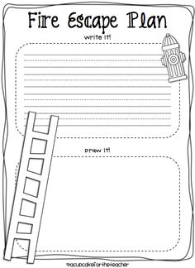

http://www.sparky.org/parentpage/pdf/Escape_plan.pdf

Learning Content: Nutrition
Essential Question: How can I use MyPlate to create a healthy meal?
Big Idea: Students can continue learning the MyPlate concepts they can make healthy choices.
Vocabulary: Healthy, Nutrients, Benefit
National Standards:
- Standard #1: Students will comprehend concepts related to health promotion and disease prevention to enhance health.
- Standard #2: Students will analyze the influence of family, peers, culture, media, technology, and other factors on health behaviors.
- Standard #3: Students will demonstrate the ability to access valid information, products, and services to enhance health.
- Standard #4: Students will demonstrate the ability to use interpersonal communication skills to enhance health and avoid or reduce health risks.
- Standard #5: Students will demonstrate the ability to use decision-making skills to enhance health.
- Standard #6: Students will demonstrate the ability to use goal-setting skills to enhance health.
- Standard #7: Students will demonstrate the ability to practice health-enhancing behaviors and avoid or reduce health risks.
- Standard #8: Students will demonstrate the ability to advocate for personal, family, and community health.
New York State Standards:
- Standard 1: Personal Health and Fitness
  - Students will understand human growth and development and recognize the relationship between behaviors and healthy development. They will understand ways to promote health and prevent disease and will demonstrate and practice positive health behaviors.
- Standard 2: Safe and Healthy Environment
  - Students will acquire the knowledge and ability necessary to create and maintain a safe and healthy environment.
- Standard 3: Resource Management
  - Students will understand and be able to manage their personal and community resources.
Resources Needed:
- Teacher –PowerPoint, LCD machine, whiteboard, blackboard pens or chalk
- Student – Notebooks and pens/pencils
Suggested Time Allowance: 5 – 10 Minutes
Grade Level: 2
Lesson Content: Creating a Healthy Meal using MyPlate
Activities / Procedures
In first grade students learned about MyPlate and the basics of nutrition in regard to fruits, vegetables, grains, proteins and dairy. They are ready to move on to decision making. In this lesson students will learn how to place foods on their plates for certain meals. What is a healthy, well balanced meal for breakfast, lunch and dinner?
Print out the following worksheets to hand out to your students. Review the plate and discuss examples of each section. The students should know examples from last year.
Go through each meal, what it entails and have the students alone, with partners or in groups create a breakfast, lunch and dinner.
Breakfast: includes dairy, fruits, protein, grains
Lunch: includes fruits, proteins, grains, vegetables
Dinner: includes vegetables, protein, grains
*We do not need to get into serving size details or cooking with this age group as it is over their heads.
Goal: For the students to understand MyPlate, the nutritional values and how to apply it to their own lives. Students should be able to design their breakfast, lunch and dinner.
Activity:
Print and distribute the blank 2 sided breakfast, lunch and dinner MyPlate. On one side have the student write or draw the meals the student consumed the day before. Discuss with the class the positives and negatives of the meals they completed on the sheet. Through group discussion encourage students to compare and contrast the meals they consumed. Have the student flip the worksheet over to a blank side and recreate a healthy meal which could include some of the food items they had on the previous day. If time allows, meals can be discussed with the class.
Teacher question: What are some good choices for breakfast? Lunch? Dinner?
Student answer: “Breakfast: includes dairy, fruits, protein, grains, Lunch: includes fruits, proteins, grains, vegetables, Dinner: includes vegetables, protein, grains”
Teacher question: How do I know if my meal is healthy and balanced?
Student answer: It follows the MyPlate chart, it has various items of color, etc.

Activity: Take the MyPlate pledge to eat healthy, prepare good nutritious meals, and focus on what you eat.
Optional: Display them in your classroom to remind students of their pledge to focus on eating healthy.

Culminating Question: Explain the benefits of eating healthier and how MyPlate could help you?

http://www.choosemyplate.gov/

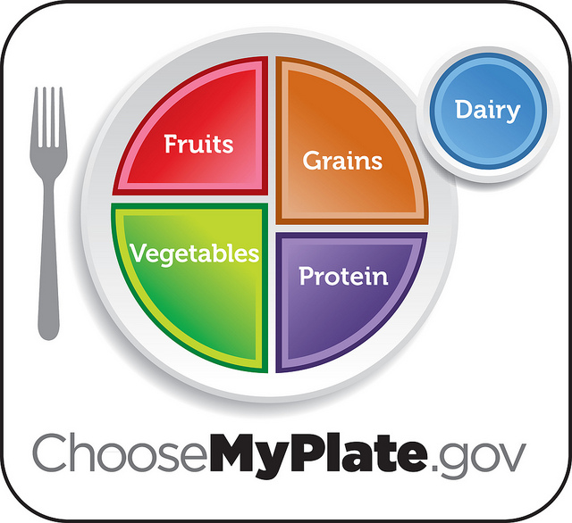

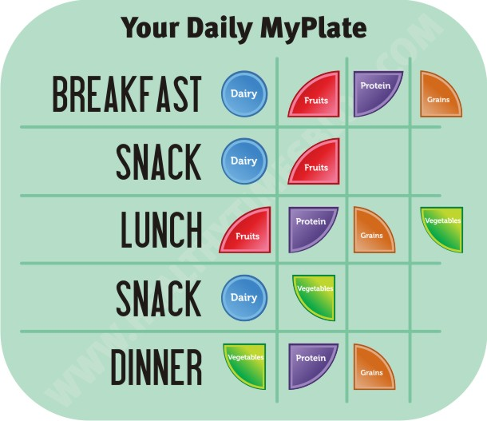
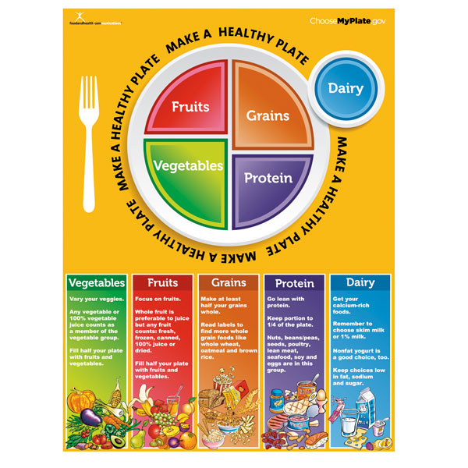
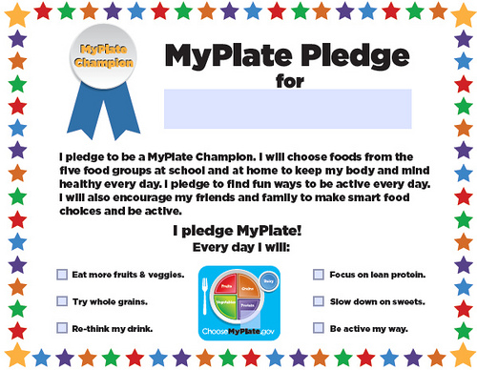
OPTIONAL: PRINT THIS TO DISTRIBUTE WHEN DISCUSSING HOW TO PACK A HEALTHY LUNCH

http://freshbaby.com/healthy_eating/pdf/Fresh-Baby-Pack-A-MyPlate-Lunch.pdf

Additional Reading Materials for Grades K – 2

Resources

Hygiene
Berger, Melvin, and Marylin Hafner. Germs Make Me Sick! New York: Crowell, 1985. Print.

Ross, Tony. Wash Your Hands! Brooklyn, NY: Kane/Miller, 2000. Print.

Slate, Joseph, and Ashley Wolff. Miss Bindergarten Stays Home from Kindergarten. New York: Dutton Children's, 2000. Print.
Ziefert, Harriet, and Mavis Smith. Harry Takes a Bath. New York: Puffin, 1993. Print.

Emergency Safety
Cuyler, Margery, and Arthur Howard. Stop Drop and Roll. New York: Simon & Schuster for Young Readers, 2001. Print.

Pendziwol, Jean, and Martine Gourbault. No Dragons for Tea: Fire Safety for Kids (and Dragons). Buffalo, NY: Kids Can, 1999. Print.

Nutrition
Berenstain, Stan, and Jan Berenstain. Too Much Junk Food. New York, NY: Random House, 1985. Print.

Carle, Eric. The Very Hungry Catepillar. London: Mantra Pub., 2010. Print.

Ehlert, Lois. Growing Vegetable Soup. San Diego: Harcourt Brace Jovanovich, 1987. Print.

Sharmat, Mitchell, Jose Aruego, and Ariane Dewey. Gregory, the Terrible Eater. New York: Four Winds, 1980. Print.

Citations Page
"BrainPOP." BrainPOP. Web. 26 Jan. 2016.

“Choose MyPlate." Choose MyPlate. Web. 26 Jan. 2016.

Dowshen, Steven. "Teaching Your Child How to Use 911." KidsHealth - the Web's Most Visited Site about Children's Health. The Nemours Foundation, 1 Apr. 2013. Web. 11 Dec. 2015.

"Fire Safety." KidsHealth - the Web's Most Visited Site about Children's Health. Ed. Yamini Durani. The Nemours Foundation, 2014. Web. 26 Jan. 2016.

"Fresh Baby Products." Fresh Baby Articles:. Web. 26 Jan. 2016.

"Parents." Sparky Fire Safety Resource for Parents. Web. 26 Jan. 2016.

Sears, William, Martha Sears, Christie Watts. Kelly, and Renée Andriani. Eat Healthy, Feel Great. Boston: Little, Brown, 2002. Print.

Slate, Joseph, and Ashley Wolff. Miss Bindergarten Stays Home from Kindergarten. New York: Dutton Children's, 2000. Print.
"Teach With Me - 1,000's of Free Downloadable Activities & Lessons for Teachers." Teach With Me - 1,000's of Free Downloadable Activities & Lessons for Teachers. Web. 26 Jan. 2016.
"Welcome! - KidsHealth in the Classroom." KidsHealth - the Web's Most Visited Site about Children's Health. The Nemours Foundation. Web. 26 Jan. 2016.
"Welcome Page-Home." Keep Your Child Safe. Web. 26 Jan. 2016.

