Users should treat this material as a working draft. This material can be used in its current form, customized, and/or printed by the user.

The author(s) request feedback on all materials so that they can be continually improved and updated.

This material may contain references to additional resources and links to external websites
that are provided by the contributing author(s) as supplemental materials. The author(s)
neither endorse these references nor are responsible for their content or availability. Also,
the inclusion of any reference to an external resource or link to a website does not imply
endorsement by the author(s) of their owners, products or services.

This material is licensed under the Creative Commons Attribution-Share Alike license
(http://creativecommons.org/licenses/by-sa/3.0/).

Author:
Kevin Hall

Dividing Integers—Teacher’s Guide
3.6d

Whole-class activity
5
0
-2
How could you take this picture of 6 and use it to show $\frac{6}{3}$ ?
Answer with a picture: 12 ÷ 4 = ?
0
1).
Answer with a picture: $\frac{10}{2}= ?$
0
12
3
3
3
3
2
2
2
Note: 6/3 asks for the size of EACH piece, so you cross out all but one.
10
5
5

2). Should the rules for dividing integers be closer to the rules for adding integers, or for multiplying them? What do you think? Please explain your reasoning. ______________________________________________

While students are writing, walk around and find 1 person who says that division is similar to multiplication because the two operations are related (or are opposites). Call on that person to start the discussion in #5.

3). Please use this space to try out people’s ideas from the discussion.

Hopefully (and most likely), a student will suggest that the rules for division will be similar to the rules for multiplication, because the two operations are related. The student may even say that the two operations are “opposites”, or that division is the backwards multiplication.
If a student does suggest this, pump for more detail: “Can anyone give specific examples of the relationship between multiplication and division?” If that question falls flat, prime the pump with a suggestion: “You say division and multiplication are related. What multiplication problem is related to the division problem $\frac{10}{5}=2$ ?” That should get them going.
Then build up a table of 3-4 examples of division problems and how to check the answers, calling on different students for maximum involvement. For example:
Division: Check answer:
Note: In pictures, it makes much more sense to check by writing (2)(5) = 10 than (5)(2) = 10.
So I follow the convention of (quotient)(divisor) = dividend.
$\frac{10}{5}=2$ (2)(5) = 10

15/3 = 5 5•3 = 15

$\frac{10}{20}=0.5$ (0.5)(20) = 10
NOTE: From this point on, the companion PowerPoint presentation shows fully worked-out solutions, animated to appear step-by-step.

How could we show this in pictures? Let’s practice:

$\frac{28}{4} =$ 7
0
4).
Check: (7)(4) = 28
$\frac{45}{5} =$ 9
:
0
5).
Check: (9)(5) = 45
Teacher Example: Show on the PowerPoint (students copy down).
28
7
7
7
7
7
7
7
7
= 28
9
9
9
9
9
Student Practice: Show PowerPoint only after students have tried it.

Please take notes

Division and __Multiplication__ Have the Same Rules

- If the 2nd number is negative, you FLIP the sign of the answer.

$$\frac{-10}{-2}$$
6).
$$\frac{-45}{5}$$
:
0
7).
Teacher example:
Student practice:
(Just watch the teacher demonstrate.)
$$\frac{45}{-5}$$
$$\frac{-40}{-5}$$
:
8).
9).
Teacher example:
Student practice:
(Just watch the teacher demonstrate.)
(See PowerPoint.)
(See PowerPoint.)
-9
-9
-9
-9
-9
0
-8
-8
-8
-8
-8
8
“F” stands for “flip”
Checking our answers: let’s show the picture for both dividing and checking.

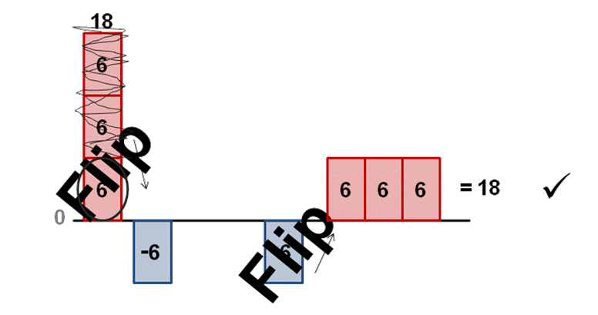
$\frac{18}{-3} =$ -6
10).
Check: (-6)(-3) = 18

WHY flip when dividing by a negative?
  - We flip it when we multiply.
  - So why should we flip it when we divide, too?

Why NOT flip when dividing by a positive?

11). Try without a picture:
Will the answer be Pos or Neg?
Stay Neg.
Will sign flip?
No.
$\frac{-100}{2}=$ $-50$
a).
Will the answer be Pos or Neg?
Flip to Pos.
Will sign flip?
Yes.
$\frac{-40}{-10}=$ $4$
b).

Independent Practice:
Teacher Note: The #12-17 are for formative assessment. Display the questions on the PowerPoint and walk around checking student work (and encouraging them). Try to spend less than 10 seconds per student. Assess whether the class has learned #12-15 well enough. It is not essential that all students know #16-17 yet, but they must all know #12-15.

Please try these at your own pace. Don’t worry about finishing all of them—just be accurate.

12). $\frac{-15}{-3}=5$
See PowerPoint for fully-animated, worked out solutions.
13). $\frac{15}{-3}=-5$

14). 15 – ⁻3 = 18

15). ⁻ 15 + ⁻3 = ⁻ 18

16). $\frac{15}{-3}+2\left(4-6\right)= -9$

17). $\frac{-8}{-2}+({}_{}^{-}8+{}_{}^{-}{2)}=-6$

Teacher Note: Follow this activity up in subsequent days with more practice opportunities that mix integer division with integer addition, subtraction, and multiplication.

