EAST MEADOW U.F.S.D.

Gr. 10 ELA Adapting the Common Core Module 1

Project Facilitator & Writer: Mary Kudla

East Meadow High School

Superintendent of Schools: Leon J. Campo

Principal: Richard Howard

English

TABLE OF CONTENTS:

ABSTRACT……………………………………………………………………Page 3

COMMOM CORE STANDARDS…….…………….…………….………….Page 3

RATIONALE……………………………………………………………….…Page 3

LITERARY SELECTIONS………………………………………………….Page 4

ESSENTIAL QUESTIONS……………………………………….…………Page 4

KNOWLEDGE AND SKILLS……………………………………..……….Page 5

LEARNING ACTIVITIES………………………………………………….Page 5

SAMPLE LESSON PLANS AND HANDOUTS…….…………………….Pages 6-11

POWER POINTS…………………………………………………………….Pages 12- 35

WORKS CITED………………………………………………………………Page 36

**Abstract:** New York State’s current reform initiative to ensure that schools prepare students with the knowledge and skills they need to succeed in college has relied extensively on

Common Core curricular modules. The goal of this CAP is to adapt the modules and provide lesson plans and worksheets that can be used in the classroom that align with the changes occurring in the assessments and the New York State ELA Common Core Learning Standards (CCLS). While primary text selections will still primarily utilize module texts, the unit and lessons will allow for more flexibility and will serve local purposes.

**Core Standards for literacy addressed:**

Reading

* Determine a theme or central idea of a text and analyze in detail its development over the course of the text, including how it emerges and is shaped and refined by specific details; provide an objective summary of the text.
* Trace and evaluate the argument and specific claims in a text, assessing whether the reasoning is sound and the evidence is relevant and sufficient to support the claims.

Writing

* Write arguments to support claims with clear reasons and relevant evidence.
* Introduce claim(s), acknowledge alternate or opposing claims, and organize the reasons and evidence logically.
* Support claim(s) with logical reasoning and relevant evidence, using accurate, credible sources and demonstrating an understanding of the topic or text.
* Use words, phrases, and clauses to create cohesion and clarify the relationships among claim(s), reasons, and evidence.
* Establish and maintain a formal style.
* Provide a concluding statement or section that follows from and supports the argument presented.

Language

* Choose language that expresses ideas precisely and concisely, recognizing and eliminating wordiness and redundancy.

**Rationale:** The focus of this cap is the creation of lesson plans and support material. Included are a series of lesson plans, worksheets, power points and texts that can be used as a whole or adapted to fit core texts in the 10th grade ELA Common Core Module 1 . This includes multiple activities to emphasize the common core focus of writing from sources, generating claims and using evidence to support reading comprehension. A performance task is modeled after part two of the NYS ELA Regents Exam and incorporates the use of the following literary selections.

**Literary Selections with links to the complete text:**

|  |
| --- |
| 1. “The Passionate Shepherd to His Love”   <http://www.bartleby.com/106/5.html>   1. “The Nymph’s Reply to the Shepherd” <http://www.poetryfoundation.org/poem/174205> 2. “Raleigh Was Right”   <http://www.poetryfoundation.org/poetrymagazine/browse/56/2#!/20582126>   1. The Palace Thief   <http://www.buffaloschools.org/uploads%5CELAIG2013-2014/the%20palace%20thief.pdf> |
|  |

**Essential Questions:**

How do effective writers hook and hold their readers?

How does the use of literary elements contribute to the central idea or purpose?

|  |
| --- |
| How does the author’s use of point of view impact meaning in a text?  How does an author establish claims and determine purpose and audience?  How does literature reveal the values of culture or time period? |

How can a character’s decisions and actions change his/her life?

How do the decisions and actions of characters reveal their personalities?

How do prejuidices or initial impressions alter relationships?

What are the elements of a strong relationship?

**Performance Task:**

Select a relationship from one of the texts read in Module 1. How does this relationship develop a central idea over the course of your chosen text?

**Knowledge and Skills**

Students will be able to:

* develop reading comprehension strategies (annotate, compare/contrast, critique, determine importance, make connections, synthesize, visualize)
* identify themes; find examples in text
* underline significant passages and defend their importance
* formulate a thesis regarding central idea and provide supporting evidence in literary selections
* generate process writing that is language appropriate for purpose and audience; using MLA conventions

**Evidence of Learning**

This will be assessed in multiple formats:

* critical reading and analysis worksheets for each text
* class discussion
* "Do Now" and Journal Activities
* process writing stages

**Learning Activities**

Activities in class will be a mixture of the following:

* Individual, partner and choral reading
* Forming evidence based claims
* Finding evidence and support
* Drafting and revising claims

THE BIG IDEA: How do effective writers hook and hold their readers?

Aim: Does Marlowe’s use of structure and figurative language develop the central idea of the text?

Do Now: What do you notice about this painting?

<http://wallacelive.wallacecollection.org/eMuseumPlus?service=ExternalInterface&module=collection&objectId=65365>

Shepherd and Shepherdess Reposing. François Boucher. 1761.

Procedure:

1. After a brief discussion of Boucher’s oil painting, lead into the word *Pastoral* which is the genre of both the painting and the poetry that is the focus of the lesson. Using the painting as the example, students will generate a definition of the word *Pastoral* and discuss why nature is often romanticized.

2. Display Christopher Marlowe’s “The Passionate Shepherd”. As a class, read punctuation to punctuation for Marlowe’s poem and have students stop if they need to discuss any unfamiliar terms. General questions to consider: To whom is the shepherd speaking? What does he promise? Why? What types of imagery are used? How does Marlowe’s Shepherd appeal to the senses? Does the structure create a musical pattern?

3. In pairs have students answer, *Where do we start* questions from the Power Point.

Closure:

1. Wrap-up discussion of Marlowe’s poem. How else does his persuasion work (ethos, pathos, logos)? Does the structure or stanza organization reinforce this? Discuss concepts of carpe diem, tempus fugit (time flies), and/or pastoral conventions.
2. Homework: Complete the following quick write. How does Marlowe's use of structure and figurative meaning develop the central idea of the text? Be sure to use specific refrences to the poem and literary elements.

THE BIG IDEA: How does the use of literary elements contribute to the central idea or purpose?

Aim: Does Marlowe’s use of structure and figurative language develop the central idea of the text?

Do Now: What do you notice about this painting?

<http://wallacelive.wallacecollection.org/eMuseumPlus?service=ExternalInterface&module=collection&objectId=65365>

Shepherd and Shepherdess Reposing. François Boucher. 1761.

*Using the same painting, photoshop stars specifically to emphasize: their bare feet, the rumpled clothes, the embrace, the rose and the eye contact between the two figures.*

Procedure:

1. The class will list on the board the items highlighted by the stars. *What’s Love Got To Do With It?* Slide from Power Point. The prior day’s focus was on the pastoral nature of the poem. It is important to also consider the topic of love and consider what the shepherd’s intentions are. Using pop culture a clip of the song *Let me Sleep on it* <https://www.youtube.com/watch?v=Pk1MpWFtteU> will be used to help students move beyond the traditional phrasing.

2. Display Christopher Marlowe’s “The Passionate Shepherd”. Where do you see “love”? What do you think the Shepherd really wants? Why?

3. In pairs have students read Raleigh’s “Nymph’s Reply”. Directly on the poem, students should annotate and highlight examples that show what the Nymph’s response is.

Closure:

1. Wrap-up discussion of Raleigh’s poem. How does Raleigh answer Marlowe?

Homework: Students must complete the questions located at the bottom of the poem worksheet.

How does persuasion work (ethos, pathos, logos)?

Does the structure or stanza organization contribute to the persuasion?

Discuss concepts of carpe diem, tempus fugit (time flies), and/or pastoral conventions.

How is Raleigh’s poem different?

THE BIG IDEA: How does the author’s use of point of view impact meaning in a text?

Aim: How does Raleigh use Marlowe’s central idea to refine and develop his own?

Do Now: What do you notice about this image? How is it similar/different in comparison’s to yesterday’s painting?

[Pastoral-Nymph's Reply](http://writingnorthidaho.blogspot.com/2014/12/the-joy-of-prosody-joy-of-pastoral.html)

Procedure:

1. Discuss the artwork and similiarities/differences. Introduce point of view and discuss how the perspective of the paintings has changed. Then pass out copies of *The Nymph’s Reply*.
2. In pairs, assignstudents to the roles of “shepherd” or “nymph.” Have the students read *The Nymph’s Reply* punctuation to punctuation in their couples. With their partner, students will discuss this poem as a companion piece or reply. Questions to consider: What does the nymph think of the shepherd’s promise(s)? Why? What types of imagery are used? Pairs will take out Marlowe’s poem and discuss the similarities/differences between the two. Finally, circling the key terms that they feel are most significant in each poem.
3. Choral reading: Divide the class in half with “shepherds” on one side and “nymphs” on the other. Choose one head “shepherd” and one head “nymph.” Have the head shepherd read the first stanza, with other shepherds backing him or her up by echoing the key terms they have circled. Have the nymph read her first stanza (with echoing nymphs), and back and forth until the end of the two poems.

Closure:

1. Whole-class discussion. Discuss which terms students echoed most loudly (for example, there might be a lot of “no” or other negative terms from the nymph). Have students discuss which poem they found more persuasive and why. Also, which poem they liked more and why. This can move into a larger discussion of verbal irony, persuasion (ethos, pathos, and logos), or [antithesis](http://grammar.about.com/od/ab/g/antithesis.htm).

Homework: Creative writing task- What would a modern day response or invitation look like? How do people “woo” today? Use a line or repeating idea from Marolwe or Raleigh and create a modern day example of at least ten lines.

THE BIG IDEA: How does an author establish claims and determine purpose and audience?

Aim: How does Williams draw upon and transform a central idea established by Marlowe and Raleigh?

Do Now: Complete the following venn diagram and list the similarities and differences between The *Passionate Shepherd* and *The Nymph’s Reply*.

Procedure:

1. Have students volunteer to fill ou the venn diagram that is projected on the board. Then as a whole class, discuss how the two poems work together.
2. Post a three circle venn diagram and pass out Williams’ poem *Raleigh was Right.* As a class, read punctuation to punctuation Williams’ poem and have students stop if they need to discuss any unfamiliar terms. Possible discussion questions include: What does the opening statement in lines 1–3 suggest about the speaker’s position in relation to the country? What type of adjectives does Williams use to describe the “small violets” and what is their effect? What quality of mind is being “praised]” (line 7)) by the “poets” (line 8)? What is the effect of Williams’s use of “if” in line 13? What “truth” does the speaker doubt (line 13)?
3. In small groups, students will re-read the poem and complete the three circle venn diagram.

Closure:

1. Return to *The Passionate Shepherd* and *The Nymph’s Reply*.What adjectives does Marlowe use to describe nature? What can you infer from this comparison about how the speaker of Williams’s poem views the relationship between humans and nature? How is Williams’s speaker’s claim about what cannot be found in the country a response to Marlowe’s vision of country life? Consider what you know about Raleigh’s use of “if” in comparison to Willliams use of if. How does this poem’s response to the invitation of Marlowe’s poem compare to Raleigh’s reply?

Homework: Quick write response. According to Williams, what was Raleigh right about? In a well-developed paragraph, explain how Williams’ transforms a central idea established by Marlowe and Raleigh.

THE BIG IDEA: How does literature reveal the values of a culture or time period?

Aim: How do ideals shift over time?

Do Now: Many argue that the American Dream is dead or unatainable? How do you feel about America’s “white picket fence”? Think about the poets that we have discussed over the past few days. What would each of them say about the idealism of the American Dream?

Procedure:

1. After discussing the do now, pass out a copy of *American Dream or Mirage?* by Robert Krauss. This will act as a transition from the set of pastoral poetry into The Palace Thief. <http://www.nytimes.com/2015/05/03/opinion/sunday/american-dream-or-mirage.html>
2. Students will independently read the text and annotate. They will be instructed to underline key words, circle unfamiliar words, write questions or comments in the margins.
3. Then with a partner they will complete and discuss the analyzing details sheet. Information should include an analysis of the text title, a general statement of purpose/ Point of View and a data collection that lists:

* 3 Facts I learned
* 2 Questions I still have
* 1 Interesting fact I will share

Closure:

1. Whole class discussion of the analyzing details worksheet. Specifically the section that asked what they plan on sharing.

Homework: Interview another. Ask a grand parent, parent, aunt or uncle what the American Dream is for them. Supplement the discussion by asking if that vision was different when they were your age.

Name: _________________________________ Date: ______

English 10: Kudla Period: _____

Analyzing Details

Directions: Read the text and annotate. Underline key words, circle unfamiliar words, write questions or comments in the margins. Then complete this sheet.

Analyzing the text title: What is it? What does it suggest?

Purpose/ Point of View: Why did the author write the piece? Who is the intended audience?

C:\Users\mkudla.INST\AppData\Local\Microsoft\Windows\Temporary Internet Files\Content.IE5\2Z6WRWTK\MC900326094[1].wmfFacts I learned

C:\Users\mkudla.INST\AppData\Local\Microsoft\Windows\Temporary Internet Files\Content.IE5\DH5Y4GLW\MC900326092[1].wmfQuestions I still have

C:\Users\mkudla.INST\AppData\Local\Microsoft\Windows\Temporary Internet Files\Content.IE5\5F295O9A\MC900326090[1].wmfInteresting fact I will share (This should be about something the text triggered in terms of your own personal experience.)

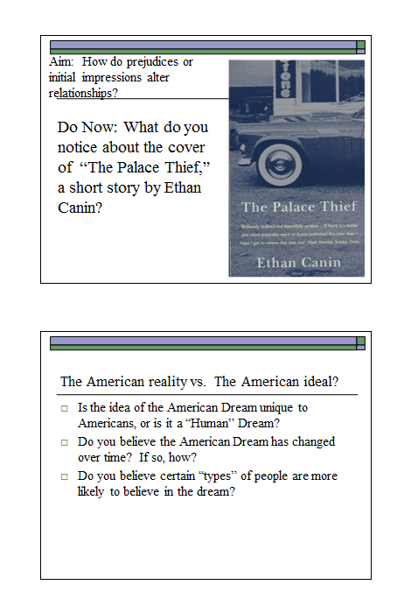

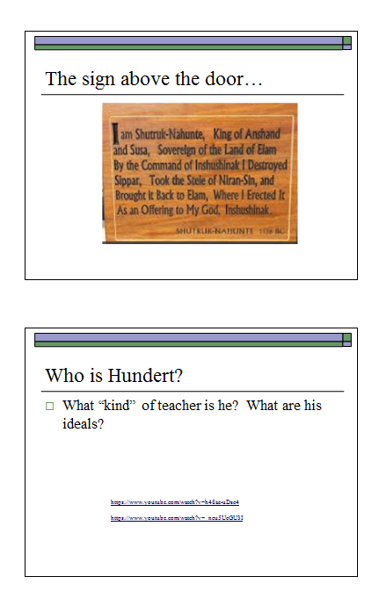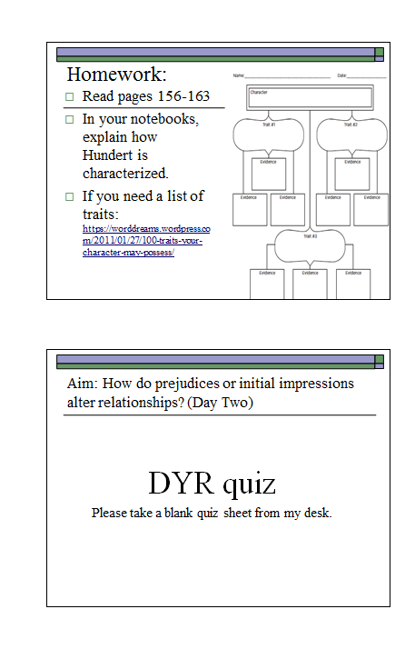

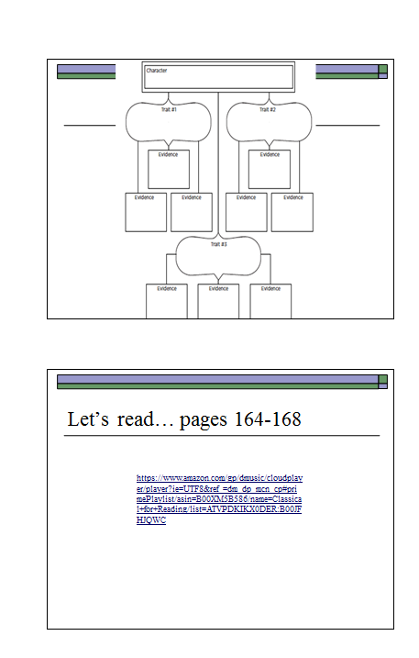

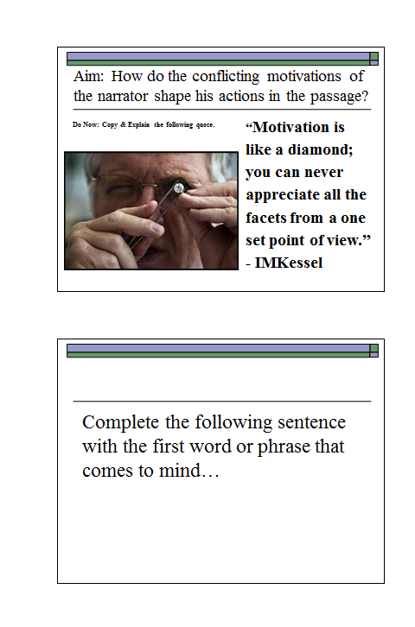



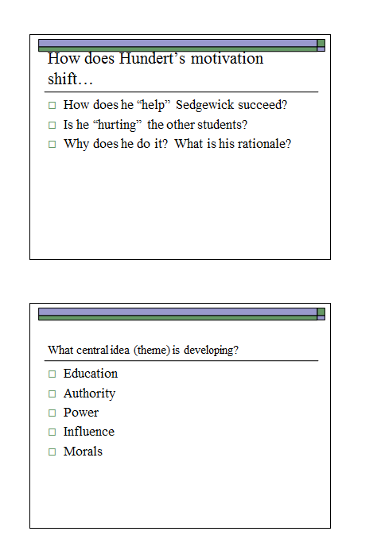

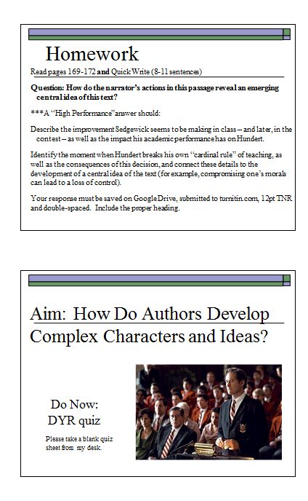

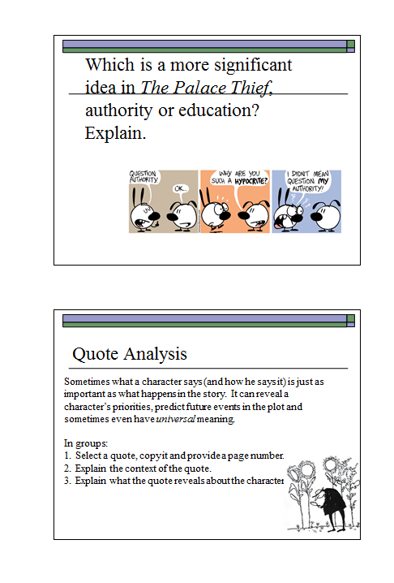

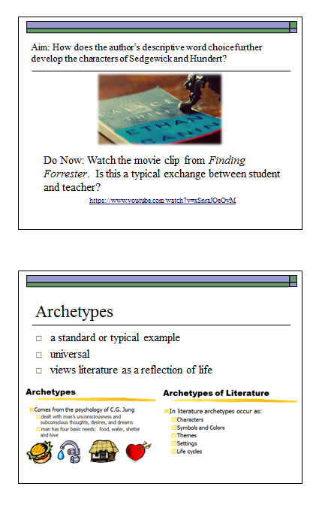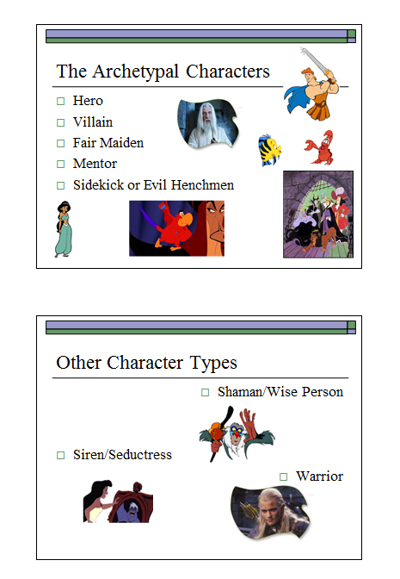

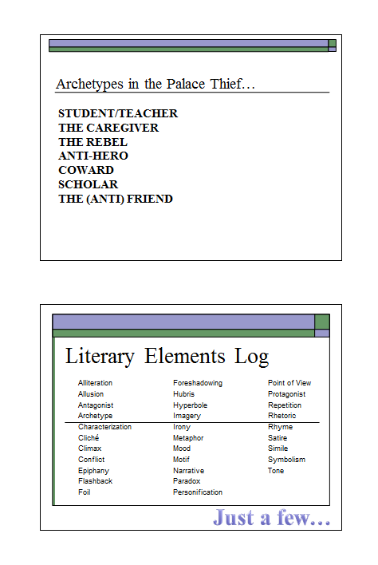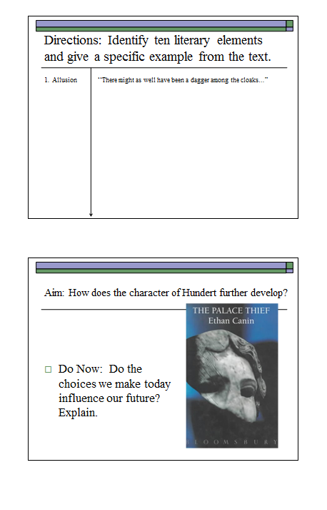

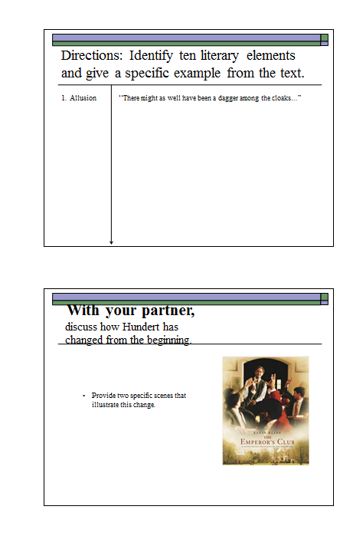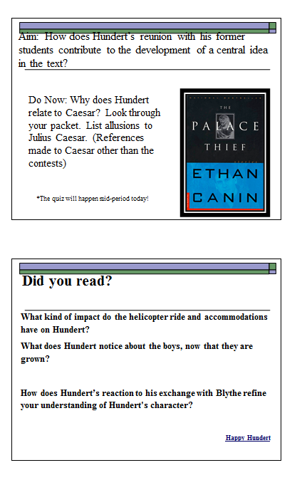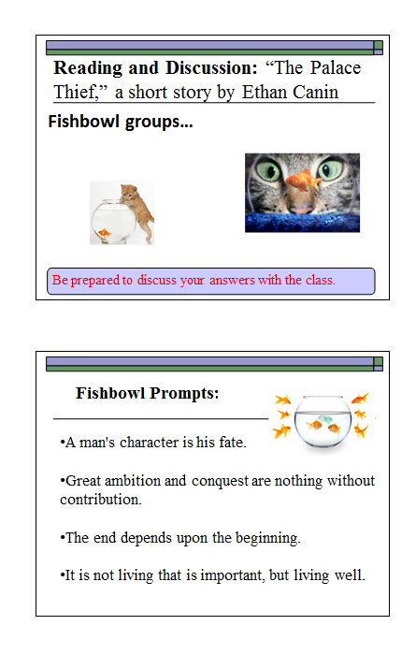

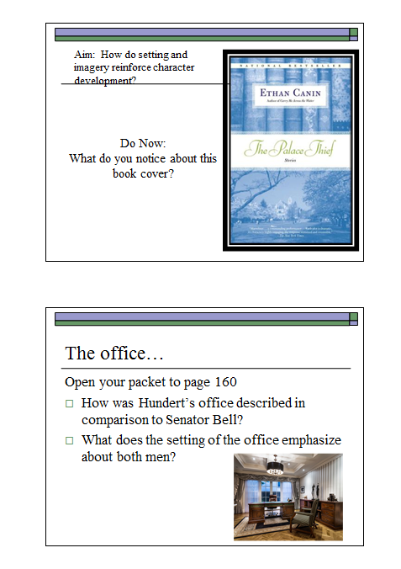

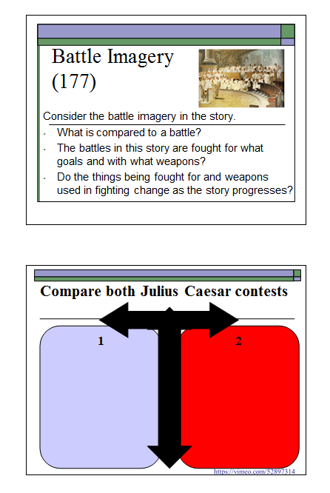

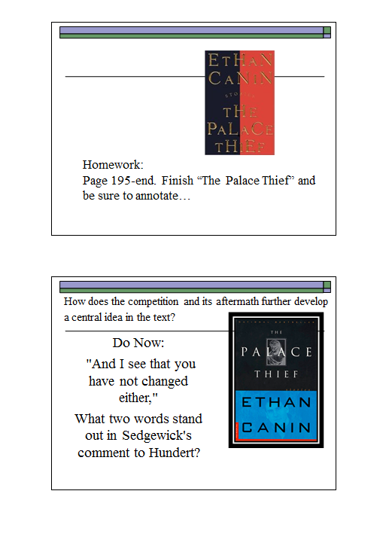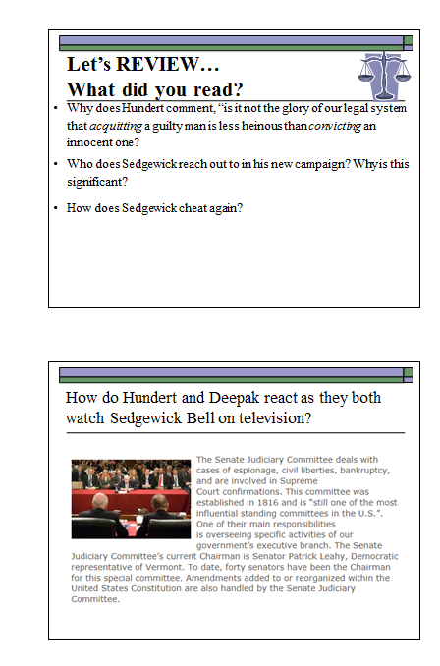

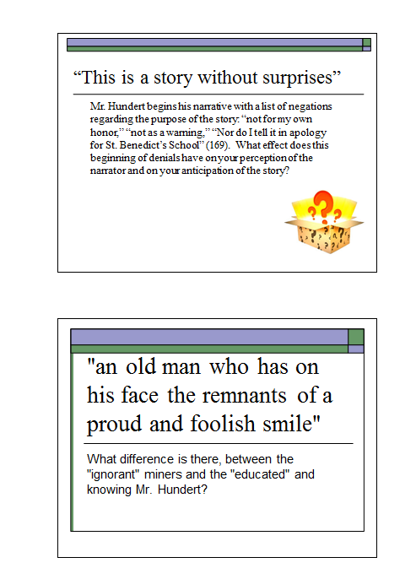

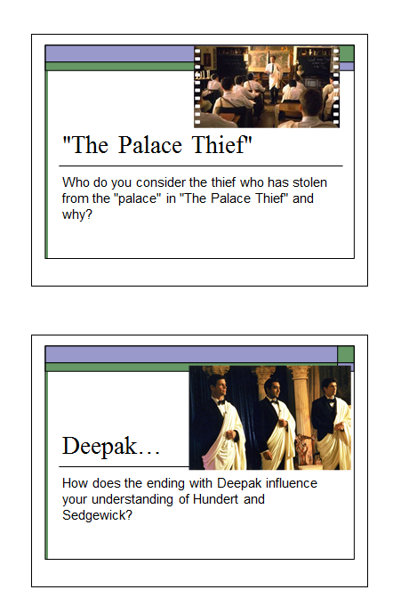

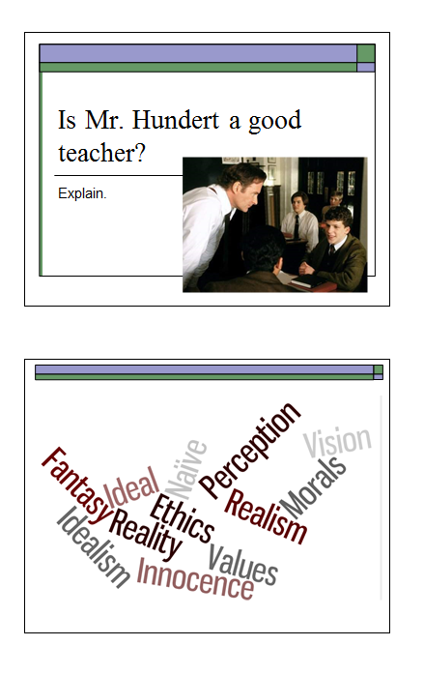

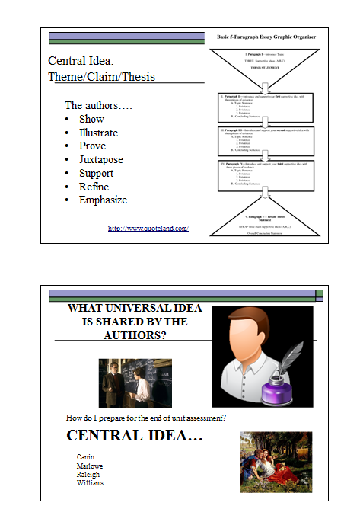

Works Cited

[Boucher](http://wallacelive.wallacecollection.org/eMuseumPlus;jsessionid=C8A3C6B2F022FFBF13373F55434CFC80.node1?service=direct/1/ResultDetailView/result.t1.collection_detail.$TspReferenceLink.link&sp=10&sp=Scollection&sp=SelementList&sp=0&sp=0&sp=999&sp=SdetailView&sp=0&sp=Sdetail&sp=0&sp=F&sp=Sartist&sp=l4490), François. *Shepherd and Shepherdess Reposing.* France, 1761.

Cain, Ethan. "The Palace Thief." Pdf Buffalo Schools. Web. 19 Aug. 2015.

Dueben, Alex. "The Nymph's Reply to the Shepherd." *Poetry Foundation*. Poetry Foundation. Web. 19 Aug. 2015.

Kraus, Michael. “American Dream? Or Mirage?” *New York Times*. 1 May 2015

"Passionate Shepherd to His Love. C. Marlowe. The Golden Treasury." *Passionate Shepherd to His Love. C. Marlowe. The Golden Treasury*. Web. 19 Aug. 2015.

"Raleigh Was Right" *Modern Poetry English 306*. 27 Feb. 2012. Web. 19 Aug. 2015.